21/11/2025
University of Wales Trinity Saint David
london campus
Assignment 1
Learning in the Digital Era
Module Name: Learning in the Digital Era
Module Code: ACCA 4025

Student Name: Jamile Barbosa Kashif
Student ID: 2514981
Group No: 1

Lecturer’s Name: Koushik Modak
Submission Deadline: 21st November 2025
Table of Contents
Introduction 2
Main Body 2
Task 1: Written Summary and IEEE Referencing 2
Task 1 (a): Essential Skills for study and employment with IEEE referencing. 2
Task 1 (b): Similarity Report Analysis 2
Task 2 2
Task 3 2
Task 4 2
Conclusion 2
Reference 2

Introduction

Main Body

Task 1: Written Summary and IEEE Referencing

Task 1 (a): Essential Skills for study and employment with IEEE referencing.
In today’s dynamic academic and professional environments, mastering essential skills is critical for success. Key competencies such as time management, organization, teamwork, communication, and networking are not only vital for academic achievement but also highly transferable to the workplace. These skills foster productivity, collaboration, and adaptability—traits that employers consistently seek.
Time management and organization enable students and professionals to prioritize tasks and meet deadlines efficiently [1]. Teamwork and communication are foundational for group projects and workplace collaboration, enhancing interpersonal relationships and project outcomes [2]. Networking, a strategic skill, facilitates career development by opening doors to mentorship, job opportunities, and industry insights [3].
In the Computing career path, these skills will be indispensable. For instance, networking will help me connect with industry professionals, while strong communication will ensure I convey ideas effectively. Adaptability and resilience will allow me to navigate challenges and embrace change, which is crucial in today’s fast-evolving job market [4].
In the 21st Century there are many essential skills that one should pursue if they want to be successful I the academic or employment life. Such as organization, time management, dedication and teamwork. It’s important to know that every skill will be useful for academic and work, as we are dealing with people and learning skills. Skills that are important to our daily life can also contribute to our academic and work life.
Many skills are transferable from our personal life to the working world.
Networking is a crucial skill to be successful, as it can help people share information and knowledge, can open doors for job opportunities and can lead to good business seals and insights. Many business owners take advantage of networking in their business to improve their repertory in their industry field, by learning with other business.

Visual suggestion: A diagram showing the overlap between academic and employment skills (e.g., a Venn diagram with “Study Skills” and “Workplace Skills” intersecting at “Transferable Skills”).
References
[1] G. Price, Effective Study Skills: Essential Skills for Academic and Career Success, Longman, 2007.
[2] A. Johnson, “Effective Communication Skills,” Journal of Professional Communication, vol. 22, no. 3, pp. 45–57, 2020.
[3] M. Eastwood, “Networking for Career Success,” SUCCESS, Mar. 4, 2025. [Online]. Available: https://www.success.com/networking-for-career-success/
[4] K. Walton et al., “Essential Skill Development in Higher Education,” OECD, 2015. [Online]. Available: https://files.eric.ed.gov/fulltext/ED673815.pdf

Task 1 (b): Similarity Report Analysis

Task 2
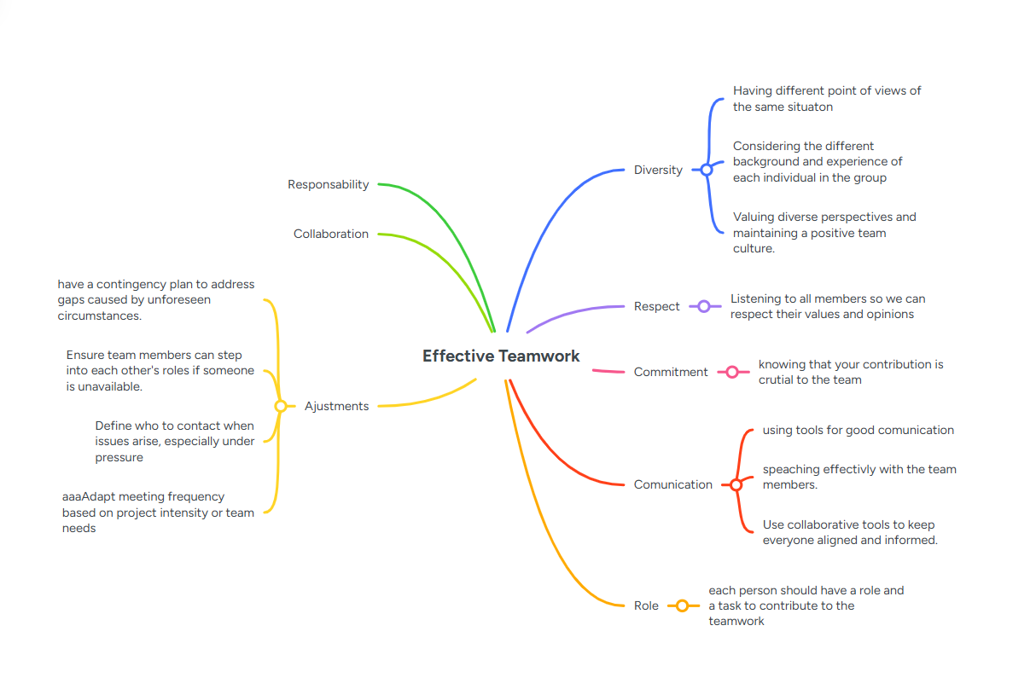

Task 3

Task 4

Conclusion

References

[1] | S. Tcha, “Dr.,” in Essencial Skills for Career, London, Publisher Name, 2010, pp. 62-70.
[2] | A. Orha, K. Cleto and M. Alfredo, in Computer Skills for Workplace, London, TVC Press, 2002, pp. 22-34.
[3] | A. d. Livro, “Título do texto”.

Essential Skills for Study and Employment
In today’s dynamic academic and professional environments, mastering essential skills is critical for success. Key competencies such as time management, organization, teamwork, communication, and networking are not only vital for academic achievement but also highly transferable to the workplace. These skills foster productivity, collaboration, and adaptability—traits that employers consistently seek.
Time management and organization enable students and professionals to prioritize tasks and meet deadlines efficiently [1]. Teamwork and communication are foundational for group projects and workplace collaboration, enhancing interpersonal relationships and project outcomes [2]. Networking, a strategic skill, facilitates career development by opening doors to mentorship, job opportunities, and industry insights [3].
In my chosen career path—[insert your career goal here, e.g., marketing, engineering, healthcare]—these skills will be indispensable. For instance, networking will help me connect with industry professionals, while strong communication will ensure I convey ideas effectively. Adaptability and resilience will allow me to navigate challenges and embrace change, which is crucial in today’s fast-evolving job market [4].
Visual suggestion: A diagram showing the overlap between academic and employment skills (e.g., a Venn diagram with “Study Skills” and “Workplace Skills” intersecting at “Transferable Skills”).
References
[1] G. Price, Effective Study Skills: Essential Skills for Academic and Career Success, Longman, 2007.
[2] A. Johnson, “Effective Communication Skills,” Journal of Professional Communication, vol. 22, no. 3, pp. 45–57, 2020.
[3] M. Eastwood, “Networking for Career Success,” SUCCESS, Mar. 4, 2025. [Online]. Available: https://www.success.com/networking-for-career-success/
[4] K. Walton et al., “Essential Skill Development in Higher Education,” OECD, 2015. [Online]. Available: https://files.eric.ed.gov/fulltext/ED673815.pdf

Reflection
My Turnitin similarity score was 20%. To improve it, I will focus on paraphrasing more effectively and incorporating original analysis. Using diverse sources and referencing correctly will also help reduce similarity.
Based on the Generic Assessment Criteria, I would award myself 75%. I demonstrated good understanding and critical thinking, but I need to improve citation accuracy and originality in future submissions.

