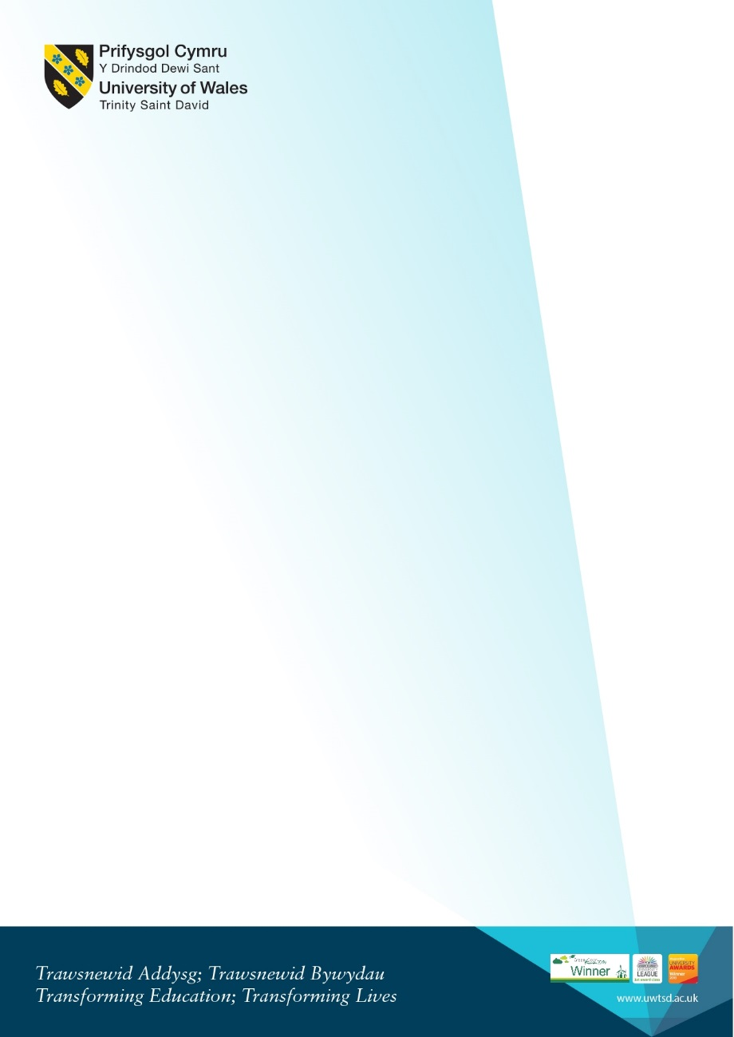
Virtual Welcome for new
Degree Apprenticeship Computing (DDA) Students
Monday 17th January 2021 10am
MS Teams: Click here to join the meeting

10am | Welcome from the team  Kapilan Radhakrishnan - Academic Director (App. Computing)  Bridget Moseley - Head of the Apprenticeship Unit  Beverley Holland and Gaynor Thomas - Programme Managers DDA scheme | Who we are, our roles. Who to contact.  Kapilan’s “Welcome to the School of Applied Computing”
 | Introduction to the Liaison officer team. | Brief introduction from each member of the team.
10.30am | Gaynor Course overview. | - Introduction to the course structure and overview of the modules.  - Study mode (online/in person, Covid regulations)  - Workshop days and when they are  - Moodle and where to find information on Moodle.  - Information on student services and procedures to follow.  - Accessing Email/Teams/Hwb/Timetable
11am | Team Q and A session | - Opportunity to ask any questions
Homework :) | Welcome videos and Campus  safety presentations link.  Please take some time to look  at the available videos. If you  have any questions please e-  mail a member of the team. | Including  - Welcome from the VC  - Welcome from Provost  - Your Campus: Safety on Campus  - Campus Virtual Tour  - Parking  - Enrolment  Link to resources on Hwb:  https://uwtsd.myday.cloud/pages/student/resources_welcomeandinduction

