


Environmental Factors impacting tesco & it’s
hr strategy
  - 12TH December 2017

Contents
- Executive Summary ___________________________________________ 1
- Introduction_________________________________________________ 2
- PESTLE Analysis_____________________________________________ 3
- Porters Five Forces___________________________________________ 8
- Key impacts to Tesco_________________________________________ 9
- HRM considerations__________________________________________ 10
  - Data & Technology________________________________________ 11
  - Talent & Labour Market____________________________________ 12
  - Communication__________________________________________ 14
- Conclusion _________________________________________________ 15
- Recommendations___________________________________________ 16
- References__________________________________________________ 17

Executive Summary
The purpose of the report is to provide an evaluation of Environmental factors currently affecting Tesco Plc. Detailing the impact on the organization and make suggestions for future HR Strategy. Two main business tools have been used to aid the report one being a PESTEL analysis which is one of the strategic analytical tools used for business environment analysis; it mostly concerns the company’s external environmental factors affecting its operation. PESTEL is an abbreviation for political, economic, social, technology, environmental, and legal factors influencing the company (REFERENCE). The second business tool is Porters Five Forces Porter's Five Forces Framework is a tool for analyzing competition of a business. It draws from industrial organization economics to derive five forces that determine the competitive intensity and, therefore, the attractiveness (or lack of it) of an industry in terms of its profitability. I have chosen Porters Five Forces to demonstrate the high competitive environment Tesco operates which underpins the inportance for competitor advantage.

The report’s findings conclude that during the post Brexit uncertainty there are two factors that impact Tesco in the short term which are:
- Talent & Labour Market
- Technology & Data protection and data privacy
The report describes these key challenges and provides the HR solutions to each factor based on academic knowledge of HRM mixed with current market data that supports the impact of Brexit on the retail sector.

The report draws on the recommendations that
- The key recommendations

Introduction
The aims of the Business report is to evaluate the major environmental trends facing Tesco by reviewing the Political, Economic, Social, Technological, Legal, Environmental, and Demographic impacts it currently faces. Building a basis for a conclusion on the best HRM strategy for Tesco Plc in the identified environment.
- Research Methodology
- Findings
- PESTEL Analysis

PESTEL analysis is one of the strategic analytical tools used for business environment analysis; it mostly concerns the company’s external environmental factors affecting its operation. PESTEL is an abbreviation for political, economic, social, technology, environmental, and legal factors influencing the company. This business essay applies PESTEL analysis to evaluate the environment of Tesco.
Whilst the use of a PESTLE provides insight into the external factors that governs an organizations environment. It does little to describe the competitive environment in which Tesco operates in. The report will now use a model called Porters 5 Forces as highlighted in (Appendix: 3)
- Porter’s Five Forces Analysis
An analysis of the structure of the industry should be undertaken in order to find effective sources of competitive advantage (Porter, 1985). Therefore, in order to analyse the competitive environment of Tesco, Porter’s five forces analysis has been used by the researcher as follows:
The market in which Tesco operates is highly competitive, where Tesco holds a disproportionate amount of power. Tesco has three major competitors – Sainsbury, Asda and Morrison. These giants of retail have many chains and a collective mass that can influence the food market as a whole. Tesco holds just under a third of the UK market share, and almost double the amount of Asda’s market share which is the second largest supermarket chain as highlighted in (Appendix 3). Tesco out of its three main competitors, dominates the online grocery market with a 17% share. Tesco of late has increased its sales and profitability but have lost market share, seeing the discounters gain market share.

- Key Impacts to Tesco
Considering both the Pestle analysis and Porters five forces, Tesco’s key challenges are underpinned by the uncertain times ahead with Brexit. The volatile economy and uncertainty of the future threatens its Transformation strategy to pay off its debts and bring back balance to its balance sheet. With uncertainty not just for the economy but also for the labour market with its agricultural supplies heavily reliant on immigrant labour, if unmanaged could provide serious implications for Tesco and the retail food industry in this VUCA world (Bennett & Lemoine, 2014). The rise in food costs will need to be offset to ensure a competitive price for its staple goods to retain their competitive advantage with consumers. With external technological threats ever more prevalent the technology strategy should be fully aligned with the overall Group strategy, investment in technology resilience should be evaluated, and greater adoption of big data analytics including cloud computing technologies would provide further resilience. Therefore the report suggests that Tesco’s key challenges ahead are:
  - Facing up to the challenge of emerging business models which compete with their own.
  - Continuing to gain a better understanding of the changing nature of consumer behaviour.
  - Making the right strategic decisions in an uncertain Pre Brexit World.

Big Data Analytics giving a Competitive advantage
Analytics is the discipline, which has developed at the intersection of engineering, computer science, decision-making and quantitative methods to organise, analyse and make sense of the increasing amounts of data being generated by contemporary society (Mortensen, et al., 2015). In Tesco’s volatile market, new emerging competitors are constantly after a slice of their market share. Therefore making the right decisions with the right data has never been more important. Tesco has long been a pioneer when it comes to technology and data driving business advantage. It was one of the first supermarket chains to begin tracking customer activity through its loyalty card system and has successfully managed the transition to online retailing. However, data has changed since then, Tesco now operates in a global market as a result of the complexities of the modern world (Farnham, 2015).

(Eric & Andrew, 2012) Described the challenge of big data in terms of three ‘V’s volume, velocity and variety. There is much more data around and its volume is expanding. It’s getting faster and spreading everywhere. It’s available through more channels and on more devices than ever before. Big Data can drive success in a business, according to Thomas Davenport, Harvard analytics guru, suggests that ‘data driven’ organisations are 6% more productive and 5% more profitable (Davenport, et al., 2012). Although there are sceptics that suggest that HR is grappling with big data and not building the big data minds to evolve with the technology. Analytics according to the Chartered Institute for Personnel Development (CIPD) is “HR analytics is a HR practice enabled by information technology that uses descriptive, visual and statistical analyses of data related to HR processes, human capital, organizational performance, and external economic benchmarks to establish business impact and enable data-driven decision-making.” (CIPD, 2017) Whilst Data Analytics can help businesses maintain their advantage. There are some disadvantages when applying this to business decisions. One important point in analytics is quite often they are not understood and this could be detrimental when using this data for business decisions. One challenge is the analytics industry mainly constitutes of data for products and services and very rarely for the value of HR data. With the gap between HR and analytics there needs to be a bridge that fills this knowledge gap and some organisations have sort the help of academics thinking on HR Analytics. Although, opinion is divided on whether academics can assist in providing the HR profession to upskill to a new world of strategic analytics-driven HR. In a recent article, Bersin (2015a) reported evidence of companies drawing on the expertise of PhDs in
occupational psychology, engineering and statistics in order to take their analytics activity to the next level. However, Rasmussen and Ulrich (2015) are rather dismissive of the idea that corporate analytics teams should draw on academic expertise, because they do not think academics have a deep enough understanding of the business to ask the right questions, and will waste time and resources developing over-specified models in answer to largely academic questions with little practical application.
Whilst academics can bring the knowledge and science to the data, it has to be meaningful to the organisation and has to attract the attention of the Boardroom to help influence decision making. This is where the HR function plays a key role. It is suggested that HR should use or seek a business need first and then seek data that helps resolve this problem. After all what use is data if it’s not part of a story or solution to a business.
Analytics takes time, resource and skills which is one of its main challenges in its uptake. However, The Google Vice Presedent Rajan Anandan and Human Resource leader Laszlo Bock has justifiably learned to demand data-based decisions everywhere. People management decisions at Google are guided by the powerful “people analytics team.” Two key quotes from the team highlight their goals; all people decisions at Google are based on data and analytics. The goal is to bring the same level of rigor to people-decisions that we do to engineering decisions. Google is replacing the 20th century subjective decision-making approach in HR. The final key to Google’s people analytics team’s success occurs not during the analysis phase, but instead when it presents its final proposals to executives and managers. Rather than demanding or forcing managers to accept its approach, it instead acts as internal consultants and influences people to change based on the powerful data and the action recommendations that they present. Because its audiences are highly analytical (as most executives are), it uses data to change preset opinions and to influence (Sullivan, 2013).
Google’s approach whilst unique and successful, suited it organisations background in Technology and data analysis. Tesco in the retail market place could adopt a mix of skill and experience, the HR structure of the organisation would need to be aligned strategically to assist this change.
Organisational & HR Structure
Tesco’s organisational structure is fairly typical of a multi-national Organisation (MNC) which is hierarchical but has also become divisionalised, operating as semi-autonomous or quasi-businesses. This proves beneficial to Tesco in ways of communication as day to day workload gets achieved efficiently. However, this can create an environment that has a lack of collaboration with organisational levels and could lack innovation or, at least the communication of.
Whilst the organisational structure of Tesco has evolved over the years to adapt to its internal and external needs, little has changed to its HR structural format In that time. As described by (Ulrich, 1997) Tesco’s organisational HR structure adopts a multi legged model of HR structures, as head office comprising of a small number of Corporate HR professionals and Centres of excellence whilst store based HR professionals are more in line with carrying out the shared services roles, undertaking a lot of HR administrative tasks and provide information and advice to Line Managers. There seems to be a disconnect between Head office’s strategic HR approach and that of the store based HR Shared Services approach. The report questions how strategic store based HR roles are and in an advanced connected world how much value do they add to Tesco.
Now policies and practices are available on all devices throughout the organisation, could Line Managers carry out the HR functions themselves in store. As outlined by (Purcell , et al., 2003) Strengthening the relationship with employees and line managers can result in a positive approach to employee performance and motivation. Line managers can also play a critical role in implementing HR policies (Renwick , 2003).

Google’s approach whilst unique and successful, suited it organisations background in Technology and data analysis. Tesco in the retail market place could adopt a mix of skill and experience, the HR structure of the organisation would need to be aligned strategically to assist this change.

Tesco will need quality and robust data on workforce and workforce programmes to make good decisions. A full review of how accessible and accurate its workforce data is to establish data such as nationality and locations will be key to providing insight into making decisions ahead of Brexit decisions. A review of all the major transformation projects will be necessary to evaluate its relevance and question will it make the organisation more agile during and after Brexit. Sharing this data with Tesco Leadership Team & the executive committee will be necessary to provide data to form decisions. Tesco may also need to look at accelerating some of its projects such as the new role out of The Payroll system in the UK to ensure resource is available for any impending Brexit impacts. Although thinking carefully about the implications of not landing a new payroll system correctly or taking short cuts may pose to the business.

6.2 Talent & Labour Market & Big Data Analytics
As outline in the PESTLE the labour market is a key focus for Tesco not just for its agricultural suppliers but also for attracting and retaining the right talent to maintain their competitive advantage. Uncertainty about the future will affect decisions made today. However, a full review of Tesco’s dependence on European Economic Area and Swiss nationals should take place. Tesco operates in six countries within the EU those being France, Czech Republic, Hungary, Poland, Slovakia & Ireland.
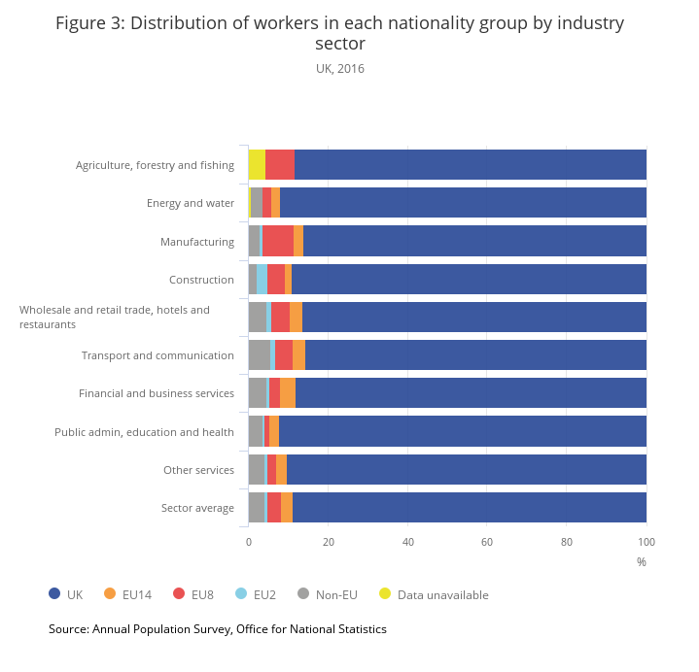
There may be opportunities to get more skilled talent from non EEA/Swiss countries. A review needs to be carried out of how fluid and efficient our visa applications and recruitment processes are, also how skilled our HR experts are in this field. If so what are the pockets of the business that would require this expertise or skill. If freedom of movement was removed from the UK in numerical terms, the sector with one of the highest number of non-UK nationals employed is the wholesale and retail trade, as shown in Table 3 below.
Table 3: Distribution of workers in each nationality group by industry sector
UK 2016

XXX One opportunity is to review succession planning for key talent and identify potential alternative talent pools for use in the event that immigration policy becomes more restrictive. Overall identifying the specialist skills required to get Brexit done and consider how to source and secure these.
- Conclusion

- Recommendations
One of Tesco’s success to date has been how agile it is at responding and adapting to its internal and external changes. In order for Tesco to lead their company through the Brexit changes the company will need to ensure its HRM Strategy is aligned with its corporate strategic plan and ensure it is using the best HR processes and policies to deliver in its competitive market. This should encompass a review of its organisational structure to ensure communication is simplified and agility is proven before the Brexit changes take place.
Tesco needs to ensure communication is at the heart of Brexit activity, with the aim of keeping stakeholders focused on and supportive of the needs of the business and its customers. HR will be primarily responsible for communication to internal stakeholders and needs to ensure its communication plan covers the breadth of the organisation.
Communications should set a purposeful tone focused on the opportunities of the future, while giving permission for employees to voice anxieties. As some employees may be feeling impacted, either directly or because they have close family members who are EEA/Swiss nationals. Some considerations for Tesco could be an online Brexit hub community for colleagues to voice their opinions and get answers to their questions once Brexit decision have been made. Assign a Change team to look after communications between colleagues and the Board to ensure colleagues feel heard and recognised. After reviewing the organisations hierarchical structure ensure that it is lean and does not duplicate levels unnecessarily aiding clear communication and allows colleagues to feel more involved and consulted through the changes.

- Bibliography

Appendix 1.

