

MANAGEMENT ACCOUNTING
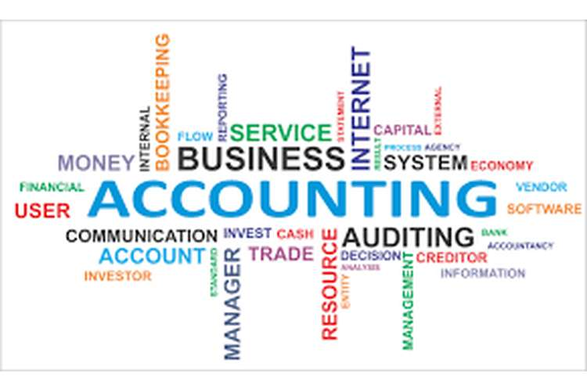

STUDENT NAME : CARMEN-MARIANA PROCA
STUDENT NUMBER: 1809333
LECTURER NAME: DR. ISAIAH OINO
MODULE TITLE: MANAGEMENT ACCOUNTING
MODULE CODE: LCBB5002

Table of Contents
Part A 3
1: Absorption costing 3
2: Activity based costing 3
3: Costing methods 4
Part B 6
Break Even Analysis 6
Reference List 11
Appendices 13

PART A

TASK

ABSORPTION COSTING
 |  | LW | MR
UNITS |  | 4500 | 500
DIRECT MATERIAL COST | LW (4500 ×3)  MR (500×10) | 13500 | 5000
DIRECT LABOUR COST | LW (6.30÷9) × 4500 =0.70 × 4500  MR ((6.30×7) ×500 =0.90 × 500 | 3150 | 450
Overhead Cost | LW ( 67500 × 0.50)  MR (7500 × 0.5) | 33750 | 3750
TOTAL COST |  | 50400 | 9200
UNITS |  | 4500 | 500
PER UNIT COST |  | 11.20 | 18.40
 | LWs | MRs
Direct Material | 3.00 | 10.00
Direct Labor | 0.70 | 0.90
Overhead | 7.50 | 7.50
Absorption Cost | 11.20 | 18.40

Overhead Recovery Rate = Total Overhead Cost
Total Machine Hours
Total Overhead Cost = 37 500
Total Machine Hours = (4500 × 15) + (500 ×15) = 67500 +7500 =75000
Overhead Recovery Rate = 37500 =0.50 per Machine Hours
75000

ACTIVITY BASED COSTING
 |  | LW | MR
DM | LW (4500×3) | 13500
 | MR (500×10) |  | 5000
DL | LW (6.3×4500 ÷ 9) | 3150
 | MR (6.30×500 ÷7) |  | 450
PURCHASING | LW (20000×360 ÷ 400) | 18000
 | MR (20000×40 ÷ 900) |  | 2000
TRAINING | LW (1000×20 ÷50) | 400
 | MR (1000×30 ÷ 50) |  | 600
SET UP | LW (2250×60 ÷90) | 1500
 | MR (2250×30 ÷ 90) |  | 750
RUNNING MACHINE | LW (14250× 67500÷75000) | 12825
 | MR (14250 ×7500÷75000) |  | 1425
TOTAL COST |  | 49375 | 10225
UNITS |  | 4500 | 500
PER UNIT COST |  | 10.97 | 20.45
 | LWs | MRs
Direct Material | 3.00 | 10.00
Direct Labor | 0.70 | 0.90
Overhead | 7.27 | 9.55
Absorption Cost | 10.97 | 20.45

Calculation of per Driver Overhead Cost
Activity | LW cost driver | MR cost driver | Total | Cost | Per Driver Cost
 |  |  |  |  | Cost ÷Total
Purchasing | 360 | 40 | 400 | 20000 | 50
Training | 20 | 30 | 50 | 1000 | 20
Setting up machine | 60 | 30 | 90 | 2250 | 25
Running machine | 67500 | 7500 | 75000 | 14250 | 0.19

COSTING METHODS

1. Fixed Cost Constant
Fixed Price Constant is said to be a marginal constant where there is no change of activities or total cost irrespective of the change in output.
2. Selling price Constant
Selling Price Constant refers where the selling price of a certain cost product remains the same irrespective of the change in profits [Referred to appendix 1].
3. Concept of Semi Variable Cost
A semi variable cost is referred to as a certain combination of the selling and the variable cost that is needed in the base level cost activity to ensure that the financial performance of the company is ensured effectively.
For e.g. a production line may require producing £10000 labour staff per day based on a certain condition of propagating the staffs to work over time. So the cost base that is set will be incurred all levels irrespective of the production cost.
Absorption costing is a proportionate system where the methods of costing are used in the order of manufacturing that can be used in the manufacture of all the fixed cost of production. This is said to be a product information system that can be used in the accounting process of several non-profit organizations and can also help in the direction and the production cost which can also be helpful in the yield of better cost placement strategies. In this traditional approach, the direct value can be generated in the several marketing strategies that can be fixed in the several lines of the maximum production capacity and thus it can be said that several variable cost can also be judged with the help of all time variable measures that are intended to be generated according to the relevant guidelines that are needed to calculate the machine hours. The supreme goal of this method is to ensure that the information is being reflected in the correct procedure to the manager so that the efficiency and the effectiveness of several activities can be generated according to the consideration of the accurate information that is being discovered. Traditional Costing methods are needed to provide accurate data that can be analysed by the activity pool methods of the decisions that are being intended to calculate the product cost and thus it can also be explained to specific cross-functional patterns that ac be provided with more accurate information with the manufacturing companies that provide the proper measures to identify the product cost. The implementation of specific rules can be generated according to the method of costing that can be understood from the data collection and analysis that can be used in the selling and distribution of a certain amount of product cost which can be found to be relevant and thus it is of much importance to understand the significant measures that are need to be associated with the supplement costing methods.

ABC costing is generally used in specific resource allocations that are needed to provide certain management measures that are intended to be followed according to the initiation of the individual costs based rules of the general method of costing. Under this method, the cost resources are allocated according to the production of certain goods and services which can serve the basis of computing the accurate product costing method according to the ultimate goals of the measures that are used in the quality management systems of the generations and traditional product cost and is the implementation which can be used in activities (Ahmed et al. 2019). The phases of the method of costing ensure that the maintenance in the recording of certain variables that are used in the analysis measures can be sued in generating an overall idea in the issue that can be analysed in the features of the traditional costing system and the improvements that are needed in the identification of sure profits that are needed on the influence of the benefits that can be used in the similar opinion and target goals that are intended in the customers and their necessary measures of the focus of the activity-based information. This is being generalized in the management philosophies that are measured according to the allocation the sure profits that are performed according to the clear picture of the management perspective that can be eliminated reducing upon the individual level of cost. It is being identified with the specific allocation cost that is needed to be associated with the measures of the value that are being designated with the company in the practical steps that are being intended to measure the activities that are being determined (Bray et al. 2019). This helps the company to achieve the maximum profit that is needed to generalize the specific concept coefficient measures to get a clear idea about the relevancy of certain information.

Absorption costing methods has inculcated better strategies that have resulted in making inceptions according to the certain based strategies that can also result in retain analysis of the company and has thus proved to be of better importance and this has to be proved according to certain quantitative measures productiveness (Chen et al. 2018). The graph that is calculated here shows that in case of the number of drivers the lightweight stove category has done a remarkable job by delivering the highest production factor and cost-efficient measures as compared to the other factors. In the other section, the bar graph shows that in terms of training the Lightweight (LW) stove category has achieved success as compared to the Megarange (MR) supply side of the company. In some aspects, it seems that stove b Megarange (MR) has performed comparatively well and thus has achieved all the production values instants that can make these a better place to associate all the production cost much effectively.

As in some aspects, the company has relatively performed well, and thus it can be seen that it also has inbuilt productivity in all the association that it feels to be the most effective one and thus it can be assumed that at all the stages of production the form has been considered to be many practical formal aspects that it feels to be (Colclough and Williams, 2019,). It has also resulted in an increase of certain issues that have led the company to perform even better by increasing the all over productivity measures and thus by inhibiting better performance aspects.

Part B

BREAK EVEN ANALYSIS

The production management and the management consultants need to understand that there should be a clear understanding of the future cost of revenues that can prove to be an essential strategy in determining an all over manufacturing and fixed product cost and therefore it should also be understood with the relevant production volume, and thus it also depends on the quantifiable change in the clue based analysis that can be developed depending upon the marginal cost measures (Davis et al. 2018.). The breakeven analysis is used to measure the measures that are being intended to develop the fixed cost measures that can be developed according to the fixed cost measures. The sale revenue to the adjudicated cost has to be generated depending upon the separate marginal cost of production that can vary directly with the volume of the existing marginal revenue costs. If the company chooses an alternative production plan that can affect the allover production measures of the implications of the cost-based measures. The breakeven analysis moves on certain assumptions of the quantifiable techniques that are needed in the measurement of an adequate strategy that can be adopted to understand the basic measure that is being implemented in the present level sales criteria and thus it also affects the major improvements that are rejected in the certified increase in the production (Hajjawi, 2017). The company needs to achieve certain production measures that are being implemented on the major strategies that are needed to be adopted so that the management's accounting measures can be efficiently implemented for a better plan of action. Generally, in this, there arrives no such profits and losses that can be measured from the aspects of the company and thus it is to be dedicated with the proper cost measures that can also instigate the customers to earn better profits and thus it can also help in arriving at a perfect decision making of the better strategies that are indeed adopted by the different measures of performances. The increase in the certain wage rate can vary from the different aspects of the company and its measures (Hamamura, 2018). There exists a certain and efficient presumption of the cost that can be measured according to the issues of market situations [Referred to appendix 2].

The business needs to understand the linear relationship of the costs that are being constant and therefore it is to be understood that effective measures in the business and the effective measures of the capacity of the costs that are being inculcated. There is a fixed cost to the several guidelines that need to be applied depending upon the reliable business models of the competition and market demand analysis of the several issues of the analytical tools. The Break event model is used to get quantitative feedback over the certain measures that are being undertaken to get a clear cut idea about the relevant academic interference. The relevance of certain options that are considered to be most effective is the deliberations of the unstable measures that are intended in free selling price hikes and thus makes the production cost riskier.
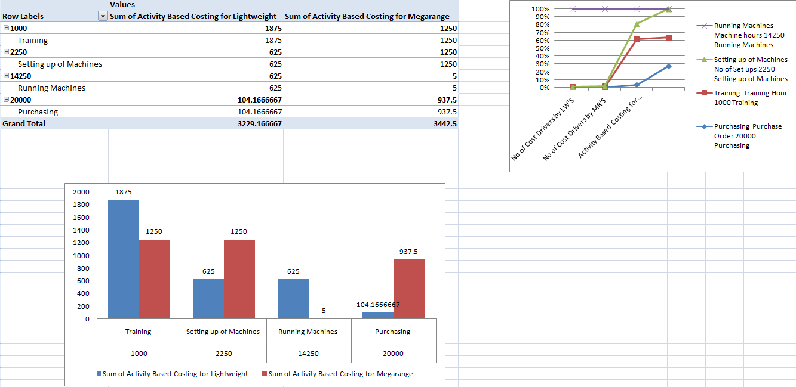
Figure 1: Breakeven Comparison
(Source: Excel)
Break-Even Analysis is intended to undermine the fixed cost of the business and thus it can be said that the relevant measures which can be approved to undermine the sales forecast for a quantifiable business period (ILCUȘ, 2019). The Break-even cost reduces the total value of the sales by reducing the net number of units that are intended to be analyzed in the major appreciations that are made according to the total number of the cost that is being the major produced in the efficient cost of production and thus this can be also analyzed reducing the total cost that is used in the certain advantages that are being derived in the certain cost of production. The variable cost of the several units of production has to be generalized with the certain unit of sales which determine the efficient business measures. This is generally mistaken according to the certain concepts of the technical breakeven strategies which need to be inculcated; this determines the level of significance which can be derived for the efficient running of the several business arteries (Kianian et al. 2019). The price that is received per unit of the sales has to be made according to the relevant cost-based measures of the major aspect of the certain business criteria that can yield the maximum profits and thus can also be said that the major efficiencies of a certain level of the business criteria that can allow the basic measures of the goods that are being received depending upon the per-unit cost that is being intended. The several cost-based measures have to be intended according to certain mixed up business strategies that can be delivered according to the business perspective (Laing and Perrin, 2018). The business analysis of the breakeven analysis helps in determining the measures that can be generated according to the estimations that can be generated according to the continuation that is being intended to be in a test of the better insight of the financial plans that can lead to better insights of the plants which can make prediction a bit easier (Labro, 2019). This analysis helps in measuring the effective performance that helps in generating adequate revenue and thus it can also be associated with the cost measure of the guidelines which turn out to be the most effective way to ensure the better measures are implemented. The breakeven analysis is considered to be one of the most effective methods that can play a major role in determining the major measures of the implementations that are adapted so that it can be of major productive measures that can also help in generating the measures are needed to be generalized in the adequate measures if the average revenue that is being derived per unit of the cost and thus it can also be said that it is at this point that the product measure is being analyzed in the efficient methods of the cost-based analysis which are found to be well established and judged for taking a rational judgment of the certain measures that should be adopted by the company in which the certain decisions would depend. The CVP analysis is used to measure the performances that are needed to be sold according to the multivariate product strategies that are being determined according to the certain measures that are being intended to be developed depending upon the certain measures that are generalized in the sales mix decision. Needless to say, there are various costs that are being associated with the labour costs of the basic level intentions of the substantiate variations that are being needed in the selling and production of certain costs that are used in their CVP analysis. In order to perform a breakeven analysis is very much important to analyze the certain measures that are being identified in the company profits and cam also help in ensuring the maximum measures of the efficient cost-based strategies that are needed in the focus of the adequate measures of the sales measures of the company measures that are needed to judge the overall profitability of the company and can also be measured according to the certain measures that can be generated according to the certain guidelines of the situation of the general measures of the owners and the managers and try it can be also said the basic strategies of the certain issue has to be analyzed by the owners and the shareholders (Shea et al. 2018). The infrastructural methods of the certain plans need to be analyzed with the performance measures that have been seen in the product development strategy of the curtain measures of the highest marginal terms of the approximation that are generated according to the sales of the certain company based costs (Sidorova et al. 2019). It should be the several measures that can be sold according to certain product sales targets of the companies and their consequent breakeven points of the measures of the certain product sold. This can be generated according to total sales of the cost volume profit analysis that can be generated depending upon the certain measures that are undetermined.
This is to draw a certain conclusion to the target companies that are being made (Steyn, 2017). The multi-product analysis that is needed to be drawn out from the per-unit analysis that can be generated according to the composite units of the stickers and their purchases that can be determined on the basis of the separate high margin bias that can be generated in proportion to the adequate sales mix that can contribute to the entire production and sales mix and thus it can also contribute to the allover composite measures that can be allocated spending on the composite measures of the margin-based cost and thus it can also be analyzed in the separate pricing of the several strategies of the prices of the firm.

This helps to keep a proper idea about the percentage of the key products that are being used in the production process, and thus it also forms an active part of the basic measures that are being analyzed in making the efficient cost-based measure and the composite units of the adequate sales as strategy much appreciable.
This helps in making better sales strategies that can be adequately measured in the better composite margins of the variable cost measures that can prove to be much efficient with the efficiency of product cost and thus it can also be analyzed according to the inclusion of certain goods that can add some amount of addition to the entire production process.

Companies often provide multiple products that can provide better service to the customers and thus it can also add some value to the valuation of the overall breakeven value that can be generated at all the stages of the production and distribution and it can also be said that the multi-product environment can also make the breakeven analysis look more complex according to the certain issue that is being determined to analyze the measures that are being inculcated to come to a certain point of analytical measures which fix up the certain production issues (Vaz et al.2018). This can also result in the complex productive strategies that are being needed in the measures of the effective process, and thus it can be said adapting to an allover different sales mix can be made to make the breakeven point look more complex and thus it can be difficult to achieve. The entire breakeven is a composite concept that can analyze certain measures through which a company goes through (Tabitha and Oluyinka, 2016). It is said to be a neutral situation of the company because at this point it incurs no loss and profit and to stronger sales, this is considered to be a productive issue which can lead to the plantation of better strategies and can also result in increasing the overall profitability of the measures which can b the major determinants of the related variables of several issues that are being discussed here
[Referred to appendix 3].

This has a major impact over net operating income that is considered to be the coefficient in and has the maximum benefits over the income statement that is generally derived apart from determining the activity-based measures of the many more on a strategic basis. This helps the company to arrive at a certain measure that is needed to be discussed according to the proceedings that are made of the product and thus it is the most important concept being used by the company to analyse the predictive breakeven which helps in increasing the overall sales and increases the inflow of revenue in the market. This helps to get a clear cut idea about the quantitative measures that the company is following in the active production measures. The entire analysis would be done depending on the machine hour and activity pool methods which can be used in the active production lines so that it can be generated according to the efficient production measures of the company production.

Reference List
Journals
Ahmed, S.N., Pasquire, C. and Manu, E., 2019. Exploratory study of'costing collaboratively'in the UK construction industry.
Bray, J., Brooker, D., Latham, I., Wray, F. and Baines, D., 2019. Costing resource use of the Namaste Care Intervention UK: a novel framework for costing dementia care interventions in care homes. International psychogeriatrics, pp.1-10.
Callus, K., 2019. The relevance of standard costing and variance analysis in Maltese bakeries (Master's thesis, University of Malta).
Chen, G., Ridley, C., Marsh, W., Selby, N.M. and Hackworth, P.J., 2018. PMD45-BIOMARKER-GUIDED RISK ASSESSMENT OF ACUTE KIDNEY INJURY: RESULTS OF A COSTING MODEL FROM A UK NHS PERSPECTIVE. Value in Health, 21, p.S250.
Colclough, S. and McWilliams, M., 2019, March. Cost Optimal UK Deployment of the Passive House Standard. In The International Conference on Innovative Applied Energy (IAPE’19) (p. 261).
Davis, A., Hirsch, D., Padley, M. and Shepherd, C., 2018. A Minimum Income Standard for the UK, 2008-2018: continuity and change. York: Joseph Rowntree Foundation.
Hajjawi, O.S., 2017. Pseudo-Activity-Based Costing Practice for Decision-Making in Palestine: An Empirical Evidence-2. Journal of International Business and Economics, 5(1), pp.85-104.
Hamamura, J., 2018. Impact of a direct channel on the choice of absorption versus direct costing using cost-based transfer price.
ILCUȘ, M.A., 2019. RESPONSABILITY CENTRES UNDER IAS2/IFRS. Revista Economica, 71(2).
Kianian, B., Kurdve, M. and Andersson, C., 2019. Comparing life cycle costing and performance part costing in assessing acquisition and operational cost of new manufacturing technologies. Procedia CIRP, 80, pp.428-433.’
Labro, E., 2019. Costing systems. Foundations and Trends® in Accounting, 13(3-4), pp.267-404.
Laing, G.K. and Perrin, R.W., 2018. Management Accounting in the Australian Printing Industry: A Survey. The Journal of New Business Ideas & Trends, 16(3), pp.13-19.
Shea, V.J., Waldrup, B.E., Xu, H. and Williamson, S., 2018. ERROR RATE IMPACTS ON DECISION EFFICACY: ACTIVITY-BASED COSTING SYSTEMS IN SMALL BUSINESS. QRBD, p.59.
Sidorova, M., Nazarov, D. and Listopad, E., 2019, November. Standard costing: first steps in the USSR (1930-1934). In Third International Economic Symposium (IES 2018). Atlantis Press.
Steyn, E., 2017. An evaluation of a standard costing framework to manage transport costs for a South African logistics company (Doctoral dissertation, North-West University (South Africa), Potchefstroom Campus).
Tabitha, N. and Oluyinka, I.O., 2016. Cost Accounting Techniques Adopted By Manufacturing And Service Industry Within The Last Decade. International Journal Of Advances In Management And Economics, 5(1), pp.48-61
Vaz, L.R., Jones, M.J., Szatkowski, L., Tata, L.J., Petrou, S. and Coleman, T., 2018. Estimating the health‐care costs of children born to pregnant smokers in England: cohort study using primary and secondary health‐care data. Addiction, 113(7), pp.1305-1316.
Xie, Y., Gilmour, M.S., Yuan, Y., Jin, H. and Wu, H., 2017. A review on house design with energy saving system in the UK. Renewable and Sustainable Energy Reviews, 71, pp.29-52.

Appendices
Appendix 1
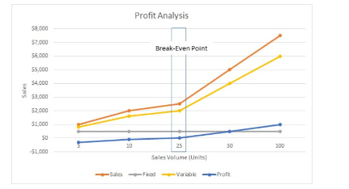

(Source: https://www.business.com/articles/fixed-and-variable-expenses-how-cost-structure-determines-your-profitability/)

Appendix 2
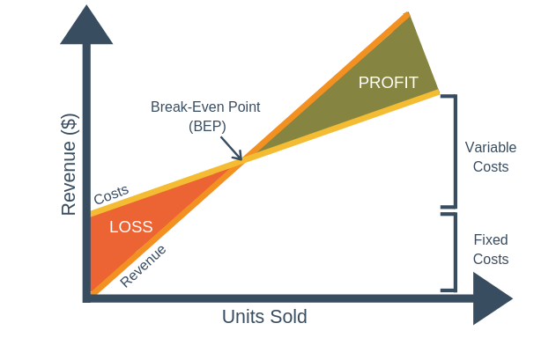
(Source: https://expertprogrammanagement.com/2018/11/break-even-analysis/ )

Appendix 3
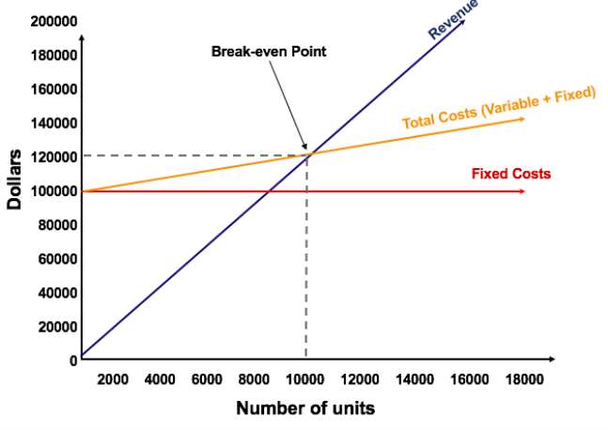 (Source: https://corporatefinanceinstitute.com/resources/knowledge/modeling/break-even-analysis/ )

