Communication within a workplace
BMSK 4002
Mohammed Ahmed (1805954)
Table of Contents
Executive Summary 2
1.0 Terms of Reference 2
2.0 Introduction 2
3.0 Findings 2
3.1 Groups vs Teams 2
3.2 Communication 3
3.2.1 Verbal Communication 3
3.2.2 Non-Verbal Communication 4
4.0 Conclusion 5
5.0 Recommendations 7
6.0 Appendix 8
7.0 References 9

Executive Summary
This report will look at how different communication methods can help the business to strive and achieve better results. Different models by Shannon Weaver (1949), Berlo’s and Schramm (1954) will be discussed. The models will be analysed and evaluated as to how Michelle can incorporate the models into her organisation to make it more successful. Verbal and non-verbal communication will be debated as well as the importance’s of two-way communication. Lastly, teamwork theories will be examined to determine how Michelle can use the theories and implement them in her organisation to create an ultimate team to drive the business forward.

1.0 Terms of Reference
This report was requested by Christian Felices from the University of Wales Trinity Saint David. The report requested on 1st February 2019 for submission on 12th April 2019. This report composed by Mohammed Nazmul Ahmed, a student at the University of Wales Trinity Saint David attending Skills for the Workplace Diploma. The report produced to discuss the different communication methods available to communicate your message and how effective communication can be for the case study in question.

2.0 Introduction
Michelle currently runs a toy store in Swansea employing a total of 27 employees. 6 employees work in the stock room, 2 work as cleaners, 14 are sales assistants, 2 security guards and 3 managers. Majority of the staff work part-time during opening hours between 8:00am and 10:00pm. Michelle currently has no teams or groups in place, just has 8 workers working at any one time. As the business expands, Michelle employs new staff members and provides on the job training by the manager on duty at the time.

3.0 Findings

3.1 Groups vs Teams
The difference between a team and a group is that a team needs individuals to work interpedently to achieve the objective where as a group may share the same objective as a team but can achieve the objective without any help from others as Rick DuFour narrates in his video. Michelle has created a business without looking at the benefits of working in a team or a group. Working in a team can bring a lot of success for Michelle and her business as the (Dyer, 2013) brothers stipulate in their book. Also backed by (Britton, 2009) believe that communication is vital within teamwork. By implementing teams, they can communicate better by being able to get their message across clearly, listen effectively to other ideas bought forward and develop them. Working in teams will help Michelle with increased productivity which will help the success of the business and drive the business forward. Teams are better when it comes to solving problems as there are many views that could help solve the problem efficiently and effectively which creates a healthy environment for the staff to work in. Also, teams help staff members to be more involved, rather than taking a back seat and let the work be done by other staff members as well as coming up with better solutions to solve any problems. On the other hand, working in a group does not really help the relationship needed between all staff members as the members may not have a common goal therefore, no care of the result also could cause conflict. For example, in lectures we have a lot of group discussions, but no one really takes any responsibilities for the outcome where as a team effort usually has the same objective for all team members and one person will take responsibility for the whole team. Working in groups does not bring motivation to the group as all members may not have the same objective which in turn could create conflict between members. It is mentioned by (Belbin, 2010) that, to have successful teams in an organisation, it is required that each team member possesses different roles within the team. Belbin announced 8 different roles, these are coordinator, plant, team worker, implementer, monitor, shaper, completer and resource investigator. Belbin added a ninth role later on in his career. This was a specialist. Each role served a different purpose in the team to make it successful. See appendix 1. A theory created by Tuckman (1965) was also analysed. Tuckman believed that teams had to go through a process in order to create effective teams. The first stage was forming, second was storming, third was norming and lastly performing. See appendix 2. This theory was favoured by (Egolf, 2013) who elaborated in his book. The two theories could have worked wonders for Michelle’s business as there would be more clear direction as to what is expected from the staff members also, they would have created an environment where everyone would want to work cutting out any conflict, helping productivity and better results.

3.2 Communication
Communication is one of the most important skill required within the workplace and can cause a lot of people to leave their jobs if there is a lack of communication as reported on freshbusinessthinking.com by (Hunter, 2016). Communication is divided into two groups. This is verbal and non-verbal communication. Verbal communication is when two or more people communicating information by using words and non-verbal is communicating information through body language or written messages.

3.2.1 Verbal Communication
Verbal communication is thought to be the most valuable way of communication however, there have been research undertaken and found that most of verbal communication is not received and non-verbal is the most received communication as (Mehrabian, 1981) reveals in his book. Also, it is argued that there are different levels of listening that we adhere to and it is believed that we do not listen carefully enough to what is being said therefore, we only listen to selective words being said.
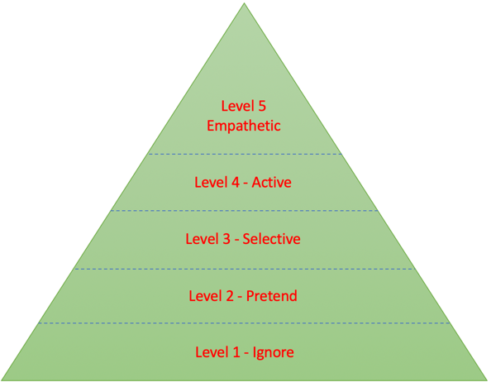
Communication % Chart Listening Levels
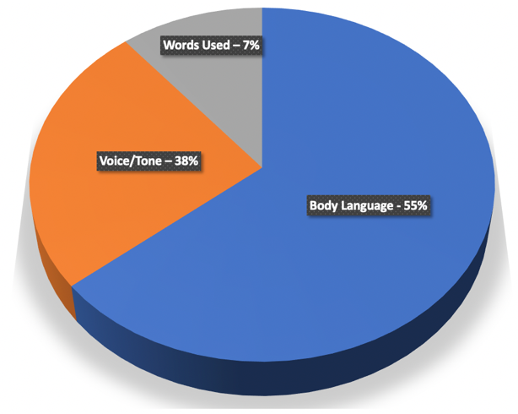

“There are many reasons why interpersonal communications may fail.” Skillsyouneed (2019). There are many barriers that can affect verbal communication, these consist of environmental, linguistic, psychological, physiological, perceptual, content and personal. These barriers can hinder communication being sent and being received. The environment can affect communication by the people around you and the atmosphere for example communication is likely to be more effective if communicating with someone in a library than someone in a nightclub therefore, it is essential that the environment does not affect the communication. Linguistic is a barrier in some cases as one’s lack of language and accent can cause a loss in communication as mentioned on toppr.com (2019). “The language barrier is one of the main barriers that limit effective communication”. Psychological can cause a breakdown in communication by one playing mind games with the other, being afraid, speech disorders, some sort of phobia and depression. Physiological can be a barrier to communication as people can get distorted by the way a person looks and any disorders an individual suffers from such as dyslexia, voice. Perceptual is a barrier to communication because of the past experience’s ones had which also can be down to an organisational relationship two people have had. It was found that content could deter the effectiveness of the communication by the transmission being unreliable also the details of what is being communicated is irrelevant to the subject therefore, most of what is said either not acknowledged or ignored completely. Personal issues can affect the way someone receives and conveys the message such as a previous couple in a personal relationship working in the same place needing to pass a message on will not go down too well.

3.2.2 Non-Verbal Communication
It is found that body language/ gestures have the most influence on one’s communication. There are advantages and disadvantages of non-verbal communication. In 1994 Judee Burgoon identified seven different nonverbal communication methods. These are “Kinesics or body movements including facial expressions and eye contact; vocalics or paralanguage that includes volume, rate, pitch, and timbre; personal appearance; our physical environment and the artefacts or objects that compose it; proxemics or personal space; haptics or touch” Nordquist (2019). It has been bought to our attention that body language has the most influence on one’s communication therefore it is highly important for an individual to approach the person with a positive demeanour. As mentioned above, there are the same barriers to non-verbal communication as there are to verbal communication. It is very important that the first impression given is a positive one as the first impression lasts and can leave a lasting impression of yourself.

In order for Michelle to produce a better-quality product and service, she can look at different communication methods available to her to help her organisation. There are models created by Shannon Weaver (1949) and Berlo’s, which help all organisations with communication skills.
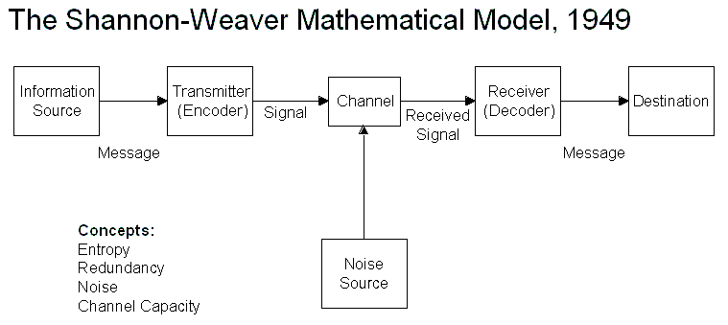
Shannon Weaver’s model gives a one-directional communication without any feedback, she also looks at any distractions or disruptions that may be caused during the channel of the communication. These include the surroundings such as working in a busy and loud environment could deter the information trying to send, also, if there are people in the room who may divert your attention. On the other hand, Berlo’s looks at a similar concept to Shannon however, Berlo’s channel looks at the five different senses sound, smell, taste, see, feel to see if this causes an interruption of the communication. Michelle can benefit from the models in question by monitoring how information is communicated within the workplace. For example, Michelle can see whether if there is a breakdown of communication in the stores because of the surroundings compared to the communication levels in the sales room. This will enable Michelle to take necessary steps to make sure that staff in the stores are communicating well together as well as communicating with mangers and sales advisors effectively. Two-way communication is vital within Michelle’s organisation to be successful and progress further. Two-way communication allows individuals to ask questions about the job at hand also it allows one another to treat people as people as well as listening in to conversations and staying tuned in. This helps staff to build a good working relationship with colleagues, build one’s confidence and help one’s communication skill in the long term.

4.0 Conclusion
After careful consideration of the different types of communication and working in either group or teams, it has been declared that Michelle needs to incorporate the models from Belbin, Tuckman and Weaver to maximise productivity within the workplace and drive the business forward. Belbin and Tuckman’s model will help Michelle create effective and strong teams within different areas in her business to help grow the business. For example, Michelle can create two teams of seven sales room staff in order to set realistic targets and as the teams are smaller, they can help one another to achieve those targets. This will also relieve some pressure on the managers therefore, they can look at other ways to can drive the business forward. Tuckman’s theory allows team members to identify one another to avoid any future conflict that could cause dis-harmony and disruption in the workplace hence Tuckman’s theory would help Michelle identify the bad apples within her group of employees and consider employing new staff. Clarity of communication has become key for Michelle and her business as she has stores that sell toys as well as employees selling toys through the phone. Her staff on the shop floor need to have a good and clear communication with the manufacturing staff and managers as they would be selling directly to consumers therefore if there are any defects in the product or lack quality service this can have a serious impact on Michelle’s business and revenue. Michelle would need to recognise how models created by Berlo’s and Weaver can help her combat any barriers that could scupper the communication. Michelle then could consider installing a walkie talkie system that would keep mangers, manufacturers and shop floor staff in contact with each other at all times.

5.0 Recommendations
For Michele’s business to take the next step, it is recommended that she looks at other communication models available to her to excel her business further. For example, there is a model by Schramm which uses a similar concept as the models mentioned in the report but what Schramm’s model improves on is the feedback element of the communication. This element is key within Michelle’s organisation as staff need to be given feedback on any work that is being carried out successfully or unsuccessfully to motivate staff or help the staff struggling. This will enable better performances from staff leading to better productivity and essentially more turnover.
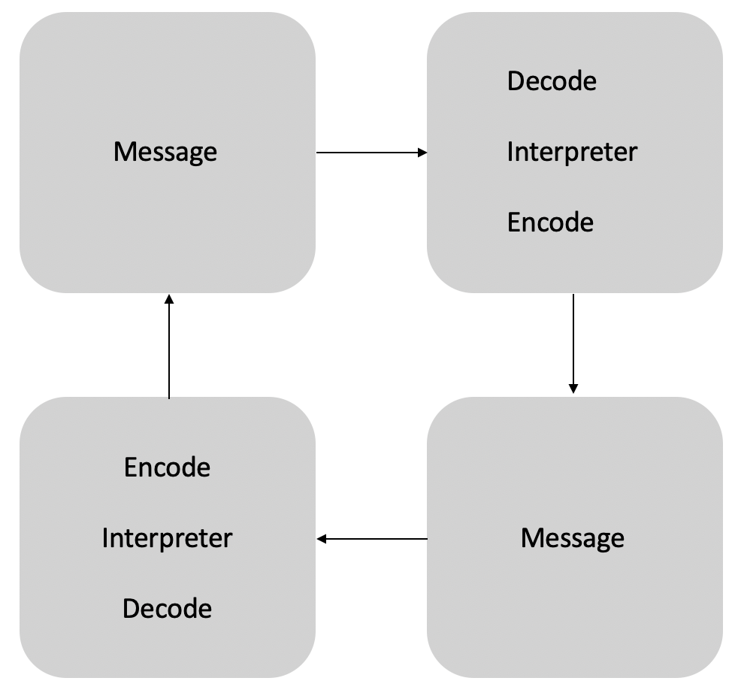
Schramm’s (1954) Model

For Michelle to improve the teamwork and productivity of her business, it is recommended that Michelle implements team building exercises/ activities to help staff to communicate better with one another.
Another way Michelle can use to improve the communication and teamwork is by offering rewards for the best performed teams or individuals as well as giving her staff recognition by doing an employee of the month.

6.0 Appendix
Belin Team Roles
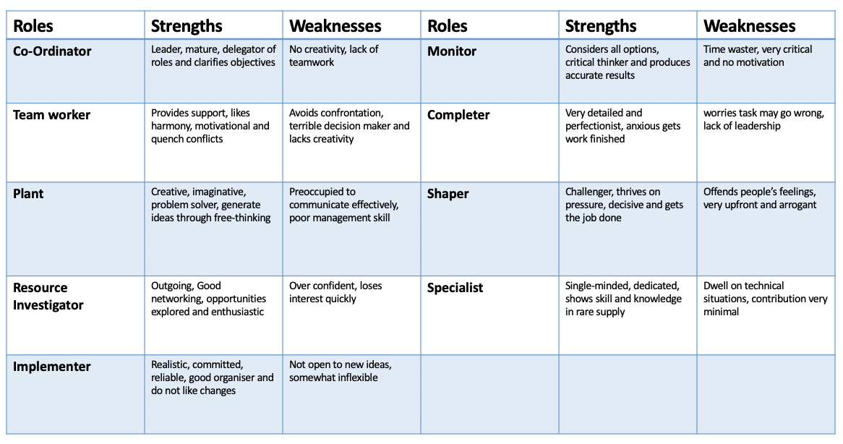
Appendix 1 - belbin team roles

Tuckman’s Theory
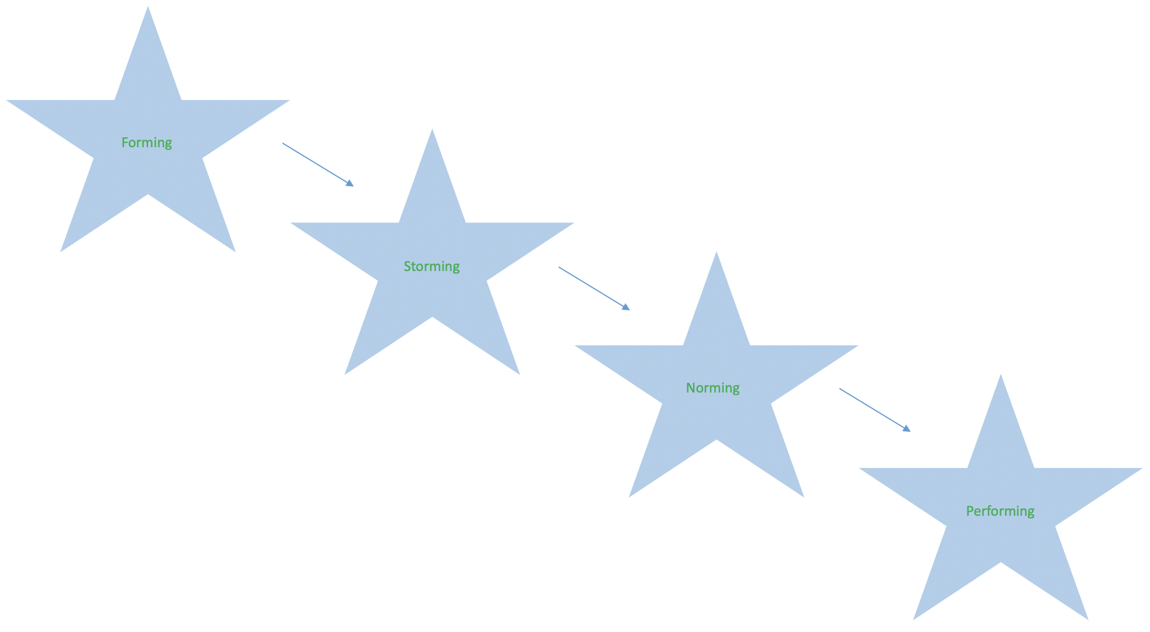
Appendix 2 - Tuckman's Theory

7.0 References
Belbin, R.M. (2012), “Team roles at work,” (Second Edition), Oxford: Elsevier Limited.
Britton, D. (2009). Teamwork: True Champions Know the Team is Stronger Than the Individual. p.104. Colorado: Gospel Light Publications,
Communication Theory (2016). Berlo’s Smcr Model of Communication. [image] Available at: https://www.communicationtheory.org/berlos-smcr-model-of-communication/ [Accessed 5 Apr. 2019].
Design Theory & Critical Thinking (2017). Shannon-Weaver Model of Communication. [image] Available at: https://medium.com/design-theory-critical-thinking/shannon-weaver-model-of-communication-ce9ca9c14741 [Accessed 5 Apr. 2019].
Dyer, W.G. and Dyer, J.H. (2013). Team building: Proven strategies for improving team performance. John Wiley & Sons.
Egolf, D.B. (2013). Forming storming norming performing: Successful communication in groups and teams. IUniverse.
Hunter, D. (2016). Poor communication is the biggest reason for wanting to leave a job. [online] Fresh Business Thinking. Available at: https://www.freshbusinessthinking.com/poor-communication-is-the-biggest-reason-for-wanting-to-leave-a-job/ [Accessed 5 Apr. 2019].
Mehrabian, A. (2017) “Nonverbal communication.” Routledge.
Nordquist, R. (2019). What Is Nonverbal Communication?. [online] ThoughtCo. Available at: https://www.thoughtco.com/what-is-nonverbal-communication-1691351 [Accessed 5 Apr. 2019].
Skillsyouneed.com. (2019). Barriers to Effective Communication | SkillsYouNeed. [online] Available at: https://www.skillsyouneed.com/ips/barriers-communication.html [Accessed 5 Apr. 2019].
Solution Tree (2009). Solution Tree: Rick DuFour on Groups vs. Teams. [video] Available at: https://www.youtube.com/watch?v=0hV65KIItlE [Accessed: 4 Apr. 2019].
Toppr-guides. (2019). Barriers of Communication: Types of Barriers to Effective Communication. [online] Available at: https://www.toppr.com/guides/business-correspondence-and-reporting/communication/barriers-in-communication/ [Accessed 5 Apr. 2019].

