University of Saint Trinity David

Nicolae Feraru 2225689 Lecturer : Antoinette Milner
Wordcount: 585
BMIH4002
FOOD & BEVERAGES OPERATIONS

Restaurant Concept: Zenith Bistro
Concept Description: Zenith Bistro is an exciting addition to the esteemed Trinity Hotel Chain, offering a unique and innovative dining experience.
- Target audience: the restaurant is designed to cater to the modern, well-travelled, and adventurous clientele who seek a remarkable gastronomic journey. The name "Zenith" symbolizes the peak of excellence and satisfaction that diners can expect.
- Seasonal and Local Ingredients: We prioritize the use of seasonal, locally-sourced ingredients to support sustainability and the community. This commitment ensures the freshness and quality of our dishes while reducing our carbon footprint.
- Diverse Dietary Options: The menu caters to a wide range of dietary preferences. Our diverse options include vegetarian, vegan, gluten-free, and protein-rich dishes to accommodate different dietary restrictions and preferences.
- Global Culinary Influences: Our menu draws inspiration from a variety of global culinary traditions, including Asian, Mediterranean, Latin, and more. Each dish tells a story of its origins while embracing the creativity of fusion.
- Beverage Pairings: In addition to our culinary creations, Zenith Bistro offers an extensive wine list, featuring international and local selections, as well as a variety of craft cocktails and mocktails designed to complement the fusion dishes.
- Progressive Service Style: Zenith Bistro offers a combination of a tasting menu and an à la carte menu. The tasting menu allows guests to embark on a culinary adventure with carefully curated dishes that highlight the best fusion creations. For those who prefer a more traditional dining experience, our à la carte menu features individual fusion-inspired dishes.

Menu Design

Concept: Farm-to-Table Seasonal Dining Experience

The restaurant's concept, style of service, and unique elements aim to provide a memorable dining experience that celebrates seasonal, locally-sourced ingredients and fosters a sense of community between producers and consumers.

Appetizers:
Vegan Stuffed Mushrooms: Mushrooms stuffed with a mixture of seasoned breadcrumbs and vegetables. 5£
Hummus Platter: A variety of hummus flavors (classic, roasted red pepper, and garlic) served with pita bread and fresh veggies.6,50£
Vegetarian Spring Rolls: Crispy spring rolls filled with mixed vegetables and served with a sweet chili dipping sauce. 4,50£

Main Courses:
Salmon with Lemon Dill Sauce: Pan-seared salmon with a creamy lemon-dill sauce, served with asparagus and quinoa. 14£
Gluten-Free Pasta Primavera: Gluten-free pasta with a variety of sautéed seasonal vegetables and garlic olive oil. 8£
Vegetarian Lasagna: Layers of pasta, ricotta, spinach, and marinara sauce, topped with mozzarella cheese. 9£
Grilled Chicken Breast: Marinated grilled chicken breast served with a choice of sides and sauces. 11 £

Side Dishes:
Quinoa Salad: Tri-color quinoa with diced cucumbers, tomatoes, red onions, and a lemon vinaigrette. 4,50 £
Roasted Brussels Sprouts: Brussels sprouts roasted with olive oil and balsamic vinegar. 3,50 £
Garlic Mashed Potatoes: Creamy mashed potatoes with roasted garlic and fresh herbs.4£
Sweet Potato Fries: Crispy sweet potato fries served with a chipotle mayo dip. 4£

Desserts:
Gluten-Free Apple Crisp: Baked apple crisp with a gluten-free oat topping, served with vanilla ice cream. 5£
Fruit Sorbet: Assorted fruit sorbet flavors served with a sprig of mint. 5£
Vegan Chocolate Avocado Mousse: Creamy chocolate mousse made with avocado and sweetened with agave nectar.5£

Beverage Options:
1 Sodas: A variety of carbonated soft drinks. 1,50£
2 Iced Tea: Traditional black tea or herbal options. 2£
3 Freshly Squeezed Juices: Orange, grapefruit, or a blend of seasonal fruits. 3,50£
4 Sparkling Water: Plain or with a choice of fruit infusions. 2£
5 Coffee: Regular or decaffeinated, with a selection of creamers and sweeteners. 2,50£
6 Local Wine Pairings: The restaurant offers a curated list of local and regional wines to pair with each course, enhancing the farm-to-table experience. 20-50£
7 Mocktails: Non-alcoholic cocktails with unique flavors, such as a Virgin Mojito or a Mango Passion Sparkler. 6£

It is very important to specify and label dishes clearly for allergens and dietary restrictions to ensure the safety of all diners. Additionally, menu items can be adapted to accommodate specific allergies, such as gluten-free or nut-free options.

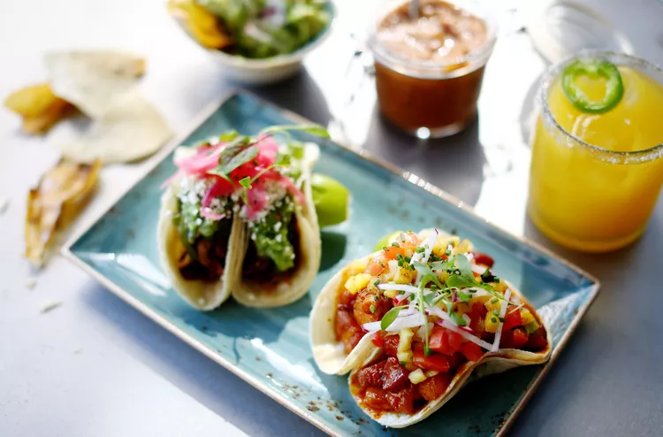

References :

www.forbes.com/sites/douggollan/2023/08/12/food-tourism-is-big-business-for-the-travel-industry/
www.menubly.com/blog/types-of-service
www.the caterer.com
www.foodandwine.com/lifestyle
www.thespruceeats.com/how-to-pair-cocktails-and-food
www.themixer.com/en-uk/learn/cocktails-and-food-pairing
www.gloriafood.com/restaurant-menu-planning
realfood.tesco.com/weekly-meal-plans.html
www.thehandbook.com/farm-to-table-restaurants-uk
www.olivemagazine.com/guides/best-farm-to-fork-restaurants
www.marriott.com/en-gb/offers/the-ultimate-farm-to-table-dining-experience

