

CERTHE BUSINESS SKILLS
FOR THE WORKPLACE

EMPLOYABILITY AND CAREER DEVELOPMENT

LECTURER: Mrs Dingning Liu

MODULE CODE: LCLM 4005

TASK 2:
REFLECTIVE REPORT

By Tesenai Bertram
2409077
TASK 1: COMPARE JOB ADVERTS

The four job adverts collectively define a clear and demanding professional profile for AP leadership in education.
Job Title, Company and Location | Key Skills & Area of Knowledge Required
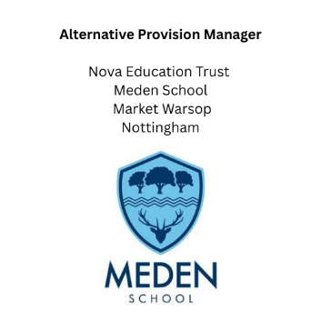 | - Strategic planning and execution  - Daily operations management  - Development of bespoke educational programs  - Commitment to supporting vulnerable learners  - Expertise in educational reintegration strategies
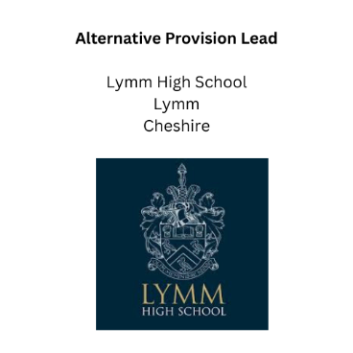 | - Design and development of a new in-house AP unit  - Leadership in shaping new provisions from the ground up  - Visionary thinking for innovative solutions  - Deep understanding of the AP landscape
 | - Daily management and organisation of the AP space  - Strong communication skills  - Curriculum access facilitation  - Post-16 guidance expertise  - Administrative and pastoral leadership  - Quality assurance oversight
 | - Leadership in managing Alternative Provision (AP)  - Integration of pastoral and AP responsibilities  - Utilisation of data to target interventions. Focus on high-need students and vulnerability factors (Pupil Premium)

Key Skills and Areas of Knowledge Required:
The essential skills can be categorised into four main areas, reflecting a robust combination of strategic, operational, and pastoral abilities.
- Leadership and Operational Management
- Specialist Educational Provision and Design
- Vulnerable Learner Support and Pastoral Care
- Data and Quality Assurance
Common Skills and Knowledge Areas:
The three key areas consistently identified across all four frameworks represent the core functional requirements of the profession:
1. Management and Organisation: The ability to effectively manage the daily operations of a provision, including staffing, resource allocation, and scheduling.
2. Expertise in Supporting Vulnerable Learners: A specialised knowledge base regarding safeguarding, reintegration, and the pastoral needs of high-risk students.
3. Programmatic Leadership and Development: The ability to not only manage a program but also to design, develop, and strategically enhance it, which often requires a deep understanding of the alternative provision landscape.

Task 2: SELF ASSESSMENT & EVIDENCE OF READINESS

SWOT Analysis
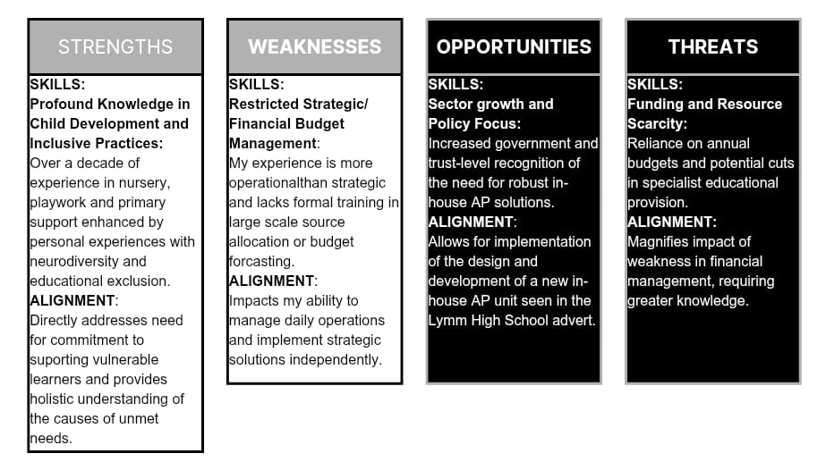
To identify areas for growth, I will conduct a self-assessment using the SWOT framework, a learning style quiz and Kolb’s Experiential Learning Cycle, aligning my perceived skills with the requirements of the AP leadership profession.

Learning Style Quiz (PHEA, 2011)
Understanding your learning style is vital for effective studying, as highlighted by the Pennsylvania Higher Education Assistance Agency (2011). After taking a quiz, I found that I am strong in Auditory and Visual learning, which informs my career development strategy. My visual skills help me create tailored AP programs and analyse complex financial data effectively. Meanwhile, my auditory preference enhances my engagement with training and policy reviews from mentors. By focusing on auditory instruction and visual analysis, I can improve retention and progress from a hands-on practitioner to a certified strategic AP Manager, bridging my practical experience with the strategic skills required for senior management.

Kolb's Experiential Learning Cycle Analysis
To identify my personal strengths and areas for strategic development, I have applied Kolb's Experiential Learning Cycle (ECL). My career history, which spans hands-on support (TA, Nursery Nurse), creative teaching (Art Teacher), self-employed Catering Business and personal advocacy for my son, aligns strongly with the Accommodating learning style. Accommodators thrive on concrete experiences (CE) and active experimentation (AE), preferring practical solutions and adapting quickly to change, which is vital in the high-stakes environment of AP (Kolb, 1984).

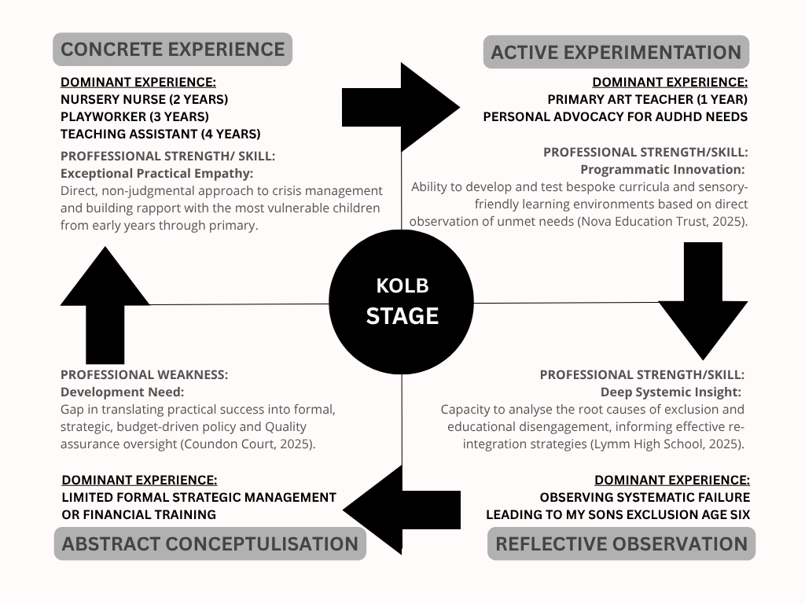

Impact on Career Development
Analytical Tool | Core Finding | Strategic Impact on Career Path
Kolb Learning Style | Accommodating:  I excel at doing and testing, which makes me an innovative, hands-on leader. I can immediately develop bespoke educational programs. | I will utilise my strengths to achieve the Short-Term Goal of becoming the AP Coordinator, where practical innovation and pastoral empathy are essential.
SWOT Analysis | Weakness:  Limited Abstract Conceptualisation  I lack formal, strategic training in finance and the large-scale oversight required for the Long-Term Goal of becoming an Accounts Payable Manager. | I need to ensure my Personal Development Plan (PDP) addresses my weaknesses by advancing to the (AC) stage. I will take formal courses from CIPFA or CMI and engage in theoretical shadowing to improve my strategic planning and execution skills.

Evidence of Readiness for Employability

My qualifications for a leadership role in Alternative Provision are backed by over a decade of experience in educational support. This background has sharpened my skills as outlined in Task 1, demonstrating my readiness to make a meaningful impact in the field. Completing analyses such as SWOT and utilising the UWTSD Infoskills module has enhanced my ability to utilise data for targeted interventions in AP, enabling me to leverage evidence-based reports to assess program effectiveness and justify resource allocation, which is essential for meeting my short-term goals.
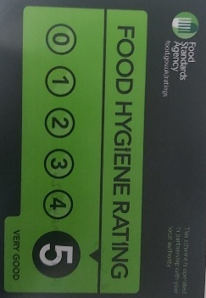


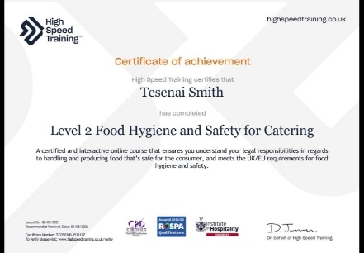


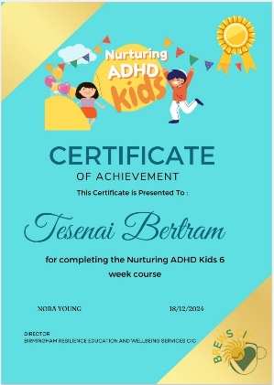
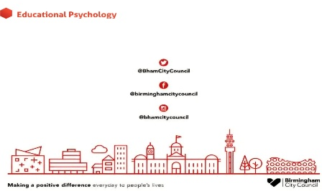

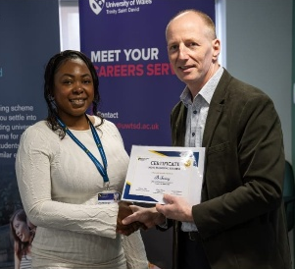

- Expertise in Supporting Vulnerable Learners
(Evidencing Readiness for Pastoral Care):
My two years as a Nursery Nurse and three years as a Playworker have given me a strong understanding of the developmental and emotional roots of behaviour, even before formal assessments begin. Additionally, my personal experience advocating for my son's ADHD needs, resulting in his exclusion at age six due to unmet needs, provides valuable insight into the system failures that AP aims to address. I have also navigated EHCP plans and pursued appropriate provisions. Additionally, I have completed courses in Educational Child Psychology and Nurturing ADHD Kids.
- Result: This combined professional and personal perspective fosters empathy and expertise in tackling exclusion, aligning with the focus on high-need students (Abingdon Learning Trust, 2025) and commitment to vulnerable learners (Nova Education Trust, 2025).
- Management and Organisation
(Evidencing Readiness for Operational Management):
I have 4 years of experience as a Teaching Assistant and 1 year as a Primary Art Teacher, where I handled daily administrative tasks, managed small group interventions, and tracked progress data. As an Art Teacher, I planned my own curriculum and managed inventory and budgets. Additionally, I run a catering company that was voted 'Most Promising Business' at the UWSTD Entrepreneurs Fair 2025.
- Result: I demonstrate strong daily management and administrative skills (Coundon Court, 2025) and adhere to rules, having achieved top hygiene status from BCC. My primary school experience provides insight into the learning journey and the importance of early intervention for proactive AP (Lymm High School, 2025).
- Programmatic Leadership and Development
(Evidencing Readiness for Visionary Thinking):
As a Primary Art Teacher, I developed a tailored educational program (Nova Education Trust, 2025) that accommodated diverse needs and sensory profiles, leveraging my inclusive practice knowledge from my TA background. My experience as a Playworker honed my creativity and adaptability in creating engaging environments for children, which informs my design of flexible AP environments. Additionally, I have academic achievements in Art Therapy and have completed the CertHe Business Skills for the Workplace course, which has enhanced my skills in personal and career development, management strategies, teamwork, and understanding relevant laws and business analysis.
- Result: This experience highlights my visionary thinking for innovative solutions (Lymm High School, 2025) and my ability to implement targeted curriculum access that helps learners successfully re-engage with education (Coundon Court, 2025).

TASK 3: EMPLOYMENT GOALS AND PERSONAL DEVELOPMENT PLAN

Setting Employment Goals
Identified Weakness:
I have limited strategic financial and budget management skills, which indicates a gap in abstract conceptualisation crucial for advanced management (Nova Education Trust, 2025). My career goals are structured in two stages, leveraging my strengths while addressing the weaknesses necessary for management advancement.
My career goals are structured as a two-stage process that leverages my current strengths while carefully addressing the weaknesses necessary for high-level management. My short-term goal is to become an AP Coordinator/Lead, which is crucial because it allows me to utilise my hands-on, accommodating learning style (CE/AE) and a decade of experience to achieve operational mastery. In this role, I can leverage data and program innovation to establish a robust managerial foundation. This position aligns perfectly with the urgent need to use data for targeted interventions (Abingdon Learning Trust, 2025).

My ultimate aspiration is to become an Alternative Provision Manager. This long-term goal is significant because it gives me the strategic authority to transform my personal experience with systemic failure—having witnessed my son’s exclusion—into meaningful system-level change. In this senior role, I aim to design alternative provision programs that are both inclusive and financially sustainable. Achieving this requires me to effectively address my weakness in abstract conceptualisation through formal governance and budgetary control, thus meeting the highest standards for strategic planning and execution (Coundon Court, 2025).

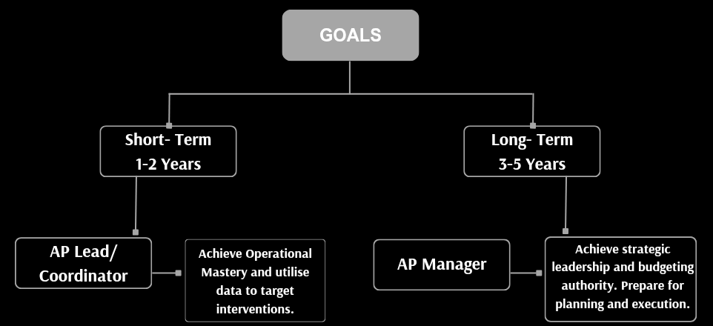

Continuous Action Plan (PDP/CPD)
This table outlines the specific, time-bound actions required to bridge the financial and strategic management gap.
DEVELOPMENT AREA | SPECIFIC ACTION | TIMELINE (RANGE) | KEY RESOURCE | MEASUREMENT (EVIDENCE)
Leadership Foundation | Enrol in and complete the CMI Level 5 Award in Leadership and Management. | Months  0 – 18 | CMI (2024) | CMI Level 5 Certificate obtained.
Operational Data | Complete a course on educational data analysis (e.g., SIMS/MIS reporting). | Months  0 – 6 | Internal Training (UWTSD, 2025) | Submission of a data-driven report to SLT on intervention impact.
Strategic Finance | Complete the CIPFA-accredited course in public sector or educational finance. | Months  18 – 30 | CIPFA (2025) | Successful course completion and certification.
Finance Practical | Execute a 3-month shadowing plan with the School Business Manager/Finance Director. | Months  18 – 21 | School Leadership | Submission of three formal cost-efficiency recommendations to SLT.
External Landscape | Maintain active membership and attend conferences with the National Association of Alternative Provision (NAAP). | Ongoing (30+ Months) | NAAP (2023) | Annual review of policy updates and professional network growth.
Continuous Reflection | Schedule a minimum of 90 minutes every quarter to formally review budget/policy documents. | Ongoing (Quarterly) | Dedicated Study Time | A detailed reflective log demonstrating the application of abstract learning to daily practice (Kolb, 1984).

Specific Action Link to SMART Goals
  - Action: Complete the CMI Level 5 Award in Leadership and Management.
SPECIFIC: The goal names a single, accredited, globally recognised qualification.
MEASURABLE: Successful attainment of the CMI Level 5 Certificate (a tangible document).
ACHIEVABLE: It's a recognised qualification available to non-degree holders, making it attainable with dedicated study.
RELEVANT: It directly addresses the Leadership requirement found in all AP Manager adverts (Nova Education Trust, 2025).
TIMEBOUND: Clearly defined as Months 0 – 18.
  - Action: Execute a 3-month shadowing plan with the School Business Manager/FD.
SPECIFIC: Names the exact activity (shadowing) and the target mentor (Business Manager/FD).
MEASURABLE: Submission of three formal cost-efficiency recommendations (a concrete output).
ACHIEVABLE: This relies on internal relationships and is a common development activity.
RELEVANT: Directly addresses the Limited Strategic Financial Management weakness and the need for Abstract Conceptualisation.
TIMEBOUND: Clearly defined as Months 18 – 21 (a 3-month window).
  - Action: Complete the CIPFA-accredited course in public sector finance.
SPECIFIC: Names the qualification and the specific focus (public sector finance).
MEASURABLE: Successful course completion and certification (a tangible document).
ACHIEVABLE: It is a standard professional certification requiring registration and completion.
RELEVANT: Crucially addresses the high-level Strategic planning and execution, as well as budgetary authority, required for the long-term goal (Coundon Court, 2025).
TIMEBOUND: Clearly defined as Months 18 – 30.

ABBREVIATIONS

Abbreviation | Full Term | Context
AC | Abstract Conceptualisation | Kolb's learning stage (theoretical knowledge)
AE | Active Experimentation | Kolb's learning stage (trying out new concepts)
AP | Alternative Provision | Education setting for excluded or high-need students
CE | Concrete Experiences | Kolb's learning stage (learning by doing/feeling)
CIPFA | Chartered Institute of Public Finance and Accountancy | Accrediting body for public sector finance courses
CMI | Chartered Management Institute | Accrediting body for management qualifications
CPD | Continuous Professional Development | Ongoing formal and informal learning activities
ECL | Experiential Learning Cycle | Kolb's model for learning and development
FD | Finance Director | Senior Management Role
MIS | Management Information Systems | Software used for educational data management (e.g., SIMS)
NAAP | National Association of Alternative Provision | Professional body for the AP sector
PDP | Personal Development Plan | Structured plan for career goals and actions
PHEA | Pennsylvania Higher Education Assistance Agency | Source of the referenced learning style quiz
SLT | Senior Leadership Team | School management team referenced in the PDP
SWOT | Strengths, Weaknesses, Opportunities, Threats | Strategic planning and self-assessment framework
TA | Teaching Assistant | Educational support role
UWTSD | University of Wales Trinity Saint David | Source of the referenced Infoskills module

REFERENCES

Job Adverts (Non-Published Source)
- Abingdon Learning Trust (2025) Student Manager (Pupil Premium/Alternative Provision). John Mason School. Job Advert.
- Coundon Court (2025) Alternative Provision Manager. Job Advert.
- Lymm High School (2025) Alternative Provision Lead. Job Advert.
- Nova Education Trust (2025) Alternative Provision Manager. Meden School. Job Advert.

Professional Development and Resources (Cited in PDP)
Chartered Institute of Public Finance and Accountancy (CIPFA) (2025) Education and Schools. Available at:https://www.cipfa.org/members/membership-benefits/cipfa-membership-matters/features/cipfa-launches-updated-qualification-cipfa-paq (Accessed: 10/11/2025).
Chartered Management Institute (CMI) (2024) CMI Level 5 Award in Leadership and Management. Available at: https://www.mollearn.com/lp/cmi-qualifications/?gad_source=1&gad_campaignid=21287743083&gbraid=0AAAAADktbf9qM0vtiQmNt3S68tgiITyg7&gclid=CjwKCAiAw9vIBhBBEiwAraSATnNrXh-BWHdy9yFE05b8V-wodX_OnJnoN9eKL5BrTjdi1D_QqTRQehoCxuYQAvD_BwE (Accessed: 02/11/2025).
Kolb, D. A. (1984). Experiential Learning: Experience as the Source of Learning and Development. Englewood Cliffs, NJ: Prentice-Hall.
National Association of Alternative Provision (NAAP) (2023) NAAP Membership and Conferences. Available at: https://naap.org/naap-membership-requirements/ (Accessed: 10/11/2025).
Pennsylvania Higher Education Assistance Agency (2011) Learning Styles Quiz. Available at: http://www.educationplanner.org/students/self-assessments/learning-styles (Accessed: 10/11/2015).
The Open University (2024). Personal Development Plan (PDP): Developing Your Career, Available at: https://help.open.ac.uk/pdp. (Accessed on 29/10/2025).
UWTSD (2014) Infoskills Module. University of Wales Trinity Saint David. Available at: [https://digitalservices.uwtsd.ac.uk/library/academic-and-infoskills/ ] (Accessed: 12/11/2025)

