
Construction and Development of a Smart Car Park Environment
[Company name] | [Company address]
REsearch proposal
Andom Alemayo (P151438)
2019
Contents
Table of Contents 1
Table of Figures 2
Table of Tables 2
Introduction 3
Industrial Context 3
Background 4
Literature review 5
Aims & objectives 7
Aim 7
Objectives 7
Research Methodology 8
Development Methodology 9
Validity and reliability 10
Research philosophy 10
Research strategies 12
Population and sample 12
Data gathering methods 12
Risks 13
Analysis and Deliverables 13
Physical Resources and planning 15
Human Resources 15
Planning 16
References 20

Table of Figures
Blue Print Draft 8
The waterfall diagram for the development methodology 9
diagram shows the research onion 11
able of the project plan 17
network diagram 18

Introduction
Nowadays, it has been discovered that the vehicles wondering in the road for search of parking spaces are the primary cause of traffic conjunction on cities and towns. Most of the driver’s precious time and energy is also waste in finding a free parking space. As a remedy to this problem, many researchers suggested that the construction of Smart Park using the Internet of Things (IoT) could be very useful. However, the construction of Smart Park using IoT devices can be quiet expensive and inefficient due to many factors. Hence, the construction of an efficient and inexpensive smart car park that can also maintain the security and safety of the users is crucial.
This research details the construction and development of an efficient smart car park .In the first section the background and literature review will be deemed and analysed, Next, the aims and objectives of the proposal will stated. After discussing the research methodologies and the way of developing it, research philosophy and the data collection methods will be overviewed. Then the research all the possible risks that can affect the project will be discussed. Finally, conclusions will be drawn after laying out the resources and the research plan.

Industrial Context
Once this project is approved, the University of Wales Trinity Saint David (UWTSD) is expected take part as a partners and if the project is found to be promising the local council of Swansea are going to be requested.
These two parties are expected to work in hand to hand with researcher mainly because the project will be performed under the guidance of the UWTSD degree program. The council of Swansea may also need adapted the system in many parking areas.

Background
In this day and age, due to the large volume of vehicles in outdoor environment’s, road traffic become increased at a higher ratio and due to the lack of parking space many drivers are forced to waste valuable time, for fuel and energy in search of locating a parking space[1].
Hence, the construction of a smart car park that has the capability of informing the users whether there is a free space or not and that alerts the users a head of any incidence is quietly interesting.
The construction of smart and automated car park is heavily relay on the Internet of Things (IoT) technology. But what is IoT? and how it came to existence?
The concepts of the Internet of Things (IoT) was primarily introduced by Kevin Ashton back in 1999. Back then, the IoT concept was defined as an object which is distinctively recognizable interoperable objects that are linked with each other and with the Radio-Frequency Identification (RFID) technology[2] [3].
Nevertheless, through time this concept has evolved to include a number of things. For instance, the Internet systems, actual sensors, electronic devices and the interconnection which exits between them, the environment and the human being [4][3].The IoT can be also defined as the internetwork of tangible objects which are comprises of embedded technology to interconnect, sense and interact with each other and or the external world[5][6]. The emergence of this technology has totally shifted direction of the traditional technological development approach where, technological development was heavily relayed on the object-oriented approach or machine-to-machine (M2M) technology. And more emphasis was placed on developing and creating a new type of machineries to boost the standard of life and productivity[7][8].
One of the most distinguishable characteristics of IoT technology is that, the presence of the global system of Internet Protocol (IP) linked computing networks, sensors, devices and machine in which the physical object is able to connect to the internet[9]. The new version of IP address (IPV6) has a huge number of IP address. And this allows as many electronic devices to be able to connect to each other either locally or globally[10].using the IoT technology it possible to construct a smart home, smart health care, smart phones, smart city, smart wearables, and so on[11].

Literature review
According to Abhirup Khanna and Rishi Anand [12] ,the issue of car parking and traffic management was addressed by constructing a smart car park and utilizing integrating the IoT and Cloud technologies. And in doing so, two types of sensors the Ultrasonic sensors and Passive Infrared sensors were used to check the availability of the empty car park slot. The Ultrasonic sensors are connected with raspberry pi wirelessly using the ESPE8266 Wi-Fi chip which contains autonomous SOS with the TCP/IP protocol[13]. Any data gathered from the sensors will be transferred to the raspberry pi where, the raspberry pi transfers the data to the IBM Message Queue Telemetry Transport (MQTT) server using the MQTT protocol. Then the IBM MQTT server is accommodated on the cloud service, which serves as database to reserve the all the data regarding the smart car parking system. Using Apache Cordova and Angular JS frame work, a mobile is created to allow the users get an information regarding the smart car park [12]. However,[14] discovered that these this approach to words solving the parking space problem is ineffective mainly because of the high cost involved due to extra sensors. In addition, [15]there will a delay of data transmission, as a considerable amount of time is required to send the data from the sensors to the cloud server and back again.
Jana et al. [16][17], presented a model of an intelligent car parking management system using the wireless sensor networks. The smart car parking is expected to show graphically the actual time information in regard to the space availability in the parking slot so that the drivers know if there is a free space and if there is, enable them to book a parking lot. Furthermore, the system allows the users to park their vehicle quickly and safely by guiding them through the empty space in the park. And to construct the smart car park, Wireless Sensors Network (WSN), Sink Automated Guidance, entrance display and user reserve system are utilised. The WSN system encompasses the sensing, distribution, routing and display statues [17]. The Sink system is used to gather information from the WSN and transmits them to the parking system management. The Sink also serves as gateway to connect the outside world with the WSN. But [18] concluded that a mote sensors are capable of covering a large area and they also provide more significant information regarding the actual scene as compared to the visual once and those monitored by the radar system if the various mode of operations assessed carefully.

Wael et al.[19]and Burak [20] proposed an innovative model to save expense, time and energy consumption that can occur place due to the delay in the transfer of data. The information collected from the sensors are immediately transmitted to parking area through the cloud technology and then the information is processed and send back again. The study has also extended its scope to seek solution about the information of the nearest cark park and traffic congestion on the road. In this research, the structure of the smart park is classified into three section. The first section contains sensor nodes, Microcontrollers and smart parking services. The second section includes the cloud technology, which serves as mediator between the mobile application users and the parking area. The last part will deal with user use of the android application so the user can get information about the nearest cark park from any location. To minimise the possible high costs, the system facilitates the communication between the sensors and the microcontroller through Bluetooth wireless technology. Similarly, communication between the users and the cloud technology is conducted through the web protocol know as Hyper Text Transport Protocol (HTTP) protocol.
Dae-hyun et al.[21] Presented a mini-parking platform, which encompasses the short parking route guidance using the Beacon and the NFC Reader, collision prevention guidance and display for the parking information as well as reserved parking slot. For the sake of practical application Beacon and RFID were used. The vehicle was also assumed as a smart phone in the modulation. In this paper the Mobius IoT was used as a platform and using the Raspberry Pi allows interconnection between the Mobius and the other electronic devices. And MQTT protocol also used to communicate the Raspberry Pi and the Mobius server. In order to navigate the shortest parking lot distance, an Android application is used to collect information from the Mobius server about the free parking space[22]. Unless a good security measure is taken, all these bunch of technology can easily be exposed to theft or damage because untheorized person can access the system and use them to do harm or steal, the identity, the properties of the users and even attack the system[23].

Aims & objectives

Aim
- The main aim of this research is to develop a smart car park, which can be used in closing in an enclosed parking system.

Objectives
- To develop a smart car park which is capable of sensing the availability of the free parking and inform the drivers.
- To analyse the efficiency of the network connectivity and the real time response of the sensors.
- To design a smart car park using a wireless technology Wi-Fi and Bluetooth to minimise cost of implementation and utilisation of the technology.
- To develop a safe smart car park which is able to inform the drivers about the possible collision occurrence or illegal parking.
- To design a smart car park with the aid of IoT devices such as Sensors, Arduino microcontroller, Light Emitting Diode (LED), CCTV (Closed-Circuit Television) and other IoT devices.
- The to develop a user friendly application and server application using the C programming language.
- To design a security system which minimises the risk of any possible hack.
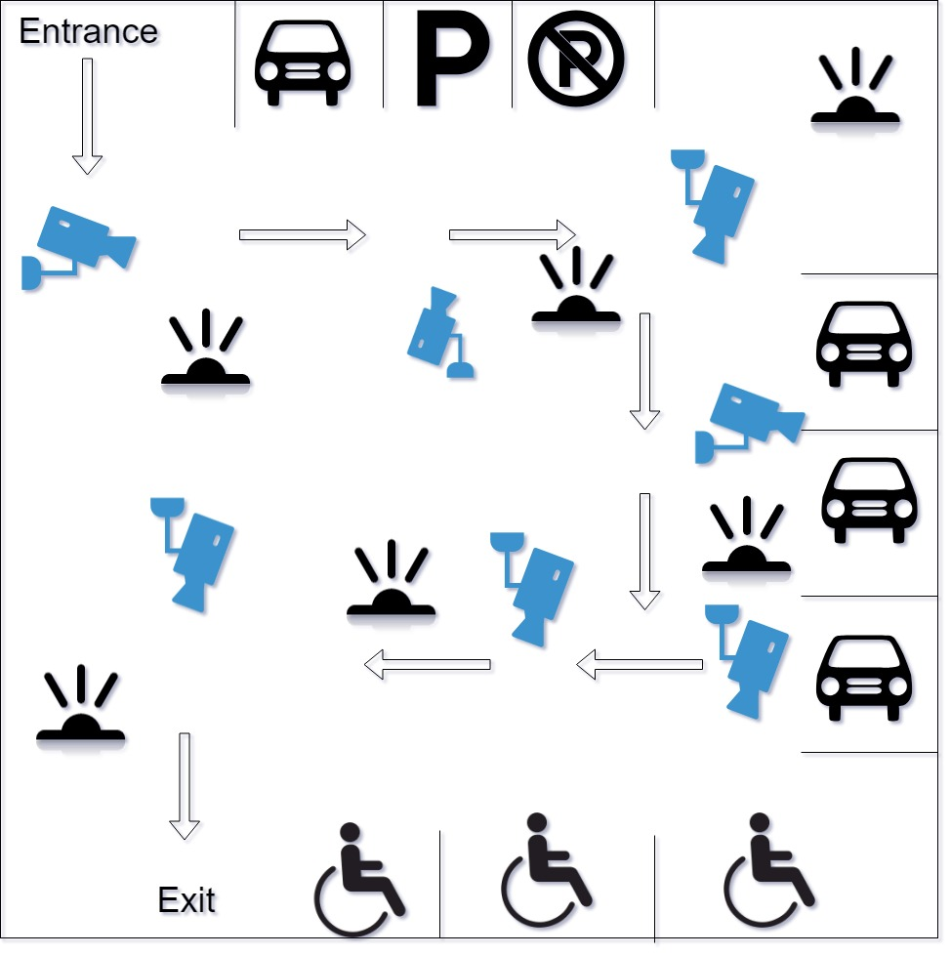Figure 1 – Blue Print Draft

Research Methodology
The author of this paper preferred to conduct a research on the implementation of IoT devices on the car park environment. And as it is in this research, first a smart car park using a car park using an IoT devices and wireless technology will be constructed and then the performance of the system will be analysed.
The researcher has also discovered that in many attempt of building a smart car park using an IoT devices, most the researchers emphasise on the utilisation of extra sensors and designing a wireless connection to set the communication within the system as well as the outside world. Issues like safety, efficiency, cost of the technology, strength of the connectivity, delay, redundancy and above all security have gained less attention by most of the researchers. Moreover, the contribution and importance of the IoT devices in improving the standard of the human beings has drawn the attention of the researcher. Hence, the author decided to use the IoT technology and implement it on a car parking environment mainly because nowadays, large number of vehicles in cities and towns in outdoor environment causes traffic jam in roads almost daily, and most of this road traffic is caused by drivers who are wondering to find a parking space[1].
Constructing a smart car park environment that fulfils the above objectives has a many benefits. Some these are, the road traffic can be reduced to some extent, the time and energy of the drivers will be saved, safety on the car parking environment will be maintained, the system will also maintain the security to words possible cyber-attack and above all the system will be affordable and cheap to maintain.
In process of conducting this project in order to minimise and find solution to the possible or unexpected obstacles the experiment will be conducted on a classroom situation first. Also test results will be compared with previous researches or experiment. For the above head problems, experts and instructors will be consulted.

Development Methodology
Research methodology can be defined as the philosophical structure that includes an activity which is consists of investigating things that have not been discovered in a systematic way[36].
The following are some research methodology that have been developed.
- Identifying the research topic
- Gathering and analysing the requirements.
- Designing
- Implementation
- Testing
- Maintenance
- Documentation of the all the necessary steps of the project

Figure 2 – The waterfall diagram for the development methodology
Developing a research method is very useful in conducting a research project. This is mainly because the research methodology gives the researcher an overview on how to complete the whole project by performing each task with the given time slot. Additionally, the progress of the project can be tracked through the completion of each task. The research methodology also allows the observation of direct behaviour and monitor of the essential variables. Moreover, it also permits a conducive environment learning continuous concepts[28].

Validity and reliability
Reliability is the measure of solidity of the test scores. In other worlds it is a process which the result remains constant as the number of tests increases during the process of testing. Validity on the other hand is a means which checks whether the test or tool is taking a precise measure of the thing which expected to be measured accurately[24][25].
There is less chance that can affect the reliability of the data mainly because the all the IoT device will be using the same amount of high speed Wi-Fi (802.11n) connection so that there will be less response delay when the data is transmitted to the cloud server and send back again. The topology of this smart cat park is designed to be connected via a wireless connection technology hence, there will be no Radio Frequency interference or crosstalk that can occur due to incorrect cabling. Additionally, the bandwidth in the whole network will be measured via a throughput. As the tests are going to be conducted in an indoor environment a large number of test are going to be conducted to check the accuracy and efficiency of the results.
Moreover, as the research is based on experimental science, there will no interference with humans. Hence there will less chance of exposing to human error or any sort of biases. And for the demonstration of this experiment new equipment will be used.

Research philosophy
In conducting this research, a positivist philosophy is used. Positivist philosophy is a philosophical system which is based on mathematics and science. The core concept of this philosophy is that everything exit can be proven via observation, experiments, tests, logical proof and other scientific methods[26]. And anything fails to prove its existence through these method is considered as not exist. The theoretical and cultural biases or believes usually lack recognition in this philosophical system as the more emphasis is on the objective truth. Moreover, statements in positivism are classified as false, true and neither false nor true(meaningless) [26][27]. As the research project is going deal about a better construction of a smart car park which involves aspects like testing and evaluating the network of wireless connections and IoT devices. Hence, the positivism philosophy is found to be more useful to proof and deal with the realistic study.
The research anion diagram is used to represent the three research philosophical, research approach and strategy along with the data collection, analysis and time zone. This diagram is also helpful in giving the researcher a detailed overview of the research project.
The diagram below shows the research onion.
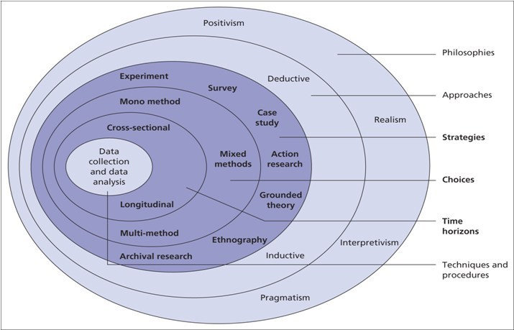
Figure 3 – diagram shows the research onion
[28]
This research will try to answer the question which states as, it is not possible to construct a smart car park which is less expensive, secure, scalable and usually accessible using the wireless technology and the IoT devices. A deductive approach has been selected to conducted this researcher. Mainly because the it allows the researcher to use scientific principles and shift from theoretical approach to more quantitative data which can used for evaluation purposes. Deductive approach is an approach that deals with creating a scientific hypothesis on the bases of the original theory and proposing a research plan to in order to check the hypothesis. This approach is helpful in clarifying the occasional that can exist between variable as well as concepts. Additionally, it is also permits the researcher to drawn an overview about the research findings[29][30].

Research strategies
In order get a better outcome and analyse the effectiveness of the design and its implementation, three strategies will be used in this project. First, to be able to compare the result of the research with previous research presented in the literature review, an experimental research strategy will be adopted where the previous research work will be left intact and any possible adjustments will be done to this project to measure and analyse the outcome. Additionally, the research will also determine the presence any relationship and its effect on the results. Finally, document review will be done. In the document review, factors that the project in both negative and positive ways will be recognised. Therefore, an explanatory, quantity and experiment strategy will be chosen in conducting this project. Manly because the research depends on the result of quantitative data as well as observational strategy study.
Moreover, a cross-sectional time horizon will be used to study the experimental and observational instead of the longitudinal time horizon meanly because the research will not be focusing in studying the effect and changes over long period of time. That is the experiment and the observation will not run more than a year[31].

Population and sample
In conducting this research project, the study population and the sample will be collected from the IoT devices like sensors and CCTV cameras. Population is defined as a large collection objects or individuals where the scientific study is desired to be conducted. Sample on the other hand is a subset of the of the large population[32][33].
Then the data obtained from the system will be simulated. And the results will be measured compared and compared against the previous research which is located on the literature review section of this paper. The Simulink simulation software will be used to conduct the simulation process.

Data gathering methods
A quantitative method will be used to as the technique of gathering the data for the achievement of the research objectives. Once the data being collected, they will be analysed using a quantitative method. Quantitative research express problems in terms of numerical data or data that can be converted into numbers or statistics. This methodology, involve quantifying attitudes, behaviour and many defined variables so that conclusion can be drawn from the given population. In this research a systematic study as well as a survey will be used to collect the desired data[34][35].

Risks
In conducting this project, following possible risks are identified
- Time constraints to build a fully functional and secure smart car park that operates using an IoT devices, wireless technology and cloud technology.
- Lack of time of management skills of the author due workload.
- Poor detection of the ultrasonic sensors for an object, which is located at a distance more than 50 centimetres.
- Lack of some good programming skills.
- Failure of the IoT sensors may let an accident to take place, as the users will not informed instantly.
- Data collection and video recording can rise some Ethical issues.

Analysis and Deliverables
The evaluation of the IoT based smart car park project required a number of different methods. Using the wireless sensors, a quantitative data will be collected. Then the data obtained from the sensors will be used to analyse the maximum and the minimum threshold. Through a network throughput, the amount of data transferred within the simulated time will also be measured in terms of bits per second (bps), megabits bits per second (Mbps) and so on. For further analysis, the quantitative data will be analysed using the Net Sim simulation software to see how much packet loss is occurring and why it is happing. Similarly, the signal to noise ratio effect will be simulated to evaluate the strength of the signal carrying information.
For purpose of evaluating the success of the project, the quantitative data obtained will be compared against the standards. And this will help to evaluate if the initial aims and objectives of the project are achieved. As the basic objective of this project is to improve the existing connectivity and reducing the amount of packet loss by identifying the main causes.
Upon the successful completion of this project, it is expected that a fully functional smart car park that is capable of maintaining the security and the safety of the users to be developed. The smart car park is also expected to be efficient and effective that can be implemented and run at a relatively lower cost.

Physical Resources and planning
In this project for the successful construction and development of an IoT based smart car park, the following physical resources are required.
- Ultrasonic sensors and Infrared sensors – to detect the distance of the vehicles, human or other objects.
- CCTV- cameras to detect and record visual seen of the objects.
- Personal computer and Laptop- to conduct tests, monitor the ongoing active and so on.
- Wireless access points – to establish connection.
- Books, journals and research papers- to conduct research.
- Cisco laboratory - to conduct and set the experiment and get access to the computers.
- Net sim software- to perform simulations.
- Access to the to the University of Wales Trinity Saint David (UWTSD) internet sources.
- Access to public and UWTD library – to barrow books.
- Access the UWTSD library online resources- to make use of the online resources in conducting a research.
- Access to cloud servers – to send the data to be process, saved and the technology can serve as a backup the data.

Human Resources
Beside the physical resources, the following human resources are also needed.
- IT member of the UWTSD.
- Instructors of the UWTSD.

Planning
The over planning of the project is illustrated in the waterfall diagram below.

The figures below shows the time line and Gantt chart of the project
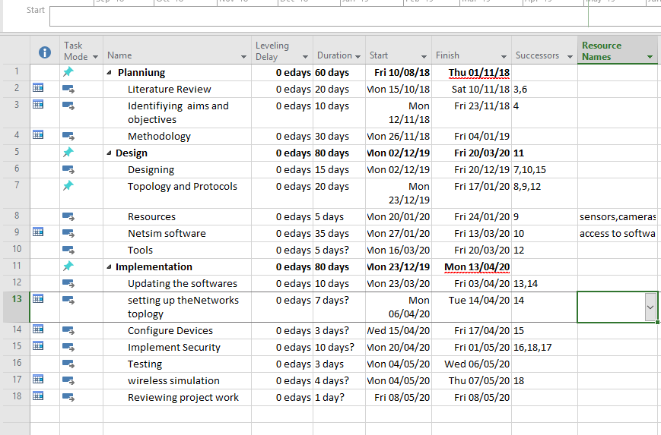Figure 4 - table of the project plan

The figure below shows Network diagram
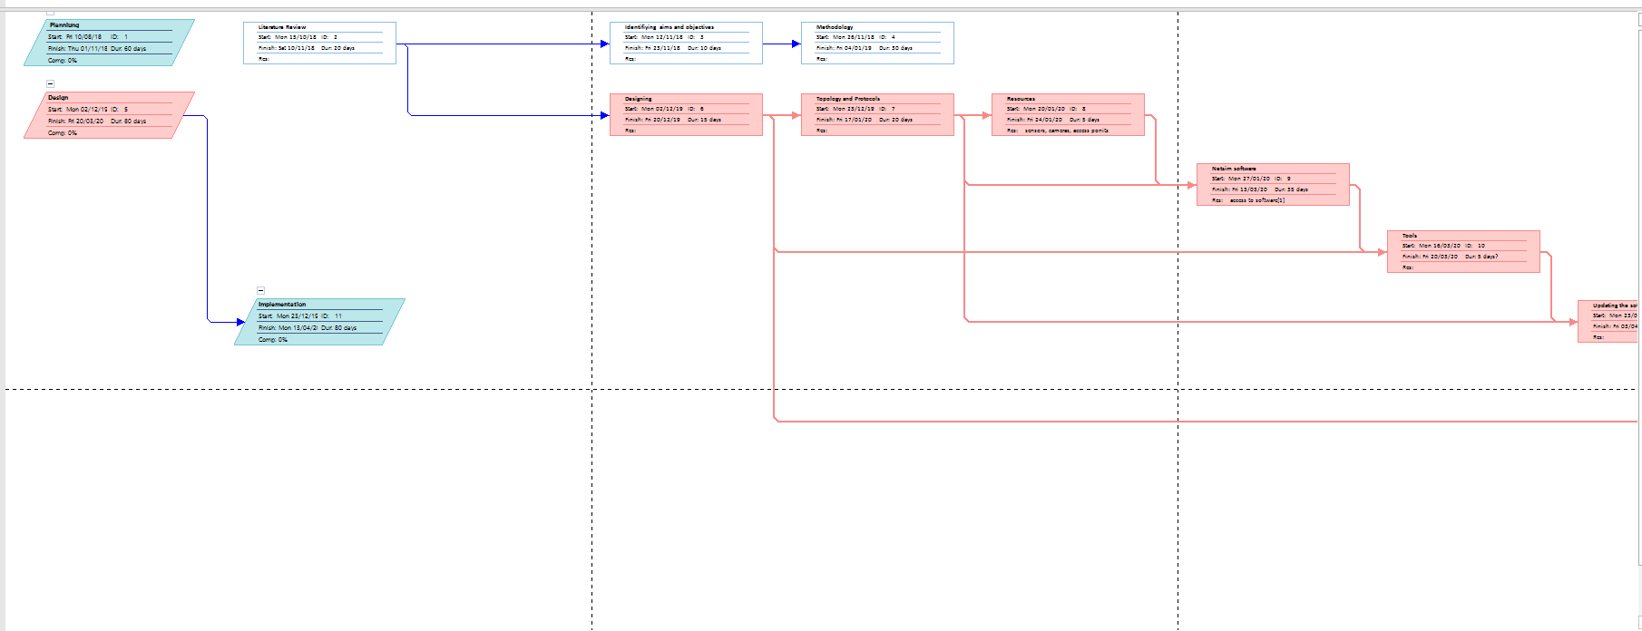Figure 5- network diagram

The figure below show the pert
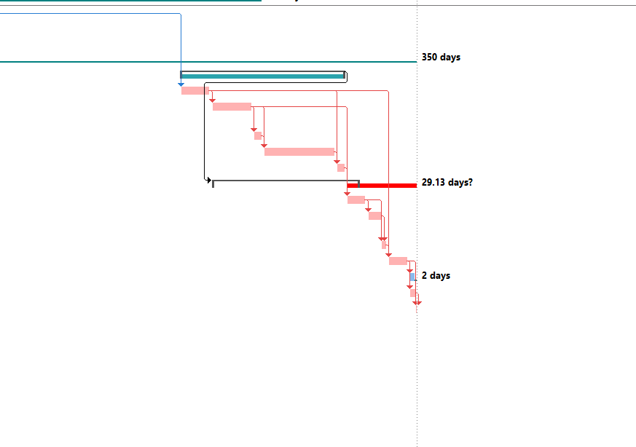
Conclusion
The project proposal completed successfully. The literature review is taken in consideration and reviewed. The research aim and objectives are clearly stated. The research methodologies and developments are drafted. Methods on how to collect and analyse the data are also viewed in detail. All the possible risks, which can affect the project, are sorted out. Finally, the collection are drawn after drafting the research and required plans.

References
<List of references cited in numerical (IEEE) order>

