
Assessment 1
Supporting Paper
Depression
Student Name: Justyna Cichocka
Student ID: 1916227
Module name: Mental Disorders and Psychopathology
Module Code: BMHP6006
Lecturer Name: Bianca Sanfilippo
Submission Date: 19.08.2022
Contents
- Introduction…………………………………………………………..2
- Prevalence…………………………………………………………….2
2.1 Impact of COVID-19 on the UK population…………………4
2.2 Association of gender and sexual orientation with depression…………………….………………………………………5
- Aetiology………………………………………………………………6
- Signs…………………………………………………………………...7
- Diagnosis……………………………………………………………..8
- Historical Overview…………………………………………………8
- Current Treatments…………………………………………………9
- Side Effects of Antidepressants…………………………………10
- Principles of Care…………………………………………………..11
- Recommendations………………………………………………...12
- Conclusion………………………………………………………….13
- References………………………………………………………….14
- Appendix A: Patient Health Questionnaire (PHQ-9)…………18
- Appendix B: PowerPoint Presentation…………………………20

- Introduction
The study will examine depression in-depth, including its description, ICD-10 categorization, relevant statistics, aetiology, signs, and diagnosis. This report also focuses on reviewing historical perspectives and an evaluation of the current treatments for this illness. Legislation and NICE guidelines for working with people suffering from depression will be included. Finally, the student presents effective, non-invasive treatment as a recommendation for alleviating depression episodes.
According to WHO (2022), mental disorders are caused by clinically substantial changes in cognition, emotional regulation, or behaviour.
Depression is a complex condition that affects the minds and entire bodies of people, from whom no group is exempt (Priory, 2022). It may persist for a long time or recur, causing discomfort and impaired functioning that reduces the quality of life (Mind, 2019). The NHS (2019c) defined depression as a low emotional state accompanied by anhedonia, a constant feeling of unhappiness, and anxiety.
WHO (2010), in the ICD-10 Manual, classifies depressive episodes in Chapter V under the heading ‘‘Mental and behavioural disorders (F00-F99)’’, more specifically in the family ‘‘Mood [affective] disorders (F30-F39)’’, with a ‘‘depressive episode’’ as a subgroup ‘‘(F32)’’.

- Prevalence
Worldwide, the number of people suffering from depression has reached nearly 280 million in all societies, with 5% of adults affected and 5.7% of the elderly over the age of 60 (WHO, 2021). In the UK, about 4.5% of adults suffer from depression, with 70% of cases being mild, 20% being moderately depressed and 10% having severe symptoms (Priory, 2022). Baker (2021) found that mental problems have grown in both genders in England since 1993 (Figure 1). However, in England, more women than men suffer from mental illness (Figure 2) (Baker, 2021).

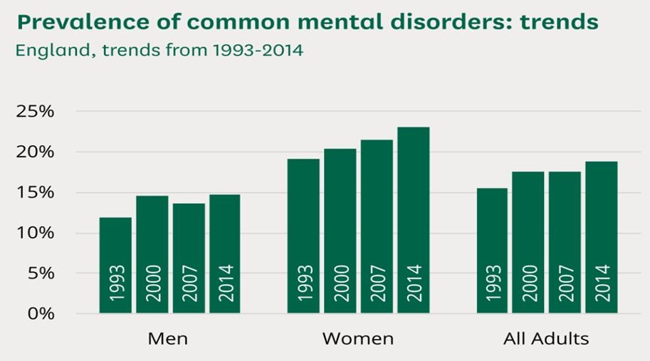

Figure 1: Prevalence of common mental disorders in England from 1993 to 2014 Source: https://commonslibrary.parliament.uk/research-briefings/sn06988/
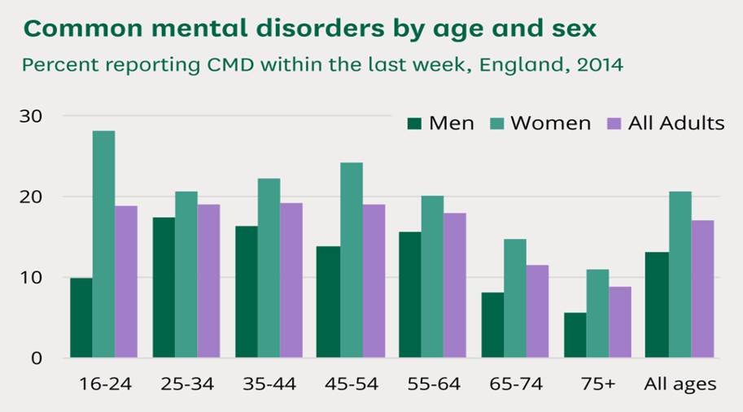

Figure 2: Common mental disorders by age and sex in England Source: https://commonslibrary.parliament.uk/research-briefings/sn06988/

2.1 Impact of COVID-19 on the UK population
According to Rocks et al. (2021), since the start of the COVID-19 pandemic, people’s mental health has been negatively impacted by social isolation, poor health outcomes, and job loss. The authors revealed that increasing referrals for mental health from COVID-19 account for an additional 300,000–730,000 cases annually by 2024. The prediction shows that COVID-19 spending on mental health services could increase from £1.6bn to £3.6bn by 2024, which is £400-900m per year, putting the NHS under a heavy financial burden (Rocks et al. 2021). Emerging referrals pose challenges such as rising treatment costs and a higher demand for help services like talking therapy (IAPT) (Rocks et al. 2021).
According to ONS (2021), moderate to severe symptoms among adults in Great Britain increased from 10% to 21% by March 2021 and then fell to 17% by August 2021 (Figure 3).
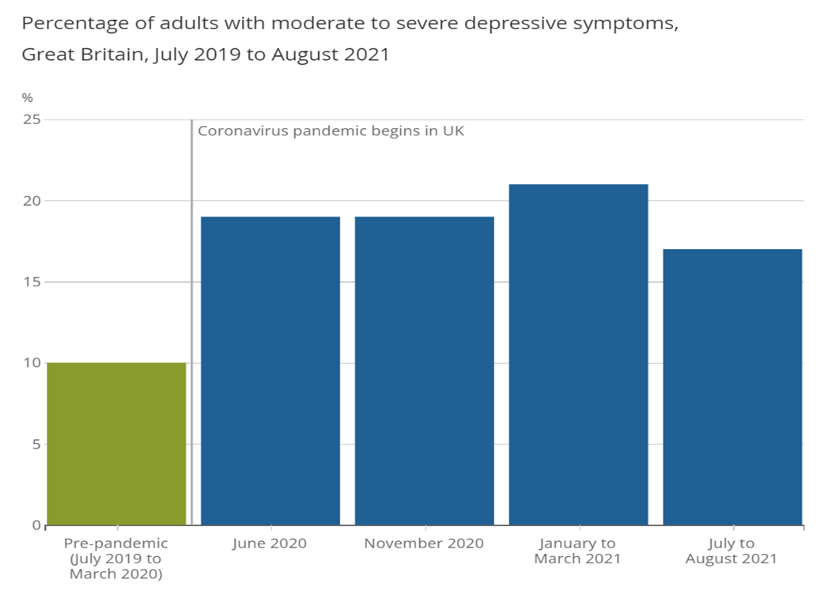

Figure 3: Percentage of adults with moderate to severe depressive symptoms from July 2019 to August 2021
Source:https://www.ons.gov.uk/peoplepopulationandcommunity/wellbeing/articles/coronavirusanddepressioninadultsgreatbritain/julytoaugust2021
NHS Digital (2021a) revealed that rates of probable mental disorders increased between the period 2017 and 2021 in both boys and girls (Figure 4). The increase was highest in young women aged 17 to 19 (from 13.4% in 2017 to 24.8% in 2021). The rates were highest in boys aged 6 to 16, showing an increase from 12.4% in 2017 to 18.6% in 2021.

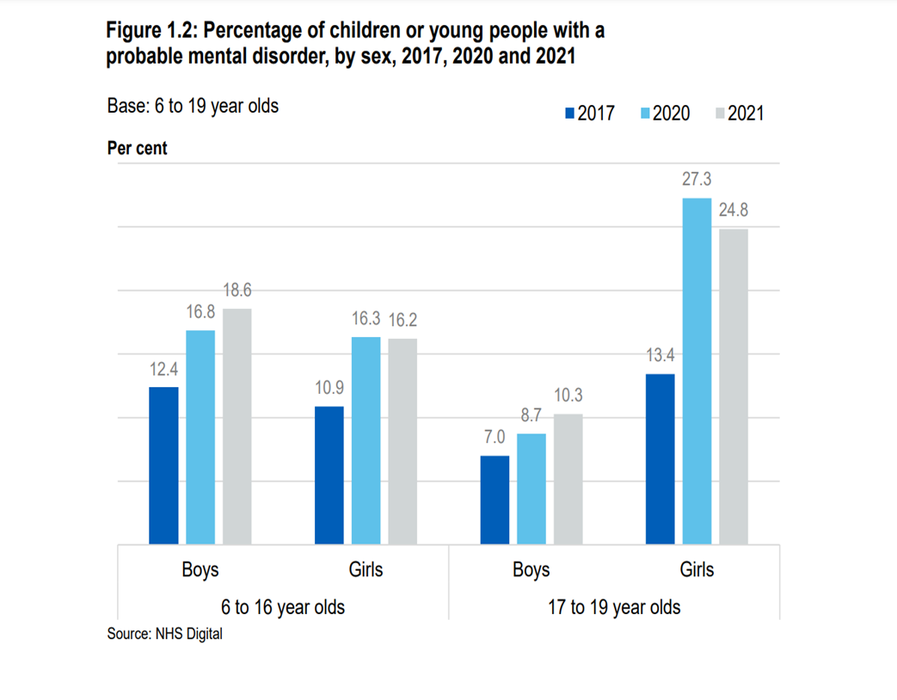

Figure 4: Percentage of children or young people with a probable mental disorder by gender, 2017, 2020, 2021
Source: https://files.digital.nhs.uk/97/B09EF8/mhcyp_2021_rep.pdf

  - Association of gender and sexual orientation with depression
Royal College of Psychiatrists (2022) revealed that people identified as transgender, lesbian, gay, or bisexual may have more severe cases of depression than heterosexuals.
It is estimated that 12% of pregnant women will experience depression, and 15% to 20% of new mothers will experience depression in the first year after giving birth. (Royal College of Psychiatrists, 2022).
Depression is the major contributor to suicide (Raue et al. 2014), accounting for two-thirds of all cases of death (NICE, 2021).
ONS (2020) showed that men more often than women commit suicide in England, where the highest rate was in 2019 (Figure 5).

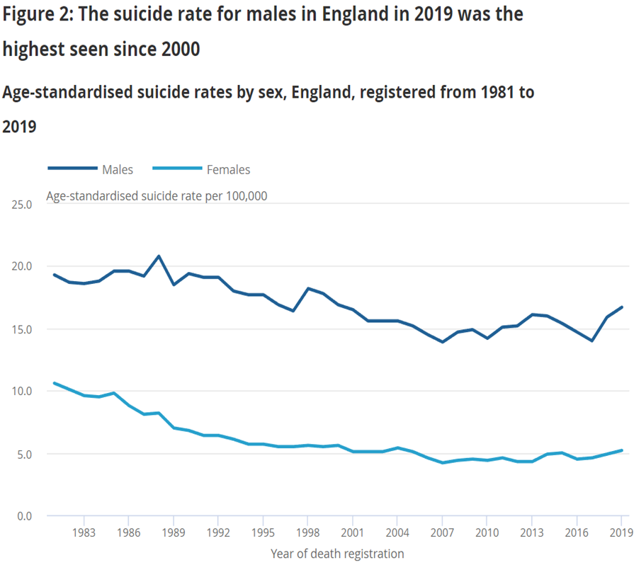

Figure 5: The suicide rate in England from 1983 to 2019
Source:https://www.ons.gov.uk/peoplepopulationandcommunity/birthsdeathsandmarriages/deaths/bulletins/suicidesintheunitedkingdom/2019registrations

- Aetiology
Extreme individual variation exists, with multiple factors potentially contributing to sudden, unexplained depression in certain people (Mayo Clinic, 2022). Older people have a higher risk of untreated depression because they are less likely to seek care and help (Mayo Clinic, 2022).
The following are factors that contribute to depressive episodes:
- Biological changes in the brain (Mayo Clinic, 2022).
- Chronic health conditions such as heart disease or dementia (Mayo Clinic, 2022).
- Heredity. People who have a family history of depressive episodes may be more likely to develop them (Mayo Clinic, 2022; Mind, 2019).
- Changes in brain chemistry and neurotransmitter function, and their interaction with the nervous circuits that regulate mood, may play a role in depression and its treatment (Mayo Clinic, 2022).
- Poor nutrition, lack of sleep, or lack of exercise cannot directly cause depression, but they can increase your risk of developing it (Mind, 2019).
- Physical changes and imbalances of hormones during childbirth cause postnatal depression (NHS, 2018).
- Stressful life events like the death of a family member, the breakdown of relationships (NHS, 2019a), or physical and sexual abuse (Mind, 2019).

- Signs
To be diagnosed with depression, patients frequently have to experience various symptoms almost daily for at least fourteen days, and these must be stronger than the regular mood swings that we all encounter on a daily basis (Tracy, 2022). The NHS (2019d) divided depressive symptoms into three categories:
- psychological include suicidal thoughts, feeling unworthy or guilty, and extreme sadness,
- physical includes abnormal sleeping or eating patterns, decreased energy,
- social signs involve loss of interest in favourite activities, and social exclusion from the group.
Doctors defined the severity of depression as mild, which has an effect on everyday existence; moderate, which has a debilitating effect on daily life; and severe, which creates extreme impossibilities to daily functioning (NHS, 2019d). Additionally, patients with severe episodes can exhibit psychotic signs like delusions like paranoia or hallucinations such as hearing voices (Mind, 2019).

- Diagnosis
GP consultation to investigate the severity of depression, which can be mild, moderate, or severe (NHS, 2019b). The examination is based on a clinically developed questionnaire relating to lifestyle and general health (NHS, 2019b). A ‘‘Patient Health Questionnaire (PHQ-9)’’ is attached in Appendix A.
The GP may also recommend a urine or blood test to determine if the patient has any medical conditions that can cause symptoms of depression, such as an underactive thyroid, in which patients feel fatigued or gain weight (NHS, 2019b).
Testing for vitamin D deficiency may also aid with depression, though studies on this are conflicting (Saji Parel et al. 2022).

- Historical Overview
Historically, mental diseases were stigmatised by society, and many extreme and invasive measures have been implemented to help people with mental illness (Hardy, 2015).
The first asylums were constructed in Britain around the mid-19th century. It was the historical counterpart to the contemporary psychiatric hospital (Science Museum, 2018). However, hospitals in the early twentieth century were not places of healing, but of great harm. In asylums, patients were subjected to bloodletting, shocking with boiling or ice-cold water, sedatives, and physical restraints such as straitjackets (Science Museum, 2018).
According to Tobin (2019), exorcism is a practise that puts people's mental health at risk and is spiritual or psychological abuse of the victim by members of their own religious organisation. In truth, the mentally ill were mistaken for victims of demon possession. In communities where exorcism is common and mental illness is stigmatised, awareness is crucial (Tobin, 2019).
Trepanation was invasive neurosurgery practise to treat head injuries and relieve mental symptoms, also used for spiritual reasons. Holes were drilled in the skull to relieve pressure (Gross, 2021).
9. Current Treatments
Social views and understanding have contributed to positive changes in the treatment of mental illness and the therapies used (Hardy, 2015). These treatments will evolve as we learn more about brain pathology (Hardy, 2015).
Treatments are categorised according to the severity of depression. Effective treatment of depression should significantly reduce the likelihood of relapse and relieve symptoms, thereby significantly improving the patient's quality of life (NHS, 2019e). Mild symptoms can be treated with exercise, local psychological therapy services, and also cognitive behavioural therapy (CBT), which helps comprehend how ideas and actions influence each patient (NHS, 2019e). Moderate cases can be cured with several talking therapies, including CBT, counselling that encourages reflection on the issues the patient is facing in order to develop new coping strategies; and interpersonal therapies (IPT) that focus on connections with people and any challenges they may be experiencing with them, such as communication difficulties or coping with loss (NHS, 2019e). The primary treatment for severe depression consists of antidepressants and psychotherapy, which include interpersonal therapy (IPT), counselling and referral to a mental health team composed of psychologists, psychiatrists, specialist nurses and occupational therapists (NHS, 2019e).
The number of dispensed antidepressants in England nearly doubled, showing an increase from 36 million to 70.9 million between 2008 and 2018 (Figure 6). Some evidence suggests that only around 30%–50% of people achieve a clinically significant response (Rafeyan et al. 2020). The study indicates that the optimal strategy is to increase the dosage of a psychiatric drug, switch to another type, or combine medication with a different therapy.

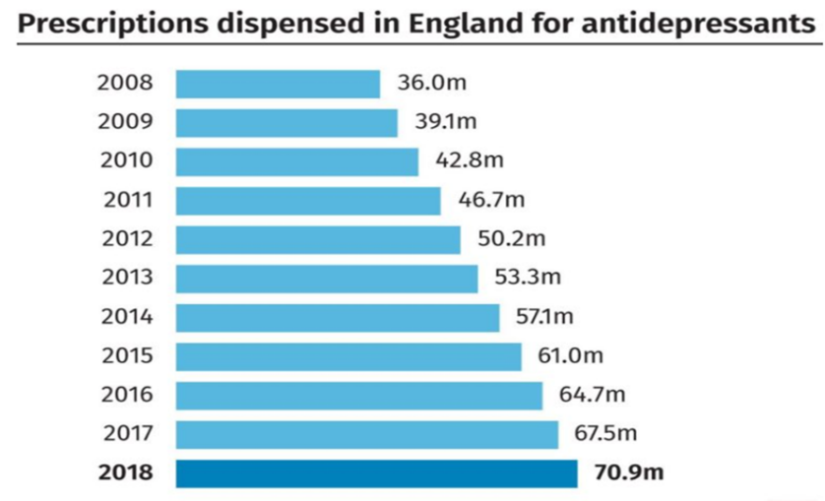

Figure 6: Prescriptions dispensed in England for antidepressants
Source: https://guernseypress.com/news/uk-news/2019/03/28/antidepressant-prescriptions-in-england-hit-70m/

- Side Effects of Antidepressants
Tommy's (2021) reported on Abby's story of postnatal depression. Abby has struggled with depression in the past. After the birth of her daughter Bethany, she was overwhelmed by the fact that she was not physically able to provide the necessary care for the infant. She was prescribed antidepressants, which only exacerbated her symptoms, eventually leading to her admission to a psychiatric hospital in the mother and child unit, where she was provided with professional help (Tommy’s, 2021).
In addition, full information is required about the consequences of taking psychiatric drugs and their adverse effects, for instance, MAO drugs are associated with liver damage (Todorović Vukotić et al. 2021).

- Principles of Care
Adhering to the NICE Guidelines is imperative when working with service users who are experiencing mental health issues. It is critical to understand and demonstrate your knowledge of policy and law. It is important to establish a relationship of trust with patients in order to approach them in an open, engaging, and non-judgmental manner (NICE, 2021).
According to the Human Rights Act of 1998, we must establish a relationship of trust by utilising a person-centered approach, including service users in making decisions regarding them and prioritising their opinions and preferences.
The Equality Act of 2010 mandates that patients receive equitable treatment and be treated with respect, fairness, and dignity. We must use anti-discriminatory practises to combat stigma. This implies not discriminating against service users and not treating them unfairly or providing unfair treatment.
According to the Mental Health Act of 1983, a person's liberty may only be restricted if they are in danger of harm or abuse. We cannot restrict patients' freedom unless it is required for health, safety, and safeguarding. When mental health practitioners determine that a service user is highly likely to commit suicide, he or she may be held in a mental health institution.
According to the Mental Capacity Act of 2005, it is crucial to always prioritise the patient's best interests. In the case of mental disorders like dementia, which rob patients of their ability to make decisions for themselves, decisions must be made in a way that serves the needs of those receiving services.
In accordance with the Data Protection Act, 2018, the gathering and processing of patient information must be confidential, fair, lawful, and transparent (NHS Digital, 2021b)

.
10. Recommendations
Suggestions for preventing and treating depression are proposed in order to stop harmful, invasive, and controversial treatments.
Providing vitamin D to women affected by depression with moderate to severe symptoms led to substantial improvement in their illness (Endocrine Society, 2012).
According to Science Daily (2020), regulation of mood was approved by affecting brain activity with powerful magnetic fields by applying non-invasive therapy known as "Repetitive Transcranial Magnetic Stimulation (rTMS)". RTMS was tolerated with a nearly 60% success rate in adults who did not respond well to psychiatric drugs in 2008.
According to Moragrega and Rios (2021), withdrawal symptoms related to an antidepressant can last for several months or years. These facts promote the search for complementary therapies. Medical plant therapy is both safe and affordable. However, both patients and prescribers should consider adverse effects. Golden root combined with saffron is effective in treating mild to moderate depressive episodes (Moragrega and Rios, 2021). Although the combination of St John's Wharf and kava relieves depression, the side effects of bipolar disorder and schizophrenia exacerbate the symptoms of psychoticism (Moragrega and Rios, 2021).
Exercise can help ease the symptoms of mild to moderate depression, however, this treatment may not be beneficial for everyone, with response rates ranging between 40 and 50 percent (Schuch et al. 2019).
Yoga also demonstrated efficacy in alleviating prenatal depression. However, outcomes varied depending on the style of yoga. Integrative approaches with a larger emphasis on meditation and breath control were useful in lowering depressive symptoms in the perinatal period, whereas exercise-based yoga did not (Saeed et al. 2019).
Literature supports the use of massage therapy to treat pregnant women with mild depression symptoms, either in conjunction with psychotherapy or as a stand-alone treatment. Individuals with HIV and severe depressive disorder stated that twice-weekly massage therapy was effective in reducing depressive symptoms (Rapaport et al. 2018).
11. Conclusion
Depression leads to functional limitations. The condition’s effects are extensive, and COVID-19 worsens the negative impact on a person's personal, social, and professional life. This places a significant burden on the individual and their caregivers, as well as a significant strain on the healthcare system. Throughout history, the social perception and knowledge of mental illness have changed significantly. Awareness of mental health allows us to challenge the stigma and discrimination associated with it. Healthcare practitioners can offer social support, mental monitoring, and alternative treatments without invasive procedures.

12. References
Endocrine Society (2012) Treating vitamin D deficiency may improve depression. Available at: https://www.sciencedaily.com/releases/2012/06/120625152358.htm (Accessed: 09 August 2022).
Baker, C. (2021) Mental health statistics (England). House of Commons Library. Available at: https://commonslibrary.parliament.uk/research-briefings/sn06988/ (Accessed: 27 July 2022).
Gaynes, B.N. et al. (2014) ‘Repetitive transcranial magnetic stimulation for treatment-resistant depression: a systematic review and meta-analysis’, The Journal of clinical psychiatry, 75(5), pp. 477–489.
Gross, C.G. (2021) A Hole in the Head: A History of Trepanation. The Mit Press Reader. Available at: https://thereader.mitpress.mit.edu/hole-in-the-head-trepanation/ (Accessed: 16 August 2022).
Hardy, J. (2015) A Beautiful Mind: The History of the Treatment of Mental Illness. History Cooperative. Available at: https://historycooperative.org/a-beautiful-mind-the-history-of-the-treatment-of-mental-illness/#:~:text=Historically%2C%20those%20with%20mental%20illnesses%20had%20a%20%E2%80%9Csocial,threatening%20the%20family%E2%80%99s%20%E2%80%9Cidentity%20as%20an%20honorable%20unit%E2%80%9D (Accessed: 18 August 2022).
Mayo Clinic (2022) Depression (major depressive disorder). Available at: https://www.mayoclinic.org/diseases-conditions/depression/symptoms-causes/syc-20356007?p=1 (Accessed: 14 August 2022).
Mind (2019) Depression. Available at: https://www.mind.org.uk/information-support/types-of-mental-health-problems/depression/about-depression/ (Accessed: 25 July 2022).
Moragrega, I. and Ríos, J.L. (2021) ‘Medicinal Plants in the Treatment of Depression. II: Evidence from Clinical Trials’, Planta Med. Available at: https://pubmed.ncbi.nlm.nih.gov/34157753/ (Accessed: 4 August 2022).
NHS Digital - National Health Services Digital (2021a) Mental Health of Children and Young People in England. Available at: https://files.digital.nhs.uk/97/B09EF8/mhcyp_2021_rep.pdf (Accessed: 25 July 2022).
NHS Digital - National Health Services Digital (2021b) Protecting patient data. Available at: https://digital.nhs.uk/services/national-data-opt-out/understanding-the-national-data-opt-out/protecting-patient-data (Accessed: 31 July 2022).
NHS - National Health Service (2019a) Causes - Clinical depression. Available at: https://www.nhs.uk/mental-health/conditions/clinical-depression/causes/ (Accessed: 25 July 2019).
NHS - National Health Service (2019b) Diagnosis - Clinical depression. Available at: https://www.nhs.uk/mental-health/conditions/clinical-depression/diagnosis/ (Accessed: 31 July 2022).
NHS - National Health Service (2019c) Overview - Clinical depression. Available at: https://www.nhs.uk/mental-health/conditions/clinical-depression/overview/ (Accessed: 31 July 2022).
NHS - National Health Service (2019d) Symptoms - Clinical depression. Available at: https://www.nhs.uk/mental-health/conditions/clinical-depression/symptoms/ (Accessed: 14 August 2022).
NHS - National Health Service (2019e) Treatment - Clinical depression. Available at: https://www.nhs.uk/mental-health/conditions/clinical-depression/treatment/ (Accessed: 29 July 2022).
NHS - National Health Service (2018) Prenatal or postnatal depression. Available at: https://www.nhs.uk/mental-health/conditions/post-natal-depression/overview/ (Accessed: 31 July 2022).
NICE - National Institute for Health and Care Excellence (2021) Guideline: Depression in adults. Available at: https://www.nice.org.uk/guidance/ng222/documents/draft-guideline-4 (Accessed: 30 July 2022).
ONS - Office for National Statistics (2021) Coronavirus and depression in adults, Great Britain: July to August 2021. Available at: https://www.ons.gov.uk/peoplepopulationandcommunity/wellbeing/articles/coronavirusanddepressioninadultsgreatbritain/julytoaugust2021 (Accessed: 27 July 2022).
ONS - Office for National Statistics (2020) Suicides in England and Wales: 2019 registrations. Available at: https://www.ons.gov.uk/peoplepopulationandcommunity/birthsdeathsandmarriages/deaths/bulletins/suicidesintheunitedkingdom/2019registrations (Accessed: 27 July 2022).
Priory (2022) Depression Statistics. Available at: https://www.priorygroup.com/mental-health/depression-treatment/depression-statistics (Accessed: 25 July 2022).
Rafeyan, R. et al. (2020) ‘Inadequate Response to Treatment in Major Depressive Disorder: Augmentation and Adjunctive Strategies’, The Journal of clinical psychiatry, 81(3).
Rapaport, M.H. et al. (2018) ‘Massage therapy for psychiatric disorders’, American Psychiatric Publishing, 16(1), pp. 24-31.
Raue, P. J. et al. (2014) ‘Suicide risk in primary care: identification and management in older adults’, Current psychiatry reports, 16(9), pp. 1-8.
Rocks, S. et al. (2021) Real Centre Projections: Health and social care funding
projections 2021. The Health Foundation.
Royal College of Psychiatrists (2022) Depression in adults. Available at: https://www.rcpsych.ac.uk/mental-health/problems-disorders/depression (Accessed: 27 July 2022).
Saeed, S.A. et al. (2019) ‘Depression and anxiety disorders: benefits of exercise, yoga, and meditation’, Am Fam Physician, 99(10), pp. 620-627.
Saji Parel, N. et al. (2022) ‘Depression and Vitamin D: A Peculiar Relationship’, Cureus, 14(4), pp. 1-10.
Science Museum (2018) A Victorian Mental Asylum. Available at: https://www.sciencemuseum.org.uk/objects-and-stories/medicine/victorian-mental-asylum (Accessed: 16 August 2022).
Schuch, F.B. et al. (2019) ‘The role of exercise in preventing and treating depression’, Current Sports Medicine Reports, 18(8), pp. 299-304.
Tobin, S.M. (2019) Exorcism, Deliverance, and Psychotherapy from a Catholic-Christian Perspective: A Critical Literature Review. ProQuest Dissertations Publishing.
Todorović Vukotić, N. et al. (2021) ‘Antidepressants- and antipsychotics-induced hepatotoxicity’, Archives of toxicology, 95(3), pp. 767–789.
Tommy’s (2021) Antenatal and postnatal depression - Abby's story. Available at: https://www.tommys.org/pregnancy-information/blogs-and-stories/im-pregnant/mental-health-and-wellbeing/antenatal-and-postnatal-depression-abbys-story (Accessed: 15 August 2022).
Tracy, N. (2022) MDD: DSM Criteria for Major Depressive Disorder. Healthy Place. Available at: https://www.healthyplace.com/depression/major-depression/mdd-dsm-criteria-for-major-depressive-disorder (Accessed: 14 August 2022).
WHO - World Health Organisation (2022) Mental disorders. Available at: https://www.who.int/news-room/fact-sheets/detail/mental-disorders (Accessed: 13 August 2022).
WHO - World Health Organisation (2021) Depression. Available at: https://www.who.int/news-room/fact-sheets/detail/depression (Accessed: 25 July 2022).
WHO - World Health Organisation (2010) ICD-10 - International Statistical Classification of Diseases and Related Health Problems 10th Revision (online). Available at: https://icd.who.int/browse10/2010/en#/F30-F39 (Accessed: 25 July 2022).

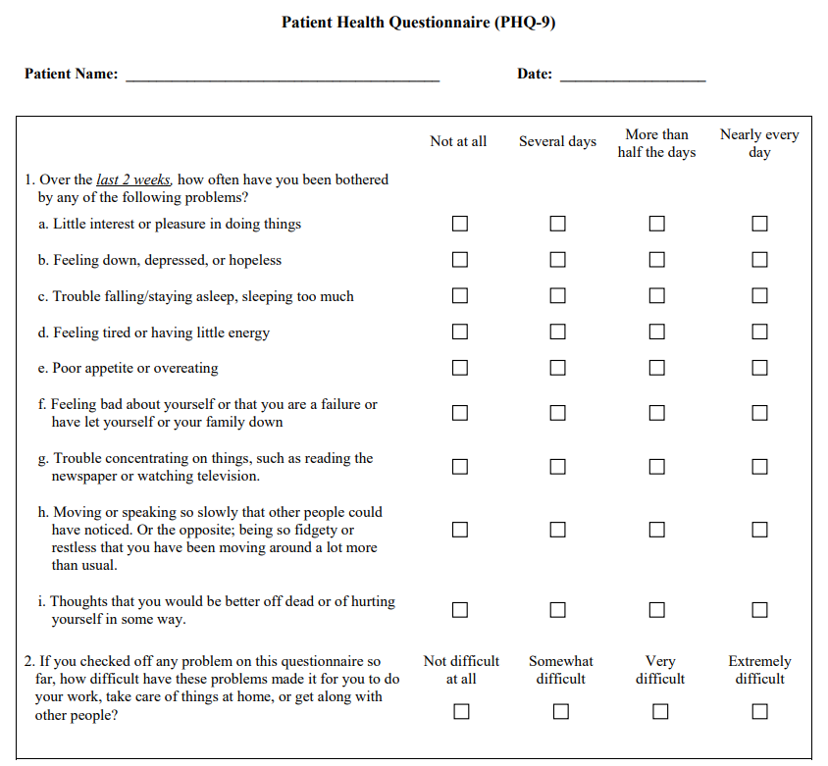
13. Appendix A: Patient Health Questionnaire (PHQ-9)

Appendix A: Patient Health Questionnaire (PHQ-9)
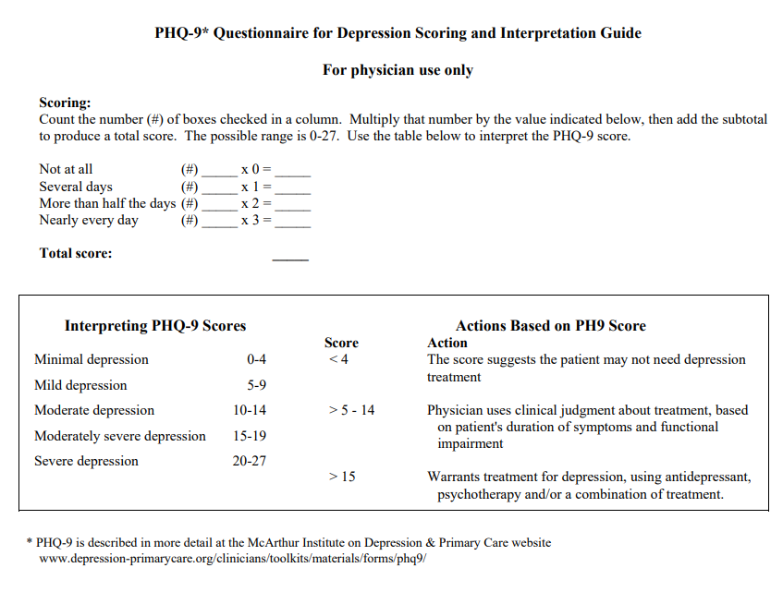

14. Appendix B: PowerPoint Presentation



