BA International Hotel Management
Entrepreneurship BMIH5001

TITLE:
Individual Business Model Canvas with entrepreneurial reflection
using appropriate academic models.

Student ID: 2210502

Name student: Antonia Lupas

Name of lectures: Ben Chong , James Scott

ECOBITE CAFÉ - AN ECO-FRIENDLY HOSPITALITY BUSINESS PLAN

Table of Contents
Introduction 3
Business Concept and BMC Overview 3
EcoBite Café's Vision and Mission 3
Key Partners 4
Key Activities 4
Channels 5
Cost Structure 5
Justification and Rationale 6
Unique Business Parameters and Justifications 6
Eco-Friendly Features 6
Market Analysis 6
Differentiation Strategy 6
Supporting Data 7
Part 2: Personal Entrepreneurial Reflection 9
Introduction to Reflection 9
Reflection on Entrepreneurial Traits 9
Personal Development Plan 10
Reference List 11
Appendix Business Canva……………………………………………………………………12

Introduction
EcoBite Café stands out as a revolutionary initiative in the hospitality sector, aspiring to re-invent café culture while upholding principles of environmental sustainability. The foundation of our idea is green practices throughout all functions, including sourcing organic local ingredients and using environmentally friendly materials as well as energy-efficient devices. Our goal is to establish a place that will not only offer good food and drinks but also community interactions while enjoying healthy, morally sourced foods.
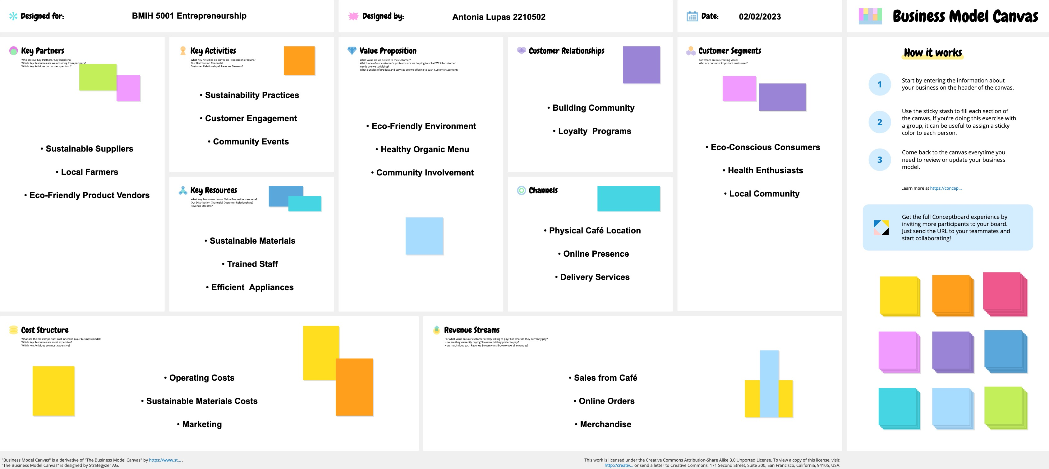
Figure 1: Business Model Canvas (BMC)
(Source: Developed based on)
Our planning process is also crucial as we use the Business Model Canvas (BMC) (https://conceptboard.com/blog/business-model-canvas-free-conceptboard/). This strategic tool allows us to systematically see and organise the different elements of EcoBite Café, ensuring balancing aspect while venturing into entrepreneurship. Through the BMC, we can identify our key partners’ activities’ resources and value propositions that match with its mission to concentrate on an ‘eco-conscious dining experience.’ This approach is this methodology that underlies our business strategy and, therefore allows EcoBite Café not just to present a unique gastronomic experience but presents itself as the evidence of sustainable managerial possibilities on the part of hospitality industry.

Part 1: Business Concept and BMC Overview

EcoBite Café's Vision and Mission
The EcoBite Café is conceptualized as something beyond a regular coffee shop; it’s the epic enter of sustainability and healthy living. We intend to achieve our objective by developing a café that not only specializes in serving organic food and drinks but also runs on deep environmental consciousness and fitness of the society. Our goal is to offer a special dining environment that contributes towards promoting sustainable living, local economies and promotion of community.

Key Partners
Sustainable Suppliers: We work with suppliers who are as committed to sustainability in their practices as we are, bringing us organic local ingredients.
Local Farmers: Partnering with local farmers would bring about fresh and seasonal produce on our menu while creating a solid job for the locals in their industry.
Eco-Friendly Product Vendors: We have a café that uses products from suppliers known for environment-friendly packaging and other commodities, in line with this sustainability philosophy.

Key Activities
Sustainability Practices: From the simplification of resource to energy optimization, our operations essay minimal impact on environment.
Customer Engagement: We wage customers in education most property living and healthy eating programs.
Community Events: Hosting shows from local artist, workshops related to the environment and farmers markets as a way of encouraging community harmony.

Value Propositions
Eco-Friendly Environment: The facility houses a property cafe victimisation perishable materials, green light and recycling programs.
Healthy Organic Menu: Catering to the populate who want healthy things by offer a range of organic and vegetarian items.
Community Involvement: connection and sponsoring unusual community events aimed at sustainability and wellness.

Customer Relationships
Building Community: To educate an magnetic atmosphere in which clients feel wish part of the EcoBite family.
Loyalty Programs: Setting up motivator promotions for the loyal customers and those ones who take part in our ecological initiatives.
Customer Feedback: More often than not, we get customer feedback so that can improve our services and products..
Customer Segments
Eco-Conscious Consumers: Individuals who prioritize environmental responsibility in their purchasing decisions.
Health Enthusiasts: Customers interested in healthy eating and lifestyle choices.
Local Community: Residents and businesses in the area who value local, sustainable options.
Key Resources
Sustainable Materials: Using recycled materials as well as Biodegradable or environmentally friendly materials in the construction and operations of our café.
Trained Staff: A team trained on sustainable practices and quality customer service (Reid et al. 2021).
Efficient Appliances: Purchasing energy-efficient home appliances to help reduce our carbon footprint.

Channels
Physical Café Location: A strategically positioned café that is easy to reach and attractive for our target segments.
Online Presence: As a means of making use of social media and website for marketing, information sharing plus engaging the larger public (Irbo and Mohammed, 2020).
Delivery Services: Providing an online ordering system and environmentally friendly delivery methods.

Cost Structure
Operating Costs: Constitutes rent, utilities and wages for all personnel, ensuring effectiveness and sustainability.
Sustainable Material Costs: Purchase of environmentally friendly materials and products, that may be more initially expensive but in the long run they offer saving while also meeting our values.
Marketing: Digital marketing, community events and promotional costs (Melović et al. 2020).
Revenue Streams
Sales from Café: It also includes revenue generated from in-house food and beverage sales.
Online Orders: Income from food and beverages that are ordered online including the delivery services as well as pick-up.
Merchandise: Sale of branded, green merchandise such as reusable cups and tote bags.

Justification and Rationale
Our business plan is designed with the intention not only to be profitable, but also socially and environmentally conscious. This is according to the studies that have shown shift in consumer preference towards sustainability; Nielsen report revealed that 73% of global consumer are willing to change their consumption behaviour for reduction on environmental impact. In so doing, not only do we address the growing need for these products and services but also help improve social life as well as environmental health. Our local sourcing contributes to the development of the economy at a regional level and cuts off on emissions from motor transport; in all this, our efforts are directed towards sustainable practices that match global attempts against climate change. Thus, EcoBite Café is a symbol of sustainability in the hospitality industry that proves it can be combined with profitable business..

Unique Business Parameters and Justifications

Eco-Friendly Features
A number of distinct eco-friendly practices demonstrate the commitment to sustainability for EcoBite Café. Zero-waste policy is a key feature of our operations as it seeks to reduce waste via composting, recycling and reuse. For example, the café produces organic wastes which are composted and used in local community gardens thus promoting a circular economy. Furthermore, the café uses renewable sources of energy such as solar panels that help to minimize our carbon footprint. In addition to the above, we also use water-saving devices and energy saving LED lighting that align with our goal of becoming a net-zero carbon establishment (Moghayedi et al. 2023).

Market Analysis
From our market analysis, we detect a huge opportunity in the budding niche of environmentally conscious consumers. When investigating local suppliers and competitors, we found that there is no café in the market which not only offers organic food to people but also embeds sustainability principles throughout its operation. Although some cafes offer organic products, none has the same holistic approach to sustainability as EcoBite Café would have. We have carefully sourced the local suppliers, mainly consisting of organic farmers and green product vendors complying with strict sustainability standards that ensure a steady supply chain fleet in accordance with our environmental principles.

Differentiation Strategy
EcoBite Café differentiates itself in several key areas:
Menu: Our menu is special because we offer a wide selection of organic, vegetarian dishes made with local ingredients. This not only attracts health-conscious customers but also those who seek to minimize their carbon footprint through diet.
Community Events: We organize frequent activities that are related to sustainability and wellness; some of these include zero-waste living workshops, yoga sessions, and talks from local environmental activists. Such activities project us as a centre of the eco-friendly community.
Eco-Education: We teach our customers about sustainability. This means that we provide information on recycling, benefits of organic products and tips for a green lifestyle making our clientele informed about what makes up out ethos.
Eco-Friendly Space: Green elements are introduced in our cafe’s design by incorporating indoor plants, natural lighting along with the solutions made from recycled materials which helps giving eco-friendly experience to customer.

Supporting Data
Using such a tool as Similarweb, we have collected the data showing the increasing interest toward eco-friendly dining (Foris et al. 2020). The data from website traffic and search will evidence an upward trend of the terms related to ‘sustainable cafes’ and “organic restaurants” especially in areas we have selected. This is supported by the observed surge in social media engagement on environmental issues during our classes observations. Further, market research shows that demand for organic products is increasing with the industry making forward progress. “In 2021, the global organic food market was valued at approximately 227.1 billion U.S. dollars” (Shahbandeh, 2022). Besides validating our business concept, this data also informs marketing efforts cantering on engaging audiences keen to lead a sustainable life.
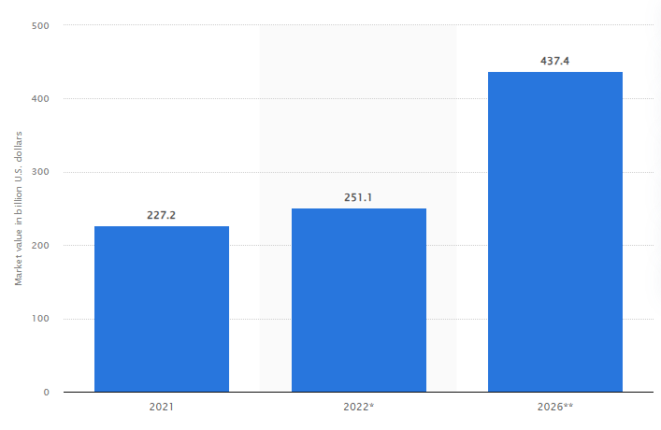
Figure 2: Global organic food market value in 2021 & 2026
(Source: Shahbandeh, 2022)
Accordingly, when we consider the generally favourable market trends and representativeness of consumer behaviour data shown in this case study then it is definitely evident that EcoBite Café’s unique position on as being some kind a beneficial team leader by using both material resources along with knowledge-based ones might be seen especially advantageous to unlike any competitors. This approach, therefore not only responds to the increasing need for environmentally sound and attractive dining opportunities but also helps positively towards conservation of nature as well as promotion of community health.
Conclusion
EcoBite Café represents, as a unique refreshing idea of the hospitality industry an interesting setting with contemporary coffee shop appeal along with environmentally conscious approach. Its US preposition is the promotion of an eco-friendly ethos not only as a principle for doing business but also as community integral. Our café is more than just a restaurant, but it evolves as an international representatives of being green and about healthy life. Specifically, the careful application of zero waste policies, renewable energy usage and operate in an ecologically responsible way based on sustainable supply chain set EcoBite Café apart from other cafes as eco-friendly consumption continues to gain momentum.
The sustainability of this business model is also reflected in the pervasiveness of a social trend towards more sustainable and healthy preferences. In the current time, where buyers believe their every purchase is a reflection of either fulfilling or abandonment of one’s own values and so choose to redirect funds towards projects that replicate them EcoBite Café showcases how profits aligned with sustainability are possible. Our method does not only take advantage of emerging market for environmentally conscious customers but also paves a bit that the developing hotels should walk. Eco Bite provides a green café that would not only flourish under as an angel business but to revolutionize the culinary world towards sustainability which is hereby deemed essential.

Part 2: Personal Entrepreneurial Reflection

Introduction to Reflection
Through my entrepreneur journey, and especially in finding the EcoBite Café idea for implementation are where those two most relevant elements of passion towards sustainability and career aspirations to start started intersecting as one. Having Gibbs reflective cycle in mind, this reflection gives me a chance to think retrospectively about my entrepreneurial personality traits and their harmony with the EcoBite Café concept as well. In addition, I will identify possibilities for further growth throughout these points of analysis. The ability of reflection is indispensable to understand the dynamics involved in my entrepreneurial identity and how it influences business conduct enabling me consistently transform with respect to changes within a dynamic social environment.

Reflection on Entrepreneurial Traits
Gaining insight regarding multiple factors on the journey through entrepreneurship has proven intriguing but most notably, understanding my internal personal attributes and if they coincide with success as an entrepreneur. Results from various entrepreneurial questionnaires and assessments have highlighted several of my key traits: creativity, adaptability and integrity. These are consistent with the paradigms of entrepreneurial mindset proposed by authors such as Chaudhary (2022) who emphasizes ‘effectuation’, a process for innovative problem-solving and scrappiness in entrepreneurship.
My creativity has played a crucial role in coming up with the key components of EcoBite Café — an environmentally friendly menu that is innovative as well. This characteristic aligns with Amabile’s componential theory of creativity that focuses on the importance of intrinsic motivation and domain-relevant skills for supporting creative thinking.
My other core trait resilience has been vital in managing the dynamics of an entrepreneurial life. The ‘entrepreneurial resilience´ is a characteristic that Pambudi and Harjanto (2020), describe as an ability to cope with challenges, continuing improved skill I have developed through the years.
While my ethical compass is a strength, it has also been the very cause of some conflict particularly on decisions pertaining consideration between sustainability and profit. This corresponds to the moral dimension of entrepreneurship defined by Morris et al. in which ethics and other values are usually of high importance for entrepreneurs while making their decisions.

Personal Development Plan
I reflect on my entrepreneurship process which is filled with the understanding of constant personal growth in some aspects like strategic thinking and financial ability. While I am looking forward to making EcoBite Café a sustainable business model, improving my strategic planning skills is essential. These include enhancing my skills in detailed market analysis, as well as long-term business planning. I intend to take strategic management courses and attend workshops on sustainable business practices. Financial expertise is also an area that should grow, as it plays a crucial role in making decisions regarding the balance between sustainability and profit. In order to delve deeper into financial modelling and forecasting, I may consider the use of online courses or mentorship from established hospitality entrepreneur. First, these development areas correspond closely to the needs of EcoBite Café. The betterment of these skills will not only improve my aptitude as an entrepreneur but also the stability and success rate of EcoBite Café, which strengthens its role in being a guide for sustainable and successful business approaches on the hotel industry.

Reference List
Business Model and it’s 9 sections Template| Concepboard. Conceptboard.com,
Available at: https://conceptboard.com/blog/business-model-canvas-free-conceptboard/
Bolton, B. and Thompson, J. (2002), “The entrepreneur in focus: achive your potential”, London: Thomson Learning.
Chaudhary, U., (2022). The Making and Breaking of Social Entrepreneurs. Drexel University.
Foris, D., Crihalmean, N. and Foris, T., (2020). Exploring the environmental practices in hospitality through booking websites and online tourist reviews. Sustainability, 12(24), p.10282.
G, G. Meredith, R, E. Nelson, P, A. Neck, (1982) The practice of Entrepreneurship.
Irbo, M.M. and Mohammed, A.A., (2020). Social media, business capabilities and performance: A review of literature. African Journal of Business Management, 14(9), pp.271-277.
Melović, B., Jocović, M., Dabić, M., Vulić, T.B. and Dudic, B., (2020). The impact of digital transformation and digital marketing on the brand promotion, positioning and electronic business in Montenegro. Technology in Society, 63, p.101425.
Moghayedi, A., Michell, K., Hübner, D., Le Jeune, K. and Massyn, M., (2023). Examine the impact of green methods and technologies on the environmental sustainability of supportive education buildings, perspectives of circular economy and net-zero carbon operation. Facilities.
Nielsen, S.L., Klyver, K., Evald, M.R. And Bager, T. (2012), “Entrepreneurship in Theory and Practice”, Cheltenham: Edward Elgar.
Oxford Dictionary (2020). Oxford: Oxford University Press.
Pambudi, N.A. and Harjanto, B., (2020). Vocational education in Indonesia: History, development, opportunities, and challenges. Children and Youth Services Review, 115, p.105092.
Reid, D.H., Parsons, M.B. and Green, C.W., (2021). The supervisor's guidebook: Evidence-based strategies for promoting work quality and enjoyment among human service staff. Charles C Thomas Publisher.
Read, S., Sarasvathy, S., Dew, N., Wiltbank, R. and Ohlsson, A. (2011), Effectual entrepreneurship”, Abingdon: Routledge.
Saad, A.M., Dulaimi, M. and Zulu, S.L., (2023). Broader use of the Modern Methods of Construction (MMC) in the UK public sector: A Business Model Canvas (BMC) perspective. Journal of Open Innovation: Technology, Market, and Complexity, 9(2), p.100035.
Shahbandeh, M., 2022. Forecast market value of organic food markets worldwide in 2021 to 2026. Statista. Available at: https://www.statista.com/statistics/869052/global-organic-food-and-beverage-market-value/
Wickham, P. A. (2006) Strategic entrepreneurship. Harlow, England: Financial Times Prentice Hall.

Appendix Business Canva Model



