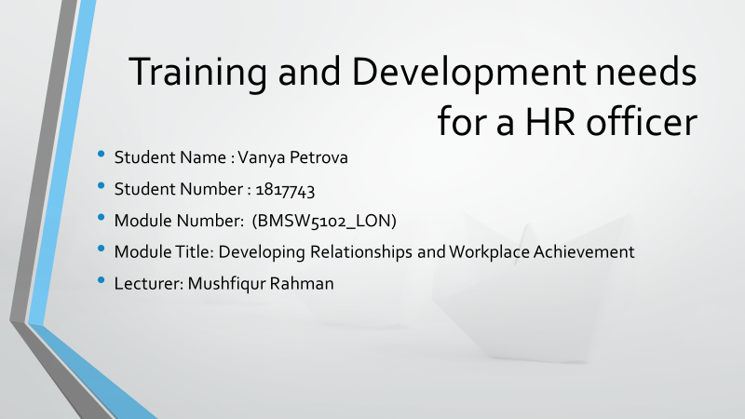

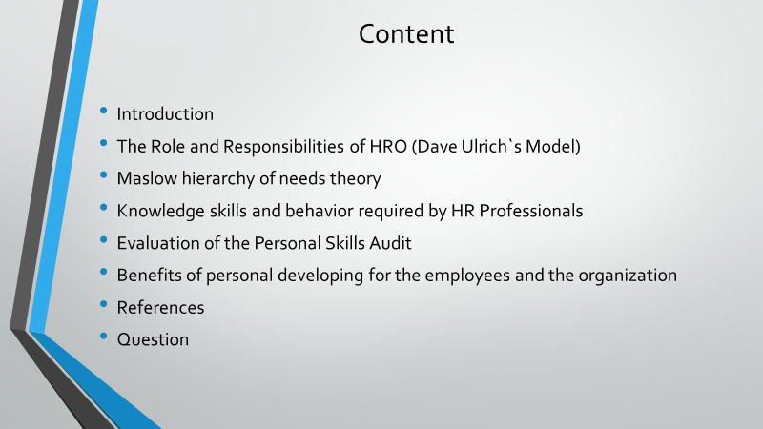

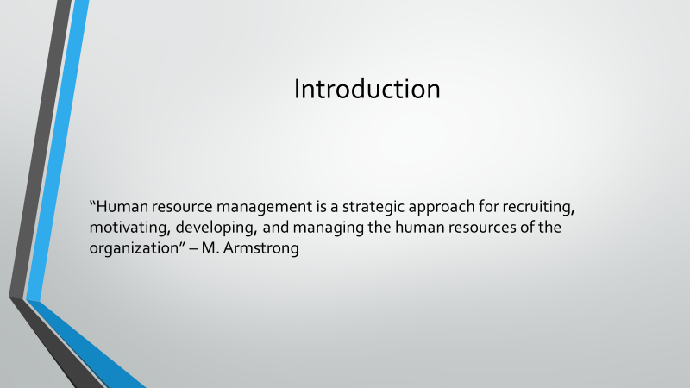

Introduction to HR Department
The development of human resources in organizations is a complex process, combining in a unique way activity at the individual and organizational level, whose results benefit both the individual and the organization, as well as society. This is reflected in the various emphases of the researchers in the analysis and defining the development of human resources in organizations. According to M. Armstrong, “human resource management is a strategic approach for recruiting, motivating, developing, and managing the human resources of the organization.

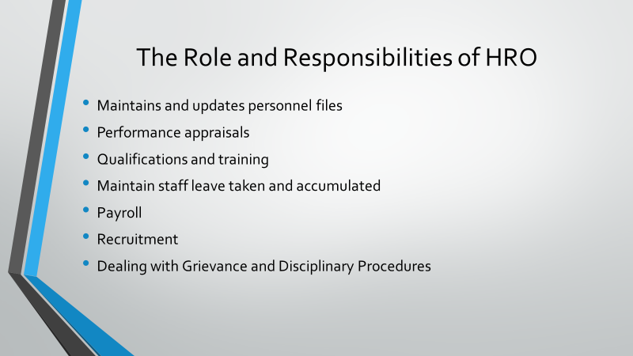

Role of HRO
The Human Resources Officer maintains and updates personnel files, such as information on transfers and promotions, performance appraisals, staff leave taken and accumulated, qualifications and training

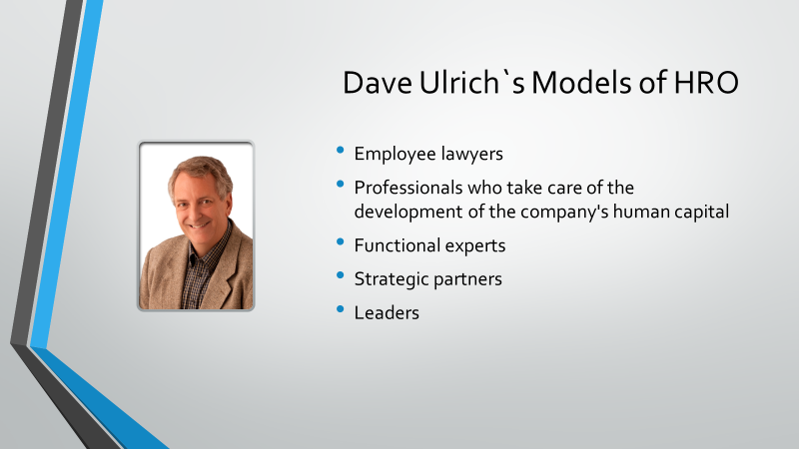

According to Dave Ulrich the HRO are:
- Employee lawyers - defenders of the interests of employees in their employment relationships with employers.
- Professionals who take care of the development of the company's human capital - i.e. training and development of knowledge, skills, and qualities on which the future development of the company's business depends.
- Functional experts - professionals who skillfully perform all their typical management activities for human resources.
- Strategic partners - professionals who partner with all other managers in the company in achieving business goals.
Leaders - professionals who can fully manage human resources management activities.

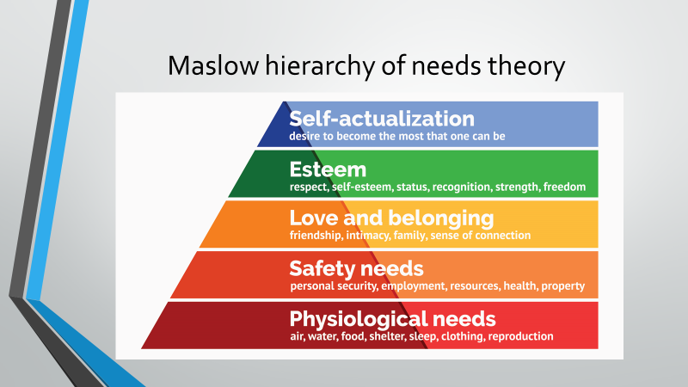

Maslow's Pyramid
At the heart of Maslow's pyramid are physiological needs. Every day each of us feels the need for sleep, food, health. Satisfying these needs allows us to exist and to move to a higher level.
And that is where the existential needs are. They are tied to our security - the need to have a home, to be safe and to carry out our daily activities in peace.
Only when these needs are met do we reach the third level of the pyramid, where our social needs are. Herein lies our need for belonging and affection. Here is the need to be loved by our friends and relatives, as well as to be accepted by the community in which we live.
At the fourth level we find the need for respect. When we have met our needs on the first three levels, we long to achieve a high level of self-esteem and respect from others. It makes us feel valuable and special, it also does not allow despair to overwhelm us.
Upon reaching the highest phase of Maslow's pyramid, one feels the need for self-cultivation. Unlike the previous four, this phase is quite different for different people because it is almost entirely related to personal abilities, talents, and interests.

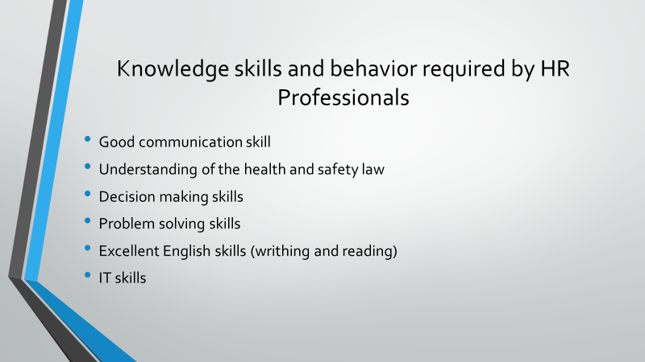

Knowledge skills and behavior required by HR Professionals

To identify the required knowledge skills and behavior I will need to analyze the main responsibilities of a HR officer set in Appendix A
Part of my daily duties will be to work side by side with the department managers and staff, meaning I will need to have a good communication skill and be able to work in a team.
To be able to promote the equality and diversity in the company I will need to know and understand the company culture.
An understanding of the health and safety law for each job position is an essential knowledge as part of the HR department.
The ability to decide is a critical skill as part of the recruiting process. Part of this process is also the skill to organize and carry and interview with all the necessary preparation of job description, job adverts and application forms.
Excellent English skills (writhing and reading) are required as well as understanding the specific terminology used for preparing any documentation needed.
The IT skills required for working with Microsoft Office, Microsoft Excel, and PowerPoint are as important as working with the specific HR software daily.
The understanding of the employment law and implementing the different procedures such as grievances and disciplinary procedures as well as advising the employees on pay, benefits and including promotions is essential. A consistent update and research for any changes and additions to the law is also necessary.

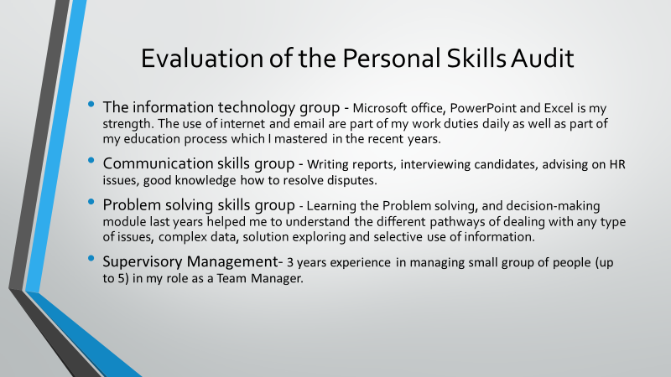
Personal Skills Audit Report
Following the analysis of the required skills and behaviors required across the HR department I have undertaken a Personal Skills Audit (see Appendix B) . They are spread across 4 main categories: Information technology, Communication skills, Problem Solving skills and Supervisory Management.
The information technology group – This is one of my strongest skills categories. The use of Microsoft office and PowerPoint is my strength, especially after the experience I gained during my 1st year in the university. The use of internet and email are part of my work duties daily as well as part of my education process which I mastered in the recent years. I found out that I can use the Excel spreadsheets good on a basic level, but when it comes to do some complex spreadsheets which includes many formulas- I struggle and need some more time to achieve the goal. I have worked with database and specialist HR software, but I was not able to use all the specifications of it, that is why I cannot say I have mastered it.

Communication skills - As an HR assistant I have some experience in the specific skills required for an HR officer. I found out that I am particularly good at writing reports, interviewing candidates, and advising on HR issues. I have only drafted a contract of employment with the employees I was supervising – such as domestic and commercial cleaners. Overall, I have good experience on delivering a training session, but again with only 1 group of employees. During my experience as a Team Manager I had the chance to assist the HR department during a disciplinary procedure and I have good knowledge how to resolve disputes.

Problem solving skills- This is my weakest group of skills compared to the rest as I cannot strongly agree that I have the all necessary experience, even that i am excellent aware of the theory. Learning the Problem solving, and decision-making module last years helped me to understand the different pathways of dealing with any type of issues, complex data, solution exploring and selective use of information.

Supervisory Management- I have 3 years’ experience in managing small group of people (up to 5) in my role as a Team Manager.

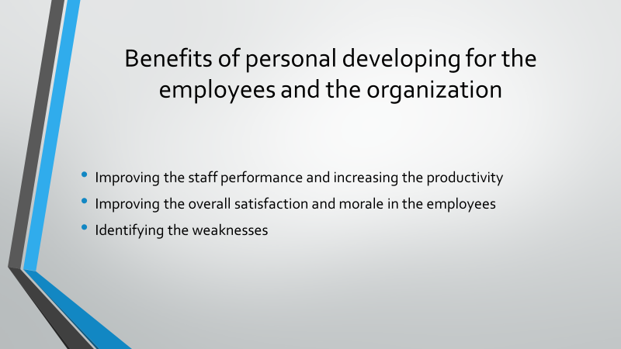

There are many benefits of the personal developing for the employees and the organization, but the most recognized are:
1.Improving the staff performance and increasing the productivity – By consistent investment in the personal development of the individuals the organization benefits from more productivity and keeps the leader position in the industry by having competent employees.

2.Improving the overall satisfaction and morale in the employees- Investing in a good training program will make the employees feeling valued by the company. They will be less likely to leave the company which will reduce the turnover and cost of hiring new individuals.

3. Identifying the weaknesses – A proper training program will identify and strengthen those skills that each employee needs to improve. This will gain more confidence in each individual and will improve their overall productivity.


