The critical analysis of the manner in which one film or television programme from the Celtic nations challenges or reinforces Celtic stereotypes.

The text I have chosen is Grand Slam (Hefin,1978) this comedy defines I think everything that makes us Welsh. Made in Wales in the late seventies it was the brain child of John Hefin the former head of BBC Wales drama and Gwenlyn Parry, both who between them have created and conceived some of the best drama and comedy that the BBC here in Wales produced during the 1970’s and 80’.
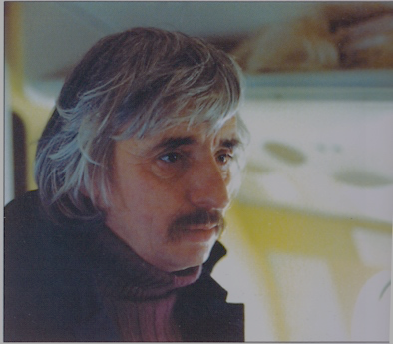
Fig 1. Gwenlyn Parry (1978)
Quinn (2012) explains that, ‘In 1974, John Hefin created the drama Pobol y Cwm (People of the Valley) with the playwright Gwenlyn Parry. Originally broadcast on BBC Wales and subsequently on S4C, almost four decades later the show retains its signature status for the Welsh-language channel and stands as the first to be broadcast five nights a week and the longest-running television soap opera produced by the BBC.’
Hefin and Parry were instrumental in bring this now iconic television programme to our screens here in Wales, and still to this day it’s one of the longest running soap operas on the BBC, Pobol y Cwm (Hefin 1974) which celebrated its fortieth anniversary on the 14th of October 2014.
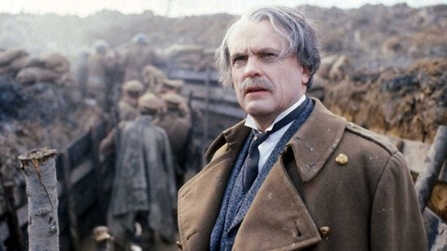
Fig 2. (1981)
Hefin was also responsible for the much acclaimed The Life and Times of David Lloyd George (Hefin 1981) which he produced for the BBC.

The original idea for Grand Slam (1978) couldn’t have been further away from what we now know about this film, it celebrates our love affair with a game of rugby and its players.
Hefin (2007) explains that, ‘William Gwenlyn Parry was from Deiniolen in Gwynedd; he had, among many other things, a huge delight in brass bands, and the aforementioned outline featured the Deiniolen Brass Band in a road movie to Brussels.’

But this idea thankfully was dismissed, and a new suggestion was made by the then assistant head of programmes at BBC Wales, D J Thomas. That maybe the film should revolve around the success that Welsh rugby was experiencing during that time. Hefin (2007) in regard to this suggestion explains that, ‘There was a hasty rewrite and a new outline submitted, this time with rugby players substituted for the brass band...’ from this Grand Slam (1978) was born.

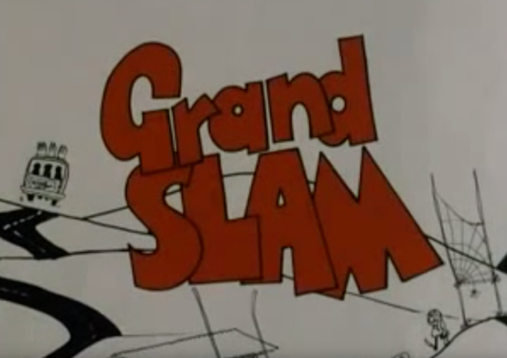
Fig 3. (1978)
This film is a true adventure and a nostalgic look back at the heyday of Welsh rugby, maybe there are some aspects of Grand Slam (1978) that might not be acceptable to today’s younger audience, because of the attitudes and behaviour of the era. This film has to be looked at in perspective and consider the time in which it was made. There are many stereotypical Welsh characters represented in this film, some might even make you squirm a little.
But they were different times and growing up in the 70s I personally have very vivid memories of going to rugby matches during that decade. Living in a town where many Welsh international rugby players were selected from and featured in this film, gives me a better understanding and appreciation of the film and of those times.
Stephens (2012) explains the ‘Hwyl’ (a stirring feeling of emotional motivation and energy) that the Welsh have especially with rugby,
‘Hefin, who wrote the script of Grand Slam with Gwenlyn Parry, first in Welsh and then in English, made the film into one of the iconic images of Welsh life by training a knowing but affectionate eye on the feverish sensibilities of his countrymen whenever the national side is called upon to defend the honour of Wales.’ (Stephens, 2012, p. 1).

It was never the intention of Hefin or Parry to belittle or undermine any of the Welsh characters represented in the film. If anything it reflects Welsh people making fun of other Welsh people in an endearing way and laughing at ourselves. I think we have a right to do that as a nation and as filmmakers here in Wales, but as most people know writing comedy is a serious business and hard work.
The cast themselves are a very interesting line-up of very experienced and somewhat familiar television, film and theatre actors, from within Wales. Except for Marika Rivera, who played the part of the Madam, or as Caradog Lloyd-Evans played by Oscar winner Hugh Griffith refers to as ‘my little butterfly’ she is the only international cast member. Hefin (2007) explains that, ‘...[she] was the daughter of the Brazilian ceramic artist Diego Riviera, and had been brought up in the company of Picasso... This colourful Russian-Mexican was a terrific force in the film.’
The main cast were made up of very familiar faces here in Wales, including Windsor Davies as Mog Jones, Dewi Morris as Glyn Lloyd-Evans, Sion Probert as Maldwyn Pugh and Sharon Morgan as Odette. But the biggest coup was getting Hugh Griffith to play the part of the funeral director Caradog Lloyd-Evans.
Which was no mean feat, Hefin and Parry had to drag themselves off to London to try and persuaded Griffith to take part in was what, a low budget BBC Wales comedy, which was originally only going to be broadcast here in Wales. Fortunately for them and the film he agreed to appear. Hefin (2007) recalls that in their meeting, ‘.... Hugh (it wasn’t Mr Griffith by now) had said, “Yes.” Boy!’

Growing up with characters like Mog Jones, the ex-rugby player, who not only liked a pint, but was a bit of what we used to call back then a womaniser. Is this character a stereotypical Welsh man, yes and there were plenty of men like Mog in the 70’s.

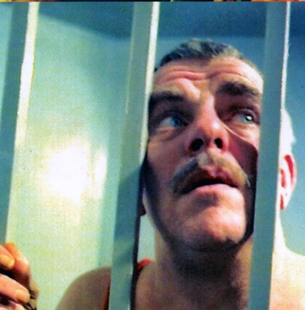
Fig 4. (1978)

Both Hefin and Parry as well as poking fun at this type of character, sympathised with them. Because usually with this type of character, with all their rhetoric, they were lonely people, but with a couple of pints and in the company of men they felt like kings again. And more often than not they dined out on their past glories.
Dewi Morris’s character Glyn Lloyd-Evans was as we would say, a bit of a boy, and it wasn’t too much of a stretch for Morris to play. Maybe a bit of a no good boyo in real life as well as on screen. I’ve met him and had a couple of conventions with him and from personal experience, I’d say he’s a bit of a boy too. So yes the character Glyn Lloyd-Evans represents the typical young hot-blooded slightly suppressed Welsh man aboard and on the loose. Living life to its full, while away from the disapproving gaze of his father Caradog Lloyd-Evans. Proving that maybe the apple doesn’t fall that far from the tree.
Hefin (2007) recalls traits about Morris as, ‘... a unique character; Mr Originality, who can get away with murder. Dewi can tell the filthiest joke in a Vicar’s tea party.... ‘

Maldwyn Novello Pugh played by Sion Probert his character is a typical representation of a gay man in the 70’s. Again I think there was no intention at the time to offend anyone and maybe it brought a different dimension to the story.
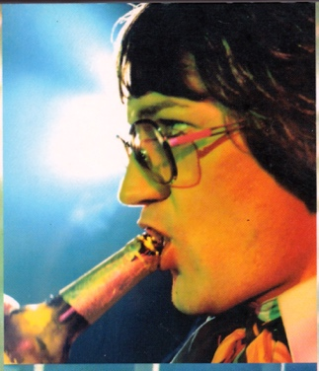
Fig 5. (1978)
Especially when we get to Paris and Mog has to not only share a room with Maldwyn but an also a bed. Which makes this red blooded man’s man and ex-rugby player very uncomfortable. It highlights the misconception and attitude of the time, from men like Mog towards gay men.
There was a positive attitude towards people like the character Maldwyn here in Wales especially in small communities.
Hefin (2007) elaborates on stories told by Sion Probert to the cast of Mr Lollipop M.A. (1978),
‘Sion would regale us with stories of Traquin from Seven Sisters, who was known to say, “When I depart there were only six left”. Traquin was known in his community, not as gay or as a homosexual, but as one was good to his mother.’ (Hefin 2007, p.16).
People like Traquin were never ridiculed or made fun of, they were simply excepted for who they were. Maybe in some cases there was a bit of name-calling but more often than not, that was as far as it went. I also think that as a society back then we were far more accepting of people no matter who they were especially in small Welsh communities.
So this again is a positive representation because its Welsh people making fun of ourselves and the surreally situations, we find ourselves in sometimes.
Grand Slam (1978) does reinforce Welsh stereotypes especially to people living outside Wales and maybe inside as well. It does paint a picture that life for the Welsh male during the 70’s revolved around rugby, drinking and women, but it does it in an endearing way while still making fun of those types of characters and the ridiculous situations they find themselves in after a couple of drinks.
As Welsh people and filmmakers we have licence to make films like this, which I think nobody else has.
Word count 1518

Reference List

Hefin, J. (2007) Grand Slam Behind the Scenes of the Classic Film. Talybont: Y Lolfa.

Quinn, M. (2012) John Hefin. Available at: https://www.thestage.co.uk/features/obituaries/2012/john-hefin/
(Accessed 9 January 2019).

Stephens, M. (2012) John Hefin: Film-maker whose work celebrated Wales and its people.
Available at: https://www.independent.co.uk/news/obituaries/john-hefin-film-maker-whose-work-celebrated-wales-and-its-people-8382234.html
(Accessed: 9 January 2019).

Image List

Fig 1. Screen Grab, Gwenlyn Parry (1978)

Fig 2. Screen Grab, The Life and Times of David Lloyd George (Hefin 1981)

Fig 2. Screen Grab, Grand Slam (Hefin 1978)

Fig 5. Screen Grab, Grand Slam (Hefin 1978)

