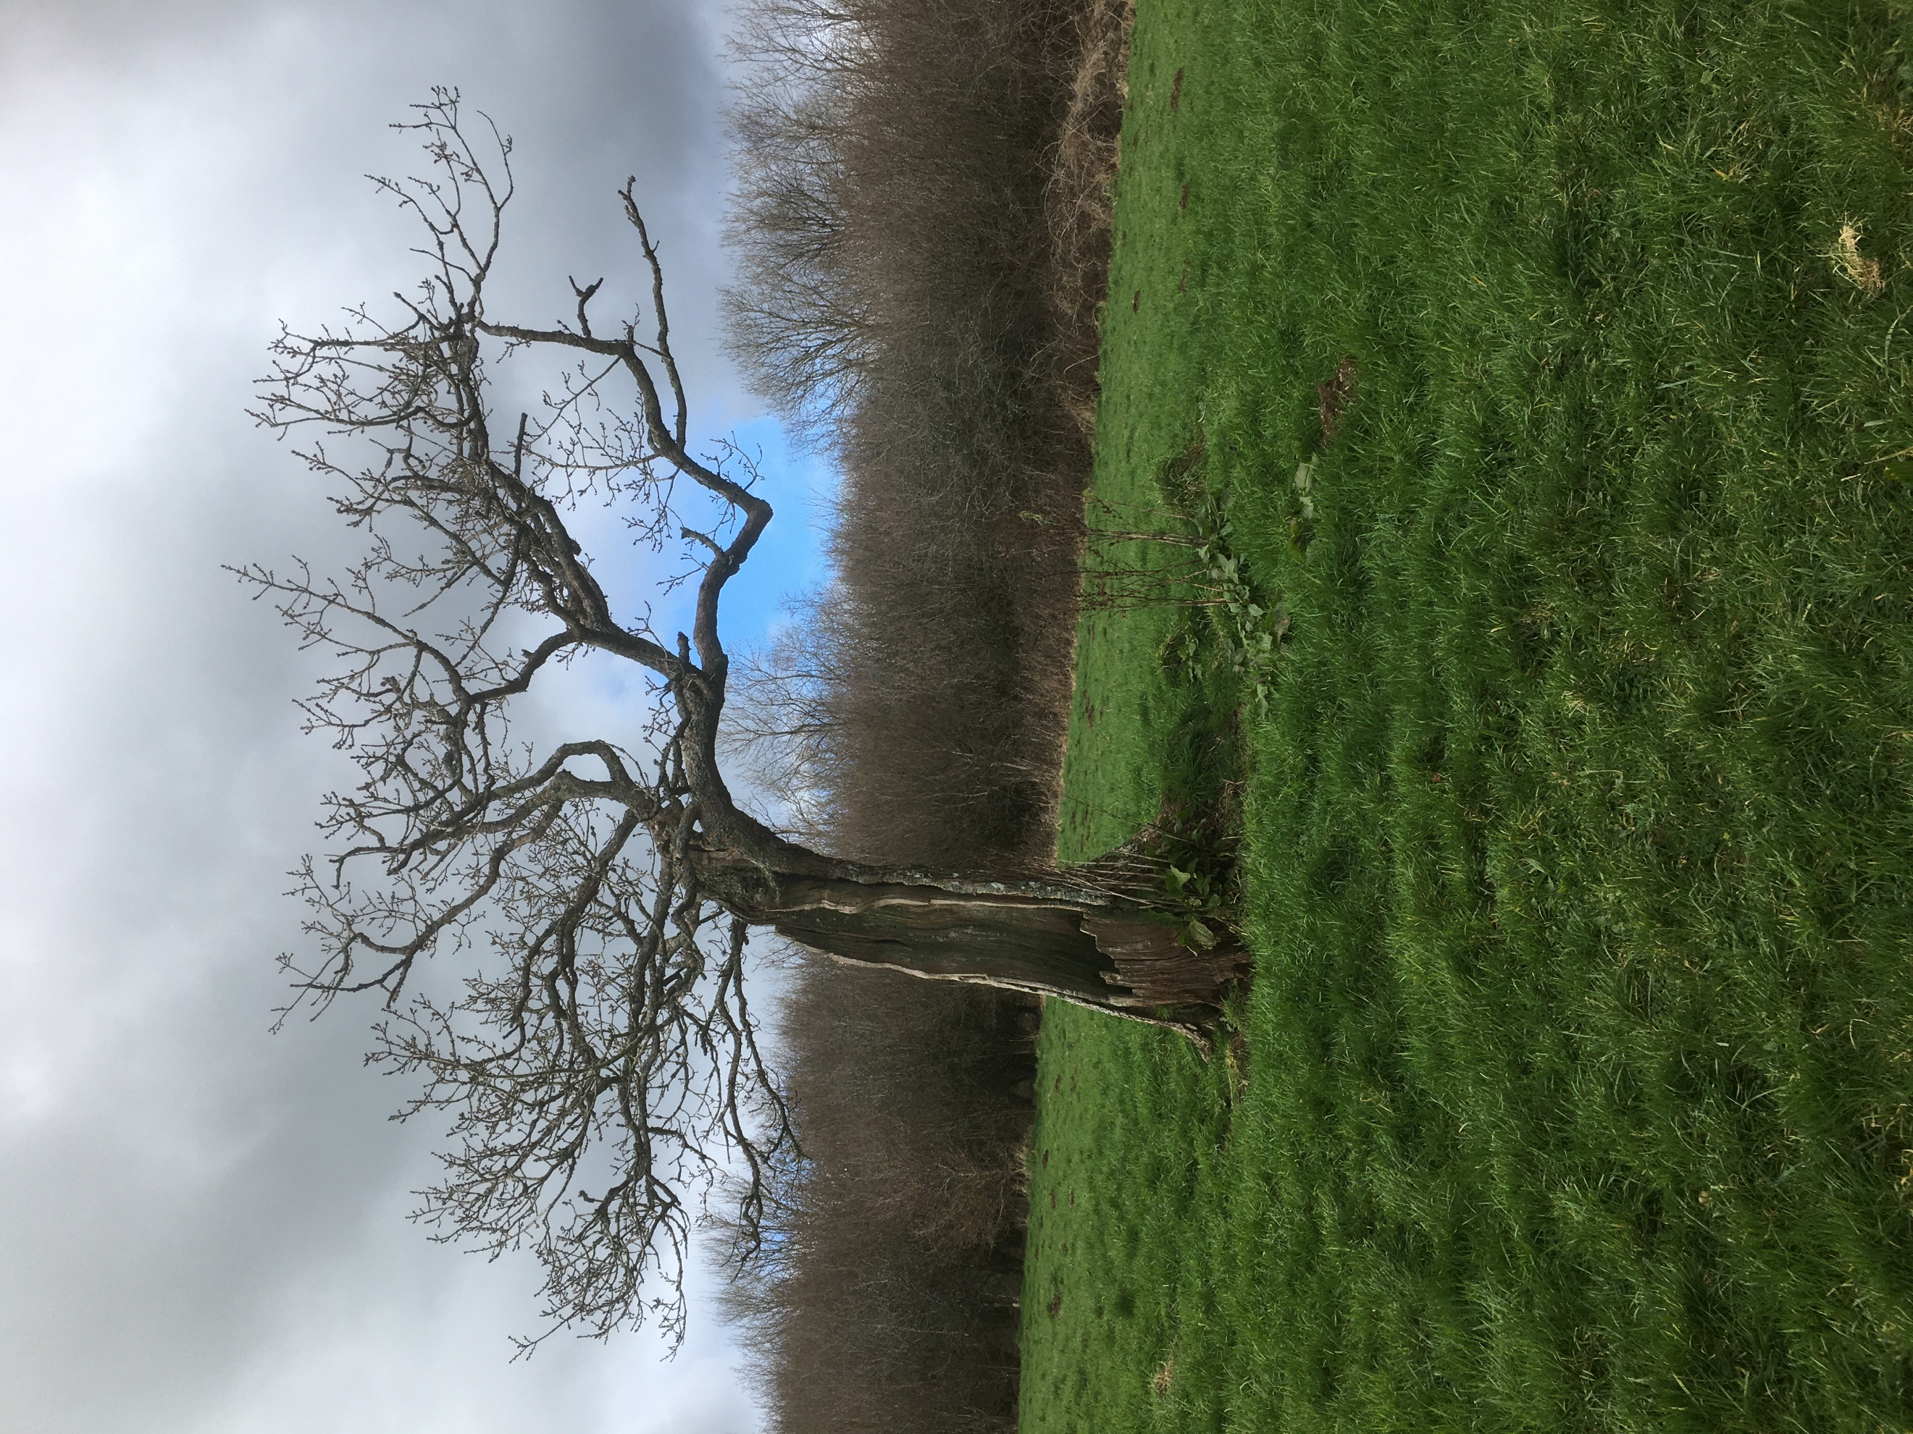  Site specific management plan for green castle woods wwwoods  Photo taken by author | Habitat Management and Building Resilience  Module ACNB6004  Helen Peake (2100410)

Contents
List of figures 2
Summary 3
Physical conditions 7
Legal status 7
Biological conditions 8
Socio-economic conditions 9
Previous and on-going conservation activities 9
Site assessment 10
Objectives for next 5 years: 21
Management Plan 22
References 26
APPENDIX A – Priority species within area of Green Castle Woods 29
APPENDIX B – Phase 1 Habitat Survey Map 31

List of figures
Figure 1: Boundary and compartments of Green Castle Woods (Woodland Trust Wales, 2024) 4
Figure 2: OS Map of Green Castle Woods to show topography 5
Figure 3: Google maps satellite image of Woods 6

Habitat Management Plan for Green Castle Woods

Summary
Green Castle Woods is one of a limited number of woods in this area of Carmarthenshire open to the public, providing a valuable amenity to visitors. Surrounded predominantly by agricultural land it is a valuable site in terms of habitat.
The overall aim of management is to conserve the Ancient Semi Natural Woodland and unimproved grasslands, while providing the conditions for more recent plantations to mature, resulting in the connectivity of a matrix of habitats for wildlife.
Key management actions include minimal intervention where appropriate, creating a mix of habitats to maintain and enhance biodiversity of flora and fauna, on-going site assessment and encouraging active participation of the public in the management of the woodland.

Site Details
Location: | Llangain, approximately 3 miles from Carmarthen
Tenure: | Owned and managed by the Woodland Trust
Grid Reference: | SN39391167, Explorer 178, OS Landranger 159
Area: | 50.51 hectares (124.81 acres)
Altitude: | Maximum 70m Minimum 10m
Aspect: | NE
(Woodland Trust, 2005)
Maps are provided to show the compartmentalisation of the woods (Figure 1), the topography and historic names (Figure 2) and a satellite image of the area (Figure 3).
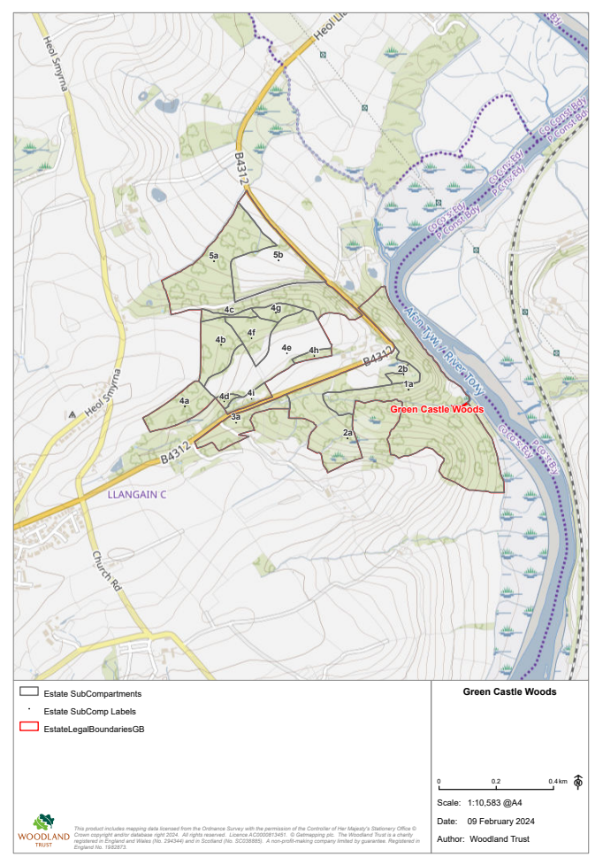
Figure 1: Boundary and compartments of Green Castle Woods (Woodland Trust Wales, 2024)
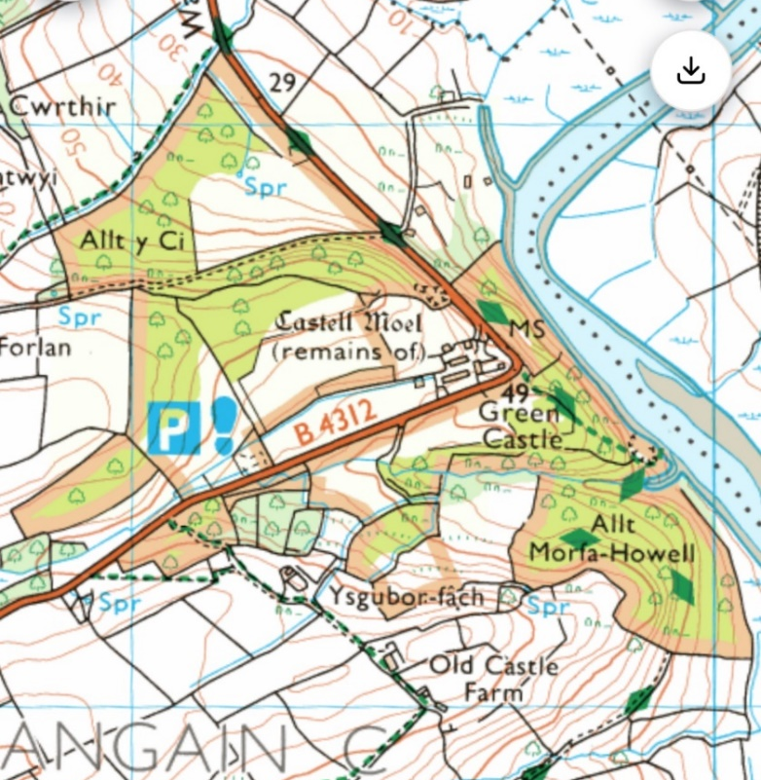
Figure 2: OS Map of Green Castle Woods to show topography

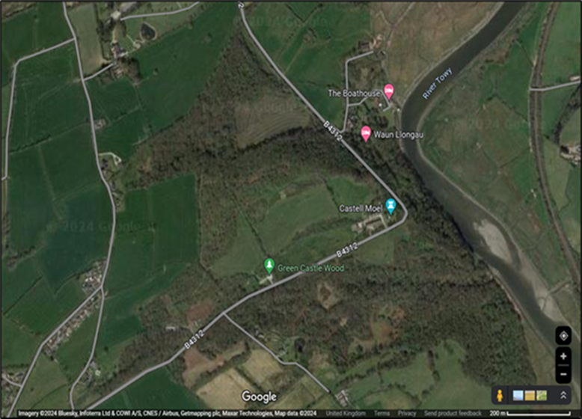
Figure 3: Google maps satellite image of Woods

Physical conditions
The ‘Green Castle’ is located approximately 50m above the Afon Tywi atop a steep sided gorge which was cut through Old Red Sandstone by the river.
The woodland is bisected by the B4312 which creates a disconnect between the two sections of land and a risk to any animals that attempt to cross the road.
The ASNW tends to be on the sloping areas, while plantation woods are on flatter or gently sloping land that would previously have been pasture. The land is generally heavy, clay soil, often wet, although some areas such as Allt y Ci woodland are sufficiently well draining to support Fagus sylvatica (beech).
Average annual temperature in Carmarthen is 9.8 °C (49.7 °F) with annual rainfall of 1344 mm ( 52.9 inches) (Climate Data, 2024). Water-courses within the woodlands flow through surrounding agricultural land to join the Tywi which is subject to the European Water Framework Directive (European Commission, n.d.).
The Woodland Trust has designated the woodland as a category ‘A’ high public usage site (Woodland Trust, n.d. a) accompanied by obligations to ensure access is appropriately maintained. This implies a compromise with regard to the level to which the habitat might be inhabited by species sensitive to human disturbance.

Legal status
While not subject to designation, the woodland borders the Afon Tywi (River Towy) which is a Special Area of Conservation under EC Directive on the Conservation of Natural Habitats of Wild Fauna and Flora (92/43/EEC) and a SSSI under the Wildlife & Countryside Act 1981 (as amended by the Countryside & Rights of Way Act 2000).
There are species within the woods that are protected through the Natural Environment and Rural Communities Act 2006.
Green Castle Woods falls within the remit of the Carmarthenshire Local Biodiversity Action Plan (Carmarthenshire Biodiversity Partnership, 2015) and is classed as a lowland mixed deciduous woodland.
Welsh government policy is concerned with management of woodlands, particularly in view of climate change, in its strategy document Woodlands for Wales (Welsh Government, 2018), currently under review.

Biological conditions
Green Castle Woods is made up of three previously fragmented ancient semi-natural woodlands (ASNW), now joined by more recently planted woodland, grassland meadows and hedgerows, forming a mosaic of habitats with corresponding flora and fauna. The woodland is surrounded by agricultural land however its proximity to the Afon Tywi and its floodplain provides opportunities for visiting species to utilise the habitat. It is possible to access the riverside through the woods, but is steep-sided and not sign-posted, reducing safety risks and possible impact on wildlife associated with the river, for example Lutra lutra (otter) (NBN, 2024).
The NBN Atlas Wales (National Biodiversity Network, 2024) provides records of flora and fauna in the area, including data from the Phase 2 Lowland Grassland Survey of Wales 1995 which assists with the classification of the woodland and pasture, and includes species such as Succisa pretensis (Devil’s Bit Scabious), important for pollinators such as Euphydryas aurinia (Marsh fritillary) though not recorded here. Dragon flies such as Sympetrum striolatum (Common darter) and Anax imperator (Emperor dragonfly) have also been recorded.
Examination of the West Wales Biodiversity Information Service records revealed entries for 702 non-sensitive species since 1972. This included 103 species of bryophyte and 226 invertebrates, the majority of which were moths and butterflies. Many species are included within Priority categories 1, 2 and 3, see Appendix A.
Species such as Pipistrelle sp. (Pipistrelle bats), known to have been recorded in the vicinity (Plume and Lucas, 2024), Meles meles (badger) and Tyto alba (Barn Owl), would be considered sensitive and not recorded on the Local Environmental Records Centre Wales system (LERC, n.d.). Therefore a lack of records does not necessarily indicate absence.
The woodland, provides shelter and food such as berries, seeds, pollen and nectar for a variety of species, and with its wet climate, streams and springs, provides a moist environment conducive to species such as bryophytes. Marshy, unimproved pasture also provides habitat for specific flora, amphibians, invertebrates, reptiles and birds.
A diverse range of species, has been shown to be present, albeit from dated records. Species are interdependent, for example, pollinators and insects such as butterflies and moths, may require different plants at different stages of their lifecycle. Cirsium palustre (Marsh thistle), rich in pollen and recorded in compartment 5b, is known to be food for 80 species of bee, fly and butterfly,( including Vanessa cardui (Painted lady), also recorded. Merckx, et al. (2014) suggest the need for woodland that features both dark, moist conditions and lighter, outer edges to accommodate the needs of different species of Lepidoptera macro-moths, which have been recorded in high numbers here previously. In turn, bats, small mammals and birds will feed on the insects.

Socio-economic conditions
Green Castle Woods is of historical interest. It was part of the Green Castle Estate in the nineteenth century, with the remains of the ‘Green Castle’ ruins first recorded in 1435. There was an anchorage below Allt y Moel woods where goods would be offloaded from ships to make the remaining journey up the Tywi to Carmarthen (Williams, 2007), and the remains of a quarry can be seen (Cope, 1982).
Farmland was predominantly pasture, occupied by small tenant farmers using basic techniques well into the nineteenth century (Williams, 2007). Many fields and hedgerows form the pattern shown on the 1776 tithe map (Woodland Trust, n.d. a). Coppicing has previously been practiced but has long been discontinued, with no potential local market currently (Woodland Trust, n.d. a).
The woodland is a popular recreational area, frequented by walkers and dog-owners. It has open access to the public, including a section of the Wales Coast Path. With views over the Tywi Valley it contributes to the health and well-being of the local and visiting population.
The woodlands provide an opportunity to increase the awareness of visitors regarding threats to nature and biodiversity, risks posed by climate change.

Previous and on-going conservation activities
Green Castle Woods has been owned and managed by the Woodland Trust since 1993, prior to which it belonged to Green Castle Farm. Conservation activities have been in keeping with their Woodland Management Approach detailed on the Trust website. The most recent Management Plan for Green Castle Woods was for 2013-18 and now requires review.
A volunteer group closely associated with the Woods since 1994 has since disbanded.
Stakeholders include neighbouring properties which include agricultural interests, the owners of Green Castle Farm, visitors to the woodland, NGO bodies such as Carmarthenshire Nature Partnership (Carmarthenshire County Council, 2024), and statutory bodies such as Carmarthenshire County Council and Natural Resources Wales.

Site assessment

To review and establish the Management Plan for the next five years, a preliminary Phase 1 Habitat Survey (JNCC, 2010) was conducted on the site. This consisted of examination of previous biological records and walking all the public access footpaths within the woodland during the first week of March 2024 by the author.
For ease of description, the compartmentalisation of the site by the Trust has been utilised in the Phase 1 Map (see Appendix B). Features of interest, requiring management and updates are highlighted as target notes. All photos taken by author.

Compartment  and target note grid reference | Description | Other species of note from Woodland Trust (2005), other records referenced | Author’s observations from site assessment and issues for management
1a  SN 397164 | Ancient oak (sessile) woodland : Allt y Morfa Howell | High forest- Quercus petraea (sessile oak) and Betula pubescens (Downy birch), coppiced Alnus (alder), multi-age Fraxinus (ash), Acer pseudoplatanus (sycamore), Fagus sylvatica (beech), Prunus avium (wild cherry) Ilex (Holly) | Areas of steep sided valley, wet ground  Ample dead wood available providing habitat, food, and openings in canopy for regenerative growth of new saplings.  Corylus (hazel) observed throughout woodlands. Evidence of birds and mice having eaten nuts, but no evidence of Muscardinus avellanarius (dormouse) although there appear to be areas that may provide suitable habitat (Bright, et. al.,2006).  Well-formed structure of canopy, understorey, shrubs and field layer with indicator plants beginning to flower. a Species rich ground layer including leaf litter, frequently supporting fungi and moisture sensitive bryophytes.  Observed: Allium ursinium (wild garlic), Lonicera (honeysuckle), Anemoides nemorosa (wood anemone)  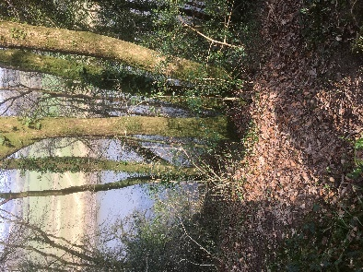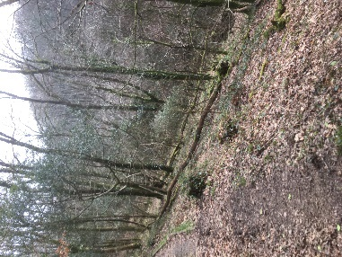  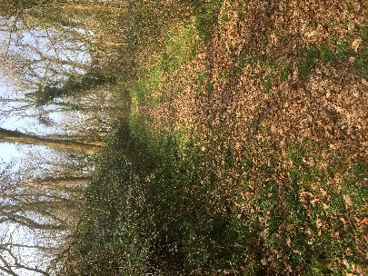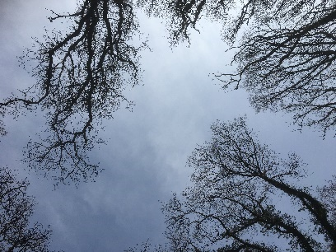
2a  SN 394164 | Area of pasture, subject to cattle grazing. Not ploughed within living memory and considered of botanical interest (Woodland Trust, n.d. a). Parkland planting of fruit trees in 2012 for wood pasture. Infill planting of native woodland 2013. | Succisa pratensis (Devil’s bit scabious)  Leontodon saxatilis, (Lesser Hawkbit (NBN, 2024) | Approached through woodland via open area where social gathering can take place. Appears to be evidence of historical coppicing. Streams and wet ground, open grassland. Some parkland trees have died. Areas of bracken and bramble encroachment. Unable to walk the full length of the field into lower fields as inaccessible due to natural succession, covered in broadleaf woodland and scrub. Propose clearance through scrub to access and confirm if any parts of fields can be returned to unimproved grassland.  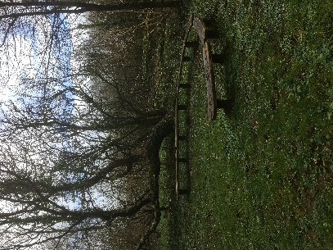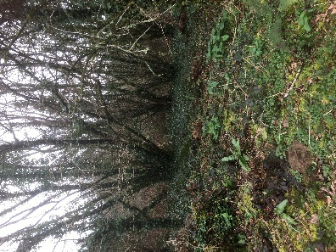  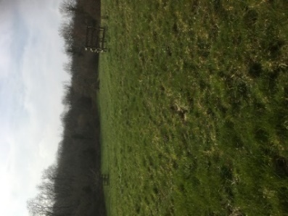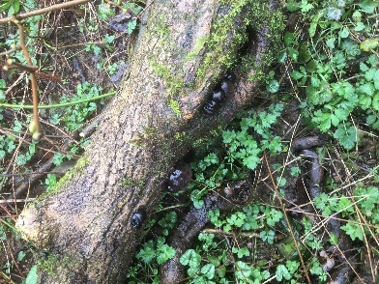  Observed: Ranunculus acris (Meadow buttercup), R. ficaria (Lesser celandine), Rumex acutus (Hybrid dock), Dadina concentrica (King Alfred’s cakes) (bottom right above)  Owl box at SN395164
2b  SN 396165 | Mixed broadleaf planted 1996 and 2013 | Rosa canina (Dogrose), Cornus (dogwood), Corylus (hazel), Acer campestre (field maple), Fraxinus (ash), Prunus avium (wild cherry), Quercus robur (pedunculate oak), Sorbus aucuparia (rowan), Euonymus europeaeus (spindle) | Surrounded by encroaching bramble
3a  SN 393163 | Ancient Quercus petraea (sessile oak) woodland: Allt Cwarre Coch. Secondary woodland in northern section. | Fagus sylvatica (Beech), Fraxinus (ash) – high forest | Steep sided in places.  See 1a – Hedera helix and hibernica (ivy) to be found covering many trees providing nectar, fruit, pollen and shelter for insects, pollinators, bats, birds and other small animals (Woodland Trust, n.d. b)  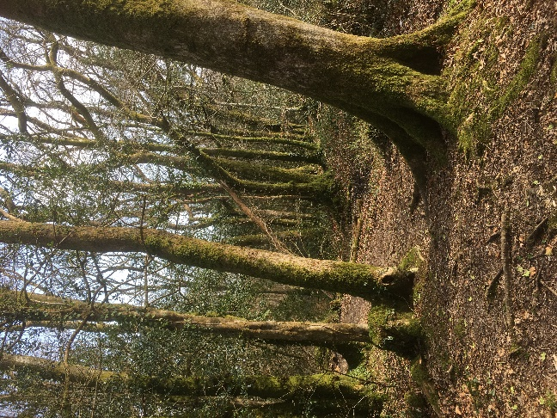  Tributaries joining main watercourse flowing through the woodland – water quality appears to differ aesthetically between streams  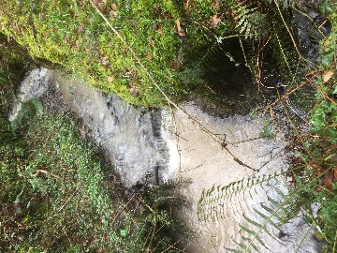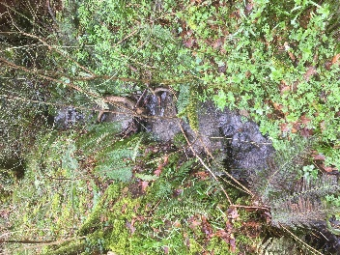  Observed ground flora including Arum maculatum (Lords and Ladies) and Chrysosplenium oppositifolium (Golden saxifrage)  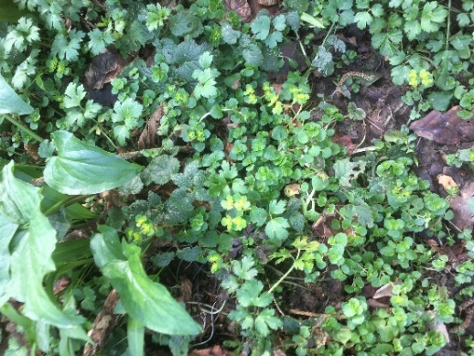
4a  SN 389163 | Previous pasture planted as Quercus-Fraxinus (oak-ash), 1995 | Sorbus aucuparia (rowan), Acer campestre (field maple), Prunus avium (wild cherry), Quercus petraea (sessile oak), Fraxinus (ash) | Planted woodland, central area transitioning from wet, marshy land, rushes, scrub and encroaching Rubus fruticosus (bramble)  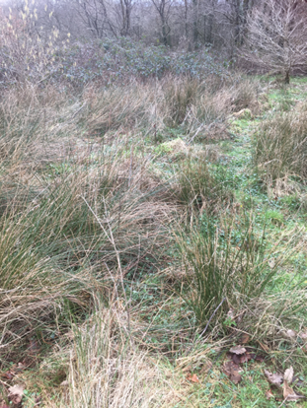  Observed Oryctolagus cuniculus (rabbit) droppings and tracks into the undergrowth. Managed population provides grazing and food source for larger mammals such as Vulpes vulpes (fox) and Mustela putorius (Polecat)  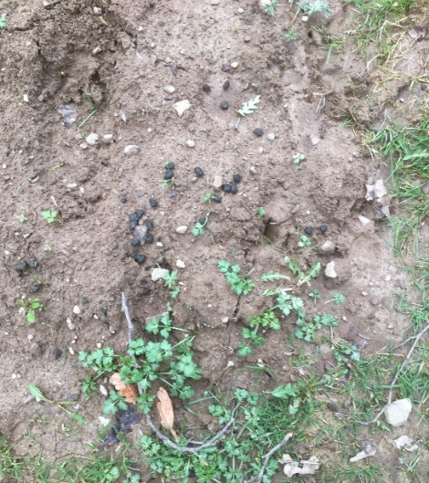
4b  SN 390166 | Previously pasture planted with oak (sessile) and ash 1995 | Betula pubescens (Downy birch), Fraxinus (ash), Sorbus aucuparia (rowan) | Hedgerows adjoining farmland overgrown and in poor condition. Mainly earth bank with trees and shrubs, poor species diversity. Wire fencing and rotten posts have been pushed over by fallen branches. Not stock proof and poor wildlife corridor (People’s Trust For Endangered Species, 2024)  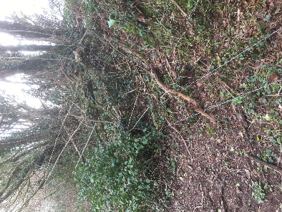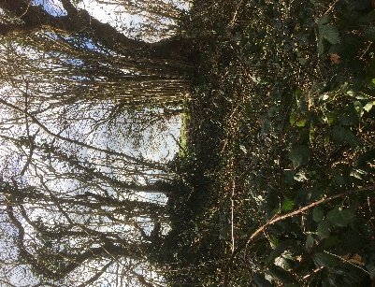  Some rides have overhanging trees which will overshadow impacting light-demanding flora and subsequently insects, and species that feed on them. However, might be conducive to Hyacinthoides non-scripta (bluebells) that are growing adjacent to old hedgerows, and small mammals may be able to use connecting trees to cross rides. Some rides are edged with Prunus spinosa (blackthorn) a food source for larvae of butterflies such as Thecla betulae (Brown hairstreak), though not recorded here.  Other rides are open with soft edges, some are East-West facing and ideal for warmth/sun loving plants, insects and reptiles.  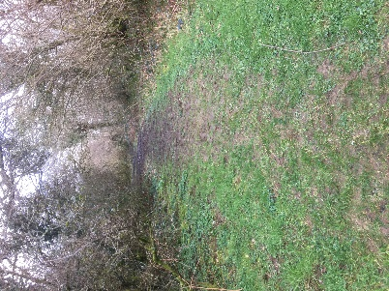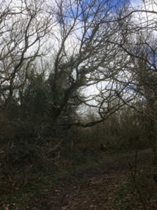  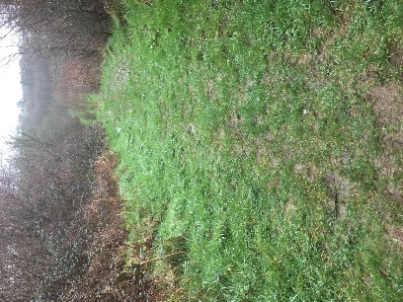
4c  SN 390167 | Quercus sp. (Oak) – former pasture, since 1995 natural regeneration encouraged
4d  SN 391164 | Former pasture planted as Quercus sp. - Fraxinus (oak-ash) 1995 | Sorbus aucuparia (rowan)
4e  SN 393166  SN 392166 | Neutral grassland, pasture fields – managed for hay/grazing, not of botanical interest | Native broadleaf parkland trees | There appears to be additional areas planted with broadleaf. Some parkland trees have failed.  Open glade at SN393166 – possible site of old Castell Moel (see figure 2)  Marshy area dominated by Juncus sp. Indicated on map as WS (water source) in a natural depression on level area of gently sloping land looking up towards SN393166.  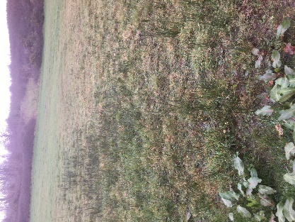
4f  SN 391166 | Former pasture – planted as Quercus petraea- Fraxinus (sessile oak-ash 1995) | Broad leaf, Sorbus aucuparia (rowan), Betula pendula (silver birch) | See above regarding rides. Field layer currently grass and leaf litter
4g  SN 393167 | Former pasture – planted as Quercus sp.-Betula pubescens (oak-birch) 1995 |  | 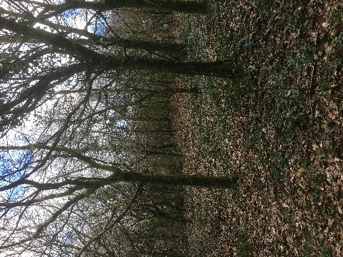  Some areas adjacent to ASNW displaying indicator species such as H. non-scripta (blue-bell).
4h | Mixed native shrubs to thicken hedgerows 1995 |  | Not visited
4i  SN 391164 | Oak (sessile) – circa 1900, high forest – around car park/picnic area | Coppiced Fraxinus (ash) and alnus (alder). | Heavy footfall and vehicle use. Dog fouling – issue throughout woodland
5a  SN390167 | Ancient woodland : Allt y ci – oak, high forest 1880 | Betula pubescens (Downy birch), Fagus sylvatica (beech), Acer pseudoplatanus (sycamore) high forest, 1920. Alnus (alder) and Fraxinus (ash) coppice, 1920 | Part wet ground, part well-draining  See 1a  Observations below: Old burrowing activity, leaves of H. non-cripta, initial flowering of Anemoides nemorosa (wood anemone), leaves of Hyacinthoides non-scripta (Bluebell), bryophyte/fungi  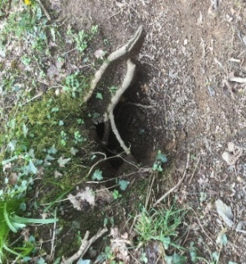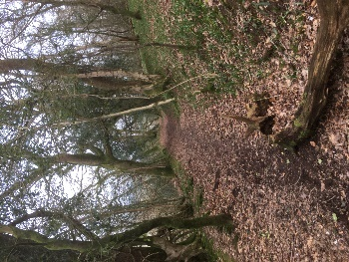  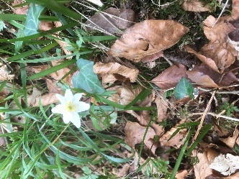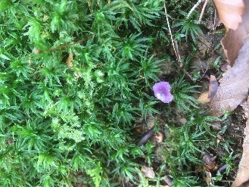
5b  SN 391168 | Neutral grassland, hay field, unimproved, botanically of interest, cut for hay | Viola palustris (Marsh violet)  Sphagnum recurvum  Filipendula ulmaria (Meadowsweet)  Holcus lanatus (Yorkshire fog)  Juncus effusus (soft rush)  Luzula pallescens (Fen woodrush)  Caramine pratensis (Cuckooflower)  (NBN, 2024) | Lower section marshy wet ground  Upper section encroaching pteridium aquilinum (bracken)  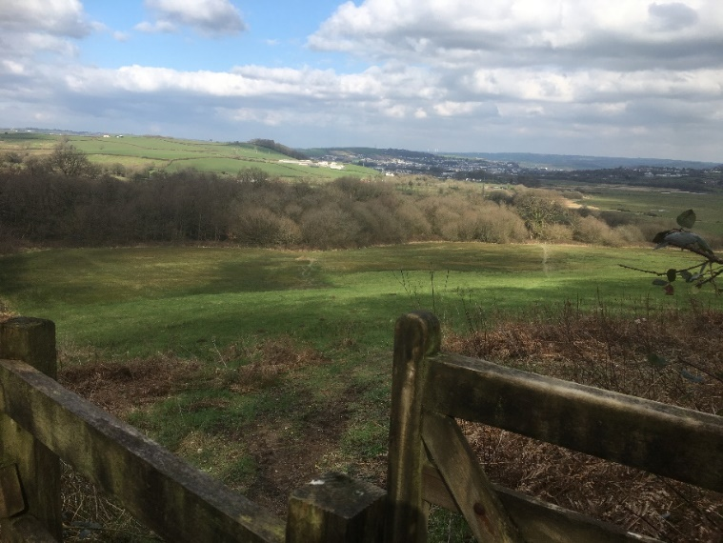

Objectives for next 5 years:
Green Castle Woods is of ecological importance due to the scarcity of ASNW and unimproved grassland in this area. This matrix of habitats provides the conditions and food sources required for a an assemblage of a diverse range of species. This Management Plan aims to:
- Manage the ASNW, newer native woodland, hedgerows ,and unimproved pasture, with the long term aim of creating resilient, connected, mature habitat with a structure that supports existing species, and increases the biodiversity of species that would normally be found in these habitat types.
- Update and improve recording of species within the woodland.
- Monitor changes within the woodland in relation to changing climate, including timing and abundance of species, apparent stresses in relation to e.g. availability of water/moisture.
- Monitor water quality within the watercourses of the woodland.
- Increase awareness among the public of the benefits of woodland and unimproved/semi-improved pasture.
- Work with stakeholders to increase connectivity with the woodland if the opportunity arises.

Management Plan
Feature for management | Action | When to commence/frequency
Phase 1 Habitat Survey | Complete survey at times of year appropriate to habitat type | Woodlands – spring  Grasslands - summer
Management of Ancient Semi Natural Woodland | Minimal intervention, conducive to birds of prey nesting sites, bats, fungi, and invertebrates (Starr, 2015). Deadwood should only be moved if blocking access or posing risk, otherwise leave on woodland floor to decompose and as food source for saproxylic invertebrates (Fuller and Peterken, 2002).  Non-native Acer pseudoplatanus (sycamore) to be kept at low levels.  Monitor level of erosion of paths and effects on adjacent ground flora – paths may need to be closed or diverted. | Periodically through year  Spring/summer  Ongoing
Management of plantations | Plantations are nearing 30 years old, while some such as ash may have had their first good seed mast - saplings were observed on the site assessment - some such as beech and oak are unlikely to have until 40-50 years or more (Starr, 2015). The aim is to develop high forest through a continuous cover forestry technique whereby woodland with varying species and ages is established. This is conducive to woodland birds, fungi and lichens (Starr, 2015).  Provide bird boxes as deadwood unavailable for cavity nesting birds such as Sitta europaea (nuthatch) and Dendrocopos major (Greater spotted woodpecker).  Confirm reported lack of demand for coppiced wood e.g. for fuel, as this is recommended technique for conservation value (Starr, 2015).  Periodic inspection to confirm if any trees need to be cut down for safety, poor condition or disease. Thinning of sections of the woodland to be carried out as appropriate depending on species, stage of life cycle, condition, and effect on/requirements of surrounding stand. | Annual, and after storms
Management of rides and glades | Rides that have become narrowed and over-shadowed can be widened in stages, allowing more open shrubs and grassy vegetation. Rides can also be ‘scalloped’ at intervals to form glades (Fuller and Peterken, 2002).  Revisit site in summer months to check need for ride-widening. | Winter
Management of grassland of botanical interest | See ‘Recording of species’ below.  Assessment of presence of ground nesting birds required.  Prevent succession of water-loving species such as Salix (willow), or Alnus (alder)  Low intensity cattle-grazing to produce tussocky, variable sward height for different invertebrate preferences, and prevent excessive growth of rushes in wetter areas. Stocking density of 0.4-0.6 LU/ha recommended. Grazing to be carried outside of wetter winter periods to prevent erosion and poaching, and outside of times of flowering species or ground-nesting birds, around early-May to late July. (Irish Native Rare Breeds Society, 2024).  See below for bracken. | Summer
Recording of species | Survey required for up-to-date data to compare with previous surveys to establish if management plan to date is successful and enable monitoring. Complete phase 2 and 3 habitat surveys in compartments 2a and 5b to address presence, frequency and abundance of plant communities (JNCC, 2010).  Lepidoptera survey to compare with previous survey as indicator species for management of site (EMEC Ecology, 2024).  Bryophyte survey – moisture sensitive species requiring closed canopy, indicator of climatic changes  Complete: walk through surveys for birds, mammals (footprint tunnels), evidence of Muscadinus avellanarius ( Hazel dormouse)  reptiles (refugia)  LERC species recording app to be promoted to visitors. | Year 1 – summer (JNCC, 2010)  May – mid-September (EMEC Ecology, 2024)  Autumn to Spring (BBS, 2021)  Ongoing  March to October (Froglife, 2015)  Publicise on notice board and website Year 1
Hedgerows | Hedgerows alongside the B4312 cut annually by highways for safety.  Improve hedgerows within compartment 4b by laying or coppice with infill planting | Between the end of September and end of March while the hedge is dormant (Gov.uk, 2023)
Pteridium aquilinum (bracken) | P. aquilinum is encroaching on grassland and glades, most notably compartments 5b and 2a. Bracken is of conservation value providing shade to woodland flowers and supports birds and butterflies (The Wildlife Trusts, n.d.). However, it could compromise the high botanical value of these compartments. Low intensity grazing may provide sufficient trampling effect to control levels however further measures will be required if unsuccessful, such as cutting or bruising (The Wildlife Trusts, n.d.). For other areas the conservation value of the bracken will need to be assessed before taking action. | For 5b and 2a assess after year of grazing before taking action.  Ongoing for remaining areas
Rubus fruticosus (bramble) | R. fruticosus is valuable for providing protection, food and nectar for small mammals, birds and invertebrates. Also protects young saplings as they grow. If encroaching excessively onto grassland competing with plants of botanical interest cut back periodically before litter changes soil composition. | Annually
Parkland | Compartment 4e – replacement of failed trees with native trees. Area to be left as open space for landscaping, and ‘sacrificial’ area where most dogs are exercised.  Manage by mowing due to access by dogs.  SN 392166 – marshy area in compartment 4e may be appropriate for creating a water body such as a pond that would support amphibians, invertebrates and bird-life. Surround with water-loving tree species such as Salix (willow) and Alnus glutinosa (alder) providing a food source for pollinators, butterflies and moths and seeds for birds.  Feasibility and funding to be confirmed. | Planting of trees in Spring  Mow after 15th July (while not an unimproved field this provides the opportunity for any plants that may have dispersed from other areas to have dropped seed)  Once feasibility and funding confirmed.
Monitoring | Extent of encroaching bracken – fixed point photographs taken in locations where species occurs.  Climate change – evidence of stress due to lack of water/moisture, change in phenology (Ausden,2010)  Water quality –test for excess nitrates and phosphates from neighbouring farmland in stream running through Allt y Morfa Howell to the Tywi  Disease/Invasive Non-native Invasive species (INNS) removal – no issues of note, however Rhododendron ponticum (Rhododendron) has been found in compartment of 5b/5a. | Each summer  Spring to monitor any change to timing of flowering H.non-scripta (bluebell) – consider visitors using LERC  Summer to monitor signs of water stress in trees, bryophytes.  Once a month over 12 month period  Periodic site inspections.
Education, awareness, public engagement | Provide notice board for information– what to look out for, LERC app, campaign to address leaving ‘ dog poo bags’.  Explore interest in reintroduction of volunteer group. | Year 1
General maintenance | Repair damaged infrastructure, particularly where grazing occurs  Remove and dispose of tree protectors that are no longer required. | Ongoing
Stakeholder engagement | Collaborate with neighbouring farmers once outcome of Sustainable Farming Scheme (Welsh Government, 2024) known, with view to connecting land devoted to woodland and conservation | As appropriate
Word count: 3,637

References

Botanic Garden of Wales (n.d.) Marsh Thistle. Available at: https://botanicgarden.wales/living-attractions/marsh-thistle/ (Accessed: 12 March 2024)
Bright, P., Morris, P. and Mitchell-Jones, T. (2006) The dormouse conservation handbook. Available at: https://ptes.org/wp-content/uploads/2014/06/Dormouse-Conservation-Handbook.pdf (Accessed: 18 March 2024)
British Bryological Society (BBS) (2021) When is the best time to record bryophytes? Available at: https://www.britishbryologicalsociety.org.uk/recording/start-recording/#:~:text=When%20is%20the%20best%20time%20to%20record%20bryophytes%3F,up%20and%20become%20harder%20to%20spot%20and%20identify. (Accessed: 17 March 2024)
Carmarthenshire County Council (2024) Carmarthenshire Nature Partnership. Available at: https://www.carmarthenshire.gov.wales/home/council-services/planning/biodiversity/carmarthenshire-nature-partnership/ (Accessed: 12 March 2024)
Carmarthenshire Biodiversity Partnership (2015) Carmarthenshire LBAP Woodland Habitats grouped action plan. Available at: https://www.carmarthenshire.gov.wales/media/3449/woodland_habitats_hap-r.pdf (Accessed: 10 March 2024)
Climate Data (n.d.) Carmarthen Climate. Available at: https://en.climate-data.org/europe/united-kingdom/wales/carmarthen-6749/ (Accessed: 10 March 2024)
Cope, J.C.W. (1982) ‘The Geology of the Llanstephan Peninsula’. in Bassett, M.G. (ed) Geological excursions in Dyfed, south-west Wales. Cardiff: National Museum of Wales
EMEC Ecology (2024) Butterfly, Moth and Dragonfly surveys. Available at: https://emec-ecology.co.uk/surveys/butterfly-moth-and-dragonfly-surveys/ (Accessed: 15 March 2024)
European Commission (n.d.) The Water Framework Directive. Available at: https://environment.ec.europa.eu/topics/water/water-framework-directive_en (Accessed: 12 March 2024)
Froglife (2015) Surveying for reptiles. Available at: https://www.froglife.org/wp-content/uploads/2013/06/Reptile-survey-booklet-3mm-bleed.pdf (Accessed: 17 March 2024)
Fuller, R.J. and Peterken, G.F. (2002) ‘Woodland and Scrub’, in Sutherland, W.J. and Hill, D.A.(eds) Managing Habitats for Conservation. Cambridge: Cambridge University Press
Gov.uk (2023) BN5: Hedgerow laying. Available at: https://www.gov.uk/countryside-stewardship-grants/hedgerow-laying-bn5 (Accessed: 13 march 2023)
Irish Native Rare Breeds Society (2024) Conservation Grazing Stocking Rates and Timing. Available at: https://inrbs.ie/conservation-grazing-stocking-rates-and-timing/#:~:text=In%20general%2C%20there%20are%20several%20situations%20where%20seasonal,active%20growth%20and%20flowering%20period.%20...%20More%20items (Accessed: 13 March 2024)
JNCC (2010) Handbook for Phase 1 habitat survey-a technique for environmental audit. Available at: https://data.jncc.gov.uk/data/9578d07b-e018-4c66-9c1b-47110f14df2a/Handbook-Phase1-HabitatSurvey-Revised-2016.pdf (Accessed: 12 March 2024)
LERC (n.d.) Aderyn: What’s in my Area? Sensitive Species. Available at: https://aderyn.lercwales.org.uk/public/search/results?latlng=&gridref=SN3916 (Accessed: 10 March 2024)
Merckx, T., Feber, R.E., Hoare,D.J., Parsons, M.S. , Kelly, C.J., Bourn, N.A.D., Macdonald, D.W. (2012) ‘Conserving threatened Lepidoptera: Towards an effective woodland management policy in landscapes under intense human land-use’. Biological Conservation 149, pp32-39
National Biodiversity Network (2024) NBN Atlas Wales. Available at: https://wales.nbnatlas.org/ (Accessed: 12 March 2024)
People’s Trust For Endangered Species (2024) Adams Hedgerow Management Scale. Available at: https://hedgerowsurvey.ptes.org/hedge-structures (Accessed: 13 March 2024)
Plume, D. and Lucas, S. (2024) Carmarthenshire Bat Atlas 1970-2023. Available at: https://www.wwbic.org.uk/wp-content/uploads/2024/01/Carmarthenshire-Bat-Atlas-1970-to-2023-Final-Version-2.pdf (Accessed: 10 March 2024)
Starr, C. (2015) Woodland Management-A Practical Guide. Marlborough: The Crowood Press Ltd
The Wildlife Trusts (n.d.) Land Management Toolkit - No.12 Bracken Control. Available at: https://www.gwentwildlife.org/sites/default/files/2020-01/No.12%20Habitat%20Management%20Toolkit%20-%20Bracken%20Control%20FINAL.pdf (Accessed 13 March 2024)
Welsh Government (2018) Woodlands for Wales: Strategy. Available at: https://www.gov.wales/sites/default/files/publications/2018-06/woodlands-for-wales-strategy_0.pdf (Accessed: 13 March 2024)
Welsh Government (2024) Sustainable Farming Scheme. Available at: https://www.gov.wales/sustainable-farming-scheme-consultation (Accessed: 13 March 2024)
Woodland Trust (n.d. a ) Green Castle Woods Management Plan 2013-2018. Available at: https://www.woodlandtrust.org.uk/media/45930/4610-green-castle-woods.pdf (Accessed: 12 March 2024)
Woodland Trust (n.d. b) Ivy. Available at: https://www.woodlandtrust.org.uk/trees-woods-and-wildlife/plants/wild-flowers/ivy/ (Accessed: 15 March 2024)
Woodland Trust (2005) Draft for Consultation: Green Castle Woods Management Plan 2005-2010. Woodland Trust.
Woodland Trust Wales (2024) Pdf document sent by email to Helen Peake, 9 February.
Williams, H. (2007) The Book of Llangain. Somerset: Halsgrove

APPENDIX A – Priority species within area of Green Castle Woods

Category | Taxa | Number of species
Category 1- Priority species with European and UK legal protection, section 7 (Natural Environment and Rural Communities Act 2006 (NERC) species, and UK BAP Priority species | Birds:  Dryobates minor (Lesser Spotted Woodpecker)  Falco tinnunculus (Kestrel)  Passer domesticus (House Sparrow)  Prunella modularis (Dunnock)  Pyrrhula pyrrhula (Bullfinch) | 5
 | Fungi :  Hypocreopsis rhododendri (Hazel Gloves) | 1
 | Invertebrates:  Agrochola lychnidis (Beaded Chestnut)  Allophyes oxyacanthae (Green-brindled Crescent  Anchoscelis helvola (Flounced Chestnut)  Cupido minimus (Small Blue)  Diarsia rubi (Small Square-spot)  Ecliptopera silaceata (Small Phoenix)  Hepialus humuli (Ghost Moth)  Hipparchia semele (Grayling)  Lycia hirtaria (Brindled Beauty)  Meloe violaceus (Violet Oil-beetle)  Perizoma albulata albulata (Grass Rivulet)  Scotopteryx chenopodiata (Shaded Broad-bar)  Spilosoma lutea (Buff Ermine)  Tyria jacobaeae (Cinnabar)  Xanthorhoe ferrugata (Dark-barred Twin-spot Carpet) | 15
 | Mammal:  Mustela putorius (Polecat) | 1
 | Vascular plant:  Hyacinthoides non-scripta (Bluebell) | 1
Category 2 – Species of concern, Global Red List, British Red Data Book, Nationally Rare and Scarce, Welsh Red and Amber Birds and Welsh Vascular Plant Red Data List | Vascular plants:  Brachypodium pinnatum (Heath False-brome)  Calystegia sepium subsp. roseata (Calystegia sepium subsp. Roseata)  Luzula pallescens (Fen Wood-rush) | 3
Category 3 – Local BAP species | Birds | 8
 | Bryophytes | 23
 | Invertebrates | 10
 | Vascular plant | 94

Source: https://aderyn.lercwales.org.uk/public/search/results?latlng=&gridref=SN3916

APPENDIX B – Phase 1 Habitat Survey Map
(Note-irregularity in solid green sections due to shading on original map)


