

A Study of Graph Neural Networks for Path Planning: GNRRT*

by
Jiaxin Zhong

Supervisor: Dr Abida Parveen
Second Marker:

Project submitted as part of the requirements for the award of
M.Sc. Applied Computing

September 2023

Declaration and Form of Consent

DECLARATION

I, Jiaxin Zhong declare that I am the sole author of this Project; that all references cited have been consulted; that I have conducted all work of which this is a record, and that the finished work lies within the prescribed word limits.

This work has not previously been accepted as part of any other degree submission.


Signed: _______________

Date: 13-09-2023

FORM OF CONSENT

I, Jiaxin Zhong hereby consent that my Project, submitted in candidature for the M.Sc. Applied Computing, if successful, may be made available for inter-library loan or photocopying (subject to the law of copyright), and that the title and abstract may be made available to outside organizations.

Signed: _____________________

Date: 13-09-2023

Abstract
Path planning plays a key role in many areas like auto robotic, video game, drones. There have been a lot of development in path planning problems. RRT* is a popular sample-based path planning algorithm. It shows promised performance on dynamic path planning. But it has been drawback by its slow convergence. Graph neural networks (GNNs) can search information and reveal relations of nodes, edges on graphs. This technique has been well studied and a lot of novel approaches have been proposed. Since maps can be represented as graphs, this study proposes a new variant of RRT* called GNRRT* which uses graph neural network to narrow down the area of RRT* searching space, therefore, speed up the convergence of tree expansion. GNN models are trained on datasets that consist of randomly generated maps and optimal path area found by Dijkstra’s Algorithm given two random configurations. The result of GNRRT* shows is outperformed RRT* in many aspects.

Table of Contents
Table of Contents
Declaration and Form of Consent 1
Abstract 2
Table of Contents 3
1. Introduction 5
1.1 Path Planning 6
1.2 Graph Neural Network 8
1.3 Purpose of Research 9
1.4 Dissertation Structure 10
2. Literature Review 11
2.1 Path Planning 11
2.1.1 Dijkstra’s Algorithm 12
2.1.2 A* Algorithm 13
2.1.3 RRT and RRT’s Variants 13
2.1.4 Neural Network Based 16
2.2 Graph Neural Network 17
2.2.1 Graph Convolutional Network 17
2.2.2 GraphSAGE 18
2.2.3 Graph Attention Network 18
3. Methodology 20
3.1 Terminology 20
3.1.1 Problem Formulation 20
3.1.2 Loss Function 21
3.1.3 Activation Function 22
3.1.4 Learning Rate 23
3.1.5 Dropout 23
3.2 Path Planning Algorithms 24
3.2.1 Dijkstra’s Algorithm 24
3.2.2 RRT* 26
3.3 Graph Neural Network 28
3.3.1 Graph Convolutional Network 31
3.3.2 Graph Attention Network 31
3.4 GNRRT* Algorithm 32
4. Design and Implementation 34
4.1 Experiment Environment 34
4.2 Dataset Generation 34
4.3 Performance Measure Method 37
4.4 Graph Neural Network Model Training 39
5. Result and Analysis 41
5.1 Model Evaluation 41
5.1.1 Graph Attention Network 41
5.1.2 MeshSeg Models 46
5.2 GNRRT* Performance 50
6. Conclusion 51
7. Reflection 52
References 54

Introduction
As the raise of many areas like autonomous vehicles, drone, unmanned van, robotics, the techniques of path planning have become more and more important. Path planning is a task that searching a path between a given start point to the given goal point without collisions. It plays a vital role in auto-navigation relative tasks. Many studies have been conducted on path planning. Classic approaches like divide and conquer method, virtual impedance method have shown promise outcomes. Due to the prospectus of Artificial Intelligence, many techniques have been introduced to path planning tasks. Such as convolution neural network, fuzzy logic technique showed high performance on path planning task. The main challenge and difficulty lay in path planning task is dealing with dynamic environment with obstacles.

Graph is a powerful tool for representing many relations and situations in real world. Normally, a graph consists a set of vertices and a set of edges, each vertex represents an individual object and an edge connect a pair of nodes shows the relation between these two nodes. Therefore, extract information and discover patterns on graph become an important topic. Traditional approaches like DeepWalk, Node2Vec have their limitations like lack of ability to aware the attributes of nodes. Some heuristics try to solve those limitations but then show weakness in generalization on new unseen graphs. As artificial neural network become more and more powerful in classification, natural language processing (NLP), clustering task, computer vision. Convolutional neural network (CNN) is famous on image recognition. An image is presented as pixels in 2-dimension in computer. Each pixel has a color depict as three or two channels. For each pixel in an image, convolutional neural network uses a kernel to aggregate information from pixels nearby and then apply a pooling approach to learning the features in those images. Since the presentation of an image can be saw as a graph which takes each pixel as a node and each node connect to neighbor pixels.

Graph neural network (GNN) takes the insight of convolutional neural network, try to discover patterns by aggregate information from one node’s neighbors to form a node’s embedding (node features). Unlike images have a regular dimension which can simply apply a fix size kernel to aggregate information from one pixel’s neighbors, graph structure can be arbitrary which means the number of one node’s neighbors differs. Therefore, graph neural network needed to create a subgraph, also call computational graph, for each node to aggregate information and then learn node features by propagate information. That’s so call graph convolutional neural network (GCN).

In this section, first, the background of path planning and graph neural network was introduced. After that, the purposes of this study were illustrated. The structure of this dissertation was demonstrated at the end of this chapter to show you a whole prospect of this dissertation.

Path Planning
Path planning is a task that searching a non-collision path between two points while considering a number of criteria like weight, cost, distance, safety. [1] Path planning is a crucial problem in automation areas, the performance of path planning not only affect the effectiveness, but also the safety.

There are two types of path planning, global path planning and local path planning. Global path planning is finding a path between two configurations given a fix environment. All information of the map was given in advance and keep constant during path planning. On the other hand, local path planning dealing with path planning in a changing environment, also known as dynamic path planning. The main challenge in path planning is to deal with dynamic environment where obstacles move or change positions. It requires the chosen algorithm has the ability to handle real-time updates and adaptability.

There are several key components of path planning, include map representation, state space, start and goal configuration, algorithm selections. For map representation, the environment in which the agent operates is usually represented in some form of a map. This map contains information about location of obstacles, terrain, road networks and other relevant features. State space defines all possible positions the agent can occupy within the environment. The start point is where the agent starts its journey, and the goal state is where it aims to reach. These states are defined within the state space.

Path planning finds applications in various domains, including robotics (autonomous robots), autonomous vehicles (self-driving cars), aerial drones, video games (NPC navigation), logistics, and even architectural design for designing efficient building layouts.

There are several types of algorithms used for path planning, each with its own strengths, weaknesses, and suitability for different types of environments and requirements. Dijkstra's algorithm is a widely used graph-based algorithm that finds the shortest path in a graph with non-negative edge weights. It guarantees optimality but may be computationally expensive for large graphs. A* is a popular graph search algorithm that combines elements of Dijkstra's algorithm and greedy best-first search. It uses a heuristic to estimate the cost to reach the goal, allowing it to prioritize paths that are likely to be optimal. RRT (Rapidly Exploring Random Trees) [2] is a sampling-based algorithm often used in robotics. It rapidly explores the configuration space by iteratively expanding a tree from the initial state toward the goal, using random samples and connecting them to the existing tree. There are more methods in sampling-based methods and hybrid methods.

The choice of algorithm depends on factors such as the complexity of the environment, the dimensionality of the state space, real-time requirements, computational resources, and specific constraints.

Graph Neural Network
There are some traditional graph algorithms which are fundamental techniques used to analyze and manipulate graphs, which are structures composed of nodes (vertices) connected by edges. Graph algorithms play a crucial role in various fields, including computer science, data science, optimization, and more. Breadth-First Search (BFS) explores a graph layer by layer, starting from a given source node. It visits all neighbors of a node before moving on to their neighbors. BFS is often used to find the shortest path in an unweighted graph and to explore connected components. Depth-First Search (DFS), on the other hand, explores a graph by visiting as far down a branch as possible before backtracking. It's used to traverse and search in graphs, identify cycles, and perform topological sorting. Dijkstra's Algorithm and Floyd-Warshall Algorithm computes the shortest path in weighted graphs where the former cannot handle negative weighs while the latter can.

Graph Neural Networks (GNNs) are a class of machine learning models designed specifically to work with graph-structured data, allowing them to capture complex relationships and dependencies present in the data. While traditional graph algorithms are well-suited for specific tasks and scenarios, GNNs offer several advantages that address some of the weaknesses of traditional algorithms. It is good at feature learning and extraction.

It's important to note that GNNs also have limitations and challenges of their own, such as difficulties with handling very large graphs, sensitivity to graph structure, and the potential for overfitting on small graphs. The choice between using traditional graph algorithms and GNNs depends on the specific problem, the characteristics of the graph data, and the available computational resources. In some cases, a combination of both approaches might yield the best results.

Here are a few classic and foundational GNN models that have contributed to the development of this field. Graph Convolutional Network (GCN) defines a convolutional-like operation on graphs, which combines information from a node's neighbors to update its representation. It's a simple and effective model for node classification tasks. GraphSAGE (Graph Sample and Aggregator) generalizes the idea of graph convolutions by using various aggregation functions (e.g., mean, LSTM) to combine neighborhood information. It enables GNNs to work with different types of graphs and varying neighborhood structures.

In the experiment of this dissertation, a model call Graph Attention Networks (GAT) will be trained to do a node classification task. Unlike GCN and GraphSAGE models which treat each neighbor of nodes with the same weight, GAT give different weights to each neighbor, hence improve the expressive of computational subgraph of nodes.

Purpose of Research
Since graph neural network has shown promised result in many tasks base on graph structure, this study is trying to discover the underlying ability of GNN for grid-base path planning presented as graph.

In this research, an investigation of GNN and Path planning was conducted to fully understand the previous work about path planning using GNN and other artificial intelligence algorithms. Since this study focus on grid-base path planning, an experiment was designed using graph representation on grid-base map and trying use GNN to do a node classification task. In this experiment, GNN models were trained to recognize each node if it was in the path of two configurations in a map.

Another purpose of this research is to test a self-created dataset on graph neural network training. This dataset was formed by maps created with random obstacles and two random points were given as start point and target point as a path planning query.

The differences of graph neural network were compared during the experiment by their performance using relative measures like accuracy, model complexity and so on.

1.4 Dissertation Structure
This dissertation constructs as follow: chapter 1 gives a brief introduction to this dissertation, includes the background knowledge of path planning and graph neural network, the purposes of this study. Chapter 2 is a review of relative literatures on path planning algorithm, graph neural network development. Chapter 3 illustrates the methodologies of Dijkstra’s algorithm, RRT*, graph convolutional network, graph attention network and the novel approach GNRRT* proposed by this study. Chapter 4 demonstrates all setup of the experiment, include datasets detail, hyperparameters of GNNs, performance measurement. Chapter 5 shows the result of the experiment, includes the training result of GNNs models, generalization abilities, and the visualization of RRT* and GNRRT*. Chapter 6 concludes all work in this dissertation and chapter 7 gives some thoughts of reflection on experiment, dissertation writing and problems solving.

2. Literature Review
Path planning is a task that finding a path between two configurations in a given environment without collision and meet the requirement of other criteria. Many approaches have been well studied in the last few decades. Most of those approaches are designed to not just find a simple path but also try to improve their performance by shorten the length of path or alleviate some limitation of other existed methods.

This experiment was inspired by the concept of Rapidly Exploring Random Trees (RRT) algorithm and the power of graph neural network which can manipulate graph structure data sufficiently.

In this chapter, some of literatures of path planning and graph neural network will be introduced. The original idea of the experiment of this dissertation is to create a hybrid algorithm to overcome the limitations in RRT using graph neural network. Hence, some relative development of graph neural network will be introduced in this section to give readers a basic comprehension.

2.1 Path Planning
Path planning, literally, can be categorized as global path planning and local path planning. Local path planning (offline path planning) refers path planning that searching a path in a fixed environment which all information have been given in advance. Classic algorithm for local path planning like Dijkstra’s algorithm, A* algorithm usually used to find the shortest path or lowest cost path in a weighted map. Global path planning (online path planning), on the other hand, dealing with tasks that need to find a path in a changing environment where obstacles or other constrains might differ anytime. The goal of global path planning is to search a sub-optimal path with high efficiency. Global path planning is the main challenge in path planning problem. Many methods have been developed. Rapidly Exploring Random Trees (RRT) is a popular method in sample-based method in global path planning. One worth notice method is called Artificial potential fields (APF) [3] proposed by Khatib in 1986. APF assumes that there is a virtual force which have a repulse force on obstacles and an attractive force to the goal point. Then an agent performs navigation according to these two joint forces. Although APF is easy operated, but it suffers from the problem that it can be stuck in local minima. [4]

2.1.1 Dijkstra’s Algorithm
Dijkstra's algorithm is a classic graph traversal and shortest path-finding algorithm. It was developed by Dutch computer scientist Edsger W. Dijkstra in 1956 and has since become a fundamental tool in graph theory, computer science, and various applications involving network analysis, routing, and transportation planning.

The primary purpose of Dijkstra's algorithm is to find the shortest path from a given source node to all other nodes in a weighted graph with non-negative edge weights. It works for both directed and undirected graphs, as well as graphs with negative cycles. However, it does not handle graphs with negative edge weights that are not part of a negative cycle.

Dijkstra's algorithm guarantees finding the shortest path from the source to any reachable node while maintaining an optimal priority queue. It has a time complexity of O((V + E) * log(V)), where V is the number of nodes and E is the number of edges in the graph. This complexity can be further optimized using advanced data structures like Fibonacci heaps.

Dijkstra's algorithm is commonly used in applications like routing and navigation systems, computer networks, and resource allocation problems where minimizing the cost or distance of travel is crucial.

2.1.2 A* Algorithm
The A* (A-star) algorithm is a popular graph search and pathfinding algorithm that combines elements of Dijkstra's algorithm and greedy best-first search. It was introduced by Peter Hart, Nils Nilsson, and Bertram Raphael in 1968 and has since become widely used in various fields, particularly in robotics, video games, and navigation systems.

A* is designed to find the shortest path from a given source node to a goal node in a weighted graph. It is particularly efficient when used in scenarios where heuristics can provide informed estimates of the remaining cost to the goal. A* maintains a priority queue of nodes to explore, and it selects nodes to expand based on a combination of the actual cost to reach that node (known so far) and a heuristic estimate of the cost to reach the goal from that node.

A* algorithm combines the advantages of Dijkstra's algorithm's optimality and greedy best-first search's efficiency. The quality of the heuristic plays a crucial role in the performance of A*. If the heuristic is admissible (never overestimates the true cost) and consistent (satisfies the triangle inequality), then A* is guaranteed to find the shortest path.

2.1.3 RRT and RRT’s Variants
RRT is a popular algorithm used for motion planning and pathfinding in robotics and autonomous systems. It was introduced by Steven M. LaValle and James J. Kuffner Jr. in 1999 as a way to efficiently explore the configuration space and generate feasible paths for robots and other agents in complex environments.

The RRT algorithm is particularly well-suited for high-dimensional and continuous state spaces. It's used to find feasible paths through obstacles, plan trajectories for robots, and explore complex environments. The basic idea behind RRT is to build a tree structure that grows from an initial configuration towards the desired goal configuration, while avoiding obstacles.

Nevertheless, RRT might not always find the optimal path, and the path quality can depend on factors like the random sampling strategy, step size, and the shape of obstacles. To address this, variations and extensions of RRT, such as RRT* and RRTConnect, have been developed to improve optimality and convergence properties.

RRT* is an extension of the original RRT (Rapidly Exploring Random Trees) algorithm that aims to improve the optimality and convergence properties of the generated paths. It was introduced by Steven M. LaValle and James J. Kuffner Jr. as an enhancement to the basic RRT algorithm. RRT* maintains the core concepts of RRT while adding additional steps to ensure that the generated paths are closer to optimal. The primary goal of RRT* is to find paths that are not only feasible but also close to the optimal path in terms of length. It does so by refining the tree structure through re-wiring and optimizing the connections between nodes. This refinement process leads to a better exploration of the configuration space and a more accurate representation of the optimal path.

However, RRT* is computationally more intensive than the basic RRT due to the additional steps involving rewiring and checking for shorter paths. Despite the added complexity, RRT* and its variations remain popular choices in robotics, motion planning, and autonomous navigation when both feasibility and optimality are important criteria for pathfinding.

The limitation of RRT* on slow convergence make it difficult to apply in many applications that require high efficiency path planning. Many approaches focus on overcome this limitation have been proposed. A. Qureshi et al. [5] proposed a method call P-RRT* which combine APF and RRT* to enhance the speed of convergence of RRT* by guiding the direction of node expanding. Different from guide node exploration, accelerating the process of convergence of RRT* can also enhanced by well design the structure of RRT*.
Jeong et al. [6] proposed Quick-RRT* which uses triangular inequality to improve the process of parent choosing and rewire functions.

Y. Li et al. [7] take the advantages of both P-RRT* and Quick-RRT*, combined these two algorithms and came up with PQ-RRT* which generate a better optimal path than both two original algorithms. In this paper they also proved that PQ-RRT* have the same complexity with P-RRT* and Quick-RRT* theoretically. Fig.1 shows the path planning result of these three algorithms performed on the same 2-d map with the same query where blue objects represent obstacles, red lines represent the expansion of tree and green line is the final path.

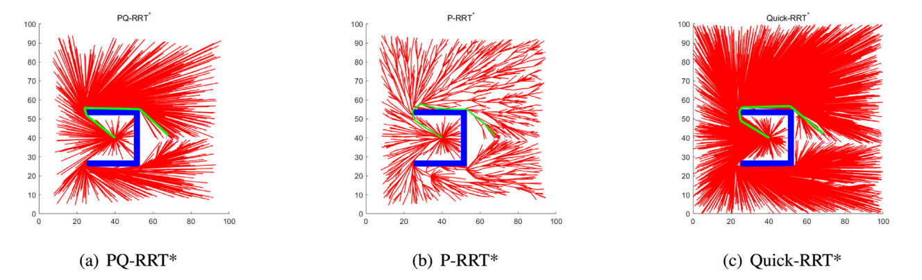
Fig.1. Performance of the three algorithms in the environment 2d [7]

Another way to alleviate the slow convergence problem is bidirectional exploration. M. Jordan et al. [8] proposed Bi-directional RRT* (BI-RRT*) which create two different trees and expanding them from start node and goal node, simultaneously. Qureshi et al. [9] introduced an Intelligent Bi-directional RRT* (IB-RRT*) Algorithm which is an enhanced version of the traditional Bi-directional RRT* algorithm, designed to further improve the efficiency and effectiveness of bidirectional motion planning in complex environments. IB-RRT* combines the principles of bidirectional exploration with intelligent sampling and pruning strategies to achieve faster convergence towards an optimal path.

However, these two algorithms still perform pure exploration without sample-biasing to lead two trees toward each other. In this regard, Z. Tahir et al. [10] proposed potentially guided bidirectional RRT* (PB-RRT*) and potentially guided intelligent bidirectional RRT* (PIB-RRT*) which used APF to potential guide two trees toward each other and therefore have a faster convergence rate. The result of their experiment showed that the proposed methods outperformed both original algorithms in many aspects.

2.1.4 Neural Network Based
Neural network-based path planning methods leverage the power of artificial neural networks to solve complex path planning problems. These methods use neural networks to learn mappings from input data, such as sensor measurements or map information, to desired navigation actions or paths. It's important to note that neural network-based path planning methods often require extensive training data and careful tuning to achieve effective results. While these methods can offer high flexibility and adaptability, they may also face challenges related to data availability, generalization, and training stability.

Reinforcement Learning (RL) technique is well studied and popular in dealing with path planning issue. Reinforcement learning consists of an agent, a set of actions and a penalty function. The agent is regularized by the penalty function after taking each movement in the actions set. V. Mnih et al. proposed Deep Q-Network (DQN) in 2015 which can deal with continuous states of discrete actions by combining DNN and RL. Ru et al. [11] introduced an indoor path planning model based on DQN to deal with the problem of large differences in different indoor scenes. There are much more process works in this area and won’t be specify in this dissertation but can be found in [12]

Some relative works that more relative to this dissertation. JB et at. [13] proposed a model call GRETEL that can extrapolating path using graph neural networks. The definition of problem, in short, is that given a prefix of a path sequence presented as nodes in a graph, and predict the suffix of this path. They’ve encountered with several challenges. First, they needed to let the model learn the direction of the path. Second, they employed a short-time memory to prevent the model walking backward. Then they evaluated their model in two tasks and showed high performance than the state of art models of that time.
J. Wang et al. [14] introduced an improved RRT* algorithm NRRT* (Neural RRT*) to overcome the slow convergence limitation of RRT*. It is different to other human-designed heuristic approaches. Instead, it learns the probabilities of each node in the space of being the path nodes. They trained their model on the dataset designed and generated by themselves. This dataset consists of 5576 maps with size 201x201, and then randomly give 12 different start and goal point on each map. After that, A* is applied to find the shortest path. In order to simulate the environment of robot movement, they also set different clearance which means how close the path can get to obstacles. Finally, they evaluated their model and compare with the performance of RRT* and IRRT* to show NRRT* is outperform those models in many aspects.

2.2 Graph Neural Network
A Graph Neural Network (GNN) is a class of machine learning models designed to operate on graph-structured data. Graphs are mathematical structures composed of nodes (vertices) and edges (connections), where nodes represent entities and edges represent relationships between those entities. GNNs are particularly powerful for tasks involving structured data with complex relationships, such as social networks, molecular structures, recommendation systems, and more.

The key idea behind GNNs is to learn feature representations for nodes in a graph by aggregating information from their neighbors. GNNs extend neural networks to accommodate graph data by propagating information through the graph structure, allowing them to capture local and global patterns.

2.2.1 Graph Convolutional Network
Graph Convolutional Networks (GCNs) are a type of Graph Neural Network (GNN) architecture designed to operate on graph-structured data. GCNs extend convolutional neural network (CNN) concepts to handle graph data by performing localized operations that aggregate information from a node's neighbors. This allows GCNs to capture both local and global patterns present in graph-structured data.

Graph Convolutional Networks have been successful in various domains, including social network analysis, recommendation systems, biological data analysis, and more. They provide a powerful framework for learning representations from graph data while effectively handling the unique challenges posed by graphs.

2.2.2 GraphSAGE
GraphSAGE (Graph Sample and Aggregator) is a Graph Neural Network (GNN) architecture designed to handle graph-structured data by performing neighborhood sampling and aggregation. Introduced by Hamilton et al. [15] in the paper "Inductive Representation Learning on Large Graphs" in 2017, GraphSAGE is designed to efficiently learn node embeddings for large graphs while considering different types of graph structures.

GraphSAGE addresses some limitations of traditional GNNs, particularly their inability to handle graphs with varying degrees, large neighborhoods, and non-uniform structures. It achieves this by employing a neighborhood sampling strategy and various aggregation functions.

2.2.3 Graph Attention Network
The Graph Attention Network (GAT) is a powerful Graph Neural Network (GNN) architecture introduced by Veličković et al. [15] in the paper "Graph Attention Networks" in 2017. GAT extends the capabilities of traditional GNNs by incorporating attention mechanisms to dynamically weigh the importance of neighboring nodes when aggregating information. This enables GAT to capture complex node relationships and adaptively focus on relevant nodes during message passing.

GAT is designed to address some of the limitations of earlier GNN architectures, such as Graph Convolutional Networks (GCNs), which treat all neighbors equally during aggregation. By introducing attention mechanisms, GAT is able to learn varying levels of attention to different neighbors, which is particularly valuable in scenarios where some neighbors are more informative than others.

3. Methodology
In this chapter, the methodologies of algorithms that used in this experiment will be introduced. Dijkstra’s algorithm is used to search a shortest path given a start node and goal node in a random constructed map. RRT* is used to plan a path in a graph-based map with either node probabilities or labels. Different GNN models are trained to do a node classification task where the input is a graph-based map with a query consist of a start node and a goal node and the output is a map with a label or probability to each node. The process of dataset generation is also demonstrated as follow. In order to compare the influences of different datasets which consist of different shape of map and path length, a set of datasets are generated randomly.

3.1 Terminology
This section illustrates the formulation of path planning and some basic terms in training a neural network model. This dissertation assumes that readers are familiar with the fundamental concepts of artificial intelligence and artificial neural network where supervised learning means training models with labeled data and unsupervised learning means training models with unlabeled data. Some details about model training and evaluation can be found in paper [16]. Here in this section some important hyperparameters are illustrated.

3.1.1 Problem Formulation
In this section, the definition of path planning problem was formulized as follows. Let $X∈R^{n}$ denotes a map with n dimensions, $X_{obs}∈X$ denotes the obstacle region, such that $X_{free}= X{ \backslash X}_{obs}$ denotes the open set. $x_{init}$ is an element of $X_{free}$ where $x_{init}$ is the initiate point and $X_{goal} ∈ X_{free}$ denotes the goal region. The path planning problem then is defined as a triplet ($x_{init}, { X}_{goal}, X_{free}$). Let $σ:\left[0, T\right]→R^{n}$ be a path where $σ\left(0\right)=x_{init}$ and $σ\left(T\right)=X_{goal}$. A function $σ:\left[0, T\right]→R^{n}$ is a path if it is continuous; it is a collision-free path if it is a path and $σ\left(τ\right) ∈ X_{free}$ for all $τ ∈[0,T]$. $X_{path}$ denotes a sequence of node in the path and $x_{path ∈ }X_{path}$ denotes a single node that in the path.

3.1.2 Loss Function
A loss function (also known as a cost function) is a mathematical function that quantifies the difference between the predicted output of a model and the actual target or ground truth. The goal of training a model is to minimize this loss function, as doing so results in better predictions that are closer to the true values.

The choice of a loss function depends on the specific task you're trying to solve, such as classification, regression, or other types of learning problems. Different tasks require different loss functions to measure the discrepancy between predictions and actual outcomes. Such that Mean Squared Error (MSE) is usually used in regression tasks. Binary Cross-Entropy Loss (Log loss, BCE) and Categorical Cross-Entropy (CE) Loss are usually used in classification tasks. This experiment will use Binary Cross-Entropy Loss or Categorical Cross-Entropy. Here the formulations of both loss functions are shown as bellow:

$$Binary Cross Entropy= -\sum{(y_{true}*\log{y_{pred}}}+\left(1-y_{true}\right)*\log\left(1-y_{pred}\right) )$$ | (1)

Where $y_{true}$ denotes the ground truth or the true labels and $y_{pred}$ denotes the output of a model.
$$Cross Entropy= -\sum{(y_{true}*\log{y_{pred}}} )$$ | (2)

Choosing an appropriate loss function is crucial for training a neural network effectively. The loss function guides the optimization process to adjust the model's parameters in the right direction, leading to improved performance on the task at hand.

3.1.3 Activation Function
An activation function is a mathematical function that determines the output of a neuron (or node) in a neural network based on the weighted sum of its inputs. Activation functions introduce non-linearity to the network, allowing it to learn and approximate complex relationships in the data. They play a critical role in enabling neural networks to model a wide range of functions and solve diverse tasks effectively. Some common activation functions are shown below:

1. Sigmoid Function: The sigmoid function maps input values to a range between 0 and 1. Formular 3 shows the formular of sigmoid.

$$σ\left(x\right)=\frac{1}{1+e^{-x}}$$ | (3)

Sigmoid functions were popular in earlier neural networks but are less commonly used now due to limitations like vanishing gradients.

2. Rectified Linear Unit (ReLU): ReLU is a simple and widely used activation function. It outputs the input if it's positive, and zero otherwise. ReLU addresses the vanishing gradient problem and accelerates convergence.

$$ReLU(x) = max(0, x)$$ | (4)

Leaky ReLU is an extension of ReLU that allows a small gradient for negative inputs, preventing the dying ReLU problem. PReLU(x) = x if x > 0, otherwise αx where α is a learned parameter.

3. Softmax Function: Softmax is used in the output layer for multi-class classification tasks. It converts raw scores (logits) into probabilities that sum up to 1. Normally, softmax takes an input vector and transform it into probabilities in the range 0-1 and the sum of all probabilities in the vector is 1. Formular 5 shows the formular of softmax, where $x_{i}$ represent an element in the input vector and n is the dimension of the input vector.

$$softmax\left(x_{i}\right)= \frac{e^{x_{i}}}{\sum_{j=1}^{n}{e^{x_{j}}}}$$ | (5)

3.1.4 Learning Rate
The learning rate is a crucial hyperparameter in training neural networks and other machine learning algorithms. It determines the step size at which the model's parameters are updated during the optimization process. A well-chosen learning rate is essential for achieving fast convergence, stable training, and accurate results. A large learning rate might lead to overshoot the minima, on the other hand, a small learning rate would cause a slow convergence. There are several learning rate strategies. Fixed learning rate which uses a constant learning rate throughout the whole training process, this is suitable for simple problem or the optimal learning rate is pre-known. Adaptive learning rate adapt a dynamically change learning rate during the training process. Popular adaptive algorithms include AdaGrad, RMSprop, and Adam.

3.1.5 Dropout
Dropout is a regularization technique commonly used in neural networks to prevent overfitting and improve the model's generalization ability. It involves randomly "dropping out" a fraction of neurons or units during training by setting their outputs to zero. This forces the network to learn redundant and robust representations, reducing the reliance on specific neurons and making the network more resilient to noise in the data. Dropout technique usually applied in the process of training in forward and backpropagation.

3.2 Path Planning Algorithms

3.2.1 Dijkstra’s Algorithm
Dijkstra’s algorithm usually uses to find a shortest path from a given start point in a graph to the destination. While searching a path from two configurations, it actually gives you one shortest path from start point to all points in a graph. [17] Here I will demonstrate an example to show how Dijkstra’s algorithm works without specific practical coding.
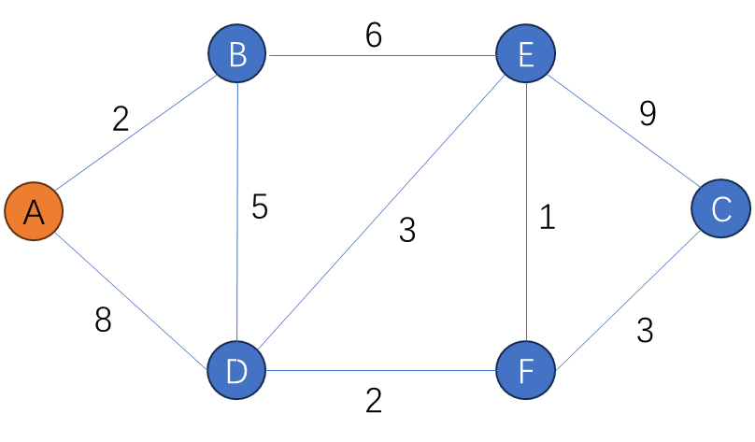
Fig.2. A weighted graph

Fig.2. shows a weighted graph. In this graph, node A is the start node. In Dijkstra’s algorithm, two lists and a distance table will be maintained. One list call visited list (VL) which records those nodes have been visited. Another list call unvisited list (UL) contains those nodes haven’t been visited. Let’s initiate those lists and table and call it step 1. As the graph shows in Fig.2., the original states of both two lists would be: VL: {} and UL: {A, B, C, D, E, F}. The structure of distance table is shown in Fig.3.

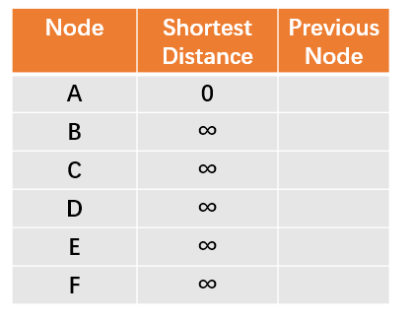
Fig.3. Initial distance table

After initiate those lists and table, step 2 is to choose the smallest distance in the distance table according to unvisited list. Since the shortest distance to A is 0 and others is infinite. So, we visit node A and update distance table. From A, we can visit B with distance 2, that is smaller than the shortest distance B have now, therefore, we update B’s shortest distance as 2, and previous node as A. Same for node D, update shortest distance as 8 and previous node is A. Fig.4 shows the updated distance table after visit node A.

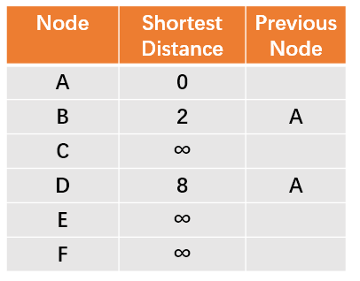
Fig.4. Distance table after visited node A

At the same time, update VL as {A}, UL as {B, C, D, E, F}. Repeat step 2, now choose the smallest shortest distance from distance table according to unvisited list. At this point, among {B, C, D, E, F}, B has the smallest distance 2. So, we visit node B next. From node B, we can visit node E and D, the distance from B to E is 6, but remember this shortest distance is measured from A to the current node. So, we need to update the shortest distance of E is 2 (the shortest distance from A to B) + 6 (distance from B to E) equals 8 and that is smaller than infinite, so update the shortest distance of E as 8 and previous node as B. Since we can reach D from B, so here we need to compare the shortest distance from B to D which is 7 to the current shortest distance of D.

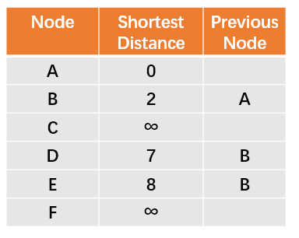
Fig.5. Distance table after visited node B
Repeat step 2 until unvisited list is empty. Fig.6 shows the final result of distance table. If we want to find the shortest path from A to C, we can look at the final distance table and find node C for its previous node which is F, then look for F’s previous node which is D, keep search back until node A. At last, we have the shortest path A->B->D->F->C

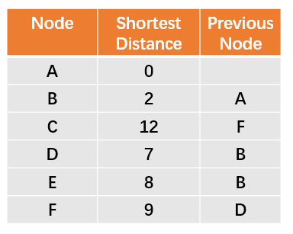
Fig.6. Final distance table

The original time complexity of Dijkstra’s algorithm is O(n^2), this can be optimized and reduce to O(nlogn) by using priority queue data structure. One drawback of Dijkstra’s algorithm is that it cannot be applied to graph with negative weight edge.

3.2.2 RRT*
The Rapidly Exploring Random Trees Star (RRT*) algorithm is a popular motion planning technique used to find optimal paths for robots and autonomous systems in complex environments. RRT* builds upon the basic RRT algorithm by introducing optimization and rewiring strategies to improve path quality and convergence.

Next, I will introduce the procedure of RRT. [18] The RRT algorithm build a tree with only one node $x_{init}$ and no edges. At each iteration, a random node $x_{rand}$ is chosen and attempts to connect with the nearest node $x_{nearest}$ in the tree. If the connection is successful, $x_{rand}$ will be adjusted to $x_{new}$ by a steer function. Then, $x_{new}$ is added to the vertex set and ($x_{nearest}$, $x_{new}$ ) is added to the edge set. The algorithm would end either when find a state in goal region or the iterations reach the threshold. Once the algorithm terminates successfully, reconstruct the optimal path from the initial configuration to the goal configuration by tracing the parent links from the goal node back to the root node.

Different to RRT, RRT* improves its performance by choose parent node more sufficiently for each $x_{rand}$ and after that, a process of rewire is performed to adjust the structure of expansion tree. While a $x_{new}$ trying to connect to its nearest neighbor, nodes in a radius r of $x_{new}$ are searched for an optimal regard to the aspect of cost. After connect $x_{new}$ to the tree, a process of rewire is performed to check and rewire neighbor vertices if the cost through $x_{new}$ is lower than the current path. For each neighboring node, calculate the cost of reaching that node from the new node. If the cost of the path through the new node is lower than the cost of the existing path to the neighboring node, update the parent of the neighboring node to be the new node. This rewiring step ensures that the tree structure becomes more optimal over time.

Furthermore, RRT* guarantees asymptotic optimality, meaning that as the number of iterations increases, the solution approaches the optimal path in terms of cost. The optimization and rewiring steps improve the quality of the path found and ensure that the tree structure converges towards an optimal solution. The algorithm inherently explores the configuration space, making it well-suited for complex and high-dimensional environments. RRT* can be extended to handle dynamic environments by updating the tree and paths as the environment changes.

Algorithm 1 RRT* [18]
Input: $x_{init }, X_{goal}$ and a map
Output: $T$
- V $←x_{init }$, E $← ∅$, $T$ = (V, E)
- for $i$ = 1 to N do
- $x_{rand} ←$ UniformSample();
- $x_{nearest} ←$ NearestNeighbor($T, x_{rand}$);
- $x_{new}$ $←$ Steer($x_{nearest}$, $x_{rand}$);
- if ObstacleFree($x_{nearest},x_{new})$then
- T $←$ Extend(T, $x_{new}$);
- Rewire();
- if $x_{new} ∈ X_{goal}$ then
- return T;
- return failure;

RRT* is sampling-based algorithm. The main procedure of RRT* include sampling, collision checking, rewiring. In this section, the process of RRT* algorithm is illustrated. Some basic functions that used in RRT* algorithm are defined as follows. [19] SampleFree: Randomly choose a sample node from $X_{free}$ and those samples are assumed choose from uniform distribution. Nearest neighbor: Given a graph G = (V, E), where $V ⊂X$ and a point $x ∈$ $X_{free}$ , the function Nearest neighbor returns nodes ‘closest’ to $x$ given a distance function. RRT* uses Euclidean distance as distance function. Steer: Given two points $x,y ∈X$, Steer (x, y) returns a point $z ∈X$ where z is closer to y than x is. The rewire function in the RRT* algorithm is responsible for updating the tree structure to ensure that the algorithm explores the configuration space efficiently. It checks if any existing nodes in the tree can be reached with a shorter path through the newly added node. If so, it updates the tree to use the shorter path.

3.3 Graph Neural Network
Graph neural network takes insight from convolutional neural network (CNN). The key idea of convolutional neural network is to extract features using a kernel. Simply speaking, a kernel like a fixed size window to scan the whole image. Each iteration, convolutional neural network would use a pooling technique. Typical pooling techniques can choose max, mean, those pooling techniques are efficient and simple. After pooling, the size of image might be smaller than the original one, that would constrain the ability of scaling layers in CNN. In this regard, a margin technique is applied to expand the concentrate image to its original size by filling 0 in the margin.

Compare to CNN which have a regular shape, graph can be arbitrary. Therefore, one single fixed size kernel cannot be applied to aggregate the information from one node’s neighbors. Graph neural network built a computational subgraph for each node and update it in each iteration until a stable equilibrium is reached.

Graph neural network constructs by stacking GNN layers. As Fig.7 shows, each layer aggregate information for one node’s neighbors. K-layer aggregate messages from k-hop neighbors and construct a computational subgraph. There several function for aggregation operation. Normally, most of the GNN models would just sum up all information from one node’s k-hop neighbors. One thing worth notice is that one node’s shallow layer computational subgraph might be its neighbor’s deeper layer computational subgraph. This can be observed in Fig.7, like the 2nd layer computational subgraph of yellow node consist the 1st layer computational subgraph of red node.

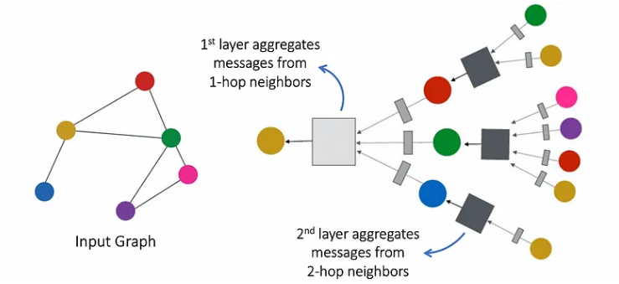
Fig.7. GNN layers stack operation [Adopted from Stanford CS224W]

There are three mechanisms in GNNs considering a graph-based and node content information as input and outputs represent the analysis of the tasks. First, node-level. At this level, Graph neural networks are designed to perform a node regression or node classification task. In node regression, graph neural network models are trained to predict node’s property values. In node classification, models are trained to classify one node’s label. Multi-perceptron or softmax layer is usually applied as an output layer in GNN to perform node level tasks. Second, edge-level. At this level, graph neural network models are trained to perform an edge classification or link prediction. Edge classification task is to classify one edge with a certain label. On the other hand, link prediction tells if there should be a link between two given nodes. This is very useful to discover the relation between two nodes. Finally, graph-level. In this level, graph classification tasks relate to classify graphs using pooling and readout operations.

The main steps of graph neural network are shown as follow:
- Graph representation. At this step, data are transformed to graph representation. (Node, edges, graph feature and so on). Normally, nodes present entities, and edges represent relationships or connections.
- Node features representation. At this step, initiate node features and represent them as vectors. Node features include node’s attributes or properties.
- Graph neural network model. At this step, graph neural network models are predefined. Graph neural network models different from the many aspects, e.g., the core component of graph convolutional neural network is stacking convolutional layers.
- Propagation rule. Propagation rule defined how messages are aggregated from one node’s neighbors. Meanwhile, the update of a node’s embedding and weight matrix.
- Activation Function. After aggregation, an activation function is applied to introduce non-linearity.
- Output layer. The choose of output layer depends on the task of the graph neural networks. Such as node classification, link prediction, graph classification.

3.3.1 Graph Convolutional Network
The propagation rule of GCN which indicated in [20] is shown in formular 6.

$H^{(l+1)}= σ({\tilde{D}}^{-\frac{1}{2}} \tilde{A}{\tilde{D}}^{-\frac{1}{2}}H^{\left(l\right)}W^{(l)})$ | (6)

Where $\tilde{A}=A+I_{n}$ is the adjacency matrix of the undirected graph, and $I_{n}$is the identity matrix (add a self-loop to each node), $\tilde{D}$ and W is a layer-specific trainable weight matrix. $σ(∙)$ denotes the activation function, such as softmax, ReLU, LeakyReLU. $H^{\left(l\right)}$ represent the l layer’s activation result, $H^{\left(0\right)}$ = X.

A graph neural network then can be constructed by stacking several convolutional layers of the form of Eq.3.5. each layer should follow by a non-linear function.

3.3.2 Graph Attention Network
Graph Attention Networks (GATs) are a type of Graph Neural Network (GNN) architecture designed for tasks involving graph-structured data, such as social networks, citation networks, and recommendation systems. GATs enhance the representation learning of nodes in a graph by allowing each node to attend to and aggregate information from its neighbors differently, based on learned attention coefficients.

Here's an explanation of GATs along with some key papers that have contributed to their development:

Graph Attention Networks were introduced as a way to improve upon previous GNN models, which often have fixed aggregation rules for neighborhood information. GATs use attention mechanisms to dynamically weigh the importance of neighbors when aggregating information, making them highly adaptive and expressive.

Key components of GATs:

- Self-attention mechanism: Each node computes attention coefficients to assign different weights to its neighbors based on their relevance to the node's representation.
- Aggregation: The aggregated neighborhood information is then combined using the attention weights to compute the updated node representation.
- Multi-head attention: GATs often employ multiple attention heads, allowing nodes to attend to different aspects of their neighbors' information.

3.4 GNRRT* Algorithm
GNRRT* algorithm is a new approach that introduced by this dissertation. It uses a pre-trained graph neural network model to narrow down the possible path area and the help RRT* algorithm samples more efficiently. Compare to RRT*, GNRRT* checks the probabilities of $x_{rand}$ before expansion.

Algorithm 2 GNRRT*
Input: $x_{init }, X_{goal}$ and a map, threshold
Output: $T$
- V $←x_{init }$, E $← ∅$, $T$ = (V, E)
- While (threshold >= 0) do
- for $i$ = 1 to N do
- $x_{rand} ←$ UniformSample ();
- if probability ($x_{rand}$) >= threshold then
- $x_{nearest} ←$ NearestNeighbor ($T, x_{rand}$);
- $x_{new}$ $←$ Steer ($x_{nearest}$, $x_{rand}$);
- if ObstacleFree ($x_{nearest},x_{new})$then
- T $←$ Extend (T, $x_{new}$);
- Rewire ();
- if $x_{new} ∈ X_{goal}$ then
- return T;
- threshold = threshold – 0.1;
- return failure;

Algorithm 2 shows the pseudo-code of GNRRT*. Here threshold gates the probabilities that predict by the GNN model. The threshold is in the range [0,1]. The threshold would decay during each iteration of sampling. When it reaches 0, it becomes normal RRT*.

4. Design and Implementation
This chapter demonstrates relative setup and information about this experiment.

4.1 Experiment Environment

These experiments are conducted on a 3060rtx (6G) GPU with cuda 11.6. Software used Jupyter kernel with Visual Studio Code 1.81.1. Python version 3.8.8. The main python libraries included Pytorch Geometric, NetworkX, sklearn, NetworkX mainly uses to handle graph structure data. It can easily create graph with many kinds of data formats and can be implemented with many popular libraries. It can create graphs randomly, manipulate node attributes and edge adjacency. Furthermore, it can visualize graphs and probabilities color with matplotlib. Pytorch geometric is a powerful tool to implement graph neural network model, it also provides a way to handle the dataset operation, including loading, splitting, batching. Sklearn is also very famous in implementation of artificial intelligence models. Here in this experiment, sklearn is mainly used to get a performance analysis. The first step is to train graph neural network models with different model architectures that can complete a binary node classification task. Second, find out the best model and integrate it with RRT* algorithm. Third, compare the performance with RRT* algorithm.

4.2 Dataset Generation

Since there is no exact the same but only similar works have been tested, so the generation of datasets I used to train those graph neural network models needed to consider several issues. First, the size of maps. As mention in chapter 2, [21] generated a dataset consists of four sets of same size maps (201x201) with different clearances and steps. The total number of their dataset contains more than 1,000,000 maps in the training dataset. Then, they treated each map as an image as the input of the convolutional neural network. Graph neural network models, however, take graphs as input. Graph structure data consumes more memory than image for each map with same size. Therefore, due to memory constrain, there would only be small and medium size maps contain in the training dataset.
By small maps refer to both dimensions smaller than 20 and medium maps refer to size under 50. In order to test the influences of different sizes and amounts of maps in the training dataset in model generalization ability, I created several sets of datasets.

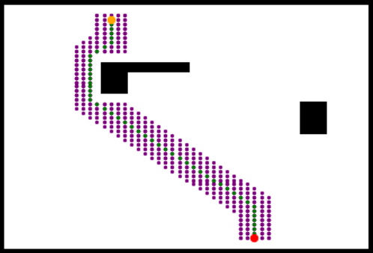
Fig.8. An example of input map

The generation of dataset were created by using a NetworkX function to generate 2D grids represented as graph structure. Once a grid was generated, random obstacles was created in this grid. After that, randomly chose a start point and goal point and used Dijkstra’s algorithm to find the shortest path which represented as a continued sequence of nodes. The purpose of GNRRT* is to speed up the convergence process by narrowing down the expanding space instead of find an optimal (shortest) path. In this regard, I widened each path found by Dijkstra’s algorithm by marking two hop neighbors of each node in the original path included diagonal direction. Fig.8 shows an input of the training data where the size of map is 51x51, white nodes represent the free space, black nodes are obstacles. The red point is the start node and the orange point is the goal node. Green line is the shortest path between start node and goal node which found by Dijkstra’s algorithm. Purple area is the widened path of the shortest path by sample two hop neighbor of the original node in the shortest path included start point and goal point.

TABLE I
Datasets Detail
No. | Size | Number of Maps | Positive Sample Ratio
D1 | 31x31 | 50 | $$\sim 9\%-30\%$$
D2 | 41x41 | 40 | $$\sim 8\%-20\%$$
D3 | 51x51 | 30 | $$\sim 8\%-15\%$$

As the principle illustrated in chapter 3, graph neural network modes calculate each node’s embedding by aggregating information from its neighbors. The original information of each node is a vector of node attributes. In this experiment, each node has 6 attributes. The first two are its coordinates. Coordinates reflect one node’s position in the graph. The third attribute is a start node flag, True or 1 means this node is the start node. Fourth attribute is a goal node flag, True or 1 means this node is the goal node. The fifth attribute is the Euclidean distance to the start node. The sixth attribute is the Euclidean distance to the goal node. The last two attributes tell the implicit relation with start node and goal node. Finally, one node’s label shows if one node is in the widen path or not. TABLE II shows the detail of node attributes.

TABLE II
Node Attributes
Attribute Name | Coordinate  x | Coordinate  y | Start Point | Goal Point | Distance to Start | Distance to Goal | Label
Value | int | int | 0/1 | 0/1 | numerical | numerical | 0/1

After successfully generated the datasets, datasets are split into three subsets, i.e., training dataset, validation dataset, test dataset. The ratio of each subset is 60%, 20%, 20% respectively.

4.3 Performance Measure Method
- Accuracy

Accuracy is a commonly used performance metric in the evaluation of machine learning models, especially in classification tasks. It provides a simple and intuitive way to assess how well a model is performing by measuring the ratio of correctly predicted instances to the total number of instances in the dataset. Accuracy is defined as follow:

$$Acc=\frac{Number of Correct Predictions}{Total Number of Predictions}$$ | (7)

Accuracy measures the ability of a model to correctly classify or predict instances from a dataset. It is easy to understand and interpret, making it a popular choice for assessing model performance, especially in binary or multi-class classification tasks. But there are some limitations of accuracy too. First, it can be misleading when dealing with imbalanced datasets (i.e., when one class significantly outnumbers the others). A high accuracy score can be achieved by simply predicting the majority class, even if the minority class is classified poorly. Second, in situations where the cost of false positives and false negatives is significantly different, optimizing for accuracy may not be the best strategy. For example, in medical diagnosis, missing a disease might be more critical than falsely diagnosing it. Third, Accuracy doesn't account for the confidence level of predictions. It treats all correct predictions equally, even if some predictions are made with high confidence and others with low confidence.

- 4.3.2 AUC-ROC

The Area Under the Receiver Operating Characteristic curve (AUC-ROC) is a widely used metric for evaluating the performance of binary classification models, particularly in machine learning and statistics. It measures the ability of a model to distinguish between the positive and negative classes by plotting the True Positive Rate (TPR) against the False Positive Rate (FPR) at various threshold settings.

The ROC curve is a graphical representation of a binary classification model's performance across different threshold values. The x-axis represents the False Positive Rate (FPR), which is the ratio of false positives to the total number of actual negatives. The y-axis represents the True Positive Rate (TPR), which is the ratio of true positives to the total number of actual positives.

The AUC-ROC is the area under the ROC curve. It quantifies the model's ability to distinguish between positive and negative classes. The AUC value ranges from 0 to 1, where a higher AUC indicates better model performance. An AUC of 0.5 represents a model that performs no better than random chance (i.e., it has no discrimination ability), while an AUC of 1 represents perfect discrimination.

An AUC-ROC value of 0.5 suggests that the model's predictions are random and lack discriminatory power. An AUC-ROC value between 0.5 and 1 indicates that the model has some degree of discrimination ability, with higher values indicating better performance. An AUC-ROC value of 1 represents a perfect model that makes perfect classifications.

- 4.3.3 F1 Score
The F1 score is a commonly used metric for evaluating the performance of binary classification models. It combines two important measures, precision and recall, into a single value, making it especially useful when dealing with imbalanced datasets or situations where false positives and false negatives carry different costs. The F1 score is defined as the harmonic mean of precision and recall and is calculated as follows:

$$F1=\frac{2×Precision×Recall}{Precision+Recall}$$ | (8)
Where:
Precision measures the accuracy of positive predictions, i.e., the ratio of true positives to the total predicted positives.

$$Precision=\frac{True Positives}{True Positives+False Positives}$$ | (9)

Recall, also known as sensitivity or true positive rate (TPR), measures the model's ability to identify all relevant instances from the positive class.

$$Recall=\frac{True Positives}{True Positives+False Negative}$$ | (10)

The F1 score combines these two measures into a single value that balances precision and recall. It reaches its maximum value of 1 when both precision and recall are perfect (all predictions are correct, and all relevant instances are identified). The F1 score is lower when there are trade-offs between precision and recall. The F1 score is particularly useful when dealing with imbalanced datasets or when false positives and false negatives have different implications. For example, in medical diagnosis, correctly identifying all cases of a disease (high recall) while minimizing the risk of false alarms (high precision) is crucial.

4.4 Graph Neural Network Model Training
Those hyperparameters set for graph neural network models training as mentioned in chapter 3 were set as follow: Learning rate = 0.001 and is continue to decay using a 1e-5 weight-decay during training process; Dropout rate = 0.5; Use Adam optimizer. Use Binary Cross-Entropy (BCE) loss function with a weight vector in case of imbalanced dataset; Batch size = 10;

During the training process, for each epoch, graph neural network models were trained on the training dataset by batches and then test in the validation dataset at each batch. Here, all performance measure would be the mean of the sum of every batch’s performance. Best models which have the highest training accuracy were returned at the end of training for each model architecture.

5. Result and Analysis

5.1 Model Evaluation
There are 2 model architectures trained on 3 different datasets respectively, so there would be 6 models in total. This report will analyze the performances of those models in training, validation, test process. The ability of generalization of each model then is showed and compared. I will refer training accuracy as accuracy on training dataset and validation accuracy as accuracy on validation dataset in the following. Same for F1-score and ROC-AUC score. Refer GAT-Dx as GAT model trained on Dx dataset, and meshSeg-Dx means meshSeg model trained on Dx dataset. Refer xx-Dx as both models trained on Dx dataset.

5.1.1 Graph Attention Network

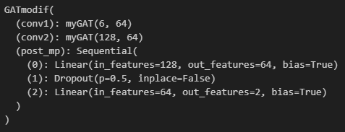
Fig.9. GATmodif Model Structure
[Adopted from Stanford CS224W Graph ML Tutorials]

The graph attention network model called GATmodif information summary in Fig.9 Where “myGAT” is a custom convolutional network with 2-heads attention mechanism. With two GAT layers, followed by a MLP layers to project the output into a two-dimension vector with probabilities. GAT layers can weight messages from neighbors differently, help to catch more important messages therefore improve the expressive ability of models.

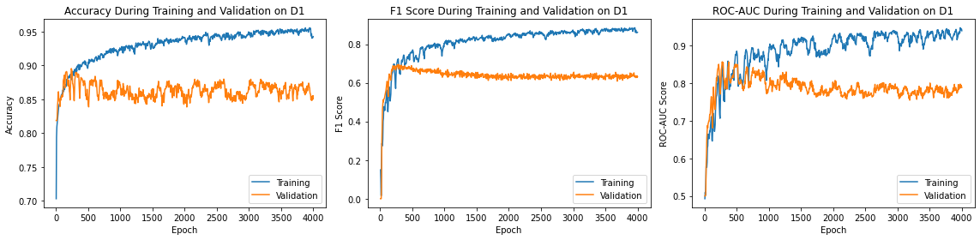
Fig.10. GAT Training and Validation on D1 Dataset

Fig.10 shows the performance of graph attention network training result on training dataset and validation dataset. As we can see in Fig.10, the accuracy on training dataset continued to increase as the number of epochs increased. The training accuracy improved steadily before 2000 epochs and became stable in 0.95 to 0.98 thereafter. One thing worth noted is that the dataset might be imbalanced as shown in table 4.2.1. Hence, a well perform model can just judge by its high accuracy. Compare to training accuracy, validation accuracy fluctuated between 0.84 and 8.87 even when training accuracy increased steadily. This shows a sign of overfitting. The highest validation accuracy occurred in the very early epochs. However, this is not necessarily mean that is the best model. The second diagram in Fig.10 shows the F1-score of positive samples. It has the same trend of accuracy which training f1-score went up steadily but almost no improvement in the performance of validation dataset. The highest point appeared in around 300 epochs. The volatility of validation F1-score was smaller than the validation accuracy. A high accuracy and low f1-score refer that the model performs better in predicting negative class than positive class. The measure of ROC-AUC shows in the third diagram in Fig.10 The validation ROC-AUC is entangled with the training ROC-AUC, it shows the same reaction with training ROC-AUC before 1000 epochs. After that, the validation ROC-AUC started to apart from training ROC-AUC. It reached its highest point in epoch 300. That is similar to the situation of f1-score. Both training ROC-AUC and validation ROC-AUC fluctuated heavily while training ROC-AUC went up to 0.93 and validation ROC-AUC stayed near 0.8.

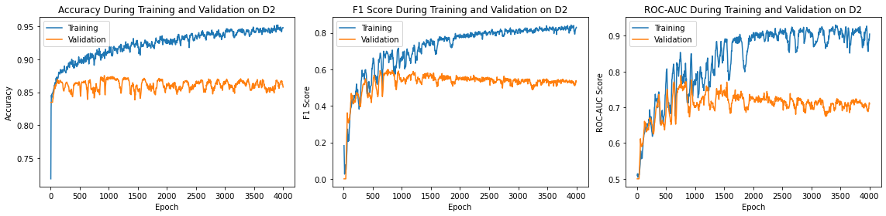
Fig.11. GAT Training and Validation on D2 Dataset

Fig.11 shows the situation of graph attention network model training on D2 dataset. The first diagram in Fig.11 denotes the training accuracy and validation accuracy. It’s similar to the situation of training on D1. Although the training accuracy continued to ascend, validation accuracy kept fluctuate between 0.84 and 0.87. The highest validation accuracy occurred in epoch 1000. Compare to situation in Fig.10, the volatility of validation accuracy is smaller. It seems that more training epochs have no positive effects on improving validation accuracy. The second diagram shows the training and validation f1-score on D2 dataset.

The maxima of validation f1-score exists in about epoch 800. One unusual thing is that the validation f1-score has a descend tendency. This can due to the model trying to achieve a higher accuracy by classify more nodes as free nodes. Compare to f1-score on D1, the training f1-score and validation f1-score separate later than in D1. These two lines separate after 1000 epochs. This means the model have difficulties in correctly predicting class 1. The third subgraph shows the ROC-AUC score on D2. It gives an intuition that the model seems not converged yet. The volatility is very high which tells by its strong fluctuation. The best number occurred in epoch 800. The whole line of validation ROC-AUC is a bit lower than validation ROC-AUC in D1.

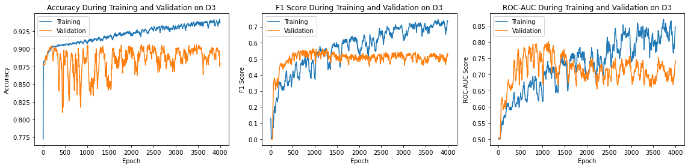
Fig.12. GAT Training and Validation on D3 Dataset

Fig.12 shows the training result of graph attention network model on D3. The first diagram shows the accuracies of training and validation. It is obvious that there is overfitting in the training process. The improvement of training accuracy has uncertain impact on model’s generalization ability. The highest point appears in epoch 1000. One thing worth mention is that D3 contains large size maps. The percentage of positive is rather small even the length of shortest path of two configurations has increased. In this case, f1-score and ROC-AUC would be reliable in measure model performance. The second subgraph shows the training F1-score and validation F1-score. As the training accuracy went high, training F1-score also went up. One strange thing is that the validation F1-score line is above training F1-score line before 1000 epochs. However, before 1000 epoch, validation accuracy went up and down severely. A high F1-score and low accuracy means that the model tried to classify too many nodes as positive. These would be attested in the following generalization report. The third subgraph shows the ROC-AUC score on D3. The validation ROC-AUC has the same fluctuation of training ROC-AUC. And the validation ROC-AUC line is also above the training ROC-AUC line. The highest point of validation ROC-AUC which is about 0.8 occurred in epoch 1100. Take experiences of result data in D1 and D2, if the training process of model is converged, training line should be separated from validation line. In this case, 4000 epochs might not be enough to train this model on D3.

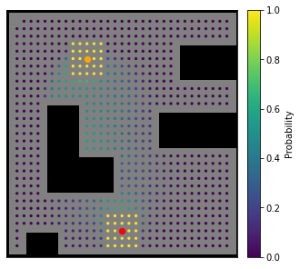 | 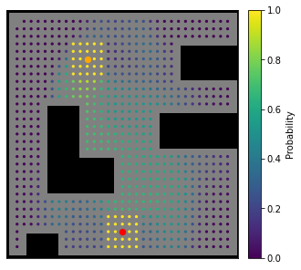 | 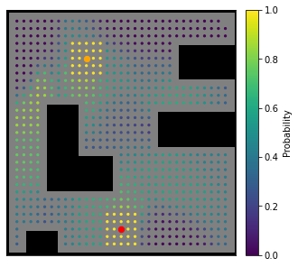
(a) GAT-D1 Output Probability | (b) GAT-D2 Output Probability | (c) GAT-D3 Output Probability
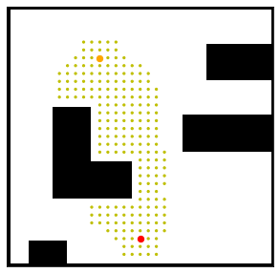 | 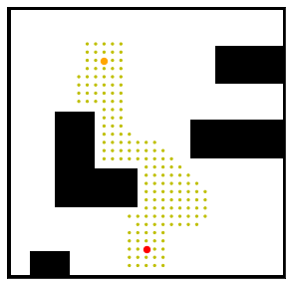 | 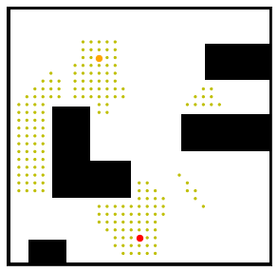
(d) GAT-D1 Output Label | (e) GAT-D2 Output Label | (f) GAT-D3 Output Label
Fig.13. GAT Output Maps with Probabilities or Labels

Fig.13 shows the visualization of GAT models perform on a 31x31 map where white areas denotes free spaces, black blocks represent obstacles, orange point is the start node and red point is the goal node. In probabilities map, nodes are colored according to their probabilities of being path nodes. Subgraph a, b, c is probability output. Subgraph d, e and f is output map with labels. As we can see on subgraph a, the area of path nodes correctly predicted by GAT-D1 model. Transform to labels in subgraph d, the area of prediction of path is actually cover the shortest path of ground truth. The subgraph b and e show the probabilities and labels. Compare to GAT-D1 probability map, GAT-D2 predicts more points with probabilities large than 0.4. However, the area of path is smaller than GAT-D1 when transfer to labels map. This experiment aims at minimize the area of path nodes as long as it covers the start node and goal node. In this regard, GAT-D2 performed better than GAT-D1 in this task. As for GAT-D3, subgraph c and f show that the GAT-D3 model seems to plan a path from the left side and have some difficulties to finish the whole path.

5.1.2 MeshSeg Models
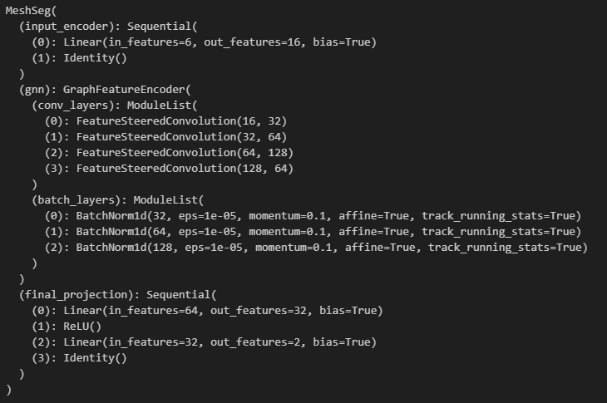
Fig.14. MeshSeg Model Structure
[Adopted from Stanford CS224W Graph ML Tutorials]

Fig.14 shows the final MeshSeg model structure which consist of an encoder to encode node features; A graph neural network contains 4 graph convolutional networks and 3 batch layers as middle device to train the neuron weights; The final part is a MLP decoder to decode the node representations and project them into a 2-dimension output with probabilities of class 1 (path node).

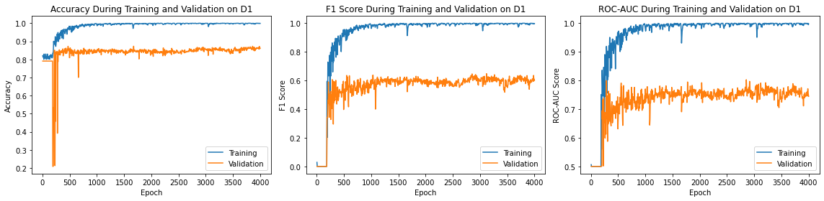
Fig.15. MeshSeg Training and Validation on D1 Dataset

Fig.15 shows the data of MeshSeg-D1 training process in accuracy, F1-score and ROC-AUC. The first subgraph of Fig.15 shows the training accuracy and validation accuracy. MeshSeg-D1 model had a very high accuracy start position and continued to grow even to 1. Validation accuracy also started at a high point but drop very severely even down to 0.2. After epoch 700, it shows the same direction of training accuracy. The highest point occurred in epoch 500. The second subgraph shows the MeshSeg-D1 F1-score. It shows the same situation of accuracy score. However, the training F1-score is much higher than the training F1-score. This shows an overfitting phenomenon. The highest validation F1-score which is about 0.62 exists in epoch 500, same as the position of validation accuracy maxima. It has no distinct improvement thereafter. The highest training F1-score can reach 1, that is another sign of overfitting. The third subgraph shows the ROC-AUC score. The volatility of training ROC-AUC score is high before 1000 epoch and then become stable around 0.97 to 1. The validation ROC-AUC fluctuate more heavily. The highest point is about 0.8 lays in epoch 400. Compare to GAT-D1 model training result, the validation situation is close, but the training scores of MeshSeg-D1 are higher than GAT-D1.

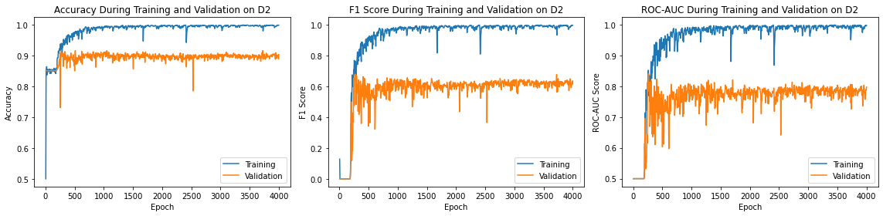
Fig.16. MeshSeg Training and Validation on D2 Dataset

Fig.16 shows the data of training result of MeshSeg-D2. The first subgraph shows the training and validation accuracy. The highest validation accuracy is over 0.9 in epoch 400. This is much better than GAT-D2. The training accuracy line is close to the validation accuracy line. This can be a good sign of excellent performance model. But still, a high accuracy does not stand for a good model while the dataset is imbalance. The second subgraph shows the F1-score. The highest training F1-score can reach 1 and the highest validation F1-score is about 0.7. This is better than GAT-D2 F1-score. The validation F1-score become stable after epoch 1500 besides some sudden drop down. Unlike accuracy and F1-score, as showed in the third subgraph, the ROC-AUC scores fluctuate more severely. The highest score of validation ROC-AUC is 0.85 and occurs in epoch 350. It continued to go up and down after epoch 1000. This means the performance of model is not stable. But it can tell that the training process is not converged cause that does not show in accuracy and F1-score. Compare to GAT-D2 ROC-AUC, the training ROC-AUC line separates with validation ROC-AUC line much earlier.

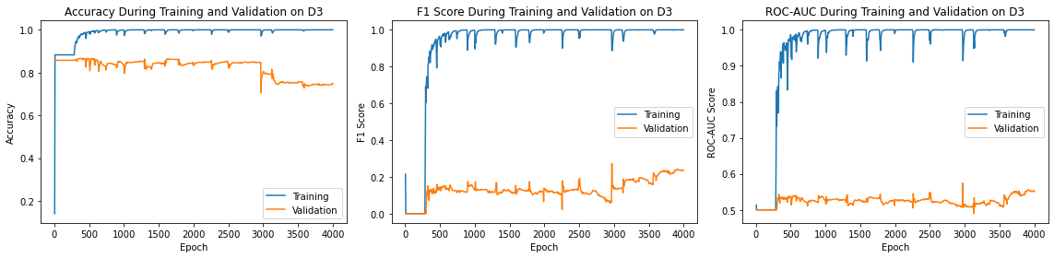
Fig.17. MeshSeg Training and Validation on D3 Dataset

The performance of model MeshSeg-D3 is very strange as shows in Fig.17 The highest validation score is about 0.82. The training accuracy goes very high at the very beginning and can reach 1 many times. However, unlike situation in other models, the validation is quite stable before 3000 epoch and then it decreases to under 0.8. The reason for that might be that the model tried to predict more nodes as positive node. But the second subgraph F1-score shows that this assumption is wrong. The training F1-score is very high but the validation F1-score is very low. The highest validation F1-score is about 0.35. The same situation happens for ROC-AUC data in the third subgraph. The training ROC-AUC shows a very good fitting of dataset. On the other hand, the validation ROC-AUC is really low. The highest validation ROC-AUC score is 0.58 in epoch 3000. That means the model has almost no discriminatory power.

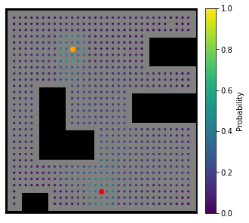 | 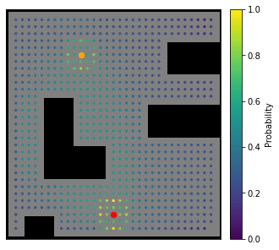 | 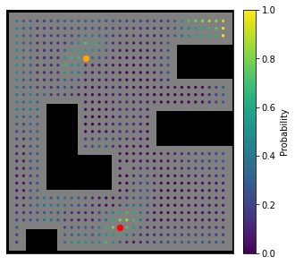
(a) MeshSeg-D1 Output Probability | (b) MeshSeg-D2 Output Probability | (c) MeshSeg-D3 Output Probability
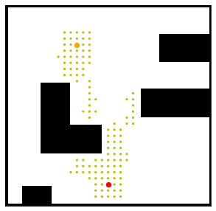 | 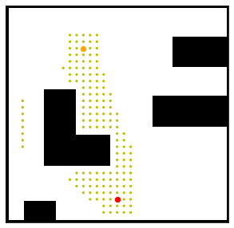 | 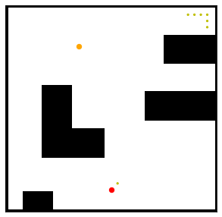
(d) MeshSeg-D1 Output Label | (e) MeshSeg-D2 Output Label | (f) MeshSeg-D3 Output Label
Fig.18. MeshSeg Output Maps with Probabilities or Labels

Fig.18 shows the visualization of MeshSeg models perform on a 31x31 map where white areas denotes free spaces, black blocks represent obstacles, orange point is the start node and red point is the goal node. In probabilities map, nodes are colored according to their probabilities of being path nodes. Subgraph a, b, c is probability output. Subgraph d, e and f is output map with labels. The MeshSeg-D1 model can predict 90% percent of the path area. It performs worse than GAT-D1 model. The MeshSeg-D2 model predicts almost perfectly of the path area. The area of path generate by MeshSeg-D2 prediction is the smallest in all 6 models. The MeshSeg-D3 model perform very badly as we can guess this situation from the training process data. It has almost no discrimination power of positive samples.
TABLE III
The Performance of GNN Models on Test Datasets
 | Accuracy | F1-score | ROC-AUC
GAT-D1 | 0.8741 | 0.5576 | 0.7014
GAT-D2 | 0.8707 | 0.5802 | 0.7694
GAT-D3 | 0.8956 | 0.4356 | 0.6442
MeshSeg-D1 | 0.9113 | 0.7637 | 0.8569
MeshSeg-D2 | 0.9281 | 0.7332 | 0.8306
MeshSeg-D3 | 0.8620 | 0.1964 | 0.5509
Table 1 shows the performance of graph neural network models test on test datasets. All numbers are the result of those models test on its own test datasets which are the subsets of Dx datasets accordingly. This can come to a conclusion that models training on D2 dataset which consists of medium size of maps have the best performances. And the best model is MeshSeg-D2 which have the highest accuracy and well performance on F1-Score and ROC-AUC score. D3 dataset is more imbalance and the length of shortest path is longer also. This increases the difficulty of prediction for both model architectures. By contrast, the D1 dataset is more balance and it requires the model have an ability to well understand the difference of positive samples and negative samples. As we can tell by Fig.13 and Fig.18, the areas of path predicted by xx-D1 models would be a little larger than areas predicted by xx-D2 models.

5.2 GNRRT* Performance
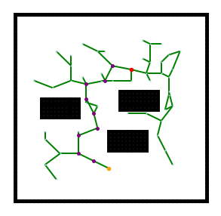 | 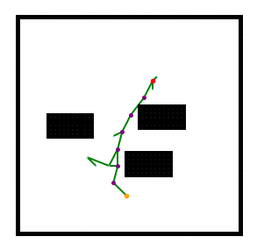
（a） | (b)
Fig.19. RRT* and GNRRT* Path Planning Visualization
Fig.19 shows the path planning result completed by RRT* and GNRRT* algorithms. The map size is 41x41, with random chosen start node (Red point) and goal node (Orange point). Green lines showed the tree build by RRT* or GNRRT*. As we can see from subgraph a and b, the RRT* tree is bigger than GNRRT*. Meanwhile, the area of RRT* is larger than of GNRRT*. The length of path between two configurations found by RRT* is also longer than path found by GNRRT*. Therefore, GNRRT* performs better than RRT* algorithm.

6. Conclusion
Graph is a powerful tool for representing many relations and situations in real world. Graph neural networks have shown promise performance on work with graphs. GNNs haven been applied to many areas like auto robotic, medical research, knowledge graph and so on. Path planning is a crucial problem in fields like navigation, automation, drones. RRT* have shown its high performance in dynamic path planning. But it still has the limitation of slow convergence. Many improvement approaches have been well studied to alleviate this limitation. One way is the narrow down the sampling area. In this regard, this dissertation introduced a GNRRT* algorithm. GNRRT* uses graph neural network model to predict the path area, and then use RRT* to search this area. The smaller path area predicts accurately by the GNN model, the fast RRT* converges. The methodologies of relative techniques are demonstrated in this dissertation which give a necessary understanding of this experiment.

The experiment this dissertation conducted, trained six models in total with two graph neural network architectures and 3 datasets consist of different size of maps. The details of training process and test result are illustrated and analysis. The best model can well predict the area of path given two configurations in a map that is unseen in that training process. This graph neural network method actually can implement with most of sampling-based path planning methods.

7. Reflection
In this reflection chapter, I would like to talk about the whole experience of this dissertation journey. Some issues I encountered during experiment conduction and how I handled them. There would also be analysis about reasons of some conditions happened.

Right from start, I was not very familiar with the implementation of the graph neural network technique. I only knew that it is a very powerful and fast developing technique that can discover information and patterns on graphs. At that time, I was engaging with a project that need to learn path planning techniques. And I realize that most maps can be represented as graphs therefore I want to apply graph neural network to do a path planning task. That was the beginning of my nightmare. I need to check a lot of existing resources and design how this would work out. I had no idea about the format of input and output. I started to design and generate datasets after I took the Stanford CS224W class. Took the insight from NRRT*, I decided to build a GNN model that can help narrow down the sampling space in RRT* therefore improve the slow convergence speed.

During experiment, the coding also took me a lot of time. I used Pytorch Geometric, NetworkX and some other python libraries to train my GNN models. There were some version conflicts between those libraries and forced me to exam and reinstall suitable versions of those libraries to work together. Another issue was that graph structure data occupy a lot of memories. Compare to NRRT* that the authors used a dataset more than 5000 maps to train their CNN models, I can only use like 10-30 medium size maps to train my model at one time. I was worry that this might not be enough maps to give information to the model. But luckily, graph neural network work out pretty well just trained on a few maps. However, graph neural network still took hours to train one model. The larger the dataset was, the more neural neurons the GNN had, hence it required more calculational time. Although I only implemented two GNN architectures and trained 6 models at the end, but actually I need to try different architectures with fine tune those hyperparameters and train a lot of times to have a reasonable combination at the beginning. I studied some posts about graph neural network practices carefully and finally adopted two model architectures from Stanford CS224W Graph ML Tutorials. There is a main issue bother me. Those graph neural network models are black boxes and lack of explanations on predictions. Z. Ying et. al [22] introduced an approach call GNNexplainer which can interpret prediction. Some other works focus on improve the expressive ability of graph neural network also have been well developed.

After I finished my experiment and collected all experimental data, the writing of this dissertation was also another main challenge for me since English is not my first language. I learned some expressions from other papers and academic materials I studied and tried to stay as objective as I can about the result of my experiment while demonstrate them in chapter 5.

There are a lot of aspects I need to improve in the future. First, I need to learn more deeply about graph neural network. Model’s outcome result more be more accurate if I can improve model architectures with sound graph neural network knowledges. Second, I need to practice my English writing skill.

At the end, I would like to give gratitude to all my teachers and my supervisors that help and support me. It is impossible that I can complete this dissertation without their assists.

References
[1] C. Lamini, S. Benhlima, and A. Elbekri, “Genetic Algorithm Based Approach for Autonomous Mobile Robot Path Planning,” Procedia Computer Science, vol. 127, pp. 180–189, 2018, doi: https://doi.org/10.1016/j.procs.2018.01.113.
[2] S. M. LaValle and J. J. Kuffner, “Randomized Kinodynamic Planning,” The International Journal of Robotics Research, vol. 20, no. 5, pp. 378–400, May 2001, doi: https://doi.org/10.1177/02783640122067453.
[3] O. Khatib, “Real-Time Obstacle Avoidance for Manipulators and Mobile Robots,” The International Journal of Robotics Research, vol. 5, no. 1, pp. 90–98, Mar. 1986, doi: https://doi.org/10.1177/027836498600500106.
[4] Y. Koren and J. Borenstein, “Potential field methods and their inherent limitations for mobile robot navigation,” Proceedings. 1991 IEEE International Conference on Robotics and Automation, doi: https://doi.org/10.1109/robot.1991.131810.
[5] A. H. Qureshi and Y. Ayaz, “Potential functions based sampling heuristic for optimal path planning,” Autonomous Robots, vol. 40, no. 6, pp. 1079–1093, Nov. 2015, doi: https://doi.org/10.1007/s10514-015-9518-0.
[6] I.-B. Jeong, S.-J. Lee, and J.-H. Kim, “Quick-RRT*: Triangular inequality-based implementation of RRT* with improved initial solution and convergence rate,” Expert Systems with Applications, vol. 123, pp. 82–90, Jun. 2019, doi: https://doi.org/10.1016/j.eswa.2019.01.032.
[7] Y. Li, W. Wei, Y. Gao, D. Wang, and Z. Fan, “PQ-RRT*: An improved path planning algorithm for mobile robots,” Expert Systems with Applications, vol. 152, p. 113425, Aug. 2020, doi: https://doi.org/10.1016/j.eswa.2020.113425.
[8] M. B. Jordan and A. Perez, “Optimal Bidirectional Rapidly-Exploring Random Trees,” Aug. 2013.
[9] A. H. Qureshi and Y. Ayaz, “Intelligent bidirectional rapidly-exploring random trees for optimal motion planning in complex cluttered environments,” Robotics and Autonomous Systems, vol. 68, pp. 1–11, Jun. 2015, doi: https://doi.org/10.1016/j.robot.2015.02.007.
[10] V. Mnih et al., “Human-level control through deep reinforcement learning,” Nature, vol. 518, no. 7540, pp. 529–533, Feb. 2015, doi: https://doi.org/10.1038/nature14236.
[11] Q. Ru, “Research and application of deep Q neural network algorithm combined with prior knowledge in indoor path planning [D],” 2018.
[12] J. Li, Y. Chen, X. Zhao, and J. Huang, “An improved DQN path planning algorithm,” The Journal of Supercomputing, vol. 78, no. 1, pp. 616–639, May 2021, doi: https://doi.org/10.1007/s11227-021-03878-2.
[13] J.-B. Cordonnier and A. Loukas, “Extrapolating paths with graph neural networks,” 2019.
[14] J. Wang, W. Chi, C. Li, C. Wang, and M. Q-H. Meng, “Neural RRT*: Learning-based optimal path planning,” IEEE Transactions on Automation Science and Engineering, vol. 17, Art. no. 4, 2020.
[15] W. Hamilton, Z. Ying, and J. Leskovec, “Inductive representation learning on large graphs,” Advances in neural information processing systems, vol. 30, 2017.
[16] S. Raschka, “Model evaluation, model selection, and algorithm selection in machine learning,” 2018.
[17] A. Javaid, “Understanding dijkstra’s algorithm,” 2013.
[18] J. Wang, W. Chi, C. Li, C. Wang, and M. Q.-H. . Meng, “Neural RRT*: Learning-Based Optimal Path Planning,” IEEE Transactions on Automation Science and Engineering, vol. 17, no. 4, pp. 1748–1758, Oct. 2020, doi: https://doi.org/10.1109/TASE.2020.2976560.
[19] S. Karaman and E. Frazzoli, “Sampling-based algorithms for optimal motion planning,” The International Journal of Robotics Research, vol. 30, no. 7, pp. 846–894, Jun. 2011, doi: https://doi.org/10.1177/0278364911406761.
[20] T. N. Kipf and M. Welling, “Semi-supervised classification with graph convolutional networks,” 2017. Available: https://openreview.net/forum?id=SJU4ayYgl
[21] P. Veličković, G. Cucurull, A. Casanova, A. Romero, P. Lio, and Y. Bengio, “Graph attention networks,” 2017.
[22] Z. Ying, D. Bourgeois, J. You, M. Zitnik, and J. Leskovec, “Gnnexplainer: Generating explanations for graph neural networks,” Advances in neural information processing systems, vol. 32, 2019.

