Human Resource Management Assignment I
By Vijaypal Godara

Name :-Vijaypal Godara
Student Number :- 2130310
Module:-LCMB7000
Lecturer:-Gladius David Kulothungan
Course:- Master In Business Administration
Submission Date:- 10/09/2022

Table of Contents
Part A: The current state of the labour market in the UK 3
Introduction 3
Labour Market Trends and Statistics 3
Conclusion 6
Part B: Changes in Human Resourcing Strategies emerged in the post-Covid, post-Brexit external environment 8
Redefining organisational culture through promoting a people-centred workplace 8
Adjusting rewards for market realities through the use of flexible and individualised pay structures 9
Encouraging data-driven decision-making through the use of workforce analytics 10
Conclusion 12
References 13

Part A: The current state of the labour market in the UK

Introduction
The overall state of labour market in the UK is unique and has witnessed one of the most unprecedented issues in the past few years. One of the reasons for the poor and challenging state of the labour market could be attributed to two events namely Brexit and Covid-19 which transformed the pre-existing standards and procedures within the market. Starting with Brexit, the political decision of the UK government to leave the EU resulted in impacting the labour market in different ways. As explained by Ishchy (2018), some of the critical sectors such as manufacturing industries in the UK would suffer serious gap in demand and supply of labour due to Brexit as free movement of labour from various EU countries from and to the UK has been restricted. In addition to this, there can be an unceremonious exit of a number of large corporations due to supply chain and raw material availability issues due to which the balance in the labour market can be affected.

In regards to the impact of Covid-19, the pandemic resulted in economic disruption which is something that the world did not witness in recent history (Lustov, 2022). The methods and procedures implemented to control the spread of virus included widespread lockdowns and movement restrictions. Such measures were introduced in all parts of the world. Hence, there was a reduction in aggregate demand for goods and services, supply chains and entire economic activities. Consequently, the slowdown and recessions in the economy resulted in influencing the labour market that saw an increased level of unemployment.

Labour Market Trends and Statistics
Despite the economy's slowing growth, the UK labour market is still hot, according to official figures released on Tuesday. While the number of full-time employees is at an all-time high, there are now a record 1.3 million unfilled vacancies (Leaker, 2022).

However, the report included some early signs that the labour market might change, with hiring stalling and unemployment ticking higher. Economists said the figures backed the case for the Bank of England to raise interest rates again. Still, they could undermine the case for a sizable increase or continued aggressive policy tightening.

In the three months before April, the employment rate rose to 75.6%, up 0.2 percentage points from the prior quarter and more than forecasted by analysts, according to statistics from the Office for National Statistics. The main factor driving this was full-time employment, which kept part-time and self-employment below pre-pandemic levels (Leaker, 2022).

Strong labour demand amidst galloping consumer price inflation would justify the further tightening of monetary policy. The data showed the challenge the BoE is up against due to central banks being pressured to tighten monetary policy when there are already several signs that growth is slowing down.

According to the data, hiring has decreased from its current frenetic pace. The number of openings was scarcely up from the month prior while at a record high. With a rise in April, the unemployment rate rose to 3.8% over the last three months, only a hair above the 50-year low milestone achieved a month earlier. The fact that worker shortages are allegedly no longer actively becoming worse suggests that the labour market has reached a turning point.

The numbers show that hiring has slowed down from its frantic pace. Despite being at a record high, the openings barely increased from the previous month. The unemployment rate increased in April to 3.8% for the past three months (figure 1.0), only slightly more than the 50-year low mark reached a month earlier. It appears that the labour market has reached a turning point because the shortage of workers is apparently no longer actively getting worse.

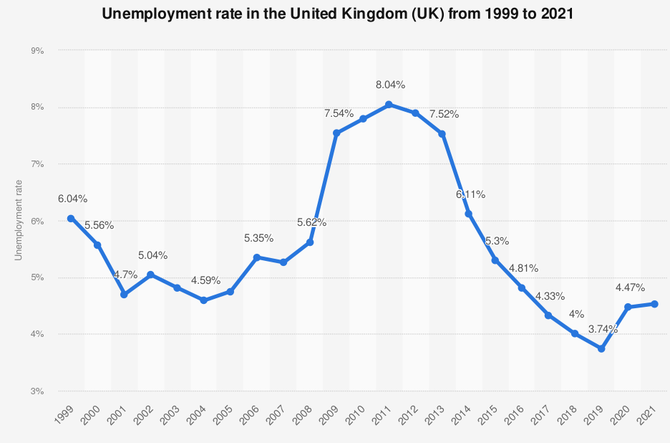
Figure 1.0: Unemployment Rates in the UK (Statista, 2022)

The jobs market was still strong, and the government provided "immediate relief with rising prices," but helping individuals find better jobs was the best long-term solution. But inflation is now significantly affecting take-home pay. Even if pay growth is still healthy by historical standards, the average weekly pay check in April—the month when the cap on residential energy bills changed—was 3.4% less in real terms than it had been a year earlier.

The single-month data for April showed that, even with bonuses, overall income had decreased slightly in real terms over the preceding three months while largely keeping up with inflation.
At 75.5%, compared to the previous quarter, the UK employment rate was basically steady, but it was still below pre-coronavirus (COVID-19) pandemic levels (figure 2.0).
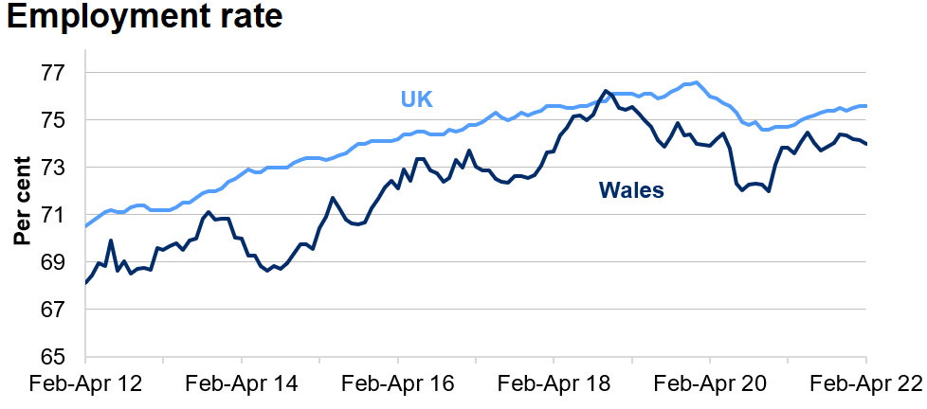
Figure 2.0: Employment Rates in the UK and Wales (Government Sources)

Over the course of the quarter, there were more full-time employees than part-timers, but a decline in the latter group offset this increase. The number of independent contractors is still much below pre-coronavirus pandemic levels, notwithstanding a little uptick in the most recent quarter.

Conclusion
Based on the available information and statistics, this could be concluded that the UK labour market is largely in a rebuilding phase as it recently faced dual challenges of Covid-19 and Brexit. The numbers related to unemployment are improving and there is a constant increase in the economic activity, which inadvertently influences the labour market in the country. The statistics point out that the country has not yet reached the pre-pandemic levels in terms of total hours worked and employment rates. However, this could be a critical phase in the recovery process of the economy as well as the labour market. The number of opportunities available for freelancers has reduced and there is a change in the trends of managing human resources in the organisations across the nation.

The economic inactivity rate increased from December 2021 to February 2022 by 0.2 percentage points to 21.4%. This trend is driven by retired people who have a chronic illness or are otherwise economically inactive due to caring for their families or houses. There were 1,288,000 more available positions from January to March 2022 compared to the previous high. However, the rate of vacancy growth remained slow. The sectors of human health and social work experienced the fastest growth in job opportunities, which increased by 50,200 during the quarter.

Part B: Changes in Human Resourcing Strategies emerged in the post-Covid, post-Brexit external environment

There are a number of issues which the human resource managers and practitioners have faced after the Brexit and Covid-19 impact on the economy. Some of the most critical aspects that will have an implication on the human resource strategies of companies are as follows:

- What potential effects would COVID-19 have on workplace health and safety?
- What impact will remote work have on daily operations and organisational culture?
- What social impacts might a shift like that have on staff engagement and communication?

The potential effects and uses of HR following COVID-19 are practically endless. There is no denying that the epidemic and its consequent impact on businesses have emphasised the importance of HR in the new normal, expedited the shift towards a new, digital economy, and underlined the need for adaptability and resilience in today's workforce.

Redefining organisational culture through promoting a people-centred workplace
As organisations strive to adopt more flexible working arrangements, restoring organisational culture will become a primary responsibility for HR departments (Rivera-Prieto, Santana and López-Cabrales, 2022). A sizable move will probably be made toward hybrid employment conditions, which combine the advantages of remote and office employment. Although this is a positive development, the ramifications of this change pose a threat to the current organisational culture. The social dynamic between employees will alter as a result of different working conditions, such as fewer face-to-face interactions and a more dispersed workforce. How will corporate leaders lead workers at all levels and affect their choices?

By scheduling regular check-ins just for business, social engagement, or emotional support, you may create a balanced structure suitable for managing a remote workforce and strengthening ties. An open dialogue should be promoted, and direct lines of communication should be maintained across all levels of an organisation to keep management informed of employee issues (Bussin and Swart-Opperman, 2021). Lastly, creating policies and programmes for diversity, equality, and inclusion will strengthen organisational culture and create an environment that promotes involvement, trust, and unity. To accelerate the pace of remote working, organisations must actively endeavour to uphold their core values and emphasise building a workplace where people are at the centre of every decision. The most important thing to remember is that focusing on employee engagement through pulse and satisfaction surveys is a wonderful way to evaluate their knowledge and opinions and obtain their advice on adjusting to the new reality successfully.

Adjusting rewards for market realities through the use of flexible and individualised pay structures
Covid-19 has resulted in posing a wide range of unprecedented challenges before the HRM professionals. Whereas the earlier measured focussed on improving employee performance and costs related with human resources, the focus has changed towards better employee engagement and ensuring that employee turnover is low. There is a need for better flexibility in the HRM processes and the managers and decision-makers must look forward at breaking the existing norms agreed in the profession.

As claimed by Joardar and Wu (2022), it would be incorrect for the human resource managers to expect that the traditional measures of performance management would work in a highly dynamic environment. It is critical that the way employees are managed and performance is evaluated should be based on transparent mechanisms. Hence, top leaders of a business would need to play an integral and critical role in redefining the performance management processes. For instance, having standard pay structures would be difficult as the salaries and compensations would be largely based on efforts made by an individual for attaining organisational goals.

Encouraging data-driven decision-making through the use of workforce analytics
The importance of data analytics in business organisations and human resources aiming to take account of satisfaction, engagement and experience has increased significantly with the improvement in technology (Bussin and Swart-Opperman, 2021). In the current scenario, it is highly recommended that companies should make the best of the analytics and latest technologies in different aspects of HRM including hiring people and training and development of the human resources. The traditional methods of performance management will need to be changed and the compensation management should also be more focussed.

Executives in the business world must also consider how the two interact because COVID-19 significantly changed the economic context of Brexit. The initial economic shock from COVID-19 will undoubtedly be substantially harsher than any immediate repercussions from Brexit, there is no doubt about it. Lockdowns in particular, have impacted demand more than ever before (both domestic and international). However, Brexit will also have broad-reaching and protracted effects.

This tendency has gained further traction due to COVID-19, which has seen a sudden, greatly extended shift toward home working and a sharp increase in digital and remote technology use. It will be critical to keeping an eye on any shifts in this pattern. Numerous people will likely return to office employment after recovering from COVID-19. But not everybody will, and those who do won't do it as regularly as before.

Depending on the type of the economic recovery, which in turn will depend on the pandemic response, the length of COVID-19 will vary sector by sector. Whether other industries, including leisure and hospitality, can resume regular operations will depend on whether partial lockdowns are renewed or whether the social distance is widened or narrowed.

The two economic shocks are putting a strain on the same human resources since COVID-19 and Brexit both need for the same degree of planning expertise. If firms lack the financial and personnel resources to carry out their Brexit initiatives as anticipated, the epidemic's abrupt start creates major issues. Some companies depleted their Brexit stockpiles during COVID-19. The pharmaceutical business is the best example of how they need to be rebuilt in an even more challenging environment.

Businesses face a unique challenge due to the COVID-19 outbreak and Brexit. The analysis provides the following significant business lessons:
- Businesses need to start making meaningful Brexit preparations right away because they are not yet fully equipped. They should cover supply chains, regulations, and taxes in addition to individuals.
- A business should revaluate your Brexit tactics in light of the changing environment. Plans that would have been logical before COVID-19 might not be logical now. Issues that could have looked unimportant in the past context might have a completely new meaning when related to COVID-19. It will be necessary to assess hastily made strategic decisions brought about by COVID-19 in light of Brexit.
- Reviewing the resources that are available and designated for carrying out the Brexit preparations. Do the same teams have the capability and knowledge to create at this time, given everything else they have to manage?
- The importance of a learning organisation is relevant more than ever in the current situation. For attaining a higher degree of employee engagement level, it is critical that a business should make enough efforts to work closely for skill development and training of the employees in a highly dynamic environment.

Conclusion
The epidemic's economic impact on businesses rapidly put them under pressure to alter and adapt to the new normal to survive. HR must develop the HR lifecycle and keep it up to date in order to be able to respond to changing organisational needs. To put it simply, HR will need to create novel, ground-breaking approaches to support business executives both during and after the outbreak, implement staff reduction plans while minimising risks associated with such moves, and increase productivity and employee engagement. The longer HR waits, the longer it will take for organisations to adapt and succeed in the post-COVID world, so HR must take action right away.

References
Bussin, M. and Swart-Opperman, C., 2021. COVID-19: Considering impacts to employees and the workplace. SA Journal of Human Resource Management, 19.
Ishchy, U., 2018. Financial Impact of Brexit. SSRN Electronic Journal,.
Joardar, A. and Wu, S., 2022. A Reexamination of Antecedents of Entrepreneur Performance During Covid-19 Pandemic. Academy of Management Proceedings, 2022(1).
GOV.WALES. 2022. Labour market overview: June 2022 | GOV.WALES. [online] Available at: <https://gov.wales/labour-market-overview-june-2022> [Accessed 2 September 2022].
Leaker, D., 2022. Labour market overview, UK - Office for National Statistics. [online] Office for National Statistics. Available at: <https://www.ons.gov.uk/employmentandlabourmarket/peopleinwork/employmentandemployeetypes/bulletins/uklabourmarket/june2022#:~:text=The%20UK%20employment%20rate%20increased,number%20of%20part%2Dtime%20employees.> [Accessed 1 September 2022].
Lustov, N., 2021. Impact of the Covid-19 Pandemic on the Global Economy. Journal of Clinical and Laboratory Research, 2(4), pp.01-02.
Rivera-Prieto, J., Santana, M. and López-Cabrales, Á., 2022. Turnaround and human resource strategies during the COVID-19 crisis. BRQ Business Research Quarterly, p.234094442211200.
Statista. 2022. United Kingdom - Unemployment rate 2021 | Statista. [online] Available at: <https://www.statista.com/statistics/263709/unemployment-rate-in-the-united-kingdom/> [Accessed 2 September 2022].

