Electromagnetic Radiation

Design and Analysis of Electromagnetic Systems

BEng Embedded Electronics systems

Module Code: ACDA5009

Name: Bailey Freeman Date: 08/04/2025
Contents

Waveguide simulation 2
Abstract: 2
Introduction: 3
Methodology: 3
Results: 4
Discussion: 12
Conclusion: 13
Antenna simulation 13
Abstract: 13
Introduction: 13
Methodology: 14
Results: 15
Discussion: 16
Conclusion: 16
RADAR Challenges 17
Introduction: 17
Literature Review: 17
Discussion: 18
Conclusion: 19
References 19
Table of Figures 20

Waveguide simulation

Abstract:
This report presents the simulation and theoretical analysis of a rectangular waveguide with Perfect Electric Conductor (PEC) walls, using ANSYS HFSS. Two models were developed, one filled with vacuum and one with Teflon. The waveguide was analysed across a frequency sweep from 2 GHz (Gigahertz) to 30 GHz, with three modes assigned at each port to observe electromagnetic mode behaviour. Key characteristics such as cutoff frequencies, and mode propagation were recorded. Results were compared with theoretical calculations to validate the simulations. The study demonstrates how the internal material significantly affects wave propagation and cutoff behaviour in waveguides.

Introduction:
Rectangular waveguides are widely used in high frequency electromagnetic systems such as radar and satellite communications, due to their ability to guide signals with low loss. The behaviour of waves within a waveguide depends on its dimensions, boundary conditions, and the material it is filled with. [1]
This project involves designing a rectangular waveguide with PEC walls, first filled with vacuum and then with Teflon, a dielectric material. A frequency sweep from 2 GHz to 30 GHz is used to analyse how electromagnetic modes propagate within the waveguide. Both theoretical and simulation-based methods are applied to identify the dominant and higher order modes and calculate and compare cutoff frequencies.
Waveguide modes are typically labelled using the TE_{mn} or TM_{mn} naming convention, where TE stands for Transverse Electric and TM for Transverse Magnetic. The subscripts m and n refer to the number of half-wavelength field variations in the wider (a) and narrower (b) dimensions of the rectangular waveguide, respectively. The TE₁₀ mode is the dominant mode in most rectangular waveguides, as it has the lowest cutoff frequency and is the easiest to excite. [2]
The aim is to understand how the choice of material affects wave propagation, particularly in terms of mode behaviour and cutoff frequency shifts.

Methodology:
The simulation was performed using ANSYS HFSS. The waveguide geometry was defined with the following dimensions:
- Width (a): 23 mm
- Height (b): 6 mm
- Length: 50 mm
PEC boundaries were applied to all walls, and the interior was filled with either vacuum or Teflon. Two wave ports were placed at the waveguide ends (port 1 and port 2), with the number of modes set to three to observe multiple propagating fields. The simulation used a frequency sweep from 2 GHz to 30 GHz, with modal field and S-parameter solutions enabled.
Tasks Performed
Vacuum Filled Waveguide
- Simulated field distributions at port 1 and port 2.
- Identified dominant and higher order propagating modes.
- Plotted cutoff frequencies using simulation data.
- Calculated theoretical cutoff frequencies for the first three modes using:
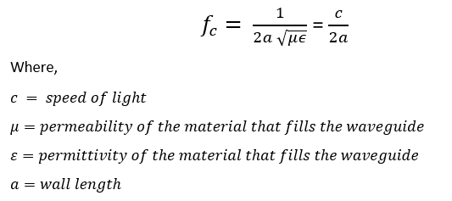
Teflon Filled Waveguide
- Used identical geometry and simulation parameters.
- Replaced vacuum with Teflon
- Repeated simulation steps to collect mode and field data.
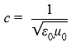
- Adjusted theoretical formula using

Results:
Vacuum Filled Waveguide
Propagating Modes
The TE₁₀ mode was observed as the dominant propagating mode. Shown in Figure 1 and Figure 2.
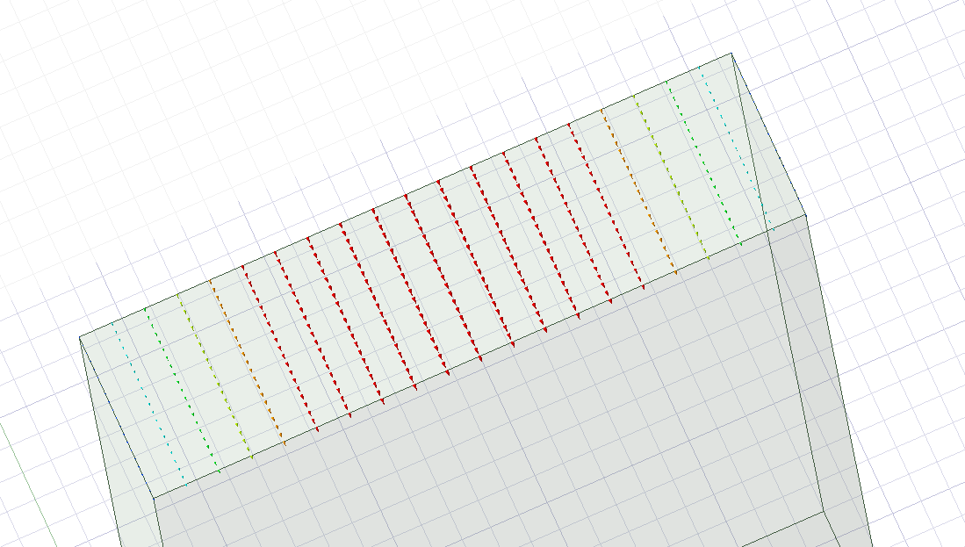
Figure 1: Port 1 TE₁₀ mode (vacuum)
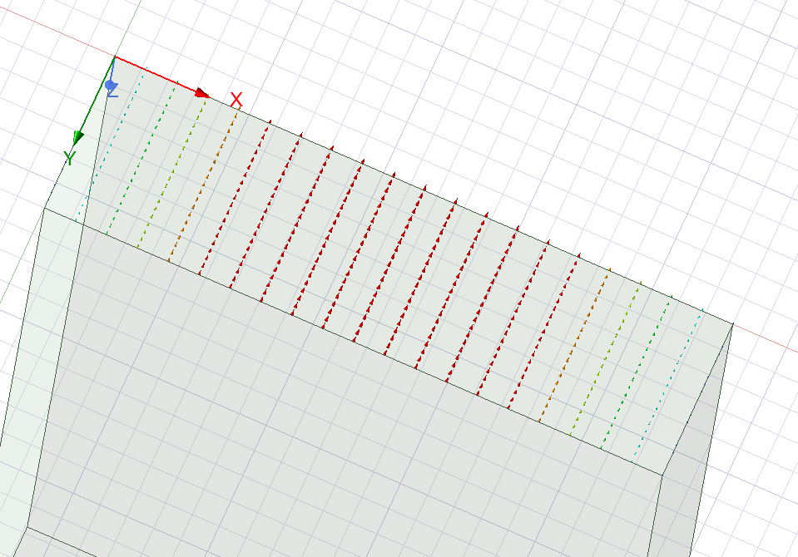
Figure 2: Port 2 TE₁₀ mode (vacuum)
Port Field Displays
Electric field distributions at Port 1 and Port 2 confirmed mode excitation and transmission.
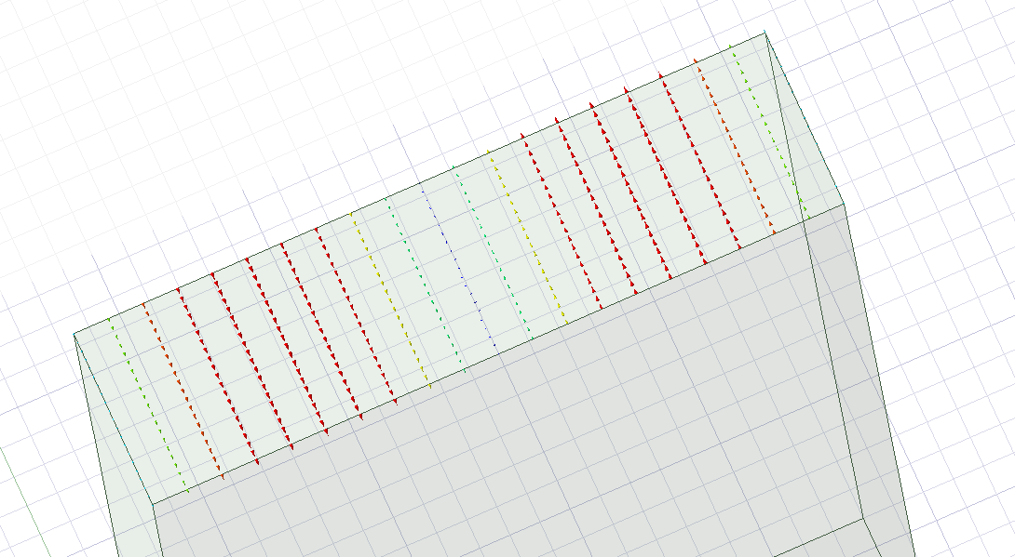
Figure 3: Port 1 TE₀₁ mode (vacuum)
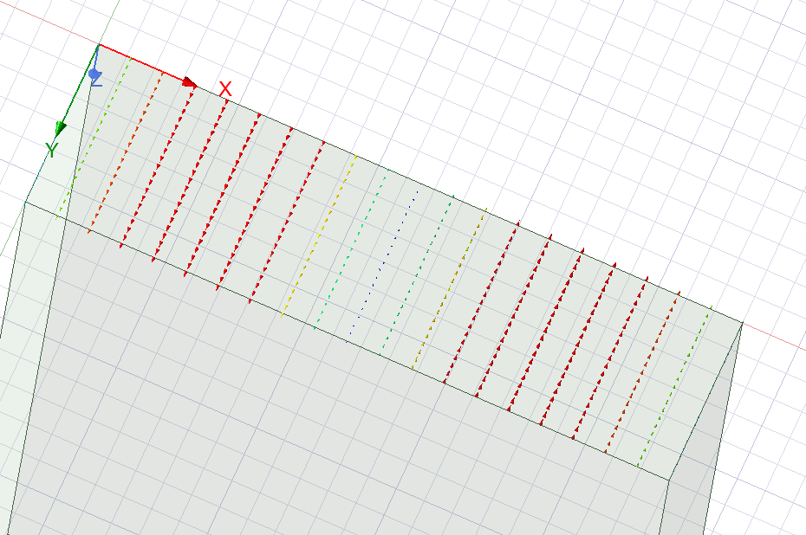
Figure 4: Port 2 TE₀₁ mode (vacuum)
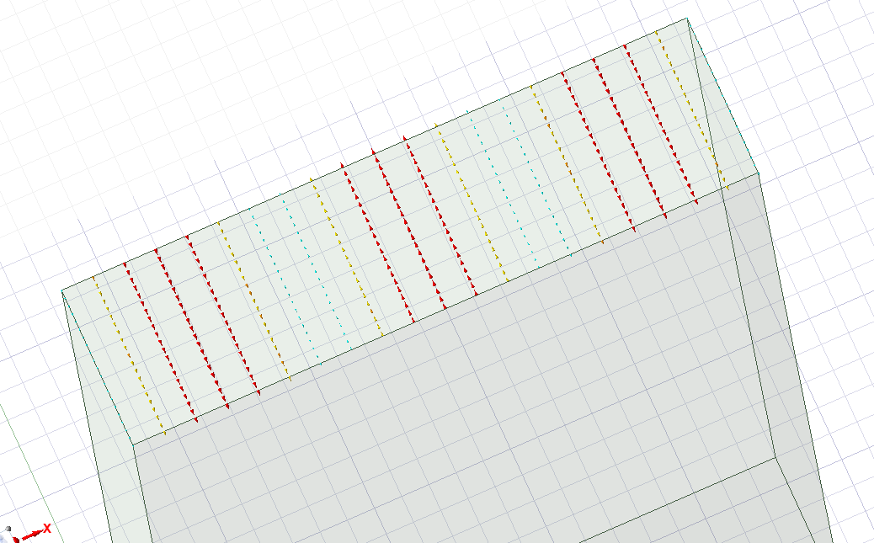
Figure 5: Port 1 TE₁₁ mode (vacuum)
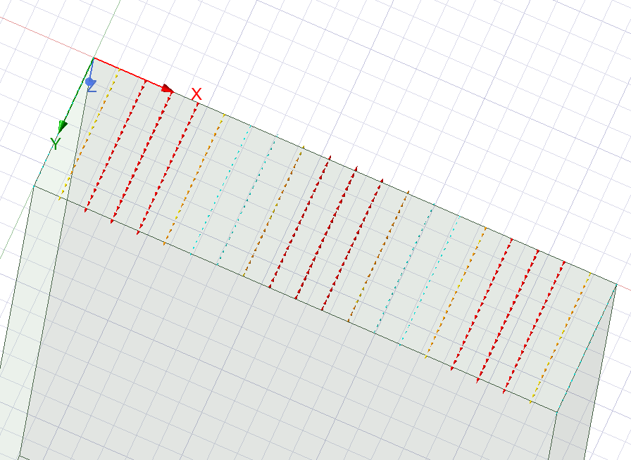
Figure 6: Port 2 TE₁₁ mode (vacuum)
Cutoff Frequency Plot
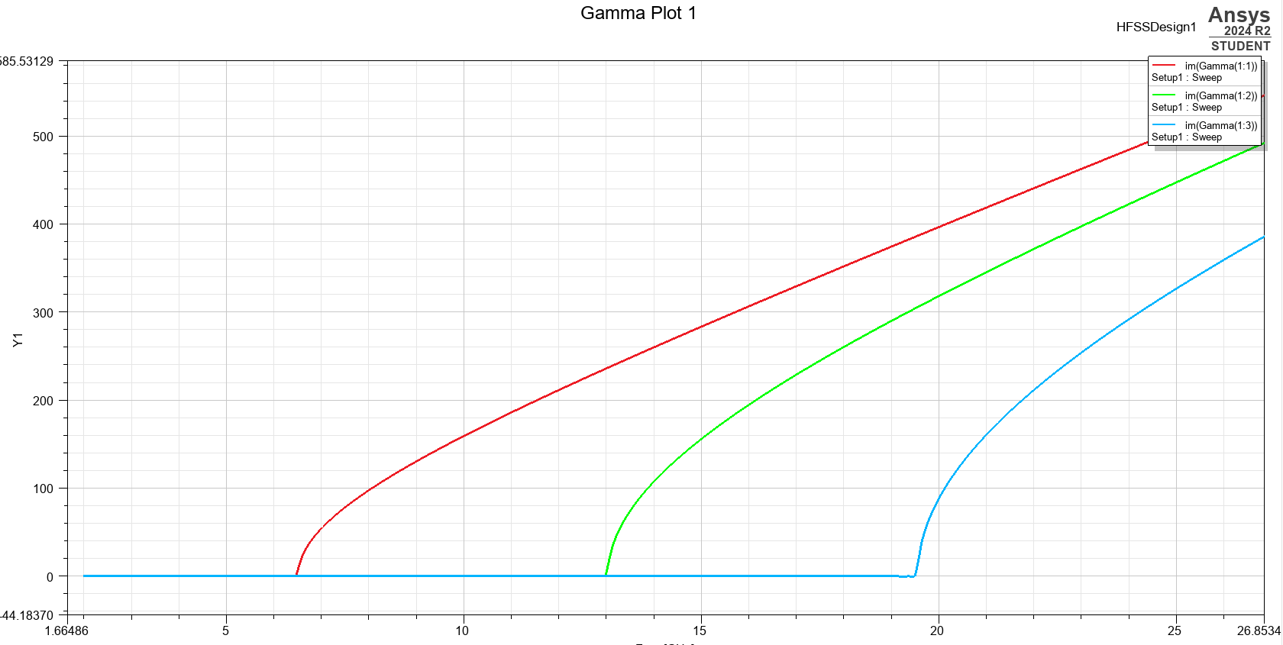
The rectangular plot of cutoff frequencies indicated the onset of propagation for each mode. These are displayed in Figure 7.

Figure 7: Cutoff frequency plots for respective modes (vacuum)
Theoretical Cutoff Frequency Calculation
Using the waveguide dimensions:
- A = 23mm
- b= 6mm
- c=3×10⁸ m/s
Theoretical cutoff frequencies were calculated as:
- TE₁₀: fc ​= 6.5GHz
- TE₀₁: fc ​= 25GHz
- TE₁₁: fc = 26.3GHz
Teflon Filled Waveguide
Propagating Modes
The TE₁₀ mode remained dominant, but all cutoff frequencies shifted lower due to the increased permittivity.
Port Field Displays
Similar field distributions were observed, with slightly altered patterns due to slower wave propagation. 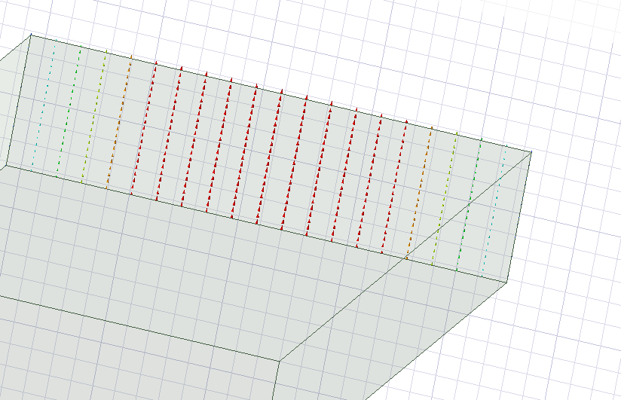
Figure 8: Port 1 TE₁₀ mode (Teflon)
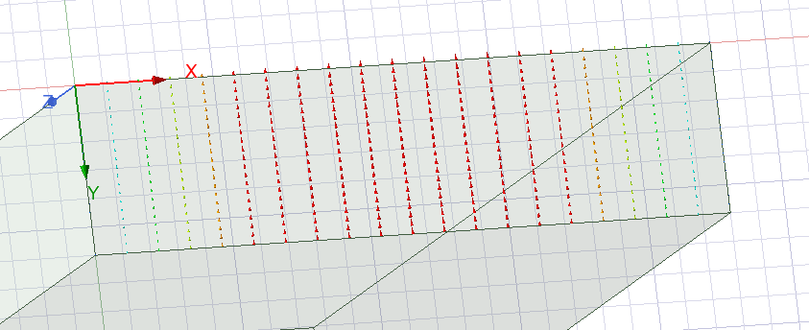
Figure 9: Port 2 TE₁₀ mode (Teflon)
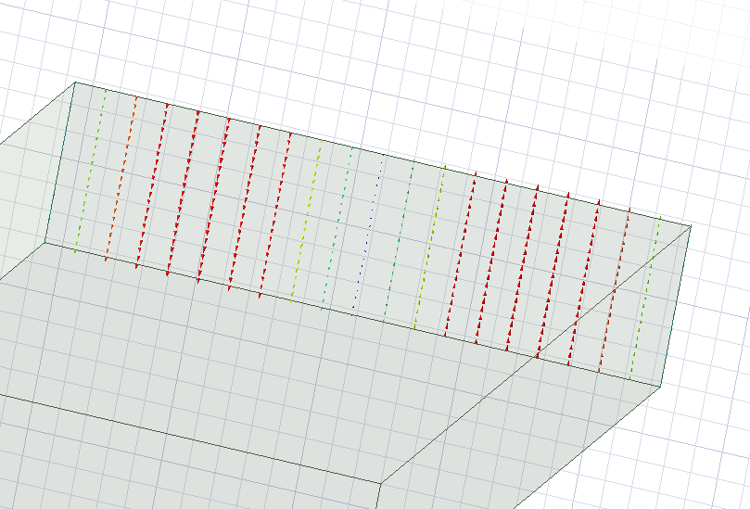
Figure 10: Port 1 TE₀₁ mode (Teflon)
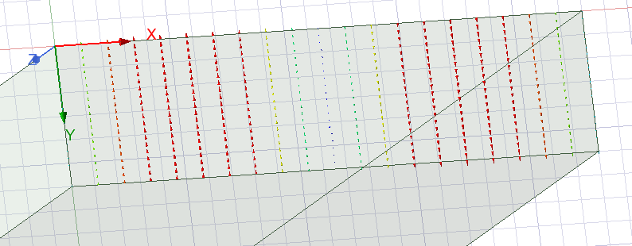
Figure 11: Port 2 TE₀₁ mode (Teflon)
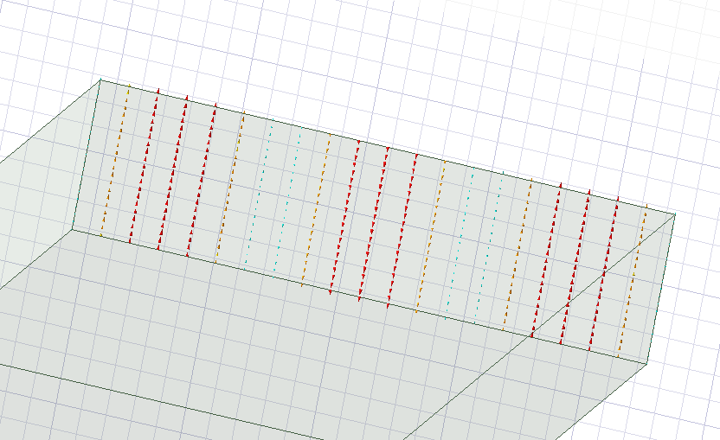
Figure 12: Port 1 TE₁₁ mode (Teflon)
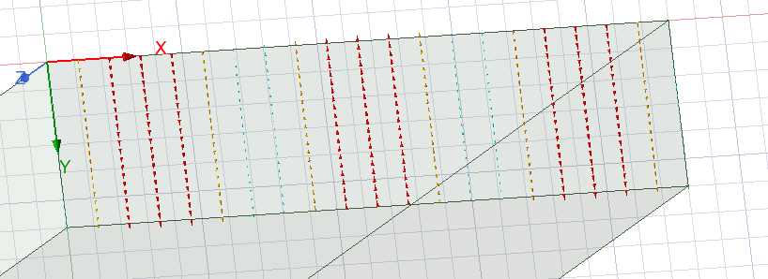
Figure 13: Port 2 TE₁₁ mode (Teflon)
Cutoff Frequency Plot
The cutoff frequency plot confirmed the shift in propagation thresholds for all modes. These are displayed in Figure 14.
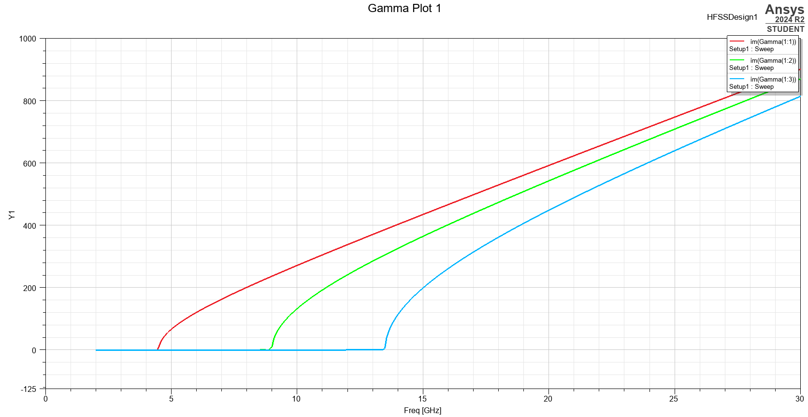
Figure 14: Cutoff frequency plots for respective modes (vacuum)
Theoretical Cutoff Frequency with Teflon
Using εr = 2.1 and applying the previously mentioned formulas the adjusted wave speed is 2.07×10⁸ m/s
Theoretical values:
- TE₁₀: fc = 4.5GHz
- TE₀₁: fc = 17.3GHz
- TE₁₁: fc = 18.2GHz

Discussion:
The simulation and theoretical results showed close agreement in identifying the dominant TE₁₀ mode. As expected, the cutoff frequencies decreased when the waveguide was filled with Teflon due to the reduced phase velocity of waves in the dielectric medium.
The shift in cutoff frequencies between vacuum and Teflon highlights how material properties significantly influence wave propagation. The field visualisations reinforced theoretical expectations, with mode patterns corresponding well to standard TE mode profiles. [3]
Minor discrepancies between theoretical and simulated results can be attributed to mesh resolution or ideal material assumptions.
A limitation of the simulation was the restriction to three modes, which may not capture all possible higher order behaviours above 30 GHz. Further analysis could expand the mode count or introduce realistic materials to study loss effects.

Conclusion:
This report demonstrated the design and simulation of a rectangular waveguide using HFSS under two conditions: vacuum filled, and Teflon filled. The analysis successfully identified propagating modes, visualised electric and magnetic fields, and determined cutoff frequencies both theoretically and through simulation. The presence of a dielectric material significantly reduced cutoff frequencies, affirming the impact of permittivity on waveguide behaviour. The comparison between the two models provided valuable insight into how material selection affects high frequency component design.

Antenna simulation

Abstract:
This report details the theoretical calculation, design, and simulation of a half-wave dipole antenna constructed using PEC material. The antenna is designed to operate at a wavelength of 231 mm, with excitation provided via a 50 Ω lumped port. Using electromagnetic simulation software, the antenna was placed within a rectangular radiation boundary and analysed to determine its performance. Key parameters such as operating frequency, return loss (S-parameters), and radiation patterns were obtained and compared against theoretical expectations. The results show a strong correlation between theoretical calculations and simulation outcomes.

Introduction:
Dipole antennas are among the most fundamental and widely used types of antennas in wireless communication, radio broadcasting, and radar systems. Their simple construction and predictable performance make them ideal for theoretical study and practical implementation. [4]
A half-wave dipole antenna operates at a length of half the wavelength (λ/2) of the target frequency. This resonant structure ensures efficient radiation and reception of electromagnetic energy. This project involves the design and simulation of a half-wave dipole intended to operate at a wavelength of λ = 231 mm, using PEC material and excited through a 50 Ω lumped port. The antenna is enclosed within a rectangular radiating boundary to simulate free space behaviour.
The aim is to determine the theoretical and simulated performance of the antenna, including the operating frequency, return loss, and radiation pattern, and to assess how well the design meets expectations.

Methodology:
The antenna was modelled and simulated using ANSYS HFSS, a high-frequency electromagnetic simulation tool. The following steps were taken:
Theoretical Calculations
Length of the Half-Wave Dipole
The length L of the dipole is calculated using L=λ/2
Given λ=231 mm the length becomes 115.5mm
ii) Operating Frequency
Using the formula: f=c/λ​
Where c=3×10⁸m/s and λ = 0.231m the frequency comes out to 1.3GHz
Simulation Setup
Antenna Design and Setup
- The dipole antenna was constructed from PEC material, with a cylindrical radius of 1 mm and a total length of 115.5 mm, divided equally on both sides of the feed point.
- A 50 Ω lumped port was placed at the centre to excite the antenna. Shown in Figure 15.
- The design was enclosed in a rectangular radiation boundary large enough to prevent reflection and simulate open space conditions.
- A frequency sweep (0.5-7GHz) was set to identify resonance.
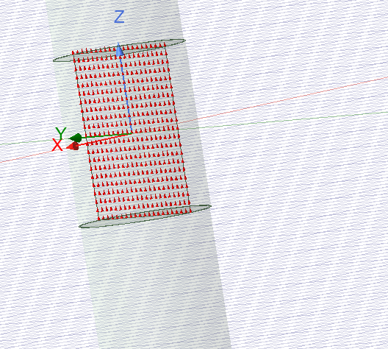
Figure 15: Lumped port with excitations

Results:
S-Parameter Plot and Resonant Frequency
The S₁₁ plot (Figure 16) shows the return loss as a function of frequency. A deep null in the curve indicates resonance (the operating frequency of the antenna).
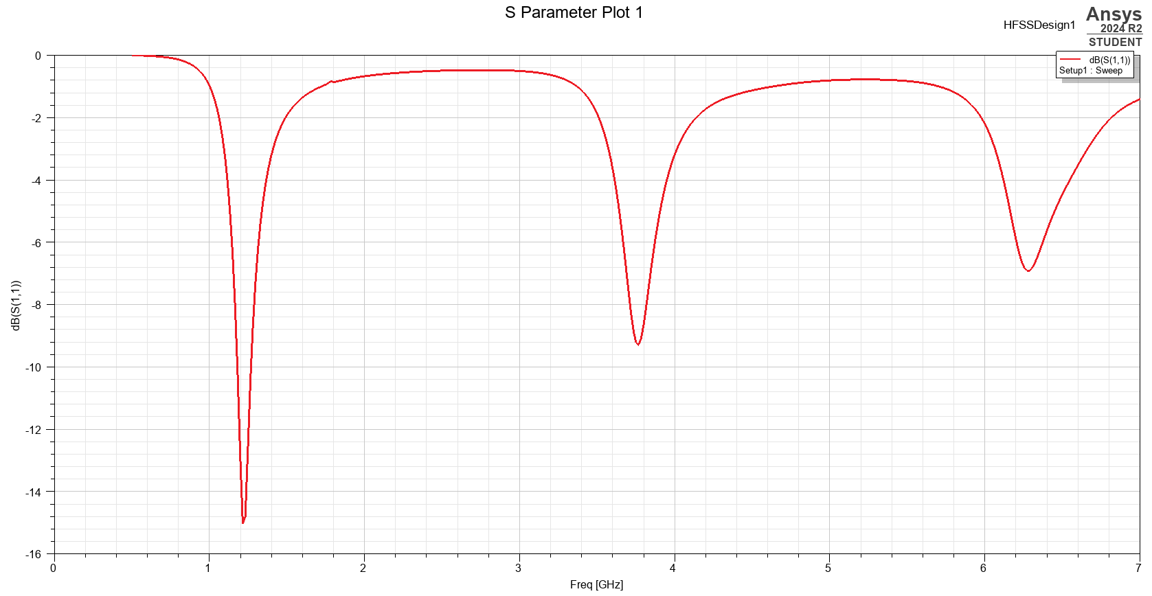
Figure 16: S₁₁ plot
Radiation Pattern
Radiation characteristics were recorded at the resonant frequency. As expected for a half-wave dipole, the pattern resembles a figure of eight in the plane perpendicular to the antenna axis shown in Figure 17.
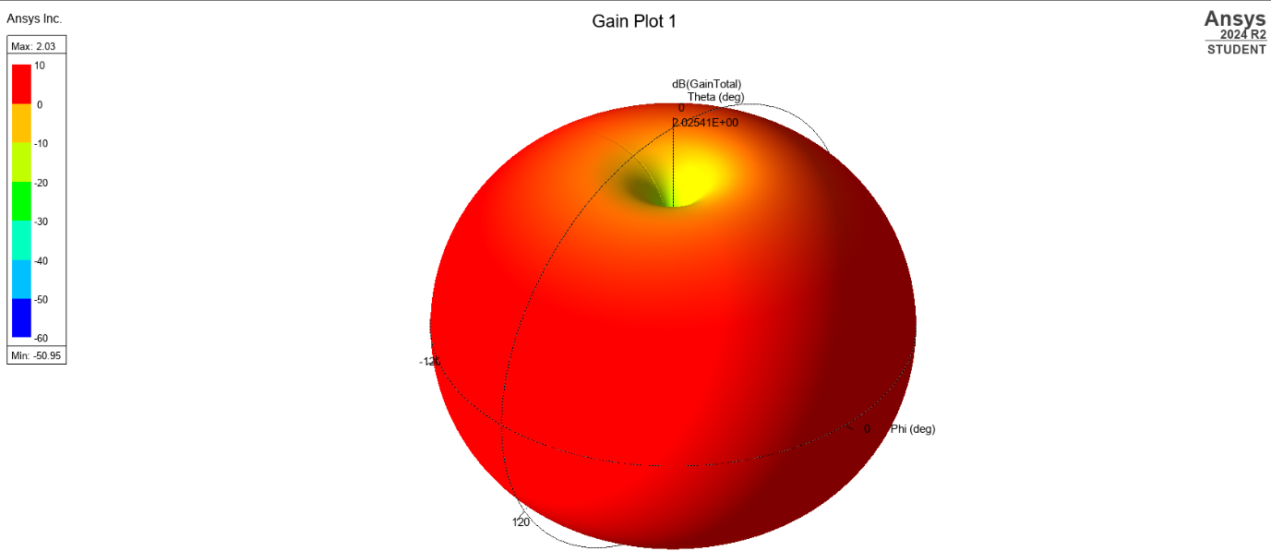
Figure 17: Half-Wave Dipole Antenna radiation pattern

Discussion:
The simulation confirmed that the antenna resonates at approximately 1.3 GHz, aligning closely with the theoretical calculation based on the given wavelength. The return loss at resonance was below -10 dB, indicating minimal reflected power.
The simulated gain of the half-wave dipole antenna was approximately 2.1 dB. This result indicates that the antenna radiates efficiently in the intended directions, with maximum radiation occurring perpendicular to the axis of the dipole.
The radiation pattern exhibited the expected dipole characteristics, with strong radiation perpendicular to the antenna and nulls along the axis. Minor deviations in operating frequency may result from lumped port gap spacing and length not exactly matching ideal resonant length or absence of real-world effects such as conductivity losses or dielectric substrates. [5]
The comparison shows that theoretical approximations are reliable for initial antenna design, but simulations provide closer insight into real-world effects and fine-tuning.

Conclusion:
This project successfully designed and simulated a half-wave dipole antenna with a resonant length of 115.5 mm. The antenna operated at approximately 1.3 GHz, as predicted by theoretical calculations. HFSS simulation provided a detailed understanding of the antenna’s return loss and radiation performance. The theoretical and simulated results showed strong agreement, validating the accuracy of the design approach. Future work could include material-based modelling, bandwidth analysis, or physical fabrication.

RADAR Challenges

Introduction:
The rise of drones and Unmanned Aerial Vehicles (UAVs) has revolutionised industries ranging from logistics to agriculture. However, their growing accessibility and versatility have posed significant challenges to airspace security systems, particularly radar (Radio Detecting and Ranging). This report investigates why radar systems struggle to detect drones and UAVs, how emerging technologies are addressing this, and the societal and environmental impacts of these innovations. It also offers suggestions for improving drone detection methods in the context of rapid technological development.

Literature Review:
Radar, originally developed to detect large, fast-moving aircraft, operates by emitting radio waves and interpreting the signals that bounce back. [6] While highly effective for traditional aircraft, radar struggles with drones due to several key factors. Drones typically have a small radar cross section, fly at low altitudes, and are often made of materials that do not reflect radar waves effectively. These features make them difficult to detect and track using standard radar systems. [7]
Recent research has explored using combinations of radar with other sensor types, such as optical, thermal, and acoustic systems, to improve detection reliability. [7] Additionally, advancements in AI (artificial intelligence) and machine learning have enabled the development of algorithms capable of identifying drone signatures with greater accuracy. [8] There is also growing attention to the societal and environmental impacts of the increasing use of drones in both commercial and recreational settings due to the security and privacy concerns as well as concerns surrounding energy consumption and electromagnetic emissions.

Discussion:
Radar Detection Challenges
One of the major difficulties with radar-based detection lies in the physical design and flight characteristics of UAVs. Unlike traditional aircraft, many drones are constructed using non-metallic materials, making them difficult for radar to detect. Their small size and low speed movement often place them below the radar’s detection threshold. Drones frequently operate in low altitude airspace, where ground clutter such as trees, buildings, and birds can obscure or confuse radar signals.
These challenges make it difficult to distinguish drones from other low flying objects, increasing the likelihood of either false negatives (failing to detect a drone) or false positives (misidentifying a harmless object as a drone).
Technological Advancements
To address these limitations, newer technologies employ a multi-sensor approach. Radar is often used in conjunction with electro-optical cameras, infrared sensors, and acoustic microphones to build a more complete picture of airspace activity. These systems can detect drones that evade traditional radar by identifying other characteristics such as sound profiles or heat signatures.
AI also plays a key role in modern detection systems. Algorithms trained on large datasets can differentiate between drones, birds, and other aerial objects with a higher degree of accuracy than older, rules-based systems. Some systems have been developed specifically for use in urban environments, combining detection with mitigation tools like signal jamming or drone capture nets.
Societal and Environmental Considerations
While these technological advancements improve safety and security, they also raise important societal and environmental questions. Widespread use of drone detection systems, particularly those using cameras or audio equipment, may impact individual privacy, especially in populated areas. There is a risk that such systems could be used for general surveillance beyond their intended purpose.
From an environmental perspective, concerns exist around the energy consumption of active detection systems and the potential for increased electromagnetic emissions. However, passive systems, which rely on ambient signals rather than emitting their own, offer a more environmentally friendly alternative.
It is also important to consider the balance between security and innovation. Overly aggressive counter drone measures could disrupt legitimate operations, including emergency services, media coverage, and conservation projects that rely on drones for aerial monitoring.

Conclusion:
Radar struggles to detect drones and UAVs due to their small size, low altitude, and use of non-reflective materials. Technological advances are addressing these limitations through multi-sensor systems, AI powered identification, and passive detection methods. While these developments greatly enhance airspace awareness, they must be balanced with societal and environmental responsibilities.
It would be recommended to invest in hybrid detection platforms that integrate radar with optical, infrared, and acoustic technologies to enhance drone tracking capabilities. Developing AI models can further improve identification accuracy. The adoption of passive detection systems should be encouraged to minimise environmental impact. Continued research and collaboration between industry, government, and academia will be essential to advance these efforts effectively. As drones continue to evolve, detection systems must remain adaptable and respectful of wider societal values.

References

[1] | D. M. Pozar, Microwave Engineering, 2012.
[2] | D. M. Pozar, Microwave Engineering, 2012.
[3] | M. Steer, Microwave and RF Design: Transmission Lines, North Carolina State University, 2019.
[4] | G. T. W.L. Stutzman, Antenna Theory and Design SE, 1998.
[5] | C. A. Balanis, Antenna Theory: Analysis and design, 2005.
[6] | J. A. S. W. A. H. Mark A. Richards, Principles of Modern Radar, 2010.
[7] | Z. Tang, “UAV Detection with Passive Radar: Algorithms, Applications, and Challenges,” Drones, vol. 9, 2025.
[8] | O. R. e. al, Detection and Classification of Drones using Radars, AI, and Full-wave Electromagnetic CAD Tool, 2023.

Table of Figures
Figure 1: Port 1 TE₁₀ mode (vacuum) 5
Figure 2: Port 2 TE₁₀ mode (vacuum) 6
Figure 3: Port 1 TE₀₁ mode (vacuum) 6
Figure 4: Port 2 TE₀₁ mode (vacuum) 7
Figure 5: Port 1 TE₁₁ mode (vacuum) 7
Figure 6: Port 2 TE₁₁ mode (vacuum) 8
Figure 7: Cutoff frequency plots for respective modes (vacuum) 8
Figure 8: Port 1 TE₁₀ mode (Teflon) 9
Figure 9: Port 2 TE₁₀ mode (Teflon) 10
Figure 10: Port 1 TE₀₁ mode (Teflon) 10
Figure 11: Port 2 TE₀₁ mode (Teflon) 11
Figure 12: Port 1 TE₁₁ mode (Teflon) 11
Figure 13: Port 2 TE₁₁ mode (Teflon) 12
Figure 14: Cutoff frequency plots for respective modes (vacuum) 12
Figure 15: Lumped port with excitations 15
Figure 16: S₁₁ plot 16
Figure 17: Half-Wave Dipole Antenna radiation pattern 16

