BEng (Hons) Mechanical & Manufacturing Engineering
Materials & Manufacturing Report
Materials & Introduction to Manufacturing [M4X01163]

Ben Woodhead [P151944]
1/3/2018

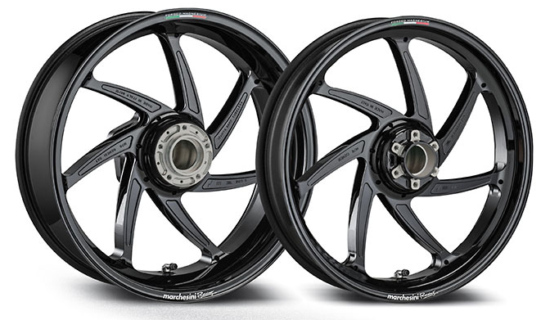
Cover image courtesy of Marchesini Wheels, part of the Brembo Group.
Contents
Abstract 2
Purpose of Part 2
Mass; 2
Strength; 3
Rigidity/Ductility; 3
Accuracy; 3
Cost; 4
Potential Materials 4
Aluminium (6061-T4) 4
Magnesium Alloy (AZ80A-T6) 4
Carbon Fibre (P-75 Carbon Fiber/Epoxy) 5
Potential Manufacturing Processes 6
Casting; 6
Vacuum Die-Casting; 6
Forging; 7
Cold Forging; 8
Warm Forging; 8
Hot Forging; 8
CNC Machining; 9
Carbon Fibre Manufacturing; 9
Layering; 9
Braiding; 9
Selection Criteria 10
Chosen Material 11
Chosen Process 11
Conclusions 12
Citations 13
Source Assessment 14

Cover image courtesy of Marchesini Wheels, part of the Brembo Group.

Abstract
The purpose of this report is to introduce and assess the materials and manufacturing processes available to a proposed design. The report will focus on the benefits and limitations of each potential process and material, and choose those which best fit the proposed selection criteria for the final part. Within the world of material and process selection there are many different ways to produce the same part for the same intended purpose, but the processes and materials selected will have a great impact on the performance, availability, cost and ultimate feasibility of a design. The part chosen to be the focus of this investigation is a high-end performance road racing wheel for a modern superbike.

Purpose of Part
The purpose of performance racing parts for any discipline is simple – to make the associated machine travel as fast as possible in the most stable manner possible. However, the keys to achieving the fastest lap times are not quite as simple, as more often than not each of the components requires a trade-off between characteristics in order to operate as well as possible; for example a cardboard wheel would be fantastically light and so theoretically aid handling no end, but would instantly collapse the moment it was required to support a bike, let alone deal with the stresses of racing. Because of this, we must break down the part in to the most important characteristics and create a balance between them;
Mass;
Mass plays a huge role within the efficiency of a motorcycle wheel. While obviously less mass equals more speed from a set engine power, a motorcycle wheel also plays a large part in the handling characteristics of a bike as well:
- One mass-related issue is that the wheels count as part of the ‘un-sprung weight’ of the bike; everything that has its mass supported by the suspension on a motorcycle is known as the ‘sprung’ weight, and everything that does not – ie. the wheels, the swingarm, the brakes etc. – is counted as the ‘un-sprung’ weight. The problem with the un-sprung weight is that while it is not constantly supported by the suspension, the suspension units still have to deal with the forces experienced by them. For example, when the wheel is forced upwards by hitting a bump in the road, the suspension still has to control and stop its ascent, push it back down and keep it in contact with the road, all while minimising the forces passed through on to the rest of the bike. If this un-sprung weight is reduced, the forces that the suspension has to deal with are proportionally reduced, resulting in a more stable ride for the pilot.
- Another primary benefit of a lighter wheel (and a lighter motorcycle in general), is the increased fuel efficiency. For a race, bikes are filled with only the amount of fuel they will need to complete a race in order to keep the total weight down and improve the power-to-weight ratio achieved by the engine. This is deemed so important that it is not unheard of during the Isle of Man TT for riders to actually run out of fuel and be unable to finish the lap, as the margins of victory are so tight that a 0.5% improvement in the power-to-weight ratio of the bike could be the difference between a podium finish and not. Because of this, every gram that can be shaved off the total weight of the machine will be, and this includes the wheels.
- Another mass-related consideration for motorcycle wheels is the Moment of Inertia. This is effectively how easy it is to start or stop the rotation of the wheel, and is calculated with the following equation;
$$Moment of Inertia \left(I\right)=mass \left(m\right)× {radius (r)}^{2}$$
Obviously the general mass of the wheel is important as one of the components of the equation, but what is interesting to note is that the distance of this mass from the axis of rotation is squared; this means that any mass reduction at the rim of the wheel will be considerably more effective at reducing the MOI of the wheel than by reducing the mass of the hub. This is why many racing wheels on the market today have an alloy hub and spokes (typically aluminium or magnesium based) to give the strength and flexibility, and a carbon fibre rim to reduce the MOI and ease acceleration and braking.
- The gyroscopic effect is a vital component of a motorcycles handling. This effect naturally wants to keep the wheel rotating in the plane that is already in, and so resists being tilted side to side as required to turn the motorcycle. This can be expressed with the following equation;
$$Rotational Force \left(T\right)=Moment of Inertia \left(I\right)×Angular Velocity\left(ω\right)×Speed of Tilt (⋀)$$As the mass of the wheel is a component of the gyroscopic effect equation (as part of the MOI), the lower the mass is then the lower the gyroscopic force is, resulting in much quicker turning (or ‘flickability’ as riders call it), as well as much more precise steering inputs – very important when trying to navigate corners at 200+mph. (Dymag, 2015)

Strength;
The rigors of the racetrack are extreme, especially in road racing, and motorcycle wheels must be able to deal with the massive stresses of braking and acceleration experienced throughout a race. In each of these scenarios the wheel will experience sheering stresses as the central hub experiences the driving and retarding forces of the engine and brakes while the outer rim tries to remain at its current velocity. Because of this a material must be chosen that has suitable strength values.

Rigidity/Ductility;
While of course the wheel must not be overly flexible, the opposite is almost as bad for the motorcycle as a system. The wheels actually act as the second stage of suspension – after the tyres and before the actual suspension system – and so are responsible for damping the impacts that can occur during racing. Having an overly rigid material will mean losing this damping effect, causing the suspension system to be overloaded and not perform at its best, making the bike unstable and difficult to ride – and most importantly, slower. A ductile material will also by nature be less brittle, allowing it to deal better with impacts and vibrations.

Accuracy;
This characteristic is less a feature of the material, and more of the process used to create the part. While the tolerances of the outer rim are not especially tight due to the flexible nature of the rubber tyre, the tolerances on the axle bores have to be very precise in order to create the proper fit around the wheel bearings. Any slack or play here could cause problems ranging from ride instability to a full catastrophic failure, so a proper bearing fit (typically F7-9) is vital here. This will limit the manufacturing processes available to the build.

Cost;
This is less of an issue in the world of high-performance racing, but is one that should still be kept in mind. While race teams will happily pay considerably more than the average road rider, teams do still have a limited budget to meet so there is not a ‘money-is-no-object’ mentality.

Potential Materials
The material chosen for this project will have an effect on every key characteristic, as well as the available manufacturing processes. The shortlist for the candidates is as follows (all mechanical property values courtesy of MatWeb.com (2018) and prices from BikeHPS.com (2011), correct at time of writing);

Aluminium (6061-T4)
UTS; 241MPa
Yield Strength; 145MPa
Density; 2.70g/cc
Wheel Guide Price; £2490/pair (Marchesini M7RS Forged Aluminium)
One of the earliest lightweight alloys, aluminium wheels first appeared in the 1930’s but encountered ductility issues, leading for OEM’s to opt for magnesium alternatives. However this material has been used extensively for lightweight performance products within the motorcycle industry since the late 1980’s once more advanced alloys had appeared on the market. From frames to swingarms to engine casings, the reduction in prices and increase in availability of suitable forming processes over the last 30 years have seen aluminium be used for almost every metallic part within motorcycles. It offers a good strength-to-weight ratio, especially for the low cost, making it appealing to designers in race applications of all disciplines. The main downside to aluminium is not really one of the material at all; the lowering of prices of other materials such as magnesium alloys and carbon fibre as materials offering even better mechanical properties at even lower weights has seen them take over some of the market share.

Magnesium Alloy (AZ80A-T6)
UTS; 340MPa
Yield Strength; 250MPa
Density; 1.80g/cc
Wheel Guide Price; £4078/pair (Marchesini M7R Forged Magnesium)
The first magnesium alloy wheels were found on early European performance cars in the 1930s, and remained popular on high-end machines until the 1960’s when advancements in aluminium alloys improved the mechanical properties of the material, for prices considerably lower than magnesium alternatives. However magnesium alloys have made a resurgence since the 1980’s for customers looking to prioritise performance over cost – magnesium wheels often come up 30-35% lighter than their aluminium counterparts (Duke, K, 2014), so are preferable for those customers chasing tenths of seconds. Another reason for this resurgence was the development of production processes involving the material; in the early days magnesium wheels were cast, but cast magnesium has problems with porosity that results in quick corrosion on wheels used in less-than-ideal conditions, as well as pressure loss when using tubeless tyres. The development of magnesium forging however all-but removed this porosity problem, with advanced additive coatings such as powder coating helping to solve corrosion issues. While carbon fibre alternatives are often stronger, lighter and cheaper, they still have issues with brittleness, causing the most high-performance full-carbon wheels to be restricted to closed circuit use only due to concerns over stress failures and rider injury.

Carbon Fibre (P-75 Carbon Fiber/Epoxy)
UTS; 930MPa
Yield Strength; 440MPa
Density; 1.70g/cc
Wheel Guide Price; £2744/pair (BST 7-Spoke for 2015 BMW S1000RR, not road legal)
Touted as the future of pretty much every metallic component in motorcycle chassis, the main benefit of carbon fibre materials is the massive strength-to-weight ratio. This allows designers to achieve the necessary strength characteristics previously achieved through metallic alloys whilst being able to save a huge amount of weight – this in turn increases the power-to-weight ratio of the machine, resulting in large performance gains. For example, a standard BMW S1000RR has a dry mass of 199Kg, while the fully carbon-framed HP4 Race has a dry mass of 146Kg (CycleNews, 2018). This 25% reduction in mass will naturally have a huge impact on acceleration, top speed and handling without the need for a complete engine design overhaul. In terms of wheels, carbon fibre composites have had huge successes in closed-circuit racing and are the standard for MotoGP and World Superbike teams; however, in terms of road racing, they have not fared as well. As previously mentioned, the brittle nature of the material has little impact on carefully controlled closed circuit tracks, but in terms of road racing it can lead to stress fractures and even failures when given long exposure to poor road conditions. This is also why many carbon wheels, such as the BST’s listed above, are not deemed legal for road use by the general public.
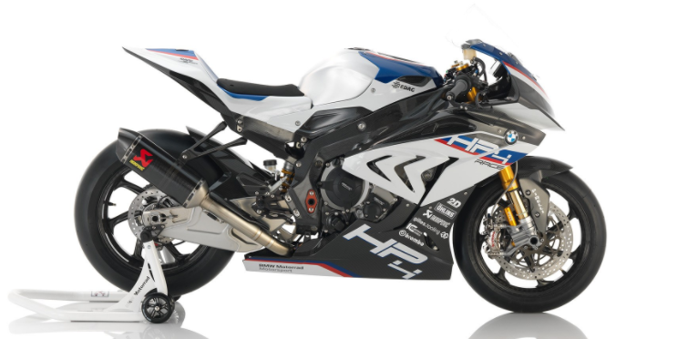
Figure 1 - BMW HP4 Race
(Image courtesy of AdventureBMW.com)

Potential Manufacturing Processes
There are a number of manufacturing processes available to produce motorcycle wheels, with each method having its own benefits and limitations. This section aims to present and discuss these options, and determine their suitability for the project in question.

Casting;
Casting is the process most commonly used for standard motorcycle wheels. Being relatively inexpensive and high-volume, OEM manufacturers can produce large quantities of standardised wheels for their line of motorcycles whilst minimising the cost incurred by the customer – due to the competitive nature of the global motorcycle market, this is understandably the driving factor in OEM’s decisions. The process involves pouring molten metal (generally aluminium) in to moulding dies and allowing it to freeze to form the parts – this use of molten metal however does mean incurring large energy costs from the furnaces required to bring the material up to temperature.
The main limitation with this process however is the strength of the resultant part. Because it is formed from molten metal, the strength of the material structure is dependent on the dendritic growth of the material during cooling (TotalMateria, 2003). This can be controlled by the foundryman by controlling cooling rates, but it will never be as strong as a billet-formed process such as forging that will keep the ordered metallic chemical structure. Because of this, more material must be used in the design to ensure the correct strength of the part, increasing the overall mass.
Another issue facing the standard casting process is that of inclusions. While this can include solid particles picked up during the pouring process, this is easily rectified and the primary concern is the inclusion of gases that have been unable to escape the mould during pouring. If the molten metal is poured in such a way that the internal gases are unable to escape, they end up being included in the final product as air pockets, which can have a terrible effect on the quality and strength of the final casting. These air pockets are prone to collapse under loads, causing failure of the part – in the specific case of motorcycle wheels, irregular loads such as road defects can cause collapse, and failure meaning the destruction of the wheel at high speed.

Vacuum Die-Casting;
The best way to rectify the issue of gas-inclusion, vacuum die casting involves using vacuum pressure to clear the die mould cavity of gas before the pouring of molten material. One of the first examples of this technique in motorcycle manufacturing was with Yamaha’s ‘Controlled Fill’ process used on the YZF-R1 and R6 swingarms, where they claimed an 80% reduction in gas inclusions. Other manufacturers followed with similar processes, including Ducati’s ‘Vacural’ process used for the casting of parts in their Superquadro engine, featured in the Panigale range of bikes.
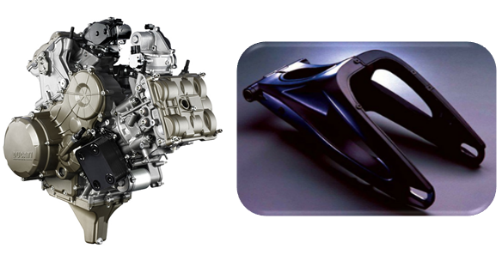
Figure 2 - Ducati Superquadro Engine & Yamaha R1 Swingarm
(Images courtesy of Motorcycle.com & KneeSlider.com)

Forging;
Forging is the oldest known method of metal forming, dating back to 5000BC (Groover, 2010). It involves using a die and pressure to shape billets of material in to the required shape, most commonly from either rectangular or cylindrical billets. Pressure is applied either as an impact force with a tool known as a ‘forging hammer’ or as a gradually increased force with a ‘forging press’. The decision of which tool to use is usually based upon the level of force and total displacement of the metal required; a press is usually required for high forces and large displacements, while a hammer is useful for quickly forming parts from a lower-strength material.
The advantage of forging over casting is that the material used does not get melted to a liquid state, meaning that the chemical structure is not weakened to the extent that the casting process requires. Because of this denser metallic structure, the resultant material is considerably stronger than a cast part, meaning that a wheel produced via this technique will not need additional strengthening material to be added to the design, creating a lighter overall part. Additionally, the solid-state forming means that inclusions are not of high concern, improving both the quality of the individual parts and uniformity across a production run. The primary disadvantage to casting is the associated price, as the shaping tools often require expensive hydraulics and the material must often be heated to a significant degree, incurring high energy costs. Due to cost being a lesser concern for this project however, a forging process is likely preferable over a cast part. As an example, Dymag advertise that their forged aluminium wheels offer a 19.6% reduction in mass and a 23.7% reduction in MOI over stock OEM cast aluminium wheels (Dymag, 2015).
All forging processes can be grouped in to three sub-categories; open-die, impression-die or flashless forging. Open-die forging simply brings two (often flat) faces together in order to shape the material with the profile of the face without constraining the run-off of the material. Impression-die forging is similar, but will have a profile shape on either one or both of the faces, shaping the billet accordingly whilst still allowing the run-off to remain unconstrained. The run-off in both these cases is known as ‘flash’, and must be removed after shaping. The final type of flashless forging does not have this feature as the name implies, and shapes the entire billet whilst containing all of the material. This process most commonly produces net or near-net products. Depending on factors such as the required shape, ductility of the metal and available tooling, the process is either performed as ‘cold forging’, ‘warm forging’ or ‘hot forging’:

Cold Forging;
Cold forging is the simplest process, where the pressure tools are simply applied to a billet of room-temperature (or not significantly higher) material to form the required shape. Because the material is at its highest-strength and lowest-ductility state at this temperature, this technique is only really suited to parts with a profile that is a small displacement from the original billet, or is comprised of a relatively weak and ductile material. The bonus of this process however is that the tolerances achieved are much tighter as there is no expansion or contraction of the material through heating and cooling stages, the surface finish is improved for the same reason and the material is often stronger and harder as it goes through ‘strain hardening’ as the chemical structure is not allowed to change through the process. Additionally, the grain direction can also be chosen as it will remain predominantly the same throughout the process. One benefit to manufacturers of this process is that it does not require any large-scale heating of the material, saving on the sizeable energy costs associated with hot forging. In terms of suitability for a motorcycle wheel design, while the tight tolerances achievable would be useful in limiting the post-machining required for the bearing bores of the hub section, the large deformation required to form the spoke sections make this process unfeasible for the desired geometry.

Warm Forging;
Warm forging tries to combine the bonuses of cold forging with the practicality of hot-forging, reducing the required pressures to form the billet by raising the temperature whilst coming close to the tighter tolerances and lower energy costs of cold forming. The temperature range for warm forging is typically designated as between 0.3Tm and 0.5Tm, with Tm being the absolute melting temperature of the material used; this is generally enough to increase the ductility of the material enough to form more complex geometries, whilst keeping the material under the recrystallization temperature in order to gain some degree of strain hardening. However similar to cold forging, the extreme level of shaping required for a wheel profile makes warm forging unsuitable for this project.

Hot Forging;
Hot forging offers the greatest level of material shaping out of the three techniques, whilst still retaining the strength advantages over casting. It typically involves heating the material to over 0.5Tm but below 0.75Tm, this being above the recrystallization point but below the melting temperature. The material is generally heated no higher than 0.75Tm as the deformation process itself will cause temperature rises within the deformed sections, so above 0.75Tm there is a risk of localised melting within the billet, losing the advantages of forging. Added to this, scaling is more likely at the higher temperatures, so this upper limit is best strictly observed.
The advantages of hot forging over the other styles are also varied; the strength of the resultant part is ‘isotropic’, meaning that it is not adversely affected by multi-directional loads, due to the lack of a defined grain structure in the resultant part. The technique is also suitable for those materials that would be prone to cracking or fracturing at lower temperature forming. An interesting advantage for the production of racing wheels using hot forging is the lack of strain hardening, which may seem strange as hardening is often a desired process in the production of metal parts; however, hardening also results in a reduction in ductility, which as previously explained is a desired property of a road racing wheel due to its ability to absorb shock impacts. This, along with the ability to form much more complex geometries, makes it the most viable option for this project from the forging options.

CNC Machining;
CNC Machining gets an honourable mention within the potential manufacturing processes, but the astronomical costs involved rule it out from practical use for even high-end race teams. Having a billet-machined wheel would offer incredibly good metallic characteristics such as high strength-to-weight and good ductility, but in order to achieve the design profiles required to create a lightweight race wheel a complex 5-axis CNC milling machine is the only real way to create a machined option. This would mean a long and incredibly complex machining program – likely 12+ hours and thousands of operations for a complete wheel – and a material loss of anywhere from 70-85%. There are some companies offering ‘CNC Billet Alloy’ wheels for cars, for prices in the region of £500-1000 per wheel, and even these are actually only CNC machined hubs mounted in to cast rims (Image Wheels, 2018), so a completely CNC milled wheel would be completely unfeasible as a race unit that is likely to sustain crash damage and have to be replaced somewhat-regularly.

Carbon Fibre Manufacturing;
Carbon fibre is extensively used in wheels by a number of race teams, but generally these are the teams focused on closed-circuit racing where the track surface is a lot more consistent and less likely to result in unexpected impacts. This is because carbon fibre, while incredibly strong in relation to its weight, is quite brittle and so more likely to break under impact than an alloy wheel. For road racing purposes, alloys are preferred due to the prevalence of poor road surfaces, track debris and other factors such as drain covers that may result in shock point loads. Cost is also to be noted, as while wheel budgets are sizeable for a racing season, due to the high chance of crashes compared to other motorsports a budget can be eaten through quickly if two or three sets of wheels are required by a team across a race weekend.
The production of carbon fibre components is still a relatively new industry, with a number of techniques still kept secret by manufacturers, such as Koenigsegg’s technique to produce their $64,000-a-set hollow Aircore line of wheels. The standard technique however involves layering carbon fibre sheets over negatives to create pre-forms which are then injected with one or more resins, with some manufacturers also pioneering ‘braiding’ techniques.

Layering;
A relatively simple process, a negative of the required shape is made from a material such as polystyrene foam or plastic, which then has sheets of carbon fibre weave layered on top of it to create a ‘pre-form’. These layers are often oriented in different directions, as due to carbon fibre’s very linear strength this is the only way to create a part with isotropic strength properties. The layers of weave are then filled with resin to bond them together, creating the final part.

Braiding;
A technique recently pioneered by Porsche for their 911 Turbo S wheels, this involves what is basically a giant textiles loom to ‘braid’ strands of carbon fibre together. This creates a much denser structure than layering, increasing the rigidity of the final unit – more desirable for cars than motorcycles. As well as the performance increases, it reduces the amount of waste during production, as the excess sections of sheet from layering must be removed and discarded. However, each of these wheels requires 18 kilometres of carbon fibre strand, and 8 square metres of sheet for the hub, resulting in a set of wheels priced in the region of 15,000 euros (Porsche, 2017).
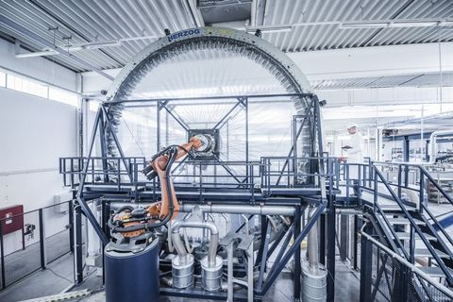
Figure 3 - Carbon Fibre Braiding Machine at Porsche Manufacturing
(Image courtesy of roadandtrack.com)

Selection Criteria
The choice of material and process for this project is based on trying to strike the best balance between a number of criteria; fully optimising for one aspect could have a hugely negative impact on another resulting in an unusable design, so compromises must be made. The criteria are weighted as follows on a scale of 1-5 (5 being most important);
- Mass, 5 – as it has such a large impact on so many factors of the motorcycle as a race machine, mass has been deemed one of the most important factors to consider.
- Strength, 5 – a wheel that excels in every other area but fails to deal with the stresses of the intended race is ultimately useless. Because of this, strength is a priority factor.
- Rigidity, 4 – while another key ingredient that ultimately dictates the overall performance of the racing system, some of the functionality required by the rigidity of the wheel can be shared with improvements to the suspension system. New technologies such as Ohlins semi-active adaptive suspension can deal with shocks much more efficiently than traditionally-damped fork setups, so the importance of wheel damping is reduced.
- Availability, 3 – these wheels are not to be produced in quantities traditionally deemed as large-scale, but they do have to be readily available in the event of replacements being required after a crash incident to a number of race teams. Estimated production quantities would be in the region of 100-200 per week.
- Price, 2 – this a project for a high-end performance product, so they are naturally going to be expensive. This does not mean money is no object however, so it is still of some concern, but decisions do not need to be based on appealing to a general public market.
- Environmental/health and safety, 1 – because of the relatively small production quantities and the recyclability of the proposed materials, environmental damage is not a major concern. As these are high-end performance products, production will be handled by trained craftsman working in a facility abiding by stringent health and safety laws so this is also a low concern.

Chosen Material
The material chosen for this project is a magnesium alloy (specifically grade AZ80A-T6), based on the selection criteria above. The detailed reasoning for the selection is below;
- Weight saving; the primary concern of the selection criteria, a ~30% reduction in weight over a standard cast aluminium wheel is a huge benefit. Comparing this to the ~20% saving of forged aluminium over cast, it puts magnesium as the lightest feasible metal available.
- Strength; the increased yield strength value of magnesium over aluminium is another advantage, making the material more suited to the rigors of road racing.
- Ductility; the increased ductility of magnesium alloy over carbon fibre is important enough for road racing to forego the further weight saving gains that could be made by employing a carbon fibre unit. As previously mentioned, a carbon fibre option would be preferable if the focus was on closed-circuit track racing, but the uncertainty and potential danger of road surfaces on the road race calendar make it an unnecessary risk.

Chosen Process
The forming process deemed most suitable for this application is to create forged parts, specifically using the hot forging technique, with a CNC post-machining operation to correctly dimension the bearing housings. This is for a number of reasons, as follows;
- Freedom of shape; in contrast to other forging techniques, hot forging allows for complex shapes and geometry, allowing for freedom to design a wheel that has a shape best suited to the application.
- Isotropic strength; unlike carbon fibre, hot-forged alloys have truly isotropic strength properties, which is vital when designing a constantly rotating part. Due to the potential for unexpected image across the width of the wheel during road racing, this is especially important.
- High strength-to-weight ratio; because of the higher strength values of forged metals compared to cast due to the denser chemical structure and lack of inclusions, the lack of need for extra supportive material allows the design to reduce the mass even further.
- Ductility; as the material does not go through the strain hardening of cold and warm forging, the resultant product will still offer a good degree of damping compared to stiffer carbon fibre options.

Conclusions
Based on the material and manufacturing processes investigated in the creation of this report, it has been decided that the most suitable product design for the intended project would be to proceed with a forged magnesium alloy wheel. The benefits of this selection are deemed to outweigh the issue of the increased costs over a stock setup, as it is believed that the mechanical characteristics gained will contribute greatly to the ultimate goal of winning events across the road-racing calendar. This issue should be constantly revisited however, as significant improvements to the materials, processes and prices available to the market can only help to achieve better and better results – because “racing is life, and anything else before or after is just waiting” (McQueen. S, 1971).
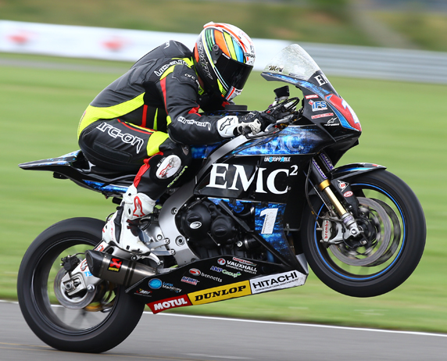
Figure 4 - Al Fagan on board John McGuinness’s Superstock TT Fireblade
(Image courtesy of 44Teeth.com)

Citations
BikeHPS, 2011, ‘Marchesini Forged Aluminium & Magnesium Motorcycle Wheels, [Online], Available: https://www.bikehps.com/marchesini/, [05-01-18]
BikeHPS,2011, ‘BST Carbon Fibre Wheels, BMW S1000RR 2015 Onwards’, [Online], Available: https://www.bikehps.com/acatalog/BMW_S1000RR_2015_Onwards_BST_Carbon_Fibre_Motorcycle_Wheels.html, [05-01-18]
CycleNews, 2018, ‘BMW HP4 Race vs. BMW S 1000 RR: Comparison Test’, [Online], Available: http://www.cyclenews.com/2017/11/article/bmw-hp4-race-vs-bmw-s-1000-rr-comparison-test/, [05-01-18]
Duke, K, 2014, ‘Exploring Lightweight Materials on Motorcycles’, [Online], Available: http://www.motorcycle.com/features/exploring-lightweight-materials-motorcycles.html, [04-01-18]
Dymag, 2015, ‘The Performance Benefits of Lightweight Wheels’, Alfreton: HPS Ltd.
Groover, M.P, 2010, ‘Fundamentals of Modern Manufacturing’, Fourth Edition, Hoboken: John Wiley & Sons Inc.
Image Wheels, 2018, ‘Billet 118 Alloy Wheel’, [Online], Available: http://www.imagewheels.co.uk/billet-118-alloy-wheel/, [04-01-18]
MagnesiumWheels, 2017, ‘Magnesium Wheels History’, [Online], Available: https://magnesiumwheels.com/history.html, [05-01-18]
Matweb, 2018, ‘Aluminum 6061-T4’, [Online], Available: http://www.matweb.com/search/DataSheet.aspx?MatGUID=d5ea75577b1b49e8ad03caf007db5ba8, [04-01-18]
Matweb, 2018, ‘Cytec Thornel® P-75 Carbon Fiber/Epoxy Advanced Composite System’, [Online], Available: http://www.matweb.com/search/DataSheet.aspx?MatGUID=e6dbe15d301448e4aed2557905a73d09, [04-01-18]
Matweb, 2018, ‘Magnesium AZ80A-T6’, [Online], Available: http://www.matweb.com/search/DataSheet.aspx?MatGUID=ea14a88a576a45f08ff009fb5749df15, [04-01-18]
Porsche, 2017, ‘World Première: Braided Carbon Wheels’, [Online], Available: https://newsroom.porsche.com/en/products/porsche-carbon-wheels-braided-world-premiere-911-turbo-s-exclusive-series-14064.html, [04-01-18]

Source Assessment
This section aims to assess the reliability and relevance of each of the sources cited in this document. Reliability is presented on a scale of 1-5, 5 being completely reliable.
BikeHPS – 5
Only used for gaining current prices of pre-existing wheels in varying materials. As the seller, these prices are completely accurate as of time of writing.
CycleNews – 4
Used to research specifications for BMW S1000RR and HP4 Race, most likely to have gained their information from BMW press-release directly and simply posting this as part of a news article. Point lost simply because the possibility for paid press-bias is not impossible.
Duke, Kevin – 3
Used to gain information of relative characteristics of materials and their effects on motorcycle performance. Points lost because he is not a materials scientist or any other authority on mechanical properties; however he has been riding motorcycles competitively and working for one of the largest moto-journalism companies in the world for 20+ years, so does know the real-world effects of these materials as experienced from a riders’ perspective.
Dymag – 4
Used to gain data on the mechanical properties and their calculations of wheels (gyroscopic effect, MOI etc.), and the properties of the wheels they specifically make. Knowledge base likely extensive as a manufacturer, reliability point lost as embellishments may have been made to aid sales.
Groover, M.P – 5
Author of a very well-established text, used to gain information on various material forming and manufacturing processes. Very little reason to embellish or otherwise distort facts, and latest revision is relatively recent so facts unlikely to have changed.
Image Wheels – 5
Only used to research current prices of CNC wheels, as the seller these prices are perfectly accurate at time of writing.
Magnesium Wheels – 3
Points lost as exact author is unknown, however as a webpage simply documenting the history of magnesium alloy usage in automotive wheels there is little reason to fabricate information.
Matweb – 5
An industry-standard web tool among professional engineers, used to research mechanical properties of materials. As simply a database of information with little reason to show bias, reliability not in question.
Porsche – 4
While obviously interested in the marketing of their products, this web page was used just to gain basic information regarding a manufacturing technique. Embellishing or distorting this information would have little effect of marketability of their product, so little reason to do so.

