University of Wales Trinity Saint David School of Engineering

Manufacturing processes and defects
Introduction to Materials and Processes

James Smithers
2316373
05/12/2023

Contents
Abstract 3
FORMING OPERATIONS 3
FORGING 3
Automotive Industry: 4
Aerospace Industry: 4
Advantages of Forging: 4
Disadvantages of Forging: 4
CASTING OPERATIONS 5
CONTINUOUS CASTING 6
Advantages Of Continuous Casting 6
Disadvantages Of Continuous Casting 6
MISCELLANEOUS OPERATIONS 8
Welding 8
Construction. 8
Aerospace 8
Oil and Gas 8
Advantages of Welding 8
Disadvantages of Welding 8
Bibliography 9

Figure 1: Diagram of basic forging operations (milwaukee forge) 3
Figure 2:DIagram showing the flow chart for the forging process (Infotech, 2015) 3
Figure 3:Diagram of examples of products made for the aerospace industry (Forging, 2017) 4
Figure 4: Diagram of the microstructure of forged steel (Eissa, M. 2012) 5
Figure 5: Diagram of the different types of continuous casting (ccc.illinois.edu. (n.d.). Intro to Continuous) 6
Figure 6:A close up look at the vertical columnar grains (X G Yang, n.d.) 7
Figure 7: A close up look at the grain structure of continuously casted steel (X G Yang, n.d.) 7
Figure 8-Image showing the many different cracks that can occur with process (Bahrami et al., 2019) 8
Figure 9-Microstructure of forged steel. (www.phase-trans.msm.cam.ac.uk, n.d.) 9

Abstract

In this report on different types of manufacturing processes and the defects that can occur from them. It will take a look at the typical microstructures and mechanical properties have from the process’. It will also look into how they are implemented into different industries while assessing the advantages and disadvantages considered before it is implemented.

FORMING OPERATIONS

FORGING

Forging is ‘The mechanical working or of a single piece of usually hot metal’. The two most common ways to achieve this are by successive blows to the metal with high amounts of force or continuous squeezing. Forgings are typically put into two categories; open and closed die.
(Materials Science and Engineer, Wiley)
(See below)

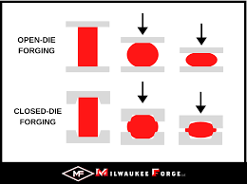
Figure 1: Diagram of basic forging operations (milwaukee forge)
(milwaukee forge)

Open-Die Forging includes two simply shaped dies typically parallel and flat or semi-circular dies. Conversely, Closed-Die Forging implements two or more die halves which make up a ready finished shape, essentially deforming the metal in the space remaining between them and allowing a variation in the finished shape. (milwaukee forge)

Below is also a typical flow chart of the process of forging on commercial levels by InfoTech.
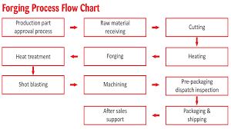
Figure 2:DIagram showing the flow chart for the forging process (Infotech, 2015)
(Infotech, 2015)

Forging is applied in many ways across a wide range of industries. For example:

Automotive Industry:

Forging is heavily used in the automotive industry for a number of essential parts, ranging from entire chassis to critical engine components. It is a preferred method due to the strength, durability and precision it can produce. (Shinichiro Fujikawa, 1992)

Aerospace Industry:

Forging is seen as the more favourable method used as the metal’s natural grain flow conforms to the desired shape of the finished product.
(Forging, 2017)

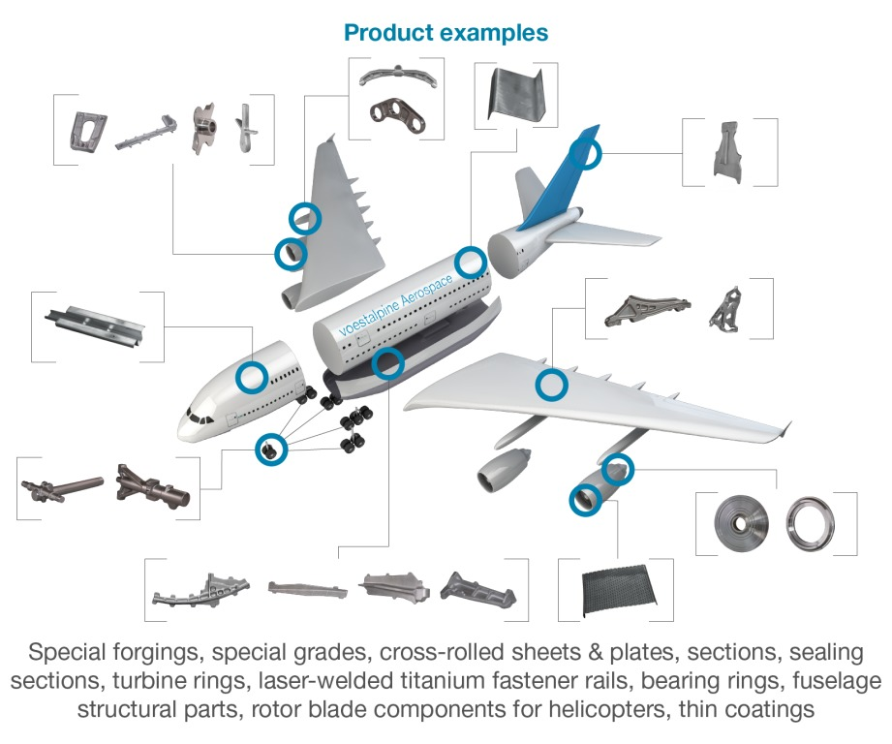
Figure 3:Diagram of examples of products made for the aerospace industry (Forging, 2017)
(Forging, 2017)

Advantages of Forging:
  - Enhanced Strength: Forging imparts superior strength to metal components.
  - Improved Mechanical Properties: It enhances toughness and fatigue resistance.
  - Precision: Forging allows precise shaping, ensuring accurate dimensions.

Disadvantages of Forging:
  - Tooling Costs: Initial setup costs for dies can be expensive.
  - Shape Limitations: Not ideal for highly complex designs.
  - Energy Intensive: The process can be energy-intensive, contributing to higher operational costs.
(Encyclopaedia of Materials: Metals and Alloys.)

Forged mid carbon steel typically produces a refined and homogenous microstructure. This produces a free grain structure, improving strength and durability. Recrystallization also occurs, removing defects by forming new stress-free grains. The microstructure can vary depending on the type of forging (closed or open die) and also the type of steel in question.
( Jiang, J., Liu, Y. and Liu, C. (2022).)

e.g
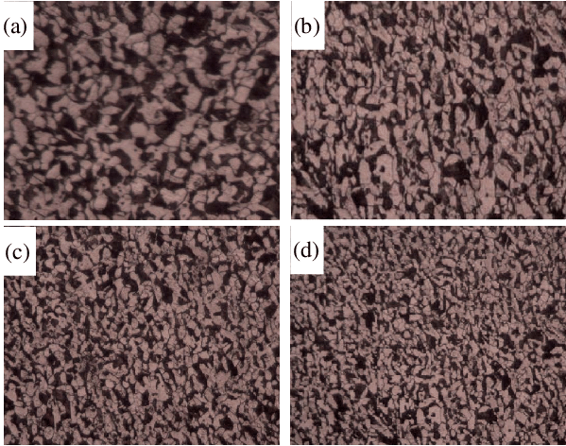
Figure 4: Diagram of the microstructure of forged steel (Eissa, M. 2012)
‌‌Eissa, M. (2012)

The ultimate tensile strength (UTS) of forged steel can vary due to a number of factors. For example, the carbon content will have a big effect on the UTS; high carbon steel having a higher UTS than low carbon. Typically when it comes to forged steel, the UTS ranges between 993mpa and 1084mpa.
(Opiela, M. & Grajcar, Adam & Gołombek, Klaudiusz. (2013).)

There are a wide range of forging defects some of which include;

  - Die shift: Misaligned upper and lower dies cause dimensional inaccuracies. Regular maintenance and the use of halves on each die can prevent this.
  - Flakes: These are internal cracks that can occur from the rapid cooling which weaken the finished product. Careful and precise cooling will lower the risk of this occurring.
  - Improper grain growth: This causes improper metal flow, altering the grain structure of the finished product. Use of suitable dies for the desired end product will prevent this.
Marinerspoint Pro. (2021)

CASTING OPERATIONS

CONTINUOUS CASTING

Continuous casting is considered a relatively new process, not being a widespread technique used until the 1960s. The process involves molten metal being poured into typically water cooled mould. The molten liquid is typically poured into a mould which is similarly shaped to the final product.
(B.G. Thomas, , Sciencedirect.com. (2014).

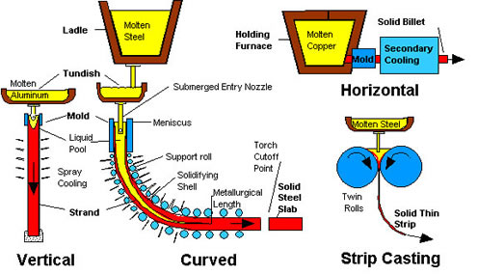
Figure 5: Diagram of the different types of continuous casting (ccc.illinois.edu. (n.d.). Intro to Continuous)
(ccc.illinois.edu. (n.d.). Intro to Continuous)

(Above is a diagram of the different types of continuous casting used)

Continuous casting has useful applications in a wide range of industries. For example, it is used in the steel industry to produce large quantities of slabs from molten steel. The process allows steel slabs to be efficiently produced with a consistent quality, thus reducing the need for further steps after the steel making process. The slabs are then typically rolled in mills into coils to be sold to customers. Another application is the railway industry.

Advantages Of Continuous Casting

  - Cost efficiency: For the amount of material that can be casted using the process, the cost is extremely low. Also steps such as reheating are not required using this method, saving in energy costs. (www.doitpoms.ac.uk, n.d.)
  - Quality: The reduced number of steps and high level of automated control combined lead to fewer defects in the casted metal.
  - Reduced pollution: By removing stages such as the cooling pits and reheat furnaces, the emission levels are considerably reduced. Increases in the yield also mean less waste. So in the steel industry, this means that less primary steel making is required which requires raw materials to be imported and fossil fuels to be burnt.
(Google.com, 2024)

Disadvantages Of Continuous Casting

  - Capital Investment: The initial set up and ongoing maintenances costs of continuous casting equipment are considerably higher than other casting methods.
  - Limited Flexibility: Due to the high levels of precision and automation the process requires, changes in requirements for the product needed are harder to implement and may require more work to accommodate.
  - Risk of impurities: Continuous casting has a much faster cooling time which can lead to a higher risk of impurities.

(Karia, 2023)

Continuous casting steel is typically made up of fine equiaxed grains, columnar grains, equiaxed grains and crossed dendrite, as shown below. Fine grains can be observed near the ‘chill zone’ of the material, which is due to the high gradient of temperature. The majority of the columnar grains are formed in the secondary cooling zone where there is an extreme cooling of water and vapour, which gives a rise in the temperature gradient vertical to the surface. This is why the columnar grains are also seen to form vertical to the surface also.(see below) ( (X G Yang, n.d.)

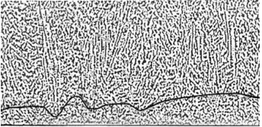
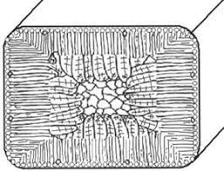
‌
Figure 6:A close up look at the vertical columnar grains (X G Yang, n.d.)
Figure 7: A close up look at the grain structure of continuously casted steel (X G Yang, n.d.)
(A broad view of the microstructure of continuously casted steel slab)
(X G Yang, n.d.)

When it comes to the UTS of continuously caste materials, there is a wide range of strengths that can be obtained. For example, Gray iron bar stock ASTM A48, which is an iron based durbar alloy. With this material, the typical UTS that can be obtained is 138mpa. Continuous casting allows this specific material to be considered as the softest of grade of Durbar grey iron, whilst still being extremely resistant to wear.

Defects are an unavoidable occurrence when it comes to all casting process. For continuous casting, there are a wide range of defects that can occur. Some of which include:

  - Surface Cracks: Cracks which can occur at any point of the casted materials surface, such as longitudinal cracks, are in the main part caused by uneven cooling. This can be avoided by optimising the cooling of the material and using the correct mould design

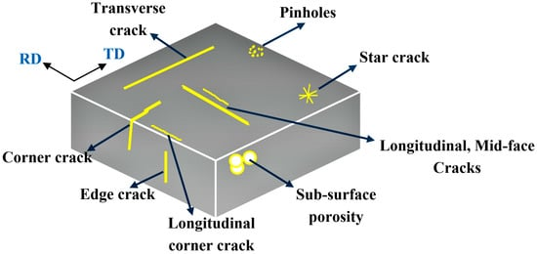
Figure 8-Image showing the many different cracks that can occur with process (Bahrami et al., 2019)

  - Segregation: This is when there is variations in the composition of the allow being casted. This leads to an uneven distribution of the elements and causes there to be variations on the composition throughout the product. This can be avoided by strict control over the cooling rates or adding the use of a electromagnetic stirring to the process.
  - Depressions: Longitudinal and transverse depressions are local deformations that occur due to an uneven transfer of heat within the mould. They leave shallow ditch like areas along the length of the material. This can be mitigated by uniformed cooling when the material is in the mould.
  - Blowholes: Blowholes are cavities that form within the outer surface of a material. These are caused when gasses are present within the casted product. They can also be caused by moisture in the product. Blowholes can be controlled by proper oxidisation of the material. Other control methods include the use of casting powders.

MISCELLANEOUS OPERATIONS

Welding

Welding is a manufacturing process where two or more materials are joined together by heat and/or pressure. This leaves a strong and permanent bond between the materials (TWI, 2019)

Welding has a wide range of applications within industry, such as:

Construction

Welding is a key part of the construction industry. It is widely used when joining construction beams, columns and in the creation of steel framework in buildings and infostructure. (PrimeWeld, n.d.)

Aerospace

Welding is heavily used in the manufacturing of aircraft components, ranging from the structural elements of aircrafts to the engine parts and fuselage frames. (Zavadski, 2018)

Oil and Gas

Finally, welding is extensively used in the oil and gas industry. It is used for the majority of pipelines, off shore oil rid and lso tools used within the industry. It is a massive part of the extraction and transportation of the resources. (Sharma and Maheshwari, 2017)

Advantages of Welding:

  - Strength and Durability: The joints formed from welding are often much stronger than the initial base material which can improve the structural integrity, resulting in a much more durable product.
  - Permanent bond: Welding ensures that a permanent bond is formed between the materials involved.
  - Versatility: Welding can be used for a wide range of process as seen above. It can also be used on a large scale in industry but also a much smaller scale.
  - Efficiency and automation: The welding process in industry can offer the ability to mass produce products by automation. Also, on a smaller scale it offers high precision if needed.

Disadvantages of Welding

  - Health and Safety: Welding involves extreme heat levels, fumes and uv radiation which all pose a large risk to the operators.
  - Material Limitations: The types of materials being welded together could pose a challenge due to the melting points of each being far apart. Cooling rates, grainsize and metallurgical properties can also affect the process.
  - Skilled labour: Welding is considered a highly skilled skill, therefore the costs of training employees can pose an issue. Equipment and initial start up costs for welding processes are also a lot higher than alternative processes

(Besley, 2022)

The microstructure of welded material can vary depending on the material in question but also the typo of welding. For example, if we take titanium welds when put through low oxygen welding exhibited an equiaxed grain structure with grainsizes ranging from 1mm at the welds centreline, going right down to 20um at the centreline of the base material. This microstructure can lead to improvements in the strength of the material.
(Danielson, Wilson and Alman, 2003)
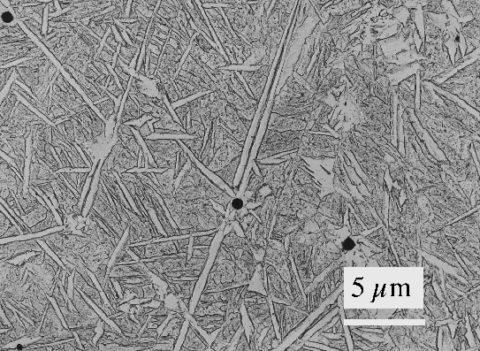

Figure 9-Microstructure of forged steel. (www.phase-trans.msm.cam.ac.uk, n.d.)

As for the ultimate tensile strength of welded material, titanium alloys such as grade 5. We typically see a UTS around the weld area of between 925 and 1060mpa. The properties of this alloy makes it one of the most widely used of the titanium alloys. (Farrokhi, 2022)

Welding, in the most part is an extremely useful process with a wide range of applications and advantages. However it does have a number of defects that can occur. For example:

  - Welding porosity: Porosity is when small cavities form in the welded joint. The most common cause of this is the entrapment. This can result in weakness at the joints and can cause mechanical failure. This can be avoided by ensuring there is proper shielding gas coverage. This will then prevent any atmospheric contamination from taking place. (BOConline UK, n.d.)
  - Lack of fusion: Lack of fusion occurs when the weld connecting the materials together does not fuse correctly/fully. This then leads to weak joins. This can be mitigated by the optimisation of welding parameters. Such as the speed travelled across the joint when welding or the heat level used. (BOConline UK, n.d.)
  - Cracking: Cracking can form along the weld. These come in two forms; hot cracks form during the cooling phase while the material is still hot. Cold cracks then occur when the material has already cooled. These both reduce the integrity of the joint. Controlling the rate of cooling will reduce the risk of these occurring, and also preheating the base materials. This will reduce the stress the welded materials will go through during the cooling phase. (BOConline UK, n.d.)

Bibliography

Callister, W.D. and Rethwisch, D.G. (2011). Materials science and engineering : SI version. Hoboken (N. J.): Wiley, Cop.

Milwaukee Forge. (2020). Open-Die Forging vs. Closed-Die Forging. [online] Available at: https://www.milwaukeeforge.com/difference-between-open-die-and-closed-die-forging/.

‌www.satvikengineers.com. (n.d.). Forging Process Flow Chart - Satvik Engineers. [online] Available at: http://www.satvikengineers.com/forging_process_flow_chart.html#prettyPhoto [Accessed 7 Dec. 2023].

‌Fujikawa, S., Yoshioka, H. and Shimamura, S. (1992). Cold- and warm-forging applications in the automotive industry. Journal of Materials Processing Technology, 35(3-4), pp.317–342. doi:https://doi.org/10.1016/0924-0136(92)90325-m.

‌Anon, (n.d.). Steel Forging for Aerospace Application | Steel Forging. [online] Available at: https://www.steelforging.org/steel-forging-for-aerospace-application/.

‌ Encyclopedia of Materials: Metals and Alloys. (n.d.). Elsevier Uuuu-Uuuu.
‌ Sugimoto, K.-I. and Andrea Di Schino (2023). Mechanical Properties and Microstructure of Forged Steel.

Al-Janabi, R.A.S.M. (2018). The Effect of Tempering Heat Treatment on Some Mechanical Properties of Medium Carbon Steel (AISI 1045) Formed By Cold Forging Process. University of Thi-Qar Journal, [online] 13(3), pp.70–80. Available at: https://jutq.utq.edu.iq/index.php/main/article/view/167/157 [Accessed 7 Dec. 2023].

‌ Jiang, J., Liu, Y. and Liu, C. (2022). Effect of forging ratio on the microstructure, mechanical properties and abrasive wear behavior of a new C–Cr–Mo–V martensitic steel. Journal of Materials Research and Technology, 19, pp.4076–4091. doi:https://doi.org/10.1016/j.jmrt.2022.06.069.

Kumar, S., Manish;Borad, Dharmesh;Patel, Krupesh;Lodhari, Dharmesh;Vaish, Ashok (2014). Development of high strength micro-alloyed forged steel. Journal of Metallurgy and Materials Science, [online] 60(4), pp.211–220. Available at: https://www.indianjournals.com/ijor.aspx?target=ijor:jmms&volume=60&issue=4&article=003 [Accessed 8 Dec. 2023].

‌ Marinerspoint Pro. (2021). Types of Forging Defects - Causes & Remedies [with Images]. [online] Available at: https://marinerspointpro.com/types-of-forging-defects-causes-remedies-images/.

‌Eissa, M. (2012). Microstructure of forged steels at finishing forging temperature 900˚C. Available at: https://www.researchgate.net/figure/Microstructure-of-forged-steels-at-finishing-forging-temperature-900C-a-reference_fig1_262698951 [Accessed 8 Dec. 2023]. *Second webpage*

B.G. Thomas, Sciencedirect.com. (2014). Continuous Casting - an overview | ScienceDirect Topics. [online] Available at: https://www.sciencedirect.com/topics/engineering/continuous-casting.

ccc.illinois.edu. (n.d.). Intro to Continuous Casting - CCC - U of I. [online] Available at: http://ccc.illinois.edu/introduction/overview.html.
www.doitpoms.ac.uk. (n.d.). Continuous casting. [online] Available at: https://www.doitpoms.ac.uk/tlplib/casting/continuous_casting.php [Accessed 4 Jan. 2024].

‌ www.doitpoms.ac.uk. (n.d.). Continuous casting. [online] Available at: https://www.doitpoms.ac.uk/tlplib/casting/continuous_casting.php [Accessed 4 Jan. 2024].
‌
Google.com. (2024). Available at: https://www.google.com/url?sa=t&rct=j&q=&esrc=s&source=web&cd=&cad=rja&uact=8&ved=2ahUKEwjjk7Kt9cODAxVtUEEAHR3CAnAQFnoECC0QAQ&url=https%3A%2F%2Fwww.princeton.edu%2F~ota%2Fdisk3%2F1979%2F7902%2F790203.PDF&usg=AOvVaw1KglBlFi80LEA-tbcDKd7n&opi=89978449 [Accessed 4 Jan. 2024]. *Takes to papers web page*

‌ Karia, P. (2023). 5 Advantages and Disadvantages of Continuous Casting. [online] ThePipingMart Blog. Available at: https://blog.thepipingmart.com/other/5-advantages-and-disadvantages-of-continuous-casting/ [Accessed 4 Jan. 2024].

‌ X G Yang (n.d.). Experimental study of the continuous casting slab solidification microstructure by the dendrite etching method. In: IOP Conference Series: Materials Science and Engineering. [online] IOP Conference Series: Materials Science and Engineering. Available at:
https://iopscience.iop.org/article/10.1088/1757-899X/283/1/012017/pdf#:~:text=By%20releasing%20the%20superheat%2C%20latent,shown%20schematically%20in%20figure%201 [Accessed 30 Jan. 2024].

‌ Anon, (n.d.). Defects in Continuous Cast Steels – IspatGuru. [online] Available at: https://www.ispatguru.com/defects-in-continuous-cast-steels/ [Accessed 31 Jan. 2024].

TWI (2019). What is Welding? - Definition, Processes and Types of Welds. [online] Twi-global.com. Available at: https://www.twi-global.com/technical-knowledge/faqs/what-is-welding.

‌ PrimeWeld. (n.d.). The Role of Welding in Construction. [online] Available at: https://primeweld.com/blogs/news/the-role-of-welding-in-construction#:~:text=Welding%20in%20construction%20involves%20using [Accessed 1 Feb. 2024].

‌ Zavadski, A. (2018). Advanced welding technologies used in aerospace industry. [online] Available at: https://www.theseus.fi/bitstream/handle/10024/153348/Zavadski_Aliaksandr.pdf [Accessed 1 Feb. 2024].

‌ Sharma, S.K. and Maheshwari, S. (2017). A review on welding of high strength oil and gas pipeline steels. Journal of Natural Gas Science and Engineering, [online] 38, pp.203–217. doi:https://doi.org/10.1016/j.jngse.2016.12.039.

Danielson, P., Wilson, R.D. and Alman, D.E. (2003). Microstructure of Titanium Welds. Advanced Materials & Processes, [online] 161(2). Available at: https://www.osti.gov/servlets/purl/807847 [Accessed 1 Feb. 2024].
‌BOConline UK. (n.d.). Porosity. [online] Available at: https://www.boconline.co.uk/en/processes/welding/welding-defects/porosity.html.
‌BOConline UK. (n.d.). Lack of fusion. [online] Available at: https://www.boconline.co.uk/en/processes/welding/welding-defects/lack-of-fusion.html.
‌
BOConline UK. (n.d.). Cracking. [online] Available at: https://www.boconline.co.uk/en/processes/welding/welding-defects/cracking.html [Accessed 2 Feb. 2024].
‌Farrokhi, A. (2022). Welding Properties of Titanium Alloys Grade 5. [online] www.intechopen.com. Available at: https://www.intechopen.com/chapters/83688# [Accessed 2 Feb. 2024].

‌Besley, T. (2022). Advantages and disadvantages of welding as a joining method. [online] Forgeway Ltd. Available at: https://forgeway.com/advantages-and-disadvantages-of-welding/.

Bahrami, A., Kiani Khouzani, M., Mokhtari, S.A., Zareh, S. and Yazdan Mehr, M. (2019). Root Cause Analysis of Surface Cracks in Heavy Steel Plates during the Hot Rolling Process. Metals, 9(7), p.801. doi:https://doi.org/10.3390/met9070801.

www.phase-trans.msm.cam.ac.uk. (n.d.). Microstructure of Steel Welds. [online] Available at: https://www.phase-trans.msm.cam.ac.uk/2005/Graz/Graz.html.
‌

‌

‌

‌

‌

‌

