BMHP5015

Student name: Rim abdulhamid
Student’s ID: 2321169
Lecturer’s Name: Parese Ahmed

Component 2: Assignment (Report)
Changemakers: Building your Personal Brand for Sustainable Employment
Contents
1. Introduction 2
3. Analysis of Employability Skills Required 3
Core Skills Required 3
Personal Attributes 4
Professional Competencies 4
Sector-Specific Skills 4
4. Evaluation of My Own Skills 5
Strengths: 5
Personal attributes: 5
Areas for development: 5
Reflection and learning: 5
5. My Current Qualifications and Experience 6
6. Building My Personal Brand & Professional Identity 6
8. Action Plan and 5-Year Timeline 8
Action Plan and Timeline 0
9. Conclusion 0
References 1

1. Introduction
The role of a Healthcare Assistant (HCA) at Apollo Home Healthcare is an important position within the UK health and social care sector, as HCAs provide direct, person-centred support to individuals with complex health needs in their own homes. This role requires a combination of personal qualities, professional behaviour, and practical skills, especially as the sector continues to face rising demand and workforce pressures (Skills for Care, 2023).
This report focuses on evaluating my suitability for this role by analysing the employability skills required, including communication, teamwork, empathy, emotional intelligence, and safe care practices. It will also include a self-evaluation of my current strengths and areas for development, supported by reflection and feedback. In line with the module learning outcomes, the report will explain how I can build a strong personal brand, promote my professional identity, and develop a meaningful network to support my future career (Hodges & Burchell, 2003). Finally, a detailed five-year action plan will be presented to outline the steps and resources needed to achieve this position.
2. Job Description and Person Specification
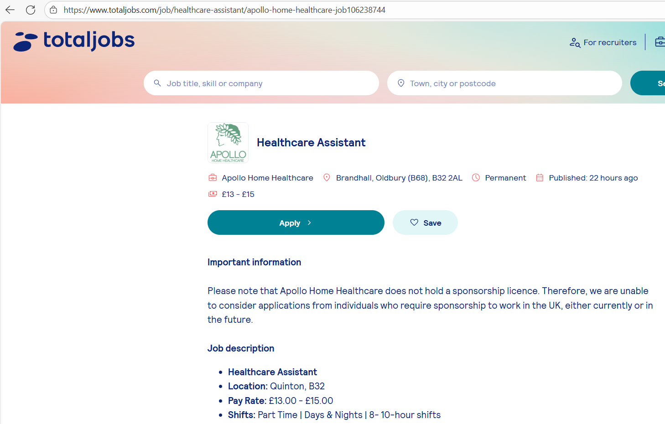
Figure 1:Healthcare Assistant role listed on Totaljobs (Apollo Home Healthcare, 2025).

The Healthcare Assistant (HCA) role at Apollo Home Healthcare focuses on providing personalised one-to-one care for people with complex health needs in their own homes. The job advert explains that HCAs support clients with daily activities, personal care, medication administration, and clinical tasks such as moving and handling, and in some cases specialist procedures (Apollo Home Healthcare, 2025). The employer expects staff to maintain a compassionate, respectful and person-centred approach while helping clients live safely and comfortably.
Key responsibilities include supporting clients with personal care, promoting independence, following care plans, observing health changes, and communicating effectively with families and professionals. The advert highlights the need for good communication, empathy, reliability, flexibility, and an understanding of safeguarding. Previous care experience is required, and HCAs must be confident in tasks such as medication support and maintaining dignity during care (Apollo Home Healthcare, 2025).
These expectations reflect wider trends within the adult social care sector. Skills for Care reports ongoing workforce shortages and increasing demand for experienced, values-driven care workers, especially in home-care settings where complex needs are rising (Skills for Care, 2023). This means employers are looking for HCAs who can work safely, adapt to challenges, and use digital tools confidently as part of modern care delivery.

3. Analysis of Employability Skills Required

Core Skills Required
A Healthcare Assistant must have strong communication skills to interact clearly with clients, families, and professionals. Good communication supports trust, reduces misunderstandings, and ensures safe care delivery (Hargie, 2021). The role also requires effective teamwork, as HCAs often work with nurses, therapists, and care coordinators. Working well in a team improves continuity of care and supports better outcomes for clients (West & Markiewicz, 2013). Another essential skill is person-centred care, which means respecting individual needs, preferences, and dignity. Person-centred approaches are central to modern social care practice and help promote independence and wellbeing (Brooker & Latham, 2020).

Personal Attributes
Personal qualities are just as important as practical skills in this role. Empathy, patience, and reliability help HCAs build supportive relationships with people who may be anxious, unwell, or vulnerable. Emotional intelligence is also vital. Week 6 highlights emotional intelligence as the ability to understand and manage one’s own emotions and respond to others sensitively, which reduces stress and improves professional relationships (Goleman, 2020). These attributes support resilience and help HCAs manage emotionally demanding situations while maintaining compassionate care.

Professional Competencies
HCAs must demonstrate key professional competencies. Safeguarding is essential to protect vulnerable individuals from harm and to recognise signs of abuse or neglect (Department of Health and Social Care, 2016). Health and safety practices, such as infection control and safe moving and handling, ensure both client and worker safety. Accurate record-keeping is another important competency, as clear documentation supports effective communication and legal accountability (Moss, 2020). HCAs must also apply principles of equality, diversity, and inclusion, treating all clients fairly and recognising differing cultural, linguistic, and social needs, which aligns with Week 5 learning on identity and inclusion (Thompson, 2016).

Sector-Specific Skills
The role requires skills specific to the health and social care sector. HCAs must be confident when working with vulnerable individuals, including people with complex health conditions. This includes understanding confidentiality, professional boundaries, and dignity in care. Modern care also relies on digital tools, such as electronic care plans and digital reporting systems, which reflect increasing digitalisation in the sector as highlighted in Week 9 (Department of Health and Social Care, 2022). HCAs also need to understand change in care settings, as services regularly adapt to new policies, technologies, and client needs. Week 8 emphasises that adaptability is essential for maintaining high-quality care during change (Kotter, 2012).

4. Evaluation of My Own Skills
To understand my readiness for the Healthcare Assistant role, I compared my current abilities with the job requirements. A skills audit and SWOT analysis helped me evaluate my strengths and areas for development. Using Gibbs’ Reflective Cycle from Week 1, I also reflected on feedback from tutors, peers, and placement supervisors to guide my progress (Gibbs, 1988).

Strengths:
One of my strongest skills is communication, which is essential for supporting clients and working with families and professionals. Tutors often comment that I communicate clearly and respectfully during group activities. My teamwork skills are also strong; I work well with others, listen actively, and contribute to shared tasks. This aligns with the teamwork expectations of the HCA role. I also demonstrate a natural caring attitude, and peers have noted that I remain calm and patient, especially when supporting others. These strengths fit well with the values-based nature of care work.

Personal attributes:
Through Week 6 learning, I recognised that I have good emotional intelligence, especially in understanding how others feel. This helps me show empathy and build trust. However, I also learned that I sometimes struggle with managing my own stress, which can affect resilience (Goleman, 2020).

Areas for development:
My SWOT analysis highlighted the need to improve my confidence in clinical tasks, such as moving and handling or using digital care systems. I also need more experience working directly with vulnerable individuals. Another area for improvement is assertiveness, especially when communicating with senior staff. Feedback from a placement supervisor encouraged me to speak up more and trust my judgement.

Reflection and learning:
Using Gibbs’ reflection, I realised that gaining more hands-on experience will help me build confidence. Week 7 emphasised setting SMART goals, which will support my development in digital skills, resilience, and clinical competence. These insights show that while I meet many personal requirements of the role, I still need structured development to match all professional expectations.

5. My Current Qualifications and Experience
I have completed several courses that support my development for the Healthcare Assistant role. These include Basic Life Support, First Aid, and Safeguarding Adults, which are essential for keeping people safe and responding confidently in emergencies. I have also completed an online digital skills course, which helps me use electronic care records and digital communication tools—important skills in modern care settings, as noted in Week 3 discussions about the changing job market (Department of Health and Social Care, 2022).
My volunteering experience includes helping at a local community centre, where I supported older adults during wellbeing activities. This experience strengthened my communication and empathy skills and gave me confidence when interacting with vulnerable individuals. Skills for Care highlights that employers value workers with practical experience and strong values, even if their paid experience is limited (Skills for Care, 2023).
I have also gained experience through group activities in class, which relate to Week 2 learning on social capital. Working with peers improved my teamwork, confidence, and ability to build helpful networks. All these experiences support my employability and match key parts of the Healthcare Assistant role.

6. Building My Personal Brand & Professional Identity
A personal brand is the way an individual presents their values, strengths, and professional qualities to others. Week 3 explains that a strong personal brand helps employers understand who you are, what you stand for, and what makes you different in the job market (Hodges & Burchell, 2003). Week 5 also highlights that professional identity is shaped through experiences, roles, and interactions, and becomes more “salient” when it influences how we behave in work settings (DeLamater & Collett, 2019). For a Healthcare Assistant role, this means showing compassion, reliability, and a strong commitment to care.
To present myself professionally, I will create a clear and well-structured CV that highlights my key skills, values, and training. It will focus on communication, teamwork, safeguarding knowledge, and any practical experience. I will also maintain a professional LinkedIn profile that includes a short summary of my goals, certificates, volunteering experience, and recommendations from tutors or peers. This supports networking and increases my visibility to employers.
Digital professionalism is also important. Week 9 emphasises that employers increasingly check a candidate’s online activity, so I will keep my online presence positive, respectful, and aligned with healthcare values (Department of Health and Social Care, 2022).
My Unique Selling Point (USP) is my combination of empathy, patience, and emotional intelligence, which helps me build strong relationships with clients. These qualities match the core values of the health and social care sector, including dignity, respect, and person-centred care.
By strengthening my personal brand and professional identity, I can show employers that I am committed, values-driven, and well-prepared for the Healthcare Assistant role.
7. Networking for Successful Employment
Building a strong network is an important part of becoming employable in the health and social care sector. Week 2 explains that social capital is developed through three types of connections: bonding, bridging, and linking (Putnam, 2000). Bonding links, such as relationships with peers and tutors, help me build confidence and gain support during my learning. Bridging connections, which include placement mentors, local volunteering groups, and community organisations, help me access new opportunities and understand different care settings. Linking connections involve building relationships with people in positions of authority, such as employers, senior practitioners, and professional networks.
Using platforms like LinkedIn, NHS networks, and online care communities strengthens these links and increases my visibility to employers. Week 3 highlights that networking plays a key role in understanding the job market and finding opportunities (Hodges & Burchell, 2003). By developing all three forms of social capital, I can improve my employability and create more pathways toward becoming a Healthcare Assistant.

8. Action Plan and 5-Year Timeline
Developing a clear action plan will help me achieve the Healthcare Assistant role. Week 7 highlights the importance of using SMART goals, which are Specific, Measurable, Achievable, Relevant, and Time-bound (Doran, 1981). This approach will help me stay organised and monitor my progress. Week 8 also emphasises the need for adaptability when working in environments that frequently change (Kotter, 2012). In addition, Week 6 explains that resilience is essential for managing challenges in health and social care, so my plan includes activities to strengthen emotional resilience (Goleman, 2020).
Below is my 5-year development plan covering skills, training, digital competence, communication abilities, and personal branding.

Action Plan and Timeline
Skill/Goal | Action Steps | Timeline | Resources Needed | Evidence of Completion
Complete key training (safeguarding, medication, moving & handling) | Enrol in accredited care courses; attend workshops | Year 1 | Training provider, funding, online modules | Certificates gained
Gain direct care experience | Apply for part-time or volunteer care roles | Years 1–2 | Local care agencies, volunteering centres | Work hours logged; supervisor feedback
Build digital care skills | Learn to use electronic records and digital reporting; complete digital literacy course | Years 1–2 | Online training, NHS digital guides | Digital skills certificate
Strengthen personal brand | Update CV; build LinkedIn profile; connect with professionals | Years 1–5 | CV templates, LinkedIn, tutor guidance | Updated profile; network connections
Prepare for HCA employment | Apply for full-time HCA roles and interviews | Years 3–5 | Job boards, careers guidance | Interview records; job offer

By following this structured plan, I will develop the essential competencies, confidence, and professional identity needed to work successfully as a Healthcare Assistant.

9. Conclusion
In conclusion, this report has shown that the Healthcare Assistant role requires strong communication, teamwork, compassion, and professional skills. By analysing the job requirements and evaluating my own abilities, I have identified the strengths I already have and the areas I need to develop. Through training, hands-on experience, and building emotional resilience, I am preparing myself for future employment in this role.
Developing a clear personal brand, maintaining digital professionalism, and building strong networks will also support my long-term career growth. These steps, combined with my five-year action plan, show that I am committed and ready to progress towards becoming a confident, capable, and values-driven Healthcare Assistant.

References

Apollo Home Healthcare (2025) Healthcare Assistant Job Vacancy. Totaljobs. Available at: https://www.totaljobs.com/job/healthcare-assistant/apollo-home-healthcare-job106238744 (Accessed: 22 November 2025).
Brooker, D. & Latham, I. (2020) Person-Centred Care in Practice. London: Churchill Livingstone.
DeLamater, J. & Collett, J. (2019) Social Psychology. 9th edn. London: Routledge.
Department of Health and Social Care (2016) Care and Support Statutory Guidance (updated 2023). London: DHSC.
Department of Health and Social Care (2022) A Plan for Digital Health and Social Care. Available at: https://www.gov.uk/government/publications/a-plan-for-digital-health-and-social-care/a-plan-for-digital-health-and-social-care (Accessed: 22 November 2025).
Doran, G. (1981) ‘There’s a S.M.A.R.T. way to write management’s goals and objectives’, Management Review, 70(11), pp. 35–36.
Gibbs, G. (1988) Learning by Doing: A Guide to Teaching and Learning Methods. Oxford: Oxford Polytechnic.
Goleman, D. (2020) Emotional Intelligence: Why It Can Matter More Than IQ. London: Bloomsbury Publishing.
Hargie, O. (2021) Skilled Interpersonal Communication: Research, Theory and Practice. 7th edn. London: Routledge.
Hodges, D. & Burchell, N. (2003) ‘Business graduate competencies: Employers’ views on importance and performance’, Asia-Pacific Journal of Cooperative Education, 4(2), pp. 16–22.
Kotter, J. (2012) Leading Change. Boston: Harvard Business Review Press.
Moss, B. (2020) Communication Skills in Nursing, Health & Social Care. London: Sage.
Putnam, R. (2000) Bowling Alone: The Collapse and Revival of American Community. New York: Simon & Schuster.
Skills for Care (2024) The State of the Adult Social Care Sector and Workforce in England 2024. Leeds: Skills for Care. Available at: https://www.skillsforcare.org.uk/Adult-Social-Care-Workforce-Data/workforceintelligence/resources/Reports/National/The-state-of-the-adult-social-care-sector-and-workforce-in-England-2024.pdf (Accessed: 20 November 2025).
Thompson, N. (2016) Promoting Equality: Working with Diversity and Difference. 4th edn. London: Palgrave Macmillan.
West, M. & Lyubovnikova, J. (2013) ‘Effective teamworking in health care: Research and practice’, in Effective Team Working in Health Care. Oxford: Oxford University Press. Available at: https://academic.oup.com/edited-volume/28326/chapter-abstract/215087819?login=false&redirectedFrom=fulltext (Accessed: 19 November 2025).

