Student Name: Matthew Gray

P Number: 1700545

Programme of Study: BA Hons Graphic Design

Module: M4X01559

Tutor’s name: Ryan Moule

Portfolio of Writing
C. Theoretical and/or historical perspective
Task: How movie posters have changed throughout history
1278 words

The exhibition that has been chosen will discuss how movie posters have changed throughout history. It will focus on how the movie industry has evolved and how film posters have evolved with it. We will discuss how movie posters have become more simplistic throughout the years, whilst also focusing on the themes of posters and why the reason a film poster is classed as being iconic is because you understand what you’re getting into before you have even watched the movie. We will also look at how propaganda during historical events have had an effect on movie posters. Another topic which will be spoken about is how women have been objectified through movie posters. This topic of discussion is important to confabulate due to the differences and similarities with old-style and contemporary posters. Whilst discussing the historical and artistic changes of movie posters we will touch upon artists and theorists such as: John Alvin, Bill Gold, Tom Jung, Linda Nochlin, John Berger and Guy Debord.

Each decade had a different style of poster design. During the 1920s, posters had illustrative designs whilst using a typeface that was legible as it was fairly traditional at the time. The 30s and 40s however, went for a more bold and experimental style. After this period though, the 50s and 60s typographic styles went back to being more minimalistic whilst also being able to take centre stage on the design. During the 1970s we saw a change in layouts with borders becoming key. Throughout the next decade, designs started to become very similar to what we see in present times. By the end of the 20th century, designers went for simplified designs and the layout often remained similar. However, in the 21st century, whilst, the designs are mostly the same in terms of layout, they do predominately stick to trends that make it catch the eyes of the audience.

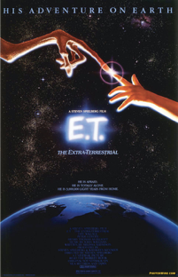

John Alvin, E.T. The Extra Terrestrial, 1982

The first piece in the exhibition is a movie poster made by John Alvin for the film ‘E.T. The Extra Terrestrial’. Many of his most famous posters were illustrated. His style became so popular with his colleagues that they called his work ‘Alvinesque’. Another famous illustrative piece that he designed was for ‘Blade Runner’ which also came out in 1982. Its intriguing to point out that considering they were both published in the same year, the layouts of the designs are quite different. Despite the fact that most movie posters in modern times are no longer illustrated and are most commonly photographed, the layout that Alvin uses for ‘E.T.’ would look similar when comparing it to contemporary movie posters such as the 2016 film “Silence” as they both use barely visible writing at the bottom of the page whilst having bold writing at the header of the page.

Due to the patriarchal society that women had to live through, many were hardly prominent at all in the film industry during the 1920s, and if they were, they had that “Bond Girl” image and were used as objects. American historian, Linda Nochlin wrote (1971 : 1) that “the white Western male viewpoint, unconsciously accepted as the viewpoint”. This can be related to past and current viewpoints of the Hollywood film industry. The second piece in the exhibition is from the James Bond film ‘For Your Eyes Only’. It was made by American graphic designer, Bill Gold. He was known for making thousands of film posters for Hollywood’s greatest filmmakers, however for this particular project - this simulacrum of an objectified woman - whilst at the time did not receive criticism, as of now Gold’s work is being scrutinised for the sexist nature of it.
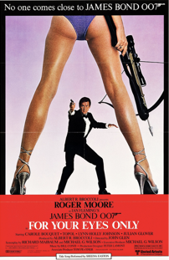

Bill Gold, For Your Eyes Only, 1981

‘For Your Eyes Only’ relates to the chosen theme as it emphasises my point that women were (and still are) being perceived as objects for the movie industry. This poster’s exact layout can also be seen in the 2014 film, ‘Kingsman: Secret Service’ with Sofia Boutella’s character also being objectified. By only showing certain parts of the woman’s body it can relate to Marcia Belsky’s project ‘Headless Women of Hollywood’. The aim of her campaign was to “bring attention to the still standard practice of fragmenting, fetishising and dehumanising the images of women we see in film”. The intertextuality between Belsky and Nochlin emphasises the objectification of woman in movie posters.


Movie posters were also important during historical events including World War II. During Adolf Hitler’s reign as Mein Fuhrer in Nazi Germany, he used propaganda significantly. They were used to make people believe that Hitler should be treated like a god. Others however, were anti-semitic towards jewish people, which was obviously a key theme during Hitlers reign. Despite their propaganda being infamous, it was widely successful for people living in Germany at the time. Because of this, Hollywood have used this marketing technique in numerous films. ‘The Eternal Jew’ was made in 1940 and was seen by many to be one of the worst anti-semitic films during the Nazi era. “The Eternal Jew is the first film that not only gives a full picture of Jewry, but provides a broad treatment of the life and effects of this parasitic race” (1940 : 54-55). This quote is from ‘Unser Wille und Weg’ the Nazi Party’s Monthly for propagandists. This highlights the horrific lifestyle that Jewish people had during the Nazi rule.

Justin Erickson, X-Men: Days of Future Past, 2014

Marvel and Fox’s 2014 blockbuster film ‘X-Men: Days of Future Past’, which is the third piece of the exhibition, uses the same method that the Nazis used on people of Jewish heritage. Erickson’s poster links to Guy Debord’s book ‘The Society of the Spectacle’ as he is trying to use a form of propaganda to make us become more interested and intrigued to watch their latest movie. This emphasises Debord’s view that the media has now become a force and highlights the role that the media plays in the communication of the public.

What helps in making a movie iconic is its poster. The saying “a picture paints a thousand words” should be prevalent in the designers’ mind when creating a poster. According to John Berger (1972 : 8) “The way we see things is affected by what we know”. This relates to why certain posters are perceived as being iconic as the key to making it memorable is to give us a taste of what the movie is about, without actually giving away the plot. This can be created in a number of different ways. They are best shown when you use key themes from their films and also when you show different elements that highlights parts of the film.
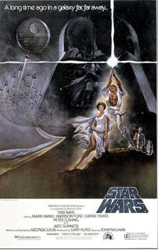

Tom Jung, Star Wars A New Hope, 1977

The original ‘Star Wars’ films have their own iconic posters as they use a key theme from their films in the poster, light against dark. When looking at the denoted signs, the signifiers would be the colours black and white, whereas the signified would be the dark side and the light side respectively. The lightsaber would be seen as the metonym. When looking back at the previous pieces in the exhibition, you can understand that the illustrative work by John Alvin clearly fits in to the category of being iconic as you understand key themes for the film. When thinking of the ‘A New Hope’ poster, Jung’s work is firmly established in the canon of movie posters.

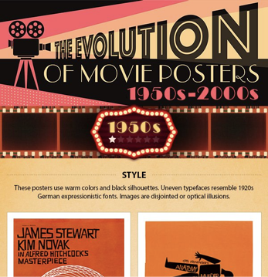
The final piece of work that would be used in the exhibition would be an infographic on ‘The Evolution of Movie Posters’ provided by ‘Company Folders’. This would give a brief overview to the audience as to how movie posters have changed. This deconstructed chart would bring a different narrative on how movie posters have changed throughout history.

Company Folders, The Evolution of Movie Posters, 2017

Bibliography
Books
Debord, Guy (1984) The Society of the Spectacle. Black & Red, Michigan
Berger, John (1972) Ways of Seeing. Penguin, London
Nochlin, Linda (1971) Why Have There Been No Great. Women Artists? Basic, New York.
(1940) Unser Wille und Weg, 10, pp. 54-55. München, F. Eher
Websites
Belsky, Marcia (2016) The Headless Women of Hollywood. Available at: http://headlesswomenofhollywood.com/ (Accessed: 15 January 2018).
Moore, Kris (2017) 24 Coolest Famous Movie Posters of All Time. Available at: https://www.companyfolders.com/blog/great-movie-poster-designs (Accessed: 7 December 2017)
Movie Posters
Alvin, John (1982) E.T. The Extra Terrestrial
Gold, Bill (1981) For Your Eyes Only
Erickson, Justin (2014) X-Men: Days of Future Past
Jung, Tom (1977) Star Wars A New Hope
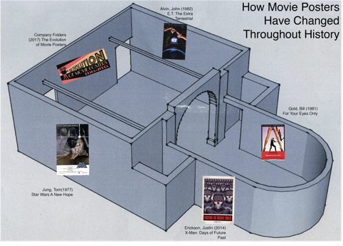
Map of the show with the works selected insitu

