DSP & Communications
ACDA5008

Scott Thomas
2015683

Assignment Report –
Simulation of Digital Modulation Techniques

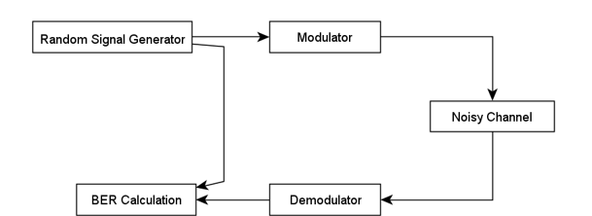

Abstract
During this experiment, several simulations were designed using MATLAB simulation software. These simulations were then analysed critically to compare the performances of variants of amplitude shift keying (ASK) and phase shift keying (PSK) in the presence of additive white Gaussian noise (AWGN). Advanced variants such as quantitative phase shift keying (QPSK) and quantitative amplitude modulation (QAM) were also produced as part of this experiment.
The designs were constructed sing MATLAB simulation software using Simulink to access the necessary components. The designed circuits all contained a Bernoulli Binary generator, threshold switches, sine wave generators, AWGN (additive white Gaussian noise), low-pass filters, Bit Error Calculator (BER) and several mathematical processes.
A Bit Error Calculator was used to compare the demodulated data and the source data. The Bit Error Rate failure threshold was decided to be 0.5, so when the BER surpassed 0.5 this was considered to be the point at which the systems failed. Through this study it was found that the QAM system was the most susceptible to noise and failed at -25db SNR (signal to Noise Ratio); the PSK was the second most susceptible to noise failing at -35db SNR and the ASK and QPSK were the least susceptible to noise both failing at -50db SNR.

Introduction
Digital Signal Processing (DSP) is defined as the techniques used for improving the reliability and accuracy of digital communications. DSP works by clarifying the states of a digital signal. A DSP circuit is used to differentiate between human-made signals, which are orderly and noise. [1]
Modulation is the process of encoding information from a source so that it is suitable for transmission. This is done by altering the characteristics of a wave by superimposing a signal onto a high frequency carrier wave signal which is a sine wave. In this modulation process, a parameter of the carrier wave is varied according to the modulating signal. The carrier wave parameters that varied are: amplitude, frequency or phase. This modulated signal is then transmitted by the transmitter. The receiver then demodulates the received modulated signal and therefore gets the information on the original signal back. [2]
An example of where modulation is required is when certain types of data such as video or voice have low frequency bands and therefore cannot travel very far wirelessly as they can not propagate through air. By modulating the signal, the much higher frequency carrier wave is used to carry the signal so that it can travel much further and quicker. [3]
The different types of modulation dealt with in this experiment are Amplitude Modulation and Phase Modulation. Amplitude Modulation is where the amplitude of the carrier signal is changed in proportion to the input signal while the frequency and phase are kept constant. Phase modulation is where the phase of the input signal is altered.
In Amplitude Shift Keying (ASK) the carrier wave amplitude is changed between discrete levels in accordance with the digital data. In the simulation the amplitude is modulated using a simple switch controlled by a Bernoulli Binary oscillator. The signal is demodulated by multiplying the received signal by the carrier signal, which is then filtered by a low pass filter. An example of where ASK is used is to transmit digital data over optical fibre.
Advantages:
- High bandwidth efficiency
- Simple receiver design
- Can be used to transmit digital data over optical fibre
Disadvantages:
- Low power efficiency
- Very suseptable to noise interference, due to the face that noise affects amplitude [4]
Phase Shift Keying (PSK) is a digital modulation technique where the phases of the carrier signal are changed by varying the sine wave input at a particular time. The phase of the carrier wave is changed according the binary inputs, with a difference of 180⁰ phase shift used between binary 0 and binary 1. The PSK technique is commonly used for contactless operations, wireless LAN’s and Bluetooth communications. [5]
Advantages:
- Carries data more efficiently compared to other modulation types. It is more power efficient compared to ASK and FSK
- Less susceptible to errors compared to ASK modulation and occupies the same bandwidth as ASK
Disadvantages:
- Low bandwidth efficiency
- Binary data is decoded by estimation of the phase states of the signal and these algorithms are very complex [6]
A variation of the PSK system is the QPSK system (Quadrature Phase Shift Keying). This type of phase modulation technique uses two information bits modulated at the same time, selecting one of the four possible carrier phase shift states. QPSK uses phase shifts of multiples of 90⁰ rather than 180⁰ in PSK. QPSK in used in a variety of cellular wireless standards, satellite and cable television applications.
Advantages:
- Good noise immunity
- Information transmission rate of QPSK is higher as it transmits two bits per carrier symbol
- Carrier power remains constant as the variation of the QPSK amplitude is small.
- Low error probability compared to other methods
Disadvantage:
- The main disadvantage of QPSK is the circuit complexity
QAM (Quadrature Amplitude Modulation) uses both amplitude and phase components to provide modulation that has the ability to provide high levels of spectrum usage efficiency. QAM is a signal with two carrier signals shifted in phase by 90⁰. Therefore, due their 90⁰ phase difference they are in quadrature. The resultant signals contain both amplitude and phase variations it can be considered as a mixture of amplitude and phase modulation. QAM is able to provide highly effective form of modulation for data and it is used in everything from Wi-Fi to mobile phones and most forms of high speed data communications systems. [7]
Advantages:
- The main advantage of QAM modulation is the efficient use of bandwidth. This is due to QAM representing more number of bits per carrier
Disadvantages:
- Due to the states being closer, QAM is more susceptible to noise. This requires the QAM receiver to be more complex compared to receivers of other modulation types.
- Linearity must be maintained due to QAM using the amplitude component of signal to represent binary data. This means that a linear amplifier is needed which consumes more power. [8]

Simulation Models and Results
The simulations were repeated with differing additive Guassian noise, adjusting the signal to noise ratio. The signal to noise ratio was changed from 100 db down to the failure point which was a bit error rate of 0.5. These readings were repeated 10 times for each signal to noise ratio and an average was taken. These readings were then used to produce graphs to illustrate the difference in the systems that have been produced. The simulations were carried out with a sample rate of 100 which should be sufficient to gain accurate results.
Amplitude Shift Keying
The first simulation was the ASK system. The modulator comprised of a sine wave and a constant 0 which were then fed into a switch. The threshold of the switch was set to 0.5. Designing the switch in this way means that any signal below 0.5 will give an output of 0 and any signal above 0.5 will output a 1. This signal is then fed into the AWGN module. The AWGN module is used to insert noise into the system so that the error rate can be determined depending on the signal to noise ratio. This signal is then fed into the low-pass filter. The signal is then demodulated using two constants, a 1 and a 0 fed into a switch. This signal is then fed into an error rate calculator. This error rate calculator compares the source signal with the output signal of the system. This then allowed the bit error rate to be found. The ASK system failed at -40db signal to noise ratio which can be seen in figure 2. The designed system can be seen in figure 1.
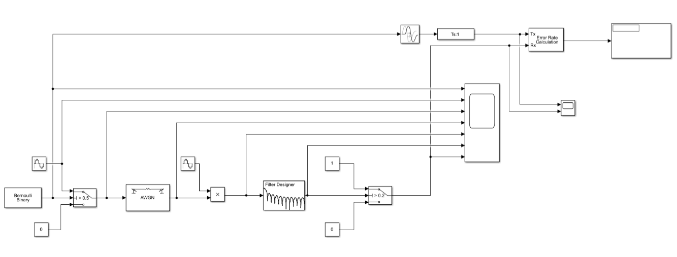
Figure 1.

Figure 2.

Phase Shift Keying
The PSK system is very similar to the ASK system with one major change as can be seen in figure 3. The change made is that a sine wave replaces the 0 constant on the modulator. This allows the phase to be shifted 180⁰ as is required for phase shift key modulation. Figure 4. Shows that PSK system failed at -30db meaning that it is more susceptible to noise than the ASK system.
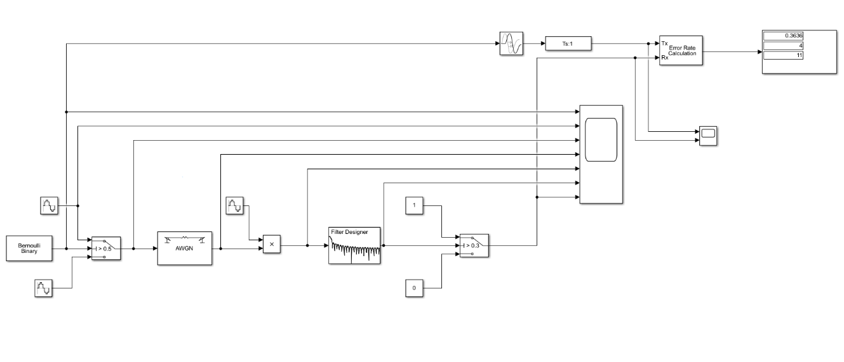
Figure 3.

Figure 4.

Quadrature Phase Shift Keying
In the QPSK design, as seen in figure 5, the signal firstly goes through a deserialiser. The deserialiser splits the signal into bytes. The demux block then extracts components of the signal into separate units so that the output is useable. This signal is then modulated using two sine wave generators. This signal is then combined and fed into the AWGN so that noise can be added for the experiment. This signal is then passed through the low-pass filter. A serialiser is then used to match the signal and the input. As can be seen in figure 6, the point of failure for the QPSK system is -50db which means that the QPSK system is the least susceptible to noise out of the systems tested.
Figure 5.
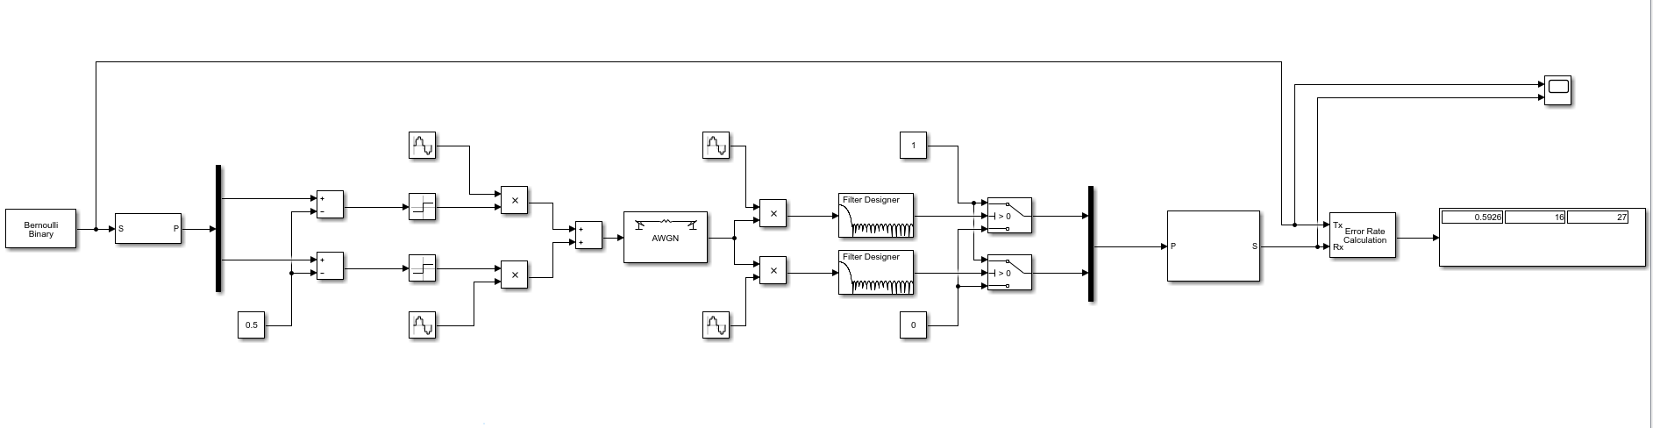

Figure 6.

Quadrature Amplitude Modulation
The QAM system has additional parts compared to the QPSK system to provide amplitude modulation as well as phase modulation. These extra components include extra switches, an absolute value to insure that the input will always be positive and extra space on the mux/demux to allow 4 inputs/outputs. As can be seen in figure 8, the failure point of the QAM system is -30db.
Figure 7.
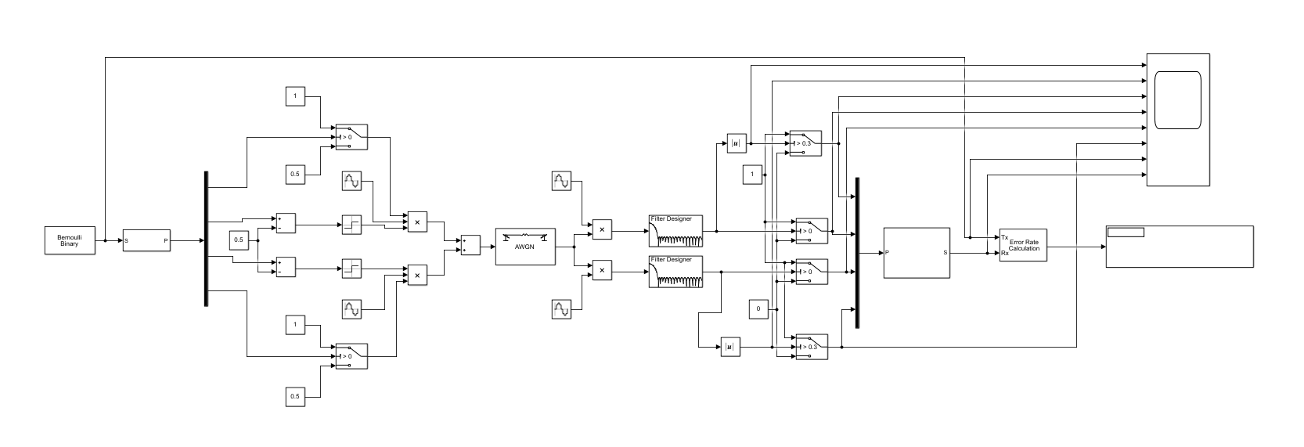
Figure 8.

Figure 9.

Discussion
In this experiment it was found that by adjusting the signal to noise ratio of the additive white Gaussian noise for the four Digital Signal Processors, it was found that the QPSK system was the least susceptible to noise, failing at -50db, and the QAM system was the most susceptible to noise, failing at -25db, as can be seen in figure 9.
The QAM system is more susceptible to noise and interference due to the reduced constellation point spacing but QAM is the most robust system as it has a more efficient packing of its constellation points.
One surprising outcome of this experiment was that the PSK system failed at -35db. This is a surprising result as through research it was found that ASK systems are more susceptible to errors than the PSK system. If the experiment was repeated more, with more sampling points then the ASK system would fail sooner than the PSK system.
Conclusion
In this experiment, it has been determined that the QAM system is the most susceptible to noise, followed by the PSK system, then the ASK system, with the QPSK system being the least susceptible to noise.
It can be concluded that there are many types of signal modulation which all have their own advantages and disadvantages as discussed previously. PSK systems would be more appropriate for localised transmission. QPSK systems are best suited for satellite transmission as these systems are the least susceptible to noise.

References
1 What is digital signal processing (DSP)? - Definition from WhatIs.com (techtarget.com)
2 What is Modulation in Telecommunications? - Carritech Telecommunications
3 What is Modulation in Telecommunications? - Carritech Telecommunications
4 ASK Advantages | ASK Disadvantages | Amplitude Shift Keying (rfwireless-world.com)
5 Digital Communication - Phase Shift Keying (tutorialspoint.com)
6 PSK Advantages | PSK Disadvantages | Phase Shift Keying (rfwireless-world.com)
7 What is QAM: Quadrature Amplitude Modulation » Electronics Notes (electronics-notes.com)
8 Advantages of QAM | Disadvantages of QAM | 16QAM,64QAM,256QAM (rfwireless-world.com)

