
Programme:
Master of Business Administration

Module Title:
Strategic Management

Module Code:
LCMB7003

Module Lecturer:
Balendran Kandasamy

Strategic Analysis of Walkers Crisps in the UK Snack Market
Submitted By:
MUHAMMED SALIM
Student ID:2518573
Submission Date:
12-August-2026

Table of Contents
Table of Contents 2
AI Use Acknowledgement 3
Section 1: Strategic Analysis of Walkers Crisps in the UK Snack Market 5
1.1. Organisational Context and Overview 5
1.2. External and Internal Analysis 7
1.2.1. PESTEL Analysis of Walkers Crisps in the UK Snack Market 7
1.3. VRIO Analysis of Walkers Crisps UK 10
1.4. SWOT Analysis of Walkers Crisps UK 12
2. Comprehensive and Holistic View of Walkers Crisps UK 14
2.1. Corporate Social Responsibility (CSR) Strategy 14
2.2. Balanced Scorecard Analysis 15
3. Strategic Choices and Implementation 18
3.1. Evaluation of Business-Level Strategic Choices 19
3.2. Strategic Evaluation Using the SAFe Framework 20
3.3. Recommended Strategy and Contribution to Optimum Performance 21
3.4. Implementation Challenges and Mitigation 22
4. Conclusion 23
Section 2: Reflective Account Using Gibbs' Reflective Cycle 24
4.1. Introduction 24
4.2. Description 25
4.3. Feelings 25
4.4. Evaluation 25
4.5. Analysis 26
4.6. Conclusion 26
4.7. Action Plan 26
References 28

AI Use Acknowledgement
I would like to state that this assignment was completed with the assistance of several AI tools. These tools were utilized in the research planning, structuring, proofreading, paraphrasing and refining of the assignment. I used the following tools from 20 July 2026 to 5 August 2026 All of the recommendations that were suggested by the AI tools were incorporated into the assignment.
Quill Bot - https://quillbot.com/ : This online application was mainly used for paraphrasing, improving the clarity of academic writing, correcting grammar and rephrasing sentences within an article. Minor adjustments to certain articles have been made using this online application while preserving the meaning of the original article. Also, it has been utilized to minimize repetition of certain ideas within articles, improve the flow of sentences and ensure that the correct word count is maintained for each article.
ChatGPT (OpenAI) - https://chatgpt.com/ - was used to help with the planning and organisation of the assignment and create associated visulaisations. It enabled to apply and explain various strategic management tools such as PESTEL, VRIO, SWOT, Porter's Generic Strategies, Ansoff's Matrix, the Balanced Scorecard, Corporate Social Responsibility and Gibbs' Reflective Cycle. Also, ChatGPT was used to develop the reflective section of the assignment using Gibbs' Reflective Cycle (1988). Finally, ChatGPT was employed to review and improve the academic writing skills. The Prompts included the following
- Describe how to use the following tools to analyse [Company Name]'s strategic position and explain how they are related to each other in a business report: PESTEL, VRIO, SWOT, Porter's Generic Strategies, Ansoff's Matrix, and the Balanced Scorecard.
- Help me to organise a reflection using Gibbs' Reflective Cycle (1988) of what I have learned during the completion of this strategic management assignment; description, feelings, evaluation, analysis, conclusion, and action plan.
- Please read this paragraph for clarity, academic tone, and structure and make suggestions for improvement while maintaining the intent and content of the paragraph.
To find relevant and academic peer-reviewed literature that supports the theoretical models and concepts within the assignment, Google Scholar was used: https://scholar.google.com/ . The site has been used to locate academic literature on topics like PESTEL, VRIO, SWOT, Porter's Generic Strategies, Ansoff's Matrix, the Balanced Scorecard, Corporate Social Responsibility and Gibbs' Reflective Cycle. Google scholar has been helpful in finding the original academic literature related to these topics and as a means of providing academic evidence for the theories that will be discussed within the assignment.
These tools were employed in addition to the students' own critical thinking abilities. The information and ideas that were generated using these tools were then reviewed and compared with relevant academic literature and company information.
I confirm that I have not presented any AI generated text as my own work. I confirm I have copies of my drafts, notes, and other resources I used before, and after the use of AI tools which I may be asked to provide in evidence.

Section 1: Strategic Analysis of Walkers Crisps in the UK Snack Market

Organisational Context and Overview
This report focuses on Walkers Crisps in the UK. Walkers is a PepsiCo snack segment company in the UK. The company was founded in Leicester in 1948 when Henry Walker moved from his business making meat products to manufacturing crisps. It was later bought by PepsiCo through Frito-Lay. This enabled Walkers to have a global buying experience, manufacturing skills, and powerful marketing. The focus is merely on Walkers Crisps in the UK, as it is a clear product-market area. It also allows for strategic evaluation of the business with a focus (Gandrita, 2023). The brand definitely has been meeting the requirements of an assignment as it has been in operation for over five years.
PepsiCo's vision is to make more smiles with every sip, every bite. Its goal is to become the world leader in both beverages and convenient foods by winning with PepsiCo Positive. This translates to growth and sustainability, as well as people and healthier food choices. For Walkers, this vision can be achieved by reformulating, serving reduced sizes, and offering lower salt and fat versions of their products. PepsiCo UK has announced that in January 2026, 59% of sales value from its snack business in the UK was from healthier brands, including Walkers and Doritos (PepsiCo, 2026).
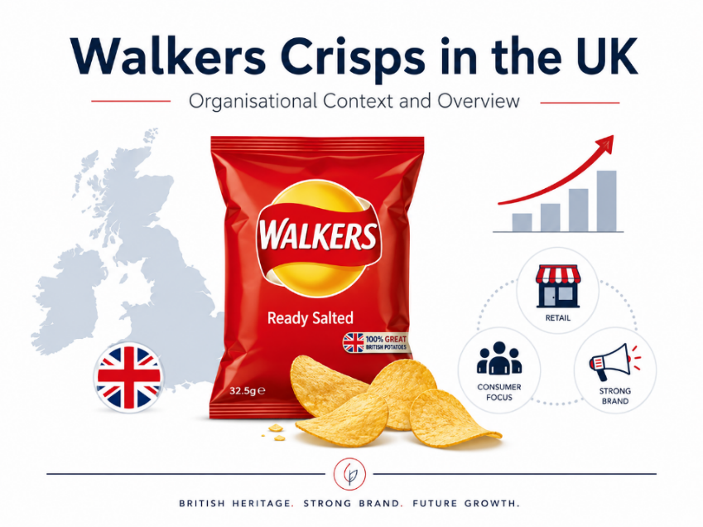
Figure 1: Walkers Crisps UK
Source: Author
The Walkers' business model is a simple scale-based model. Grows potatoes, processes chip, breeds good potato varieties, sells them in supermarkets, service stations, wholesalers and in online grocery stores. Walkers has been sourcing its potatoes from more than 80 UK farms (Hu et al. 2025).
It's a British business that makes crisp and savoury snacks. The convenience of eating, promotions, flavour innovation, and the power of the retailers dominate this market. Other factors that influence it are related to health issues, inflation, private brands, and HFSS legislation. The main competitors of Walkers are Pringles, KP Snacks, Intersnack, Tyrrells, Burts, Seabrook, and supermarket own-label crisps (Haverkort et al., 2022).
It has a strong market position with the goodwill and reach of the Walkers brand and the distribution and extensive resources of PepsiCo. Its biggest challenge is retaining customer loyalty amidst the need for healthier diets and a greater value and sustainability from consumers.
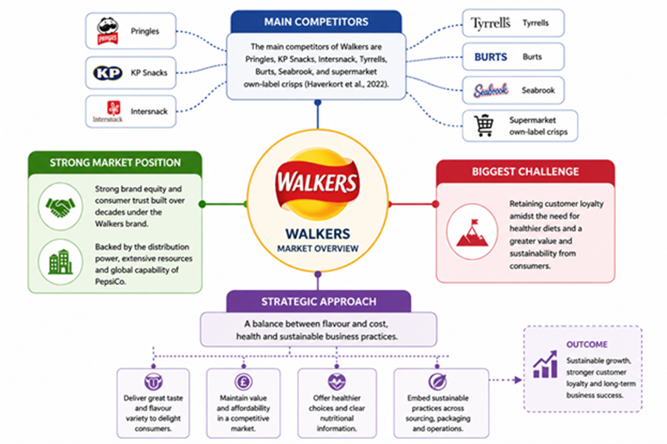
Figure 2: Key Competitors | Source: Prepared by Author

External and Internal Analysis

PESTEL Analysis of Walkers Crisps in the UK Snack Market
The PESTEL analysis is used to make an analysis of macro-environmental factors which have impact on the strategic position of Walkers Crisps in the UK snack market. Walkers is part of PepsiCo, which functions in the context of the government, the economy, the changing preferences and expectations of consumers, new technology, and sustainability (Senturk and Cakir, 2023).
- Political Factors
Government policies significantly influence the UK snack industry. There are regulations for foods high in fat, salt and sugar (HFSS) that limit the promotion, advertising and placement of traditional crisps which helps to lower the temptation to buy them and increases compliance costs. In response, Walkers has tweaked product offerings, cut salt content, and offered smaller sizes, as part of PepsiCo's healthier product initiative. In addition, purchasing potatoes from more than 80 farms in Britain makes for more secure supply and supports British farming.
Opportunity: increasing health product offerings to achieve government goals.
Threat: Other HFSS policies may further restrict marketing activity and growth of sales.
- Economic Factors
UK food production costs have risen due to inflation, higher energy costs and transport costs. These pressures can lower the margin for profit and increase the demand for the low-priced supermarket owned crisp brands. But crisps are still a low cost convenience snack, with relatively constant demand. PepsiCo's purchasing power, efficient operations and economies of scale are advantages for Walkers (Masih et al, 2019).
Opportunity: Operational efficiency and brand strength allow them to stay in the market.
Threats: with ongoing inflation, customers could become more price conscious, and there could be greater competition from store brands.
- Social Factors
Consumer attitudes are changing towards healthier, more sustainable food. Low salt, reduced fat and natural ingredient snacks continue to be popular and convenience and flavour are important buying drivers. Walkers has accomplished this through product enhancements, flavour innovation and a long-standing track record of satisfaction with the product. But the younger generation is more aware of health or environmental impacts in their product choice.
Opportunity: As customers increasingly demand health-conscious snacks, product innovation is being driven.
Threat: Consumers with a focus on health will have lower consumption of traditional crisp patterns which will lower demand in the long-term.
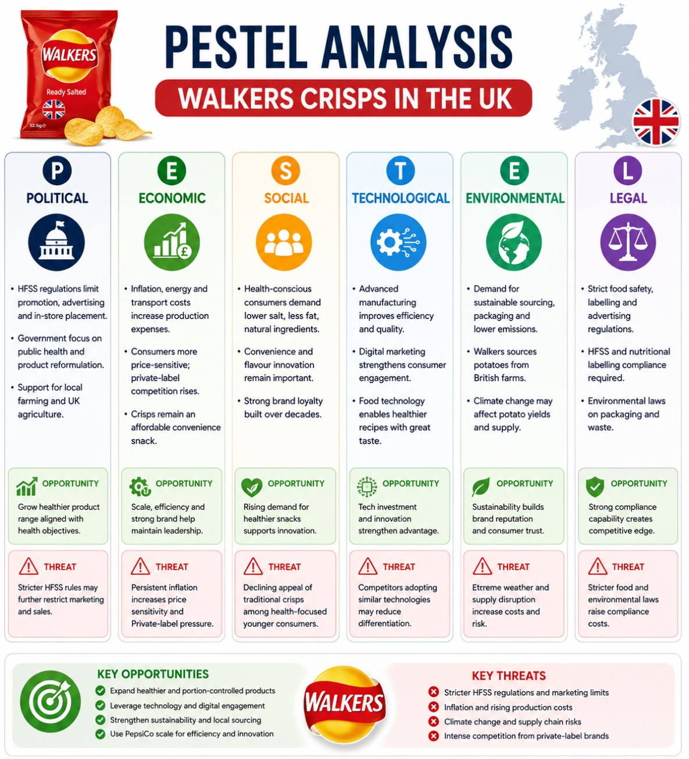
Figure 3: PESTEL Analysis | Source: Written and Created by Author
- Technological Factors
New technology improves production processes, quality of products, and relationships with the customer. Advanced production systems allow to increase productivity and consistency and digital marketing helps to enhance the relationship between the consumer and Walkers, promoting new products. Food technology helps develop healthy products while not greatly affecting flavor (Jiang, 2021).
Opportunity: investing in digital marketing and product innovation will provide a competitive advantage.
Threat: Competing technologies may be adopted by others limiting differentiation.
- Environmental Factors

Customers and shoppers are becoming more and more conscious of sustainability. Walkers also supports sustainable sourcing by buying potatoes from British farms, and helping to ensure sustainable manufacturing and packaging by funding PepsiCo's sustainable initiatives. But agricultural production will be at risk from climate change because of the disruption of normal weather patterns which may impact potato yield and raw material prices.
Opportunity: Sustainable practices offer a potential opportunity to improve brand reputation and customer loyalty.
Threat: Disruptions in supply lines due to climate change may also contribute to increased operating costs and production shortages.
- Legal Factors
The very controlled business of Walkers faces all sorts of challenges including food safety, labelling, advertising and environmental compliance. The law on HFSS and the stricter nutritional labelling are pushing for a constant change in product and marketing adaptation. If you don't comply, you could face fines and a tarnished reputation. PepsiCo's regulatory expertise, however, means that Walkers is better able to adjust than some of its smaller competitors (Rashid, 2023).
Opportunities: Be competitive with good compliance abilities.
Threat: increasingly stringent food and environmental regulations may raise compliance costs.

VRIO Analysis of Walkers Crisps UK
The VRIO framework is used to determine if an organization's resources and capabilities can create a sustainable competitive advantage by measuring the organization's resources and capabilities against the four questions: Valuable, Rare, Inimitable, and Organized (Lin et al, 2012). Walkers is a flagship brand of PepsiCo, and it has a number of strategic resources that make it a formidable competitor in the UK snack market.
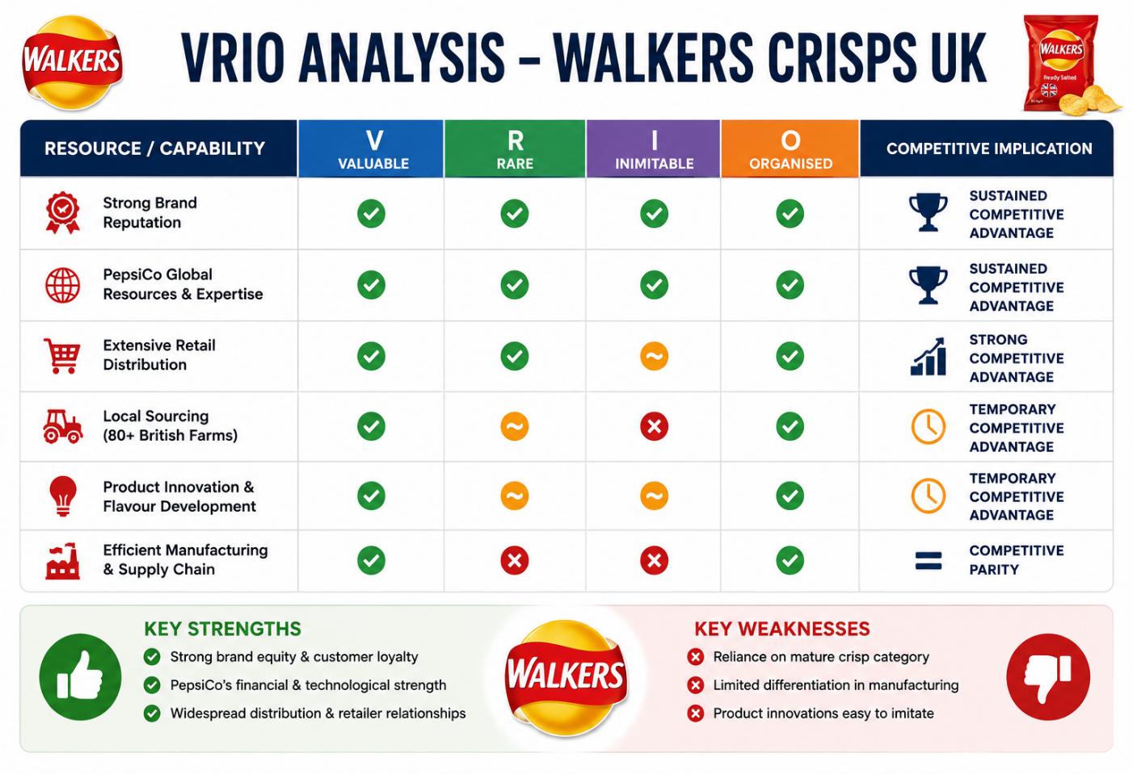
Figure 4: VRIO Analysis | Source: Prepared by Author

- Valuable Resources (Value)
Walkers has a large number of useful resources that help them to react to opportunities and external threats. Its existing brand reputation, built over 70 years in the UK, is the company's greatest asset. Virtual to repeat purchases and successful product launches are high levels of customer recognition, trust and loyalty. Additionally, Walkers' access to PepsiCo's extensive financial resources, research and development capabilities, and marketing power allows for ongoing innovation and efficiency in product development and operations. In addition, potatoes are purchased from over 80 farms in Britain, which provides a high level of product quality, security and consumer demand for locally-sourced produce (Wei and Davis-Ngatai, 2017).
- Rare Resources (Rarity)
Several of Walkers' resources are relatively rare within the UK snack market. Many competitors have a hard time matching the national brand recognition and financial and global capabilities of PepsiCo. Walkers also has long established relationships with major retailers in the UK, thus allowing for favourable shelf space and wide market coverage. Local sourcing and flavour innovation, however, are not as uncommon because other manufacturers are starting to follow the same sourcing habits and often create new variants of their products.
- Inimitable Resources (Imitability)
The most difficult capability for competitors to imitate is Walkers' brand equity. It is hard to replicate intangible assets that have been built over the years thanks to customer loyalty, heavy marketing and constant product quality. Likewise, PepsiCo's integrated global supply chain, research and financial capability gives it an edge that can only be achieved after a lot of time and investment. Manufacturing technologies, healthier product reformulation and flavour innovation, however, are more easily copied, making them less likely to provide long-term competitive advantage (Cardeal and Antonio, 2012).
- Organisational Support (Organisation)
Walker is well organized to leverage its strategy. In PepsiCo, it has in place effective organisation systems, modern manufacturing plants, a flexible supply chain and marketing power which optimize its resources. By investing in product innovation, sustainability initiatives, and regulatory compliance, Walkers can continue to operate efficiently and adapt to consumer preferences and government regulations.
To sum up, the VRIO analysis reveals that Walkers has a strong brand image, PepsiCo has global financial and technological resources, and it has a broad distribution network – all of which provide long-term competitive advantages. However, there are some short comings, like an increasing dependence on a mature crisp category facing health challenge and under-differentiation of the manufacturing process and product innovations which can be easily copied by competitors in relatively short order.

SWOT Analysis of Walkers Crisps UK
The SWOT analysis is created by integrating the outcomes from the external (PESTEL) and the internal (VRIO) analysis to obtain an overall understanding of the UK snack market and the standing of Walkers Crisps. It demonstrates the company's internal strengths and weaknesses and outlines how these can be used to capitalize on external opportunities and reduce threats (Soegoto, 2021).
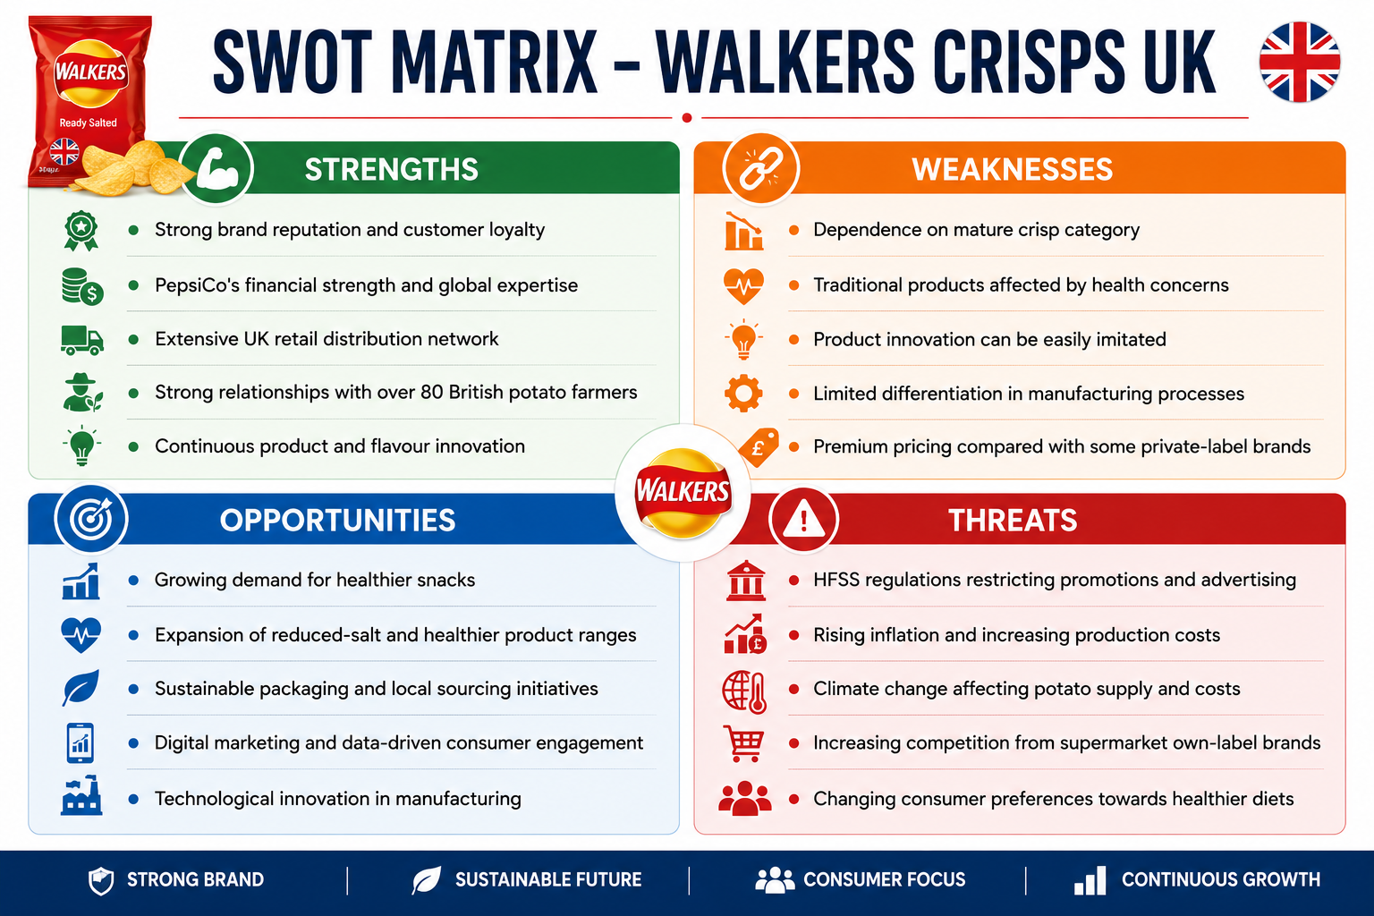Figure 5: SWOT Analysis | Prepared by Author
- Leveraging Strengths to Exploit Opportunities (SO Strategy)
Walker's brand value, retail distribution and PepsiCo's world-class resources give the company a strong platform to build on when it comes to leveraging new market opportunities. PepsiCo is focused on reducing salt in their products, smaller packs and healthier snacks, as well as fulfilling the consumer demand for healthier snack options.
Research and development is continuing and Walkers can reformulate products whilst complying with the HFSS regulations. The investment in digital marketing and manufacturing technology also offers the chance of improving customer interaction, process efficiency and product innovation (Sun et al, 2024).
- Addressing Weaknesses
Walkers has market leadership, but has several limitations within it that may impact its future competitiveness. The business continues to be very reliant on the mature crisp segment, where healthy eating is now more of a driver. While flavours help to hold onto customers, new product development is rather easy to emulate by competitors, which decreases the long-term differentiation.
Furthermore, this efficiency advantage is no longer exclusive to the manufacturing process as many snack manufacturers have similar equipment. The premium pricing could also push price-conscious shoppers to opt for the cheaper supermarket brands in times of economic troubles. Healthier product lines need to be invested in more, innovation is key, and the value needs to be differentiated.
- Managing External Threats
Walkers are facing a more difficult external environment. The HFSS regulations remain effective and products are still restricted from being promoted, advertised, and placed in the retail environment, which limits chances for impulse buying. Higher inflation, higher energy costs and disruption of supply chains add to operating costs and profit margins.
Climate change also poses additional risks as it may impact potato production and raise raw material prices due to the impact of uncertain weather patterns. Competition from supermarket own-label brands, KP Snacks and Pringles is also a pressure on pricing, product innovation and customer loyalty. Walkers must increase cost efficiency, build supply chain resilience and move to healthier product development quicker in order to withstand these threats (Reid and Reid, 2014).
- Strategic Implications
The SWOT analysis suggests that Walkers has good internal strengths to retain its market dominance in the UK snack market. But the challenge of maintaining a competitive edge over the long haul will rely on how well it can capitalize on its brand power and PepsiCo's global assets and distribution channels, and on its ability to be responsive to shifting consumer tastes and requirements and new laws (Parnell and Brady, 2019).
The strategic priorities should be an increase in healthy snack options, enhancing sustainability efforts, ongoing product development and efficiency and optimization. Walkers can strengthen its competitive position by building on its strengths, mitigating their main weaknesses and threats and increase sustainable growth in the UK snack market in the long term.

Comprehensive and Holistic View of Walkers Crisps UK

Corporate Social Responsibility (CSR) Strategy
CSR, or corporate social responsibility, is the company's responsibility to be ethical and to generate economic, social and environmental value for their stakeholders. While CSR is not a business for business activity, it is also a business for long-term sustainability, trust and engagement among stakeholders (Strategy, 2021).
Walkers Crisps UK is part of PepsiCo, which has a PepsiCo Positive (pep+) strategy that focuses on sustainability at the heart of business growth. It centers on three strategic areas, Positive Agriculture, Positive Value Chain and Positive Choices, all working towards the change in food production, less impact and healthier food choices. In the UK snack market Walkers uses this approach by buying potatoes from over 80 British farms, making their manufacturing more efficient, cutting salt and saturated fat in their products and investing in sustainable packaging.
- Critical Evaluation of Walkers' CSR Strategy
Walkers' CSR strategy is based around three key areas: environmental sustainability, social responsibility and health and nutrition. The company works with over 80 British farmers to promote sustainable potato growing through the use of potatoes from within the local area. To further drive water conservation, PepsiCo has also invested in areas of water conservation, renewable energy, carbon reduction and recyclable packaging. However, recycling packaging is difficult and sustainability programs are a source of operating costs (Velte, 2022).
Socially, Walkers builds farmer confidence in UK farmers, promotes employee health and diversity, and ensures responsible sources and strengthens stakeholder relationships and community confidence. In terms of health, the company has modified their product ranges to reduce saturated fat, salt and serve sizes and to include healthier snack products to comply with the HFSS.

- Alignment with Business Objectives
Walkers' CSR strategy is firmly linked to the overall business goals and contributes to developing the brand's reputation, customer trust, regulatory compliance and overall competitiveness. The brand differentiation and strengthening of relationships with a more sustainability-conscious consumer is achieved through sustainability aspects of sourcing, innovation of healthier products and environmental efforts. Adhering to the changing regulations of food also reduces the risk of lawsuits and bad reputation, as well as aids in maintaining market access (Ardiansyah, 2024).
CSR is not just about doing what's right, it's about doing what's right for the longer term. Nevertheless, challenges remain. The packaging waste, health issues that are still present with the crisps and sustainability costs are things that can have an impact on short-term profitability. Hence, CSR should be seen as a strategic project that can provide opportunity for a competitive advantage and business resilience, not as a compliance-driven programme. Overall, Walkers has demonstrated that its CSR approach is a successful and effective strategy, supporting the company's business objectives and helping to achieve sustainable growth and address the evolving needs of stakeholders.

Balanced Scorecard Analysis
The Balanced Score Card (BSC) can be used as a performance management tool to allow the organization to determine its performance in both financial and non-financial terms. The Balanced Scorecard is a performance measurement system that differs from traditional ones, because it puts more weight on the financial results; it also links the organization's vision or strategy to measurable operational goals from four points of view: Financial, Customer, Internal Business Processes and Learning and Growth (Hasan and Chyi, 2017).
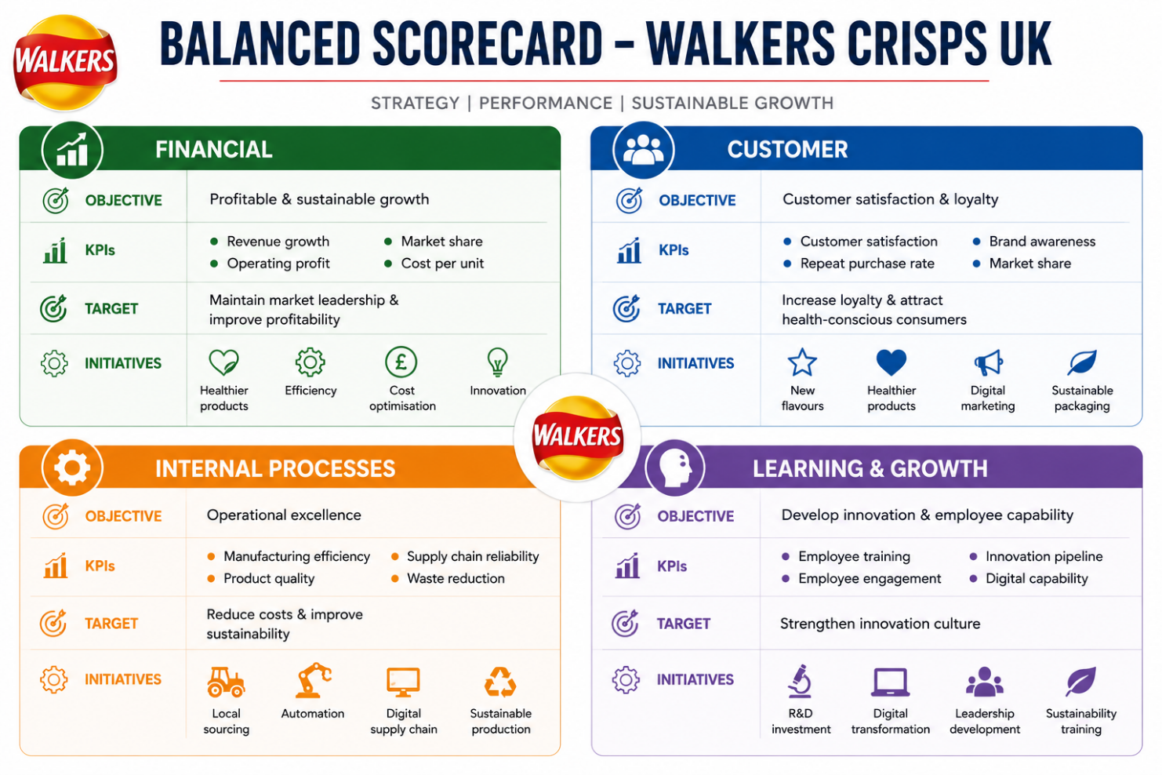
Figure 6: Balanced Scorecard | Source: Prepared and Written by Author

- Financial Perspective
The first financial target for Walkers is to grow profitably and sustainably – and to stay ahead in the UK snack market. Some key metrics, or key performance indicators (KPIs), are revenue growth, market share, operating profit, and production cost per unit. The Company's goal is to increase profits without compromising on product quality and its sustainability commitments (Krylov, 2014).
Walkers' aims are constantly to expand its healthy product range, improve manufacturing efficiency, minimise production costs and invest in product innovation. These efforts enable the business to adapt to changing tastes of consumers and influence the profitability of the company. But financial measures are not enough as they are based on the past and not on the future competitiveness. Customers' satisfaction, innovation, sustainability and operational efficiency are also key factors in achieving long-term success and are not reflected by financial metrics.

- Customer Perspective
Walkers’ targets to build consumer satisfaction and loyalty, as well as to appeal for the growing health-conscious consumers. Some KPIs relevant to this include, but are not limited to, customer satisfaction scores, brand awareness, repeat customer rates, and market share. The goal is to sustain any existing customers, and to increase the reach to consumers who are looking for healthier snack options (Banker et al, 2004).
In order to do this, Walkers funds flavour innovation, healthy product development, digital marketing campaigns and sustainable packaging projects. These efforts support the company's solid brand reputation and customer engagement. But the consumers' expectations have outgrown the taste and convenience of the product. New consumer purchasing criteria that can be influenced by nutrition, environmental stewardship, and corporate responsibility are now coming into play.
- Internal Business Process Perspective
The internal business process view is concerned with improving operational excellence and supply chain performance. Some of the important KPI's are manufacturing efficiency, supply chain reliability, product quality and waste reduction. The goal of Walkers is to reduce the cost of its operations, increase sustainability and production efficiency (Hoque, 2003).
Strategic initiatives include the use of potatoes from British farms, automation and digitalization of the supply chain and sustainable manufacturing. These programs can make your business more resilient, less damaging, and help ensure the consistency of products. The smooth internal procedures also help to innovate products, interact with suppliers and adapt to the changing markets. This not only implies operational excellence is not simply about cost leadership, but about product differentiation as well that further reinforces Walkers competitive edge in the UK snack market.
- Learning and Growth Perspective
Learning and growth is a perspective focused on employee skills and the building of innovation competency, which leads to long-term competitiveness. The measures include: Employee training, Innovation performance, Employee engagement, and Digital capability. The company's goal is to promote the culture of continuous learning and innovation.
Walkers is making progress toward this goal in several ways, from investing in R&D to digital transformation, leadership development to sustainability training. These initiatives help employees build their skills and encourage continuous product innovation and operational innovation. Innovation is an important part of a contemporary transforming food system and a competitive advantage. By building healthier products, advancing production technologies and building digital capabilities, Walkers can better meet consumer shifting preferences and regulatory demands.
Table 1 Balance score Dimensions, KPIs and Strategic Initiatives
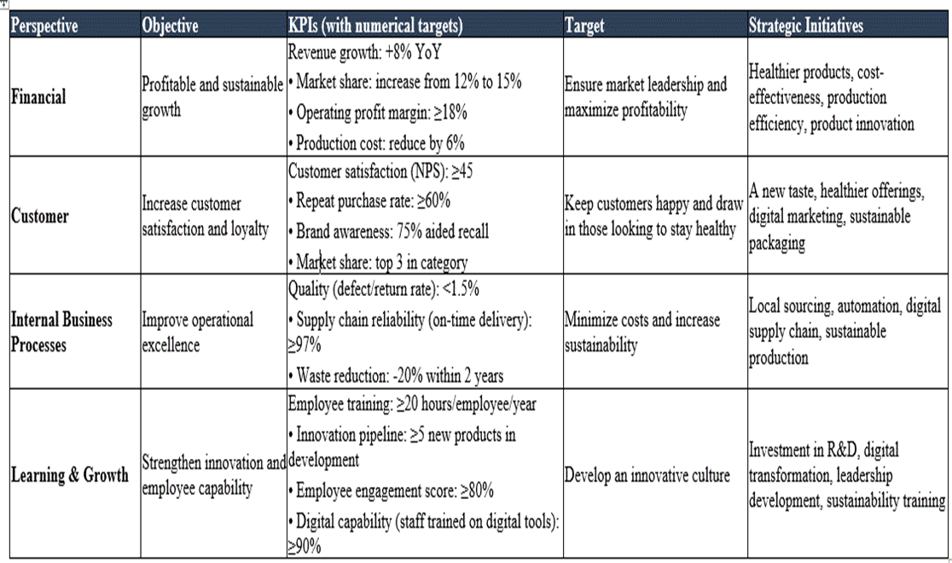
Source: Written by Author

Strategic Choices and Implementation
Strategic choice is a decision-making process that aims to select and implement the appropriate course of action to fulfil long term objectives and sustain competitive advantage in the dynamic business environment. For Walkers Crisps UK, changing consumer preferences, increasing health regulations, and intense market competition require continuous evaluation of strategic alternatives. This section critically analyzes the business-level strategic choices that can be made by Walker, and also assesses future growth possibilities by utilizing the Ansoff's Matrix.
These frameworks are then used to determine the best strategy to be adopted and then evaluated for its potential to enhance the competitive advantage and sustainable growth of the UK snack market.

Evaluation of Business-Level Strategic Choices
Organizations can gain competitive advantage using cost leadership, differentiation, and focusing according to Porter's Generic Strategies (Islami, 2020). There are various ways in which to compete in an industry for each of the strategies. Choosing the right business-level strategy is crucial for Walkers Crisps UK to ensure market leadership amidst shifting consumer tastes, rising health requirements, and fierce competition in the snack market in the UK.
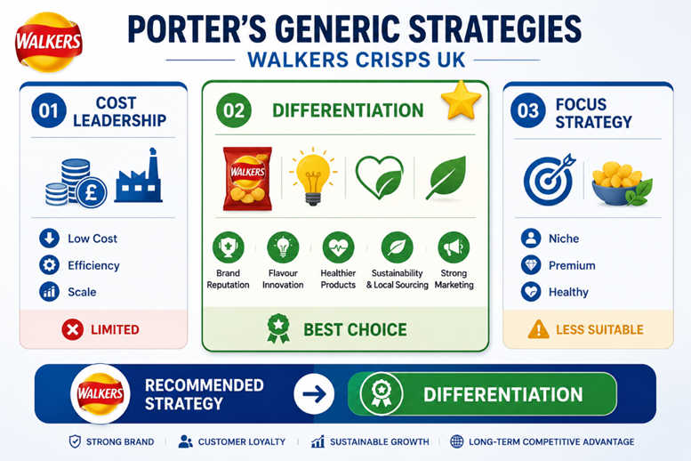
Figure 7: Porter’s Generic Strategies | Source: Prepared by Author

- Option 1: Cost Leadership
A cost leadership strategy is based on low production cost with offering competitively priced products. The economies of scale, efficient manufacturing and PepsiCo's powerful buying power makes Walkers profitable. But this approach is not possible in the UK snack market. Walkers are competing with other own label products, which are already established in the market on price (Jerab and Mabrouk, 2023). Moreover, over-trimmed roots will affect the quality of the product, brand reputation, and customer loyalty.
- Option 2: Differentiation
By using a differentiation strategy, Walkers can compete on the basis of value added, which is not common. Its brand is a strong asset, its continuous flavour development, the healthier products, its sustainable supply chain, working with over 80 British potato growers and marketing power are all strengths of the company (Tomlinson, 2008).
This strength results in high customer loyalty, premium pricing and boost that competitive position. Furthermore, the entire concept is consistent with the trend of healthier and more sustainable snack products. But maintaining the differentiation will cost more as it will involve constant investment in research, product development, and marketing. Despite all these challenges, differentiation is the best option to maintain Walkers' competitive edge in the long run.
- Option 3: Focus Strategy
A focus strategy targets one specific customer group, e.g. premium crisps or health-conscious consumers, with a focus on the product to serve a specific customer group and tailored value. Growth in consumer demand for healthier snacks could be met by increased availability of healthier snacks to walkers. But this approach is not ideal since Walkers is a mass-market brand available all over the country, and has mass customer appeal (Peltokorpi et al, 2016).
Narrowing the focus would mean less sales, less economies of scale and less market leadership. A niche product line can supplement its product mix, but a pure focus strategy would not be compatible with Walkers' business model.

Strategic Evaluation Using the SAFe Framework
The SAFe framework evaluates a strategic option through Suitability, Acceptability and Feasibility. Suitability covers the matter of responsiveness of a strategy to the external environment and organisational position. Acceptability evaluates anticipated returns, risks and reactions of the stakeholders, whereas Feasibility evaluates if the organisation has resources and capabilities necessary to implement it (Dawes, 2018). In Walkers Crisps UK, SAFe can be used to test flexibly whether to follow differentiation on healthier and innovation-based products that are sustainable.
Table 2 Evaluation of Strategic Options as per SAFe
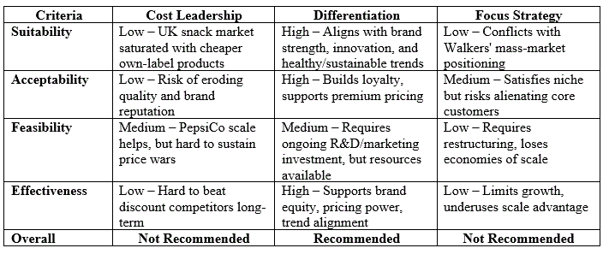

As per the analysis, SAFe indicates that differentiation is strategically appropriate, acceptable to major stakeholders and achievable with existing capabilities. Pursuit of the strategy should then be in a controlled form of investment, with quantifiable goals and regularity of consumer testing.
Differentiation fits rising demand for healthier snacks, tighter HFSS restrictions, sustainability expectations and strong competition from private labels. It also uses Walkers’ brand reputation, flavour innovation, local sourcing and PepsiCo capabilities.

Recommended Strategy and Contribution to Optimum Performance
The recommended strategy is broad differentiation centred on healthier product reformulation, distinctive flavours, sustainable sourcing and packaging, and strong digital brand engagement. According to Porter, differentiation brings about advantage where customers are able to perceive unique value and will be ready to remain loyal or to pay a premium (Clarissia, 2020). It is more suitable than some price-based competition since the supermarket's own-label brands have an opportunity to be below the branded products, although Walkers already have good brand equity and national coverage (Hossain et al. 2023).
This strategy would enhance the optimum performance in the following aspects. Firstly, it could be wiser to begin with a reduced amount of salt and saturated fat and a better ratio to suit health-conscious customers and be on par with the required HFSS. Second, consistent flavour and format innovation can enhance repeat purchase and shelf presence security. Third, sustainability efforts have the power to bolster trust and build brand meaning. Fourth, the PepsiCo size can consolidate differentiation with operational effectiveness, and the costs of innovations might not erode the margins (Krishnan and Ulrich, 2001). The resource-based view is of the opinion that Walkers can be compared based on maker of good brand equity, distributor relationship, and knowledge of PepsiCo, which cannot be easily created by other competitors. Dynamic capabilities are necessary as well since the company should constantly feel the evolving consumer demands, capture and restructure products at a quicker pace than competitors in a shifting market.
Real-world evidence supports this direction. PepsiCo is another company that reformulates products and adds positive options by reducing saturated fat and sodium levels. Mondelēz balances mindful snacking and sustainability and long-term growth objectives and demonstrates how big snack brands can be differentiated beyond taste on its own (Mondelēz International, 2025). Knowledge and science among consumers and research capabilities allow Nestle to create differentiated nutrition products and speed up popular product innovations scaling (Nestle, 2026). Sugar-free products have enabled Coca-Cola to enhance its range of products; Coca-Cola Zero Sugar has shown an increase in volume growth in 2026, therefore demonstrating that established brands can remain relevant through making decisions and reformulation.

Implementation Challenges and Mitigation
Implementation still creates risks. The accustomed flavour predetermined by health reformulation can destroy loyalty. The method Walkers should employ before the national release is using blind taste testing, staged launching, and special edition. Increased cost of research, case packing, and sustainable packaging might decrease the level of profitability; hence, stage gate investment, supplier negotiation, and packaging manufacturing efficiency should be resorted to safeguard profits (Gurcaylilar-Yenidogan and Aksoy, 2018). Other competitors can follow flavours or health claims; Walkers needs to react faster to the innovation cycle, do it with more unique branding and more robust retailer relationships instead of focusing on what can be easily copied product attributes.
Feasibility could also be affected by supply disruption and price volatility of potatoes. Such exposure can be reduced by making relationships with farmers long-term, sourcing from climate-resilient farming, diversified. Lastly, employees and retailers might have resistance to changing portfolios regularly. Implementation should be aligned with the use of clear performance targets, cross-functional teams, training, and involvement of the retailers (Loredana, 2016). The measuring of success should be relative in terms of healthier range sales, market share, repeat purchase, margin, pace of innovation, reducing waste, and customer satisfaction. These measures would help the management bail out poor initiatives on time and grow winning ones whose differentiation would be an added value, enhance competitive advantage, and support sustainable production in the UK in general (Hossain et al., 2023).

Conclusion
As per the analysis done Government policies in the UK snack industry, particularly regulations on high fat, salt, and sugar (HFSS) foods, influence product offerings and marketing strategies of companies like Walkers. Economic pressures like inflation increase costs but Walkers benefits from economies of scale. The VRIO analysis indicates Walkers utilizes its strong brand, financial backing from PepsiCo, and distribution network for sustained advantage.
However, maintaining this edge will depend on adapting to market demands and improving sustainability efforts while managing operational costs associated with compliance and packaging recycling. In conclusion, Walkers Crisps UK’s strategic analysis demonstrates that differentiation is the most suitable approach for maintaining competitive advantage. The SAF analysis proves that the with the support of healthier innovation, sustainability, and high brand value. However, implementing it comes with the risk of cost management, consumer expectations, and supply that can be managed efficiently only with proper planning. Through the PepsiCo resources and capabilities, Walkers has an opportunity to reinforce its market position, sustain performance, and meet the evolving needs in the market of snacks.

Section 2: Reflective Account Using Gibbs' Reflective Cycle

Introduction
Reflective practice allows people to analyze what has happened, to understand what they have learned and to enhance the effectiveness of what they are going to do next time. This reflection uses Gibbs' Reflective Cycle (1988) to critically analyse the research, analysis and preparation of the strategic management report into Walkers Crisps UK (Markkanen et al, 2020). The reflection examines the research process, the use of strategic management frameworks, the difficulties faced, what has been learned and how this experience has improved my analytical, critical thinking and report writing skills for my future academic and professional life.
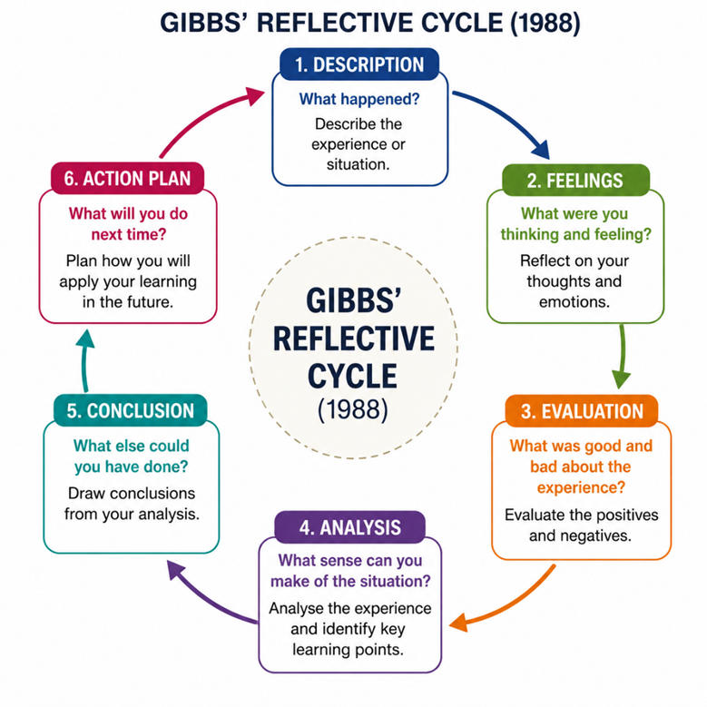
Figure 8: Gibbs Reflective Cycle

Description
Walkers Crisps UK has been chosen for this assessment due to its market presence, being a well-established brand with a wide range of publicly accessible information for strategic analysis purposes. The company is also facing some current problems such as consumer preference, health regulations, and the presence of competition, which is suitable for strategic evaluation. In preparing the report, secondary research was undertaken by gathering reliable and relevant information from PepsiCo sustainability reports, publications, academic journals and reports. I then used a number of strategic management techniques to analyze external, internal and sustainability dimensions of the company in question, PESTEL, VRIO, SWOT, CSR, Balanced Scorecard, Porter's Generic Strategies and SAFe, to identify the most appropriate strategy for the company to use in order to grow and expand its business.

Feelings
Initially I was confident about choosing Walkers Crisps UK as the business I would like to assess and was unsure about being able to use several strategic management frameworks effectively. It was difficult at first to identify models that would be most suitable and to relate theoretical ideas to actual business practice in a critical way. Careful analysis was also needed to interpret academic theories and put them into practice in the company's strategic position. As I continued my research and study of the reports and academic papers of companies, I became a little more confident and assured. On completing the various sections, I have enhanced my knowledge of strategic management, and also have strengthened my ability to analyse the organisation's performance using the appropriate framework and to make recommendations based on evidence (Dünya et al, 2026).

Evaluation
This experience of preparing this report has been a valuable learning experience, and has helped me develop my research and analytical abilities. It is because I get to read PepsiCo reports, research papers, and industry publications, so that I will have a better understanding of the concept of strategic management and how I can apply those conceptual tools in a real business environment like the VRIO, SWOT, the Balanced Scorecard, Porter's Generic Strategies, and the SAFe. This was really useful for me to understand how learning information is relevant for real life decision making and to develop critical thinking. I had difficulties with the amount of information to process and the selection of relevant evidence, however. It took a lot of work to balance theory and example and maintain an analytical perspective. In general, it enhanced my time management skills, analytical skills, and confidence in creating strategic management reports.

Analysis
This project boosted my strategic thinking skills and helped me think through business problems in different ways than I had assumed before. It was nice that I had to trust the recommendations because it was based on the credible information provided by the company, academic literature and industry data. The other thing I learned was that there isn't one strategic framework that will give you a full picture of an organisation. Instead, the combination of several frameworks was used, resulting in a much larger analysis. PESTEL identified external opportunities and external threats and VRIO identified internal resources and internal capabilities.
To establish a strategic position SWOT combined these findings. The Balanced Scorecard assessed the financial and non-financial performance, Porter's Generic Strategies determined the best competitive strategy and Ansoff's Matrix helped make decisions about future growth. Combining these models improved my analytical skills and illustrated the applications of various strategic tools in an integrated manner to assist in making informed, practical, and well-supported business recommendations.

Conclusion
In general, I have developed more knowledge in strategic management and how theory can be used in the business world. I learned that strategic analysis is not limited to one type of model; it has to be integrated together to make strategic recommendations. This experience has made me more confident about my ability to assess the external environment, capabilities, performance and growth opportunities of an organisation using strategic management concepts. I also acquired research, critical thinking, analysis and report writing skills which I will be able to use in my future academic studies, and for making informed decisions in a business setting.

Action Plan
To enhance learning in the future, I will plan my time better, begin research at an earlier stage, and develop a study timetable. I will also want to read more academic journals, company reports and industry databases to further enhance the quality of evidence that I utilize in assignments. In addition, I will seek to enhance my ability to critically evaluate and write reports by practicing analysis beyond description. Lastly, I will keep advancing my strategic management skills through the use of various analytical tools, applied to real business scenarios, so that I can deliver more in-depth and evidence-based recommendations in my next evaluations.

References
Ardiansyah, M. (2024). Integrating corporate social responsibility into business strategy: creating sustainable value. Involvement International Journal of Business, 1(1), pp.29-42.
Banker, R.D., Chang, H., Janakiraman, S.N. and Konstans, C. (2004). A balanced scorecard analysis of performance metrics. European journal of operational research, 154(2), pp.423-436.
Cardeal, N. and Antonio, N.S. (2012). Valuable, rare, inimitable resources and organization (VRIO) resources or valuable, rare, inimitable resources (VRI) capabilities: What leads to competitive advantage?. Cardeal, N., António, (2012), pp.10159-10170.
Clarissia, S.M.S. (2020). A study on Ansoff Matrix Technique: As a growth strategy and an adaptive learning technique adopted in the leading brand of products. BIMS Journal of Management, 18.
Dawes, J. (2018). The Ansoff matrix: A legendary tool, but with two logical problems. But with Two Logical Problems (Accessed 20 July, 2026).
Dünya, C.P., Özkan, İ. and Özen, N. (2026). Learning from authentic patient narratives in nursing education using Gibbs' Reflective Cycle: A qualitative study using reflexive thematic analysis. Nurse Education in Practice, pp.104887.
Gandrita, D.M. (2023). Improving Strategic Planning: The Crucial Role of Enhancing Relationships between Management Levels. Administrative Sciences, [Online] 13(10), p.211. doi:https://doi.org/10.3390/admsci13100211.
Gurcaylilar-Yenidogan, T. and Aksoy, S. (2018). Applying Ansoff’s growth strategy matrix to innovation classification. International Journal of Innovation Management, 22(04), pp.1850039.
Hasan, R.U. and Chyi, T.M. (2017). Practical application of Balanced Scorecard-A literature review. Journal of Strategy and Performance Management, 5(3), pp.87.
Haverkort, A.J., Linnemann, A.R., Struik, P.C. and Wiskerke, J.S.C. (2022). On Processing Potato 3: Survey of Performances, Productivity and Losses in the Supply Chain. Potato Research, [online] 66(2), pp.385–427. doi:https://doi.org/10.1007/s11540-022-09576-7.
Hoque, Z. (2003). Total quality management and the balanced scorecard approach: a critical analysis of their potential relationships and directions for research. Critical Perspectives on Accounting, 14(5), pp.553-566.
Hossain, K., Che Abdullah, A.S., Mohd Balwi, M.A.W.F., Lubis, A., Azizan, N.A., Alam, M.N. and Taha, A.Z. (2023). Linking entrepreneurial orientation with export performance: mediation effects of multiple differentiation strategies. Journal of Business & Industrial Marketing, 38(9), pp.1769-1793.
Hu, X., Jiang, H., Liu, Z., Gao, M., Liu, G., Tian, S. and Zeng, F. (2025). The Global Potato-Processing Industry: A Review of Production, Products, Quality and Sustainability. Foods, [online] 14(10), p.1758. doi:https://doi.org/10.3390/foods14101758.
Islami, X., Mustafa, N. and Topuzovska Latkovikj, M. (2020). Linking Porter’s generic strategies to firm performance. Future Business Journal, 6(1), pp.3.
Jerab, D. and Mabrouk, T. (2023). Achieving competitive advantage through cost leadership strategy: Strategies for Sustainable Success. Available at SSRN 4574945.
Jiang, B. (2021). Investigating the Market Strategy of Smart food’s latest product based on Business Analysis Models. In 2021 3rd International Conference on Economic Management and Cultural Industry (ICEMCI 2021) (pp. 2218-2223). Atlantis Press.
Krishnan, V. and Ulrich, K.T. (2001). Product development decisions: A review of the literature. Management science, 47(1), pp.1-21.
Krylov, S.I. (2014). Theoretical aspects of economic balanced scorecard analysis. Asian Journal of Finance & Accounting, 6(1), pp.90.
Lin, C., Tsai, H.L., Wu, Y.J. and Kiang, M. (2012). A fuzzy quantitative VRIO‐based framework for evaluating organizational activities. Management Decision, 50(8), pp.1396-1411.
Loredana, E.M. (2016). The use of Ansoff matrix in the field of business. In MATEC Web of Conferences (Vol. 44, p. 01006). Les Ulis, France: EDP Sciences.
Markkanen, P., Välimäki, M., Anttila, M. and Kuuskorpi, M. (2020). A reflective cycle: Understanding challenging situations in a school setting. Educational Research, 62(1), pp.46-62.
Masih, J., Rajkumar, R., Matharu, P.S. and Sharma, A. (2019). Market capturing and business expansion strategy for gluten-free foods in India and USA using PESTEL model. Agric. Sci, 10, pp.202-213.
Parnell, J. and Brady, M. (2019). Capabilities, strategies and firm performance in the United Kingdom. Journal of Strategy and Management, 12(1), pp.153-172.
Peltokorpi, A., Linna, M., Malmström, T., Torkki, P. and Lillrank, P.M. (2016). Five focus strategies to organize health care delivery. International journal of health care quality assurance, 29(2), pp.177-191.
PepsiCo (2026). More than half of our UK snack sales now come from healthier choices. [online] United Kingdom. Available at: https://www.pepsico.co.uk/our-stories/story/more-than-half-of-our-uk-snack-sales-now-come-from-healthier-choices [Accessed 30 Jul. 2026].
Rashid, C.A. (2023). PESTEL Analysis and Porter’s Five Forces as marketing tools to evaluate Morrison’s performance and strategy. Journal of Global Social Sciences, 4(15), pp.75-83.
Reid, D.J. and Reid, W.H. (2014). Managing facility risk: External threats and health care organizations. Behavioral Sciences & the Law, 32(3), pp.366-376.
Senturk, H.A. and Cakir, M. (2023). Healthy Food for Snack Lovers: The Way to Success in the Market of Healthy Food Products. Российский журнал менеджмента, (3), pp.398-418.
Soegoto, F.A. (2021). Product development using SWOT analysis. International Journal of Entrepreneurship & Technopreneur (INJETECH), 1, pp.1-10.
Strategy, T.C. (2021). Corporate social responsibility. Universal Registration Document 2021, pp.37-135.
Sun, W., Chen, K. and Mei, J. (2024). Integrating the resource-based view and dynamic capabilities: a comprehensive framework for sustaining competitive advantage in dynamic markets. EPRA International Journal of Economic and Business Review, 12(9), pp.1-8.
Tomlinson, C.A. (2008). Goalsof Differentiation. Educational leadership.
Velte, P. (2022). Meta-analyses on corporate social responsibility (CSR): a literature review. Management Review Quarterly, 72(3), pp.627-675.
Wei, H. and Davis-Ngatai, P.S. (2017). How to gain a competitive advantage in the healthy fast food industry? [Accessed 1 Aug. 2026].

