
Skills for the Workplace
Module Assignment Submission
Student Name: | Ismatara Begum
Student Number: | 1811538
Module No: | BMSK5006
Module Title: | KNOWLEDGE AND INFORMATION MANAGEMENT
Date: | 23.05.2021

Statement of Confirmation of Authenticity
By the act of making this submission, the student declares that this is the work of the student named above. The work has not, in whole or in part, been knowingly presented elsewhere for assessment, or where assessment has been built on a previous assessment, this has been identified. Where materials have been used from other sources it has been properly acknowledged. If this statement is untrue, the student acknowledges that an assessment offence has been committed.
Attention is drawn to the plagiarism and unfair practice policies of both the University and of ILM.

The aim of this report is to determine the value of knowledge management within an organisation, as good knowledge management practises provide competitive advantages for businesses and multinational corporations alike. The writer will conduct research on Knowledge Information Management (KIM) and then determine how knowledge management (KM) is implemented and applied at an organisation, as well as at the writer's workplace. Based on the writer’s experience and knowledge of working in a Large civil service department, they will illustrate knowledge-based data and information, as well as how successful knowledge management is in the organisation throughout this assignment. Information management has been portrayed as a critical component for a company looking to establish a strategic competitive advantage. The assignment will show how information management can be a vital driver of organisational success and a critical tool for a company's survival, battle, and gain to achieving its mission. As a result, properly creating, maintaining, exchanging, and utilising information is critical for organisations to take full use of the value of information as stated by (Waddington, 2012). To describe the KM method, various models and techniques are used. Many theorists such as Russell Ackoff (1989) will be used by the writer to establish the link between data, information, and wisdom. The writer would then apply Nonaka and Takeuchi's (1996) SECI model, as well as other models and techniques, to create and process KM practises in organisations, and then explain how KM is used in her own workplace. Finally, the author will outline a structure for building a knowledge management culture as well as potential KM challenges.

The importance of knowledge management today is essential for all type of organisations in order to create a competitive advantage. This can be done by having and effective knowledge management process in place to identify and facilitate collaboration and help keep knowledge workers connected and comfortable in sharing the necessary knowledge. This will help organization in making decision based on complete, valid, and well interpreted data, information, and knowledge.
The role of information management in today's world is critical for all types of businesses to gain a competitive advantage. This can be accomplished by implementing a sound knowledge management framework that identifies and facilitates cooperation while also keeping knowledge staff linked through efficient communication and the right processes/channels to share the data, information and knowledge. This will assist organisations in making decisions and carrying out work highly effectively based on accurate, reliable, and well-interpreted data, information, and knowledge.
According to Dammann (2019), Ackoff (2009) proposed a model known as the knowledge hierarchy in the form of a pyramid with details at the bottom, information and knowledge above, and wisdom at the top.
The first four categories deal with what has been or what is understood, while the fifth category, wisdom, deals with the future since it combines vision and design, and with wisdom, people will build the future rather than only understand the present and past, according to Ackoff (1989). Wisdom, on the other hand, is not easy to attain since people must progress through the other categories within the system.
According to Bellinger atel, (2004), who conducted extensive research on Russell Ackoff, (1989), the substance of the human mind is divided into five categories: Data is a living representation of an idea, a reality that has been observed, a sign or symbol that may be real or artificial. Data may be the product of objective categorization, measurement, or comparison of what is seen. Data is only available during the season of dynamic information comprehension. Data create the environment that reveals the gaps between what is known and what is happening. Information is a representation of opinion or fact that expresses anything that has been learnt, established or experienced. For example, the earnings of an organization's employees are considered statistics, but their average earnings or average age are considered information. Within the data stored in the organisation’s system the detailed personal information available of the public are of high value and would need to be stored safely to prevent GDPRR issues or identity fraud etc.
Information is the product of data processing that makes them meaningful to the user. Raw data is given significance through this method. Data must be contextualised, categorised, measured, and condensed before it can be used as information (Davenport & Prusak 2000). The relationship between information and data, which are the fundamental components, and information meaning, which helps to generate knowledge.
Knowledge is a higher degree of understanding achieved by the collection or collecting of information on a particular subject. People internalise information and form it through their experiences and expectations. The acquisition of information is a gradual process. You must reflect back from data harvesting, information composition, and knowledge production in order to be fulfilled and achieve the highest level of knowledge (Davenport & Prusak 2000).
The distinction between "learning" and "memorising" is the difference between understanding and experience. Understanding allows people to take useful decisions because they can synthesise new knowledge, or at the very least new information, from what they already know and understand.
At the end of the day, regardless of how organisation information is defined, everything plays an important role in the day-to-day operations of an organisation. However, in order to create a successful learning sharing system, you must first understand how different types of information are transmitted and stored most efficiently.
Knowledge is defined as theoretical or practical gains obtained through the experience and application of facts or information. Data may be converted into knowledge using a variety of approaches, including policy, algorithm, translators, and human brains (Madnick, Wang, Lee & Zhu, 2009). The point at which knowledge comes into contact with information has the potential to modify it. For instance, an employee's analysis and knowledge of the data and information of the individuals would assist them in making the right decisions or paying the right amount of benefits/monies to the individual/customer.
Knowledge and wisdom can be influenced by experience and can be reinforced positively or negatively. From training and experience of working and following the same process wisdom develops in how to handle a specific customer case in the writer’s workplace.
Wisdom is regarded as knowledge, but knowledge is not regarded as wisdom in and of itself. Data are used to create information, which is then used to create knowledge. As a result, facts, information, knowledge, and wisdom are interdependent and assist in dealing with a situation (Waddington, 2012).
The writer of this report is a qualified specialist caseworker working within a large civil service department who receives individual customer information, return details, business income and expenditures, profit and loss accounts etc as well as the compliancy reports and other business information, statistics and crucial data to undertake business risk reviews and make decisions on repayment requests and other customer dealings. She can establish how data, information and knowledge is applied and shared with its employees and across different departments and agencies as well as to the customers.

Individual statistics such as data, profits, losses, yield, revenues, monthly imports and exports and profits are gathered into combined or mixed data, which are known as information. These information are all analysed, and risk reviews are made as well as decisions. Some of the gathered information are shared with other departments within the organisation and others with external departments and stakeholders. This all depends on the information and the needs of managing and requirements of sharing data of the customer to third parties. GDPRR would have to always been considered before sharing the data, information and knowledge with other departments and stakeholders. However, freedom of information access request also allows the Data, information and knowledge and wisdom to be shared with those are permitted to have access to them. But it is extremely important to protect such detailed private information of the customers such as the businesses details to be communicated and shared securely with confidentiality maintained by all parties and no risks of interception by an unauthorised person or losing the data, information etc.
Some of the data, information can be used as evidence in a court/tribunal case so it could involve extremely sensitive matters, and much be dealt with high significance and priority with extreme measures and careful consideration given before it is shared with others. For example, processes need to be followed, you need to have authority to share the information sometimes such as signatures from senior management or if you are qualified to sign it off yourself. You would also need to question, if it is necessary for it to be shared, risk assess the reliability of the data and information, password protect it with encryption, keep copy in the controlled access folder (CAF) which is a highly secure folder only the specialist caseworker dealing with the customer case has access too. This too within limited time during investigating or managing the case. Even then the footprint is left for each time the data and information has been accessed to prevent any security or risks of data leaking or any security breaches. Analysing and looking over the collected data and information about the customer situation, checking for any anomalies or errors to determine what was going on. These comprehensions are the knowledge that allows you to make any conclusion about this case.
After accumulating this type of information over and over, writer arrives at the wisdom that may be derived from long-term experiences and observations as well as from analysing the customer information both internal and external. The wisdom assists the writer and other caseworker’s management in making organisational and customer account decisions. It is also important in the organisation to determine how data, details, and expertise are applied and shared with the company's employees, both within the team as well as across the department. Data from taking customer information from their website or which is easily accessed online can be used and shared more easily. However, highly sensitive and protective data, information and knowledge need to be maintained with yourself and only those that have authority and really need the knowledge of this. Most employees can view the Electronic folder (EF) where the customer data such as returns, account knowledge, call logs, notes, files and other general information are stored. The specialist caseworkers also have access to the CRMM system where any investigative or case matters are stored securely and can view who has interest or assigned to this customer case from within department and other civil service departments. By searching the information logged on CRMM such as notes or reports or any open cases for the customer, it can be determined if any new Data, information, knowledge and wisdom needs to be communicated/shared to other parties. Some the data would be analysed and transformed from the EF and CRMM and added to the CAF (Controlled Access Folder) which is the highly secure and encrypted digital customer file, the caseworker has access to for the limited time of the investigation or casework. The data is then transformed into information and knowledge and a business risk review is undertaken. The Business risk review report also includes any data, information and knowledge gathered from other internal and external sources as well as the customer’s website. This would then be shared with the Officers dealing with the customer from different departments during a business risk review meeting. The findings will then determine if the business customer should be classed as high risk, medium risk or low risk. This private meeting allows them to provide accurate information to one another with interest in the customer and share the necessary knowledge and information to carry out their own work. Discussions, concerns and ideas/wisdom are shared from such meeting to successful deal with the customer as well as handle the sensitive cases. All this shared data, information and knowledge becomes essential knowledge, and the officers present at the meeting must make sure it is all recorded securely, and confidentiality is maintained while they use these information and knowledge to immediately do their customer related work. Customer visits are also arranged in order to collate more data, information and knowledge as well as share the relevant findings of the business risk reviews. If any complicated information is shared or disputes take place from this, that could pose any risks/harm physically or either customer and/or organisational reputational damage, it must be reported to the Senior managers to prevent major issues and advice how to deal with it all. The relevant information and expertise are then passed on to the employees working on this, administrators, stakeholders and the health and safety department.

Learning is perceived as defended truth by a person and stored in memory (which may be recovered) in a subjective framework through a psychological activity known as information processing (Bhatt, 2002). Individual/singular information suggests that vital perception, correspondence, social cooperation, or talent improved learning of a situation or truth. Working in any organisation will require you to acquire specific business related skills as well as utilise the skills, previous knowledge and experiences to your current job. There are many skills and individual knowledge people possess, such as the knowledge of previous employers organisations, customers and competitors information. Some of the skills include the ability to listen, timekeeping, social awareness, and IT skills, as well as the ability to perceive a broader perspective and assign value in the objective language, which is Personal/singular information. The writer’s individual knowledge also is extensive in the specialism she qualified in. This took two years of training and several years of ongoing training and experiences. Her individual knowledge became valuable and asset to the organisation and they were reluctant in losing the knowledge if she left the department. To make her individual knowledge, organisational knowledge she had to become a mentor to other employees as well as deliver monthly training sessions and present her findings and results in regular meetings across the departments. She had to also sign a disclosure barring contract upon resigning so the highly protective information and knowledge she gained from the specialist training and qualification, she would not share with any customers or competitors. So even though she joined a new organisation with the information she gained during her time at the Civil service organisation, she was not allowed to share the knowledge. As Bhatt stated Organisational knowledge refers to the broad range of skills and abilities possessed by someone who works for or with a company (Bhatt, 2002). It might be difficult to share and retain organisational knowledge. Knowledge is defined as a living type of info that is successfully transmitted and utilised in persons. Organisational knowledge is difficult to replace and maintain. Tactic and explicit knowledge are the two basic types of organisational knowledge. Knowhow, experience, practise, values, and so on are examples of tacit knowledge, whereas explicit knowledge refers to knowledge that has been transformed in terms of documentation and databases. Based on these two basic kinds of knowledge, tacit knowledge and explicit knowledge, there are eight forms of organisational knowledge that are described and defined below. Tacit knowledge encompasses know-how, localised knowledge, business culture, and generalist knowledge, whereas explicit knowledge includes inferred knowledge, disseminated knowledge, expert knowledge, and information (Spacey, 2017). Working in a national government department meant the writer had to follow the rules and regulations to the tee, and most importantly, everything needed to be written down, stored digitally on electronic folder to maintain a log and trail in case any discrepancies or issues took place.
To be effective in KM, one must have a thorough understanding of what constitutes information.
Nonaka and Takeuchi (1996) developed the SECI model which has become the most influential model of information formation and transition theory, according to Hajric (2011). Nonaka and Takeuchi (1996) suggested four ways in which information forms are often mixed and transformed, demonstrating how knowledge is communicated and generated within organisations.
Individual knowledge is transformed into organisational knowledge by socialisation, externalisation, internalisation, and mixture, according to Nonaka and Takeuchi (1996).
• Socialisation: Tacit to tacit, according to Nonaka and Takeuchi (1996). Training, instruction, imitation, and observation are all methods for passing on information.
• Tacit to clear externalisation. This is regarded as an especially difficult and critical conversion mechanism. Tacit information is codified into records, manuals, and other forms so that it can be more readily disseminated within the company.
• Explicit to explicit combination This is the most basic version. To generate new information, codified knowledge sources (such as documents) are combined.
• Explicit to implicit internalisation- The knowledge is internalised when explicit references are used and understood, changing the user's current implicit knowledge.
To foster organisational awareness, individual knowledge must be passed to other individuals and groups. Information must be externalised by those who possess it and internalised by those who lack it in order to be transmitted, which is especially true of tacit knowledge.
In the current economy, an increasing number of organisations recognise that intangible assets are the most important strategic resources, whereas physical assets have become, in most cases, not quite fleeting commodities. Companies must be obligated to manage their intellectual capital explicitly in order to gain and maintain a competitive advantage. To achieve the organization's objectives through operational operations, information that is based on intellectual assets and capital that ensures the competitive quality of this information is required (Wiig, 1997).
It is critical for businesses to understand whether or not they're utilising their intangible assets in a cost-effective and efficient manner to generate revenue. As a result, they must identify and appraise their existing intangible assets, as well as manage them. The writer is using SWOT and PEST analysis of KM Techniques to analyse challenges and issues connected to knowledge assets (Models).

Pestle Analysis

 | Political | Economic | Social |  | Technological
 | - Trading policies  - Freedom of Information and access requests  - Copyright law  - GDPRR  - Agency Rule & regulations Taxation Government | - The income of the EU population increased  - Recession having impacts  - Tax rules changed due to pandemic  - BREXIT & Global Crisis  - Industry development | - Lack of training for employees  - Public information on websites, potential misinformation  - Flexibility issues  - New staff  - Knowledge and experience staff promoted to different departments or resign to work with the businesses |  | - The smart device in use online portal for work  - Digital communications online payments manage online customer folder, emails  - Risk of losing data stored digitally  - Secure controlled access
Figure 02: PEST analysis
Source: (Chatti, 2012)
The organisation must preserve political considerations such as trading practises and copyright laws. Political problems have emerged as a result of COVID-19, which would require the government to take specific measures and make adjustments to their policies about how customers/businesses may operate, at what rate they would have to pay tax or consider any exemptions, as well as the looming Brexit situation. These issues can obstruct and affect business. COVID-19, a virus that has engulfed the entire globe, has put the business industries on lockdown, creating more work for the organisation who would have to amend the rules and expectations as well as provide business tax reliefs and benefit support to the customers which are businesses.
Technological – as a result of the COVID-19 pandemic, technology such as the internet, smartphones, and various software are commonly used by all. People are working from home using the internet, video conferences, chat rooms, and a variety of work-related software sites and applications. Technology has progressed to the point that the government has launched new social media channels to keep you up to date on COVID-19 and how many people in your region have been infected. These technological advancements and messages have an impact on the organisation. The internet has become slow, therefore delaying the efficiency of official work to be completed on time. Also, with employees off sick due to the virus or in isolation, there is not enough workers to complete the work, therefore creating backlog and lack od data or information, knowledge shared on time. The business is affected by BREXIT and global economic problems, as well as the COVID-19, which has had a global impact. Awareness can be learned and identified in a variety of areas, including social issues such as work culture, homeworking and time flexibility. Ultimately, technical concerns assist organisations management in identifying and measuring employees' overall existing skills and even the company's organisational understanding so work can still be shared effectively from homeworking as well as security and confidentiality maintained. If we as a company are unable to adjust to these developments, it will be difficult for us to achieve a competitive advantage or bring in enough yield to support the public like before.
Actual information assets, according to Nguyen et al. (2014), are knowledge that has already been obtained or learned by a person or an organisation. Individuals or organisations own intellectual property in the form of information properties. Potential information assets, on the other hand, make decisions based on predictions or expectations about the future.
The SWOT analysis to identify the knowledge assets
According to writer’s organisation SWOT analysis there are various knowledge assets that the organisation holds:

STRENGTH | WEAKNESS | OPPORTUNITY | THREATS
- Employees  - Customer service  - Customers  - Stakeholders  - Equipment  - Electronic Folder  - Secure folders | Lack of Training  Inexperience staff  Loss of trained staff  Absences  Lack of resources | Extra training  New technology  Training new staffs  Mentoring  Online learning | Staff retention  COVID-19  Brexit  Loss of qualified staff

Actual and potential knowledge assets in the organisation rated (1-5) 5 being the strongest and 1 being the weakest.
In order to identify the actual knowledge & potential knowledge assets at the workplace, the writer has created a table below which she believes are relevant criteria and adds value to this organisation.
Actual Knowledge Assets | Add Value to the business [ 1-5]
Employees | 5
Customers | 5
Technology | 5
Equipment’s | 4
Suppliers | 4
Systems | 5
(source: developed by the writer)
The employees of the organisation are an asset because they run the daily operations of the business with their experience and skill set as well as from the knowledge they gained from training and processes they follow. The specialists will be an asset to the organisation because of their unique knowledge and extensive training to qualify and broad variety of experiences. Stakeholders/ suppliers are also a part of an asset as they supply us with the revenue and yield. Technology is a great asset as without the equipment, it would be impossible to communicate or store data securely and efficiently.

Potential Knowledge assets | Add Value to the business [ 1-5]
Invest in new Equipment’s | 5
Management experience | 3
Advance Technology | 4
Training more staffs | 5
Mentoring schemes | 4
Hiring more employees from large organisations | 5
(source: developed by the writer)

Potential Knowledge assets may be in investing in new training schemes or employees to grow the resources of the business. With the pandemic causing social distancing requirements, the introduction of new technologies such as creating own app can allow employees to work more efficiently during homeworking. This would ensure the employees can answer customer calls on the phone fast without the network issues due to too many people using the internet and customers would be able to call with any queries or to make their tax payments directly and quickly using the app direct.
The organisation can further improve knowledge assets by providing more online learning and mentoring scheme virtually, making sure all the staff are up to date with their training even if from home and the mentors share the individual knowledges to mentees to then make it organisational knowledge. New equipment being potential assets can enhance the delivery by faster broadband and updated new windows and systems that are not impacted by the extremely high volumes of internet usage at the moment by everyone. The department is responsible for maintaining political variables such as trading policies, copyright legislation, and agency rules. The management of this organisation handles its operations based on the expertise gained from numerous government policies and extensive training. The management has recognised these policies in order to gain information from them and apply it in relevant domains. The impact caused by BREXIT and global economic difficulties as well as the pandemic obstruct the free flow of imports and exports among EU member states with the added tax within EU dispatches now too. The function of undertaking customer visit to gather more information and knowledge is also being reduced as a result of the pandemic issue, which has resulted in a decrease in the number of customer visits therefore more risks of non-compliancy and missing information and lack of knowledge to determine if rules are being followed or accurate returns, profit and loss information are being submitted or tax evading. Knowledge can be gained and identified in a variety of ways without customer visit, including analysing websites, communicating with other relevant departments via telephone, emails and online meetings on zoom/teams etc as well as using these platforms to also query customers to share data, information etc digitally. However, the effective culture and communication of undertaking customer visits as well as building customer relationship through this is lost from factors such as the pandemic lockdown and restrictions. Technology management and online communication does however help identify and measure overall individual employee knowledge as well as the organisational knowledge. However, recognising knowledge assets is a difficult undertaking because the quality of knowledge is defined differently by different specialists (Chatti, 2012). Knowledge has been considered a tool for enhancing organisational growth and establishing a competitive advantage by organisations that compete in an unfavourable or unstable environment (Miller & Shamsie 1987). Writer identified their actual and potential knowledge assets within the scope of our organisation. Actual knowledge assets are defined as knowledge that has already been acquired or attained by a person or a company. Individuals or organisations own intellectual property in the form of knowledge assets. Potential knowledge assets, on the other hand, are similar to making decisions based on future estimates or assumptions (Nguyen, Li, Nguyen & Pramoolsook, 2014). The actual knowledge assets are considered as the knowledge which is already acquired or gained by an individual or the organisation. These knowledge assets are essentially the intellectual property of the individuals or organisations. On the other hand, the potential knowledge assets are like taking the decisions on the basis of future projections or assumptions (Nguyen, Li, Nguyen & Pramoolsook, 2014). Say, for example, the organisation purchases more pool cars for increasing the number of customer visits. This decision is based on the actual knowledge assets because of observing the real scenario. If the organisation purchased the cars on the assumptions that the number of customers may increase, this knowledge would be the potential knowledge assets. The organisation uses CRMM, EF, CAF & EPOS [ Customer Relation Management] systems to create, store and integrate knowledge. So that every personnel at work who uses this particular equipment will have the knowledge necessary to carry out his or her duties as well as share the relevant information with customers and other departments if necessary. This is done by inputting data, information relating to customer’s account. Regular organisation team and other meetings are held regularly to enable all employees to share their knowledge within the business which enables the manager to make decisions to improve its delivery of services and hit targets.
This Seci model depicts or represents a certain flow of knowledge management that includes socialisation, externalisation, connection, and embodiment. The empathising process initially socialises knowledge, and then the articulation process begins to externalise it. Following the externalisation of knowledge, it has begun to be linked with stakeholders in order to provide specialised information. Other theorists agree with this model, concluding that it focuses on the knowledge management cycle or process within the organisation appropriately (Nonaka, Toyama & Konno, 2000).
The creation of knowledge: The organisation should supply sufficient data and information to the personnel in order to build knowledge. The organisation conducts training and runs development programmes for their staff to help them become more skilled and competent. Knowledge storage: Retaining and recruiting knowledgeable employees is the most effective approach to store knowledge. The application of the intellectual property legislation, which protects individual and institutional intellectual properties, is another approach to store information.
Knowledge application: Knowledge application can be accomplished through developing an inventive environment within the organisation. Employees should be encouraged to share and implement their ideas so that the innovation process can continue.
Integration of the knowledge: Integrating knowledge is primarily concerned with combining individual and organisational knowledge. To integrate knowledge, team-building and group discussion can be regarded key techniques that can help individuals integrate their knowledge and lead an organisation.
In today's competitive business environment, an organisation must almost likely use its associated experiences and expertise in a realistic way to get an advantage over its competitors. KM is a successful tool for dealing with an organization's/information company's resources, which provides benefits in the short term and fosters innovation in the long-term knowledge may be utilised across the organisation (Waddington, 2012).

My workplace’s data capturing with knowledge & information using Davenport model is illustrated and evaluated below.
Data | knowledge | Information
Customer personal details such as name, address, NI Numbers.  Customer business details  Customer revenue details  Compliance details | Business Risk review report  Compliancy  Business type  Stocks  Imports/exports | Customer information  Accurate business trading details  Profit and loss details
Figure 05: Davenport model to capture knowledge and information
Source: (Davenport & Cronin, 2000)
Another aspect that is equally important is the company's corporate assets and human resources, as well as its name and credibility in terms of intellectual property and copyrights. The Copyright Act's exclusive rights clause grants creators and publishers the ability to restrict unauthorised use of their works, according to the statute. GOV.UK, (2012), which ensures that if a company discovers that other companies or rivals are attempting to copy or manufacture its goods without permission or payment of a copyrights charge, the company will prosecute or reimburse the others because the results have harmed the company's reputation and trust. Apple has sued Samsung in the past, claiming that instead of creating its own mobile technology, it hired Samsung to do so. Samsung preferred to imitate Apple's technology and user experience, according to Apple. The intellectual property rights at the organisation are limited as it is a public department; these intellectual property rights include the logo and forms, procedures, supplier, website etc.
People are an organization's most asset. The people, their abilities, skills, and knowledge, as stated by Mathew, et al (2012), are the key foundations of organisational performance and the foundation for a strong culture that enables the success of the KMS. Team members at all levels of the organisation can rely on and benefit from the experience of others. Organizations are explained by Mathew et al. (2012). Culture is critical for the performance of KM as well as the growth of KM success and practise. As a company with cutting-edge technologies and other tools to aid in KM implementation, If employees are unable to share their experience, the whole KM programme would be jeopardised. As a result, the first step in establishing an effective KM programme for an organisation is to foster a culture of mutual confidence, which allows for information sharing and organisational learning. Spacey (2017) adds the true importance of an organization's culture is intelligence, such as a manager who knows the motivations and tendencies of other managers and team members and can use that knowledge to influence them.
Small and large organisations face many obstacles when it comes to implementing Knowledge Management processes, such as research and development, which are critical components of the KM system but also cost a lot of money or take a long time.
According to Tryon (2012), this obstacle may be one of the most important that businesses will face in the next two decades. Businesses of all sizes and styles are confronted with a challenge and an opportunity. These businesses are losing important human capital due to "boomer" retirements and downsizing initiatives at a time when global markets are becoming more available. As tools become available to enable information sharing across organisational and individual boundaries, many workers are clinging to their company knowledge as a means of job protection.
When an experienced highly skilled member of staff leaves, this knowledge and experience/skill will be lost or captured by the competitors, in other words, the knowledge asset will be lost.
As a result of the COVID-19 pandemic, technology such as the internet, smartphones, and various software are commonly used by all. People are working from home using the internet, video conferences, chat rooms, and a variety of work-related software sites and applications. Technology has progressed to the point that the government has launched new social media channels to keep you up to date on COVID-19 and how many people in your region have been infected. These technological advancements and messages have an impact on my business.
Actual information assets, according to Nguyen et al. (2014), are knowledge that has already been obtained or learned by a person or an organisation. Individuals or organisations own intellectual property in the form of information properties. Potential information assets, on the other hand, make decisions based on predictions or expectations about the future.
Iaea.org (2015) goes on to say that an information asset is an economic perception of an organization's knowledge that is built by investments with the intention that the investment will increase the organization's future income earning. Best practises, codified explicit knowledge, and intellectual property are examples of knowledge assets. Information is rooted in individuals as part of an organization's knowledge, and knowledge asset necessarily overlaps with human assets and requires knowledge of individual members of the organisation.
Talk rooms have been created by the writer’s organisation where representatives can engage in unstructured, unmonitored discussions with privacy. The process of team meetings also occurs in cafeterias and other places where a certain location is valuable but not required as highly sensitive and protective information would not be shared during such meetings.
A successful knowledge management strategy allows a company to develop, apply, and exchange information while also increasing the use of useful data, all of which will help the company become more efficient (Ackoff, 1999). As technology advances, the right approach ensures that the organization's goals are met. Sophisticated tools used to build and communicate around company data, information, and expertise are required for effective use of vast and diverse knowledge and resources. Companies' ability to reduce departmentalization, stimulate creativity, and adapt rapidly to evolving market environments improves when these tools are introduced.
Nonaka and Takeuchi (1995) analyse the dynamics of knowledge formation, in contrast to the importance of implicit knowledge and its translation into explicit knowledge, according to the writer's research on the two models Nonaka and Davenport. Unlike the Davenport and Prusak (1998) model, which focuses on the design of organisational processes that allow knowledge generation, codification, and transfer, the Davenport and Prusak (1998) model focuses on the design of organisational processes that enable knowledge generation, codification, and transfer. These two most influential models provide a systematic structure for managing information in organisations.
The following are some suggestions for improving the current framework organisation:
- knowledge management system should be easier to access and share
- The management should foster sociability, dialogue sharing, and teamwork even whilst homeworking.
- They should seek out feedback and enquiries, as well as centralise the data.
- Employees should be encouraged to come up with fresh ideas and to develop a quick communication channel.
- It is necessary to build a proper knowledge-sharing mechanism among staff by mentoring schemes, so knowledge is not lost when qualified/experienced employees leave.

Conclusion
Data, information, knowledge, and wisdom are all connected in some way. Data is converted into information, then knowledge, and finally wisdom. Despite the many differences between individual knowledge and organisational knowledge, they can both be utilised in organisational situations. Organizational knowledge should be created by retaining employees with incentives and benefits as well as continuous development and training, mentoring opportunities to share knowledge with other and new employees. Recruiting the people with the necessary transferrible skills, knowledge, and expertise will benefit the organisation greatly. This report identifies and analyses the many models that are used to identify knowledge assets. The methods for creating, storing, applying, and integrating knowledge are discussed, as well as the implications of intellectual property rights organisations should concentrate on developing a knowledge sharing system that can generate knowledge assets and give them a competitive advantage (Kamardeen, 2015). To conclude data, information, knowledge, wisdom and the knowledge assets are paramount for the success of any organisation as long as used appropriately and effectively.

Reference

Maund, A. (2018). BA in Leadership and Management. Skills for the Workplace Student Yearbook, 1st Year. SAGE Publications.
Ackoff, R. L. (1999) Ackoff’s Best. New York: John Wiley & Sons, pp 170 – 172.
Apple sues Samsung for “copying” iPhones and iPad. (2011). BBC News. [online] 19 Apr. Available at: https://www.bbc.co.uk/news/business-13124753, [Accessed 19 May 2020].
Becerra-Fernandez, I., & Sabherwal, R. (2001). Organizational knowledge management: A contingency perspective. Journal of Management Information Systems, 18(1), 23-55.
Birlanga, J., Rouyet, J. and Joyanes, L., 2012. Components of art and knowledge management through Nonaka and Takeuchi s model. International Journal of Arts and Technology, 5(1), p.86.
Chatti, M. (2012). Knowledge management: a personal knowledge network perspective. Journal Of Knowledge Management, 16(5), 829-844.
Christensen, P. (2005). Facilitating Knowledge Sharing: A Conceptual Framework. SSRN Electronic Journal.
Davenport, E., & Cronin, B. (2000). Knowledge Management: Semantic Drift or
Conceptual Shift?. Journal Of Education For Library And Information Science, 41(4), 294. Davenport, T. H., Prusak, L. (1998) Working Knowledge: How Organisations Manage What They Know, Harvard Business School Press, Boston Massachusetts.
Hajric, E. (2019). Organisational Culture
Dammann, O. (2019). Data, Information, Evidence, and Knowledge: A Proposal for Health Informatics and Data Science. Online Journal of Public Health Informatics, [online] 10(3). Available at: https://www.ncbi.nlm.nih.gov/pmc/articles/PMC6435353/, [Accessed 18 May 2020].
Davenport, T.H., & Prusak, L. (2000), Working Knowledge: How Organizations Manage What They Know, Harvard Business School Press, Boston, MA.
Davenport, Thomas H., and Lawrence Prusak. 1998. Working Knowledge: How Organizations Manage What They Know. Cambridge, MA: Harvard Business School Press.
Davenport, Thomas H., Robert G. Eccles, and Laurence Prusak. 1992. "Information Politics." Sloan Management Review 34, no. 1: 53-63.
Government Digital Service (2012). Intellectual property and your work. [online] GOV.UK. Available at: https://www.gov.uk/intellectual-property-an-overview,
‌Hajric, E. (2011). The SECI Model & Knowledge Conversion. [online] Knowledge-management-tools.net. Available at: http://www.knowledge-management-tools.net/knowledge-conversion.html
‌Iaea.org. (2015). Knowledge asset - NKM WIKIDOC. [online] Available at: http://wiki-nkm.iaea.org/wiki/index.php/Knowledge_asset,
Kamardeen, N. (2015). Community Rights to Intellectual Property in Asia-From Rhetoric to Consensus. The Journal Of World Intellectual Property, 18(6), 311-334.
Kevin Emerson Collins, the University of Chicago Law Review, Vol. 84, No. 4 (Fall 2017), pp. 1603-1673
Macintosh, A., Filby, I. & Tate, A., (1998). Knowledge Asset Road Maps. Proceedings of The
Madnick, S., Wang, R., Lee, Y., & Zhu, H. (2009). Overview and Framework for Data and Information Quality Research. Journal Of Data And Information Quality, 1(1), 1-22. Nguyen, L., Li, Q., Nguyen, L., & Pramoolsook, I. (2014). Expected Knowledge and Actual Composition. The Asian Business Studies, 20(3), 161-176.
Loris Giuseppe Navoni (2015). About Data, Information, Knowledge Relationships and their representation. [online] Medium. Available at: https://medium.com/@lorisnavoni/about-data-information-knowledge-relationships-and-their-representation-b1599f70130b,
Nguyen, L., Li, Q., Nguyen, L., & Pramoolsook, I. (2014). Expected Knowledge and Actual Composition. The Asian Business Studies, 20(3), 161-176.
‌Nonaka, I. (1994). The dynamic theory of organizational knowledge creation. Organization Science, 5(1), 14-37.
Schultz, M. (2001). The uncertain relevance of newness: Organizational learning and knowledge flows. Academy of Management Journal, 44(4), 661-681.
Serious Insights. (2018). What is the difference between Data, Information, Knowledge and Wisdom? - Serious Insights. [online] Available at: https://www.seriousinsights.net/what-is-data-information-knowledge-and-wisdom/
Spacey, J. (2017). 8 Types of Organizational Knowledge. [online] Simplicable. Available at: https://simplicable.com/new/organizational-knowledge
Systems-thinking.org. (2020). Data, Information, Knowledge, & Wisdom. [online] Available at: http://www.systems-thinking.org/dikw/dikw.htm, [Accessed 19 May 2020].

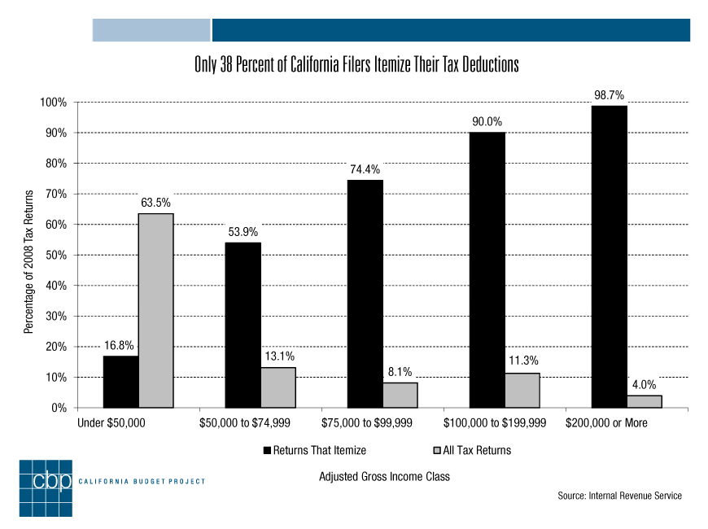
Appendix A:Examples of different types of data and knowledge sharing

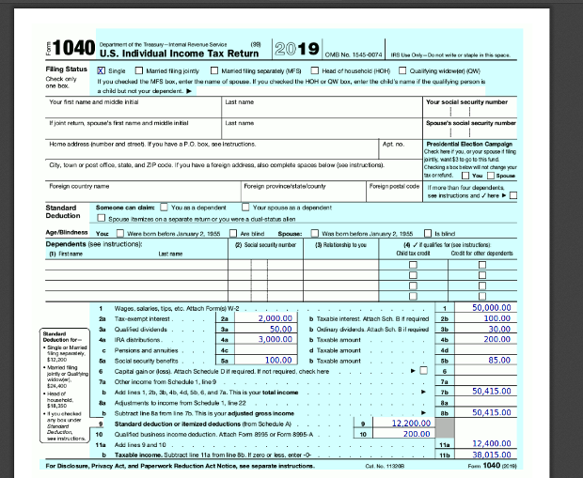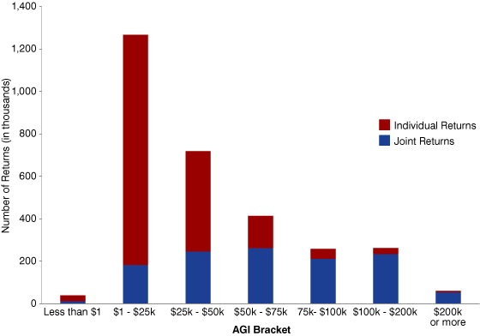
Appendix B: Different theorist’s models

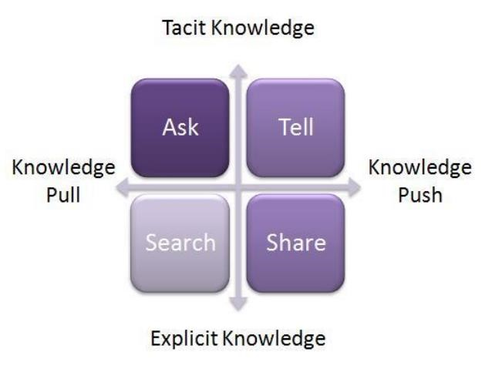

Framework of knowledge sharing

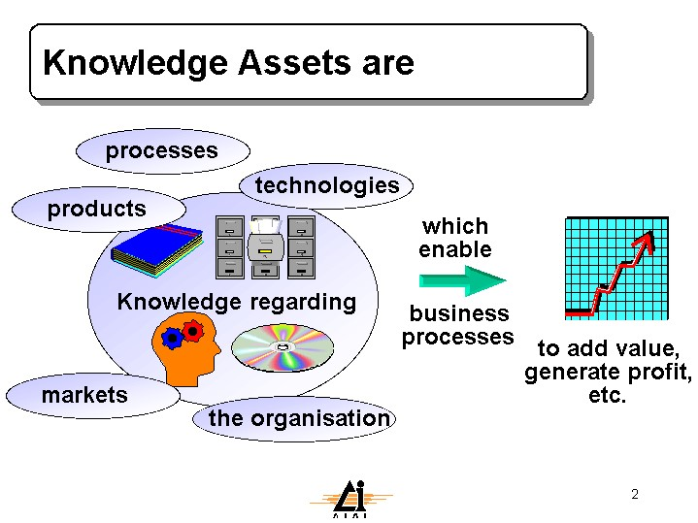

Knowledge assets
Source: (Wal, 2017)

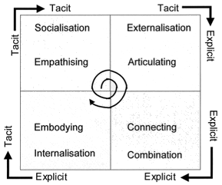

Nonaka and Takeuchi’s SECI model
Source: (Nonaka, Toyama & Konno, 2000)

