Methods and Finding

Phenomenological research

Since the content of the research is highly subjective, and the descriptive content is mainly biased towards feelings, by collecting these original data, we try to describe the essential phenomenon carefully, so we choose the phenomenological research method here.

Phenomenological Method, Suspension Phenomenological research method originated from the philosopher Edmund Husserl, who used the German "Lebenswelt" in his book "The Crisis of European Science and the Phenomenology of Transcendence" , in English for life-world, refers to the individual "direct experience of the world". Therefore, the phenomenological research method refers to the description of one or more individuals' awareness and experience of a phenomenon. The purpose of phenomenology is to understand the research life of research subjects, from understanding their "experiences" to construct personal meaning.

According to Husserl, the motivation for phenomenology "does not come from various philosophies, but from facts and problems", and the purpose of phenomenology "is not to build up, but to dig down again and again, in order to lay the foundation for existing insights. A stronger foundation than ever before." Phenomenology "with the extreme attitude that belongs to the essence of a true philosophical science, does not accept anything existing, does not recognize anything traditional as a beginning, but obtains its beginning in a free devotion to the problem itself and the demands it generates" . Therefore, the research method of phenomenology insists on "no premise", and seeks the source of knowledge and action with the help of the experiencer's environment. Vierkandt further clarified the application of phenomenological methods in the field of sociology in his book "Sociology: The Main Problems of Philosophical Sociology", which he regarded as a thorough formal study of social phenomena, That is to say, sociological research should intuitively grasp the "essential type", "ultimate fact" and "overall meaning" in social interaction and social group life with a phenomenological method, and through the analysis and induction of the essence of social phenomenon, so as to understand the social phenomenon within the group. A general grasp of the social way of life.

Advantage
It is a research method that studies the essence of things, iteratively matures in qualitative research, and it does not require particularly complicated equipment or expensive scientific instruments to collect and analyze raw data. Phenomenology has certain advantages for revealing the complex social world, and it is easier to understand because it accurately describes the nature of things based on the experience and feelings of daily life. an approach to research
Shortcoming
Overall, it is a very subjective qualitative study that emphasizes description and interpretation, and its non-positivist nature has limitations. It is often necessary to combine a variety of research methods for research to fill in the lack of objective data for quantitative, analytical and measurement.
Action research

Action research was proposed by social psychologist Lewin in the 1940s. Action training research he advocates is to assist community workers through field research, using scientific methods to study the problems encountered by themselves, in order to correct their actions and decisions. Different from the scientific method of purely studying objective laws, in the process of action research, researchers and research subjects participate in the formulation and implementation of solutions at the same time, which is obviously democratic. At present, action research has become the preferred method for on-site real-time research. When a group of people participates in research, it is also called Participatory Action Research (PAR).

The process of using action research to solve an identified problem involves multiple steps, usually divided into planning, acting, monitoring, and thinking. The benefit of using this helical step is that multiple attempts can be made, effectively reducing stress, while adjustments can be made during each iteration to achieve better results.

Before the start of action research, after identifying the research question, it is necessary to plan the action research program, including how to collect relevant data. It is important that the planning phase is integrated with the process of continuing to discuss and reflect on this. Then it is carried out according to the plan. During the implementation process, it is necessary to observe and monitor the results, and get evaluation and feedback to obtain certain conclusions. Thinking is actually throughout the process, and when evaluating outcomes, be sure to avoid pre-specified outcomes that can be scheduled. At the same time, it is necessary to judge whether the problem has been solved. If not, what should be improved in the next step? How to plan the next step? In actual use, these 4 processes are iterated continuously until the problem is solved.

Shortcoming
Action research also has some limitations and disadvantages. For example, if stakeholders are directly involved in the research, the abstract objectivity of purely theoretical research will be lost. At the same time, stakeholders have little interest in training, or some prior knowledge already exists, which will reduce the validity of the collected data. Likewise, action research can take a long time, and some researchers are now questioned about speeding up the process in order to get results as quickly as possible.

Advantage
Proponents of action research argue that iterative processes can go some way towards removing these limitations. And, action research always yields results.

Case Study
In addition to the analysis of other cases, the most important thing is to reflect on self-practice behavior. The question I ponder in this research is the impact of social media behavior on the film and television industry. The reform of the playback terminal has changed the production process, but it does not mean that the traditional perspective has been replaced, but a new perspective. It also points to the intuitive impact of Internet social media on creation. On this issue, I have chosen my own practical case for analysis.
In the article, I use this method to conduct a retrospective analysis of my past works, starting from the motivation of creation, analyzing the whole process and the results of the output, and summarizing some valuable thoughts. At the same time, because it is linked to the commercial market , so to a certain extent, subjective cognition has received some positive feedback, which can confirm some conjectures.

Advantage
The data source is intuitive and comes from itself, eliminating a lot of ethical considerations.

Shortcoming
Self-reflection is easy to be too subjective, so it needs to be combined with other objective data.

Mixed methods
Mixed methods, using quantitative data to corroborate behavioral pattern tendencies in qualitative research. The specific performance is the use of big data analysis to analyze the possibility of population trends. Quantitative research is the quantitative analysis and research of things, focusing on revealing various essential problems under the description of numbers. It can help people understand social phenomena more accurately, and analyze various social phenomena quantitatively, which is a necessary way to further accurately grasp the internal laws of the development of things. Qualitative research refers to the process of collecting data through on-site observation, experience or interview under natural environment conditions, analyzing and in-depth research on social phenomena, summarizing rational concepts, and rationally explaining things.

The difference between mixed methods research and qualitative research and quantitative research is that mixed methods research attempts to comprehensively use both qualitative and quantitative research approaches, emphasize pragmatism, and maximize the realization of research purposes. Mixed methods research aids research by achieving a strong combination of qualitative and quantitative research methods: (1) Obtaining two different perspectives, quantitative research perspectives are taken from closed data, and qualitative research perspectives are taken from open-ended individuals data; (2) obtain a more comprehensive perspective, and obtain more data than quantitative or qualitative research alone; (3) give instrumental data (quantitative information) more about context, field, and personal experience (qualitative information) details. (4) Initial exploration of individuals (qualitative research) can confirm whether the research tools, measurement variables, and interventions employed (quantitative research) are truly suitable for the research object and the research field; (5) qualitative data are added to the data predicted by the trial ( Quantitative studies), such as identifying participants to recruit and interventions to pursue, assessing individual experiences in the study, and conducting follow-up studies to further interpret findings.

Based on summarizing and analyzing the behavior patterns of user groups, we need to analyze and corroborate from an objective perspective with the help of charts and statistical data, and we need a research method to quantify feelings. Here we choose Internet big data analysis.

At the same time, in the follow-up research, as a supplement to the phenomenological research method, the design of the questionnaire will be increased to collect more data.

Economics (Marketing and Publicity)

Considering the output and communication of works of art, the market economy is also a factor that we should consider. The audience analysis and data statistics methods in economics also play a key role in this research, such as user age map, demand The analysis map, etc., is established by the basic economic model. It indirectly provides an internal connection that allows us to discuss two disparate fields together. It's also a question of our motivation, a question of our motivation to create. Our vision for a wider dissemination of our work necessarily involves marketing considerations. The social media we face is an extension of our consciousness. We are actually in a dialogue with another person in another space. Only one person cannot form the Internet. Likewise, only one person cannot complete social behavior. So we make changes in social form without our original desires iterating more. In fact, this article also has such a purpose when studying the user group. We focus on the right people and respond to their needs. In turn, it is also conducive to our self-expression.

Shortcoming
Personally, I think the only disadvantage of the hybrid method is that the workload will be larger and the data to be processed is more cumbersome.

Findings
Imagination and Mirror Theory
We can control ourselves in the mirror just as we can control ourselves as others see. In the virtual social world, through the extension of consciousness, we find a better version of ourselves. We show the side we want to show. People who are out of touch with real life.
In this way, we can see a similar mechanism in the star system that was born in the early days of Hollywood. Today, the images presented by the stars are completely different from what we see in the film. They are shaped into what we want to see. When the truth is revealed, more people are unwilling to accept it. And that is the real self.
So what we live, is the ontology or the mirror image, in the Internet age, with the penetration of social media into real life, this concept has become blurred.

Based on our demand for attention, we will choose a more communicative form to spread the image we created and hope to be accepted by the public. In this process, we use the symbolic research of traditional film theory to deconstruct their works. . This is also a form of exchange of audience and author identities. As a result of the development of media and the decentralization of technical thresholds, people can communicate and communicate under relatively fair conditions. When we receive information, the works produced are in When we are in the same information level, we have the characteristics of authors.
If this can be used as the material for audience analysis, then we can study what content they like, and we can lay it out accordingly. For competition, we have a work evaluation website, such as the previous description, the immediacy of the new media era, and the objective record. , we can easily get valuable feedback and evaluation.

Media Author Theory
In the 1950s, French New Wave director Truffaut put forward the theory of Film Author Theory（politique des auteurs）. It emphasizes the intrinsic connection between the film work and the filmmaker, and systematically looks at the convergence of individual styles. If we look at the content of these social media from the perspective of authorship, we have reason to believe that these selected social media posts truly reflect the current mood of the publisher. When authors in different periods perceive the world, they generate thoughts and then externalize them through different media. Such as literature, painting, etc.

Mixed method
Big Data analysis and human behaviour

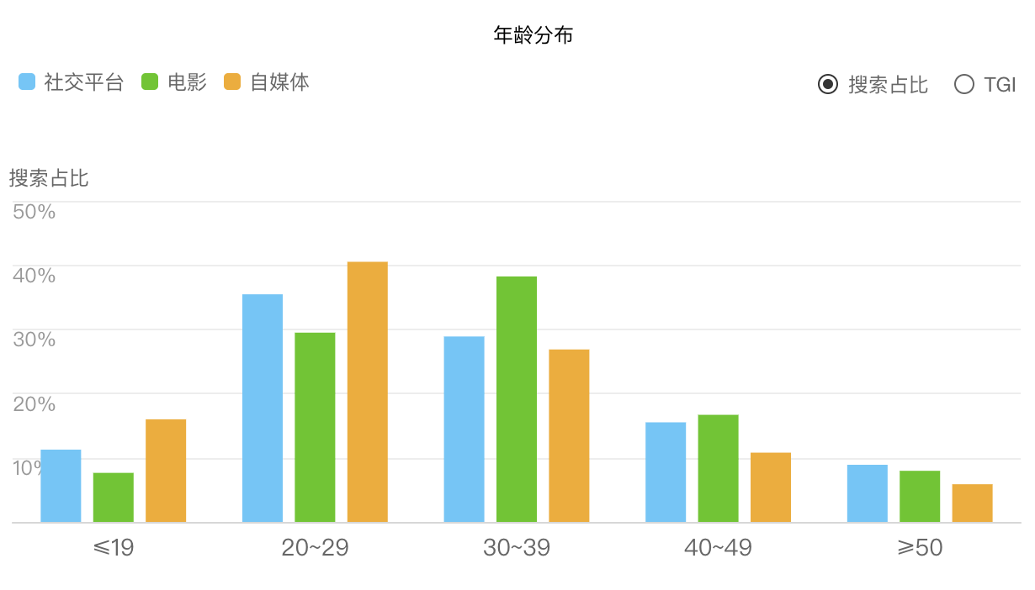The data in Fig.1 is the age-segmented statistics of people who are active on social media on the Internet, as well as the age-segmented statistics of groups interested in movie-related content. Among them, blue represents social media, green represents movies, and orange represents self-media. From the chart, we can find that the most active age group on the Internet is between 20-39 years old. After subdividing this age range, we can find that the 30-39-year-old group's demand for social media is lower than that of the 20-29-year-old group (including social media and self-media), while the 30-39-year-old group has a lower demand for movies. The attention is higher than that of people aged 20-29. So we can assume that the 20-29 age group has a greater need for more concise messages than the 30-39 age group. One possibility analysis is that people aged 20-29 generally cover college students and relatively young people who have just graduated and entered the society. Their lives are full of more possibilities and unknowns. In the rapidly developing environment of the Internet, they hope to obtain information more efficiently and show themselves on social platforms. The 30-39-year-old group has a certain life experience, but compared with the 40-49-year-old group, they are still relatively young, and their enthusiasm for new things is still relatively high. And they are more interested in film, a time-consuming medium that requires a certain amount of patience.

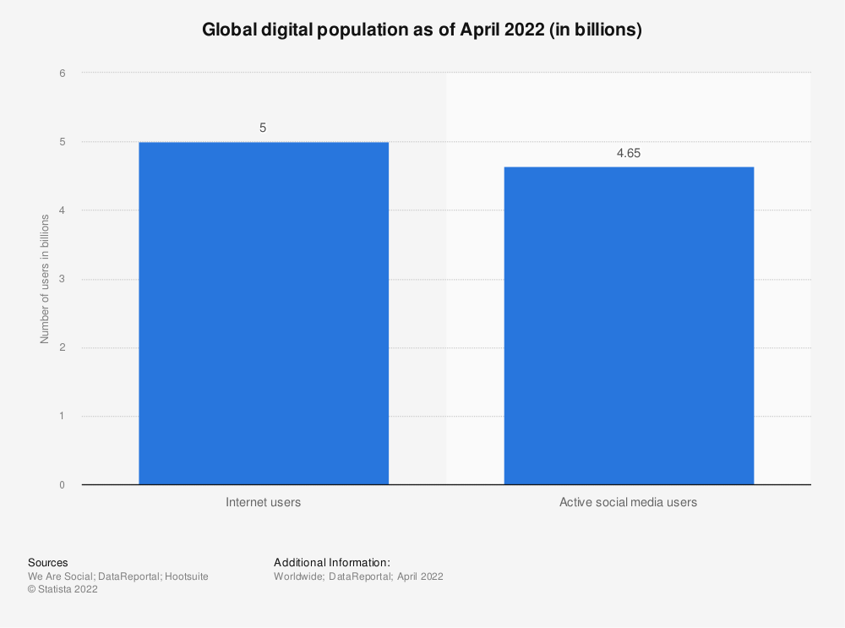
The values reflected in Fig. 2 are as of 2022, the range of people with Internet penetration in the world, and the population base active in social media. We can find that out of a population of 5 billion, more than 4.6 billion people are active on social media. This means that 93% of Internet access users use and regularly use social media.
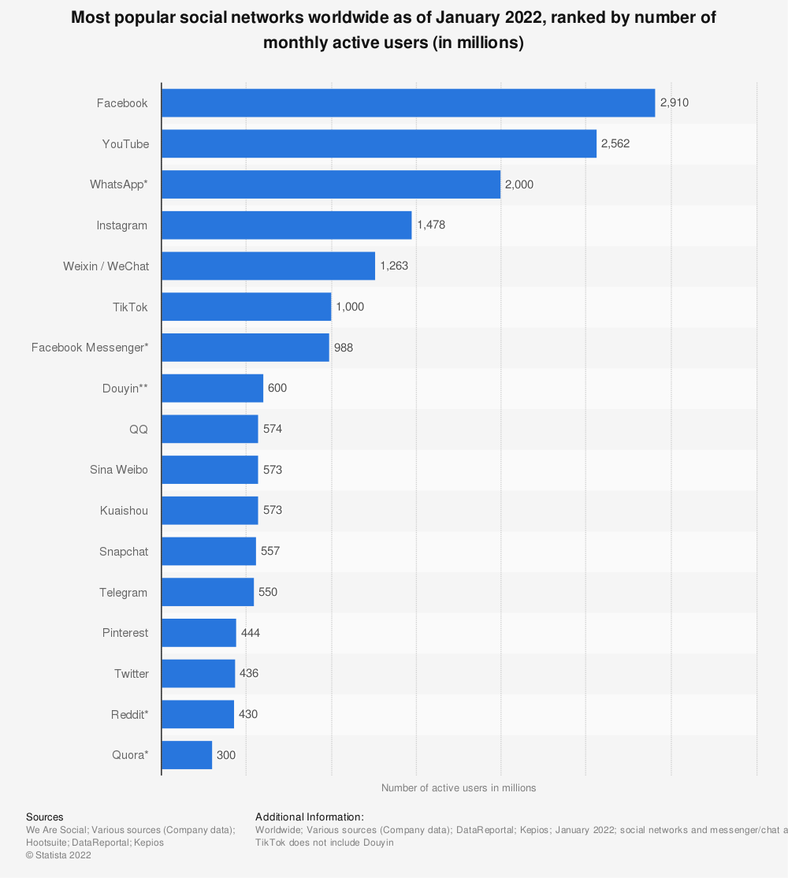
Fig.3 reflects the statistics of the number of users of mainstream social media platforms in the world as of January 2022. If we look at these data with 1 billion users as the dividing line, we find that a total of 6 products meet this standard, of which Facebook has the most users, with 2.9 billion users, and the least is tik tok, with 1 billion users. What these products have in common is that they all have a rich and complete multimedia publishing platform, and users can share their lives and express themselves through other means other than text, such as pictures, videos, and so on. Besides being a very old company, the reason Facebook has so many users is its social nature. His number of users and social mode cover most of the world, basically forming an online social environment that rivals the real world. In recent years, the company has changed its name to meta to explore a more immersive social model. Relying on its huge user base, it was able to develop smoothly.(Facebook messenger as a chat function software of Facebook platform is not included in the statistical results)
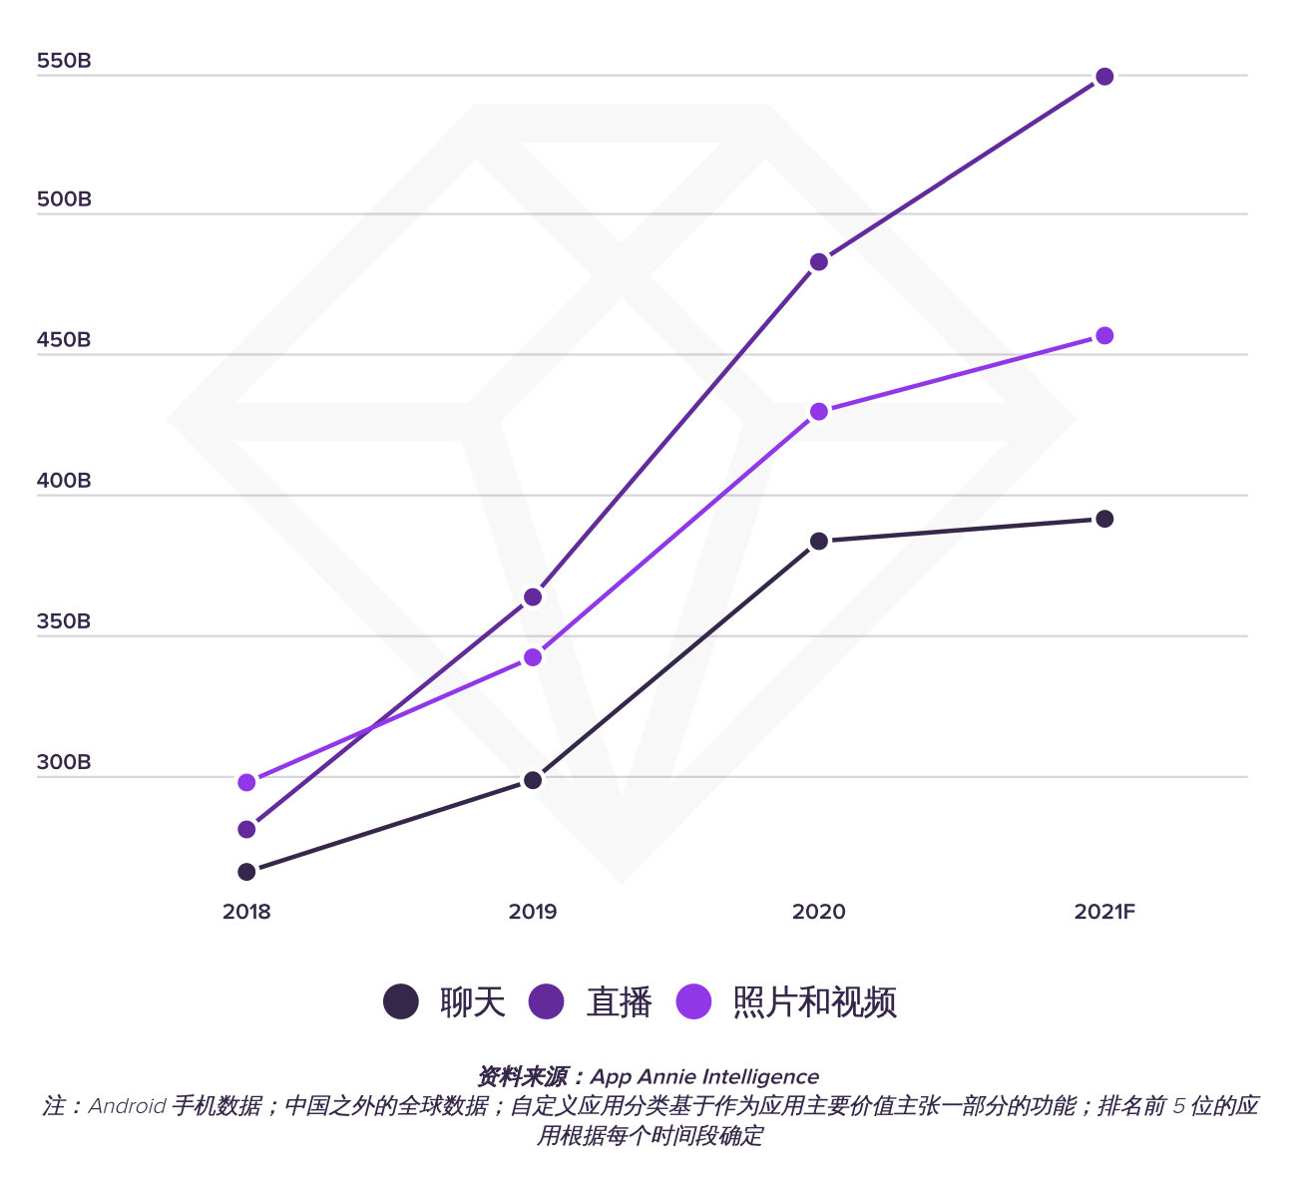Fig.4 shows the changing needs of users on social media between 2018 and 2021. The black line is the chat function, the dark purple line is the live broadcast function, and the light purple line is the photo and video function. We found that starting in 2018, the number of users of the live broadcast function surpassed the users of photo and video sharing and ranked first in the subsequent years, while the chat function ranked third in the entire statistical range. However, we analyze from the year, combined with the news data, we can see that the covid19 epidemic that began to spread globally in 2019 also affects the development of social media. Between 2019 and 2020, the demand for social media has grown significantly, and this period is the worst period of the global epidemic. Many traditional social forms cannot be realized, so more users pour into online social platforms. These values also reflect the importance of social needs in basic human needs.
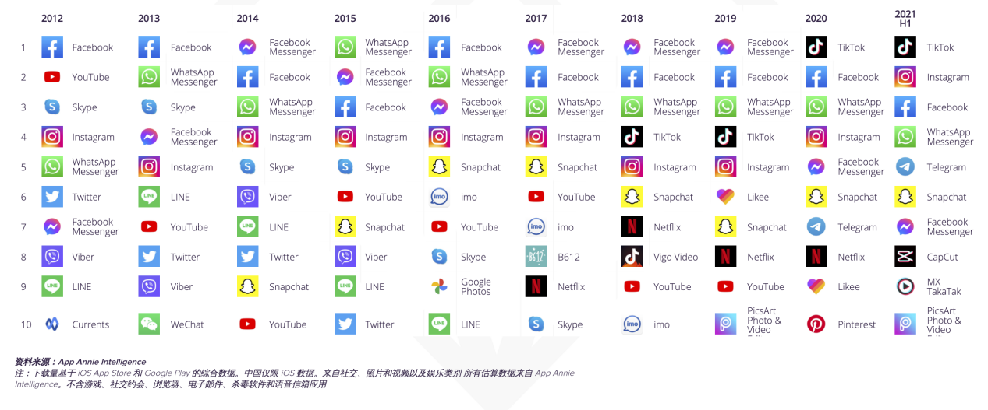
Fig.5 reflects the ranking of social media products by number of downloads from 2012 to 2021. These software reflect the functional needs of people in social media. Before 2017, people's biggest demand was the integrated social media Facebook, and products with chat function, and products with pure image sharing like ig were always in the top five range, second only to traditional chat function products. Since 2018, when tik tok appeared, it entered the top five directly and surpassed ig. And it only took two years to top the list. From here, it can be seen that the new mode of self-expression and socialization through short videos is welcomed by all users. It also represents that products with a higher-level expression system can well meet people's self-expression needs. And YouTube, which also uses video as its main function, has not had a good ranking. The biggest reason may be because the time and economic cost of producing a youtube program is much higher than that of tik tok short videos. Whether it is the way of reading or the way of writing, there is no particular advantage. In the Internet era where information transmission speed is getting higher and higher, people's requirements for information are more fragmented and more efficient.
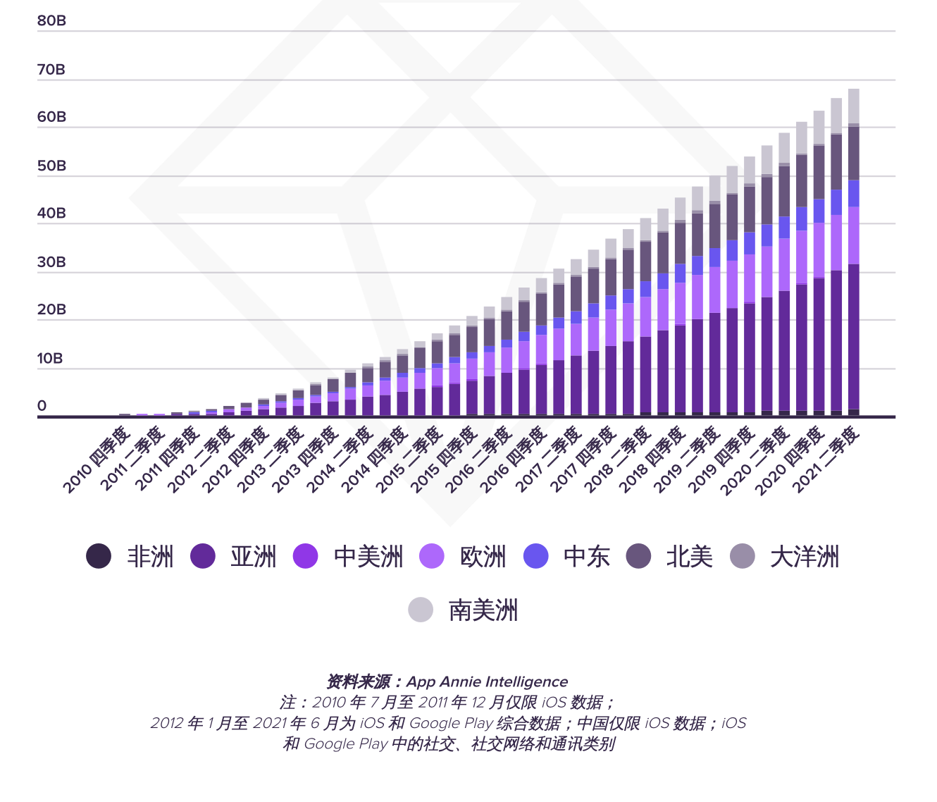
Fig.6 reflects the growth in the number of people participating in social media globally from 2010 to 2021. We can find that global social media users are in a steady growth trend. Every year new people join social media. This also serves as a supplement to the data in the previous chart. Under the premise of steadily increasing the number of users year by year, the demand for social media products is dynamic. Meaning that user selection is experienced once a year. On the other hand, we can also see that people's need for social interaction has not decreased.

Reliability of data sources
The first is that the sample base is sufficient. At present, there are more than 4.6 billion active social media users in the world, and the largest market is China. (Based on population advantages and Internet penetration) the distribution is relatively even, and there are no extreme regional differences. At the same time, the information carrier is large enough to have analyzable connotations.
At the same time, the memory attribute of the Internet preserves behavioral traces for many social behaviors. Combined with the statistics of big data, some trend analysis can be easily drawn.
Because social media exists on the Internet in the form of digital information, social media itself is documentary, and due to the existence of digital avatars, social identities often diverge from real identities. Therefore, trends in social media can give us Provides a lot of valuable data.

Case Studies and Action Research

Practical behavior, creation based on market demand.
The biggest change that the format of social media has had on traditional media is that it has changed our viewing habits.
In the traditional film format, the picture we watch is as close to the human eye's perspective as possible, and the horizontal expression is mostly, from 8mm square to 35mm 4:3 to 16:9 2.35:1, etc., the perspective of the film curtain is always developing horizontally.

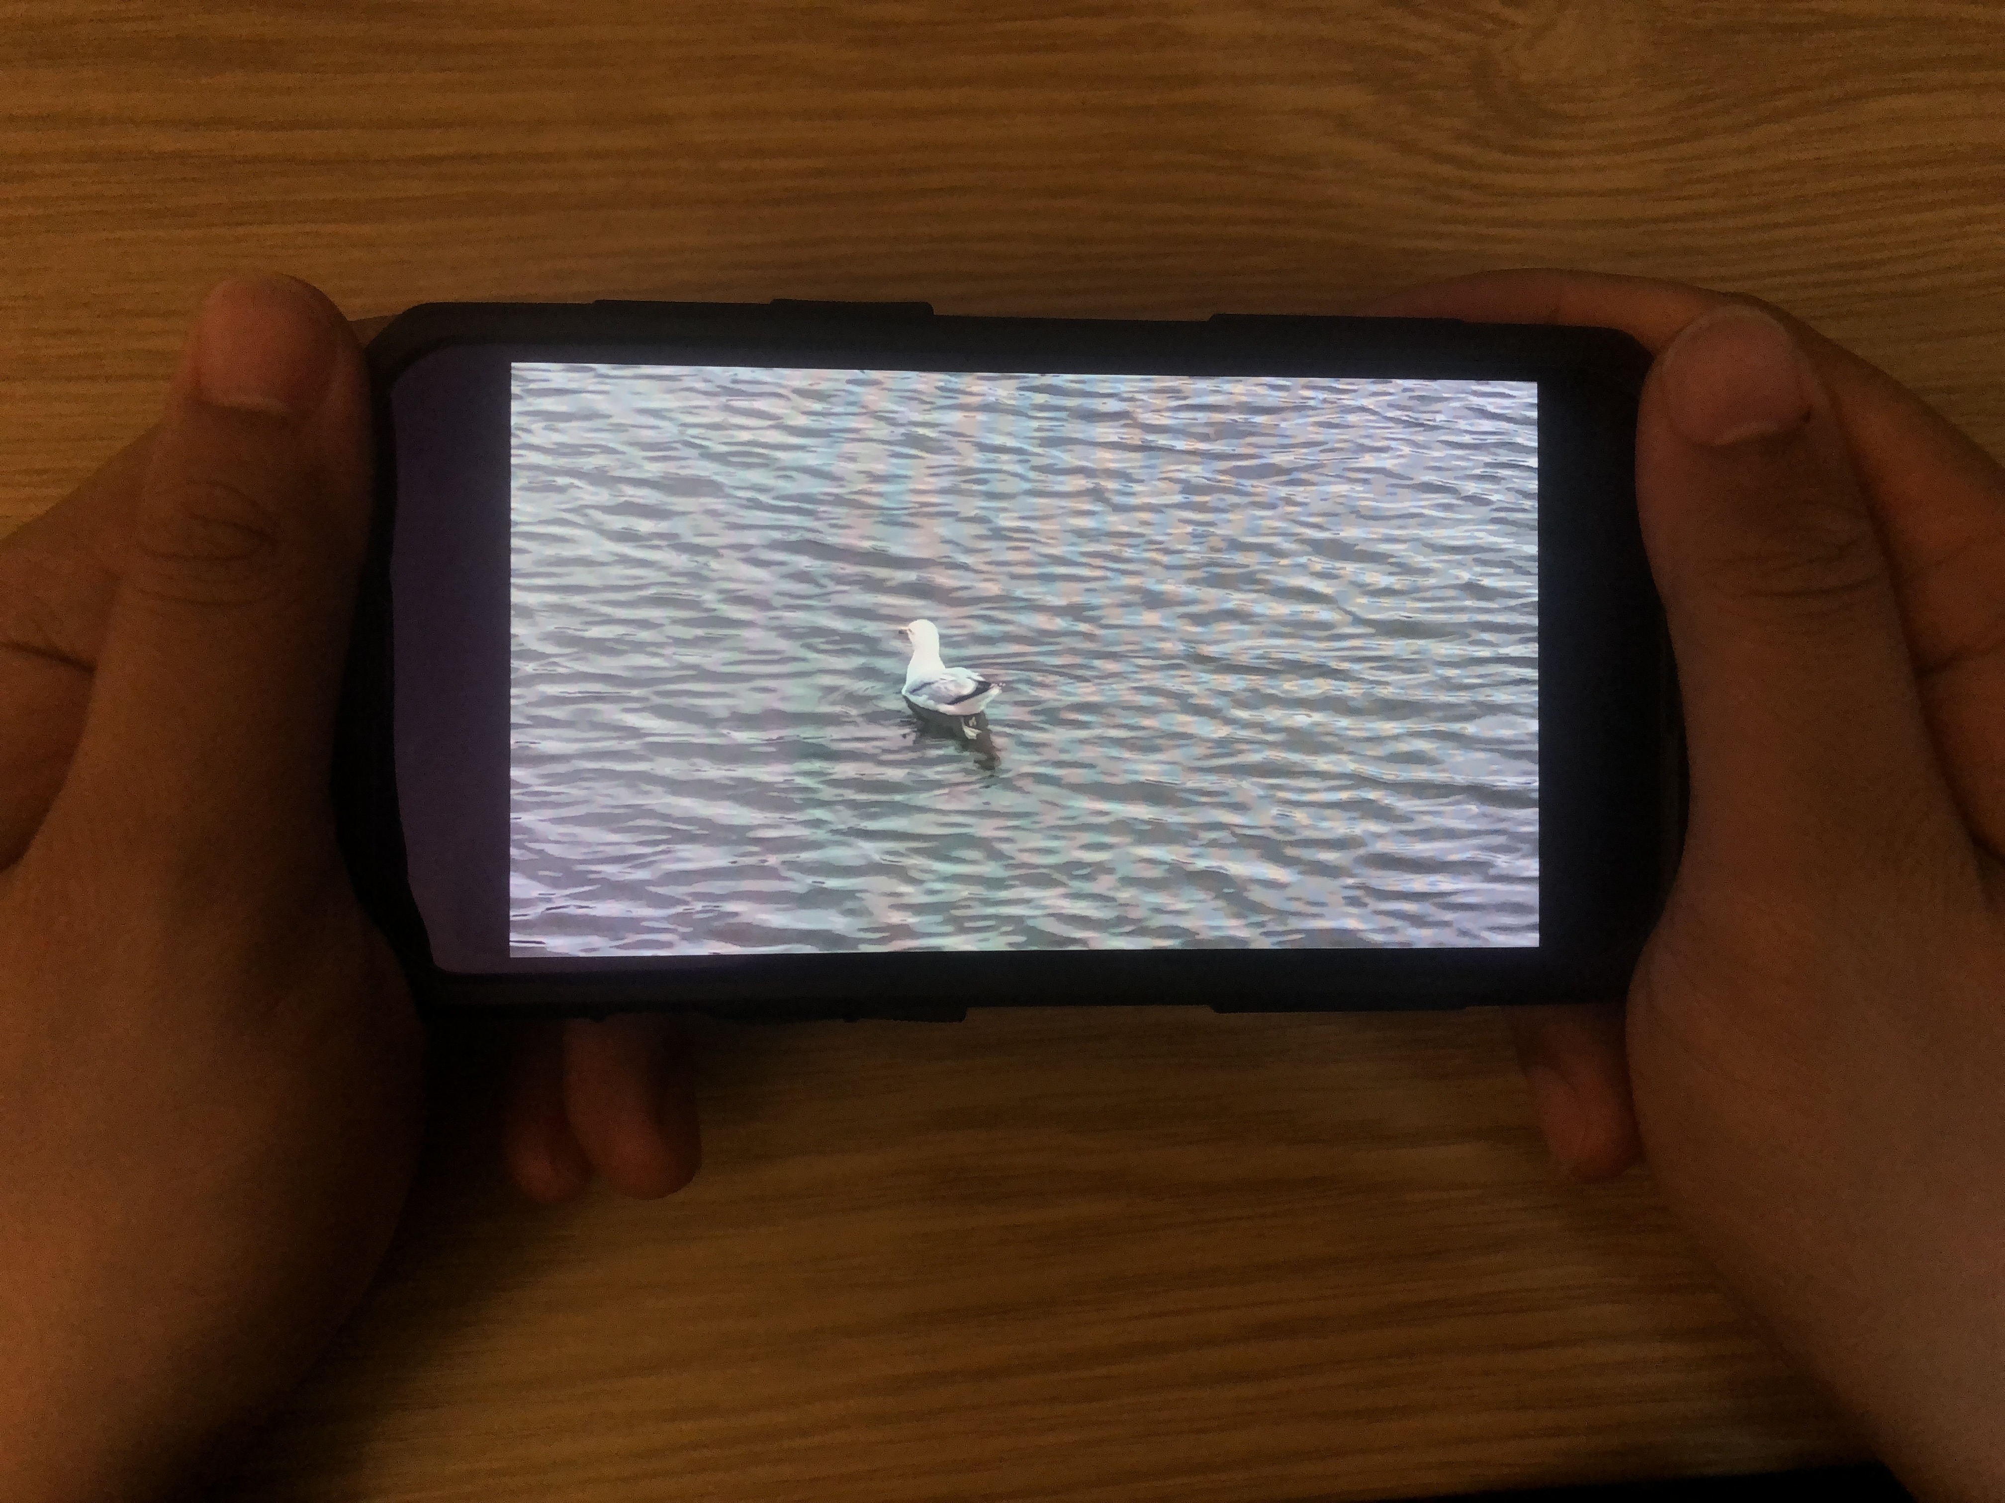
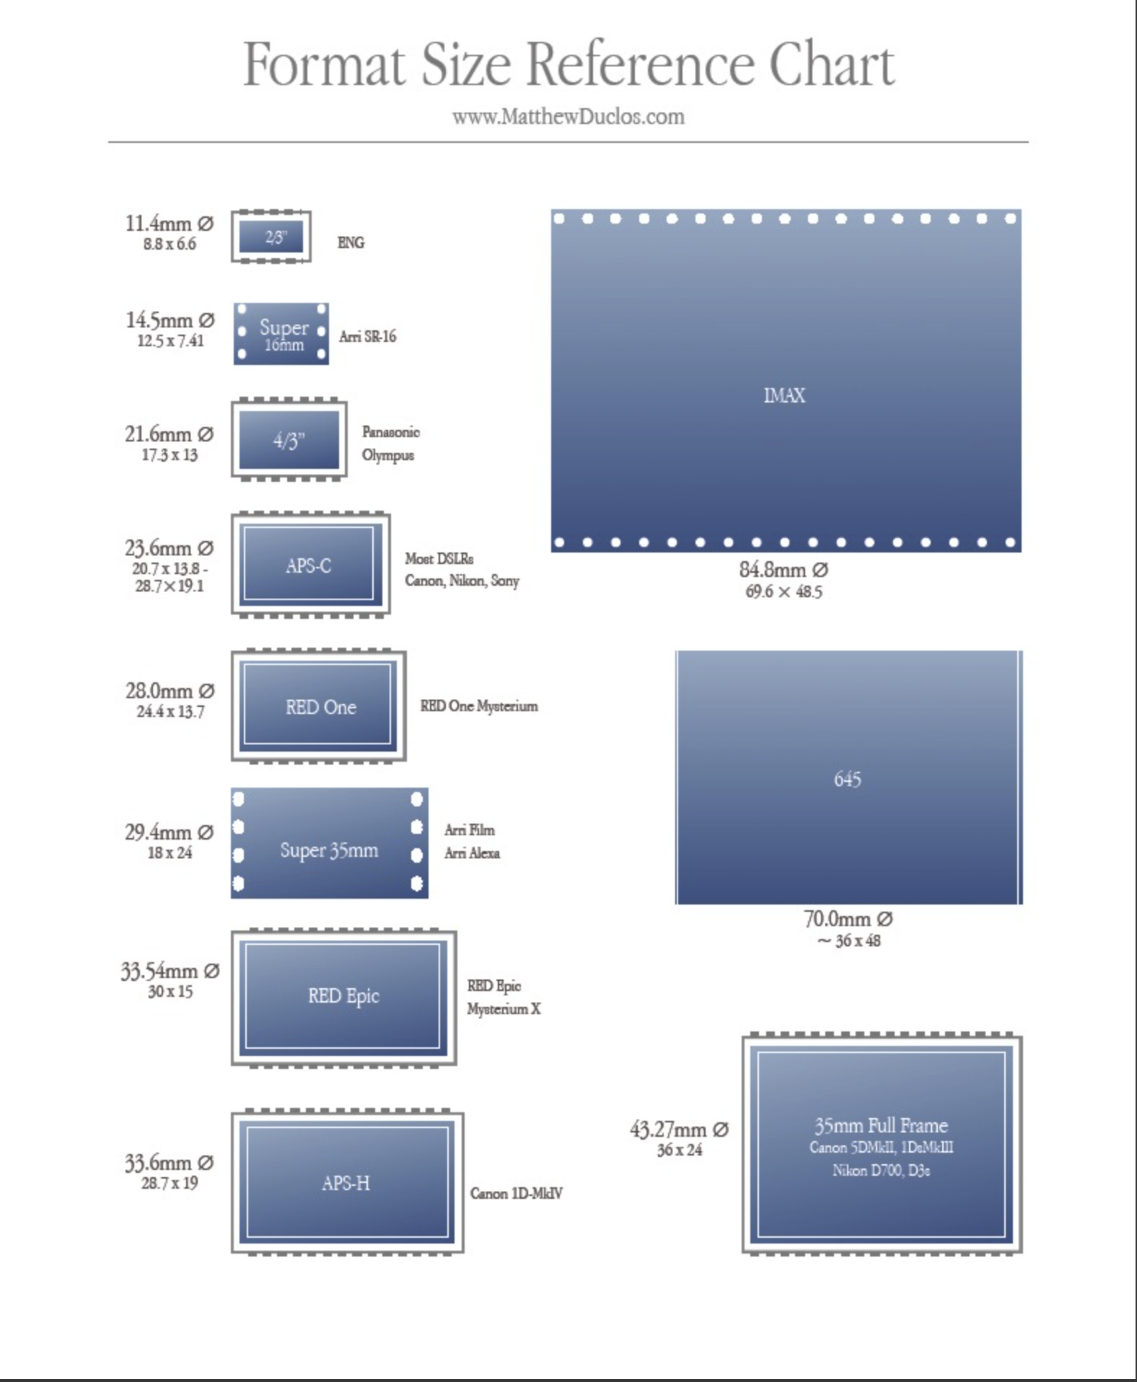
Fig.2 traditional way of viewing
Chiqian Huang 2022

Fig.1 format size reference chart
www.MatthewDuclos.com 2022

Because of the characteristics of the human eye, the upper and lower horizons are smaller than the left and right, so when we work on composition, movement, and art, we work with perspective and perspective from the theater stage. After the Internet era has developed into a mobile smart terminal, due to our habit of holding mobile phones, the screen cannot always be filled. If a standard full-screen fixing screen is required, we need to turn the mobile phone sideways. But often this extra action does not conform to daily usage habits, affects user experience, and hinders transmission efficiency.

As a result, vertical screen shooting has entered the film and television industry. In 2015, I participated in a series of vertical composition specially customized for mobile phone users. At that time, there were already online shopping platforms that used vertical screens to play advertisements, which were displayed directly on the full screen at startup. The reform of this composition for smart mobile terminals also illustrates a problem from the side that the visual habits of the audience have changed, and whether the immersion of the vertical screen is effective still needs to be verified, but the emergence of video social media software followed closely. gives us good answers, we probably don't need that kind of immersion that's completely faithful to visual habits, we're more of a fleeting message in it. At this time, it is possible to reduce a flipping action to gain more opportunities for playing the complete message.

And we still need the traditional horizontal system to bring us a truly immersive experience and the way of dreaming. This form has not changed too much, and even with the emergence of VR technology, there has not been an essential change. Therefore, in this process, people actually know what experience they can get on what device, and their expectation of smart devices is not an immersive experience, but a fast-paced social behavior medium.
This is a commercial shot in 2021, we can see that we are still shooting the commercial with a regular movie camera, for the picture quality and lens we want to get, so we use a 90 degree adapter to put the camera upright to Shoot an ad that can be played in portrait orientation.
It can be seen that social media behavior and audience preferences are also affecting the expression of lens language and industrial processes. Our visual habits have gone from being habitually horizontal in the past to accepting rotated images without feeling overly strange.

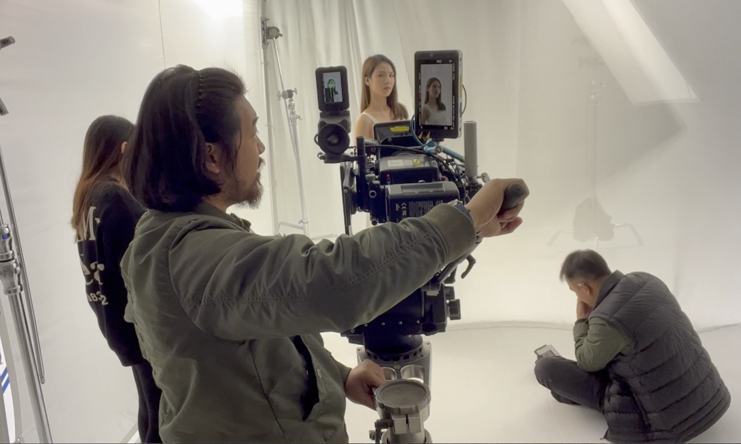
Fig.3 camera perpendicular to the ground
Chiqian Huang 2021

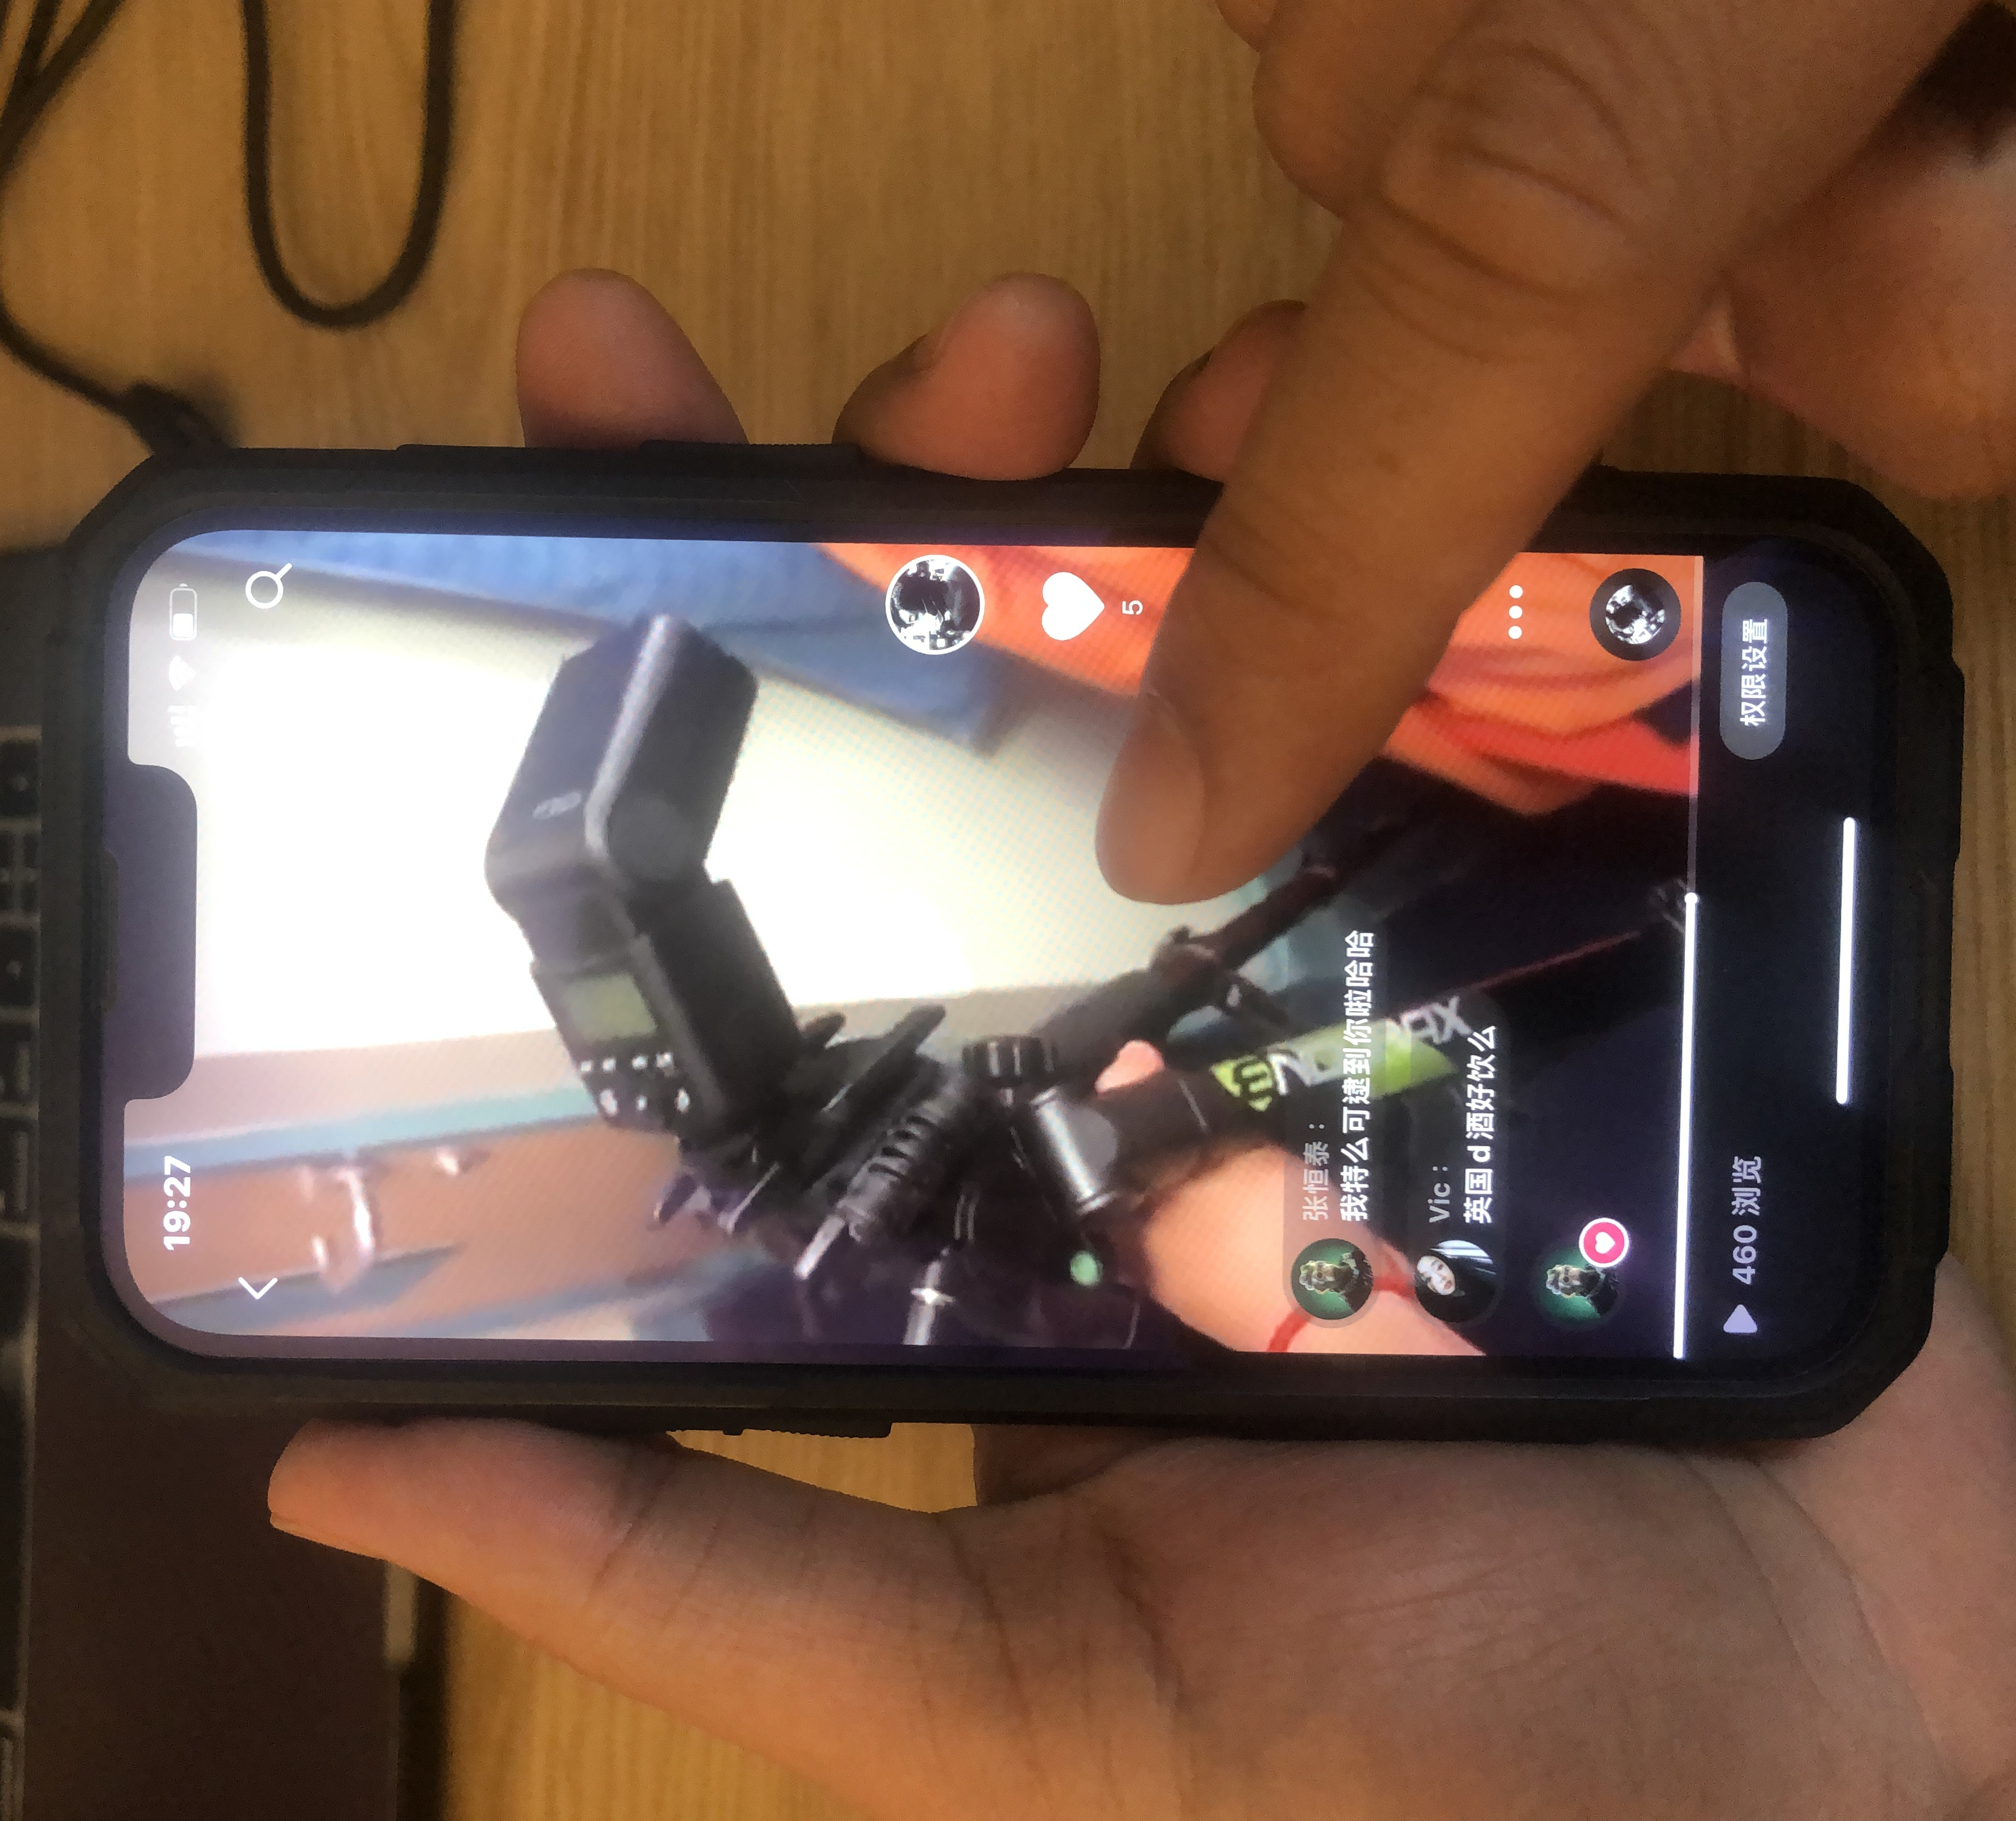
Fig.3 new way of viewing
Chiqian Huang 2022

The use environment of the mobile terminal is relatively complex than that of the computer and the TV, and the immersion may no longer be mandatory in the past, and the voyeurism caused by the environment and window. The immersive form of smart devices is special, spontaneous, and derived from information. We can naturally focus on the screen of several inches in a noisy environment, reflecting itself like a black mirror.

Conclusion
The influence of social media behavior on form is the starting point for a study, in which a more in-depth observation lies in the process of shaping the social image of the self originating from the heart. This behavior and process can be understood as an externalized form of emotional contagion, and its content and form must be directly related to the author’s inner expression. Through the study of social media behavior, and its impact on the industrial system The impact of , we first determine the active population and popular expressions, and the next step is to delineate the sampling range of our follow-up research and the sampling data nodes by summarizing this process.
Based on the analysis and thinking of the nature of social media, it is feasible to use social media as one of the data sources to study the behavioral laws of subjective emotional expression.
The second stage of research and demonstration planning is to study how emotions are transmitted and communicated, and whether there is a pure emotional language in visual art, which is relatively independent from narrative and pure image.

Discussion

Does the overly figurative expression hinder the audience's gestalt?
Narrative behavior in literature and art is learned by filmmakers and used for a long time. Narrative with video has become a new way of expressing self-emotion. In this way, we still express through specific stories and plots. The deviation between the script and the finished film is objective, and there is always a deviation caused by randomness between expectations and reality. Because everyone's abstract understanding of words is different, the stories presented by different people using visual elements will be very different. Would it contradict this if one were to study the language of pure emotion? Not to deny the diversity and subjectivity of art. It is precisely to recognize this subjectivity, but also to recognize the subjectivity of information recipients, as well as the deviation of other social attributes, such as race, nationality, gender, background and so on. These experiences affect our judgment and gestalt to some extent.

How to Define Stripped Narrative, Poetic Cinema
When visiting the exhibition of traditional art, it is relatively easy to understand and generate associations and resonance. In the new art form, the emotions the author wants to express become extremely personal, so it becomes jerky and difficult to understand. As a carrier of author's self-appreciation and observation, it cannot bring intuitive feelings to the general audience, and the audience group becomes relatively narrow. This phenomenon also exists in art films.
Traditional film is a large integration of art forms, covering many forms of expression and a wide range of contents. The forms of expression support each other and produce good results, while the imagination space left is deprived and limited. The author expresses his own attitude and evaluation of the story in a form with strong personal subjective consciousness, and uses as many forms as possible to concretize these concepts.
The close relationship between the development of art forms and science and technology determines that in different historical periods, the forms we can use for expression are restricted by technical conditions. Therefore, when technology is relatively developed, we must have more forms than in the past. Concrete our ideas. But can figurative expressions produce the same emotional experience?

Bibliography

Denscombe, M. (2017) The good research guide : for small-scale social research projects. Sixth edition. London: Open University Press.

Lipschultz, J.H. (2018) Social media communication : concepts, practices, data, law and ethics. Second edition. New York: Routledge, Taylor & Francis Group.

Truffaut, F. (1984) Hitchcock. Revised ed. London: Simon and Schuster.

Truffaut, F., Fox, A. and Gillain, A. (2017) Truffaut on Cinema. Translated by A. Fox. Bloomington, Indianapolis, Indiana: Indiana University Press.

Metz, C. et al. (1982) Psychoanalysis and cinema : the imaginary signifier. Basingstoke: Macmillan.

Metz, C. (1991) Film language : a semiotics of the cinema. Chicago, Ill: University of Chicago Press.

Mirzoeff, N. (2009) An introduction to visual culture. 2nd ed. London ;: Routledge.

Homer, S. (2005) Jacques Lacan. London: Routledge.

Coxon, M. (2012) Cognitive psychology. London: Learning Matters.

