Marketing Plan
Student’s Name: Rares-Cristian Puian
Student’s ID:2232736

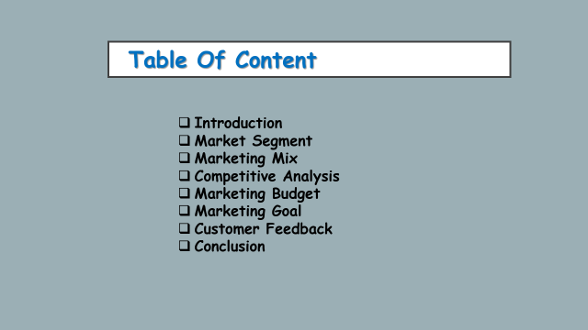

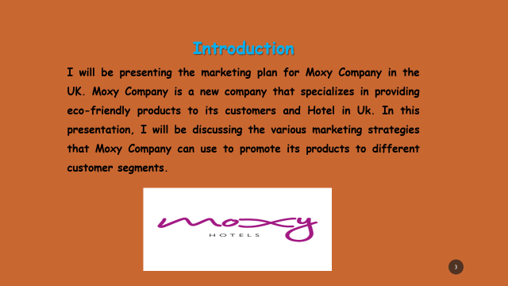
I am here today to present the marketing plan for Moxy, a UK-based company that specializes in creating high-quality, affordable skincare products for men and women. In this presentation, I will be discussing the key concepts and ideas of our marketing plan and how we plan to market these to our identified customer segments.
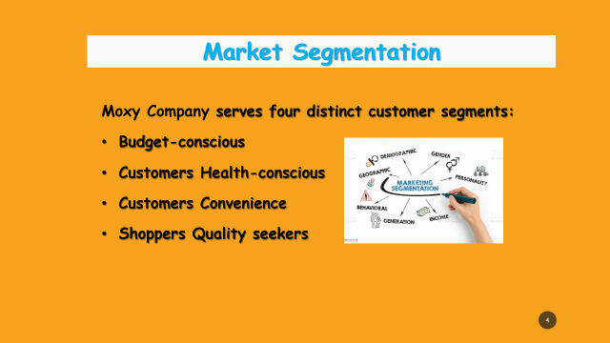
Market Segmentation:
Our marketing strategy begins with the identification of our target market categories (Kotler, 2020). Through extensive study and analysis, we have determined that Moxy Hotel serves four distinct customer segments:
- Budget-conscious customers
- Health-conscious customers
- Convenience shoppers
- Quality seekers
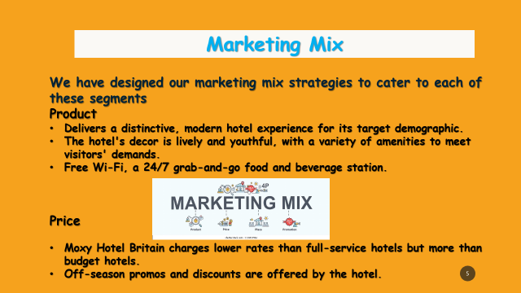
Moxy Hotel UK, operated by Marriott International, targets younger guests. Moxy Hotel UK's 4P mix:
Product: Moxy Hotel UK delivers a distinctive, modern hotel experience for its target demographic. The hotel's decor is lively and youthful, with a variety of amenities to meet visitors' demands. Free Wi-Fi, a 24/7 grab-and-go food and beverage station, and multiple communal places for guests to work, rest, and interact are Moxy Hotel UK's main features.
Price: Moxy Hotel Britain charges lower rates than full-service hotels but more than budget hotels. Off-season promos and discounts are offered by the hotel.
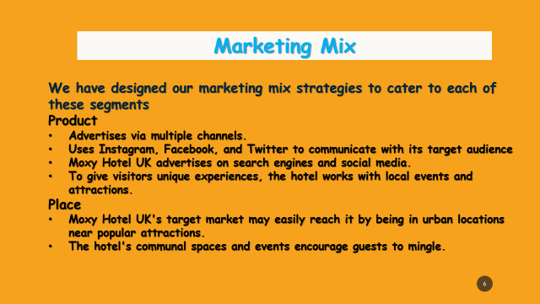
Place: Moxy Hotel UK's target market may easily reach it by being in urban locations near popular attractions. The hotel's communal spaces and events encourage guests to mingle.
Promotion: Moxy Hotel Britain advertises via multiple channels. The hotel uses Instagram, Facebook, and Twitter to communicate with its target audience and promote its unique design and facilities. Moxy Hotel UK advertises on search engines and social media. To give visitors unique experiences, the hotel works with local events and attractions.
Moxy Hotel UK's marketing mix aims to offer its target demographic a unique, modern, and inexpensive hotel experience (Cravens, 2020).
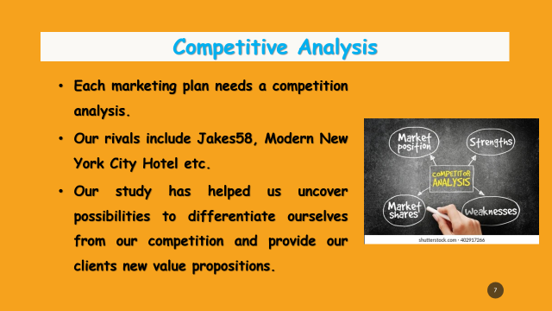
Competitive Analysis:
Every marketing plan needs a competitive study. Jakes58, Modern New York City Hotel etc compete with us. We compared their strengths and weaknesses. Our investigation has revealed ways to differentiate ourselves from competitors and offer fresh value propositions to clients.
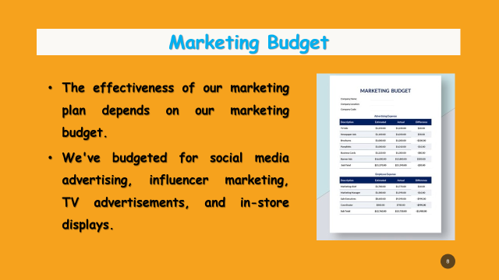
Marketing Budget:
The effectiveness of our marketing plan depends on our marketing budget. We've budgeted for social media advertising, influencer marketing, TV advertisements, and in-store displays.
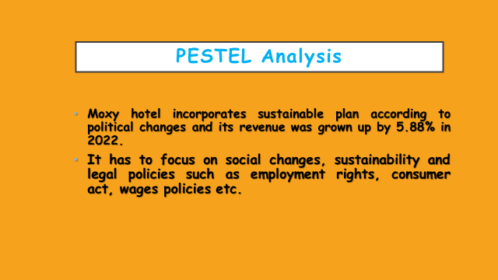
PESTEL analysis: PESTEL analysis of Moxy hotel helps to understand the impact of micro environmental factors on the organisation, its performance and how this organization has to take policies based on this factors can be understood from this analysis.
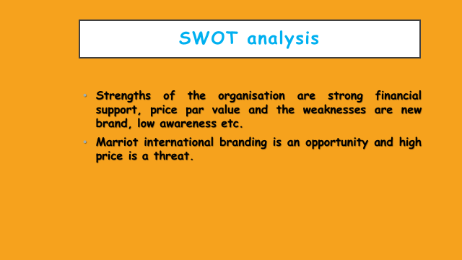
SWOT analysis: Strengths of the organisation are strong financial support, price par value and the weaknesses are new brand, low awareness etc. Marriot international branding is an opportunity and high price is a threat.
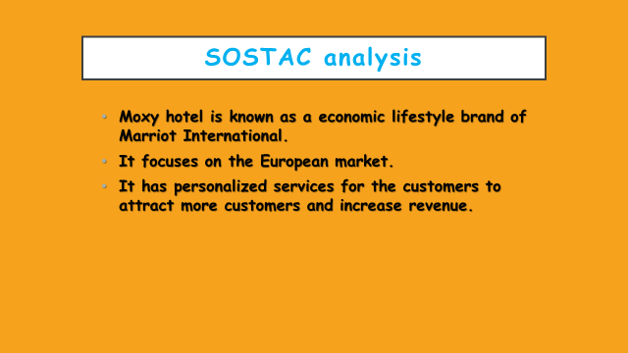
SOSTAC analysis: Moxy hotel takes various strategies to attract customers as it is a new brand compared to other brands of Marriot. High price of hotel rooms is a threat for the organization which should be considered.

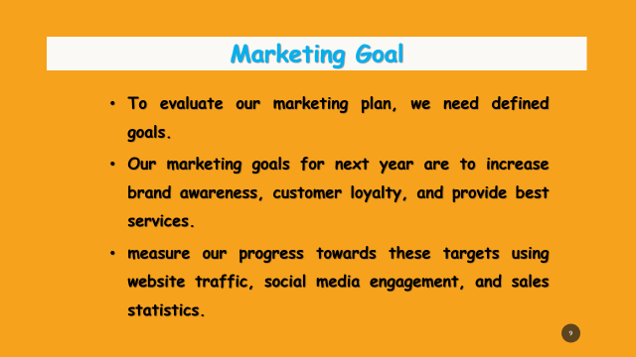

Marketing Goals:
To evaluate our marketing plan, we need defined goals. Our marketing goals for next year are to increase brand awareness, customer loyalty, and sales (Bradbury, 2020). We will measure our progress towards these targets using website traffic, social media engagement, and sales statistics.
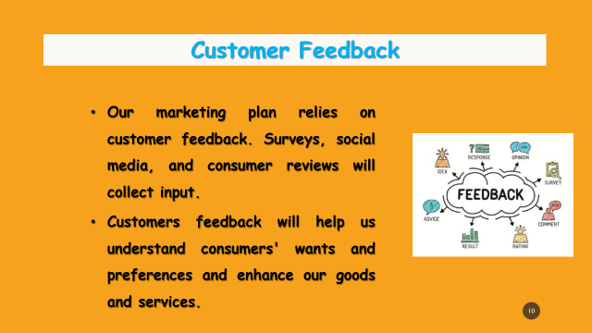
Customer Feedback: Our marketing plan relies on customer feedback. Surveys, social media, and consumer reviews will collect input (Baines, 2019). Your input will help us understand consumers' wants and preferences and enhance our goods and services.

Gannt Chart
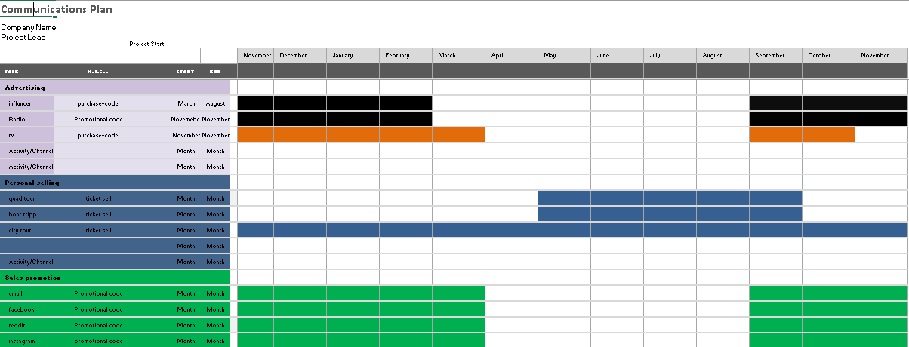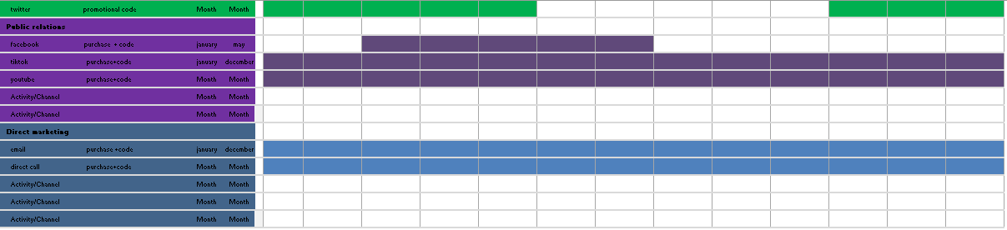

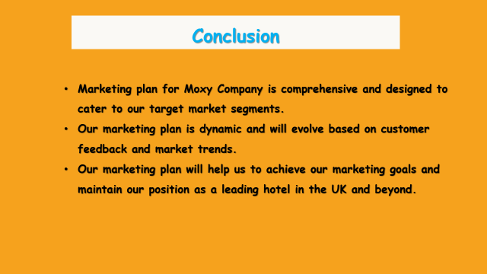
Conclusion:
In conclusion, Moxy Hotel's marketing plan targets our target markets. We'll market to customers and offer great value. Our marketing strategy changes based on client input and market trends. Our marketing plan will help us reach our goals and remain a leading retailer in the UK and worldwide.

References


