Installation art

https://medium.com/@harrydavidhm/why-modern-art-installation-attracts-more-people-nowadays-288cd06e1edd

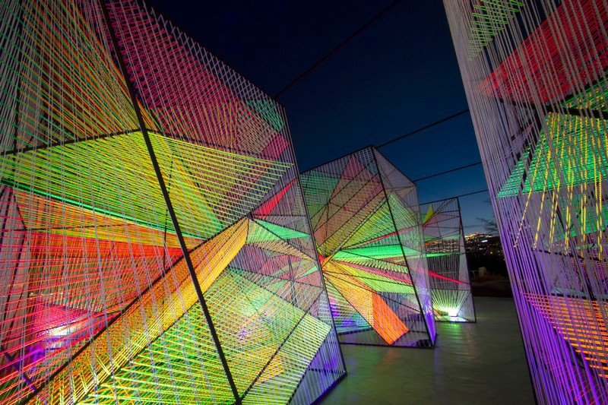

https://magazine.artland.com/installation-art-top-10-artists/
Installation Art
Often site-specific, and occasionally occurring in public spaces, the boundaries of what constitutes installation art have been blurred since its very inception as an artistic genre. Though installation art varies widely it can best be thought of as an umbrella term for three-dimensional works that aim to transform the audience’s perception of space. Sometimes temporary, sometimes permanent, installation artworks have been constructed in spaces ranging from art galleries and museums to public squares and private homes and will often envelop the viewer in an all-encompassing environment or within the space of the work itself. Installation art developed primarily in the second half of the twentieth century (though there were clear precursors) as both minimalism and conceptual art evolved, culminating in installations in which the idea and experience was more important than the finished work itself. See the artists below, all of whom have made a unique contribution to the dialogue about installation art and how it should be defined.

Kurt Schwitters

Best known for collages made out of paper scraps, wood, advertisements, and anything else he could get his hands on; 20th century Dada-artist Kurt Schwitters (1887-1948) ultimately turned his own art studio into a collaged art installation. His studio-installation, entitled Merzbau, was borne out of an artistic process which Schwitters explained as both a philosophy and a lifestyle branded “merz”. Merz was a nonsense word that the artist used to describe himself, his life, and his work, meaning that his Merzbau was essentially his merz-building. Over the years his studio took on the form of a walk-in collage, ever-shifting and ever-growing, composed of columns and stalagmites of found objects. Schwitters grew his Merzbau over time, eventually consuming eight rooms in his home in Hannover from roughly 1923 until 1937, when he was forced to flee to Norway to escape Nazi Germany. By 1943, when he was still in exile, the Merzbau was destroyed by an Allied bombing — effectively rendering Schwitters’ living site-specific artwork time-specific as well.
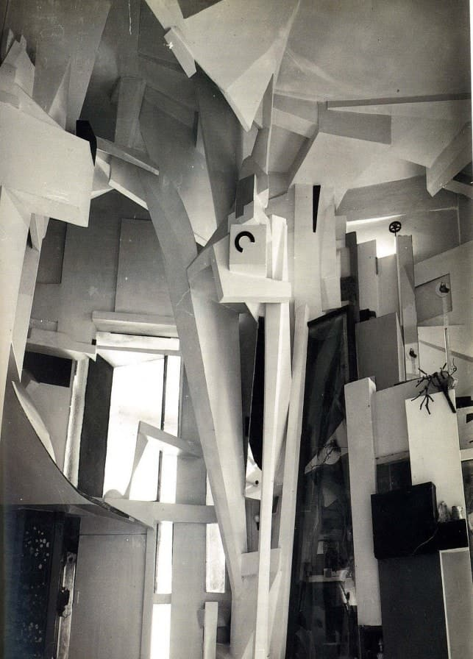

Doris Salcedo

“We have lost our ability to mourn…I want my work to play the role of funeral oration, honoring this life.”
Doris Salcedo, January 2015
Utilising the facade of Bogotá’s Palace of Justice as her canvas, Colombian installation artist Doris Salcedo’s immense work Noviembre 6 y 7 (2002) was an act of remembrance for the 17th anniversary of the seige of the Palace by M-19 guerrillas and the government’s subsequent counterattack in 1985. Focused on acknowledging and remembering violent deaths, Salcedo’s work has highlighted this theme through her work through Colombia’s civil war casualties as well as Chicago’s gun violence victims. Her poetic works are often monumental in size, forcing her audience — which is often comprised of unwitting passersby — to recall these violent acts and engage in the act of mourning.
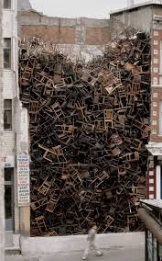
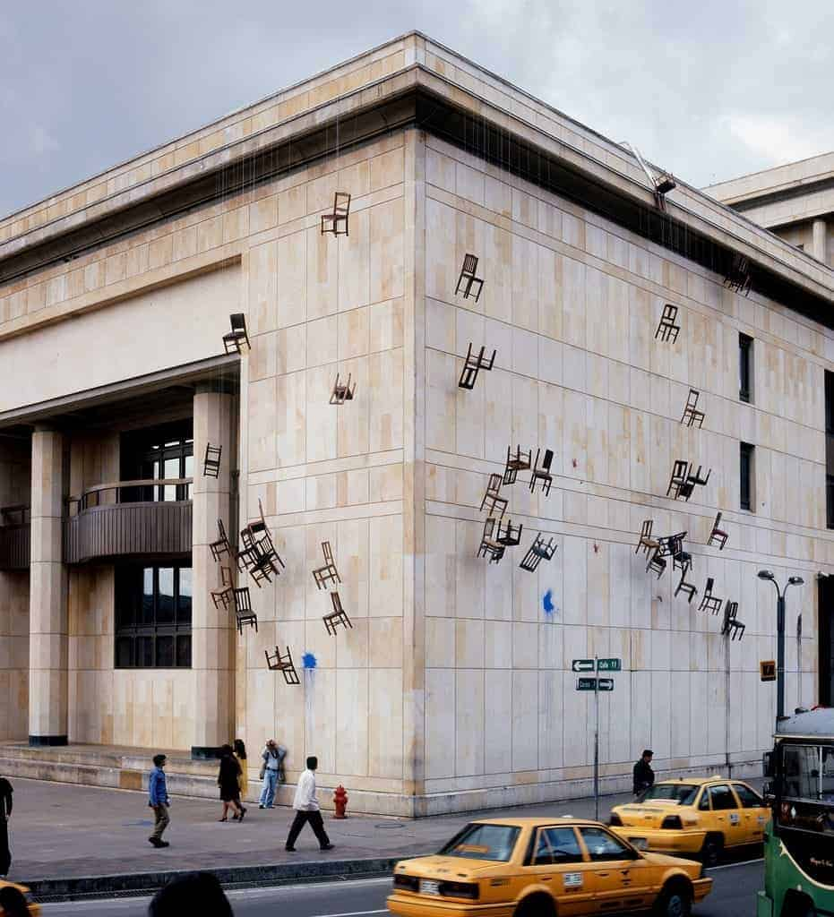


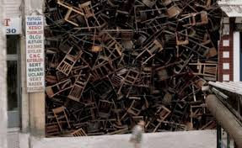

Thomas Hirschhorn

“Destruction is difficult. It is as difficult as creation.”
Antonio Gramsci (Italian-Marxist theorist & inspiration for Hirschhorn’s In-Between)
Creating political statements out of mundane, everyday craft materials, Swiss artist Thomas Hirschhorn’s installation art and public pieces are legendary for the amount of attention they receive. Hirschhorn’s sculptural constructions made of mass goods reference the work of radical theorists such as Gilles Deleuze and Georges Bataille’s beliefs on capitalism and consumerism. His works, like Gramsci Monument, a major public installation held at the New York City Housing Authority’s Forest Houses in the Bronx, create alternate dystopian realities for his consumers; holding a mirror up to daily life upon which to reflect and react. His more recent work, In-Between (2015) is informed by his research of bomb-damaged locations around the world; and is an expression of the deep-seated human fascination with destruction and violence that comes from many forms: disaster, structural failure, corruption, fatality, or war.
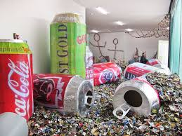
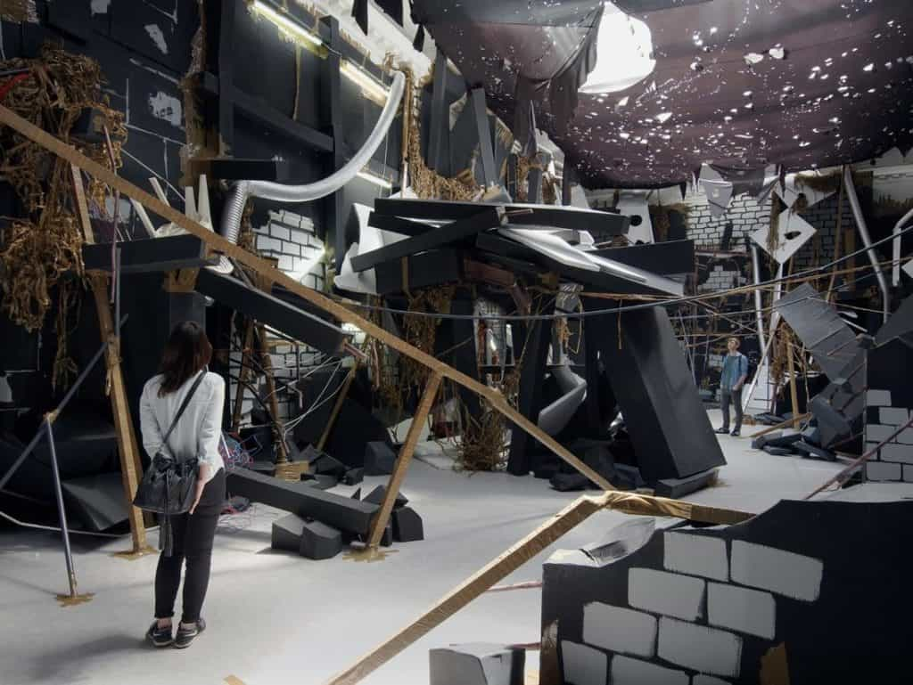

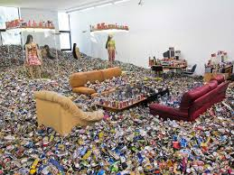
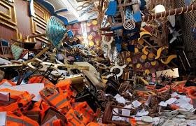

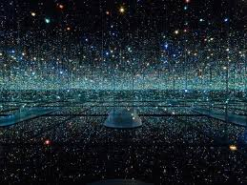
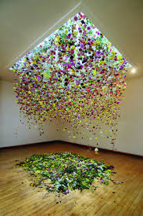

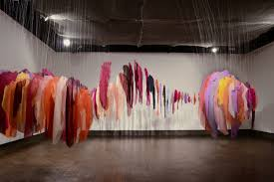

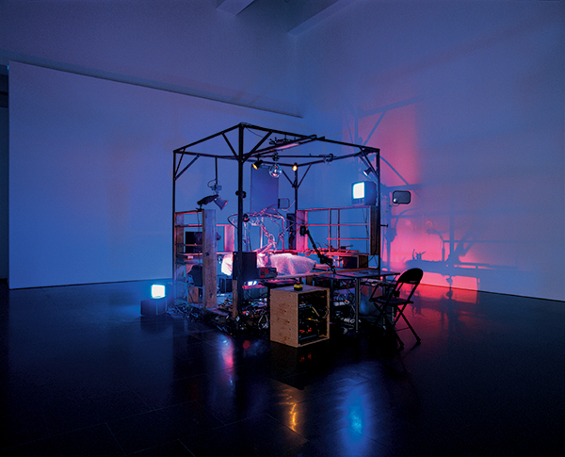

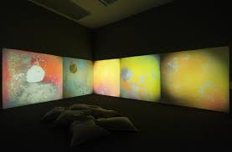

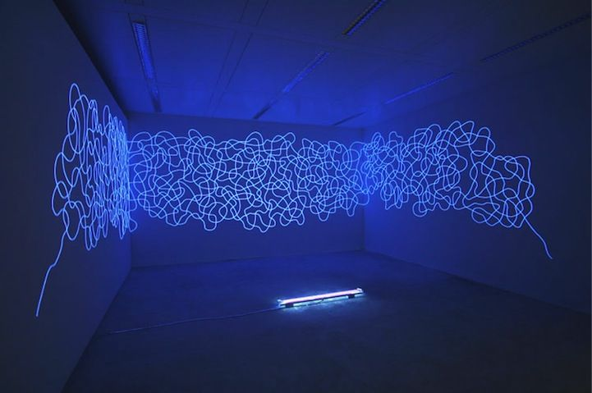

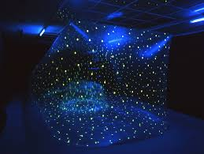

https://www.bocadolobo.com/en/inspiration-and-ideas/playful-art-installation-graphic-artist-camille-walala/

Camille Walala

“Walala has set out to create a temple to wonder in which visitors can unleash their inner child and lose themselves in color and pattern,” said the gallery.

Walls covered in bold geometric patterns, mirrors, and bright hues, the interactive installation explores ideas of art, wellbeing and human scale and invites visitors of all ages to explore the space.

“With walls of different heights, passageways of different widths, enclosed spaces and curved and zigzag paths, the installation foregrounds the idea of human scale, giving visitors both a lasting visual impression and an extraordinary physical experience as they pass through it.”

The heart of the contemporary art installation is a puzzle, three-dimensional game where visitors will be confronted with a challenge exploring colors, patterns, shapes, and scales.
“The layout of the installation playfully mirrors the shape of the building and its components are positioned in response to the mapping of the building and the peninsula around it,” said the gallery
“Seen from above, there is a clear, fluid relationship between the walls of the installation and the aerial view of the wider area, making the piece a structural extension of its immediate environment.”

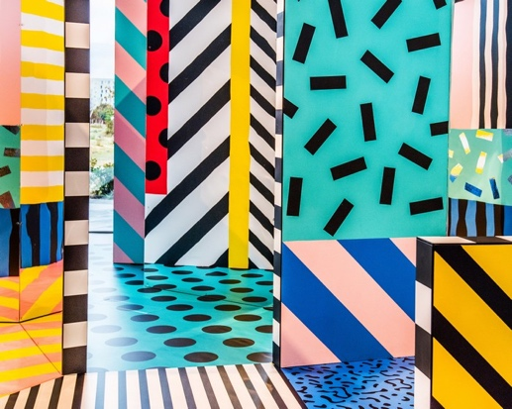
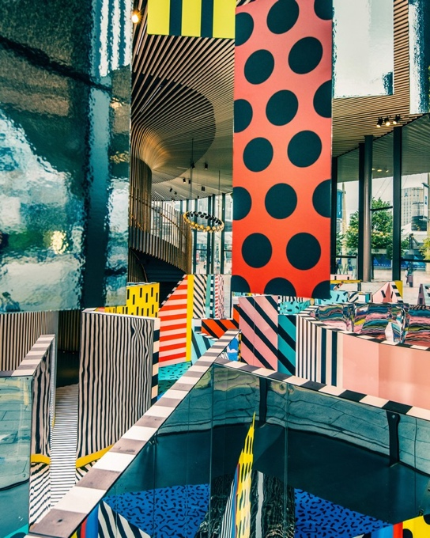
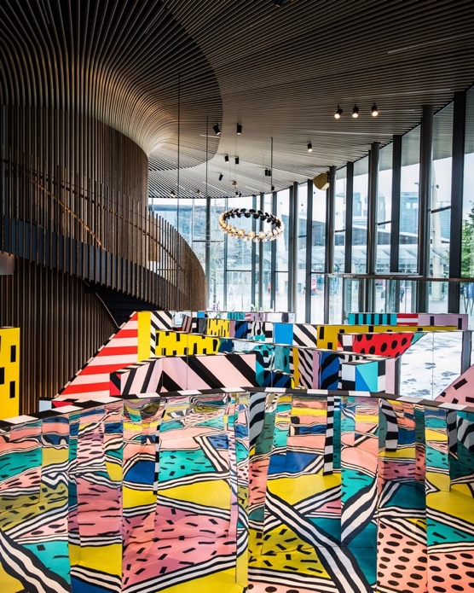

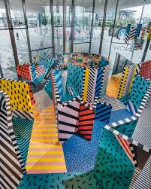

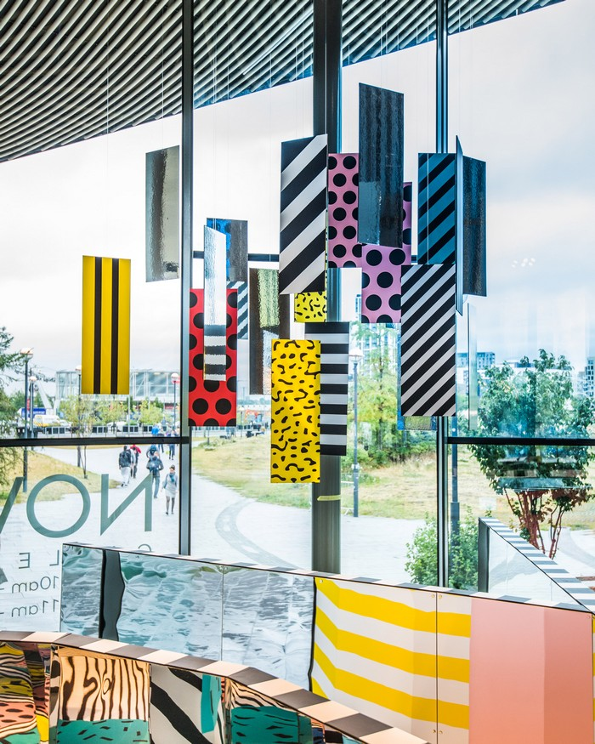

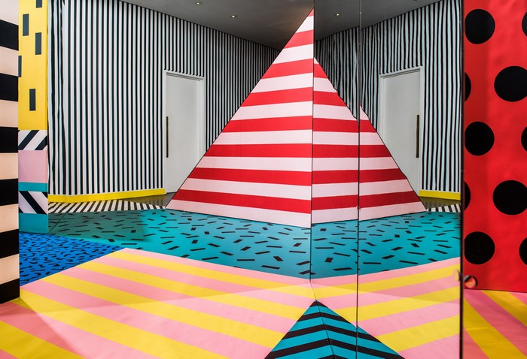

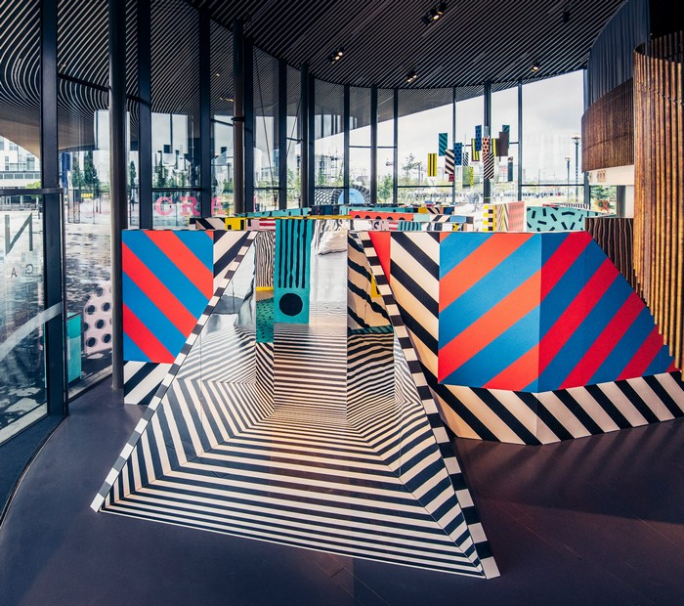

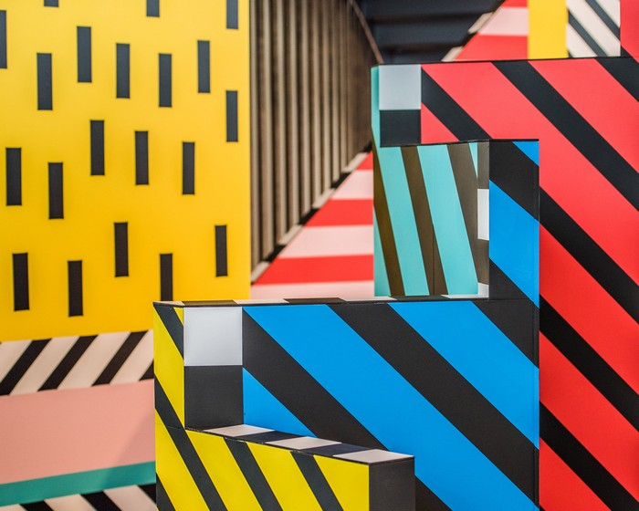

https://www.artnews.com/art-news/news/installation-art-today-3429/

Once upon a time, storytelling was the most ambitious mission of painting. Panel by panel, Renaissance artists told the lives of Christ and the saints on the walls of churches. Michelangelo presented the sweeping drama of the Old and New Testaments across the vast expanse of the Sistine Chapel Ceiling. Closer to our own era, Diego Rivera celebrated the struggles of the Mexican people, while Thomas Hart Benton created heroic epics with Depression-era characters from the Midwest. With the rise of modernism in this country and elsewhere, the storytelling impulse among artists seemed to disappear, dismissed as tired, irrelevant, or embarrassingly academic.
But the drive toward narrative, and an art audience’s fascination with stories, has resurfaced in recent years, often in video, but perhaps more evocatively in installations, which invite comparisons with developments in contemporary fiction—shuffled chapters, meandering plot lines, mash-ups of genres, and elusive or unreliable narrators. But the dizzying challenge for the installation artist, as opposed to the filmmaker or writer, is that he or she is free to choose from so many mediums to realize a completed project—video, sound, ready-made props, photography, conventional approaches like drawing and sculpture, and even the great outdoors. To make it all cohere in a gallery or museum setting, and in the viewer’s mind, is the goal, and what’s expected of the audience often goes beyond the demands of more traditional art forms. And that can be either an exhilarating trip or an exercise in frustration.
“If I could, I would probably write,” says the Toronto-based artist Iris Häussler. “But I can’t. Some people define my works as novels in three dimensions.” Häussler’s installations center around the lives of fictitious protagonists, whose stories are fleshed out in some detail in documents or even in the words of a tour guide/archivist (often Häussler herself) who leads the audience through her creations.
One of Häussler’s more imposing projects, He Named Her Amber (2008–10), took place in a 19th-century house called the Grange, embedded in the Art Gallery of Ontario in Toronto. Visitors were told that a diary belonging to a butler who had worked there recorded the story of an Irish maid who had secretly fashioned and buried a number of objects throughout the building, including a long wax cone and a blob of clay and beeswax the size of a baby’s fist.
“A descent into the darkened Grange basement revealed an archaeological dig going on full throttle, with bright yellow tape, danger warnings, and three long containers full of soil and rubble,” wrote curator Elizabeth Armstrong, who included parts of Häussler’s project in the exhibition “More Real? Art in the Age of Truthiness” last year at Site Santa Fe and the Minneapolis Institute of Arts.
Häussler’s characters are often marginalized, living on the fringes of society. “One thing I’m interested in is that history is told only by survivors,” she says, “and I often wonder what the people who cannot tell their stories would have to say.” Novelists will sometimes claim that their protagonists begin to dictate the story as they are in the process of writing it; Häussler says she experiences something similar: “I do research and these characters start becoming more alive, and I flesh them out, and then they flesh me out, telling me what they want from me.”
Occasionally the desire for verisimilitude leads the artist in extreme directions: because the Irish maid in the “Amber” project was diagnosed with hysterical blindness, Häussler blindfolded herself to create some of the objects in the installation.
Just as Häussler’s protagonists hint at alternative ways of understanding history, other artists concern themselves with redressing the record or telling the stories that fall through the cracks, especially when racial identity plays a part. Long before the recent movie Twelve Years a Slave earned high praise for dispensing with the Hollywood stereotypes of lovable masters and cheerful field hands, Kara Walker’s videos, cut-paper silhouettes, and installations zeroed in on an antebellum South of casual violence and unspeakable savagery. Native American artist Jamison Charles Banks, who is at work on a project that connects the Louisiana Purchase to the eventual exile of the Cherokee people to what he calls “the reclaiming of identity through baseball,” sees it as part of his mission to “enrich the story part of storytelling” handed down for generations by ancestors.



