Accor’s Organisational Audit

Student number: 1705539
Student name: Andreea Dumitru
Module name: Management and Organisational Behaviour
Module code: 5004
Lecturer: Julia Ault

Contents

Accor’s Organisational Audit 1
Executive Summary 3
1. Introduction 3
2. Organisation structure 4
2.1 The Matrix Structure 5
2.2 Organisational Culture 7
2.2.1 Hofstede’s Six cross-organisational Dimensions 7
2.3 Organisational Goals 8
2.3.1 Adair’s Action-Centred Leadership 8
3. Current transformation initiatives, effects, and management 9
4. Business Strategy and Performance 10
4.1 The 4P’s (Product, Price, Place, and Promotion) 10
4.2 Accor’s SWOT Analysis 11
5. Conclusion 12
6. Recommendations 13
7. Reference List 14
Appendices: 16
Appendix A 16

Executive Summary

Setting goals is a key part of any business plan. Goals are a great way to ensure that the team is going in the right direction. Yet for goals to work, they need to be able to be measured. It is not enough to just set goals; they need to be strategic goals that help the business reach its general aim. The purpose of this report is to perform an internal audit, in-depth analysis, and critical evaluation of Accor Hotel’s organisational structure, culture, and goals, applying concepts and theories to investigate how successfully the company has managed change in recent years, its strategic goals, and present its financial performance. This research will then attempt to provide direct and meaningful comparisons with market rivals, followed by a conclusion and recommendations, pointing Accor Hotel in the right direction of becoming more successful.

Introduction

Everyone contributes to an organisation a distinct collection of personal qualities, identity, history, and experiences gained through working in other organisations. It is essential to get an understanding of how people behave in companies and the reasons behind their actions to work well with others and effectively manage them.
When it comes to Accor Hotel (2023), is the most famous hotel and leisure group worldwide (Accor,2023). They are more than 290,000 hospitality specialists who put people first, create emotion for guests, and inspire limitless service and accomplishment. In 1967, Paul Dubrule and Gérard Pélisson created Société divertissements et d'exploitation hôteliers (SIEH) and opened the first Novotel outside Lille in northern France. (“In 1967, Paul Dubrule and Gérard Pélisson founded the SIEH (Société d ...”) Accor was listed on the Paris stock exchange in 1983 after Novotel-SIEH purchased and united with Jacques Borel International (Accor 2023).
Accor reinvents hospitality and inspires new worldviews by using its people and integrated ecosystem of top brands, personalised services, and expert solutions. As a worldwide employer, Accor is crucial to social, ethnic, racial, and cultural diversity. They can meet the needs of their teams and their communities by offering jobs and training.
The Group promotes local community integration through mentoring programmes, sponsorships, associative partnerships, recruitment events, and job and training opportunities. Accor teams worldwide have pioneered this field to address regional difficulties and goals (Accor,2023).

Organisation structure

The organisational structure is a concept used to expand businesses of different shapes, designs, and sizes. The organisation has a distinct hierarchy, and its organisational structure eminently describes the role that every individual plays within the bigger picture as well as how that role fits into the hierarchy (Organ and Bottoff,2023). The organisational structure can also be defined as a set of rules that defines the flow of information, authority, and decision-making across the organisation. Organisations bring individuals together to do more than they could alone, yet they must be profitable and efficient. Organisations might be hierarchical, circular, flat, or vertical (Organ and Bottoff,2023).
Accor's functional organisational structure is illustrated in Figure 1, which also provides a diagram of the division of the functional work departments. In other words, may be broken down into the activities that staff members participate in. The CEO is responsible for monitoring the work that is completed by personnel in each functional area. The task allocation, supervision and coordination are directed towards the aims and goals of the Hotel, also it helps the employees see where they stand.
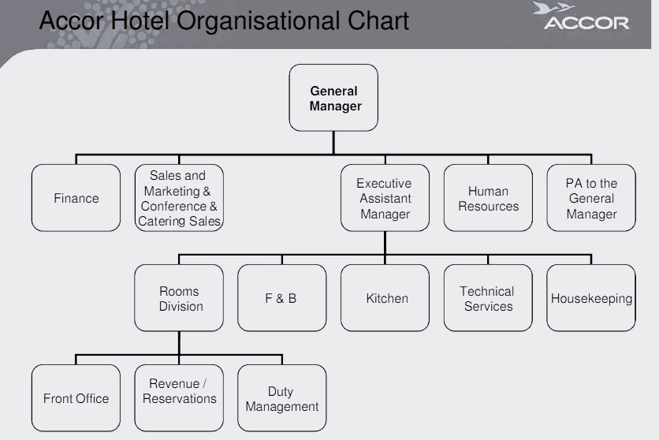
Figure 1, Accor Hotel organisational chart, Scribd.com

2.1 The Matrix structure
A simple definition of a Matrix organisational structure is one where people have more than one boss, competing goals, accountability without control and influence without authority, all this becoming a norm. See Figure 2.
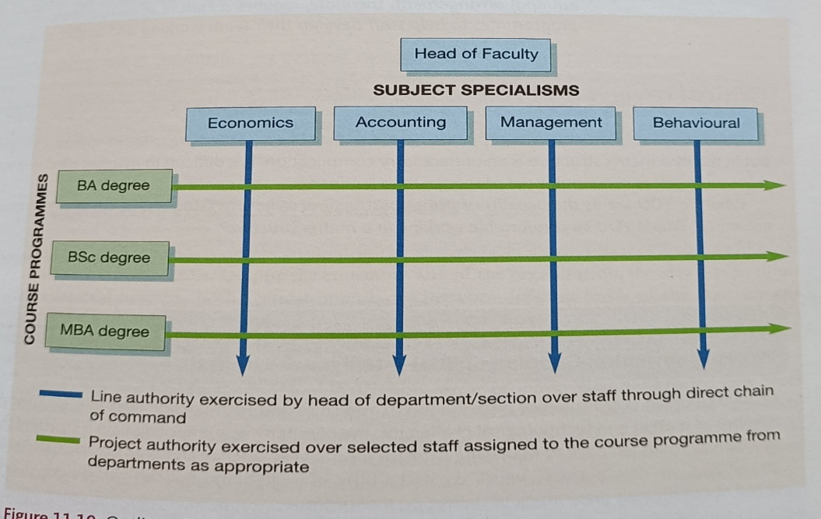

Figure 2, Management & Organisational Behaviour, pp-409
When Matrix structure is run properly, it delivers enormous business benefits in operating supply chains, flexibility, greater security and control of project information, opportunities for staff development, services to global customers and generating synergies internally, however, there are some predictable and preventable disadvantages in this more integrated way of working. The disadvantages are as follows: increased number of meetings, delays in decision-making and lack of accountability (Mullins,2016, pp-410).
Analysing and applying this structure to Accor Hotel demonstrates that Accor is currently restructuring and improving its operations, focusing on using its dominant market positions in the most thriving hospitality markets and segments.
Pfalz (2023) was a good source of information stating that Sébastien Bazin, Group Chairman & CEO, and Jean-Jacques Morin, Group Deputy CEO, oversee the two divisions, which are backed by a Group Management Board and a Global Shared Platform focused on digital, technology, and procurement. Morin leads the "Premium, Midscale & Economy" brands throughout the Americas, Europe & North Africa, the Middle East, Africa, Turkey & Asia Pacific, and Greater China (Pfalz,2023).
This demonstrates that changing Accor’s organisational structure is a natural step in the transformation they started several years ago, which turned Accor into an asset-light group that is more agile and efficient, with a global profile, and which has become a key player in Luxury and Lifestyle (Pfalz,2023). (“Accor restructures into two distinct divisions - THP News”)
Accor’s goal is to significantly increase its appeal to talent, owners, partners, and investors by transitioning from a generalist to a multi-specialist model by taking advantage of leadership positions to advance their careers, better concentrate on skills, and enhance their output.

Organisational Culture

Organisational culture, also known as corporate culture, is a collection of an organization's internal values and behaviours. It comprises past experiences, thought patterns, beliefs, and future anticipations. Additionally, it is characterised by repetitive behaviours and emotional responses (Mullins,2016, pp-537). Is the collection of shared values and norms that define a specific organisation. Culture's pervasiveness in "how things are done around here" and common values, beliefs, and attitudes will affect organisational processes like decision-making, structure design, group behaviour, work organisation, motivation, and job satisfaction (Mullins,2016, pp-537).

2.2.1 Hofstede’s six cross-organisational dimensions

Positive organisational culture helps employees understand their company and feel that their voices count in achieving their goals. Hofstede’s six cross-organisational dimensions (1980) are one of the best frameworks that help explain differences in culture among nations (Nickerson,2023). They are as follows:
- Process vs result
- Person vs job
- Parochial vs professional
- Open systems vs closed systems
- Loose vs tight control
- Normative vs pragmatic (McGrath et al, 2017, pp.130).
Accor may use Hofstede's cultural dimensions to assist in culturally appropriate product and marketing development. Hofstede's framework can aid Accor’s managers in understanding why their staff members act in certain ways inside a company. For instance, a manager may need to consider that the staff members originate from cultures with varying levels of collectivism if he or she is having trouble getting them to operate as a team (Hofstede, 2011), (CIPD,2023).
Person-driven organisations prioritise employee well-being whereas job-driven cultures value task accomplishment over employees ((McGrath et al, 2017, pp.130). Accor’s commitment is to value each one of their team members just as they are, they value variety because they have talent in all four parts of the world. They work to create a culture that is open and welcoming to everyone, gives team members responsibility, and encourages both individual and group innovation and success. Their goal is to stop unfairness and injustice and give everyone the chances they need to grow and reach their full potential. In other words, Accor is person-driven (Accor,2023).
Richard Templar (2015, pp. 29), said ‘If we were all the same, we wouldn’t be able to work as a team- we would all be leaders or all followers’ (Templar, 2015, pp. 29).

Organisational Goals

A company's management establishes organisational goals as strategic objectives to define expected outcomes and direct employees' efforts. There are numerous benefits to establishing organisational objectives such as they guide employee efforts, justify a company's activities and existence, define performance standards, impose limitations on the pursuit of superfluous objectives, and serve as behavioural incentives (TechTarget,2023).

2.3.1 Adair’s Action-Centred Leadership

Business success requires good judgements, optimal problem-solving, and innovative thinking, and Adair Action Centred- Leadership (2007) believes, that the establishment of work groups and organisations takes place when there is a task that must be completed but is too large for a single individual to do on their own (Adair, 2007, pp.43-45). His approach suggests that leaders must balance their actions across three core areas as illustrated in Figure 3.

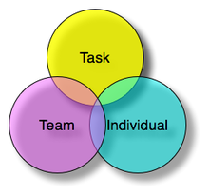
Figure 3. Mind Tools, 2023

According to Adair’s diagram, Accor established a goal, developed a strategy, delegated duties to its team, and encouraged its members to be creative. After that, the members of the team worked together to achieve the goal, and Group Accor (2019), announces the introduction of a new lifestyle loyalty programme on February 21st, 2019: ALL, Accor Live Limitless, a fully integrated worldwide platform fusing digital, loyalty, brands, and partnerships (Accor,2019).

Current transformation initiatives, effects, and management

Accor anticipates that with disruption and pragmatism in their DNA, they learn from consumer behaviour shifts, assess their operations and services, and decide how to adapt with their owners and partners to (Accor,2022).
Unlimited inventiveness, exciting expectation and ‘From Change to Opportunity’ shows what counts. As industry experts, they collaborate with the hospitality community and their business partners to address these transformations and show how their sector can expand sustainably and creatively. Lifestyle and travel redefine Accor’s experiences and in future, their industry must evolve where innovative companies are promising (Accor,2022).
Society has awoken and people examined their self, community, and planet-related habits, attitudes, and behaviours to determine what they needed. These mental shifts and responses to these concerns have changed civilisation. Accor evaluates these trends for hospitality industry possibilities such as:
- The Hybrid Way of Life
- The well-being Imperative
- The new community boundaries
- The consumption Paradox (Accor, 2022).

Business strategy and performance

Most people view business rivalry as a battle for sales and market share. Businesses employ several strategies to acquire clients, win the market, improve operations, and achieve their goals. It describes business success. General managers develop Accor's business strategy from its stated goals and long-term vision (Business Jargons, 2023).

  - The 4P’s (Product, Price, Place, and Promotion)
Putting the right product in the right place, at the right price, and at the right time is what marketing is all about. (“The Marketing Mix and the 4Ps of Marketing - Understanding How to ...”) McCarthy formalised the 4 Ps in 1960. (See Appendix A)
The marketing strategy of Accor Hotels looks at the company with the 4Ps as a framework. There are many ways to market, such as coming up with new products, taking a different approach to price, and planning promotions (MBA SKOOL, 2021).
With competitors like Starwood Hotels, Marriot International, Continental Group, Hilton Hotels, Wyndham Hotels, etc. It must compete with overseas luxury hotels and domestic mid-range and economy hotels.
Accor Hotels expanded from Novotel in France to 100 countries and 6 continents via marketing mix dispersion. Paris, Singapore, Dubai, Mauritius, Hongkong, Jakarta, Bali, Mumbai, Shanghai, Toronto, Cairo, and others host Accor Hotel brands. The group's business model combines owned, managed, and franchise assets (MBS SKOOL,2021).
Club Accor Hotels points. Promo codes, "From the Heart" discounts, and "Happy Monday" off-season accommodation reservations. The group's well-designed website promotes and books all brands. Regional Accor accounts have 1.8 million likes.
Accor Hotels employs 250,000 workers, 55% under 35 and 77% engaged. The company boasts 800+ managers/trainers and 100 partner universities and institutions for worldwide employee training. The organisation has over 100 titles and wants 35% women in management by 2020. Customers may book using a seamless online and mobile app interface and redeem discounts and loyalty points. Booking is straightforward and hotel check-in requires only a valid ID (MBA SKOOL,2021).

4.2 Accor’s SWOT Analysis

Accor Hotels is one of the biggest hotel chains worldwide. They sell hotel rooms and services under prominent brands. June 2018 brand offers: Raffles, Orient Express, Sofitel Legend, Fairmont, Sofitel, Pullman, and Swissotel. Mantra, Novotel, Mercure, Adagio and many more.
Based on Accor Hotels' marketing mix, these business plans help the brand do well in the market. SWOT analysis assesses Accor Hotels' strengths, weaknesses, opportunities, and threats. SWOT Analysis of Accor Hotels includes internal and external issues (MBA SKOOL, 2020).

Strengths  - internal attributes offer it a market edge and reinforce its position. | Weaknesses  - Market participants also use their projections.  - Accor Hotels serves various categories, and guests have trouble relating to the brand.
Opportunities  - Since hotel management education is growing worldwide, Accor may create new academies and provide its students with a global experience.  - Each country will receive international service.  - Accor's penetration lets them plan consumer bundles. Inclusive growth | Threats  - A highly competitive market poses a constant threat and increases demand for innovation in offerings. (“Accor Hotels SWOT Analysis | MBA Skool”)  - "The global economic condition can hamper sales in the luxury and upscale segments." (“Accor Hotels SWOT Analysis | MBA Skool”)


Refer to Recommendations for the SWOT summary.

Conclusion

Because time passes, and everything evolves along with it, Accor's efforts to maintain its leadership position in the hospitality sector in the wake of COVID are unique, while also demonstrating that the company is more than simply a building; more so, it is a brand. It does this by relying on the commitment and inventiveness of its staff to provide the seemingly impossible to its guests: personalised goods and services worldwide.

Recommendations

Accor is recommended to establish a new programme consisting of contactless check-in kiosks and contactless food and beverage vending machines to prosper in the face of relentless competition. This ensures that Accor has the resources it needs, which in turn encourages guests to extend their stays. Because the industry is only now beginning to show signs of recovery from the COVID tragedy, attracting and keeping guests is crucial to Accor's success, thus the company places a premium on personalization using guest data and innovative use of technology to improve guests’ stays, such as mobile device check-in and value-added extras.

Reference List

Accor. (2019) The new Accor's Strategy [video]. Available at: https://www.youtube.com/watch?v=10Hre8f_Qug&t=356s (Accessed: 8 June 2023).
Accor. (2022) Sébastien Bazin on How Change Means Opportunity. Available at: https://group.accor.com/en/Actualites/2022/11/sebastien-bazin-editorial-from-change-to-opportunity (Accessed: 10 June 2023).
Accor. (2022) Where to Next? 4 Trends Shaping Opportunities in Hospitality. Available at: https://group.accor.com/en/Actualites/2022/11/change-opportunities-hospitality-trends (Accessed 10 June 2023).
Accor. (2023) About Accor. Available at: https://group.accor.com/en/group/who-we-are/about-us (Accessed: 4 June 2023).
Accor. (2023) Our Commitment. Available at: https://group.accor.com/en/careers/our-culture-of-inclusion/our-commitment (Accessed: 7 June 2023).
Adair, J, (2007) The Sunday Times. Decision Making and Problem-Solving Strategies. London: Kogan-Page.
CIPD. (20230 Organisational culture. Available at: https://www.cipd.org/uk/views-and-insights/cipd-viewpoint/organisational-culture/ (Accessed: 4 June 2023).
Good to SEO. (2021) The 4 Ps of Marketing [Picture]. Available at: https://www.goodtoseo.com/the-4-ps-of-marketing/ (Accessed: 9 June 2023).
Hofstede, G. (1980) Culture’s Consequences. Beverly Hills: Sage.
Hofstede, G. (2011). Dimensionalizing cultures: The Hofstede model in context. Online readings in psychology and culture. Vol 2 (1). pp 2307-0919.
MBA SKOOL. (2021) Accor Hotels Marketing Strategy & Marketing Mix (4Ps). Available at: https://www.mbaskool.com/marketing-mix/services/18116-accor-hotels.html (Accessed: 10 June 2023).
MBA SKOOL. (2020) Accor Hotels SWOT Analysis. Available at: https://www.mbaskool.com/brandguide/tourism-and-hospitality/2897-accor-hotels.html (Accessed: 10 June 2023).
McGrath, J. and Bates, B. (2017)’ Hofstede’s six cross-organisational dimensions’, (2nd ed). The Little Book of Big Management Theories. Harlow: Pearson.
Mind Tools. (2023) [Picture] Available at https://www.mindtools.com/aghzl5f/action-centered-leadership (Accessed: 8 June 2023).
Mind Tools. (2023) ‘The Marketing Mix and the 4Ps of Marketing’, Mind Tools. Available at: https://www.mindtools.com/akksnwa/themarketingmixandthe4ps (Accessed: 9 June 2023).
Mullins, L.J. (2016) Management & Organisational Behaviour. 11th edn, Harlow: Pearson Education Limited.
Nickerson, C. (2023) ‘Hofstede’s Cultural Dimensions Theory & Examples’, Simply Psychology. Available at: https://www.simplypsychology.org/hofstedes-cultural-dimensions-theory.html (Accessed: 8 June 2023).
Organ, C and Bottorff. C (2023) ‘7 Organizational Structure Types (With Examples)’, Forbes. Available at: https://www.forbes.com/advisor/business/organizational-structure/#3_alternative_organizational_structures_section (Accessed: 4 June 2023).
Pfalz, L. (2023) ‘Global hotel corporation Accor is now implementing a new two-division organizational structure to lead its future developments, one for its premium, midscale and economy brands and another for its luxury and lifestyle brands as of January 12023’, Travel Pulse. (“Accor Announces New Organizational Structure with Two ... - Travel Pulse”) Available at: https://www.travelpulse.com/News/Hotels-and-Resorts/Accor-Announces-New-Organizational-Structure-with-Two-Main-Divisions#:~:text=Global%20hotel%20corporation%20Accor%20is%20now%20implementing%20a,and%20lifestyle%20brands%20as%20of%20January%201%2C%202023. (Accessed: 6 June 2023).
Scribd. (2023) ACCOR HOTEL Org Chart [Picture]. Available at: https://www.scribd.com/document/50268264/ACCOR-HOTEL-Org-Chart (Accessed: 6 June 2023).
TechTarget. (2023) Organizational goals. Available at: https://www.techtarget.com/searchcio/definition/organizational-goals (Accessed: 4 June 2023).
Templar, R. (2015) The Rules of Management. Harlow: Pearson Education Limited.
McCarthy, E.J. (1960) Basic Marketing - A Managerial Approach. Harlow: Pearson.

Appendices:

Appendix A

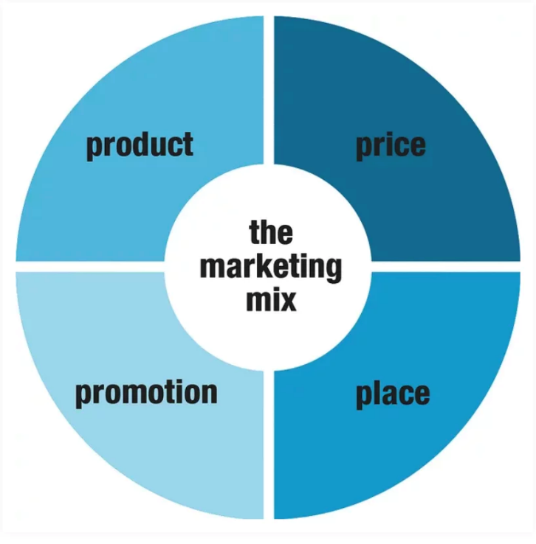
Good To SEO.com

