Part 3 – Pairs
- Identifying the Problem
1.1 Storing, updating and displaying the “card” variables
- Create 3x4 array
- Total of 12 array elements representing the values between 1-6 x2
- Assign randomised string of character variables to data elements
- Assign co-ordinates to each data element in the grind
- Print grind using for loop to display and update grid for each incremental attempt
- Request user input as integer with defined ranges match value with grid elements in compare function
- Use pointers to update array elements with via function
1.2 Keeping the score + win conditions
- Create variables to represent the number of successful or unsuccessful attempts
- Increment win or loss variable for each loop
- Break loop and end game when win or loss condition is met
- Do while loop around main program code to allow user to play again
1.3 The rules
- Request user input within specific grid range
- Enforce defined rules to prevent invalid data entry i.e. selecting out of co-ordinates outside the limit of elements within an array
- Differentiate user input for card 1 and 2 with two unique index variables

2. Annotated Code

#include <stdio.h>
#include <stdlib.h>
#include <time.h>

void requestInput(int* row, int* col, int* row2, int* col2); //function to get user input
void printGrid(char grid2[3][4]); //prints game grid
int compareResult(char A, char B); //function to comapre input return 1 if true
void rules(); //displays rules at start of game

int main()
{
char again; // variable used to re-play game

do {
int counter = 1;
char grid[3][4]; // array to create 3x4 game grid
int i, j;
srand(time(NULL)); //used for shuffle

printf("** Welcome to Flip'O'Roonie **\n"); //prints visual header at start of new game
printf("* Version No. Over 9000 *\n"); //manditory meme
rules(); // calls rules function
printf(" 0123\n"); //prints grid border
printf(" ----\n"); // ^^

for (i = 0; i < 3; i++) //loop to print grid and boarder
{
printf("%d|", i);
for (j = 0; j < 4; j++)

{
grid[i][j] = 'X';
printf("%c", grid[i][j]); //prints visual array
if (j == 3)
{
printf("|\n");
}
}
}
printf(" ----\n");

char datastr[] = "112233445566"; //string top shuffle
int ind, r, temp;

for (ind = 0; ind < 12; ind++)
{
r = rand() % 11;
temp = datastr[ind]; datastr[ind] = datastr[r]; datastr[r] = temp; //shuffles string to randomize elements in grid
}

//play game

int correct, incorrect; //variables for score tracking
correct = 0;
incorrect = 0;

while (correct < 6 && incorrect < 6) //condition for when the game is still in play

{
int input1_row, input1_col, input2_row, input2_col; //declares variables to store user inputs
requestInput(&input1_row, &input1_col, &input2_row, &input2_col); //calls function which asks user for 2 sets of rows and cols

int index1, index2; //index for storing and manip user inputs

index1 = (input1_row * 4) + input1_col;
index2 = (input2_row * 4) + input2_col;

printf("\n");

if (grid[input1_row][input1_col] == ' ') //prevents users from re-selecting 'consumed' tile locations

{
printf("A card has already been Selected. Choose another.\n\n");
continue;
}

grid[input1_row][input1_col] = datastr[index1];
grid[input2_row][input2_col] = datastr[index2];
printGrid(grid);
//prints updated grid

if (compareResult(datastr[index1], datastr[index2]) == 1) //calls function, if tiles match, set tile to ' ', redraw, and increment 1 to # correct

{
printf("You have matched %c!\n\n", datastr[index1]); // print the variable in the array element that was matched
grid[input1_row][input1_col] = ' ';
grid[input2_row][input2_col] = ' ';
printGrid(grid); //prinmts updated grind with blank space where variables have been matched
correct++;
}

//when results do not match, set tiles back to 'X', redraw and increment 1 to # incorrect
else
{
printf("Unlucky, try again.\n\n");
grid[input1_row][input1_col] = 'X';
grid[input2_row][input2_col] = 'X';
printGrid(grid);
incorrect++;
}

printf("\nCorrect: %d, Incorrect: %d\n", correct, incorrect); // prints current score
printf("\n");

if (incorrect == 0) //displays attempts remaining - update every round of input
{
printf("LIVES REMIANING: ||||||");
}
else if (incorrect == 1)
{
printf("LIVES REMIANING: |||||");
}
else if (incorrect == 2)
{
printf("LIVES REMIANING: ||||");
}
else if (incorrect == 3)
{
printf("LIVES REMIANING: |||");
}
else if (incorrect == 4)
{
printf("LIVES REMIANING: ||");
}
else if (incorrect == 5)
{
printf("LIVES REMIANING: |");
}
printf("\n\n");
}

if (correct == 6) //Checks winning condition

{
printf("WINNER WINNER CHICKEN DINNER!!!\n\n");
}
if (incorrect == 6) //checks losing condition
{
printf("GAME OVER\n\n");
}

printf("Do you want to play again?(Y/N)"); // requests booleon value to return to the start of main loop
scanf_s(" %c", &again);

} while (again == 'y' || again == 'Y'); // makes input case irrelevant
}

int compareResult(char A, char B) //function to compare input with element stored in array
{
if (A == B) {
return 1;
}
else {
return 0;
}
}

void requestInput(int* row, int* col, int* row2, int* col2) // function using pointers to pass variables to an array

{
printf("Flip card A (0-2) (0-3):");
scanf_s("%d %d", &*row, &*col); // requests user input co-ordinates and stores in row/col pointer variables
while ((*row <= -1 || *row >= 3) || (*col <= -1 || *col >= 4)) //stops users from selecting co-ordinates outside the range of grid. Need to include exceptions top catch non integer entries in future release
{
printf("Invalid co-ordinates - Flip again.\nFlip card A (0-2) (0-3):");
scanf_s("%d %d", &*row, &*col);
}

printf("Flip card B (0-2) (0-3):");
scanf_s("%d %d", &*row2, &*col2);
while ((*row2 <= -1 || *row2 >= 3) || (*col2 <= -1 || *col2 >= 4) || (*row2 == *row &&* col2==*col)) // additional check on row 2 to prevent cheating!! (entering same co-ordinates twice)
{
printf("Invalid co-ordinates - Flip again.\nFlip card B (0-2) (0-3):");
scanf_s("%d %d", &*row2, &*col2);
}
}

void printGrid(char grid2[3][4]) // function to print grid when called

{
printf(" 0123\n"); // prints header above grid
printf(" ----\n");
int m, n;
for (m = 0; m < 3; m++)
{
printf("%d|", m); // prints boarders
for (n = 0; n < 4; n++)

{
printf("%c", grid2[m][n]); //prints updated grid
if (n == 3)
{
printf("|\n");
}
}
}
printf(" ----\n"); // prints footer below grid
}

void rules() // set as function to remove bloat from main code - option to integrate user call if game rules become more complicated in future

{
printf("\n ~GAME RULES~\n");
printf("-----------------------------------------------------------------------\n");
printf("*Match all cards to win! Get 5 wrong however and YOU LOSE!!\n");
printf("*Enter coordinates from the Grid to flip a card\n");
printf("*Repeat to flip a second card\n");
printf("-----------------------------------------------------------------------\n");
}

3 Testing
3.1 Print grid
3.1.1 Initialise at start of program
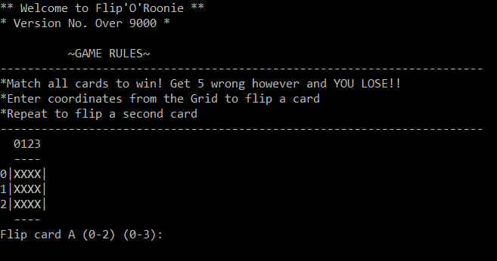

Result: Grid drawn Successfully
3.1.2 Grid update for Incorrect choice
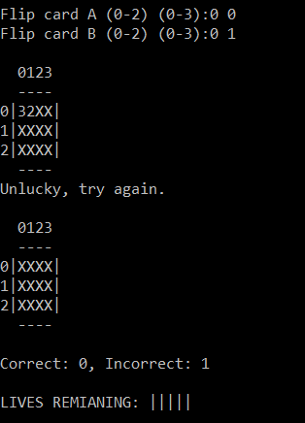

Result: Grid correctly updated, then redrawn correctly.

3.1.3Grid update for Correct Choice
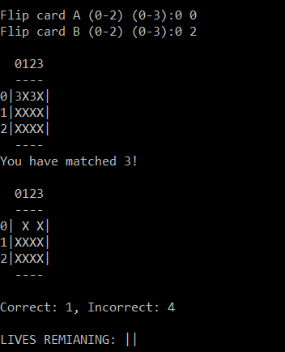
Result: Grid correctly updated, then redrawn correctly.
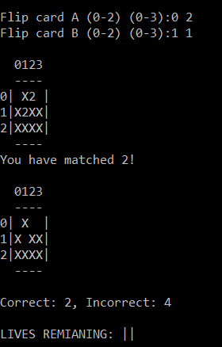
3.1.4More than 1 set of pairs matched

Result: Grid correctly updated, then redrawn correctly.
3.1.5 more than 2+ sets of pairs matched
Result: All scenarios same result: Grid correctly updated, then redrawn correctly.

3.2 Input Values
3.2.1.1 Negative (outside co-ordinate range)
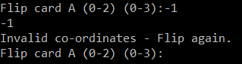
Result: successful. prevent entry and re-prompt for input.
3.2.1.2 Positive (outside co-ordinate range)
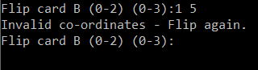
Result: successful. prevent entry and re-prompt for input.
3.3 Score capturing
3.3.1 Unsuccessful attempts
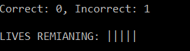
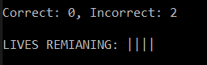
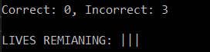
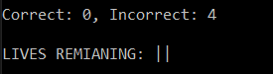
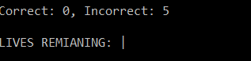
Result: successful. Incorrect counter incremented, lives remaining depreciated by 1.

3.3.2 Successful Attempts
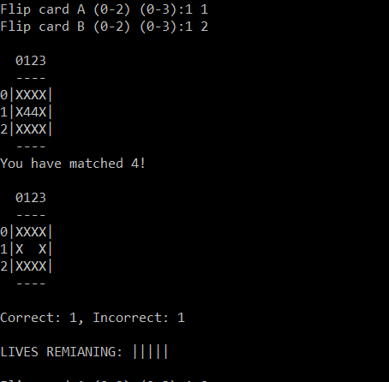

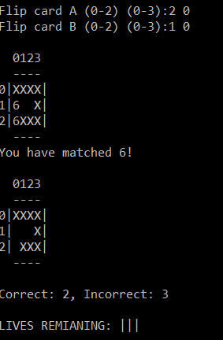

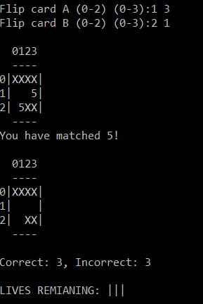

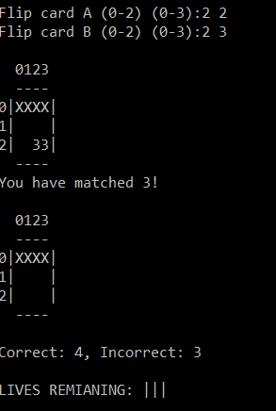

3.4 Play Again

3.4.1 Loss Condition

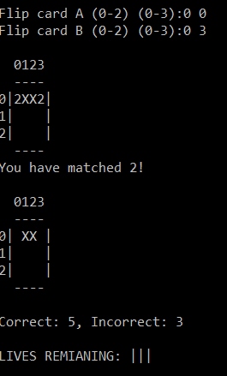

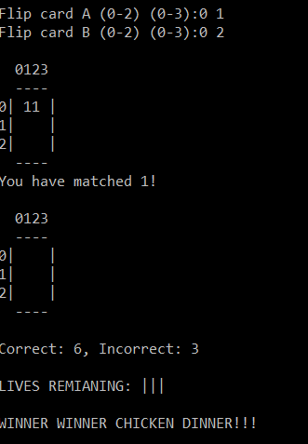

Result: successful. Correct counter incremented, lives remaining remain the same, win message displayed upon win condition.
3.4 Restart Game
3.4.1 Loss Condition
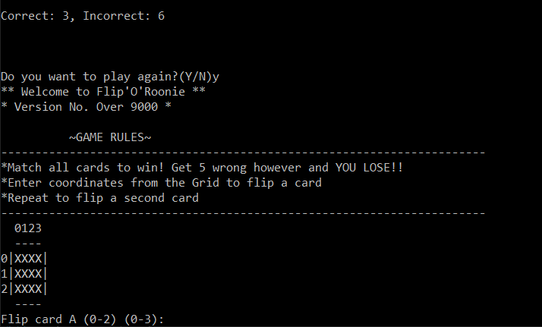

Result: successful. User prompted to play again. New loop for game restarted.
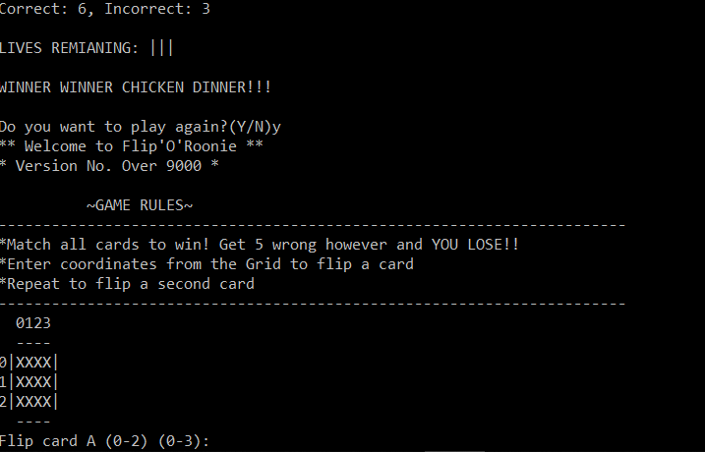
3.4.2 Win condition

Result: successful. User prompted to play again. New loop for game restarted.

Notes for future release:
- future release to include validation to capture exceptions for non-integer co-ordinate entries.
- Allow user to select difficulty. Integrate into solution by setting loss condition to variable that users can select.
- In-corporate graphical front end outside of console

Adam Vimpany
1810613
Apprentice group (Wednesday)

