ARTHUR’S BRIDAL – BUSINESS PLAN

LCBB5001 ENTREPRENEURSHIP
LECTURER: VASILIOS TAVLARIDIS
STUDENT: 2108392 FLORINA ROXANA GAVRIL

Table of Contents
Overview of the business idea and its product/service
Ownership and Legal format of the start-up
Management of the company
PESTEL analysis
The 4Ps of marketing mix model
Product (Services)
Place
Promotion
Pricing
A cash flow forecast for the first 12 months.
References

Business Overview

The Arthur’s Bridal is a bride and special occasion dresses for the powerful women who wants to express themselves with their look.
The shop wants to cover all the types and tastes of various women and to be the best shop created for them. So, covers all the shapes and body types even if you want a princess or a mermaid dress the shop is able to provide this with special adjustments, crystals or special material, precious or simple whenever you need for your iconic day.
As per numerous studies the brides and the concept was changed during the last 30 years and the women wants something different and unique for their big day. The Arthur’s Bridal is able to create and to push this concept in a different way creating something that before was called “inappropriate” in something suitable, fashion and to fulfil the clients wishes.
As per statista.com the UK wedding In 2021 was 470,000 and 350,000 in 2022, with 200,000 more weddings than in pre-pandemic years, and for the shop is a good and satisfactory news which increase the confidence and the ambition to open it as soon as possible.

Target Market
- Possible brides aged between 25-35 years
- The younger women are most possible to get married and to want a bridal look
Source: Office for National Statistics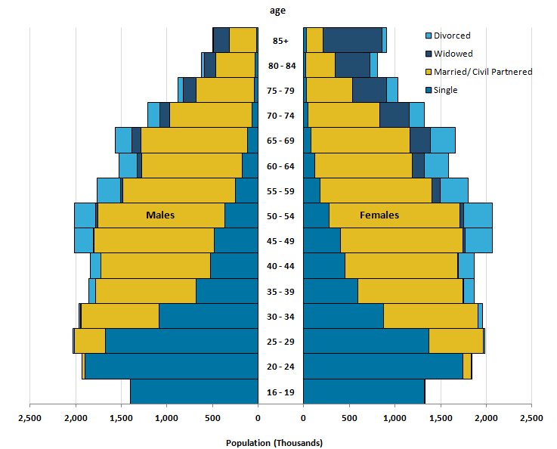
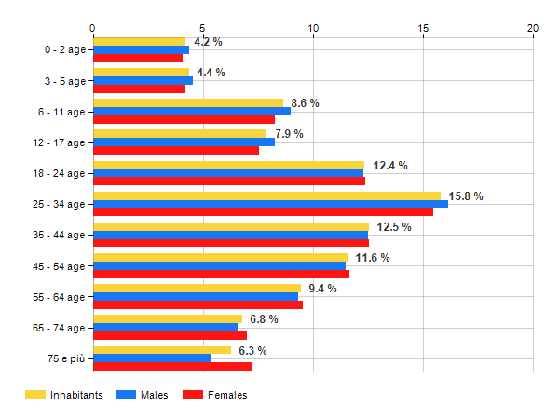
Population of Birmingham by age – source Age Classes: Fonte ONS

Ownership and Legal format

The company will be a SOLE Trader company because of its purpose which require a total implication of the owner, as because is the owner idea for many years, requires an attention and a good schedule of all the steps for a good outcome.
After the registration to the HMRC, the place will be the second priority and the most important factor, as depends of the position and customers involved in this kind of business how can survive, keep roots and grow.

Management

As per legal format, the company will be running by Roxana Gavril with a smooth help of the family.
The most important supplier for the business will be a Turkish retailer and requires a visit per month to check the models, material and the quality of the products. This will be an important factor for the business, because if the shop provides good and quality products that will be one of the biggest strengths.

PESTLE analysis

The main goal of the organization is to provide excellent customer services because this fact prove the consistency and the profitability of the company and the ways to achieve it.
To show this as smooth as the study requires is best to highlight it in a rigorous analysis of Pestel which describes the business in two factors: micro and macro.
The micro side is highlighted by suppliers, buyers, competitors etc. and the macro side is founded by activities of the state or the state of society.
The PESTLE analysis is the best way to combine the both sides to show the performance and the goals of a company. In the same time makes clear for the organization to gain a brief idea about market conditions, opportunities, threats, determination of the business strategy, methods of competition, management of risks etc (Kazantsev, 2002).
On the other hand, this type of analysis helps the company to demonstrates the key factors that can prove the goals which requires the organization to be more competitive on the market (Campbell, 2003).
Pestle can helps to highlight the actual and future situation that can happened within the Arthur’s Bridal company. This analysis is based on the political, economic, social, technology and law factors (Perera, 2017).

Political
- Treat of Terrorist Attacks – Arthur’s Bridal needs to operate under the possibility of a terrorist attack and the prudent policy is to have insurance and all the instruments to covers losses occurring because of this
- Regulatory policy – improved the way of doing business by consulting the global norms
- Local Governments – are influential in the policy- making process and implementation because the best part of it are implemented by them and the enforcement agencies are likely to report to local government regarding laws
- International Trade – the country has a good record of international trade with global countries
- Government Regulations – the governments follow all the rules of World Trade Organization

Economical
- Price fluctuations – can consider the currently situation for example, the inflation and risks of currency depreciation
- Employment rate – it will provide enough customers but in case of hire some candidates for different positions will be expensive to hire the most skilled and talented
- Exchange Rate – Arthur’s Bridal needs to be careful regarding the history of forex risk before entering new market to avoid losses
- Government Spendings – affects by boosting sales in short term but expose to medium term forex and currency depreciation risks

Social
- Education level – impacts the quality of jobs and level of income
- Attitude for Health & Safety – reflected in the quality of the products
- Birth Rate – affects future demand
- Level of immigration

Technological
- Acceptance of Mobile Payments
- Cost of production and trends
- E-commerce and Related Infrastructure Development
- Transparency
- 5G Infrastructure
- Level of acceptance of technology in the society

Environmental
- Climate change
- Environmental Standards and Regulations (National and Local levels)
- Focus and Spending on Renewable Technologies – how Arthur’s Bridal can make this as part of the competitive strategy
- Recycle policies
- Waste management

Legal
- Security Law
- Law regarding monopoly and restrictive trade practices
- Business Law
- Data protection law
4P’s of marketing mix model

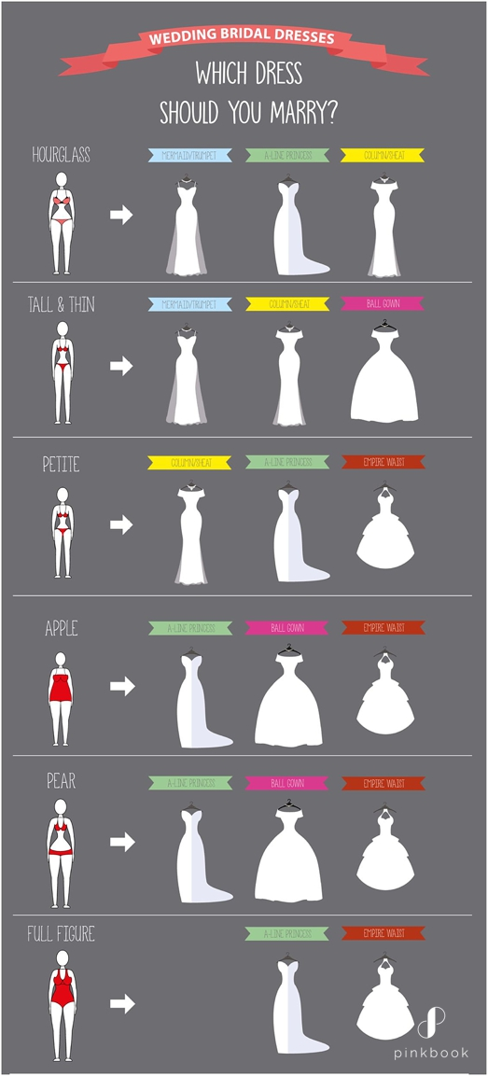
Wedding Dress Styles For Body Types | Pink Book Weddings (pink-book.co.za)

PRODUCT
- Large spectrum of bridal dresses
- The shop’s aim is to cover different body types
- One year warranty
- Special packaging with special hungers (bride’s name), special boxes with brand name and possibility to rent a mannequin to keep the dress safe and ironed in your big day
- The possibility to come in your big day to help you to put on the wedding dress

PRICE
- The company has different discounts depending of events and holidays (Valetines’ Day, Spring and Autumn discounts)
- Possibility to pay in installments (weekly, monthly)
- Catalogues with different models and prices
- The possibility to make some adjustments or modify your dress

PLACE
Distribution mix of Arthur’s Bridal is used to be in shop and online retailing and domination of players such as AMAZON.

PROMOTION
Advertising is shop, online, Facebook and Instagram page, online events, presentations etc.

A cash flow forecast for the first 12 months

Description of cost/sale figures | Months
Cash in/out | 1 | 2 | 3 | 4 | 5 | 6 | 7 | 8 | 9 | 10 | 11 | 12
Anticipated sale figure | 1000 | 1500 | 1800 | 3600 | 4800 | 6000 | 8000 | 10000 | 12000 | 13000 | 15000 | 20000
Steam Ironing Press | 270 | 0 | 0 | 0 | 0 | 0 | 270 | 0 | 0 | 0 | 0 | 270
Rent or premises costs | 500 | 500 | 500 | 500 | 500 | 500 | 500 | 500 | 500 | 500 | 500 | 500
Business rates for your business premises | 49.9 | 49.9 | 49.9 | 49.9 | 49.9 | 49.9 | 49.9 | 49.9 | 49.9 | 49.9 | 49.9 | 49.9
Utilities (gas, electricity, water) | 300 | 300 | 320 | 300 | 340 | 320 | 340 | 350 | 360 | 340 | 400 | 430
Insurance | 123 | 123 | 123 | 123 | 123 | 123 | 123 | 123 | 123 | 123 | 123 | 123
Advertising | 100 | 100 | 100 | 100 | 100 | 100 | 100 | 100 | 100 | 100 | 100 | 100
Total | -342.9 | 427.1 | 707.1 | 2527.1 | 3687.1 | 4907.1 | 6617.1 | 8877.1 | 10867.1 | 11887.1 | 13827.1 | 19027.1

References

- Campbell D. Strategic management – Moscow, 2003
- Kazantsev A.K. Basic management. Moscow, Infra.M, 2002
- Perera, R., 2017. The Pestle analysis, 2021.
- Office for National Statistics
- Wedding Dress Styles For Body Types | Pink Book Weddings (pink-book.co.za)
- Age Classes: Fonte ONS
- https://embapro.com/frontpage/pestelcase/13287-david-s-bridal

