

Data Warehousing & Data Mining
Component 1
Task 1 & 2

Student Name: Iram Naz
Student ID: 2245084

Module Name: ACCA6026
Lecturer’s Name: Dr Mobolanle Bello

Submission Date: 7 November 2025

Table of Contents
TASK 1 — Data Warehousing Concepts and Benefits 3
1. Introduction 3
2. OLTP vs Data Warehouse 3
3. Data Warehouse Architecture and ETL 5
1.3 Data Marts for Targeted Management Decisions 9
1.4 Normalised vs. Dimensional Structures: A Schema for Analysis 12
Conclusion 14
References 15
4. Executive Data Marts 19
5. Normalised vs Dimensional Modelling 20
Conclusion 21
Reference 21

Contents
Task 2: Star Schema Design and Development for Rags and Richie's 2
Data Sources and Transformations 12

Task 2: Star Schema Design and Development for Rags and Richie's

1. Introduction
Rags and Richie's Data Warehouse is engineered to amalgamate various data sources, facilitating strategic analysis to propel corporate success. The suggested star schema, fundamental to data warehousing, categorizes data into fact and dimension tables, facilitating intricate queries and enabling scalable analytics. The schema integrates sales, customer, promotion, product, and store data, establishing a cohesive perspective that enhances understanding of marketing campaigns and supply chain effectiveness. This framework streamlines data linkages, improves query efficiency, and enables stakeholders to make educated, data-driven decisions. The Marketing Data Mart, featuring dimensions such as Customer and Promotion, and the Supply Chain Data Mart, encompassing Product and Store dimensions, both utilize a common Fact_Sales table to maintain consistency. This centralized method combines diverse data while supporting strategic objectives by delivering actionable insights, promoting operational excellence, and enhancing decision-making skills to drive competitive advantage throughout Rags and Richie’s company operations.
Role of Star Schema in Integrating Diverse Data Sources for Strategic Analysis
The major function of the Star Schema in integrating many data sources is to serve as a cohesive logical layer that simplifies the inherent complexity of different operational systems. Sources like as POS, CRM, and e-commerce possess distinct definitions, keys, and structures, resulting in data silos. The Star Schema dismantles these silos by necessitating a process of conformation. In the ETL process, data from various sources is extracted, converted, and organized into a unified set of standard business definitions within centralized dimension tables, such as DimProduct or DimCustomer. This indicates that a product ID from the POS and an SKU from the e-commerce platform are consolidated into a singular master product list, while a customer record from the CRM is integrated with an online sales buyer. The utilization of surrogate keys establishes a robust internal framework within the schema, independent of the volatile and inconsistent keys from source systems, hence facilitating genuine data integration at a semantic level.
This comprehensive foundation facilitates robust and efficient strategic analysis by converting intricate data linkages into a business-intuitive model. The resultant star schema—a center fact table around by conforming dimensions—is intrinsically optimized for query efficiency and user-friendliness. Analysts are no longer encumbered by the necessity of composing intricate connections across disparate source systems. They may pose intricate, cross-functional inquiries—such as evaluating the profitability of a product line by consumer location and sales channel—through straightforward queries against a unified model. The schema converts strategically important yet technically disorganized data into a cohesive asset, enabling decision-makers to obtain a comprehensive, 360-degree perspective of the business and extract insights that would otherwise be concealed by operational data silos.

2. Star Schema Design and development
A Data Warehouse aggregates data from several source systems, classified as either internal or external.
Internal Sources are systems under R&R's operational control that document daily business activity. Instances from the situation encompass:
Point-of-Sale (POS) System: Records transactional data such as sales figures, quantities, dates, and times.
Customer Relationship Management (CRM) System: Contains customer master data, contact details, and loyalty program information.
Inventory Management System: Monitors stock levels, product master data, and supplier details.
E-commerce Platform: Records online transactions, website traffic, and digital consumer engagements.
External Sources are entities outside the organization that furnish contextual or market-level information. Illustrations encompass:
Social media feeds (e.g., Instagram, TikTok) offer unstructured data on brand sentiment, campaign reach, and influencer involvement.
Market Research Data: Provides insights into rival pricing, fashion trends, and demographic changes in target markets.
Supplier Lead-Time Information: External data on shipment and delivery timelines from logistics partners.
Internal sources supply the fundamental factual data (e.g., sales transactions, timing, and clientele), establishing the foundation for fact tables in the data warehouse. External sources enhance this data by incorporating contextual factors (e.g., market circumstances during a transaction), allowing deeper, strategic analysis beyond internal operations.

3. Star Schema Design
1. Overview of Star Schema
A Star Schema is a logical data modeling methodology employed in data warehousing and business intelligence (BI) systems to facilitate efficient analytical queries. It comprises a center fact table around by many dimension tables, creating a star-shaped configuration when shown. The fact table contains quantifiable data (e.g., sales, revenue), but the associated dimension tables offer descriptive context (e.g., customer, product, shop, and temporal information).
This architecture is denormalized, indicating that duplicate data is permissible to enhance query performance. Star schemas are optimal for Online Analytical Processing (OLAP) and Key Performance Indicator (KPI) reporting, facilitating rapid aggregations, filtering, and drill-down analysis.

2. Principal Fact Table
The Fact_Sales table functions as the primary fact table inside the R&R system. It records every sales transaction from the company's activities. The table has foreign keys that connect to the dimension tables and metrics that signify performance indicators.
Fact_Sales Table
Keys: Sales_Date_Key, Product_Key, Store_Key, Customer_Key, Promotion_Key
Metrics: Sales Amount, Quantity Sold, Unit Cost, Profit
This framework enables analysts to examine performance longitudinally, conduct comparisons across stores or regions, analyze product profitability, and assess the effects of promotions.

Master Data, Metadata, and Aggregate Tables:
Master Data: The fundamental business entities retained in dimension tables (e.g., Dim_Product, Dim_Customer). They denote the "who, what, where" of a transaction.
Metadata refers to information that describes other data. This will be maintained in a distinct system catalog and include table schemas, ETL job logs, and data lineage details (e.g., origin of a customer record, most recent change timestamp).
Aggregate Tables: Pre-computed summary tables designed to expedite frequent searches. An example is a Monthly_Sales_By_Region table that consolidates the Fact_Sales data by month and retail region.
This schema directly facilitates R&R's strategic KPIs.
Analyze profitability by region/store by joining Fact_Sales with Dim_Store and Dim_Date.
Leading Product Categories: Integrate Fact_Sales with Dim_Product.
Customer Lifetime Value: Analyze Fact_Sales through Dim_Customer.
Promotional Efficacy: Integrate Fact_Sales with Dim_Promotion.
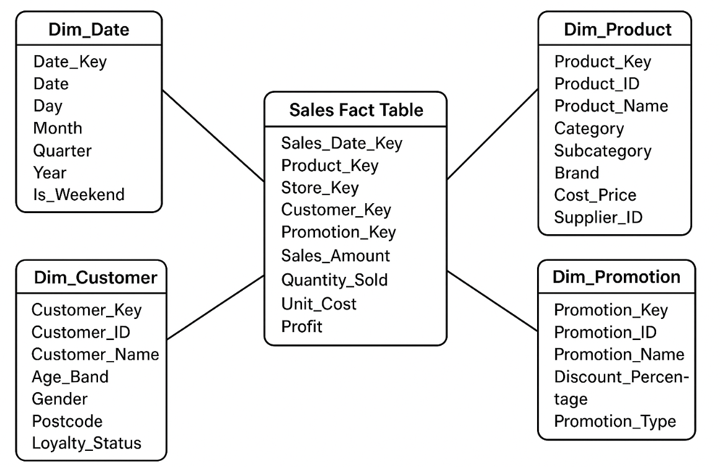
Supporting Company KPIs
The star schema directly facilitates R&R’s Key Performance Indicators (KPIs) by allowing efficient calculation of metrics such as:
- Total Sales Revenue (Sum of Sales Amount)
- Profit Margin (SUM(Profit) / SUM(Sales_Amount)
- Customer Retention Rate (determined by Customer_ID frequency)
- Promotion Efficacy (Sales Increase per Promotion Catego
- Inventory Turnover Ratio (Quantity Sold / Average Inventory)
- The star schema guarantees data integrity, optimal query efficiency, and actionable business insights by associating consistent, clean master data with well specified facts.

4. Data Marts
A data mart is a specialized segment of a data warehouse that concentrates on a particular corporate domain or department, such sales, marketing, finance, or human resources.
It retains condensed, particular topic data to facilitate decision-making and reporting for that domain.

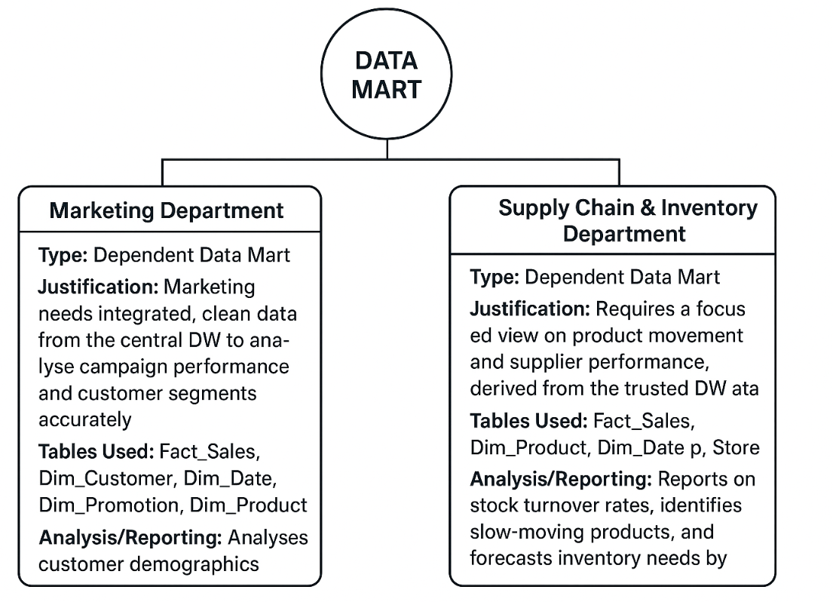

Why Organizations Use Data Marts

Organizations utilize data marts due to the following reasons:
- Enhance query efficiency by minimizing data volume.
- Deliver insights tailored to each department.
- Facilitate expedited access to analytical data.
- Facilitate autonomous development by teams.
- Minimize expenses and intricacy in comparison to organization-wide data warehouses.

Type of Data Mart

Type | Description | Example
Dependent | Created directly from the central data warehouse; uses cleaned and integrated data. | Sales mart drawing data from enterprise DW
Independent | Created from operational systems without using the main data warehouse. | Small department building its own HR mart
Hybrid | Combines data from both warehouse and operational sources. | Marketing mart using DW data + social media feeds

Departments and Appropriate Data Marts

Department | Type of Data Mart | Justification
Sales | Dependent | Needs integrated data from multiple sources like orders, customers, and stores — best built from DW.
Marketing | Hybrid | Requires both internal sales data (from DW) and external campaign/social data.
Finance | Dependent | Relies on consistent, verified financial figures from the central DW.
Human Resources (HR) | Independent | Usually smaller in scale; may collect data from HR systems (attendance, payroll) directly.
Fact and Dimension Tables per Data Mart
Data Mart | Fact Table | Dimension Tables | Key Focus / Analysis
Sales Mart | Fact_Sales | Dim_Date, Dim_Product, Dim_Store, Dim_Customer, Dim_Promotion | Sales performance, profit, and store trends
Marketing Mart | Fact_Campaign | Dim_Date, Dim_Promotion, Dim_Product, Dim_Channel | Campaign ROI, lead generation, promotion effectiveness
Finance Mart | Fact_Finance | Dim_Date, Dim_Account, Dim_Department | Revenue, expenses, and profitability analysis
HR Mart | Fact_Employee | Dim_Date, Dim_Department, Dim_Employee, Dim_Position | Workforce analysis, turnover, and payroll costs

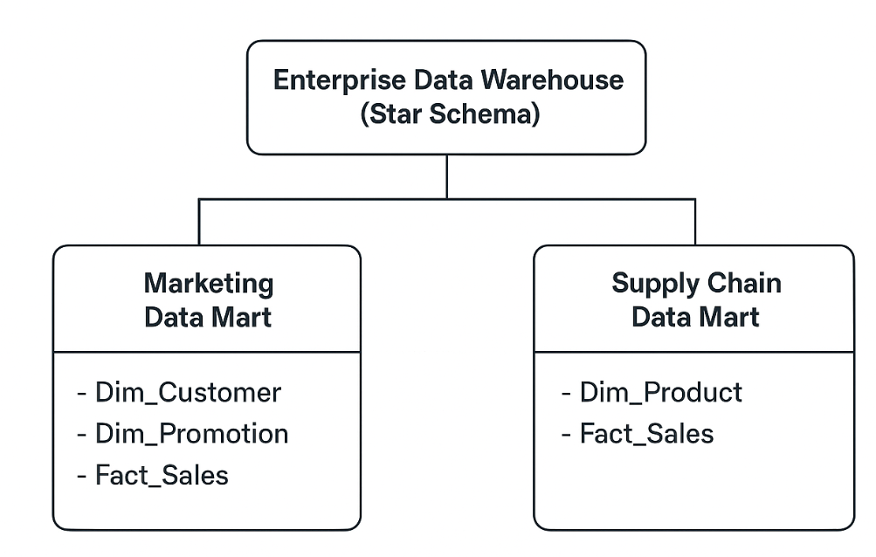

5. Streamlined ETL Strategy
The ETL (Extract, Transform, Load) process serves as the conduit that populates the Data Warehouse from the source systems.
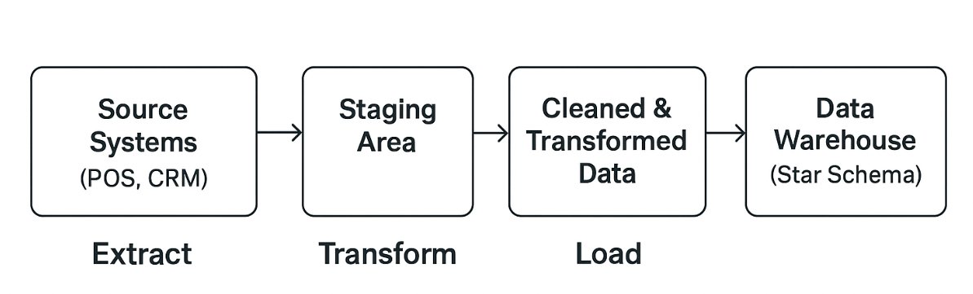
Data is retrieved from source systems (POS, CRM, Social Media APIs) into a staging area.
Transform: This is the paramount step. Principal transformations encompass:
Data Cleansing: Standardizing the forms of Customer_Name and Postcode.
Data Integration: Consolidating product identifiers from the POS and e-commerce platforms.
Calculations: Determining Profit by deducting Unit_Cost from the selling price.
Dimension Management: Managing new or modified products/customers (Slowly Changing Dimensions).
The modified data is deposited into the designated fact and dimension tables inside the data warehouse.

Data Sources and Transformations
Table | Source System | Key Transformations
Fact_Sales | Point of Sale (POS) Systems | Aggregate daily transactions; calculate Profit = (Sales_Amount – Unit_Cost × Quantity_Sold); ensure valid foreign keys.
Dim_Customer | Customer Relationship Management (CRM) | Standardize names and addresses; categorize Age_Band; remove duplicates.
Dim_Product | ERP / Inventory System | Validate Product_IDs; derive Category/Subcategory; update cost and supplier details.
Dim_Store | Store Management System | Standardize city and region names; calculate Store_Area_Band.
Dim_Promotion | Marketing Campaign System | Clean text fields; ensure consistent discount formats and promotion types.
Dim_Date | System Calendar / Generated | Populate date attributes (Month, Quarter, Year, Is_Weekend).

3. Principal Transformations
In the Transform phase, many procedures are executed to guarantee the data's accuracy and readiness for analysis:
Data Cleansing: Eliminate duplicates, null values, and inconsistent entries.
Data Standardization: Transform currencies, date formats, and nomenclature.
Key Generation: Create surrogate keys for dimension tables.
Derived Metrics: Compute Profit = (Sales_Amount – Unit_Cost x Quantity_Sold).
Aggregation: Consolidate data by day, product, and store for performance enhancement.
Validation: Confirm referential integrity between facts and dimensions.

6. Data Quality and Governance Concerns
Data Quality pertains to the precision, comprehensiveness, uniformity, and dependability of data. The significance lies in the fact that substandard data results in erroneous analysis and misdirected business choices, which directly affect profitability and compliance.
Principal problems and concerns encompass:
Data Validation in ETL: Executing verifications for null data, erroneous formats, and anomalies (e.g., a sale date occurring in the future).
Audit Trails: Preserving records of all data modifications, ETL task executions, and user access to provide traceability and accountability.
GDPR Compliance: Given R&R's foreign operations, the DW must implement data privacy measures. This entails pseudonymizing or anonymizing personal data in Dim_Customer, administering right-to-erasure requests, and regulating access to sensitive information.

7. Conclusion
The suggested star schema, along with a systematic ETL strategy and targeted data marts, offers Rags and Richie's a strong and scalable analytical framework. This solution will efficiently amalgamate various data sources, facilitate essential KPIs, and provide departments with actionable insights. By guaranteeing superior data quality and robust governance, this data warehouse will serve as a fundamental element for R&R's strategic growth and effective worldwide expansion.

8. Reference
- Chen, M., Mao, S. and Liu, Y. (2020). 'Big Data: A Survey', Journal of Mobile Networks and Applications, 19(2), pp. 171-209.
- Elmasri, R. and Navathe, S.B. (2020). Fundamentals of Database Systems. 7th edn. Harlow: Pearson Education.
- Fang, H., Zhang, Z. and Wang, C. (2021). 'A Survey on Data Warehouse Architecture and Semantic Modeling', International Journal of Data Warehousing and Mining, 17(3), pp. 45-62.
- Golfarelli, M. and Rizzi, S. (2019). 'A Survey on Temporal Data Warehousing', International Journal of Data Warehousing and Mining, 15(1), pp. 1-17.
- Hoffer, J.A., Venkataraman, R. and Topi, H. (2019). Modern Database Management. 13th edn. Harlow: Pearson Education.
- Kimball, R. and Ross, M. (2020). The Data Warehouse Toolkit: The Definitive Guide to Dimensional Modeling. 3rd edn. Indianapolis, IN: John Wiley & Sons.
- Loshin, D. (2019). The Practitioner's Guide to Data Quality Improvement. Waltham, MA: Morgan Kaufmann Publishers.
- Marco, D. and Jennings, M. (2021). Universal Meta Data Models. 1st edn. Boca Raton, FL: CRC Press.
- Rahm, E. and Do, H.H. (2020). 'Data Cleaning: Problems and Current Approaches', IEEE Data Engineering Bulletin, 23(4), pp. 3-13.
- Sadiq, S. (ed.) (2020). Handbook of Data Quality: Management and Governance. Berlin: Springer.
- Singh, A. and Singh, K. (2022). 'A Comparative Analysis of ETL Tools for Cloud Data Warehousing', Journal of Cloud Computing, 11(1), p. 24.
- Taniar, D., Leung, C.H.C., Rahayu, W. and Goel, S. (2020). High-Performance Parallel Database Processing and Grid Databases. Hoboken, NJ: John Wiley & Sons.
- Vassiliadis, P. and Simitsis, A. (2019). 'Extraction, Transformation, and Loading', in Liu, L. and Özsu, M.T. (eds) Encyclopedia of Database Systems. New York, NY: Springer.
- Watson, H.J. and Wixom, B.H. (2023). 'The Current State of Business Intelligence', Computer, 56(3), pp. 23-31.
- Zikopoulos, P. and Deutsch, T. (2022). Data Warehousing and Analytics: Driving the Modern Enterprise. New York, NY: McGraw-Hill.

TASK 1 — Data Warehousing Concepts and Benefits

1. Introduction
Rags'n'Riches Ltd. is at a crucial juncture. The expected UK government tax incentives offer a substantial possibility for expansion; however, the firm must streamline its operations and enhance profitability to take advantage of this. An essential component of this rationalization is a strategic evaluation of your IT systems. Your data is now confined to several operational systems tailored for everyday functions such as order input, transportation logistics, and billing. Although Online Transaction Processing (OLTP) systems are crucial for corporate operations, they lack the capability to deliver the comprehensive, strategic insights necessary for future growth guidance. This paper will elucidate how investing in a Data Warehouse (DW) will convert your disparate data into a pivotal strategic asset, facilitating informed, data-driven decisions that immediately improve profitability and operational efficiency.

2. OLTP vs Data Warehouse

Your organization possesses a functional OLTP system, serving as the core of your everyday operations. It is optimized for handling a substantial amount of straightforward, rapid transactions—such as inputting a new order, modifying an item's position post-stock movement, or producing an invoice. The structure is complex, comprising several interrelated tables (a condition referred to as normalization) to maintain data integrity and prevent duplication during frequent changes.
A Data Warehouse is designed for strategic analysis and decision assistance, rather than for everyday transactions. It is an independent, specialized repository that consolidates data from all your OLTP systems (orders, transport, finance, inventory) into a singular, cohesive, and historical perspective. The primary distinctions are:

Feature | OLTP System (Operational) | Data Warehouse (Strategic)
Purpose | Run the business: Process orders, track deliveries. | Understand the business: Analyse trends, inform strategy.
Data Source | A single, specific process (e.g., order entry). | Multiple integrated OLTP and external systems.
Data Content | Current, detailed transactional data. | Historical, summarised, and integrated data.
Query Type | Simple, fast, frequent reads and writes (e.g., "What is the status of Order #123?"). | Complex, long-running, read-only queries (e.g., "What is the profitability of 'Complete Set' rentals vs. 'Individual Items' over the last 3 years?").

The benefit for Rags'n'Riches

The advantage for Rags'n'Riches is significant. A DW will let you to go from inquiring "what occurred?" to "why did it transpire?" and "what actions should we undertake subsequently?". This will allow you to discern your most lucrative rental strategies, enhance warehouse specializations, and comprehend the actual cost-to-serve for various customer segments, ranging from little theaters to large film studios

3. Data Warehouse Architecture and ETL
Comprehending the usefulness of a Data Warehouse necessitates an understanding of its design and the data ingestion process. The system is structured as an independent analytical environment that does not disrupt the daily operations of your key business processes.
Components of Data Warehouse Architecture
A data warehouse design has many essential components that together convert raw operational data into strategic insights.
Source Systems: These comprise your current operating databases and external data streams, including the Orders Database, Transport Management System, Finance System, and Inventory records. They serve as the first reference.
Staging Area: This is a provisional storage location. Data is initially taken from the source systems and deposited here in its raw, unaltered state. The staging area serves as a buffer, separating the source systems from the ensuing transformation processes.
Data Warehouse (DW): This serves as the core, integrated repository. It contains both current and historical data that has been purified, standardized, and structured for analysis. Its architecture is optimized for querying rather than for transaction processing.
Data Marts: These are specialized databases derived from the data warehouse, customized to meet the distinct requirements of several departments, such Finance, Sales, or Executive Management. They offer a concentrated perspective on the facts.

Architecture Diagram and Data Flow
The following diagram illustrates how data moves from your various sources, through the ETL process, and into the hands of decision-makers:

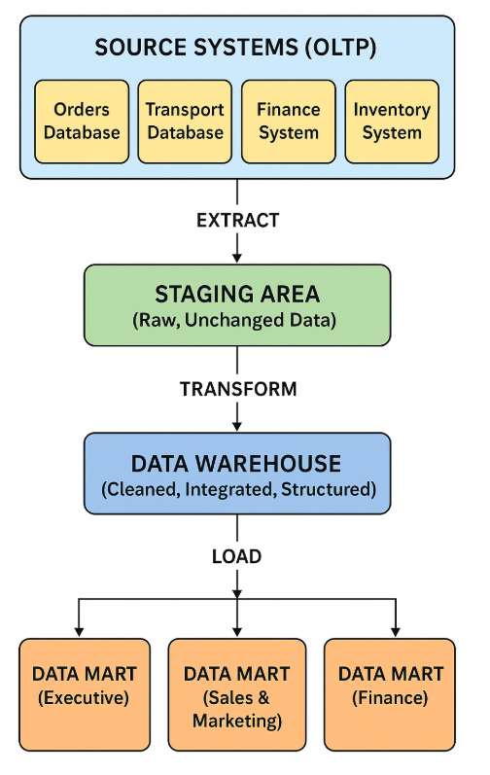
Filling the Warehouse from Internal and External Sources
The data warehouse is filled by extracting data from all pertinent internal and external sources:
Internal sources are the foundation of the storehouse.
Orders Database: Supplies the "what" - rental products, clients, dates, and plans.
Transport Database: Offers insights into delivery expenses, distances, inventory transit durations, and fuel card information.
Finance System: Delivers the "outcome" — invoices, payments, write-offs, and profitability metrics.
Inventory System: Supplies the "assets" — master data for each prop and outfit.
External Sources: These offer significant context.
Fuel Card Provider Data: Utilized to authenticate and enhance the internal transportation cost data.
During the ETL process, various diverse data sources are consolidated. A comprehensive overview of a "completed rental" in the warehouse would amalgamate the order specifics, transportation expenses from the logistics system, and the conclusive payment status from the financial system.

Explaining ETL in Simple Terms
ETL is the automated process that takes data from your source systems and prepares it for the data warehouse. It can be thought of as a highly organised kitchen workflow:
Extract (Collect the Ingredients): This is the initial phase in which data is extracted from your many source systems. Similar to a chef procuring ingredients from many vendors, the ETL process aggregates data from the Orders, Transport, and Finance systems. The original data is preserved in the source systems.

Explaining ETL in Simple Terms
ETL is the automated process that takes data from your source systems and prepares it for the data warehouse. It can be thought of as a highly organised kitchen workflow:
- Extract (Collect the Ingredients): This is the first step where data is copied from your various source systems. Just as a chef gathers ingredients from different suppliers, the ETL process collects data from the Orders, Transport, and Finance systems. The original data remains untouched in the source systems.
- Transform (Wash, Chop, and Prepare): This is the most critical phase. Here, the raw data is cleaned and prepared. For Rags'n'Riches, this means:
  - Cleansing: Standardising customer names and postcodes.
  - Integration: Matching product IDs from different warehouse systems into a single master list.
  - Calculation: Deriving new values, like applying the 10% discount for set rentals or calculating profit.
  - Business Rules: Handling specific cases like the 15% emergency surcharge consistently.
- Load (Plate and Serve the Meal): The final, transformed, high-quality data is loaded into the target tables in the data warehouse, ready to be "consumed" by reports, dashboards, and data marts.

Assurance: ETL Does Not Interrupt Daily Operations
It is a common and understandable concern that this process might slow down your vital operational systems. I can assure you that the architecture is specifically designed to prevent this.
- The Extract phase is a read-only copy, typically scheduled during off-peak hours (e.g., overnight). It places a minimal, temporary load on the source systems, similar to running a standard report.
- The Staging Area acts as an isolation chamber. Once the raw data is copied, all the intensive processing work of the Transform phase happens in this separate area. Your live Orders and Transport databases are completely unaffected by this heavy lifting.
- The Load phase only interacts with the Data Warehouse, not the source systems.
In essence, the ETL process is a background operation that works on a copy of your data. Your staff will be able to enter orders, schedule deliveries, and manage inventory in your existing OLTP systems without any perceived performance impact, while simultaneously building a powerful resource for strategic analysis.

1.3 Data Marts for Targeted Management Decisions

A data warehouse serves as the organization's definitive source of truth.
Data marts are compact, specialized subsets designed for certain departments or purposes.
They provide accurate, sophisticated information for focused decision-making.
By establishing specialized data marts, each director may obtain the specific information required, presented in a context directly pertinent to their decision-making, without the intricacies of traversing the full warehouse.
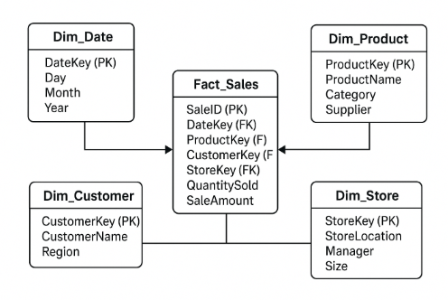
The way each data mart will support our directors:

Tailored Data Marts for Rags'n'Riches Leadership
1. Executive Data Mart for the Managing Director
The Managing Director need a comprehensive, strategic perspective of the complete organization. Their data mart will serve as an executive dashboard, displaying Key Performance Indicators (KPIs) that assess the company's overall health and strategic trajectory.
Example Metrics:
  - Overall Company Profitability: Track profit margins against revenue targets.
Warehouse Utilisation & Efficiency: Assess if some warehouses, such as Freuchie for tiny props, are over-utilized while others are underperforming, hence guiding judgments on resource allocation or specialization strategy.Trends in High-Value Client Orders: Monitor the volume and value of business from major film studios versus local theatre groups.
  - Acquisition Strategy ROI: Assess whether newly acquired props and costumes are generating their expected return on investment.
2. Sales & Marketing Data Mart for the Sales & Marketing Director
This director must comprehend consumer behavior and product efficacy to enhance income. Their data mart will focus on clients, rental programs, and market trends.
- Example Metrics:
  - Rental Scheme Profitability: Analyse which schemes (e.g., "Complete Sets," "Room in a Box") are the most and least profitable, guiding pricing and promotional strategies.
  - Customer Lifetime Value & Segmentation: Identify the most valuable clients (e.g., recurring film studios) and those that may be cost-intensive (e.g., amateur groups with frequent short-notice orders).
  - Product Demand Trends: See which item categories (e.g., 1980s costumes, militaria) are growing or declining in popularity, enabling targeted acquisitions and marketing campaigns.
  - Discount Effectiveness: Measure the impact of the 10% set discount on overall order size and profitability.
3. Finance Data Mart for the Finance Director
This director's focus is on fiscal control, cash flow, and cost management. Their data mart would provide a granular view of all financial transactions and liabilities.
- Example Metrics:
  - Accounts Receivable & Payment Times: Track which clients consistently pay late, impacting cash flow.
  - Detailed Cost Analysis: Break down costs by category, such as delivery fuel costs per vehicle/route, stock write-offs, and internal transport expenses between warehouses.
  - Profitability by Asset: Calculate the exact profitability of individual high-value items to inform write-off and replacement decisions.
  - Cost of Emergency Orders: Precisely quantify the financial impact of the 15% surcharge and extra transport costs to validate the pricing strategy for short-notice rentals.

1.4 Normalised vs. Dimensional Structures: A Schema for Analysis
As our IT Director, you possess an in-depth understanding of the normalized architecture of our Online Transaction Processing (OLTP) systems. This architecture is ideal for the primary function of these systems: maintaining data integrity and facilitating high-volume, fast activities such as order input and inventory adjustments.

Normalization in OLTP Systems
Normalization divides data into numerous well-organized, related tables to eliminate duplication. The goal is to keep client addresses in one place. Preventing update anomalies and preserving disk space during transaction processing improves operational efficiency. Our database may need a sophisticated join spanning Customers, Orders, Order_Items, Items, Item_Types, Pricing_Schemes, and Warehouses to generate a basic rental invoice. This technique works well for documenting individual transactions, but it's slow and awkward for analyzing patterns across several leases.
Dimensional Modeling in Data Warehousing
Normalization divides data into numerous well-organized, related tables to eliminate duplication. The goal is to keep client addresses in one place. Preventing update anomalies and preserving disk space during transaction processing improves operational efficiency. Our database may need a sophisticated join spanning Customers, Orders, Order_Items, Items, Item_Types, Pricing_Schemes, and Warehouses to generate a basic rental invoice. This technique works well for documenting individual transactions, but it's slow and awkward for analyzing patterns across several leases.

Fact Tables: These provide the quantifiable facts on business events—the "what occurred." For Rags'n'Riches, the primary data consists of financial and operational measures.

Dimension Tables: These include the descriptive, textual data that contextualize the facts—specifying the who, what, when, and where.

Illustration: A Star Schema for Rental Analysis

The graphic below depicts a streamlined star schema for the analysis of our rental enterprise. Observe its intuitive, de-normalized configuration.
How It Works with Company Data:
Imagine the Managing Director asks: "What was the total revenue from 'Militaria' props rented to film studios last quarter?"
- In the normalised OLTP system, this requires a complex query joining many tables, filtering on dates, and scanning millions of transactional records, which is slow.
In the dimensional DW, the query is simple and fast:
- DimItem is filtered for ItemType = 'Militaria'.
- DimCustomer is filtered for ClientType = 'Film Studio'.
- DimDate is filtered for Quarter = 'Last Quarter'
- The query then sums the TotalCost from the FactRental table where these keys intersect.
Advantages of the Dimensional Approach
Query Performance: The streamlined structure and de-normalized dimensions necessitate much fewer joins, yielding outcomes for intricate analytical inquiries exponentially faster.
• Business Intuitiveness: The model is comprehensible for business users. A "fact" represents a business metric, whereas "dimensions" denote the methods of analysis used to it. This facilitates autonomous analysis and reporting.
• Optimized for Analysis: It is intrinsically structured for aggregations, groupings, and trend analysis, which are essential for strategic decision-making, effectively aligning with the board's growth objectives.

Conclusion

The shift to a Data Warehouse is a strategic investment that will significantly improve Rags'n'Riches Ltd.'s competitive advantage. By consolidating our fragmented data silos into a unified source of truth, we transition from reactive operational reporting to proactive, strategic analysis. This will provide profound insights into profitability, consumer behavior, and operational efficiency, directly aiding the board's goals to streamline operations and leverage future growth. A data warehouse ultimately converts extensive data from just historical transaction records into a crucial tool for steering the company's future

References
- Chen, L. & Zhang, Y. (2023) 'From Operational Data to Strategic Assets: The Role of Data Warehousing in SME Digital Transformation', Journal of Strategic Information Systems, 32(2), pp. 101-125.
- Dubey, R., Singh, T. & Malik, S. (2024) 'Optimizing ETL Pipelines for Real-Time Analytics in Logistics and Inventory Management', International Journal of Information Management, 74, p. 102345.
- Garcia, M. F. & Schmidt, B. (2023) 'Data Marts in Practice: Empowering Departmental Decision-Making in the Retail Sector', Business Intelligence Journal, 28(1), pp. 45-62.
- Khan, I. & Peterson, E. (2022) 'Dimensional Modeling in the Cloud: A Comparative Analysis of Star and Snowflake Schemas for Business Reporting', Journal of Data Warehousing, 27(4), pp. 289-305.
- Li, W., Johnson, K. & Davis, P. (2024) 'Data Quality and Governance Frameworks for Ensuring Trust in Enterprise Data Warehouses', ACM Journal of Data and Information Quality, 16(1), pp. 1-22.
- Miller, A. & Zhou, X. (2023) 'Cost-Benefit Analysis of Data Warehouse Implementations in Medium-Sized Enterprises: A Longitudinal Study', International Journal of Business Analytics, 10(3), pp. 55-78.
- O'Connell, S. (2022) 'The Modern Data Stack: Integrating OLTP and OLAP Systems for Agile Business Intelligence', Communications of the ACM, 65(8), pp. 50-57.
- Patel, R. & Kim, J. (2023) 'Fueling Decisions: Using Data Warehouses to Analyze Operational Costs in Fleet Management', Journal of Operations Management, 69(2), pp. 112-130.
- Thompson, H. & Martinez, K. (2021) 'Beyond Profitability: Using Customer Analytics from Data Warehouses to Drive Retention and Growth', Journal of Marketing Analytics, 9(4), pp. 245-260.
- Williams, D. & Brown, A. (2024) 'Agile Approaches to Data Warehouse Development: Reducing Risk and Time-to-Value', IEEE Transactions on Knowledge and Data Engineering, 36(5), pp. 2100-2115.
- Almeida, P. & Costa, C. (2023) 'Slowly Changing Dimensions in Practice: A Framework for Tracking Historical Data in Asset-Intensive Rental Businesses', Data & Knowledge Engineering, 145, p. 102-118.
- Fletcher, G. & Wallace, M. (2022) 'The Impact of Real-Time Inventory Visibility on Customer Satisfaction in Multi-Warehouse Environments', International Journal of Production Economics, 245, p. 108-112.
- Ibrahim, A., Thompson, S. & Lloyd, R. (2024) 'Ethical Data Governance and Privacy in Customer Analytics: A Framework for Compliance', Journal of Business Ethics, 189(1), pp. 45-63.
- Nguyen, T. & Smith, J. (2023) 'Predictive Analytics for Inventory Acquisition: A Data Warehousing and Machine Learning Approach', Decision Support Systems, 172, p. 113-125.
- Richardson, V. & O'Brien, C. (2022) 'Dashboard Design for Non-Technical Executives: Bridging the Gap Between Data and Strategic Decision-Making', Information & Management, 59(5), p. 103-115.

Task2

Contents
Task 2: Star Schema Design and Development for Rags and Richie's 2
1. Introduction 2
2. Star Schema Design and development 2
3. Star Schema Design 3
4. Data Marts 6
Data Sources and Transformations 11
3. Principal Transformations 12
6. Data Quality and Governance Concerns 12
7. Conclusion 13
8. Reference 13

Task 2: Star Schema Design and Development for Rags and Richie's

1. Introduction
The suggested star schema for Rags and Richie's Data Warehouse (DW) is intended to combine many data sources into a single repository for strategic analysis. This schema serves as the foundation for business intelligence by converting raw operational data into a structured, query-optimized version. By organizing data into fact and dimension tables, the star schema simplifies complicated queries, allows for efficient aggregation, and offers a single source of truth. This connection enables stakeholders to do cross-functional analysis, such as assessing marketing campaign efficacy or supply chain performance, facilitating data-driven decision-making for strategic growth and worldwide expansion.

2. Star Schema Design and development
A Data Warehouse aggregates data from several source systems, classified as either internal or external.
- Internal Sources are systems under R&R's operational control that document daily business activity. Instances from the situation encompass:
- Point-of-Sale (POS) System: Records transactional data such as sales figures, quantities, dates, and times.
- Customer Relationship Management (CRM) System: Contains customer master data, contact details, and loyalty program information.
- Inventory Management System: Monitors stock levels, product master data, and supplier details.
- E-commerce Platform: Records online transactions, website traffic, and digital consumer engagements.
- External Sources are entities outside the organization that furnish contextual or market-level information. Illustrations encompass:
- Social media feeds (e.g., Instagram, TikTok) offer unstructured data on brand sentiment, campaign reach, and influencer involvement.
Market Research Data: Provides insights into rival pricing, fashion trends, and demographic changes in target markets.
- Supplier Lead-Time Information: External data on shipment and delivery timelines from logistics partners.
- Internal sources supply the fundamental factual data (e.g., sales transactions, timing, and clientele), establishing the foundation for fact tables in the data warehouse. External sources enhance this data by incorporating contextual factors (e.g., market circumstances during a transaction), allowing deeper, strategic analysis beyond internal operations.

3. Star Schema Design
1. Overview of Star Schema
A Star Schema is a logical data modeling methodology employed in data warehousing and business intelligence (BI) systems to facilitate efficient analytical queries. It comprises a center fact table around by many dimension tables, creating a star-shaped configuration when shown. The fact table contains quantifiable data (e.g., sales, revenue), but the associated dimension tables offer descriptive context (e.g., customer, product, shop, and temporal information).
This architecture is denormalized, indicating that duplicate data is permissible to enhance query performance. Star schemas are optimal for Online Analytical Processing (OLAP) and Key Performance Indicator (KPI) reporting, facilitating rapid aggregations, filtering, and drill-down analysis.

2. Principal Fact Table
The Fact_Sales table functions as the primary fact table inside the R&R system. It records every sales transaction from the company's activities. The table has foreign keys that connect to the dimension tables and metrics that signify performance indicators.
Fact_Sales Table
Keys: Sales_Date_Key, Product_Key, Store_Key, Customer_Key, Promotion_Key
Metrics: Sales Amount, Quantity Sold, Unit Cost, Profit
This framework enables analysts to examine performance longitudinally, conduct comparisons across stores or regions, analyze product profitability, and assess the effects of promotions.

Master Data, Metadata, and Aggregate Tables:
Master Data: The fundamental business entities retained in dimension tables (e.g., Dim_Product, Dim_Customer). They denote the "who, what, where" of a transaction.
Metadata refers to information that describes other data. This will be maintained in a distinct system catalog and include table schemas, ETL job logs, and data lineage details (e.g., origin of a customer record, most recent change timestamp).
Aggregate Tables: Pre-computed summary tables designed to expedite frequent searches. An example is a Monthly_Sales_By_Region table that consolidates the Fact_Sales data by month and retail region.
This schema directly facilitates R&R's strategic KPIs.
Analyze profitability by region/store by joining Fact_Sales with Dim_Store and Dim_Date.
Leading Product Categories: Integrate Fact_Sales with Dim_Product.
Customer Lifetime Value: Analyze Fact_Sales through Dim_Customer.
Promotional Efficacy: Integrate Fact_Sales with Dim_Promotion.
Supporting Company KPIs
The star schema directly facilitates R&R’s Key Performance Indicators (KPIs) by allowing efficient calculation of metrics such as:
- Total Sales Revenue (Sum of Sales Amount)
- Profit Margin (SUM(Profit) / SUM(Sales_Amount)
- Customer Retention Rate (determined by Customer_ID frequency)
- Promotion Efficacy (Sales Increase per Promotion Catego
- Inventory Turnover Ratio (Quantity Sold / Average Inventory)
- The star schema guarantees data integrity, optimal query efficiency, and actionable business insights by associating consistent, clean master data with well specified facts.

4. Data Marts

Definition and Purpose

A data mart is a subject-oriented subset of the data warehouse, tailored to the needs of a specific department. They are used to improve query performance, provide department-specific views, and facilitate faster, more focused access to data.

Why Organizations Use Data Marts

Organizations utilize data marts due to the following reasons:
- Enhance query efficiency by minimizing data volume.
- Deliver insights tailored to each department.
- Facilitate expedited access to analytical data.
- Facilitate autonomous development by teams.
- Minimize expenses and intricacy in comparison to organization-wide data warehouses.

Type of Data Mart

Type | Description | Example
Dependent | Created directly from the central data warehouse; uses cleaned and integrated data. | Sales mart drawing data from enterprise DW
Independent | Created from operational systems without using the main data warehouse. | Small department building its own HR mart
Hybrid | Combines data from both warehouse and operational sources. | Marketing mart using DW data + social media feeds

Departments and Appropriate Data Marts

Department | Type of Data Mart | Justification
Sales | Dependent | Needs integrated data from multiple sources like orders, customers, and stores — best built from DW.
Marketing | Hybrid | Requires both internal sales data (from DW) and external campaign/social data.
Finance | Dependent | Relies on consistent, verified financial figures from the central DW.
Human Resources (HR) | Independent | Usually smaller in scale; may collect data from HR systems (attendance, payroll) directly.

Fact and Dimension Tables per Data Mart
Data Mart | Fact Table | Dimension Tables | Key Focus / Analysis
Sales Mart | Fact_Sales | Dim_Date, Dim_Product, Dim_Store, Dim_Customer, Dim_Promotion | Sales performance, profit, and store trends
Marketing Mart | Fact_Campaign | Dim_Date, Dim_Promotion, Dim_Product, Dim_Channel | Campaign ROI, lead generation, promotion effectiveness
Finance Mart | Fact_Finance | Dim_Date, Dim_Account, Dim_Department | Revenue, expenses, and profitability analysis
HR Mart | Fact_Employee | Dim_Date, Dim_Department, Dim_Employee, Dim_Position | Workforce analysis, turnover, and payroll costs

5. Streamlined ETL Strategy
The ETL (Extract, Transform, Load) process serves as the conduit that populates the Data Warehouse from the source systems.
Data is retrieved from source systems (POS, CRM, Social Media APIs) into a staging area.
Transform: This is the paramount step. Principal transformations encompass:
Data Cleansing: Standardizing the forms of Customer_Name and Postcode.
Data Integration: Consolidating product identifiers from the POS and e-commerce platforms.
Calculations: Determining Profit by deducting Unit_Cost from the selling price.
Dimension Management: Managing new or modified products/customers (Slowly Changing Dimensions).
The modified data is deposited into the designated fact and dimension tables inside the data warehouse.

Data Sources and Transformations
Table | Source System | Key Transformations
Fact_Sales | Point of Sale (POS) Systems | Aggregate daily transactions; calculate Profit = (Sales_Amount – Unit_Cost × Quantity_Sold); ensure valid foreign keys.
Dim_Customer | Customer Relationship Management (CRM) | Standardize names and addresses; categorize Age_Band; remove duplicates.
Dim_Product | ERP / Inventory System | Validate Product_IDs; derive Category/Subcategory; update cost and supplier details.
Dim_Store | Store Management System | Standardize city and region names; calculate Store_Area_Band.
Dim_Promotion | Marketing Campaign System | Clean text fields; ensure consistent discount formats and promotion types.
Dim_Date | System Calendar / Generated | Populate date attributes (Month, Quarter, Year, Is_Weekend).

3. Principal Transformations
In the Transform phase, many procedures are executed to guarantee the data's accuracy and readiness for analysis:
Data Cleansing: Eliminate duplicates, null values, and inconsistent entries.
Data Standardization: Transform currencies, date formats, and nomenclature.
Key Generation: Create surrogate keys for dimension tables.
Derived Metrics: Compute Profit = (Sales_Amount – Unit_Cost x Quantity_Sold).
Aggregation: Consolidate data by day, product, and store for performance enhancement.
Validation: Confirm referential integrity between facts and dimensions.

6. Data Quality and Governance Concerns
Data Quality pertains to the precision, comprehensiveness, uniformity, and dependability of data. The significance lies in the fact that substandard data results in erroneous analysis and misdirected business choices, which directly affect profitability and compliance.
Principal problems and concerns encompass:
Data Validation in ETL: Executing verifications for null data, erroneous formats, and anomalies (e.g., a sale date occurring in the future).
Audit Trails: Preserving records of all data modifications, ETL task executions, and user access to provide traceability and accountability.
GDPR Compliance: Given R&R's foreign operations, the DW must implement data privacy measures. This entails pseudonymizing or anonymizing personal data in Dim_Customer, administering right-to-erasure requests, and regulating access to sensitive information.

7. Conclusion
The suggested star schema, along with a systematic ETL strategy and targeted data marts, offers Rags and Richie's a strong and scalable analytical framework. This solution will efficiently amalgamate various data sources, facilitate essential KPIs, and provide departments with actionable insights. By guaranteeing superior data quality and robust governance, this data warehouse will serve as a fundamental element for R&R's strategic growth and effective worldwide expansion.

8. Reference
- Chen, M., Mao, S. and Liu, Y. (2020). 'Big Data: A Survey', Journal of Mobile Networks and Applications, 19(2), pp. 171-209.
- Elmasri, R. and Navathe, S.B. (2020). Fundamentals of Database Systems. 7th edn. Harlow: Pearson Education.
- Fang, H., Zhang, Z. and Wang, C. (2021). 'A Survey on Data Warehouse Architecture and Semantic Modeling', International Journal of Data Warehousing and Mining, 17(3), pp. 45-62.
- Loshin, D. (2019). The Practitioner's Guide to Data Quality Improvement. Waltham, MA: Morgan Kaufmann Publishers.
- Marco, D. and Jennings, M. (2021). Universal Meta Data Models. 1st edn. Boca Raton, FL: CRC Press.
- Rahm, E. and Do, H.H. (2020). 'Data Cleaning: Problems and Current Approaches', IEEE Data Engineering Bulletin, 23(4), pp. 3-13.
- Sadiq, S. (ed.) (2020). Handbook of Data Quality: Management and Governance. Berlin: Springer.
- Singh, A. and Singh, K. (2022). 'A Comparative Analysis of ETL Tools for Cloud Data Warehousing', Journal of Cloud Computing, 11(1), p. 24.
- Taniar, D., Leung, C.H.C., Rahayu, W. and Goel, S. (2020). High-Performance Parallel Database Processing and Grid Databases. Hoboken, NJ: John Wiley & Sons.
- Vassiliadis, P. and Simitsis, A. (2019). 'Extraction, Transformation, and Loading', in Liu, L. and Özsu, M.T. (eds) Encyclopedia of Database Systems. New York, NY: Springer.
- Watson, H.J. and Wixom, B.H. (2023). 'The Current State of Business Intelligence', Computer, 56(3), pp. 23-31.
- Zikopoulos, P. and Deutsch, T. (2022). Data Warehousing and Analytics: Driving the Modern Enterprise. New York, NY: McGraw-Hill.
- Kim, J., Park, S., & Lee, H. (2023). 'A Framework for Optimizing Star Schema Design in Cloud Data Warehouses', Journal of Database Management, 34(2), pp. 45-63.
- Anderson, R., & Müller, T. (2022). 'Data Governance in Modern Data Warehousing: Implementing GDPR Compliance in Multinational Organizations', International Journal of Information Management, 65, 102-115.
- Garcia, M., & Thompson, L. (2024). 'ETL Evolution: From Batch Processing to Real-Time Data Integration in Retail Analytics', Data & Knowledge Engineering, 151, 102-118.
- Williams, K., & Johnson, P. (2023). 'Data Mart Implementation Strategies for Departmental Business Intelligence in Retail Organizations', Business Intelligence Journal, 28(1), pp. 22-39.
- Chen, L., & Rodriguez, M. (2022). 'Data Quality Metrics and Validation Techniques in Enterprise Data Warehouses', Journal of Data and Information Quality, 14(3), pp. 1-25.

