Gyulten Harla (2133453)
[Date]

Mental Health Diseases
Introduction to Public Health
Module code: LCHS4004
Lecturer name: Bianca Sanfilippo

‌Introduction
People need to take care of their mental health in various ways, just as we do with our physical health. Four out of every five adults experience mental health problems each year. They range from common issues like depression and worry to less frequent ones like schizophrenia and bipolar disorder. A mental illness can ruin people life and prevent them from engaging in normal activities like work, school, and relationships.
Anxiety and depression
More than 300 million individuals worldwide experience depression, the leading cause of disability and over 260 million people suffer from anxiety problems (Dianova, 2017). Both illnesses are prevalent. Anxiety is feeling stressed, worried, or afraid, especially about impending or improbable future events (Mind. 2017). When they feel a threat to their safety, humans inherently experience anxiety. It is something that we can sense, consider, and actually experience.. Anxiety interferes with our ability to enjoy life as fully as we want. Depression is a persistently depressed state that interferes with daily life (Mind, 2017). Depression can be defined as feeling down. Although it does not prevent you from living a regular life, it makes everything more complicated and less critical. Everyone has low moods and negative feelings about life at times. There are numerous signs and symptoms of anxiety and depression (Figure 1).

Figure 1: Symptoms of anxiety and depression (Betterhealth, 2022)
Bipolar disease and schizophrenia
Other mental diseases are bipolar diseases and schizophrenia. A mental health condition called bipolar disorder primarily affects people's emotions. “Extreme mood swings, including emotional highs (mania or hypomania) and lows, are symptoms of bipolar illness, formerly known as manic depression” (‌Mayo Clinic, 2022, p.1). Users can feel ecstatic, energized, or particularly irritable when their mood swings into mania or hypomania. These mood changes might impair one's ability to think effectively, sleep, be active, have energy, and make decisions. Schizophrenia, on the other hand, is a severe mental illness where patients have aberrant perceptions of reality (‌Mayo Clinic, 2022). The symptoms of schizophrenia may include hallucinations, delusions, disorganized thinking, and incredibly abnormal thoughts and behaviour that make it challenging to go about daily activities and can even be incapacitating.
Causes
There are numerous potential causes of mental health issues. Several complex elements are probably at play for many people, while some may significantly impact others. There may be a family history of mental health issues (Mind, 2017). For instance, people are more likely to acquire schizophrenia if they have a parent with the disorder. Many environmental factors contribute to mental diseases in general. The mental disease may occasionally be associated with prenatal exposure to chemicals, inflammatory disorders, environmental stressors, alcohol, or narcotics (Mayo Clinic, 2022). There are many risk factors of developing a mental illness, the figure below summarizes some of these:

Figure 2: Risk factors of mental diseases (Mayo Clinic, 2022).
There are many people who occasionally struggle with their mental health. However, a mental health condition becomes a mental illness when persistent symptoms cause great stress and limit a person's ability to carry out regular responsibilities (Mayo Clinic, 2022; Mrazek and Haggerty, 2016). A mental illness can ruin people's life and prevent them from engaging in normal activities like work, school, and relationships.
Strategies used to measure the incidents of mental health diseases
The prevalence and mortality of physical illnesses are higher in those with mental illnesses than in the general population, according to evidence. Several causes have been identified, including an unhealthy lifestyle, drug side effects, and a lack of physical healthcare. Other recognized dangers include higher rates of accidents and suicide. Patients who receive treatment for mental illness are more likely to smoke, be less likely to exercise, have poor eating habits, and be more likely to be obese due to either general inertia, the side effects of neuroleptic medications, or increased alcohol use. Diabetes, metabolic syndrome, dyslipidemia, cardiovascular problems, extrapyramidal side effects, and sexual dysfunction are all linked to psychotropic drugs. The issues above are made worse by various clinical and organizational barriers that hinder access to good physical healthcare (Latoo, Mistry & Dunne, 2013).
Type 2 diabetes mellitus is twice as likely to occur in depressed individuals, and the incidence of myocardial infarction and stroke is three and five times higher than it is in depressed individuals, respectively (Latoo, Mistry & Dunne, 2013). In general, patients with schizophrenia or bipolar disorder have a mortality rate ratio (MRR) of two to three. People with schizophrenia are more likely to have diabetes, osteoporosis, obesity, and cardiovascular problems, and medication side effects may also contribute to these disorders. Life expectancy is thought to have decreased by at least ten years. People with learning difficulties are more likely to experience new issues, especially if they also have epilepsy, dementia, or polypharmacy. Because anorexia/bulimia nervosa affects other organ systems physically, eating disorders are linked to a high mortality rate. Hepatitis, the human immunodeficiency virus (HIV), TB, and poor oral health are all diseases that are often more common in people with a mental disorders (Latoo, Mistry & Dunne, 2013).
The greater risk of suicide is one explanation for the higher morbidity and mortality associated with mental illness and cardiovascular and pulmonary issues. Inactivity, smoking, and obesity all lead to high blood pressure (Latoo, Mistry & Dunne, 2013). When a patient has a mental illness, poor physical healthcare results are caused by various variables typically categorized as patient/illness, doctor/physician, and service provider/system problems. Another patient/illness component is that patients are less likely to address physical issues due to psychiatric symptoms. Because mental patients may be cognitively impaired, some medical professionals find it difficult or uncomfortable to conduct clinical assessments. In addition, general-care doctors are less likely to encounter mental patients, which makes it harder for them to get other treatments like cancer screenings. The overemphasis on mental health to the exclusion of physical health, low rates of metabolic abnormality screening, failure to examine patients because physical complaints are frequently a component of the psychiatric presentation, poor communication with the patient and the primary care teams, ignorance of and perhaps noncompliance with treatment guidelines, a lack of medical knowledge, and errors in diagnosis and treatment are all characteristics of psychiatrist-related factors (Latoo, Mistry & Dunne, 2013).
Even though there has not been much research that examines how the COVID-19 pandemic has affected the mental health of the general public nationally, there are signs that things are worsening. For instance, a national survey involving 17,452 participants in the United Kingdom discovered that the percentage of people experiencing clinically significant levels of mental anguish increased from 18.9% in 2018 to 27.3% in April 2020 (BinDhim, 2020). According to research conducted in the United States, in April 2020, 13.6% of adults reported experiencing significant psychological discomfort, up from 3.9% in 2018. These findings imply that COVID-19 significantly impacts the general public's mental health (BinDhim, 2020).
A report conducted and published by NHS Digital, indicates that among 17 to 19 year olds, the proportion with a probable mental illness increased from 17.4% in 2021 to 25.7% in 2022 (NHS Digital, 2022). The figure below shows how serious is the situation about mental health disorders among children and young people in the UK.
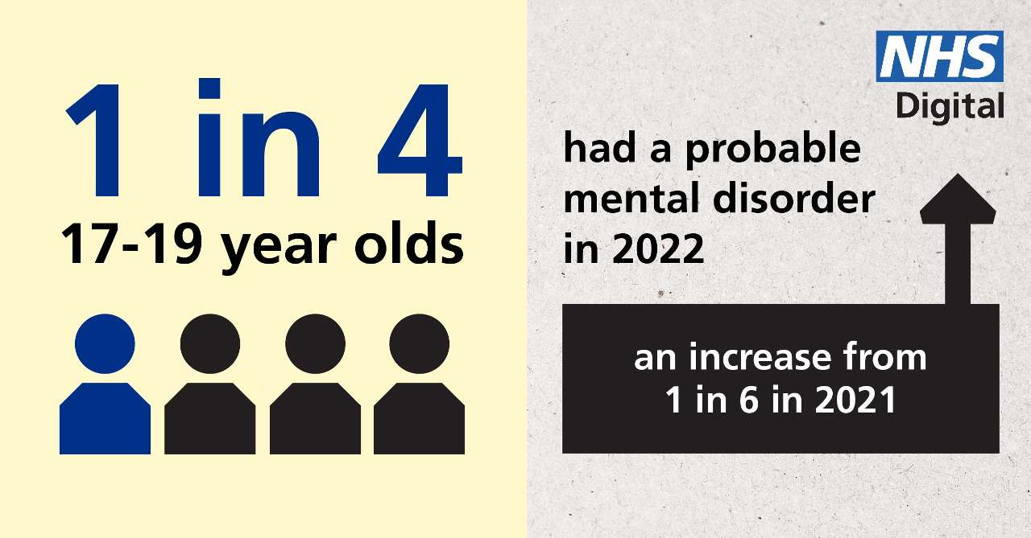
Figure 3: Prevalence of mental health among children and young people (NHS Digital, 2022)
Strategies used in the UK to monitor the incidents of mental health disease
Monitoring the incidents of mental health diseases involves gathering timely and practical information which decision makers use to manage mental health initiatives. Although talking therapies and community care are highly valued in the United Kingdom (UK), community mental health teams may need more education and training to handle physical health issues effectively (Latoo, Mistry & Dunne, 2013). Psychiatry needs to reestablish a more complex framework for treating mental diseases that includes routine physical health monitoring because it seems to have lost its way. Improvements in clinical education and training, strong coordination between primary and secondary care, increased funding for research, and legislative changes can improve overall health care for psychiatric patients.
Various smartphone apps are available for managing and monitoring mental health illnesses or symptoms (Wang, Varma and Prosperi, 2018). However, most lack convincing, clinically confirmed evidence, raising questions about their long-term patient benefits. Fourteen applications were found to provide clinically relevant evidence of lowering mental health symptoms or illness.The great majority of currently available apps, however, have not yet had their efficacy validated by science. Given the quantity and rate at which mobile health (mHealth) apps are being developed, additional comprehensive research is necessary to build and evaluate programmes based on evidence.
Strategies used to control the incidents of mental health diseases
Controlling the incidents of mental health diseases involve systematic, continual gathering, management, analysis, and interpretation of data, followed by the prompt transmission of this information to public health programs to encourage public health action towards mental health diseases (BinDhim, 2020). Numerous vital public health research and practice initiatives can use data from surveillance programs for the general public. These duties include estimating the extent and scope of mental health disorders, identifying mental health emergencies, monitoring developments, and documenting the progression of a mental health event within a community (BinDhim, 2020).
Today, mental health examinations are a part of reputable health surveillance studies, including the Behavioral Risk Factor Surveillance System, the National Health Interview Survey, and the National Health and Nutrition Examination Survey, all conducted by the Centers for Disease Control and Prevention (CDC) (BRFSS).
Data can be gathered on various subjective symptoms that correspond to clinical illnesses, including shifts in thought, mood, behavior, and related suffering. In screening surveys, high-quality mental health data are produced using surveys that have been empirically proven to differentiate between people with and without specific mental disorders or general psychological discomfort (BinDhim, 2020). Therefore, surveillance data are essential to achieving public health objectives such as lowering the incidence, prevalence, severity, and economic impact of mental health problems through timely data delivery to decision-makers and creating early intervention opportunities.
Mental health community service is now available in every Sustainability and Transformation Partnership (STP) in the UK. All general hospitals currently offer mental health liaison services, and more than 50% of them fulfill the ideal "Core 24" requirements. Mental health support teams are established in schools or colleges, and the NHS supports services. Increased accessibility to evidence-based psychological therapies allow at least 66,000 women with moderate to severe perinatal mental health issues to get specialized community care from conception to 24 months after giving birth (NHS, 2020). Children and young people with mental health problems (CYP) aged 0–25 have access to support through NHS-funded mental health services and school- or college-based Mental Health Support Teams (NHS, 2020).

Mental health campaign
There are different campaigns on mental health in the world. The Dianova International network has been focusing on education and health promotion for the past ten years through global campaigns to raise social awareness among teenagers and their parents/families of the risks of drug abuse, whether legal or illegal, and behavioral addiction (Dianova, 2017). Since Dianova is present in 3 continents and 18 countries, this year's campaign will raise awareness of the problem and persuade decision-makers to provide appropriate resources. Associations and foundations in the Americas, Europe, Asia, and Africa work under the name Dianova, an international non-governmental organization. Through various initiatives and programs in the social, health, and humanitarian sectors, member organizations of Dianova, help people, communities, and organizations grow.
Another mental health campaign that will be held on February 2, 2023 is Time to Talk Day 2023 (Change Your Mind, 2022). Organised by Mind and Rethink Mental Illness with support from Time to Change Wales, See Me, and Change Your Mind / Inspire (Figure 4).
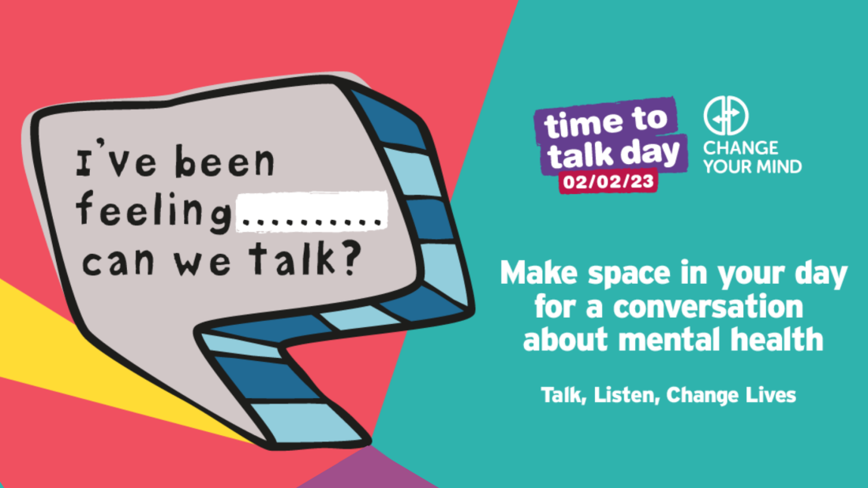
Figure 4: Mental health campaign (Change Your Mind, 2022)
Conclusion
Most people are familiar with someone who has struggled with mental illness. People from all backgrounds and types can experience them. Moreover, it will likely improve once they find a self-care, treatment, and support strategy that works for them. Around the world, there are different ways to treat mental diseases and maintain good mental health. UK medical practitioners generally accept specific causes and therapies for mental health issues to be similar.
Every year on October 10, people worldwide mark World Mental Health Day to spread awareness and mobilize support for improved mental health. The WHO has selected the topic of mental health in the workplace as the focus of World Mental Health Day 2017.

References
Dianova. (2017). Campaign on mental health [online]. Available at: https://www.dianova.org/press-room/releases/campaign-on-mental-health/ (Accessed 29 Dec. 2022).
NHS. (2020). NHS Long Term Plan [online]. NHS Long Term Plan. Available at: https://www.longtermplan.nhs.uk/ (Accessed 2 December 2022).
Change Your Mind. (2022). Mental Health Awareness Campaigns UK and Ireland [online]. Available at: https://www.changeyourmindni.org/our-campaigns (Accessed 10 December 2022).
NHS Digital. (2022). Rate of mental disorders among 17 to 19 year olds increased in 2022, new report shows [online]. Available at: https://digital.nhs.uk/news/2022/rate-of-mental-disorders-among-17-to-19-year-olds-increased-in-2022-new-report-shows (Accessed 10 November 2022).
Mind (2017). About Mental Health Problems [online]. www.mind.org.uk. Available at: https://www.mind.org.uk/information-support/types-of-mental-health-problems/mental-health-problems-introduction/about-mental-health-problems/ (Accessed 7 November 2022).
Mayo Clinic. (2022). Mental Illness - Diagnosis and Treatment [online]. Available at: https://www.mayoclinic.org/diseases-conditions/mental-illness/diagnosis-treatment/drc-20374974[ (Accessed 13 December 2022).
Latoo, Mistry and Dunne (2013). Physical morbidity and mortality in people with mental illness | British Journal of Medical Practitioners [online]. Available at: https://www.bjmp.org/content/physical-morbidity-and-mortality-people-mental-illness (Accessed 5 November 2022).
Care Quality Commission. (2022). Monitoring the Mental Health Act - Care Quality Commission [online]. Available at: https://www.cqc.org.uk/publications/monitoring-mental-health-act
(Accessed 7 Dec. 2022).
BinDhim,N.F., et al. (2020). General Population Mental Health Surveillance System during the COVID-19 Epidemic. Available at: https://www.researchprotocols.org/2020/11/e23748/ (Acceassed 10 November 2022).
Youth. (2000). Risk & Protective Factors [online]. Available at: https://youth.gov/youth-topics/youth-mental-health/risk-and-protective-factors-youth. ( Accessed 8 December 2022).

Mrazek, P.J. and Haggerty, R.J. (2016). Risk and Protective Factors for the Onset of Mental Disorders [online]. Available at: https://www.ncbi.nlm.nih.gov/books/NBK236306/. (Accessed 19 December 2022).

‌
‌

‌

