
Module Name: Academic Skills in the Digital Era
Module Code: BMSW4013
Assessment 1: E-Portfolio
Student Name: Maria Stetco
Student Number:2530464
Lecturer: Christopher Wilkin
Deadline: Friday 27 February 23:59PM

Wordcount: 1,494
AI Acknowledgement
I confirm that I have not presented any AI-generated text as my own work. I confirm that I have retained copies of drafts, notes, and resources used before and after the use of AI tools.
Contents
Component 1 – Development of Academic Skills (500 words) 4
Component 2 – Application of Academic Skills (1,000 words) 6
Component 3 – Academic Poster 8

Component 1 – Development of Academic Skills
Source 1
RAJI, N.A.S., BUSSON-CROWE, D. and DOMMETT, E.J., 2023. University-Wide Digital Skills Training: A Case Study Evaluation. Education Sciences, 13(4), pp. 333.
The source was accessed via library of UWTSD.
Using CRAAP test, the source shows currency because it is a recent publication, published in 2023. The source is relevant because it relates to the use of digital skills in higher education. The authors are academics recognised in education, so they have the authority to write the article. The accuracy is strong because the researchers use systematic evaluation which can be verified. The purpose of the source is academic as it helps audience understand digital training in higher education.

Source 2
Inamorato dos Santos, A. et al. (2023) “The digital competence of academics in higher education: is the glass half empty or half full?,” International Journal of Educational Technology in Higher Education, 20(1). Available at: https://doi.org/10.1186/s41239-022-00376-0.
The source was accessed via library data base of UWTSD.
Using the CRAAP test, the source shows currency because it was published in 2023, meaning it is recent. The relevance is high because it studies the topic relevant to my which is use of digital skills in higher education. The authors are credible because they are academics, which are known in education. The accuracy is strong because the method used it is clear and uses large sample size. The purpose of the source is educational because it evaluates competence of academics in higher education.

Synthesis of Academic Sources
The theme both sources address is the development of digital skills in higher education. Raji et al. (2023) and Inamorato dos Santos et al. (2023) both issue is that digital skills in higher education are influenced by teachers or educators’ skills.
The sources differ because the techniques and focus of research are different. Raji et al. (2023) studies and research on digital training programs for students in higher education, while Inamorato dos Santos et al. (2023), uses a framework to study the teachers and academics competence. The sources complement each other because they offer insights not just from students but also from teachers to help and provide a better understanding of digital skills in higher education. Findings from both sources agree that both digital competence is essential for effective higher education from students and academics. By combining both sources, helps to improve understanding of digital learning by showing that student success depends on both effective training and helpful and competent teachers. (Raji et al., 2023; Inamorato dos Santos et al., 2023).

Identifying a Key Challenge and Opportunity
One key challenge students face in the digital era is when they find it difficult to learn if there are teachers which are unprepared to use digital tools in a helpful way when they teach because it was studied in the source. It shows that the teacher’s competence can limit students’ ability to learn in an efficient way. (Innamorato dos Santos et al., 2023).
One key opportunity student face in the digital era is training programs that can be used by students and are focused on increasing digital skills. (Raji et al., 2023). It is an easier way to build competence and success in studies.

Academic Planning for Component 2
I will prioritise the section of challenges and opportunities because I will have to evaluate in more depth. I will develop time management and planning skills and reflective feedback skills. Component 2 will explain what digital learning is, then show two challenges such as too much information and low motivation. It will also show two opportunities such as easy access to materials and quick feedback from quizzes. In the end, it will have three simple strategies such as making a study plan, take notes and ask questions and use feedback to fix mistakes, then the conclusion.
Timeline
Task | Date/ Deadline
Finish research | 10/02/2026
Draft first section | 12/02/2026
Complete first draft | 15/02/2026
Final editing | 26/02/2026

Reference List – Component 1
Mardiana, H. (2024). Perceived Impact of Lecturers’ Digital Literacy Skills in Higher Education Institutions. SAGE Open, 14(3). https://doi.org/10.1177/21582440241256937
RAJI, N.A.S., BUSSON-CROWE, D. and DOMMETT, E.J., 2023. University-Wide Digital Skills Training: A Case Study Evaluation. Education Sciences, 13(4), pp. 333.

Component 2 – Application of Academic Skills

- Introduction
Digital learning is often used in higher education, and it is taught in lessons through online lessons, virtual learning environments, and digital assessment platforms. Digital learning is useful for both students and teachers because it is a flexible way to learn. However, digital learning can also have flaws because it requires more mental that can influence academic results. It is important to understand both challenges and opportunities so digital learning can be used effectively to support the academic success of students instead of causing difficulties.
This report will explore key challenges students face in digital era, but it will also evaluate opportunities provided by digital learning to students. The report will also suggest academic strategies which can support students to succeed in the digital era.
- Challenges
An important challenge in digital learning is overwhelming information. Study (Tang et al., 2025) shows that obligatory digital learning can be difficult for students because there is a demand of continuous online coursework or digital tasks. Online learning has a numerous number of recorded lectures or readings which students may find difficult to receive such a huge amount of information so fast. This can cause reduced academic performance as it can be difficult for students to stay focused, understand the content of the coursework and prepare for assignments.
Another important challenge students face in the digital era is the lack of motivation. In digital learning, students must study on their own and get less support from teachers. Study (Wang et al., 2025) shows that students in digital learning may feel unsupported and alone when completing independent study and need to stay active so they don’t lose motivation. Low motivation can cause students to give up on tasks and fall behind in class. This affects success because students need to study regularly and complete the work given on time. These challenges are connected to skills which are taught in class such as independent learning, which is obligatory, time management and staying focused.
- Opportunities
Despite the challenges, digital learning can also offer opportunities which are important for students to use to improve learning and academic success.
An important opportunity to be considered is the flexible access to learning materials. Access to learning materials is through online platforms which help students to watch lectures, access books using online libraries or go back to content at any time. Study (Turan et al., 2022) shows that students can benefit from digital learning because they have the chance to revisit lectures in their own time to fix mistakes and understand the difficult parts. This flexible access is important for students because with so much information, they can study in a way easier for them. Flexibility can also be a problem for students who don’t organise their time. Flexible access to online learning is a key opportunity as students have the chance to control the learning pace and understand better but with presentable planning.
A second important opportunity for students in digital learning is the feedback tools and online quizzes. Digital quizzes help students with instant and important feedback to understand and show what needs to be improved. It also helps students to correct mistakes and plan for the next time how to improve. Study (Al-Hail et al., 2024), shows that quizzes are helpful and effective for students who participate and show interest. There could be a problem if students ignore the feedback and only complete quizzes to pass because they then have little understanding of what and where to improve. This shows that digital tools like quizzes can be a benefit for students, but it depends on how students interact with them and apply the feedback from teachers and also the course and learning.

- Adaptation strategies
There are strategies which students can use to succeed in their academic journey.
- First strategy is to make a structured plan. Creating a plan for lessons, reading and assignments can help students manage their time and the work given in class and reduce stress. Planning can lead to development of time management skills . Study (Wang et al., 2025) shows that planning helps students to stay motivated and to do tasks on time. For example, breaking the study times helps students stay organised and finish work on time.
- A second strategy for students is to take notes, ask questions and go back over materials and lessons. This helps students with reading and taking notes skills. Study (Wang et al., 2025) shows that students who interact with materials or in lessons understand and improve better in assignments. This strategy can contribute to motivation because students can control their learning and can apply the knowledge immediately. An example is when students answer questions after reading to check understanding and identify where needs improvement.
- A third strategy is going back over feedback and assignments to find mistakes which need to be improved. This can help with improving reflective learning skills. Study (Wang et al., 2025) shows that checking feedback helps students learn better strategies and hold information for longer. For example, a student that goes over feedback may find a repeated mistake for a specific course and can do revision to improve. This is a strategy students can use to stay motivated because they can see their progress, make changes and feel more confident.

- Conclusion
Digital learning presents flexibility, challenges and opportunities. The challenges such as information overload and low motivation make studying harder and reduces academic success. However, opportunities such as flexible access to materials such as online quizzes with feedback can be used for improved learning when students use them effectively. This report shows three strategies to help students succeed: making a structured plan, engaging with materials often and using feedback in a critical way. Students benefitting from digital learning it’s important to be motivated, use academic skills and self- discipline. Students can manage challenges and make most of opportunities from digital learning if they apply this strategy and also improve their understanding and confidence in higher education.

Reference list:

Al-Hail, M., Zguir, M.F. and Koç, M. (2024) “Exploring Digital Learning Opportunities and Challenges in Higher Education Institutes: Stakeholder Analysis on the Use of Social Media for Effective Sustainability of Learning–Teaching–Assessment in a University Setting in Qatar,” Sustainability, 16(15), p. 6413. Available at: https://doi.org/10.3390/su16156413.
Tang, S. and Cui, T. (2025) “Exploring the impact of mandatory digital learning on digital learning engagement: a longitudinal study from higher vocational education,” Education and information technologies, 30(18), pp. 26433–26456. Available at: https://doi.org/10.1007/s10639-025-13793-1.

Turan, Z., Kucuk, S. and Cilligol Karabey, S. (2022) “The university students’ self-regulated effort, flexibility and satisfaction in distance education,” International Journal of Educational Technology in Higher Education, 19(1). Available at: https://doi.org/10.1186/s41239-022-00342-w.

Wang, X. et al. (2025) “Empowering teachers’ professional development with LLMs: An empirical study of developing teachers’ competency for instructional design in blended learning,” Teaching and teacher education, 165. Available at: https://doi.org/10.1016/j.tate.2025.105091.

Component 3 – Academic Poster
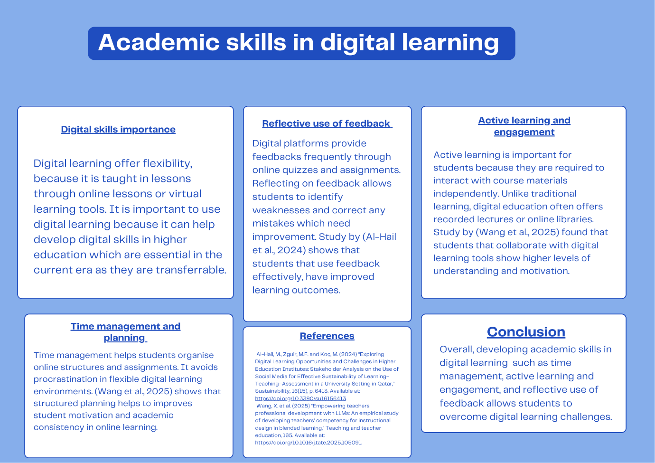

Reference:
Al-Hail, M., Zguir, M.F. and Koç, M. (2024) “Exploring Digital Learning Opportunities and Challenges in Higher Education Institutes: Stakeholder Analysis on the Use of Social Media for Effective Sustainability of Learning–Teaching–Assessment in a University Setting in Qatar,” Sustainability, 16(15), p. 6413. Available at: https://doi.org/10.3390/su16156413.
Wang, X. et al. (2025) “Empowering teachers’ professional development with LLMs: An empirical study of developing teachers’ competency for instructional design in blended learning,” Teaching and teacher education, 165. Available at: https://doi.org/10.1016/j.tate.2025.105091.

