Group Project
Group Project for Electronics (ACDA5017) (EES Version)

Table of Contents
Table of Figures 5
Table of Equations 6
Table of Tables 6
1. Abstract 7
2. Introduction 7
2.1 Problem Statement 7
3. Literature Review 8
3.1 Problem Analysis 8
3.2 HEPA filters 8
3.3 Carbon Filters 9
3.4 Other alternatives 10
3.5 Market Research 10
4. Initial Project Planning 11
4.1 Objectives 11
4.2 Budget 11
4.3 Gantt Chart 12
4.4 Impact & Ethical Considerations 12
4.5 Work breakdown structure 13
5. Design 14
5.1 System Block Diagram 14
5.1.1 System Breakdown 14
5.2 Initial Concepts 14
5.3 Circuit Design & Hardware Research 17
5.3.1 Components 17
5.3.2 Circuit Block Diagram 20
6. Development 20
6.1 Electronics, Circuit Design & Simulation 20
6.1.1 Circuit Breakdown: 20
6.1.2 Boost converter design 21
6.1.3 Simulations 23
6.1.4 USB-C implementation 23
6.1.5 Low side switch 24
6.1.6 Prototyping 24
6.1.6 Safety considerations 26
6.2 Additional Peripherals 26
6.3 Coding & Software 27
6.3.1 Flow Chart 27
6.3.2 Setting up 28
6.3.3 Fan Interfacing 29
6.3.4 Sensor Interfacing 30
6.3.5 Screen’s User Interface 31
6.4 Hardware & Mechanical 33
6.4.1 Safety features 37
7. Implementation 37
8. Testing 37
8.1 Scope 37
8.2 Objectives 37
8.3Test Methods 37
8.3.1 Gas Sensor 37
8.3.2 Temperature Sensor 38
8.3.3 Humidity Sensor 38
8.3.4 Air Flow 39
8.3.5 Air Quality Change 39
9. Results 39
10. Evaluation 40
10.1 Reviewing Objectives and Requirements 42
10.2 Comparison to research 43
10.3 Improvements 43
10.4 Difficulties/problems faced 43
10.5 Total Expenses 44
11. Group Admin 44
11.1 Group Operation & Organisation 44
11.1.1 File Storage & Data Transfer 44
11.2 Group Responsibilities 45
11.3 Logbook & Team Decisions Record/Minutes 47
12. Conclusion 47
12.3 Further work 47
12.2 Benefits of Final project 47
13. Reflections 47
13.1 Louis 47
13.2 Saffina 48
13.3 Chris 48
13.4 James 48
Bibliography 49
Appendix 49
Appendix A - Tools and software used 49
Louis 49
Hardware 49
Software 49
Saffina 50
Hardware 50
Software 50
Chris 50
Hardware 50
Software 50
James 51
Hardware 51
Software 51
Appendix B - Logbook 51
19/05 51
26/05 51
02/06 52
09/06 52
16/06 52
23/06 53
30/06 53
07/07 53
Appendix C - Code 54

Table of Figures
UWTSD
Louis S (2322688), Saffina H (2322601),
Chris B (2322626), James T (2322728)
Figure 1: Particulate concentration with HEPA filters on/off 8
Figure 2: HEPA filters removing particulates 9
Figure 3: Carbon pellet adsorption of particles 9
Figure 4: Project Gantt chart 12
Figure 5: Work breakdown structure 13
Figure 6: Concept sketch SH 15
Figure 7: VentraClear logo CB 15
Figure 8: VentraClear logo on the PCB 16
Figure 9: VentraClear logo on the enclosure 16
Figure 10: Initial CAD concept model JT 17
Figure 11: ESP32 schematic 17
Figure 12: LED and reset circuit schematic 18
Figure 13: 5V to 3V3 linear regulator 18
Figure 14: GDI connector schematic 18
Figure 15: Schematic of USB-C circuit 19
Figure 16: Schematic of boost converter circuit 19
Figure 17: Circuit block diagram CB 20
Figure 18: Ripple caused by capacitor value in the boost circuit SH 21
Figure 19: Output from the boost converter simulation SH 22
Figure 20: Simulated circuit CB 23
Figure 21: Simulated results of output voltage and power JT 23
Figure 22: Low side switch simulation LS 24
Figure 23: Veroboard testing with oscilloscope and bench power supply SH 24
Figure 24: Oscilloscope output of the boost converter SH 25
Figure 25: USB power monitor CB 25
Figure 26: Full prototype testing CB 26
Figure 27: Pinout diagram of the ESP32 SH 26
Figure 28: Coding flow chart 27
Figure 29: Code defining variables, functions and libraries 28
Figure 30: Code with the initial set up function 28
Figure 31: Code of the main function loop 29
Figure 32: Code of the fan on and off function 30
Figure 33: Code to retrieve sensor values 30
Figure 34: Code to display the sensor reading values and units 31
Figure 35: Mock-up of the screen display layout 31
Figure 36: Code to draw a curve on the screen 32
Figure 37: Code creating the leaf icon 32
Figure 38: Code creating the thermometer icon 32
Figure 39: Code creating the humidity icon 33
Figure 40: Complete CAD model 33
Figure 41: CAD model showing each element 34
Figure 42: 3D printed enclosure 34
Figure 43: Top panel of the enclosure 35
Figure 44: Internal view of the final enclosure 35
Figure 45: Carbon pellet tray 36
Figure 46: Mounting holes for sensors and bottom of enclosure 36
Figure 47: Final product - top view 41
Figure 48: Final product - side view 41
Figure 49: Final product - screen display 42
Figure 50: Shared OneDrive for exchanging files 45

Table of Equations
Equation 1: Equation to calculate capacitor value in Boost circuit 21
Equation 2: Equation to calculate the inductance value 22
Equation 3: Calculating PWM duty cycle value 29

Table of Tables
Table 1: Current products on the market 10
Table 2: Budget plan 11
Table 3: Air Quality sensor test results 38
Table 4: Temperature test results 38
Table 5: Humidity sensor test results 38
Table 6: Air through-put test results 39
Table 7: Air quality improvement testing 39
Table 8: Analysis of test results compared to expected 40
Table 9: Specifications met 42
Table 10: Recorded expenses 44
Table 11: Group responsibilities breakdown 46

Abstract
This report outlines and records the processes used to develop the group project, including the design, manufacture and testing of a small-scale, air monitoring and filter system aimed at hobbyists and home applications. The write-up also includes additional project topics such as budget and group decisions.
The project aims to help and improve the environmental conditions of hobbyist workshops and other small-scale manufacturing setups by providing air quality monitoring and filtration. CB

Introduction
This report details the development of a compact filtration system to filter pollutants created in hobbyist and 3D printing environments. The product was designed to incorporate an ESP32, USB-C connection, a digital screen, and sensors for gas, temperature, and humidity. Regular team meetings, good documentation and team coordination were maintained throughout the project.
A prototype circuit was created where testing was performed. An enclosure was 3D printed in addition to having a PCB Manufactured.
Testing confirmed the functionality of the product, which proved a reduction in airborne pollutants and particulate matter. LS

Problem Statement
DIY is increasingly popular [1], with its’ popularity predicted to increase further. In this report, 3D printing will be discussed as an example of at-home DIY, however the concepts discussed can be applied to many other hobbyist equipment. 3D printing’s use is increasing across all demographics [2]; the key issue arising from this increased popularity is air quality [3]. Both FDM and Resin printers can produce emissions of Ultrafine Particles (UFP) and Volatile Organic Compounds (VOC) [4] [5]. SH
VOCs can be toxic both to the environment and to health. They can contribute to the effect of global warming and can contaminate groundwater if not filtered correctly [6]. If inhaled, VOCs can cause headaches, nausea, and breathing difficulties; some are carcinogens [7]. LS
UFPs can be equally dangerous, worsening symptoms of cardiovascular and respiratory disease [8]. Exposure has a high correlation to lung cancer, heart disease, and diabetes [9]. It can cause lung inflammation and has also been shown that children and pregnant women are more vulnerable to these emissions [10]. JT

Literature Review

3.1 Problem Analysis
Current solutions include ventilation control systems such as fume hoods or ventilated exhaust racks [3], which cannot be applied easily to an at-home scenario. Solutions also involve HEPA and carbon pellet filters [5]; however, these require two separate products, not being space or cost effective. There is a need for a portable, cheap, and easily implemented air filtration system which has the benefits of both filters. CB

3.2 HEPA filters
An article by Dubey et.al. [11] looked at the effectiveness of HEPA filters in removing pollutants. It was found to greatly reduce the concentration of particulates in both general indoor air (GID) and candles and incense smoke (CIS), their results are shown below in Figure 1.
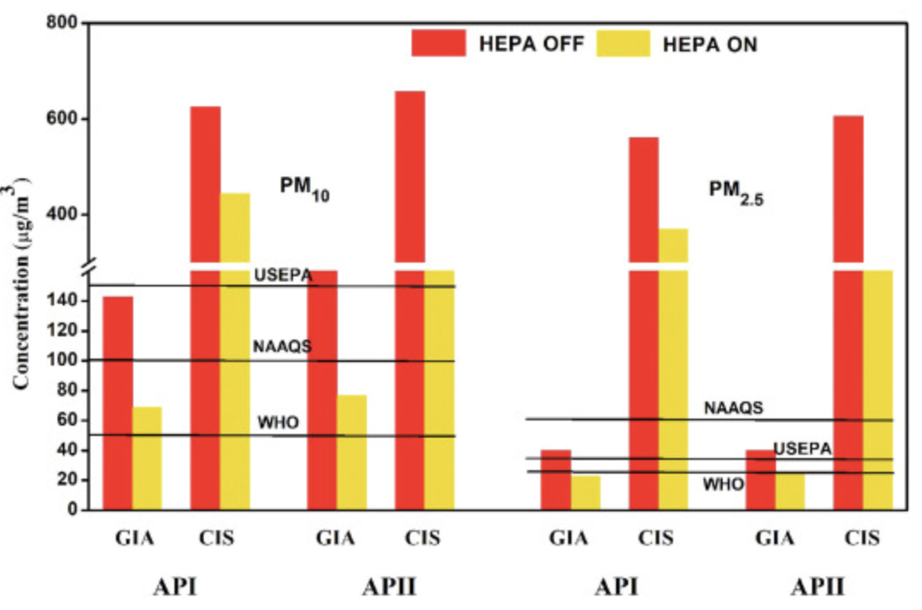 [11]
Figure 1: Particulate concentration with HEPA filters on/off
Another study by the University of Melbourne [12] came to a similar conclusion that “portable air cleaning devices were very effective for removal of aerosols”. While the study was within a medical context, the theory can also apply to a workshop environment.
These filters are an efficient way to separate UFPs and dust from the air, removing up to 99.9% of these particles [13].
HEPA filters are typically rated to remove particles at sizes around 0.3 microns, however, can remove particles smaller and larger than this [14], by physically trapping particulates, shown in Figure 2. CB
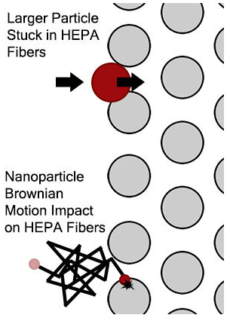 [14]
Figure 2: HEPA filters removing particulates

3.3 Carbon Filters
The performance of activated carbon filters has been looked at: a peer-reviewed article from Savitribai Phule Pune University [15] studied charcoal filters’ effectiveness to combat indoor air pollution. They found a “noticeable improvement in air quality” and suggested that in future, could be integrated into smart home systems [15], which could be in explored in this project.
These results are supported by findings from a study by Mondal et.al. [16] in which charcoal based activated carbon pellets had an adsorption efficiency of around 50%, and the highest surface area of the materials tested.
Carbon pellets have excellent adsorbent characteristics, allowing them to adsorb gases and chemicals through pores, either from a chemical reaction or physically trapping gas particles [17]. This process is shown in Figure 3. SH
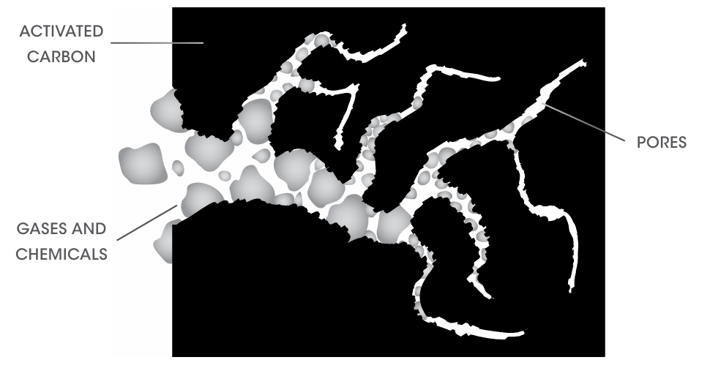 [17]
Figure 3: Carbon pellet adsorption of particles

Other alternatives
A study by Tseng et.al. [18] found that nanogold-silver, coated activated carbon filters were at least 15% more effective that uncoated filters in removal of pollutants. This cannot be easily implemented simply or cheaply to an everyday consumer product.
Other suggested filtration techniques include:
- UV technology – using UV lamps to disinfect the air
- Negative Ion technology – negative ions are generated, which attach to particles in the air
- Transparent PAN filter – uses polyacrylonitrile nanofibers [19]
These each have difficulties in implementation in this context, including price, complexity, and range of effectiveness [20]. LS

3.5 Market Research
Current solutions include a range of different modules, both plug-and-play and Do-It-Yourself (DIY). A selection of these can be found in Table 1 below [21] [22] [23] [24] [25].
Table 1: Current products on the market

The selected products available come at a range of prices and sizes; the more expensive lean towards industrial applications, while the smaller ones are focused on individuals. The products looked at are either air quality monitors or purifiers/filters. The AirWatch system uses a laser to detect particulate matter; meanwhile, the Amazon smart and Temtop monitors use sensors built up of different compounds [26]. An example of this is the MQ-135 sensor, which has an $Al_{2}O_{3}$ ceramic tube and $SnO_{2}$. These monitors also sense temperature and humidity, making them useful for a broad range of applications. JT
The filter systems are similarly priced, both have HEPA filters however the BentoBox also uses carbon pellets, which is good for absorbing VOCs. These do not have sensors or a monitoring system; they are manually turned on/off. Neither filter has a user interface, but the BentoBox has the option to connect to a device, such as a 3D printer, or can use an external power supply. This also has limitations, as it is specifically designed for 3D printers with enclosures, which reduces its versatility. JT

Initial Project Planning

4.1 Objectives
The product is to be designed to the following specifications:
- Air monitoring system with temperature, humidity, & quality sensing capabilities
- Display for each sensor readout
- Fans activate past a threshold of air quality
- HEPA & carbon filters, with easy replacement
- Low profile & discrete, quiet fans
SH
Potential further specifications:
- Scent options
- Wireless connectivity to other modules
- Touch Screen as a user interface
JT

4.2 Budget
The following budget estimate was created before continuing, as shown below in Table 2:
Table 2: Budget plan

It’s important to add a budget tolerance to account for unexpected issues, such as supply chain disruptions or cost increases. This was done in addition to creating a budget for miscellaneous materials that may not have already been included. LS

4.3 Gantt Chart
At the start of the project, a Gantt chart was created to help the team stay on track and to have performance indicators. This ensures that everything is made on time and gives a clear project timeline. The Gantt chart is show below in Figure 4. CB
Figure 4: Project Gantt chart
As shown above, some timeframes are overestimated to allow time for technical delays or supply chain issues [27]. CB

4.4 Impact & Ethical Considerations
This project aims to being to improve general/respiratory health [28]. The device does not provide any dangers to humans or society; it aims to improve the health of the users by removing dangerous chemicals and VOCs [29] CB. There are ethical considerations in the production, the enclosure will be 3D printed, which can generate microplastics, however, 3D printed items can be ground up and used to create new filaments, that are recyclable [30] [31] JT. Easily changeable filters and carbon pellets will be used, allowing filters to be replaced, extending the overall lifespan, and reducing waste CB. British products will be used where possible, to reduce the carbon footprint of the supply chain. The use of AI will be minimised, as AI models use large amounts of energy [32], and can reduce the work available for humans. SH
COSHH and WEEE regulations will be followed in the production environment, meaning the separation and proper disposal of hazardous chemicals and electronic waste. LS
The aim is to have a net benefit on society, as the reduction of harmful gases and particulates will improve the health of the users which will offset environmental impact from production [33]. LS

4.5 Work breakdown structure
Before the project design was started, a Work Breakdown Structure (WBS) diagram was created to have a better understanding of the overarching tasks required for project completion, shown in Figure 5.
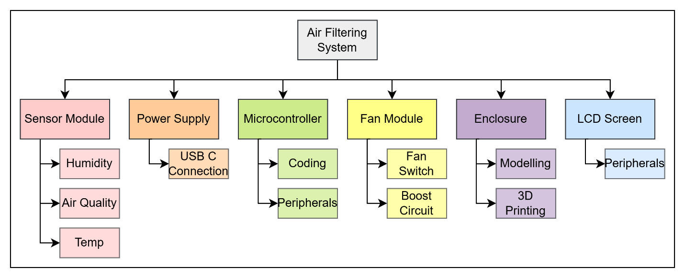
Figure 5: Work breakdown structure
The WBS allows for more clarity on each of the project's constituent parts and the work required in each of them and allowed a logical process to be followed. LS

Design

5.1 System Block Diagram
An initial block diagram was created to lay out the basic system of our project.
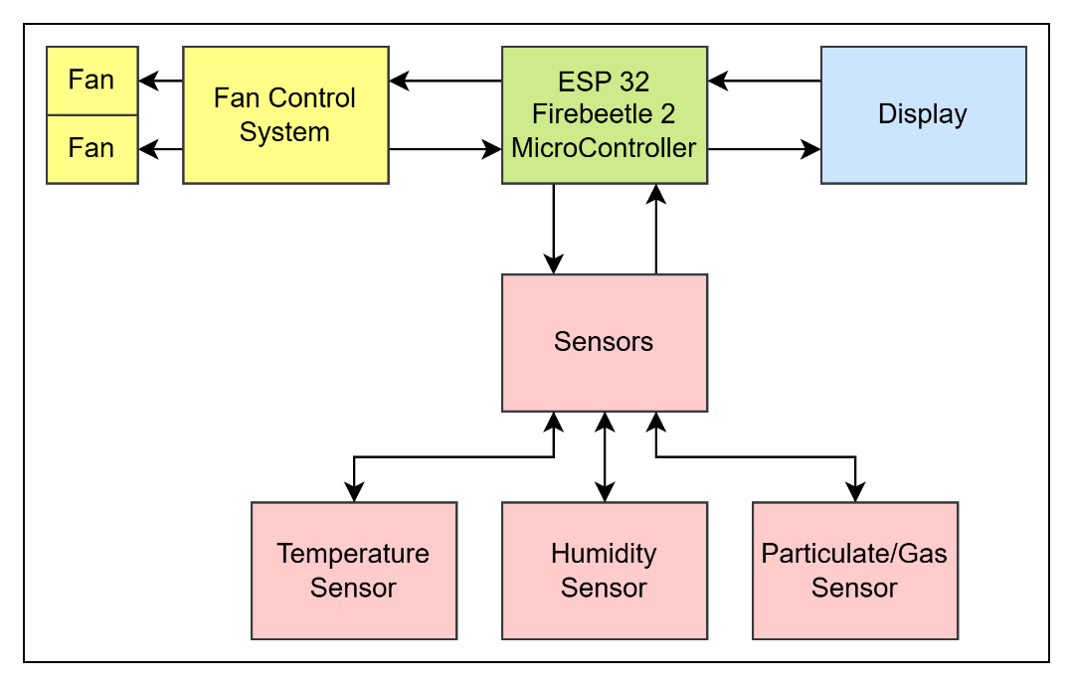
Creating this block diagram allows the project to be easily split into segments, where the technical aspects of each can be broken down. CB

5.1.1 System Breakdown
Fan control - The fans need a 12V supply, so a boost circuit is needed, controlled by the ESP32
Display – The display is powered via the ESP32 GDI interface
Sensors – The sensors are powered by the ESP32 and relay data back to it
Micro controller – The ESP32 receives input data from the sensors, processes it, updates the display, and determines if the fans must be turned on or not. It requires a 5V input, regulating down to 3V3. SH

5.2 Initial Concepts
Based on the market research, a concept sketch was created. This features a tray for the activated carbon, with the HEPA filters behind it, a screen on top and two fans to pull air through the purifier. The filters will slide in and out for easy replacements and are covered by a magnetised panel. There will be room for a PCB in the bottom. The basic diagram is shown in Figure 6. SH
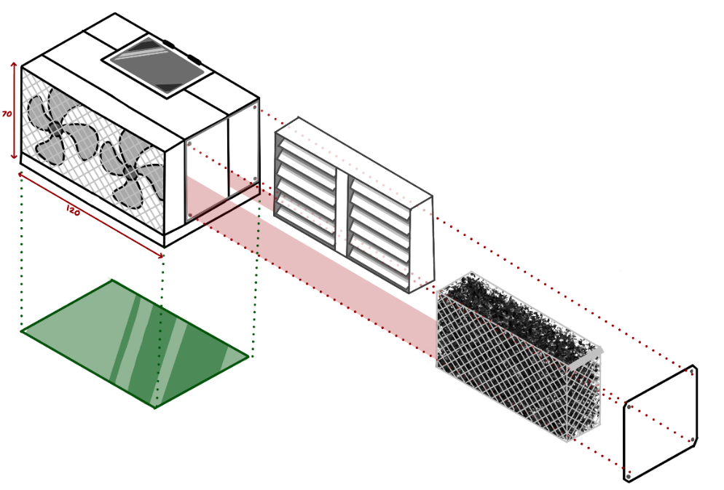
Figure 6: Concept sketch SH

A logo was created for the product, to better understand and visualize the brand concept, and allow continuity across different elements, by including the logo on each. The logo is shown in in Figure 7, and its’ inclusion to the final product in Figures 8 and 9. CB

Figure 7: VentraClear logo CB

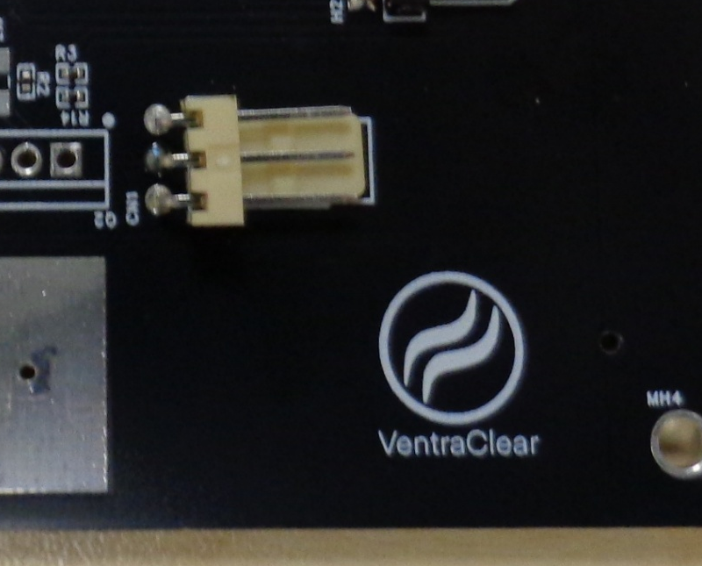
Figure 8: VentraClear logo on the PCB
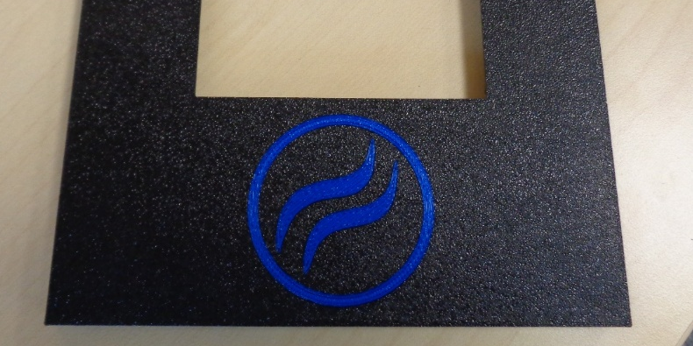
Figure 9: VentraClear logo on the enclosure

A CAD model shown in Figure 10 was created as a basic visualisation of the product. Allowing for easier design and communication across group members, as each had an idea of the final product. JT
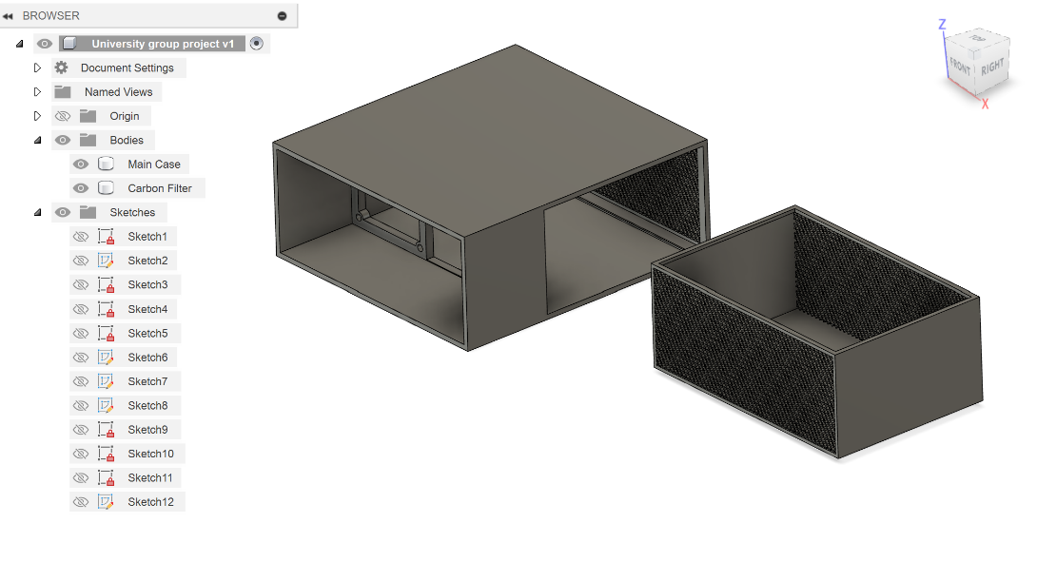
Figure 10: Initial CAD concept model JT

5.3 Circuit Design & Hardware Research

5.3.1 Components

PCB
The ESP32-E was selected as it provides opportunity for future development. It has Wi-Fi capability, allowing integration to networks using Wi-Fi [34]. It has lots of documented support, making development easier. It runs on 3.3V, so a linear regulator was added reduce the USB-C 5V down to 3.3V, with capacitors on the input and output improving stability and transient response JT.
LEDs with current limiting resistors were added to indicate power and code outputs. A reset circuit was added to the reset pin, which charges the capacitor to 3.3V, and the resistors pull the reset pin high. When the button is pressed, the capacitor discharges (at the rate of the RC time constant) and the reset pin is pulled low, resetting the micro. The schematics are shown in Figures 11-13. LS
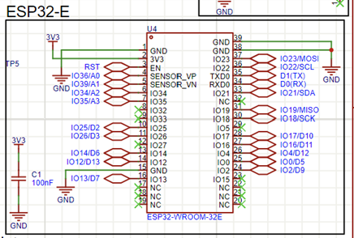
Figure 11: ESP32 schematic
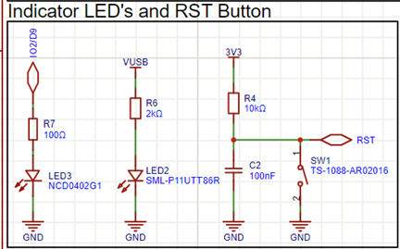
Figure 12: LED and reset circuit schematic
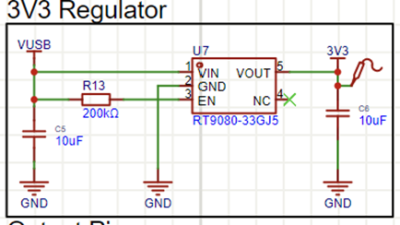
Figure 13: 5V to 3V3 linear regulator

The ESP32 also can communicate through GDI which makes connecting other modules, such as an LCD display far simpler. The schematic is shown below in Figure 14 [35]. SH
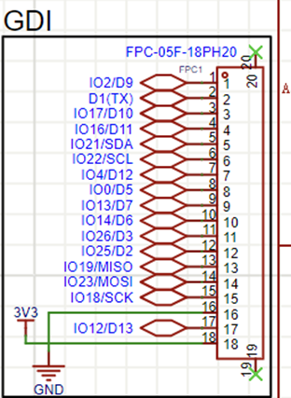
Figure 14: GDI connector schematic

USB-C was selected as it is an industry standard across many devices [36]. It has 5.1k pull-down resistors for USB detection and power negotiation. It also uses a driver circuit using a CH340k, which controls reset and boot mode selection between the USB-C and ESP32, shown in Figure 15. CB
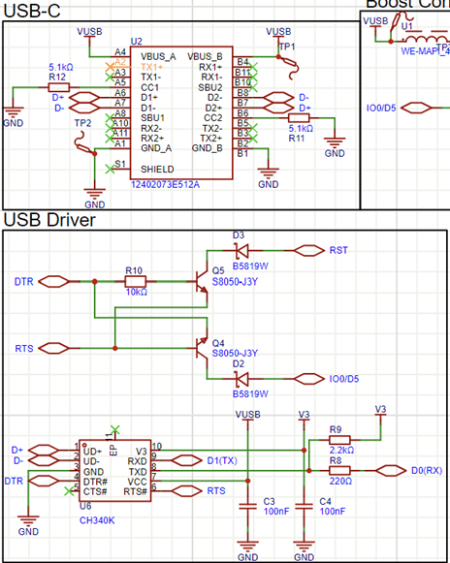
Figure 15: Schematic of USB-C circuit

The boost convertor is made with an inductor, N-channel MOSFET, diode, and the load. It boosts the 5V to 12V for the fans. The MOSFET's frequency is generated from the ESP32 PWM pin. The circuit has a potential divider to make a lower voltage for the microcontroller to read, acting as feedback for the output voltage of the boost. This allows the micro to adapt the frequency to keep a constant 12V. In series with the load is a low-side switch, used by the microcontroller to switch the fans on and off. The schematic is in Figure 16 below. JT
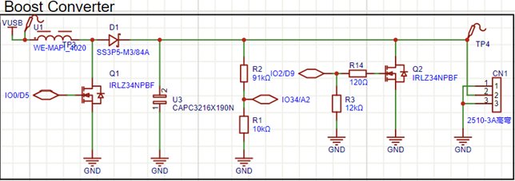
Figure 16: Schematic of boost converter circuit

Output devices
The output devices include 2 Noctua fans, a 3.5-inch LCD touchscreen display, and sensors. The fans selected were Noctua since they are known for being low noise. The 3.5-inch LCD was selected due to the size of the box. With a smaller screen, it would have looked out of place. Since the LCD has touchscreen capabilities, there are possibilities in the future for a touchscreen user interface. [37]The MQ-135 sensor was selected as it works at the USB-C input voltage and senses gases, alcohol, benzene and smoke. A DHT22 sensor was selected to reliably read the temperature and humidity values. CB

5.3.2 Circuit Block Diagram
The diagram below in Figure 17 shows the basic circuit block diagram, which allows us to break them down into further steps, while knowing what parameters must be met. CB
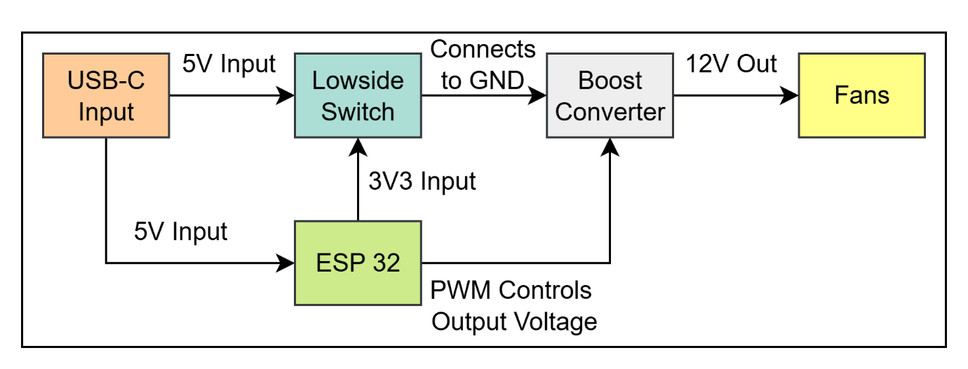
Figure 17: Circuit block diagram CB

Development

Electronics, Circuit Design & Simulation

6.1.1 Circuit Breakdown:
The simplest method of providing 12V is a 12V DC wall adapter and use a linear voltage regulator to provide 5V for the ESP32. However, the team decided to use USB-C, to make it easier for the customer to replace the cable if it got lost or damaged, also reducing the risk of damage if they used a wall adapter that was not capable of supplying the current needed, or supplied too high a voltage. JT
The low side switch is a simple circuit, needed as the fans still run weakly when the PWM signal from the ESP32 was turned off (due to 5V being across them, not 12V). This switch will be controlled by a GPIO pin on the ESP32. LS

6.1.2 Boost converter design
To design the boost converter, the following design parameters were defined.
- V_{in} – 5V
- V_{out} – 12V
- I_{out} – 160mA each fan runs at 80mA
The maximum frequency of the PWM pins on the ESP32 is 40Mhz [38]. When choosing a frequency to work at, higher is better, allowing smaller parts to be used [39].
As the frequency can be changed, and so can the duty cycle arbitrary values of 500Khz, and 50% were chosen, to allow other calculations to be completed. CB

Component selection
Capacitor value was selected using Equation 1 below.
Equation 1: Equation to calculate capacitor value in Boost circuit
$$Cout\left(min\right)=\frac{Iout\left(max\right).D}{fs.Vout}$$

With D being the duty cycle, fs being the frequency, this gives a minimum value of 13nF. However, during simulation, the small resistor had an too ripple on the output, as seen below in Figure 18.SH
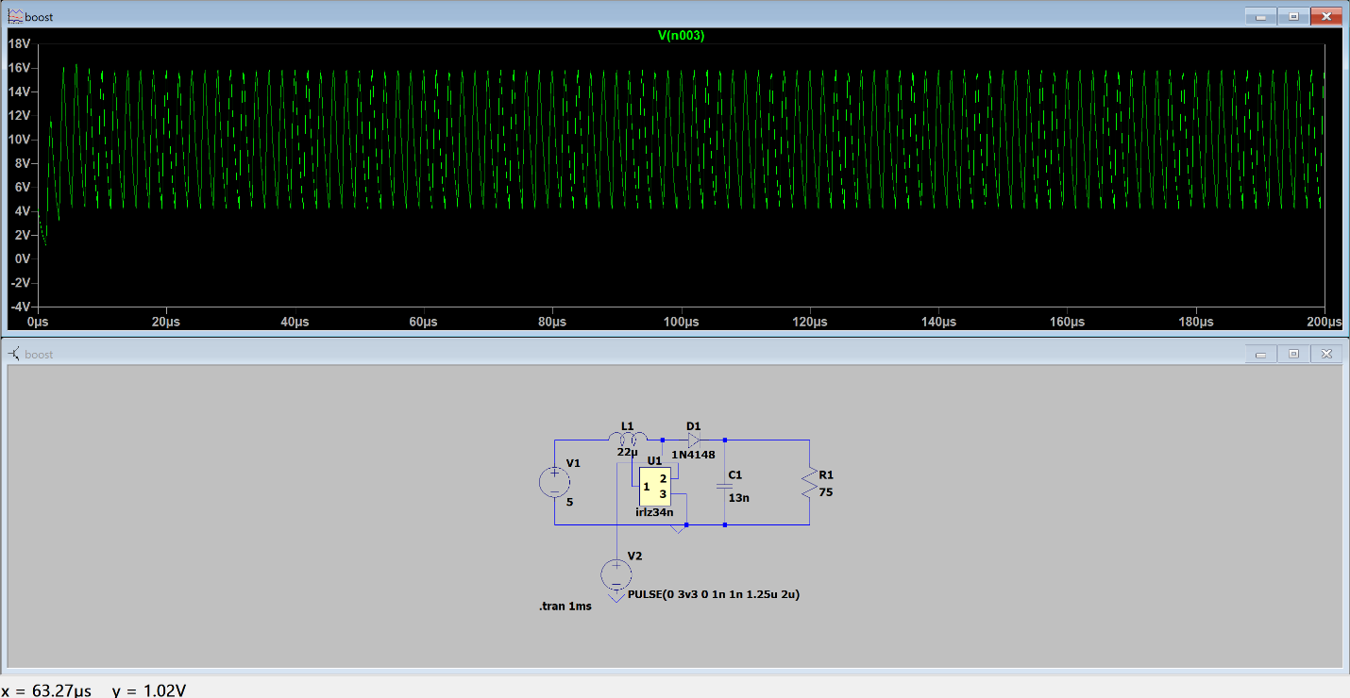
Figure 18: Ripple caused by capacitor value in the boost circuit SH

To decrease this to a reasonable value, the capacitance was increased to another standard value we had available, of 10uf, the results are shown below in Figure 19. SH
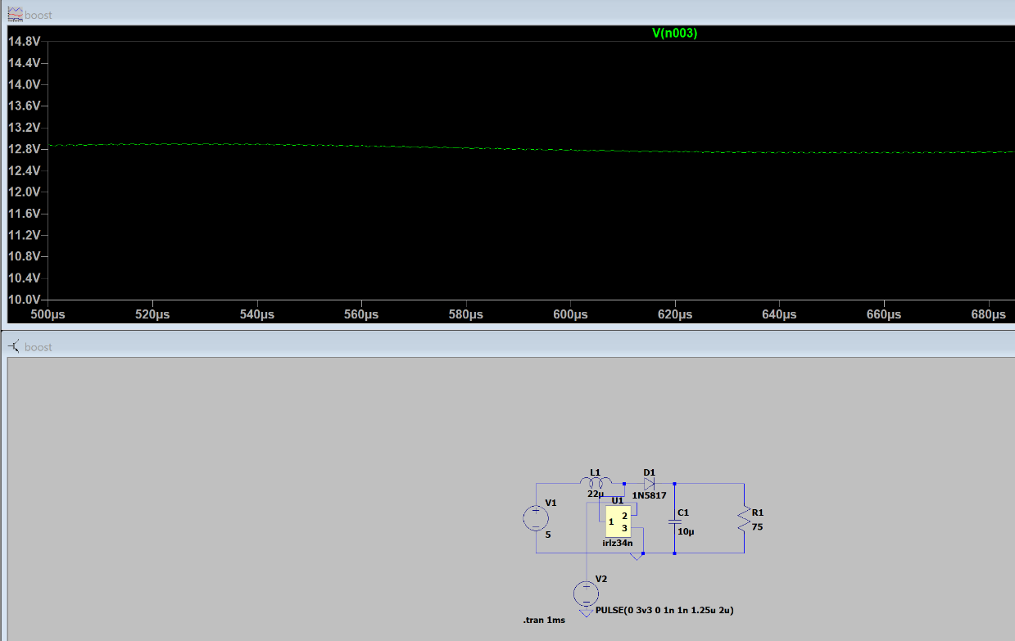
Figure 19: Output from the boost converter simulation SH

The inductor value was calculated using Equation 2 below, where IL = $\left(0.2 to 0.4\right).$
Equation 2: Equation to calculate the inductance value
$l=\frac{Vin.\left(Vout-Vin\right)}{Il.fs.Vout}$ [40]
$Iout\left(max\right).\frac{Vout}{Vin} CITATION Tex22 \backslash l 2057 [40]$ so using 0.4, and I_{out} as 200mA, I_{out} = 192mA. This is rounded to 200mA for a better safety margin. Using this data, the inductor value is 29.16uH. An inductor value of 22uH was used, as there was a standard E6 value inductor readily available. LS
The diode must be able to handle the reverse voltage applied and the peak current. It must also be a fast-switching diode. The diode picked was a 1N5817, as it was available to order in small quantities for a low price, and fast to ship. It has a peak inverse voltage of 20V, a forward current of 1Amp, and is a fast switching diode [41]. JT
The switching device had to be capable of switching at 500kHz and be in saturation at 3V3. For this, a IRLZ34N logic-level power MOSFET was chosen, which can switch at over 500Khz, has a low gate capacitance (880pF), a low gate threshold voltage(1-2V), and is saturated when operating at 3V3 [42]. It was the only one available that had a low lead time and was able to be purchased in small quantities. CB

6.1.3 Simulations
A basic circuit diagram was created for testing, shown in Figure 20. The IRLZ34N is not on LTSpice by default, so a .lib file was found, and a symbol created using a SUBCKT model line. The V1 supply mimics the 5V from the USB-C, and V2 mimics the PWM 3V3 from the ESP32, with a 62.5% duty cycle, which was found to give 12V output. However, due to parasitics, the duty cycle may need to be tweaked. The 75 Ω resistor was used to simulate the load of the fans. CB
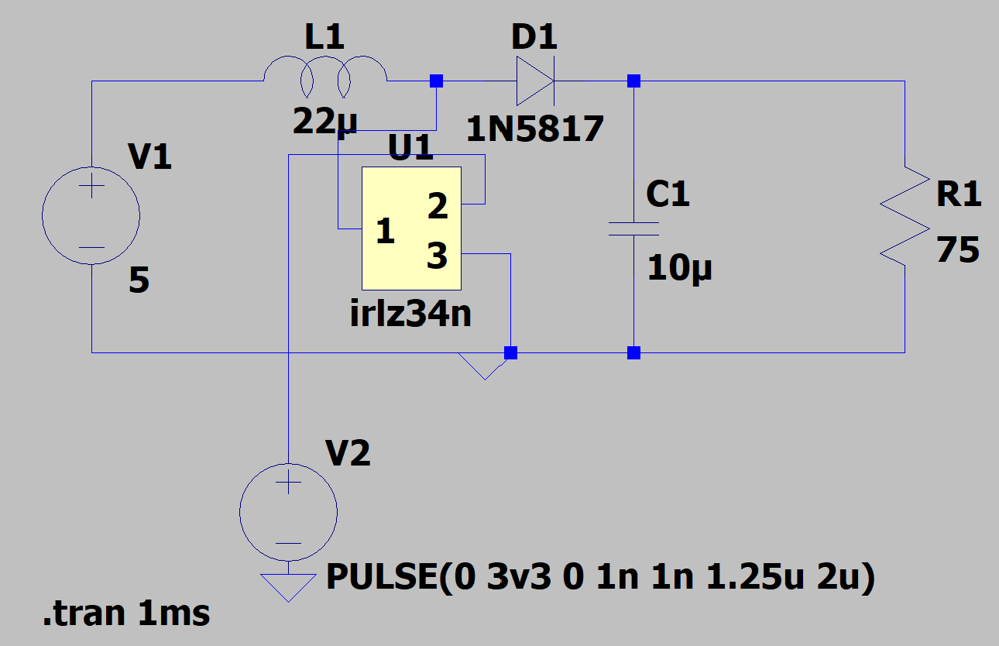
Figure 20: Simulated circuit CB
Figure 21 shows the output voltage in green, the blue trace shows the power dissipation of the MOSFET, which peaks briefly at 44W, still below its max, but in typical usage bounces between 0-8W. JT
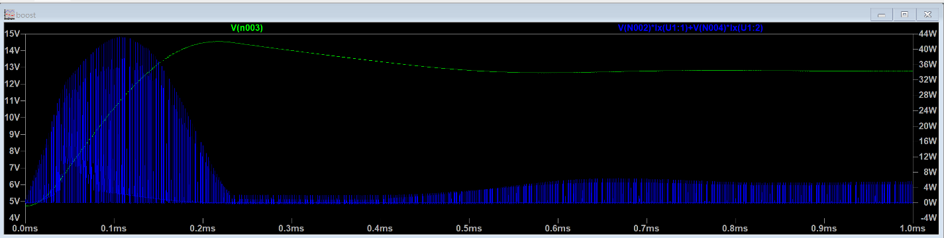
Figure 21: Simulated results of output voltage and power JT

6.1.4 USB-C implementation
The USB-C power circuit required some extra circuitry around it. As the product draws over 500mA some USB-C negotiation was needed because as default, USB-C will supply 500mA@5v [43]. To negotiate a higher current, a set voltage must be read on the CC1 or CC2 pins of the USB-C header. The wall power supply is the DFP (downward facing port [43]) and has resistors on its CC1/2 pins, and complementary resistors must be added to our USB-C, which is the UFP (Upward facing port [43]),CC1/2 pins to create a voltage divider, reading between roughly 0.9V and 1.7V (for 1.5A or 3A). To do this, 5.1kΩ resistors were added on the pins, going to ground [43]. CB

6.1.5 Low side switch
The low side switch shown in Figure 22, uses an N-Channel MOSFET, with two resistors. The MOSFET was the same as we used in the boost converter, to save on buying extra parts. R2 (12kΩ) is a pull-down resistor, to make sure that the ESP32 pin was dropped low when it was off, turning the MOSFET fully off. R3 (120Ω) was used to ensure the MOSFET was fully turning on when the ESP32 pin went high. LS
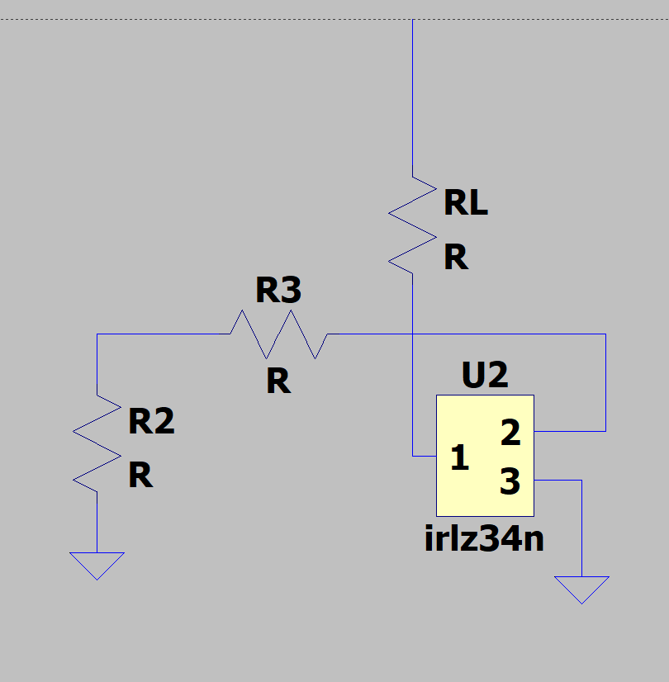
Figure 22: Low side switch simulation LS

6.1.6 Prototyping
To test these circuits, they were laid out on Veroboard, tested first using a lab power supply, and then a USB-C cable with a USB power monitor attached. This is shown in Figure 23 below .SH
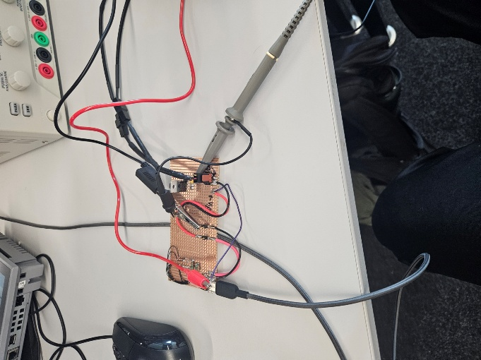
Figure 23: Veroboard testing with oscilloscope and bench power supply SH

Before powering the boost converter from USB-C, it was tested to ensure it could draw over 500mA. This was done using an electronic load, set to 5V 1A, which the USB-C was able to supply, verified by both the electronic load, and the USB power monitor. JT
The boost converter was tested first using a bench-top power supply, limited to 5V 1A , and a signal generator to mimic the ESP32 (square wave signal, 3V3, offset 1.65V, 500kHz, duty cycle 62%). An oscilloscope was used to measure the output of the boost converter, shown in Figure 24. SH
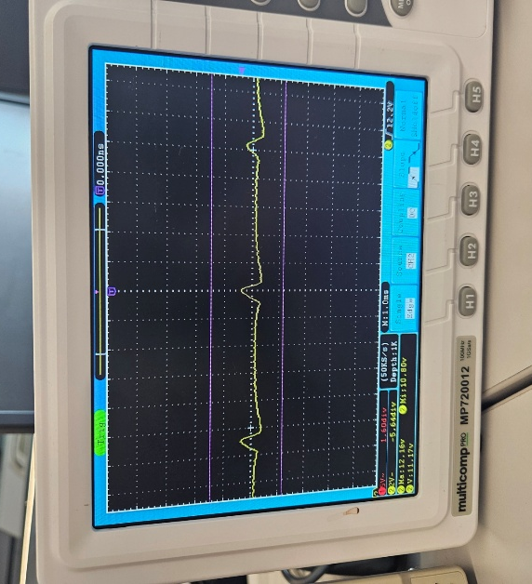
Figure 24: Oscilloscope output of the boost converter SH

The full system was then tested. The ESP32 controlled the low-side switch and provided a PWM signal to the boost converter. Functionality was confirmed by toggling the fans, adjusting PWM, and reading sensor data via the screen. Voltage readings showed a stable 12V output with ~0.5V ripple. CB
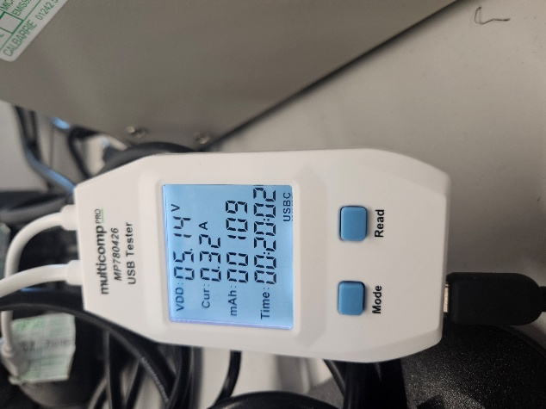
Figure 25: USB power monitor CB
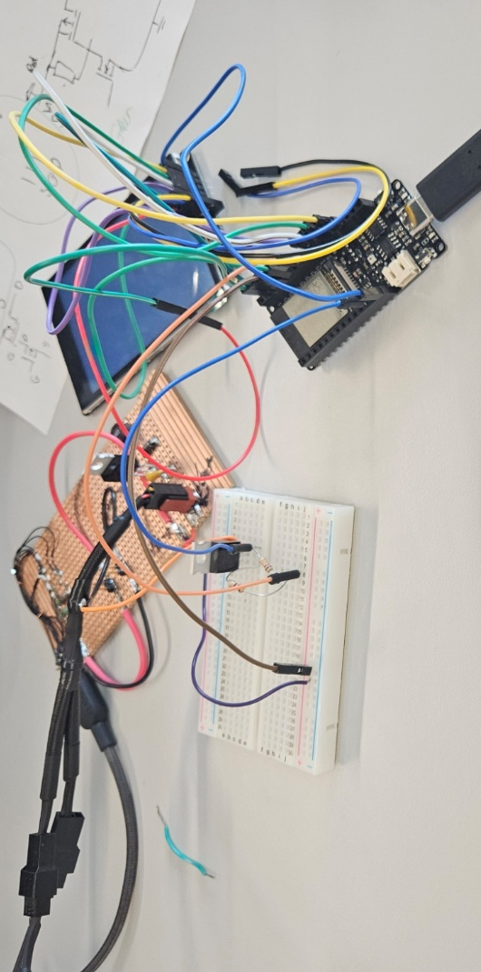
Figure 26: Full prototype testing CB

6.1.6 Safety considerations
The product uses low voltage and the USB-C plug itself is fused. It is limited to 1.5A via the CC pins and plug. There are safety considerations when building and prototyping JT. While soldering, there is exposure to burn threats from the iron, respiratory issues from solder and flux fumes, and sharps related injuries from tools. To mitigate this, each team member completed a relevant risk assessment and employed all mitigations, including using extraction fans and ensuring no-one was working alone in case of injury. CB

6.2 Additional Peripherals
A pinout diagram of the ESP32 was made on excel to better visualize and wire the prototype board, shown in Figure 27 below. SH
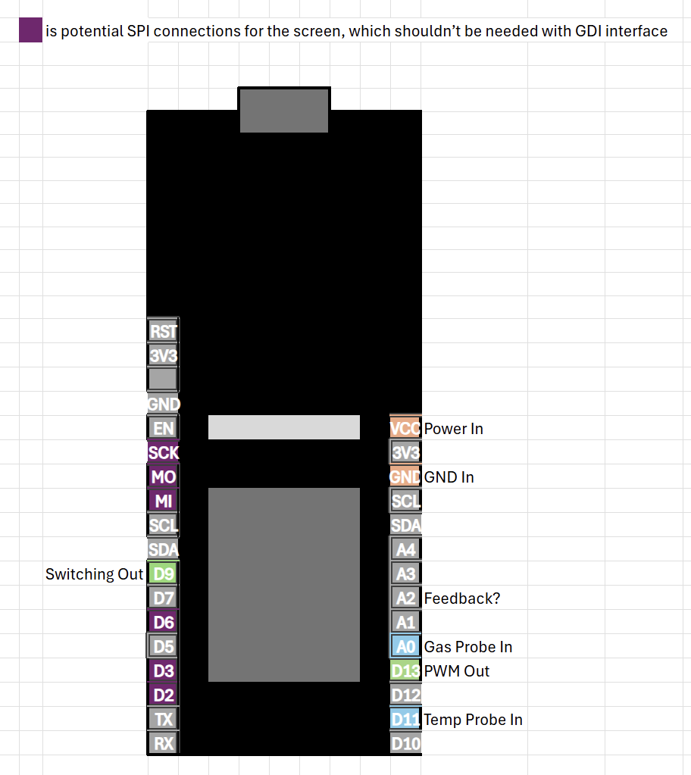
Figure 27: Pinout diagram of the ESP32 SH

6.3 Coding & Software

6.3.1 Flow Chart
Before any coding was started, a flow-chart was created to understand the logical flow of the system. This is shown in Figure 28. SH
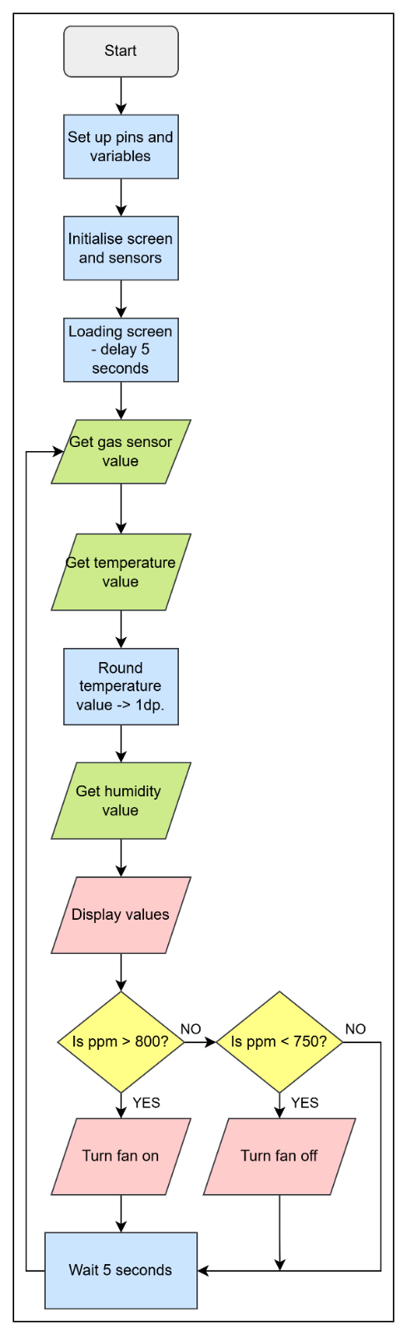
Figure 28: Coding flow chart

6.3.2 Setting up
The code was made modular for better organisation, easier debugging, and greater efficiency. To start the code, all variables, functions and libraries etc. had to be defined, shown below in Figure 29. JT
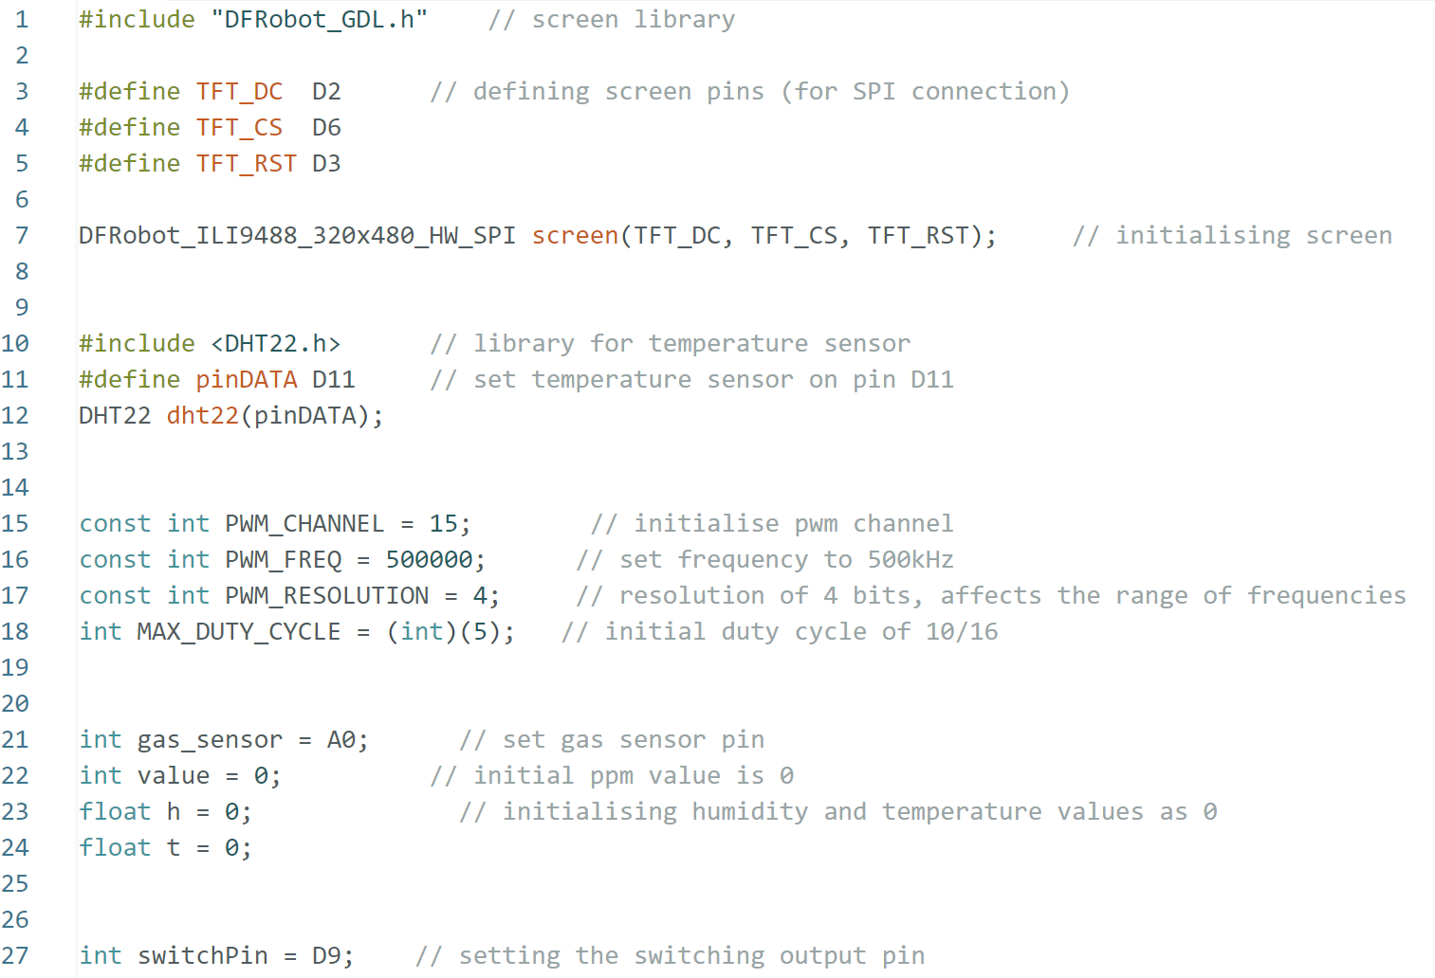
Figure 29: Code defining variables, functions and libraries

This defines each input and output pin, and sets the values for the PWM channel, as well as initialising the screen. Below, Figure 30 shows the setup code, which includes the loading time for pins and PWM to initiate, assigning the pin functions, and displaying the icons and title. LS
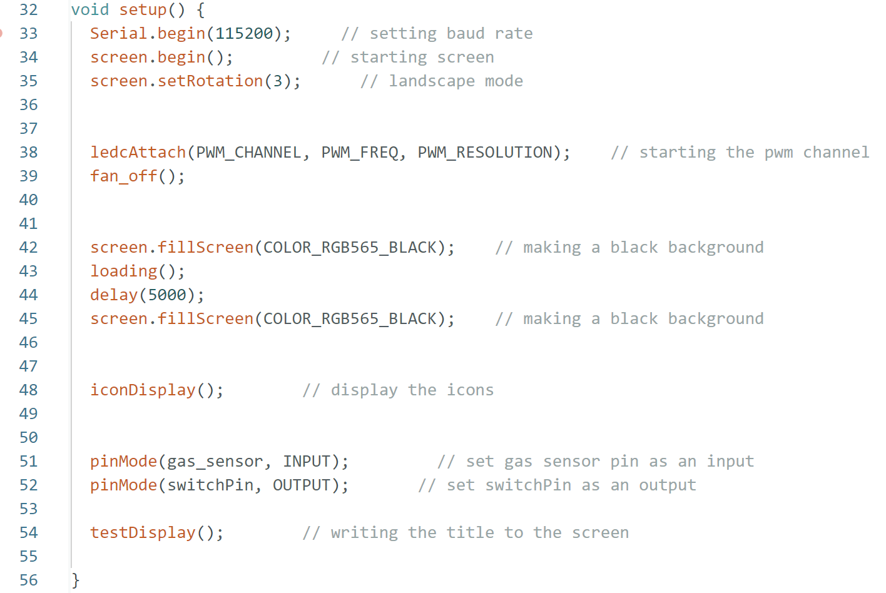
Figure 30: Code with the initial set up function
For the main program loop, it had a refresh rate of 5 seconds. It obtains the gas, temperature, and humidity values, then outputs them to the screen. It compares the gas ppm values to the threshold set at 800ppm, at which point it will turn the PWM on to control the fans, which then only turns off when it goes below 750ppm, ensuring it doesn’t immediately turn off, shown in Figure 31. SH
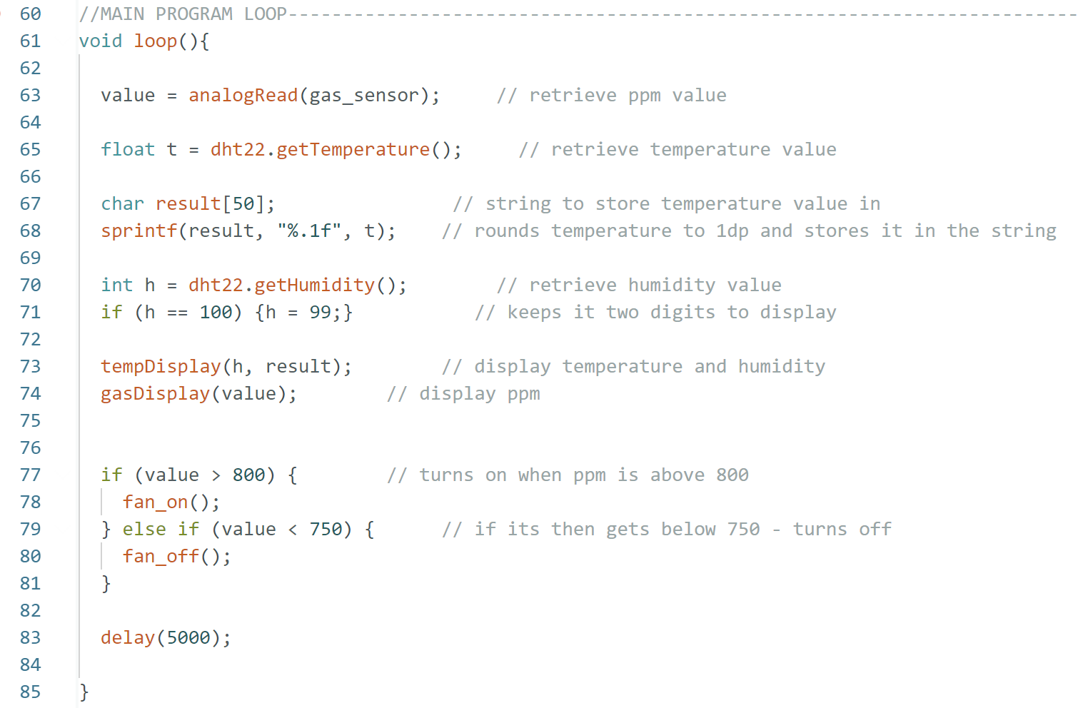
Figure 31: Code of the main function loop

6.3.3 Fan Interfacing
The fans are turned on and off using the PWM output on GPIO pin 12 of the ESP32. When on, it sets the duty cycle to 10, as with a 16-bit resolution, this makes the duty cycle around 60%, using Equation 3 (V_{in} = 5V, V_{out} = 12V, Efficiency = 80%).
Equation 3: Calculating PWM duty cycle value
$D=1- \frac{Vin × η}{Vout}$ [40]
The code in Figure 32 shows how the duty cycle is set at 10 when the fan_on() function is called and then set to 0 in the fan_off() function. CB
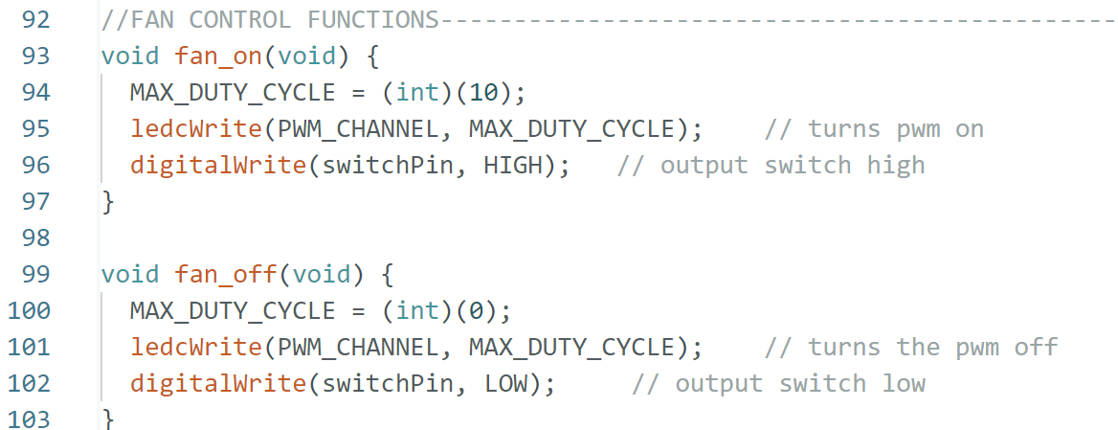
Figure 32: Code of the fan on and off function

6.3.4 Sensor Interfacing
The sensors were communicated with by reading the value on the pin they were each connected to. For the gas sensor, this was done with the analogRead() command, while the temperature/humidity sensor used a dht22 library, shown in Figure 33.
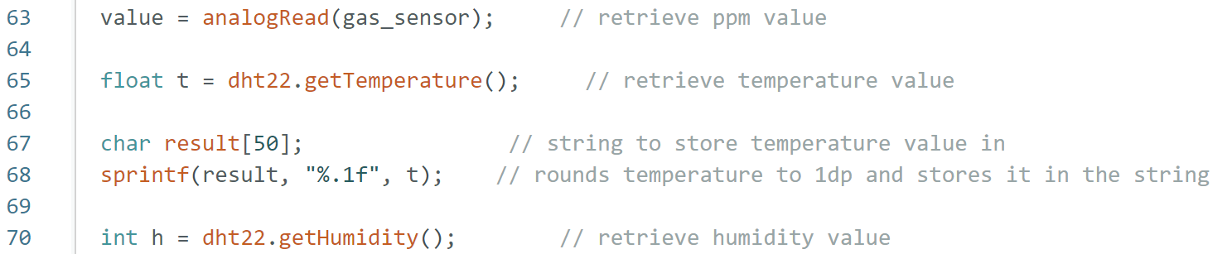
Figure 33: Code to retrieve sensor values

Their values are displayed to the screen as shown in Figure 34 below, with the units printed separately to keep them from moving if the number of digits change. CB LS JT
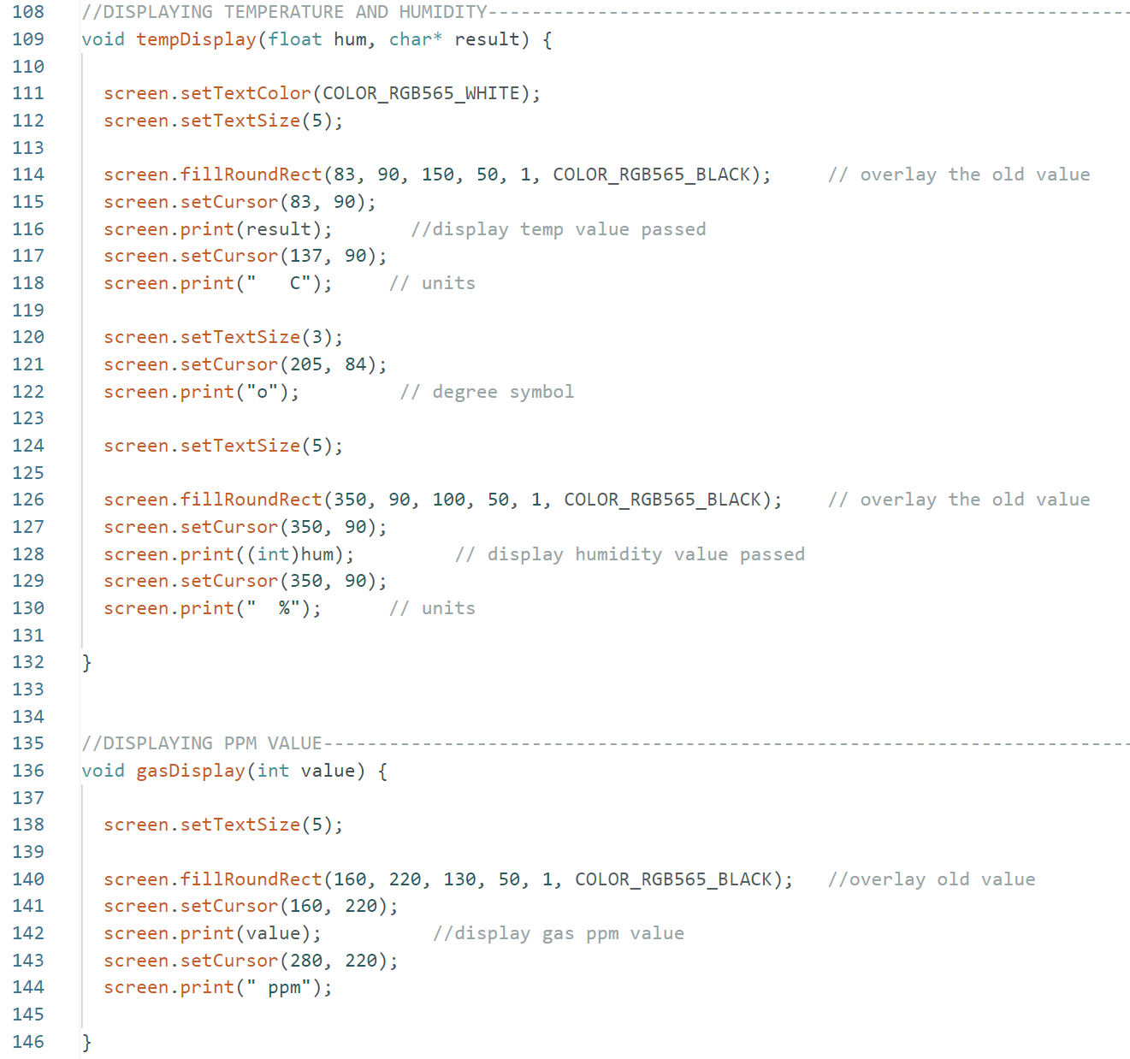
Figure 34: Code to display the sensor reading values and units

6.3.5 Screen’s User Interface
The user interface of the screen was designed to be simple, and easily readable. A rough sketch was created first, which could then be used as reference when coding, this can be seen below in Figure 35. SH
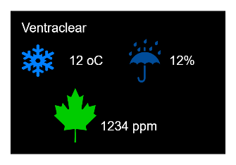
Figure 35: Mock-up of the screen display layout

A function to draw a curve was created, where the start, end, and middle coordinates were given, and an array of circles are generated along the line plotted. This was used in many of the icon displays and is shown in Figure 36. SH
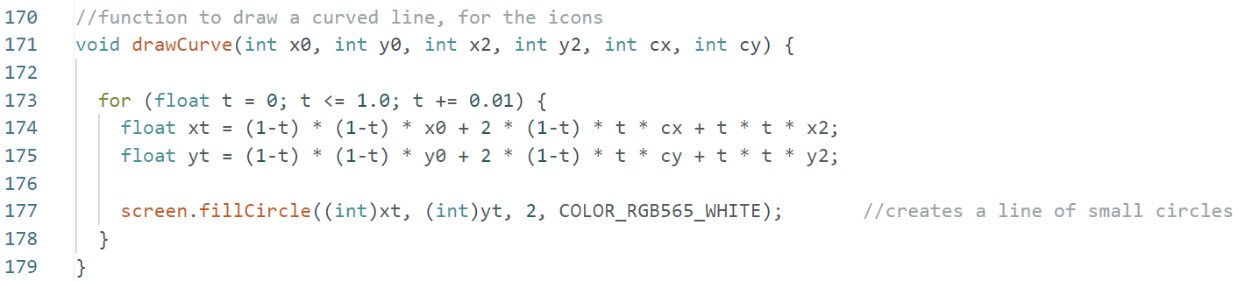
Figure 36: Code to draw a curve on the screen

The icons created were a leaf, two water droplets, and a thermometer, for gas particles, humidity, and temperature respectively, their creation is shown in Figures 37-39. SH
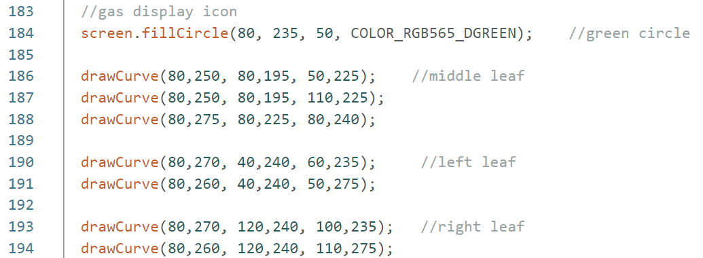
Figure 37: Code creating the leaf icon
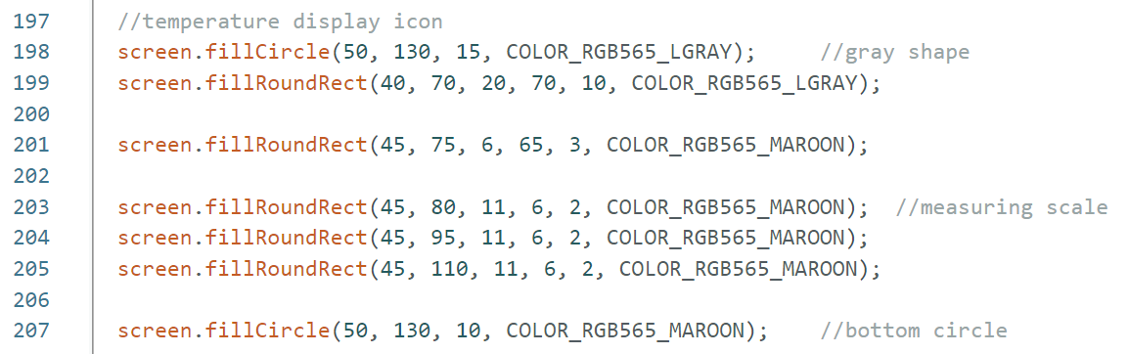
Figure 38: Code creating the thermometer icon
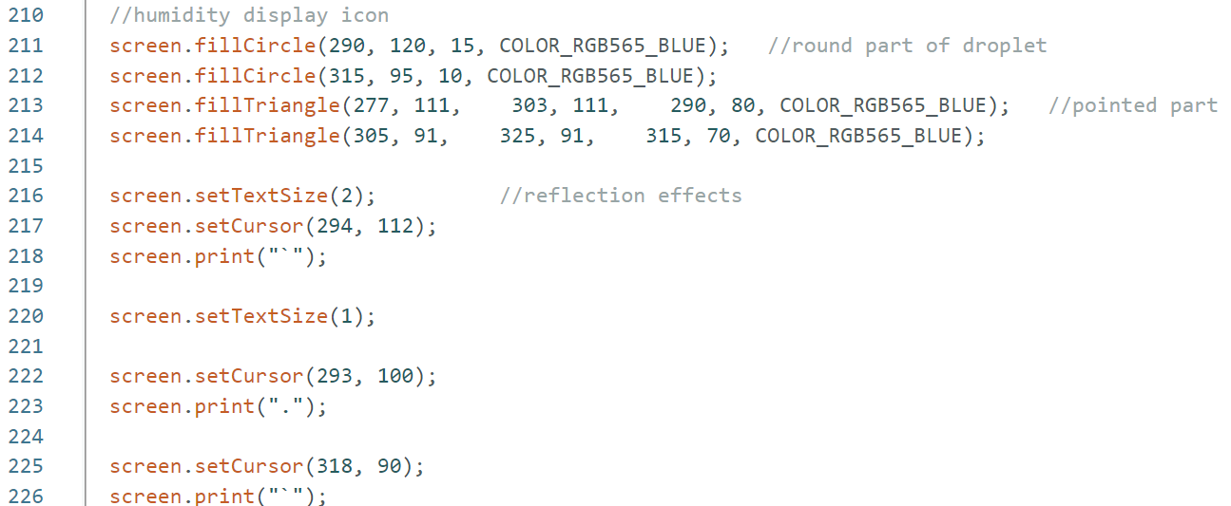
Figure 39: Code creating the humidity icon

6.4 Hardware & Mechanical
The box was designed in 3 layers and printed on a BambuLabs X1C 3D printer in ABS. ABS was selected as it is impact resistant and can withstand higher temperatures compared to other filament alternatives [44]. JT
The final CAD model, based off of the dimensions of the fans, filters and screen is shown in Figures 40 and 41.
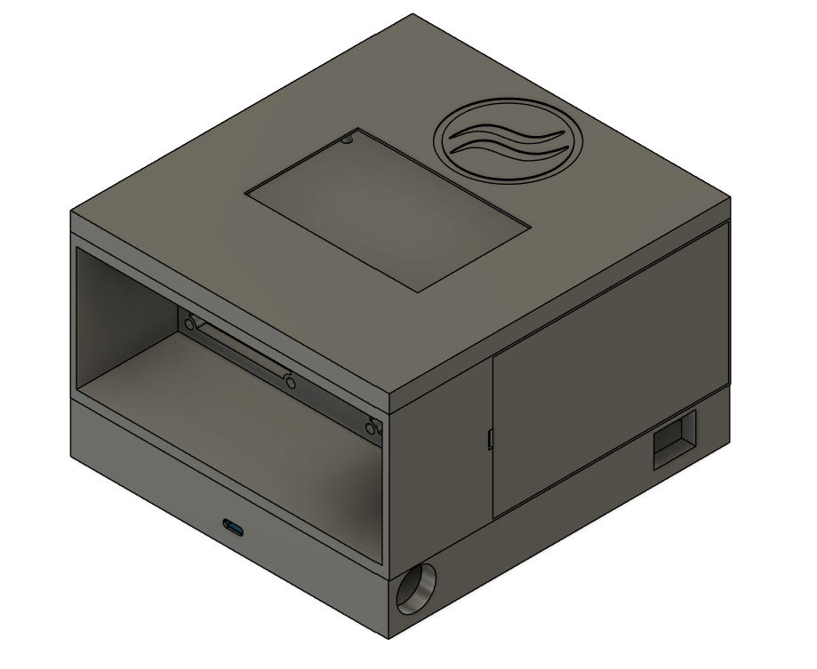
Figure 40: Complete CAD model
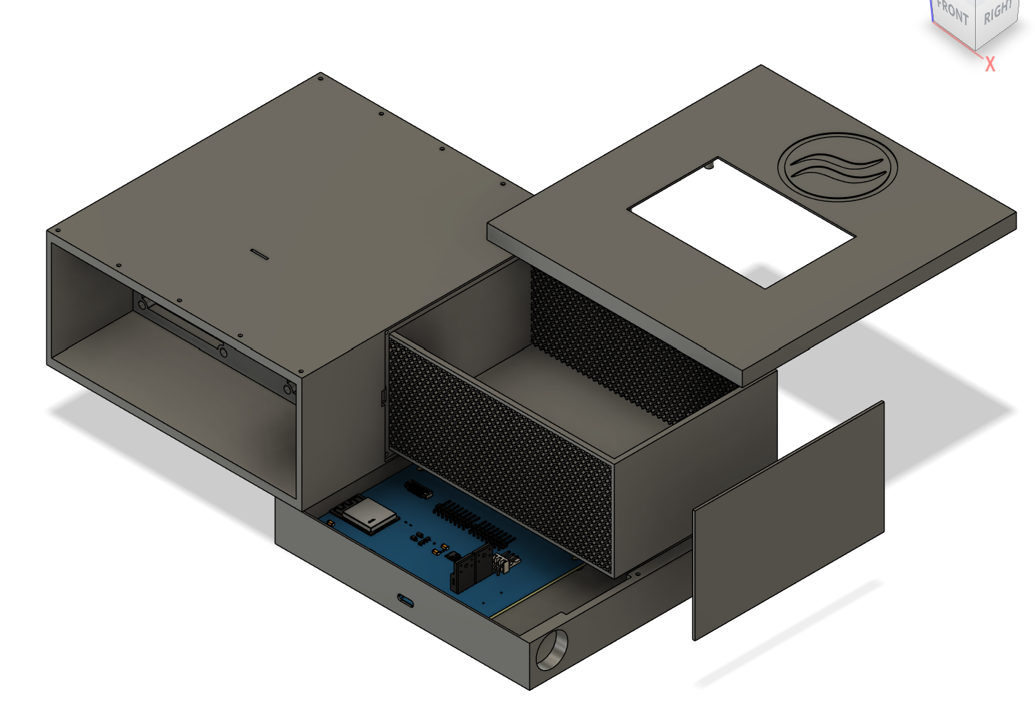
Figure 41: CAD model showing each element

The final printed box is shown in Figure 42 below
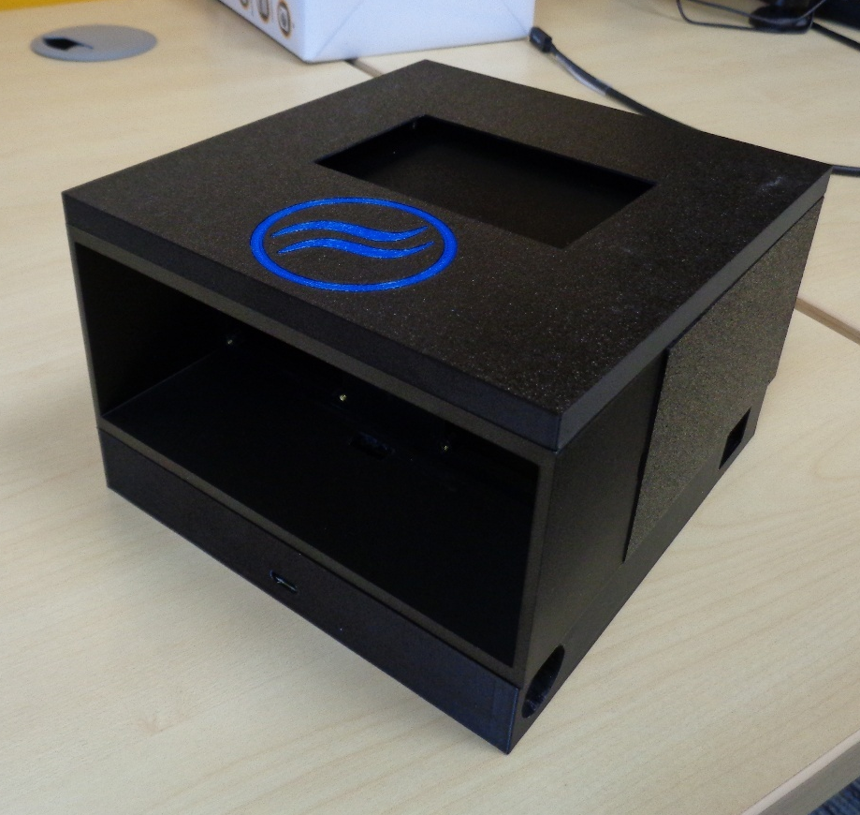
Figure 42: 3D printed enclosure

The Top of the box has a cutout designed for the screen to fit inside and be flush to the surface, shown in Figure 43. LS
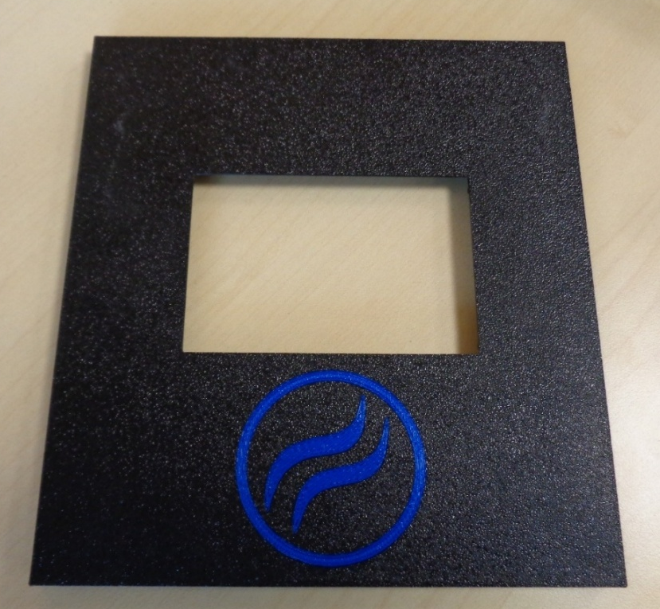
Figure 43: Top panel of the enclosure

The Central section is split into three: the fan mounts, carbon filter and HEPA Filter. The fan mounts are designed to take two Noctua fans with M3 heat set inserts to bolt them in. The HEPA filters are slid along guide rails inside of the box, kept flush with the mesh, shown in Figure 44 below. JT
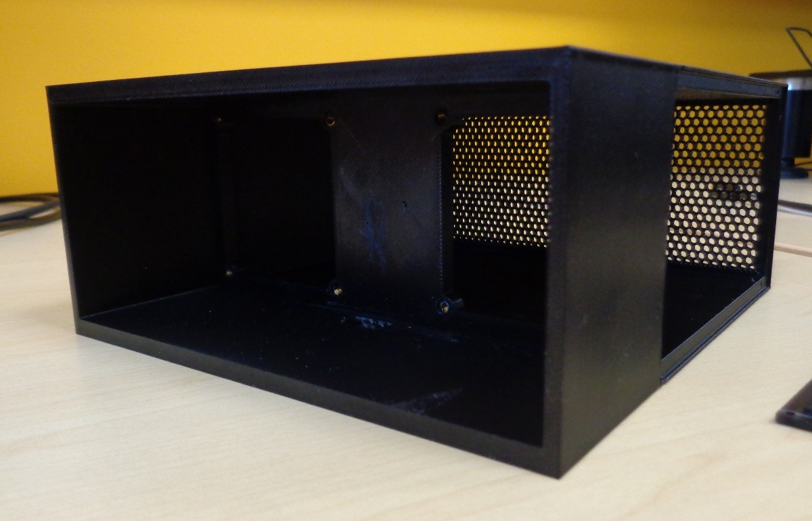
Figure 44: Internal view of the final enclosure
The carbon filter is a separate tray with a hexagonal mesh that can slide in and out of the case for ease of changing and disposal shown in Figure 45. CB
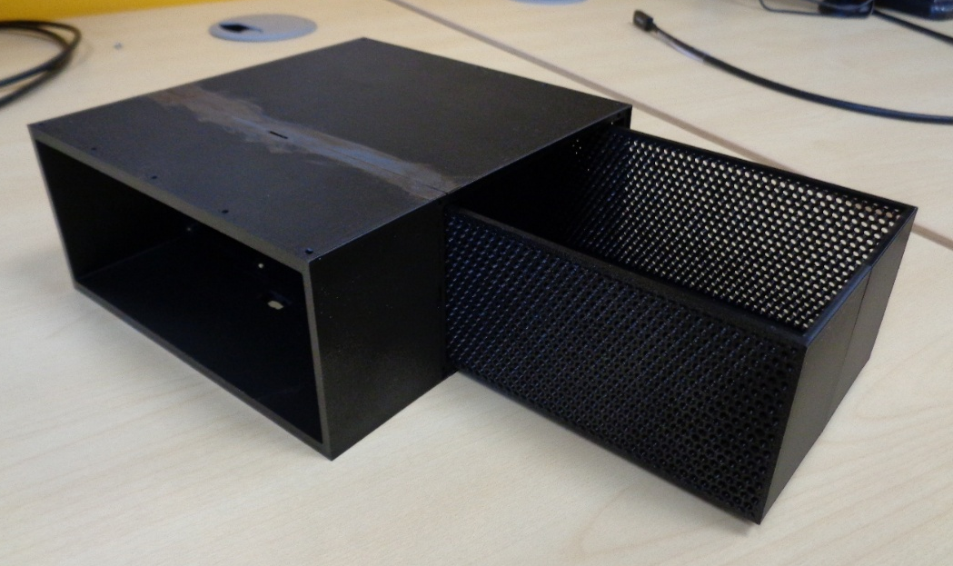
Figure 45: Carbon pellet tray

The bottom tray has mounting points for the PCB, as well as cut outs designed in the sides of the walls for the USB-C to be accessible and the sensors to fit outside of the box to provide data of the environment, seen in Figure 46. SH
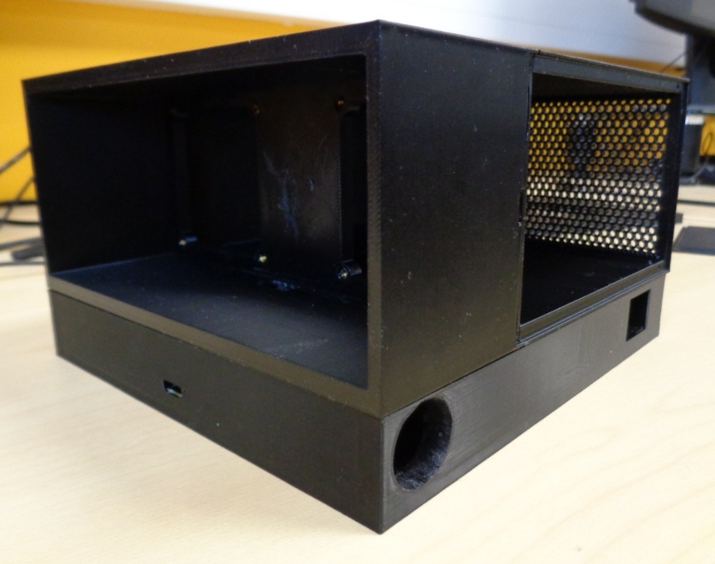
Figure 46: Mounting holes for sensors and bottom of enclosure

6.4.1 Safety features
Future revisions should include a protection mesh for fans so users cannot touch or poke them, reducing the risk of injuring themselves and prevents potential damage to the fans. JT

Implementation
The mechanical box, with the magnets installed, came together easily, and most tolerances appear to have been befitting JT. The Carbon tray required some filing before it was glued together, for it to be easier to remove CB. The carbon tray side panel cover was easy to take off with the help of an added notch JT. The PCB tray has the outputs labelled for the ESP engraved in its base. The PCB fit inside the box perfectly, and the USB-C was flush to the outside wall for a sleek appearance. The sensors press fit inside of the case for a snug fit, with optional mounting holes for screws SH.
The PCB, once assembled, could have been better since there were parts of the circuit which had been overlooked and needs revising. Further information can be found in the improvements section of this report LS. The sensors, screen and ESP32 communicated well, and readouts are produced on the LCD as intended. The LCD GDI cable has a channel that runs through the case for a seamless connection. The cables powering the fans were routed through a slot in the case for an efficient path to the connector ALL.

Testing
Note – Testing had been carried out on the prototype, due to the PCB not yet finished manufacturing; however, the components from the prototype were then used on the PCB once it was completed and delivered.

8.1 Scope
- Sensors (Gas, Temperature & Humidity)
- Air Flow through fan
- Change in air conditions after filtering

8.2 Objectives
- Test Functionality of each of the key sensors
- Test User Experience, how easy it is to operate
LS

8.3Test Methods

8.3.1 Gas Sensor
Testing the gas sensors consisted of placing the product in various atmosphere conditions, and test how the sensors and readouts change in response to environment. Testing data is shown in table 3 below. SH

Table 3: Air Quality sensor test results

8.3.2 Temperature Sensor
Testing of the temperature sensor was performed by using a calibrated Fluke thermometer sensor in the same conditions as the sensor under test, shown in the table below:
Table 4: Temperature test results
From the results table, the temperature sensor is fairly accurate, at most being 0.11°C from the Fluke thermometer reference. LS

8.3.3 Humidity Sensor
Testing the humidity sensor consisted of placing the sensor and product in various conditions and reading the displayed sensor reading, results are shown in Table 5.
Table 5: Humidity sensor test results
When testing the humidity sensor, the reading changed to a percentage that is expected of the conditions it was placed in. CB

8.3.4 Air Flow
Testing the unit’s air flow/throughput involved suspending a piece of paper in front of the fan's output held perpendicular to the unit, then with each of the different filter combinations, the change in the papers angle was recorded in Table 6 whilst it was running.
Table 6: Air through-put test results
This was to give a quantifiable description of how the different filters impact the air flow through the unit. CB

8.3.5 Air Quality Change
Change in air quality was also tested and recorded in Table 7 with each of the filter combinations and the change in PPM from the no filter baseline. JT
Table 7: Air quality improvement testing

Results
Each test had an estimated result, and were compared to recorded results, if the test values were close to estimates or within the range, it was considered a pass, this is shown in Table 8. LS
Table 8: Analysis of test results compared to expected

Evaluation
Overall, the project was a success, it was successfully planned and prototyped, however when the design for manufacturing began some issues were encountered. Due to the short time frame, only one PCB design was ordered. There were some PCB routing errors that caused the board to draw too much current, design errors that caused the ESP to reset (PWM signal was sent to RST pin), and feedback was not correctly implemented. This meant that the first PCB did not function as expected, but provided valuable insight into PCB and circuit design, and provided experience in debugging and improving designs. CB
Pictures of the final product, which used the original working prototype can be found below in Figures 47-49:
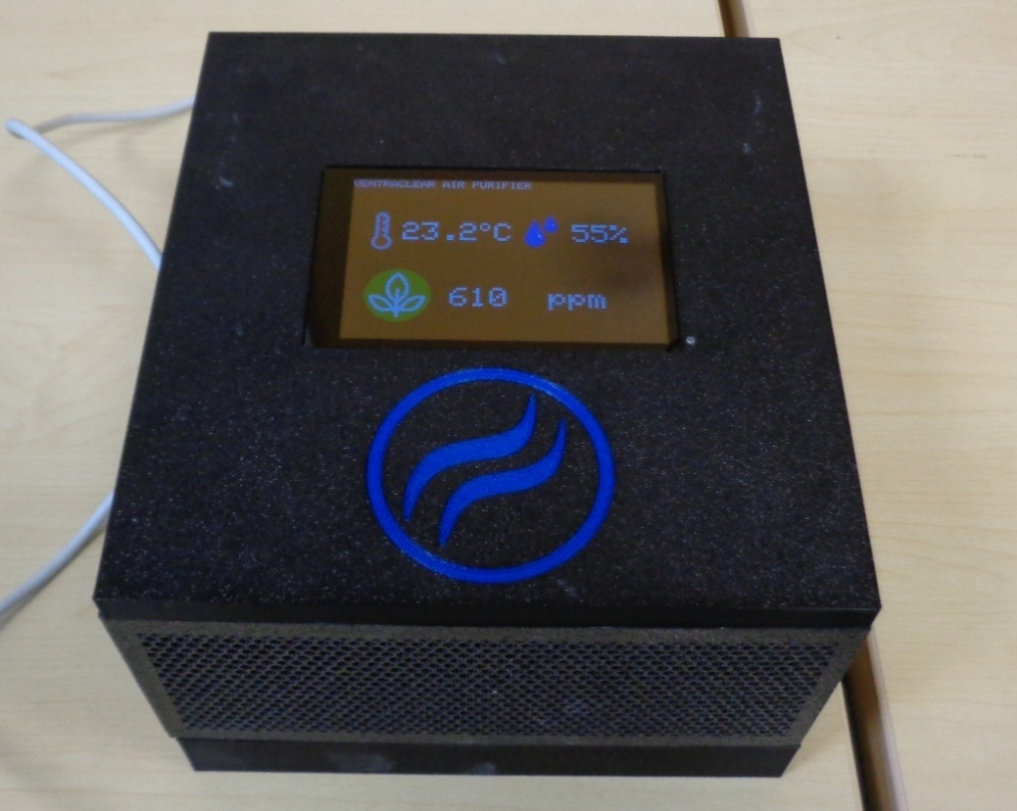
Figure 47: Final product - top view
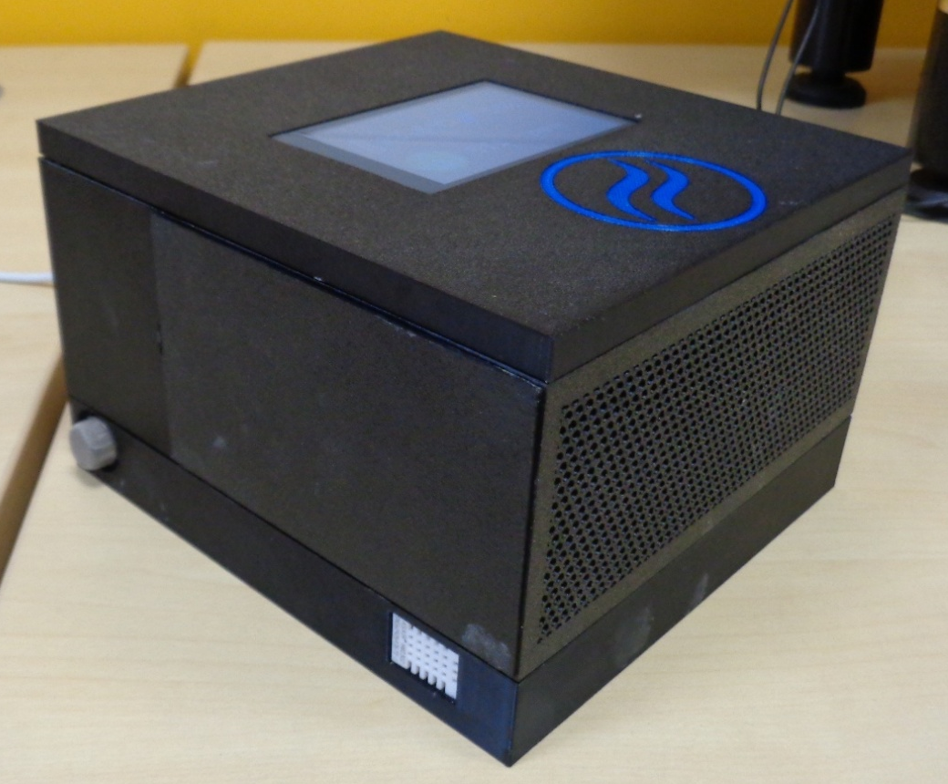
Figure 48: Final product - side view
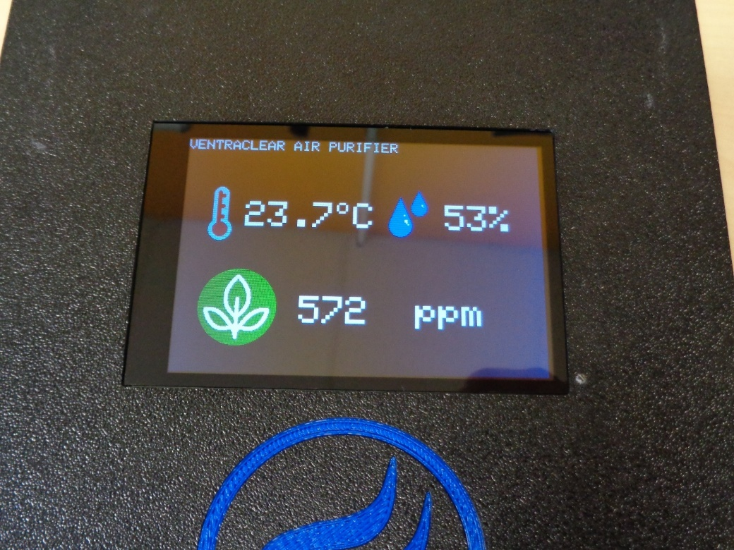
Figure 49: Final product - screen display

10.1 Reviewing Objectives and Requirements
The project achieved all main objectives, with only the non-essential specifications not being met, but possible in the future with the design. The specifications met are in Table 9. JT
Table 9: Specifications met

10.2 Comparison to research
Looking at products currently on the market, such as the Blueair Purifier [22] and the Bentobox [25], our product matches the features they advertise. Our product contains both a carbon and HEPA filter, so has double the filters compared to the Blueair purifier, and, while the Bambu Bentobox has both filters, our product is less bespoke and can be used in wider contexts than 3D printing enclosures. CB
Our air quality monitoring system is currently less advanced than the monitors in the market research, as there is not currently capability to connect to a smartphone app. As the ESP32 has wireless capability however, this option can be explored in future developments.
The results collected are not as detailed as the peer-reviewed articles, as the more advanced scientific measuring equipment was inaccessible. With the measurements and tests undertaken however, our initial findings do match the suggestions from these papers, with the air through-put and quality difference suggesting that our HEPA and carbon filters greatly improve air quality when active. SH

10.3 Improvements
There are a couple of improvements that could have been made to our current design. These do not include fixing errors in our PCB, but include things that would make our design more efficient.
- MOSFET had no gate pull-down resistor, which helps reduce instability and interference from noise
- Mechanical tolerance made the assembly too tight
- Some PCB labels had been left off the silk screen, making assembly difficult
- Charcoal container needs a handle to remove it easier
- Larger Test point pads
CB

10.4 Difficulties/problems faced
Some of the minor problems included ordering the incorrect cable for the GDI interface. The backlight came on showing it had power, but the screen wouldn’t change. We discovered that a reverse/B-type cable was required, which was easy to order but created unnecessary costs.
The first error with the code occurred when trying to program the screen. After researching the error and having a second person review the code, we realised that it was being compiled for the wrong version of the Firebeetle – a Firebeetle ESP32, when we were using a Firebeetle 2 ESP32-E. SH
Another issue we faced when programming the board was the IDE was presenting us with “error code 2” which we discovered was caused by the boost circuit turning on while programming. This was initially resolved by disconnecting an inductor when programming, however this became inefficient. During later inspection with a multimeter we removed a MOSFET from the PCB which had been wired incorrectly in the schematic, which resolved the issue. CB
A current problem we are facing is the overheating of the MOSFET Q2, which in some test scenarios on the PCB, has broken completely and needed to be replaced. We are still investigating the source of this, however found that the boost circuit was providing close to 50V instead of the 12V we had calculated. Our next steps are to review the libraries used for generating the PWM duty cycle, and to attempt to change this if possible; we also intend to create a new iteration of the PCB, in which the schematic for Q2 is wired correctly, allowing us to more securely switch the boost circuit. Additionally, a feedback input will be connected to the ESP32 to adapt the duty cycle according to the current output of the boost converter. JT
There are some issues which are still being resolved, such as the boost circuit providing too much voltage. However, with such an inflexible timeframe it was impossible to have another iteration of the PCB made and delivered, even if it was designed in time. LS

10.5 Total Expenses
The total expenditure for the project was recorded in Table 10 below:
Table 10: Recorded expenses
Whilst total expenditure was less than the estimated budget, some items such as the PCBs, were more expensive than anticipated. This further reinforces the importance in accounting for unexpected expenditure. LS

Group Admin

11.1 Group Operation & Organisation
When the group was first formed, certain ways of working were established to allow cohesion between team members during the project.

11.1.1 File Storage & Data Transfer
A shared OneDrive folder was created and set up to provide all team members with constant access to all project files and the ability to work on them whenever needed, shown in Figure . CB
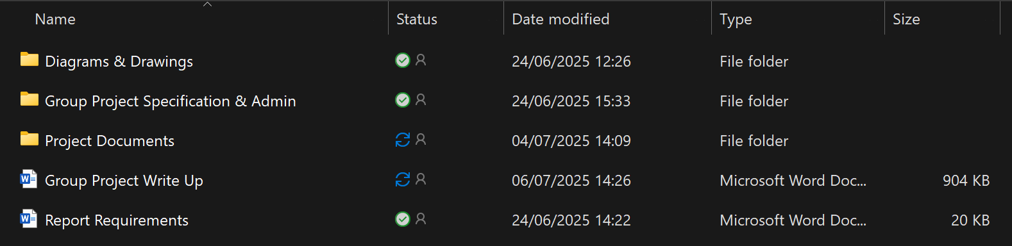
Figure 50: Shared OneDrive for exchanging files

Each file was organised into folders for the diagrams, specifications for the assignment and project documents. In doing so, members could easily and quickly access relevant documents, reduce the risk of confusion as well as aiming to prevent file duplication or variations of the same document. LS

11.2 Group Responsibilities
Project tasks were determined and divided equally among team members in accordance with their strengths, ensuring both fairness and efficient working. This was then kept as a record in Table 11: ALL
Table 11: Group responsibilities breakdown

11.3 Logbook & Team Decisions Record/Minutes
Regular team meetings were held on Mondays, aimed at settling on decisions (major & minor), updating the team on the previous week’s progress & each member discussing their upcoming tasks. See appendix for full records. ALL

Conclusion

12.3 Further work
Further functions to be implemented could include:
- Boost Circuit on a separate board, that plugs into the main board, allowing for easier testing and debugging. Removal of the boost circuit would also allow for easier reprogramming. CB
- Mechanical assembly to change the orientation of the screen to suit the user’s preferences. JT
- Utilise the ESP 32’s wireless connectivity to facilitate LS
  - Connection to the internet to check levels remotely
  - Create a network of multiple units that work together
  - Local WiFi to check reading when in proximity
  - Graphing for data readouts
- Filters on a ‘rail’ to slide out and stop to allow for easy replacement of the filters. SH

12.2 Benefits of Final project
The testing on the prototype board showed that this product combined the functionality of air purifier and air quality sensors on the market into one overall product that has a wide range of available future developments possible. The HEPA filter reduces indoor allergens (pet dander, pollen and dust) and removes airborne particles, reducing the risk of allergic reactions and provides relief for people suffering from asthma. The carbon filter absorbs unpleasant odours and VOCs, improving the smell of homes. These benefits improve consumers’ health, contributing to their wellbeing. ALL

Reflections

13.1 Louis
Reflecting on the project, I feel as if I’ve gained valuable experience in operating as a team and insights into how different aspects of a project come together. The benefit of having other team members to exchange ideas within all parts of the project I found to be particularly useful as others may have suggestions or alterations that you may have not considered, ultimately resulting in a better outcome than a single person may have reached.
Thanks to other team members, I could improve the area less suited to my skill sets (such as coding), whilst helping others with organisation, documentation, as well as data and record keeping.
I am quite satisfied with the outcome of the product, both in design and in its functionality in addition to adhering to the specifications

13.2 Saffina
I have learnt a lot during this project, with the key takeaway for me being able to work as a team. I learnt about the importance of consistent communication with our weekly meetings, which helped us to stay on track with the timeframe. I also learnt how to effectively debug a board, with one of the most helpful things being to get a fresh set of eyes to look at it. I was able to lead the team on the coding aspect, which allowed me to gain confidence in presenting and helping others to learn new skills. I enjoyed working as a team, especially in the initial planning stages, as the wide diversity of ideas allowed us to choose a project that would cater to each of our unique skills sets, Practically, I have also gained experience using oscilloscopes, multimeters, prototyping on Veroboard and breadboard, and using the Arduino IDE to develop my C programming skills. I am overall very proud of our finished product, which fits our specifications, and look forward to developing it further.

13.3 Chris
In this project, I learnt the importance of simulating your specific components and carefully considering the information available in the datasheets, I also learnt the importance of working together with your team to peer review things and gather new ideas. This allowed me to get outside perspectives, and identify issues that I may have overlooked. I also was able to present and lead the team through my ideas, allowing me to function as a leader for periods of time , while also providing input when other members lead me through their ideas. This project also allowed me to determine my skill sets(mechanical design and electronics) while also giving me valuable practice in things I am less capable of, for example coding.

13.4 James
During our work on this project, I learnt to reverse engineer an ESP32, looked into ways of improving the ESP32 design, the importance of checking datasheets and communicating with your team throughout. This made the project more efficient and work off each other’s different skills, allowing me to work on my weaknesses, such as coding. I was able to design part of the case and PCB and with the peer review from the team, was able to get less potential for issues to arise. Unfortunately, we still had issues with the PCB due to the limited time and caused the PCB to be made faster than ideal. Overall, working as a team has been a useful experience to develop my skills and helping the team.

Bibliography

[1] | M. Wolf and S. McQuitty, “Understanding the do-it-yourself consumer: DIY motivations and outcomes,” Academy of Marketing Science Review, pp. 154-170, 2001.
[2] | M. Mavri, E. Fronimaki and A. Kadrefi, “Survey analysis for the adoption of 3D printing technology: consumers’ perspective,” Journal of Science and Technology Policy Management, vol. 14, no. 2, pp. 353-385, 2021.
[3] | I. Kaupplia, “3D Printing Fumes & Air Quality – A Practical Guide,” All3DP, 30 04 2024. [Online]. Available: https://all3dp.com/1/3d-printing-emissions-air-quality/. [Accessed 30 05 2025].
[4] | sentryair, “A discussion on 3D printers, UFP emission, and HEPA filtration,” Sentry Air Systems Inc., 01 07 2016. [Online]. Available: https://www.sentryair.com/blog/industry-applications/3d-printing/a-discussion-on-3d-printers-ufp-emission-and-hepa-filtration/. [Accessed 30 05 2025].
[5] | A. Alder, “DIY Ventilation & Filtration For 3D Printing,” 4Dfiltration, 11 04 2024. [Online]. Available: https://4dfiltration.com/resources/diy-ventilation-filtration. [Accessed 30 05 2025].
[6] | R. Yadav and P. Pandey, “A Review on Volatile Organic Compounds (VOCs) as Environmental Pollutants: Fate,” International Journal of Plant and Environment, vol. 4, no. 2, pp. 14-26, 2018.
[7] | sans, “What Are VOCs and at What Level Are They Dangerous?,” sans, [Online]. Available: https://www.livesans.com/blogs/education/vocs-level-dangerous. [Accessed 30 05 2025].
[8] | G. Hong and Y.-K. Jee, “Special issue on ultrafine particles: where are they from and how do they affect us?,” Experimental & Molecular Medicine, vol. 52, no. 3, pp. 309-310, 2020.
[9] | US Air Purifiers, “Why You Need an Air Purifier for 3D Printing,” [Online]. Available: https://www.usairpurifiers.com/blog/need-air-purifier-3d-printing/?srsltid=AfmBOoqfvszPR5fpFpaGDk1AHhJB5LZbzkacmA-KjPWhfgUCAm22mdPH. [Accessed 30 05 2025].
[10] | D. E. Schraufnagel, “The health effects of ultrafine particles,” Experimental & Molecular Medicine, vol. 52, pp. 311-317, 2020.
[11] | S. Dubey, H. Rohra and A. Taneja, “Assessing effectiveness of air purifiers (HEPA) for controlling indoor particulate pollution,” Elsevier, vol. 7, no. 9, 2021.
[12] | J. Hoon Lee and et.al, “Effectiveness of portable air filtration on reducing indoor aerosol counts:,” Journal of Hospital Infection, vol. 119, pp. 163-169, 2021.
[13] | M. L. Croom, “New developments in filter dust collection,” Chemical Engineering, vol. 103, no. 2, 1996.
[14] | makergadgets, “Air Purification System for 3D Printers (FDM and Resin),” 2022. [Online]. Available: https://www.makergadgets.org/how/3-phase. [Accessed 02 06 2025].
[15] | Y. Ingale and et.al, “Air Pollution Control By using Activated Charcoal,” International Advanced Research Journal in Science, Engineering and Technology , vol. 10, no. 7, pp. 294-299, 2023.
[16] | S. Mondal, S. De and P. Saha, “Removal of VOCs and Improvement of Indoor Air Quality Using Activated Carbon Air Filter,” in National Conference on Advances in Structural Technologies, Silchar, 2019.
[17] | A. Chambre, “Effects of Carbon Filtration Type on Filter Efficiency,” 03 2014. [Online]. Available: https://www.air-science.com/lib/sitefiles/pdf/WhitePapers/Carbon-Filtration-Whitepaper.pdf. [Accessed 10 07 2025].
[18] | C.-H. Tseng, “Performance of coated activated carbon filters used in the building environment,” Journal of Chemical Technology & Biotechnology, vol. 97, no. 9, pp. 2511-2518, 2022.
[19] | A. Shrivastava and P. Raj, “A REVIEW OF DIFFERENT AIR FILTRATION TECHNIQUES,” International Research Journal of Modernization in Engineering Technology and Science , vol. 5, no. 6, pp. 3804-3812, 2023.
[20] | A. Shrivastava and P. Raj, “A REVIEW OF DIFFERENT AIR FILTRATION TECHNIQUES,” International Research journal of Modernization in Engineering Technology and Science, vol. 5, no. 6, pp. 3804-3812, 2023.
[21] | Amazon, “Amazon Smart Air Quality Monitor (Newest gen) | Know your air, Works with Alexa,” Amazon, [Online]. Available: https://www.amazon.co.uk/amazon-smart-air-quality-monitor-know-your-air/dp/B08X2V5K28/ref=sr_1_1_ffob_sspa?crid=2PR8S7CRDFZ1&dib=eyJ2IjoiMSJ9.28y61kWTAp-Ab3vu0JleG_jy_66h_EbckvSHqxUiYcNumm2wJyHiNXCLKHOixpF87lMAkV8NQoO-D1vZ-_uyE4gjryguThWraGAyUr8utqkbOb1e2. [Accessed 8 July 2025].
[22] | Amazon, “Blueair Blue Pure Mini Max Air Purifier with HEPASilent Filter For Rooms Up To 20m2 Removes 99.97% Particles, Pollen, Dust, Mould, Bacteria, Viruses, Activated Carbon Reduces VOCs [Amazon Exclusive],” Blueair, [Online]. Available: https://www.amazon.co.uk/Purifier-HEPASilent-Particles-Activated-111524/dp/B08KQJ7XGM/ref=sr_1_2_sspa?crid=2PR8S7CRDFZ1&dib=eyJ2IjoiMSJ9.28y61kWTAp-Ab3vu0JleG_jy_66h_EbckvSHqxUiYcNumm2wJyHiNXCLKHOixpF87lMAkV8NQoO-D1vZ-_uyE4gjryguThWraGAyUr8utqkbOb1e2TnPsK. [Accessed 8 July 2025].
[23] | Amazon, “Temtop M10+ Air Quality Monitor Indoor, 6-in-1 CO2, PM2.5, VOC Detection, Smart Temperature & Humidity Sensor, with App Connectivity for Home Air Quality Testing & Analysis,” TemTop, [Online]. Available: https://www.amazon.co.uk/Temtop-M10-Detection-Temperature-Connectivity/dp/B0D1DYBY38/ref=sr_1_4_sspa?crid=30GRT2WC01AAB&dib=eyJ2IjoiMSJ9.deQZA0YamTYHmAYbb0YaBTHOmRaC7bUnHJ0hIGhtJAZR6_hsQvZVQv7gHGmheok4pQPf37B-FvY6uYks56KSToB_ibMBrEJBI9ZbugY3pLLDLQ3ovMHkLK. [Accessed 8 July 2025].
[24] | Weldingandwelder, “KEMPER AirWatch Air Monitoring System (390 200),” Kemper, [Online]. Available: https://www.weldingandwelder.com/product/new-kemper-airwatch/?msclkid=f51a20ac5db71945633648c0bb3e1725&utm_source=bing&utm_medium=cpc&utm_campaign=Shopping%20-%20Best%20Sellers&utm_term=4587780996706379&utm_content=Kemper%20-%20Shopping%20-%20Best%20Selle. [Accessed 8 July 2025].
[25] | thrutheframe, “BentoBox v2.0 Carbon filter for Bambu Lab X1C, enclosed P1P & Voron Trident & others?,” 24 June 2025. [Online]. Available: https://www.printables.com/model/272525-bentobox-v20-carbon-filter-for-bambu-lab-x1c-enclo. [Accessed 8 July 2025].
[26] | Waveshare, “MQ-135 Gas Sensor,” [Online]. Available: https://files.waveshare.com/upload/7/71/MQ-135.pdf. [Accessed 8 July 2025].
[27] | T. Gomes and N. Nagappan, “How can you add contingency time to your project schedule?,” Linkedin, [Online]. Available: https://www.linkedin.com/advice/0/how-can-you-add-contingency-time-your-project.
[28] | HSE.gov, “Ventilation in the workplace,” HSE, [Online]. Available: https://www.hse.gov.uk/ventilation/overview.htm. [Accessed 07 07 2025].
[29] | United States Environmental Protection Agency, “What are volatile organic compounds (VOCs)?,” 24 02 2025. [Online]. Available: https://www.epa.gov/indoor-air-quality-iaq/what-are-volatile-organic-compounds-vocs. [Accessed 07 07 2025].
[30] | O. K. B. V. A. A. O. M. I. Bankole I. Oladapo, “Net zero on 3D printing filament recycling: A sustainable analysis,” Science of The Total Environment, vol. 894, 2023.
[31] | D. K. F. B.-H. S. F. M. J. L. G. S. S. Henning Zeidler, “3D printing of biodegradable parts using renewable biobased materials,” Procedia Manufacturing, vol. 21, pp. 117-127, 2018.
[32] | Y. J. a. E. S. Sasha Luccioni, “Power Hungry Processing: Watts Driving the Cost of AI Deployment?,” in FAccT '24: Proceedings of the 2024 ACM Conference on Fairness, Accountability, and Transparency, New York, 2024.
[33] | Z. Hausfather, “Mapped: The world’s largest CO2 importers and exporters,” Carbon brief, 05 07 2017. [Online]. Available: https://www.carbonbrief.org/mapped-worlds-largest-co2-importers-exporters/. [Accessed 19 06 2025].
[34] | Espressif, “ESP32-WROOM-32E Datasheet,” [Online]. Available: https://www.espressif.com/sites/default/files/documentation/esp32-wroom-32e_esp32-wroom-32ue_datasheet_en.pdf. [Accessed 9 July 2025].
[35] | DFRobot, “FireBeetle Board ESP32 E SKU DFR0654,” [Online]. Available: https://wiki.dfrobot.com/FireBeetle_Board_ESP32_E_SKU_DFR0654. [Accessed 9 July 2025].
[36] | T. Brant, “What Is USB-C? Everything You Need to Know About the One Port to Rule Them All,” pcmag, 19 February 2025. [Online]. Available: https://uk.pcmag.com/laptop-how-to/40348/what-is-usb-c-an-explainer. [Accessed 9 July 2025].
[37] | Waveshare, “MQ-135 Gas Sensor,” Waveshare, [Online]. Available: https://www.waveshare.com/wiki/MQ-135_Gas_Sensor. [Accessed 8 July 2025].
[38] | Espressif Systems, “ESP32-S3Series,” [Online]. Available: https://dfimg.dfrobot.com/nobody/wiki/73fc2522117073a9181e85ce7e78edbd.pdf. [Accessed 02 07 2025].
[39] | Texas Instruments, “Understanding boost power stages in switch mode power supplies,” 03 1999. [Online]. Available: https://www.ti.com/lit/an/slva061/slva061.pdf?ts=1751470221925. [Accessed 03 07 2025].
[40] | Texas Instruments , “Basic Calculation of a Boost Converter's Power Stage,” 2022. [Online]. Available: https://www.ti.com/lit/an/slva372d/slva372d.pdf?ts=1751521947844. [Accessed 02 07 2025].
[41] | STMicroelectronics, “DIODE SCHOTTKY 20V 1A DO41,” [Online]. Available: https://www.st.com/content/ccc/resource/technical/document/datasheet/26/db/14/60/52/47/47/5b/CD00001625.pdf/files/CD00001625.pdf/jcr:content/translations/en.CD00001625.pdf. [Accessed 2025 07 03].
[42] | International rectifier, “IRLZ34N,” [Online]. Available: https://docs.rs-online.com/4e7f/0900766b80028e40.pdf. [Accessed 2025 07 03].
[43] | USB org, “USB Power Delivery,” 06 05 2025. [Online]. Available: https://www.usb.org/document-library/usb-power-delivery. [Accessed 2025 07 04].
[44] | S. Miely, “Everything you need to know about ABS 3D printing,” nexa3d, 9 March 2023. [Online]. Available: https://nexa3d.com/blog/everything-you-need-to-know-about-abs-3d-printing/#:~:text=In%20this%20blog%20post%2C%20we%20will%20cover%20everything,resistance%20but%20can%20be%20easily%20molded%20and%20shaped.. [Accessed 9 July 2025].
[45] | Q. Zhang and M. . S. Black, “Exposure hazards of particles and volatile organic compounds emitted from material extrusion 3D printing: Consolidation of chamber study data,” Chemical Insights Research Institute, 2023 November 7. [Online]. Available: https://www.sciencedirect.com/science/article/pii/S0160412023005895#s0010. [Accessed 6 June 2025].
[46] | Public Health England, “Indoor Air Quality Guidelines for selected Volatile Organic Compounds (VOCs) in the UK,” Public Health England, 13 September 2019. [Online]. Available: https://assets.publishing.service.gov.uk/media/5d7a2912ed915d522e4164a5/VO__statement_Final_12092019_CS__1_.pdf. [Accessed 2025 June 6].
[47] | Air Care, “The Biggest Air Quality Contaminants in the Workplace,” Citron Hygiene, 23 September 2024. [Online]. Available: https://www.citronhygiene.co.uk/resources/the-biggest-air-quality-contaminants-in-the-workplace#:~:text=They%20are%20emitted%20as%20gases%20from%20certain%20solids,the%20most%20prevalent%20VOCs%20found%20in%20indoor%20environments.. [Accessed 2025 June 6].
[48] | Alveo, “3D printer fume extractor | NEW ALVEOPRO – M100,” Alveo3D, [Online]. Available: https://www.alveo3d.com/en/product/alveopro-3d-printer-fume-extractor/. [Accessed 30 05 2025].
[49] | Waveshare, “DHT22 Temperature & Humidity Sensor,” The PiHut, 10 2024. [Online]. Available: https://thepihut.com/products/gravity-dht11-temperature-humidity-sensor-for-arduino. [Accessed 03 06 2025].
[50] | V. K. Vijayan, H. Paramesh, S. S. Salvi and A. A. Kumar Dalal, “Enhancing indoor air quality –The air filter advantage,” Lung India, vol. 32, no. 0970-2113, pp. 473-479, 2015.
[51] | L. Store, “LEVOIT Air Purifiers for Home Large Room With Air Quality Monitor, Quiet Odor Eliminators for Bedroom, 3-in-1 Filter, Auto Mode, Cleaner for Allergies, Pets, Smoke, Mold, Pollen, Dust, LV-H133, White,” Amazon, [Online]. Available: https://www.amazon.com/LEVOIT-Purifier-Allergies-Eliminator-LV-H133/dp/B07CNQQM9N/ref=as_li_ss_tl?th=1&linkCode=ll1&tag=3dly-20&linkId=7e13f529b51bbc22213e974c76ae1ab6&language=en_US. [Accessed 30 05 2025].
[52] | G. Liu and et.al., “A review of air filtration technologies for sustainable and healthy building,” Sustainable Cities and Society, vol. 32, no. 2210-6707, pp. 375-396, 2017.
[53] | J. Gu, E. Uhde, M. Wensing, F. Xia and T. Salthammer, “Emission Control of Desktop 3D Printing: The Effects of a Filter Cover and an Air Purifier,” Environmental Science & Technology Letters, vol. 6, no. 8, pp. 499-502, 2019.
[54] | Creality, “Resin Printer Enclosure,” Creality Store, 2024. [Online]. Available: https://store.creality.com/uk/products/resin-printer-enclosure. [Accessed 30 05 2025].
[55] | ANYCUBIC Store, “Anycubic Mini Air Purifier, Lightweight Ultra Quiet Air Purifier with High Density Activated Carbon Filter for LCD DLP 3D Printers (Pack of 2),” Amazon, [Online]. Available: https://www.amazon.co.uk/Anycubic-Purifier-Lightweight-Activated-Printers/dp/B08CRKVRLS/ref=sr_1_1_sspa?dib=eyJ2IjoiMSJ9.67oLyuWvLa0Y4xPBF3QMekgZdSCkdMECQWsx0w_o38nDYsehrMQD3keHjO06-FFL2oujaF3M8RfKfFFW-2t7ONoxcO7E0Sf07VPx8xWvJ1C_lBTN87CmlWQeWd0EqvRrsZtrMd. [Accessed 30 05 2025].
[56] | thrutheframe, “BentoBox v2.0 Carbon filter for Bambu Lab X1C, enclosed P1P & Voron Trident & others?,” 24 June 2025. [Online]. Available: https://www.printables.com/model/272525-bentobox-v20-carbon-filter-for-bambu-lab-x1c-enclo. [Accessed 9 July 2025].
[57] | T. Brant, “What Is USB-C? Everything You Need to Know About the One Port to Rule Them All,” pcmag, 19 February 2025. [Online]. Available: https://uk.pcmag.com/laptop-how-to/40348/what-is-usb-c-an-explainer. [Accessed 9 July 2025].

Appendix

Appendix A - Tools and software used

Louis

Hardware
- Soldering Station + Extractor Fan
- Breadboard + Jumper Leads
- Wire Cutters & Strippers
- Veroboard
- MultiComp
- Multimeter
- Oscilloscope

Software
- Draw.io
- Excel
- Word
- Notepad
- LTSpice
- Proteus

Saffina

Hardware
- MultiComp USB Tester
- Oscilloscope
- Signal generator
- Breadboard and jumper leads
- Multi-meter

Software
- Arduino IDE
- Proteus
- Microsoft Word
- Microsoft Excel

Chris

Hardware
- Solder station and hot air station
- Extractor fan
- Microscope
- Tweezers for SMD parts
- Heat shrink for custom Y split cable
- Wire cutters
- Wire strippers
- MultiComp USB Tester
- Signal generator
- Multimeter
- Oscilloscope
- Ender3pro 3d printer

Software
- Word
- Excel
- Draw.io
- LT spice
- Fusion360
- Arduino IDE
- Cura slicer
- easyEDA

James

Hardware
- BambuLabs X1 Carbon Combo
- BambuLabs ABS reusable spools
- Solder station and Hot air station
- Extractor Fan
- Microscope
- Wire strippers
- Wire cutters
- MultiComp USB Tester

Software
- Autodesk Fusion
- EasyEDA
- BambuLabs Bambu Studio
- LT spice
- Microsoft Word
- Microsoft Excel

Appendix B - Logbook

19/05
LS

Previous Week Progress
- N/A, First Project Week

Major Decisions
- Determined Group Members
- Determined Project idea, Consumer Scale Filter Unit aimed at hobbyists
- Determined the Product Project Specifications
- Components to be used; USB-C, ESP 32, Screen
- Filters Types to be used
- Determined Budget Estimates of ~ £270 for production, based on the required components' rough pricing

Minor Decisions
- Make Y Split cable to save costs

26/05
SH

Previous Week Progress
- Created & Presented Project Proposal Presentation
- Submitted Proposal Paperwork
- Research into Existing Systems, Components & Started
- Project Block Diagram

Major Decisions
- Circuit Design & Sub Circuits (Boost Circuit, Highside Switch)
- Which Design Specifications can be done via Code

Minor Decisions
- Changed brands of some components due to some original selections being out of stock/ newer versions being more suitable.

02/06
CB

Previous Week Progress
- Ordered Components for the prototype
- Finished building the boost circuit prototype

Major Decisions
- Testing Plan for Sensor Modules
- Switched from high side switch to low side switch for simplicity, and to reduce unnecessary complexity
- Determined the Design of the enclosure

Minor Decisions
- Determined the test print material

09/06
JT

Previous Week Progress
- Ordered the Circuit Components
- Started designing the enclosure in CAD

Major Decisions
- Layout/Design for the PCB

Minor Decisions
- FPC 18 Pin Cable A was swapped to B & a longer length cable.

16/06
LS

Previous Week Progress
- USB-C Connection functional for power
- Ordered Fans & Other Peripherals required, components selected to fit the design specifications (i.e. Quiet fans)

Major Decisions
- Determining Layout of Information Displayed to the screen, what potential graphical elements may be included for a better user experience

Minor Decisions
- GDI over SPDI for the screen connections, simpler requires less connections

23/06
SH

Previous Week Progress
- Screen Functional, displays real-time data from sensors via the ESP
- Boost Circuit functional and powers Fans Sufficiently

Major Decisions
- Determined PCB Manufacturer JLC, (would’ve used British manufacturing but weren’t able to in the given timeframe)

Minor Decisions
- Analog over digital for gas sensor, exact value for PPM and allows modification in code

30/06
CB

Previous Week Progress
- All modules tested together, functional, performed run time testing
- PCBs Manufactured, started connecting Modules

Major Decisions
- Final Tests to perform with the completed product

Minor Decisions
- Structure and layout of the report

07/07
JT

Previous Week Progress
- Manufactured and assembled enclosure
- Testing the product according to the test plan

Major Decisions

Minor Decisions
- Small Tweaks to report before upload

Appendix C - Code
#include "DFRobot_GDL.h" // screen library

#define TFT_DC D2 // defining screen pins (for SPI connection)
#define TFT_CS D6
#define TFT_RST D3

DFRobot_ILI9488_320x480_HW_SPI screen(TFT_DC, TFT_CS, TFT_RST); // initialising screen

#include <DHT22.h> // library for temperature sensor
#define pinDATA D11 // set temperature sensor on pin D11
DHT22 dht22(pinDATA);

const int PWM_CHANNEL = 15; // initialise pwm channel
const int PWM_FREQ = 500000; // set frequency to 500kHz
const int PWM_RESOLUTION = 4; // resolution of 4 bits, affects the range of frequencies
int MAX_DUTY_CYCLE = (int)(5); // initial duty cycle of 10/16

int gas_sensor = A0; // set gas sensor pin
int value = 0; // initial ppm value is 0
float h = 0; // initialising humidity and temperature values as 0
float t = 0;

int switchPin = D9; // setting the switching output pin

void setup() {
Serial.begin(115200); // setting baud rate
screen.begin(); // starting screen
screen.setRotation(3); // landscape mode

ledcAttach(PWM_CHANNEL, PWM_FREQ, PWM_RESOLUTION); // starting the pwm channel
fan_off();

screen.fillScreen(COLOR_RGB565_BLACK); // making a black background
loading();
delay(5000);
screen.fillScreen(COLOR_RGB565_BLACK); // making a black background

iconDisplay(); // display the icons

pinMode(gas_sensor, INPUT); // set gas sensor pin as an input
pinMode(switchPin, OUTPUT); // set switchPin as an output

testDisplay(); // writing the title to the screen

}

//MAIN PROGRAM LOOP--------------------------------------------------------------------------------------------------------------------------------
void loop(){

value = analogRead(gas_sensor); // retrieve ppm value

float t = dht22.getTemperature(); // retrieve temperature value

char result[50]; // string to store temperature value in
sprintf(result, "%.1f", t); // rounds temperature to 1dp and stores it in the string

int h = dht22.getHumidity(); // retrieve humidity value
if (h == 100) {h = 99;} // keeps it two digits to display

tempDisplay(h, result); // display temperature and humidity
gasDisplay(value); // display ppm

if (value > 800) { // turns on when ppm is above 500
fan_on();
} else if (value < 750) { // if its above 480 and already on - stays on - hysterisis
fan_off();
}

delay(5000);

}

//FAN CONTROL FUNCTIONS-----------------------------------------------------------------------------------------------------------------------------
void fan_on(void) {
MAX_DUTY_CYCLE = (int)(5);
ledcWrite(PWM_CHANNEL, MAX_DUTY_CYCLE); // turns pwm on
digitalWrite(switchPin, HIGH); // output switch high
}

void fan_off(void) {
MAX_DUTY_CYCLE = (int)(0);
ledcWrite(PWM_CHANNEL, MAX_DUTY_CYCLE); // turns the pwm off
digitalWrite(switchPin, LOW); // output switch low
}

//DISPLAYING TEMPERATURE AND HUMIDITY-----------------------------------------------------------------------------------------------------------------
void tempDisplay(float hum, char* result) {

screen.setTextColor(COLOR_RGB565_WHITE);
screen.setTextSize(5);

screen.fillRoundRect(83, 90, 150, 50, 1, COLOR_RGB565_BLACK); // overlay the old value
screen.setCursor(83, 90);
screen.print(result); //display temp value passed
screen.setCursor(137, 90);
screen.print(" C"); // units

screen.setTextSize(3);
screen.setCursor(205, 84);
screen.print("o"); // degree symbol

screen.setTextSize(5);

screen.fillRoundRect(350, 90, 100, 50, 1, COLOR_RGB565_BLACK); // overlay the old value
screen.setCursor(350, 90);
screen.print((int)hum); // display humidity value passed
screen.setCursor(350, 90);
screen.print(" %"); // units

}

//DISPLAYING PPM VALUE------------------------------------------------------------------------------------------------------------------------------------
void gasDisplay(int value) {

screen.setTextSize(5);

screen.fillRoundRect(160, 220, 130, 50, 1, COLOR_RGB565_BLACK); //overlay old value
screen.setCursor(160, 220);
screen.print(value); //display gas ppm value
screen.setCursor(280, 220);
screen.print(" ppm");

}

//LOADING SCREEN------------------------------------------------------------------------------------------------------------------------------
void loading() {

screen.setCursor(250, 50);
screen.setTextColor(COLOR_RGB565_WHITE);
screen.setTextSize(2);
screen.print("LOADING..."); //main title

}

//USER INTERFACE ICONS AND DISPLAY--------------------------------------------------------------------------------------------------------------------------
void testDisplay() {

screen.setCursor(0, 0);
screen.setTextColor(COLOR_RGB565_WHITE);
screen.setTextSize(2);
screen.print("VENTRACLEAR AIR PURIFIER"); //main title

}

//function to draw a curved line, for the icons
void drawCurve(int x0, int y0, int x2, int y2, int cx, int cy) {

for (float t = 0; t <= 1.0; t += 0.01) {
float xt = (1-t) * (1-t) * x0 + 2 * (1-t) * t * cx + t * t * x2;
float yt = (1-t) * (1-t) * y0 + 2 * (1-t) * t * cy + t * t * y2;

screen.fillCircle((int)xt, (int)yt, 2, COLOR_RGB565_WHITE); //creates a line of small circles
}
}

void iconDisplay() {

//gas display icon
screen.fillCircle(80, 235, 50, COLOR_RGB565_DGREEN); //green circle

drawCurve(80,250, 80,195, 50,225); //middle leaf
drawCurve(80,250, 80,195, 110,225);
drawCurve(80,275, 80,225, 80,240);

drawCurve(80,270, 40,240, 60,235); //left leaf
drawCurve(80,260, 40,240, 50,275);

drawCurve(80,270, 120,240, 100,235); //right leaf
drawCurve(80,260, 120,240, 110,275);

//temperature display icon
screen.fillCircle(50, 130, 15, COLOR_RGB565_LGRAY); //gray shape
screen.fillRoundRect(40, 70, 20, 70, 10, COLOR_RGB565_LGRAY);

screen.fillRoundRect(45, 75, 6, 65, 3, COLOR_RGB565_MAROON);

screen.fillRoundRect(45, 80, 11, 6, 2, COLOR_RGB565_MAROON); //measuring scale
screen.fillRoundRect(45, 95, 11, 6, 2, COLOR_RGB565_MAROON);
screen.fillRoundRect(45, 110, 11, 6, 2, COLOR_RGB565_MAROON);

screen.fillCircle(50, 130, 10, COLOR_RGB565_MAROON); //bottom circle

//humidity display icon
screen.fillCircle(290, 120, 15, COLOR_RGB565_BLUE); //round part of droplet
screen.fillCircle(315, 95, 10, COLOR_RGB565_BLUE);
screen.fillTriangle(277, 111, 303, 111, 290, 80, COLOR_RGB565_BLUE); //pointed part
screen.fillTriangle(305, 91, 325, 91, 315, 70, COLOR_RGB565_BLUE);

screen.setTextSize(2); //reflection effects
screen.setCursor(294, 112);
screen.print("`");

screen.setTextSize(1);

screen.setCursor(293, 100);
screen.print(".");

screen.setCursor(318, 90);
screen.print("`");

}

