Digital Skills and research methods

DSR Assessment 1- online group presentation.

Lecturer: Syed Jaffery
Module code: BMSW4003
Module Leader: Koushik Modak

The group:
Rex Amu, ID: 2028603 -background of the organization;
Silviu Tanasa, ID 2028900 - the challenge(s) before the introduction of modern technology;
Yeliz Koncak 2028995- Insights to Amazon’s Modern Technology
Teodor Panev 2028893- The impact of the technology introduced
Rosa-missing

Rex Amu, ID: 2028603 -background of the organization;

Slide 1
Slide 2


Slide 3
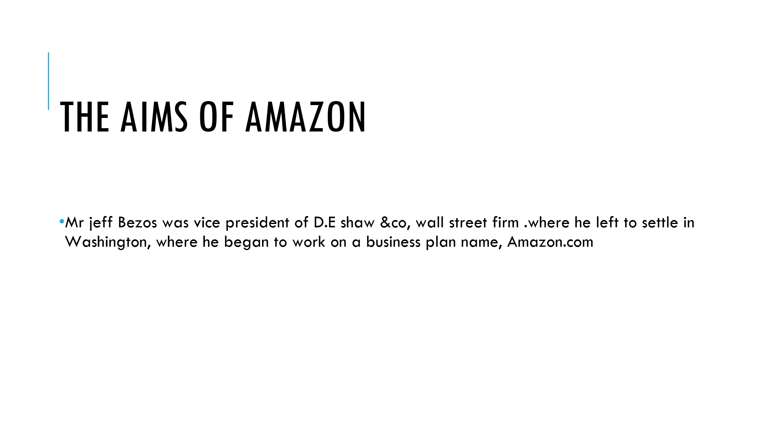
Slide 4



Slide 5

Silviu Tanasa, ID 2028900 - the challenge(s) before the introduction of modern technology;
Slide 6
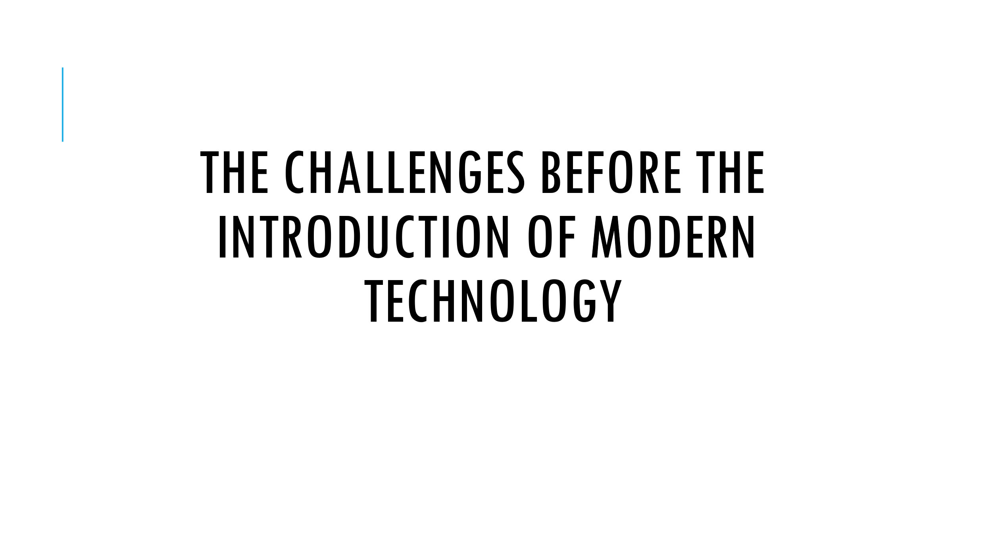

Slide 7
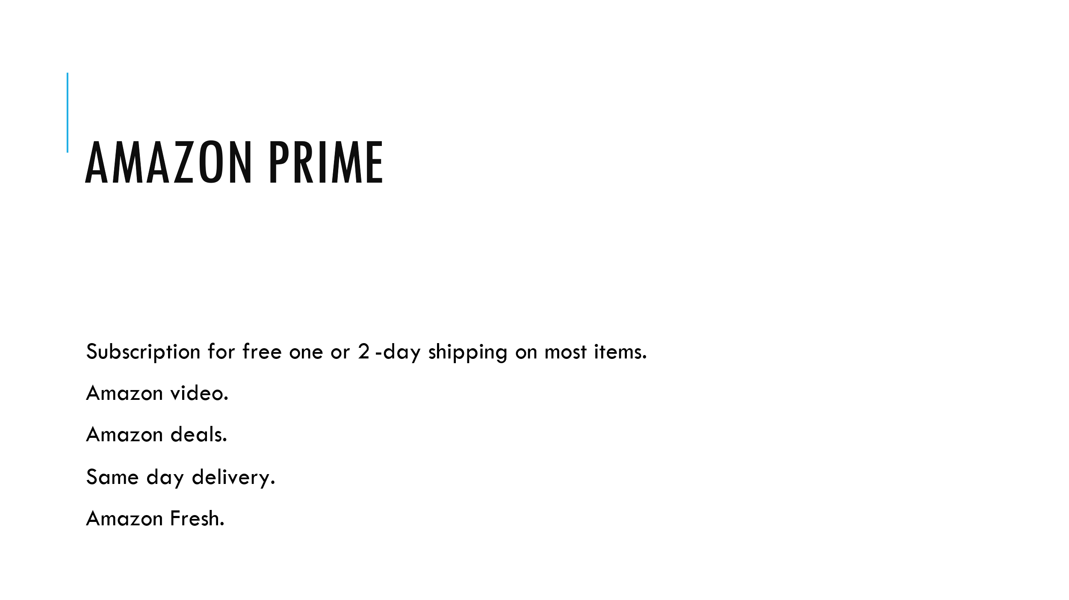

Firstly, the idea of Amazon prime came in place within the Amazon company. Apart from the other benefits of amazon prime like amazon video, amazon deals and many others, there is the idea to deliver everything quick, the same day or the next day at the customer’s door. Moreover, amazon fresh which is a service for members to shop for everyday essentials, household items, food/grocery needed quickly, CREATED NEEDS within the old process of packing and delivering.
Everything had to become quick and efficient.

Slide 8
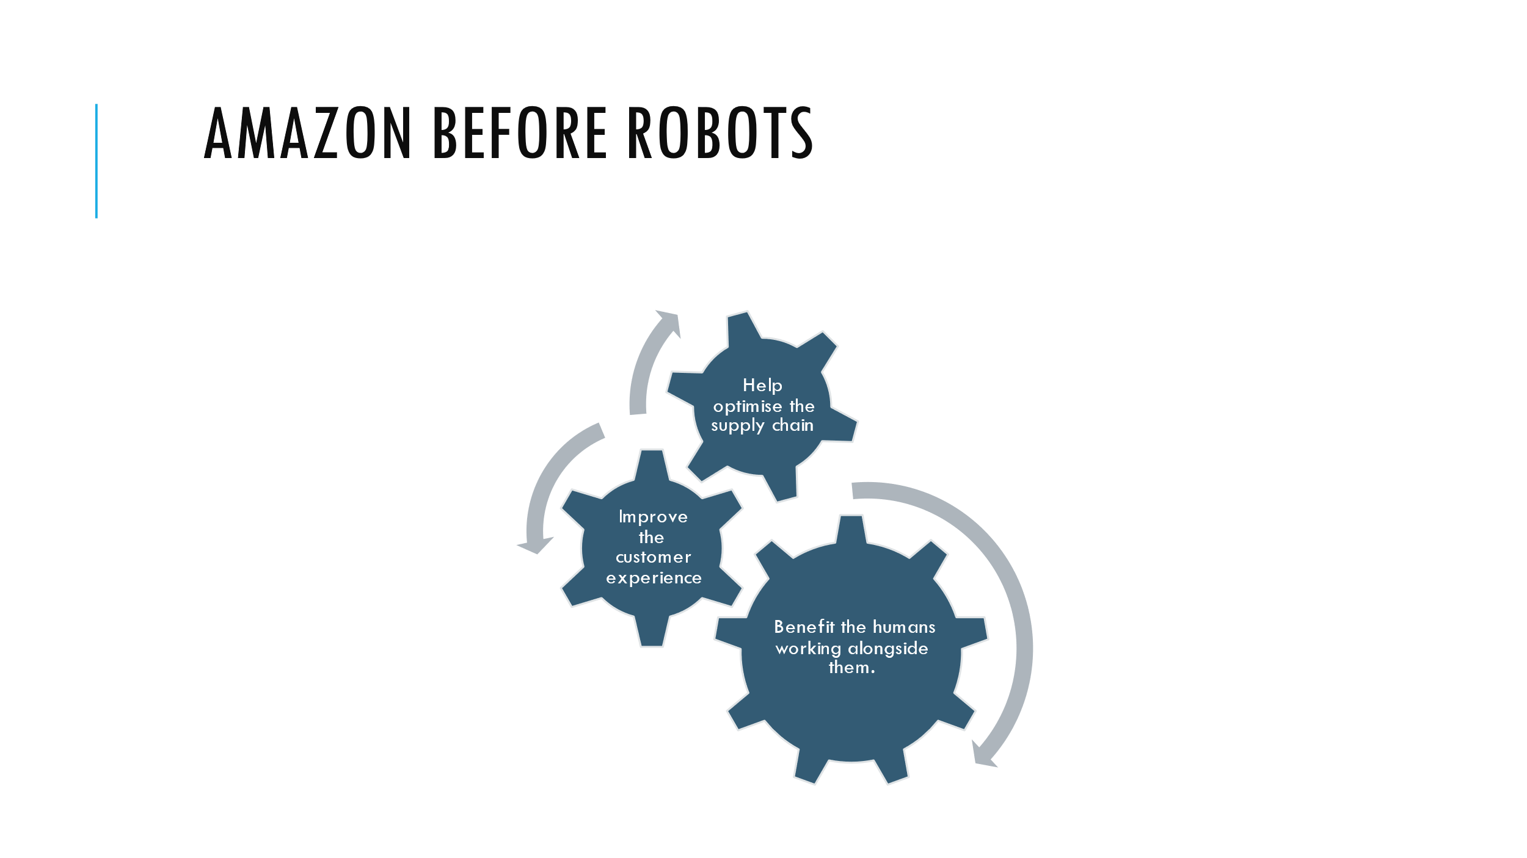
In order to go on with amazon prime and its benefits :
The company had to optimise the supply chain.
This came the need of improving the customer experience (because not everything quick every time comes with the quality and the high standards of customer experience).
Bonus, there was an option to benefit the humans working alongside robots within warehouses.

Slide 9
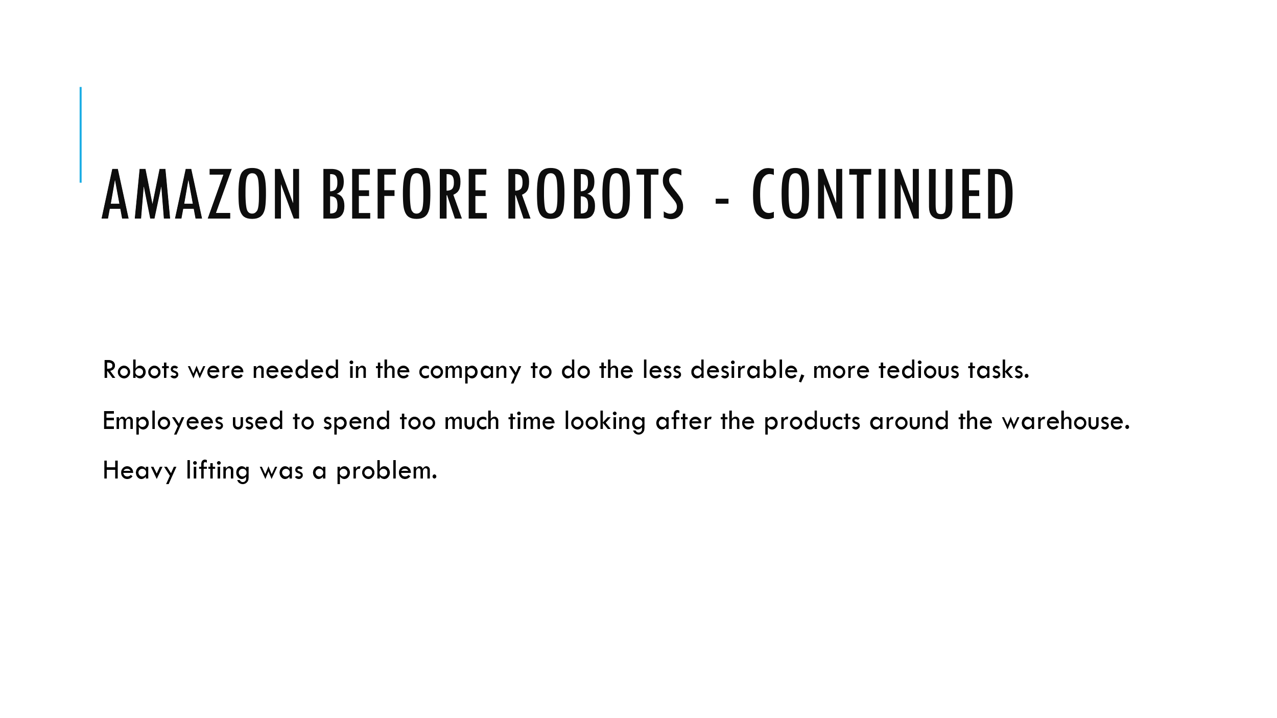
Robots were needed in the company to do the less desirable, more tedious tasks. Robots are in place to help people with low skilled jobs, tasks that take time and effort and create better jobs in IT and maintenance of the robots.
Employees used to lose time looking around in the warehouse for products. It was hard to find it and even identify the right product sometimes. However, the high volume of orders and the idea of Amazon Prime where everything is the next day at your door didn’t permit these things to happen.
The heavy lifting was also a problem within the warehouses, a problem that robots do not have.

Slide 10
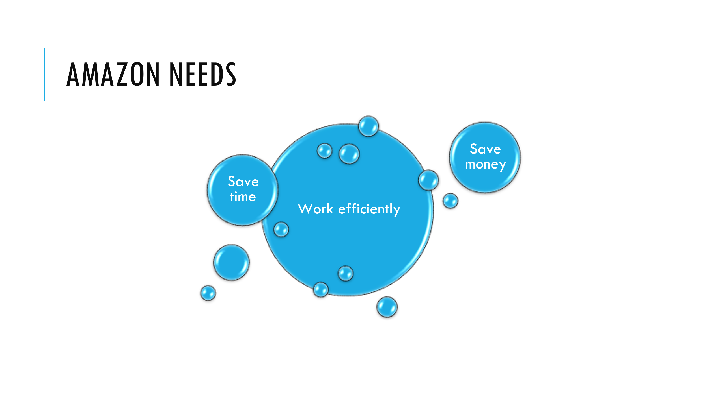
To conclude the idea about “what made amazon need robots “: mainly the needs of Amazon after the Amazon prime idea were to save money, save time and work efficiently.
More about this technology will explain my colleague Yeliz.

Yeliz Koncak 2028995- Insights to Amazon’s Modern Technology
Slide 11.


Slide 12
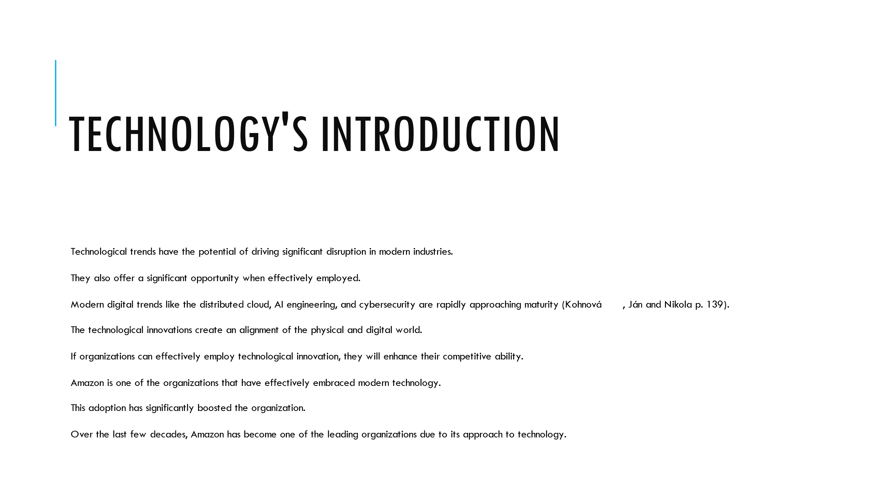
Modern technology is changing at a faster rate and industries to adjust to it to ensure that they maintain their relevance in the industry.
Amazon provides a key example of how early adoption of technology helps organizations gain a competitive edge over competitors.
Amazon has been ranked the best in several years due to how its role in transforming its industry.
It has made shopping easier and comfortable for the clients.

Slide 13.
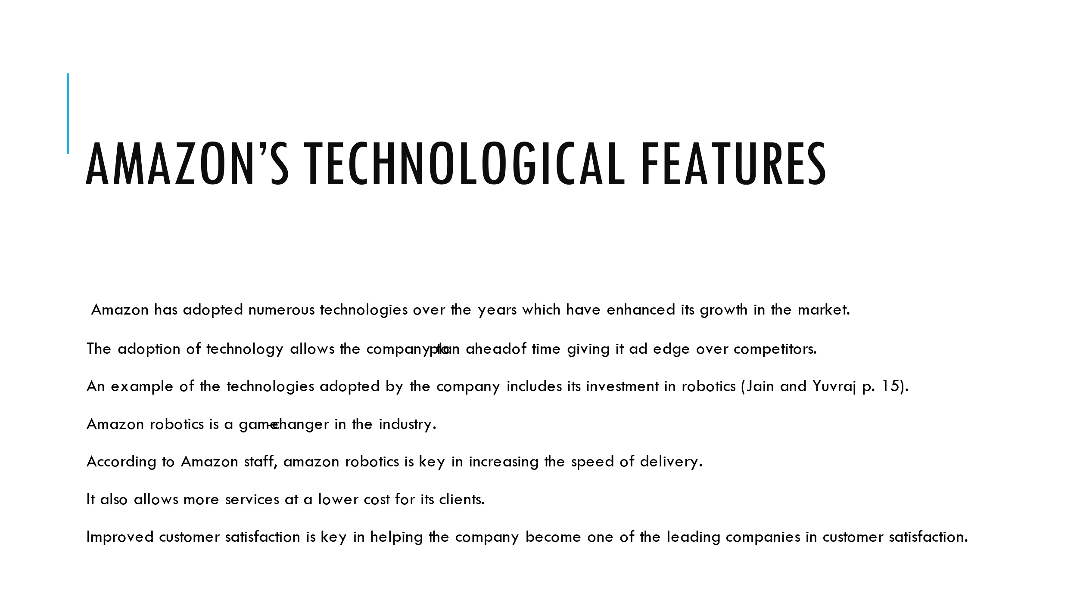
Amazon is one of the leading companies in terms of customer satisfaction.
This event has resulted from the company’s investment in modern technology.
The technology allows easier and faster service delivery to the clients.

Slide 14.
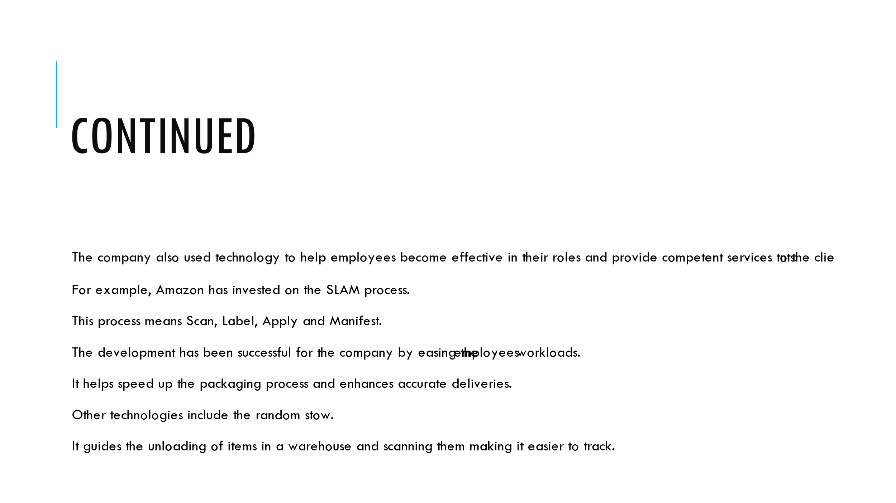
Embracing modern technology has helped improve employee performances.
They are provided with different tools that make their duties easy to execute.
This ensures that one person can execute different roles within a short time.
The combination of employees and technology makes it easy to satisfy the customers.

Slide 15
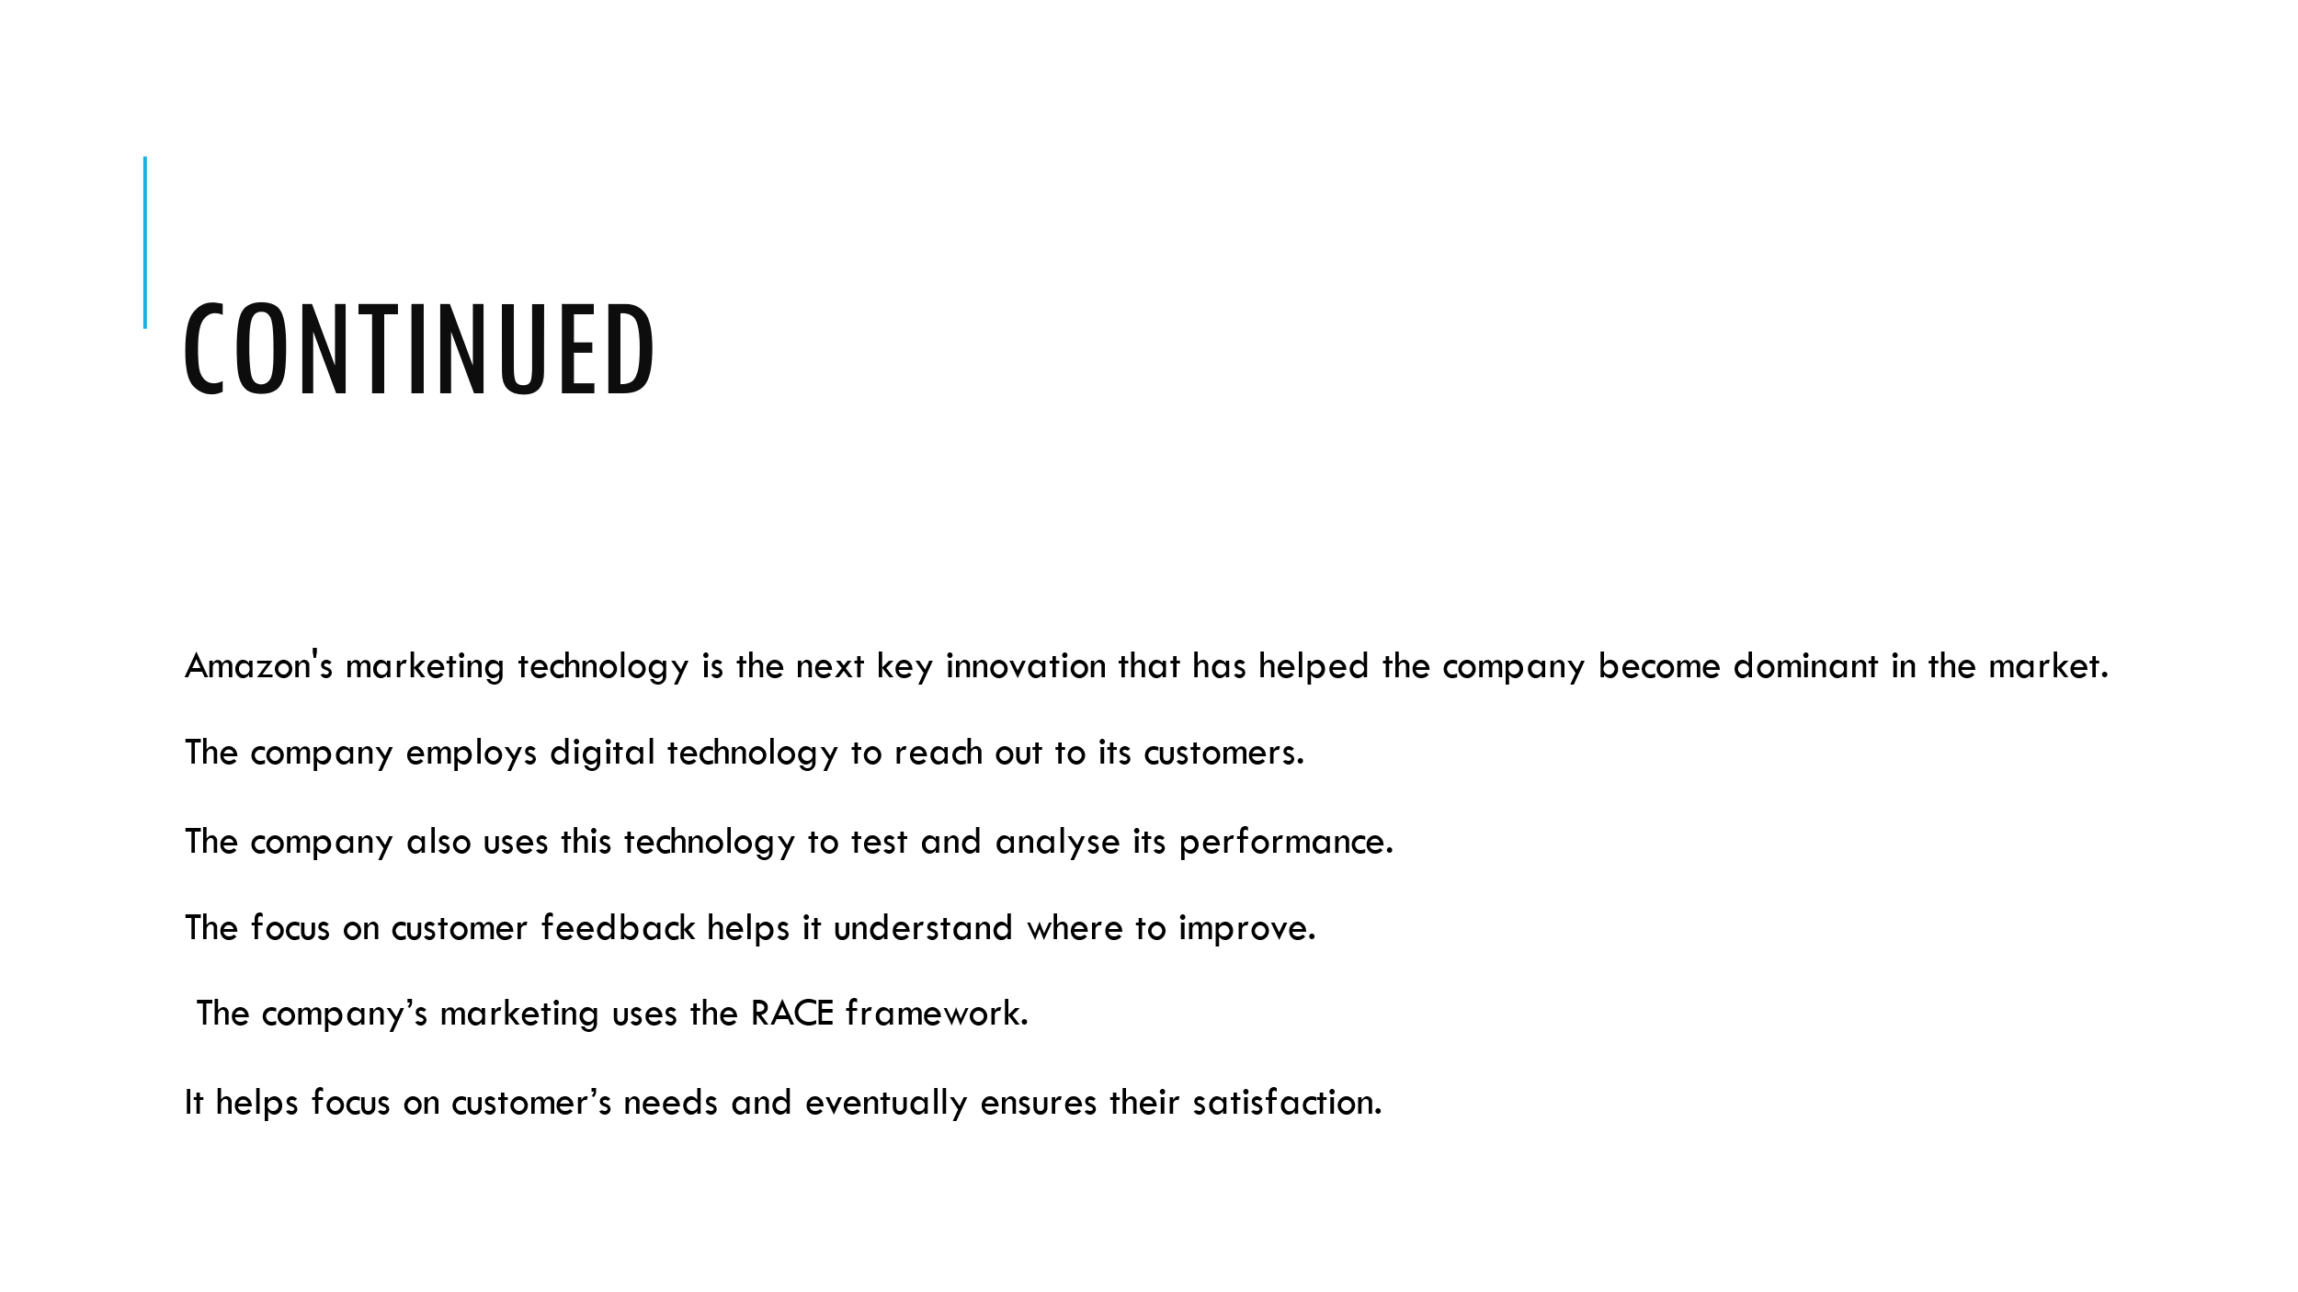
Digital technology is key in reaching out to clients.
Amazon has exploited this opportunity to its advantage.
It allows the company to focus on customer satisfaction by conducting regular analysis and determine areas of improvement.

Teodor Panev 2028893- The impact of the technology introduced

Slide 16


Slide 17
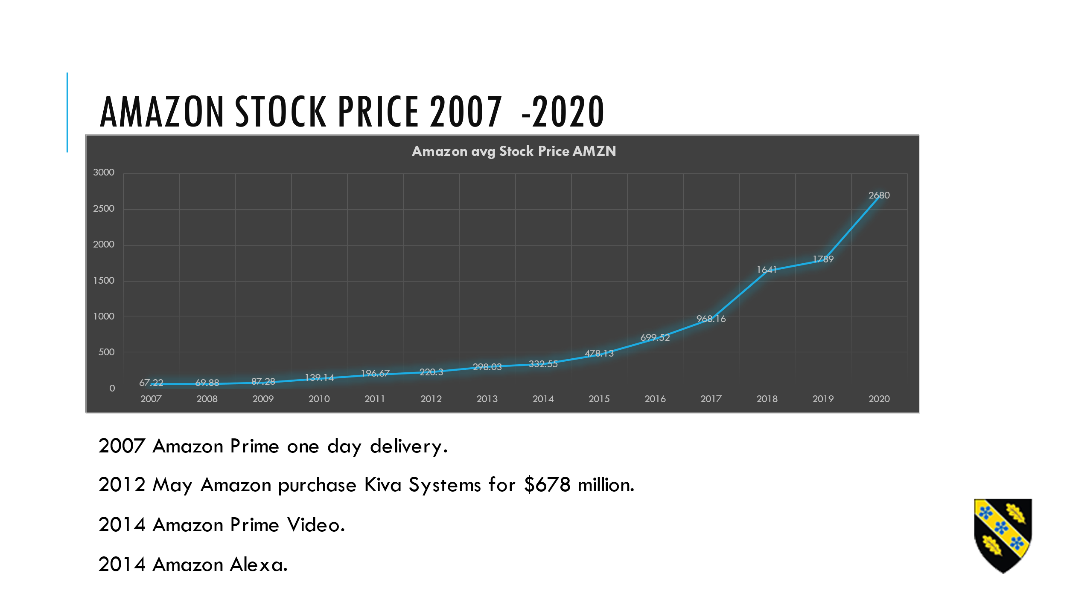
Slide 18
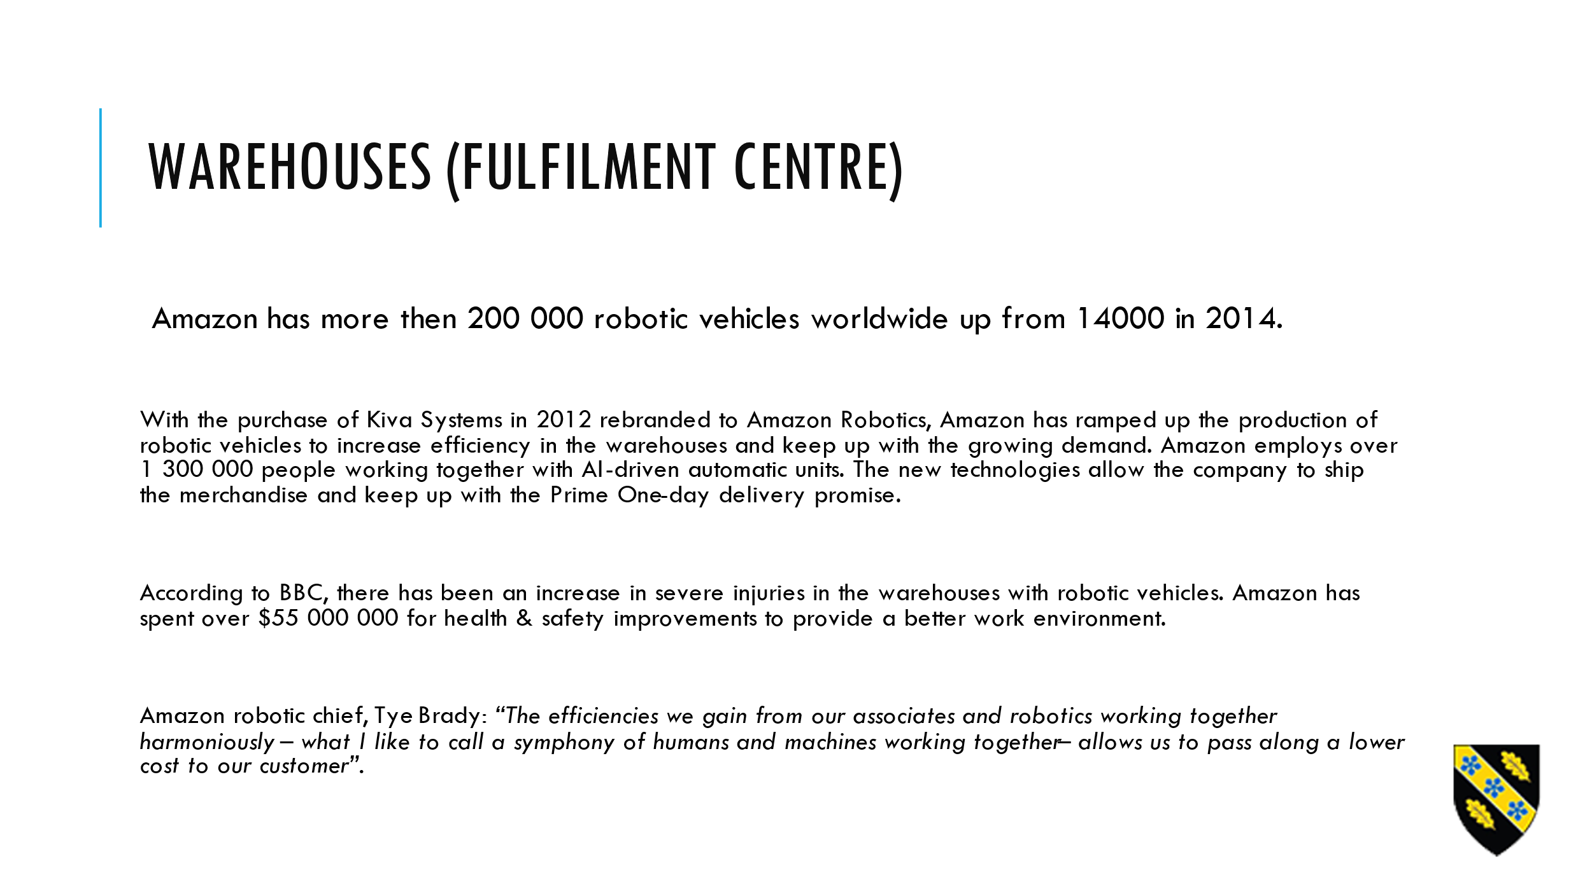

Slide 19
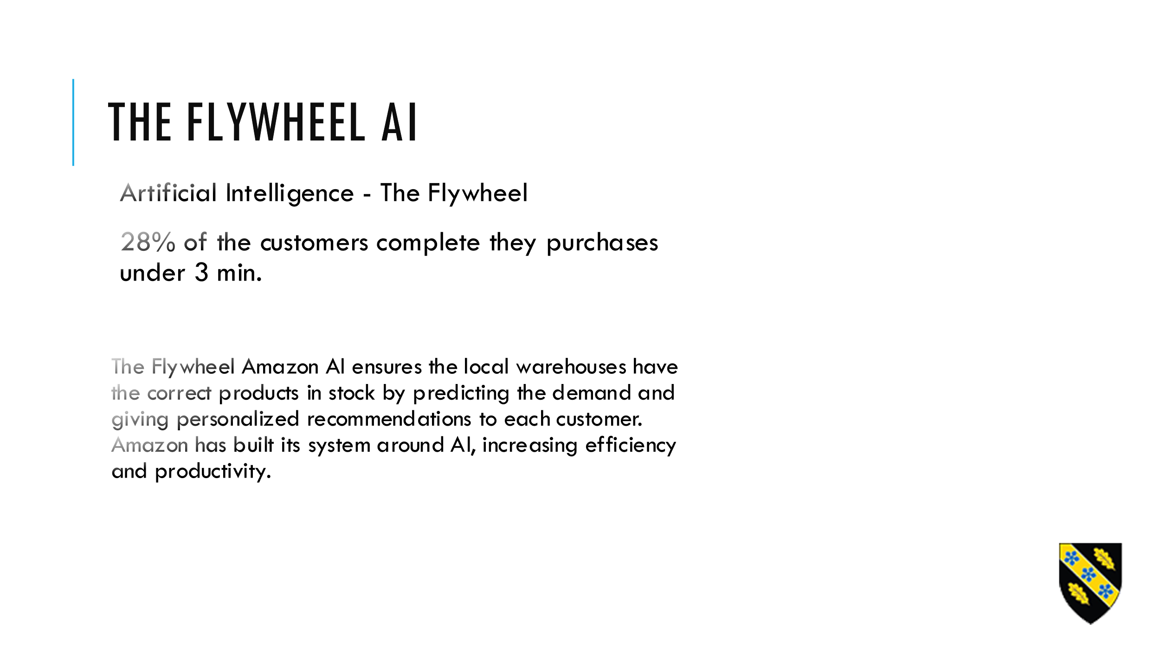
Slide 20

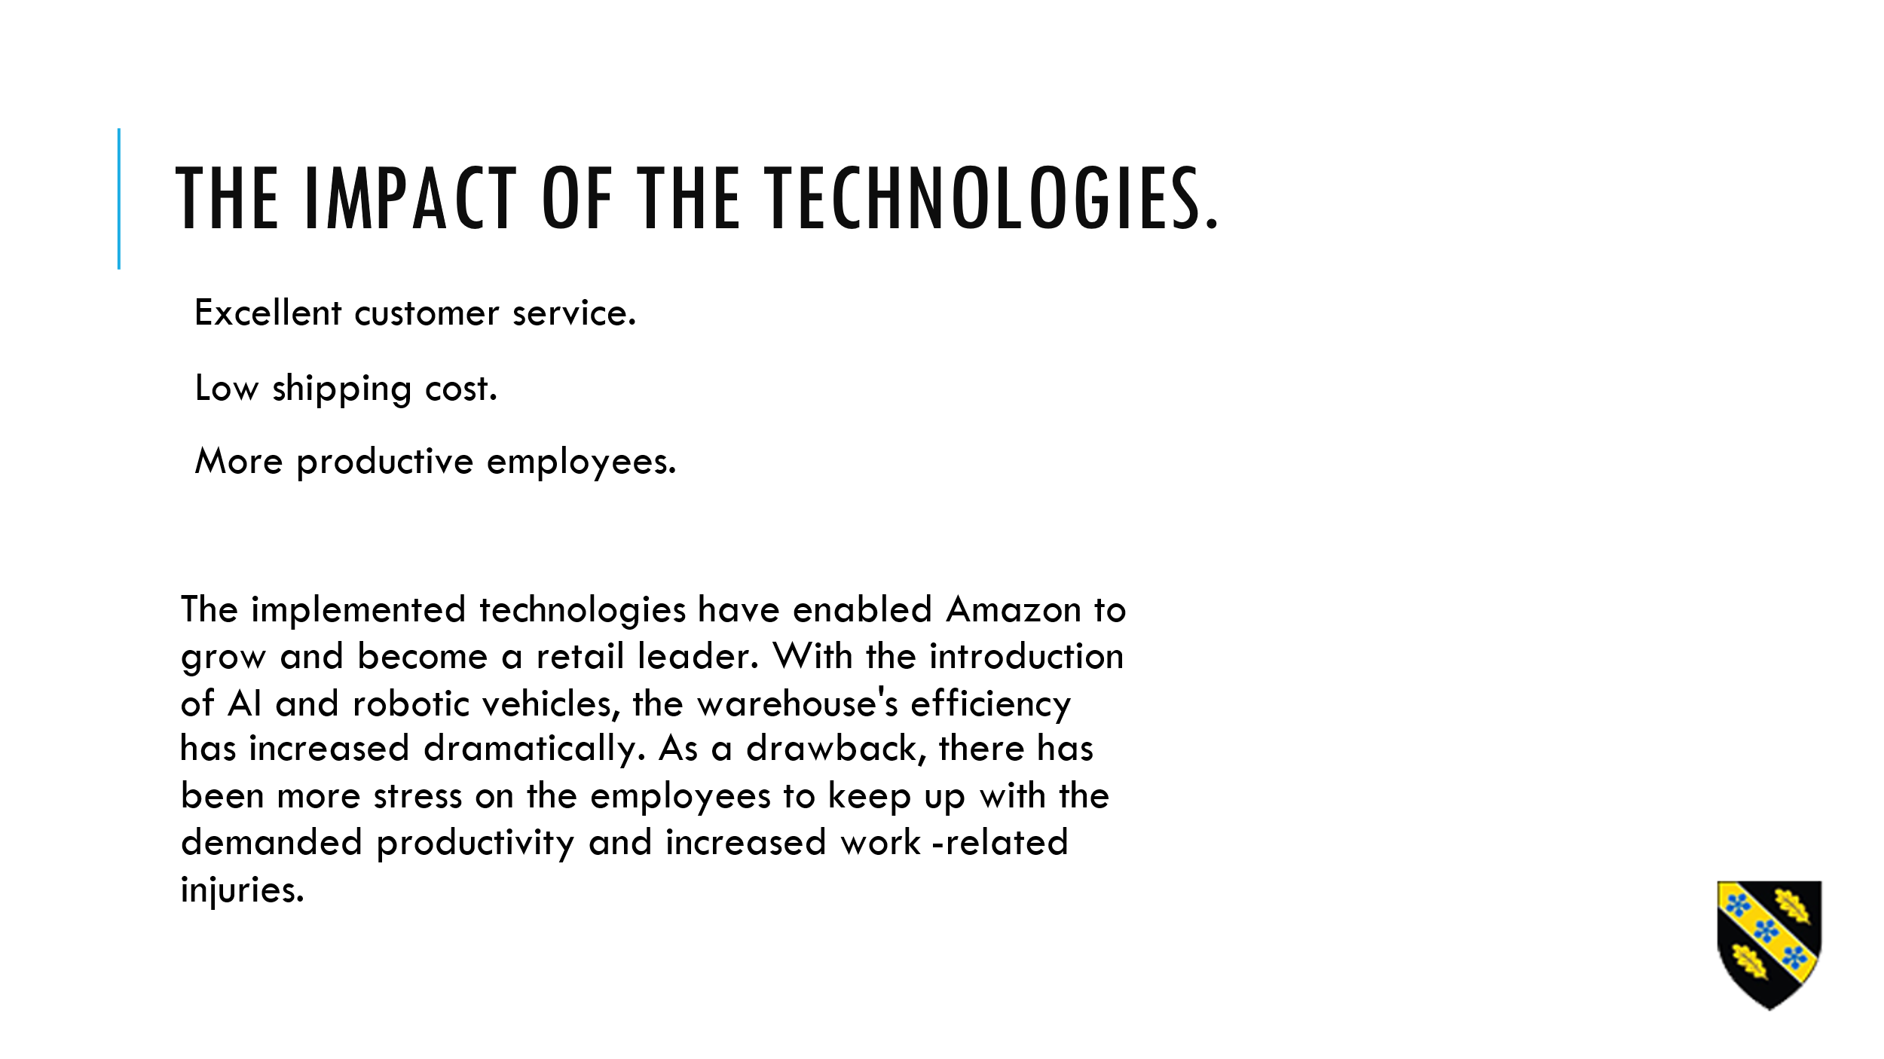

Slide 21
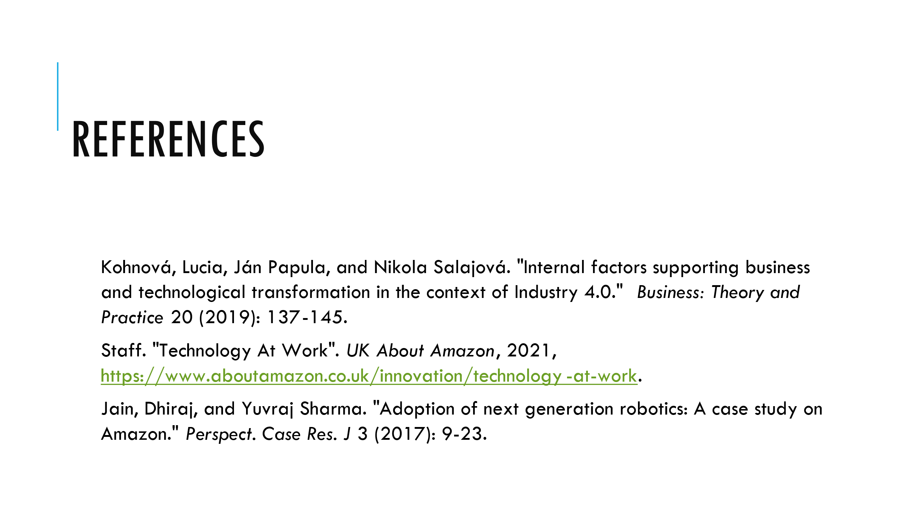
Yeliz-references
Slide 22
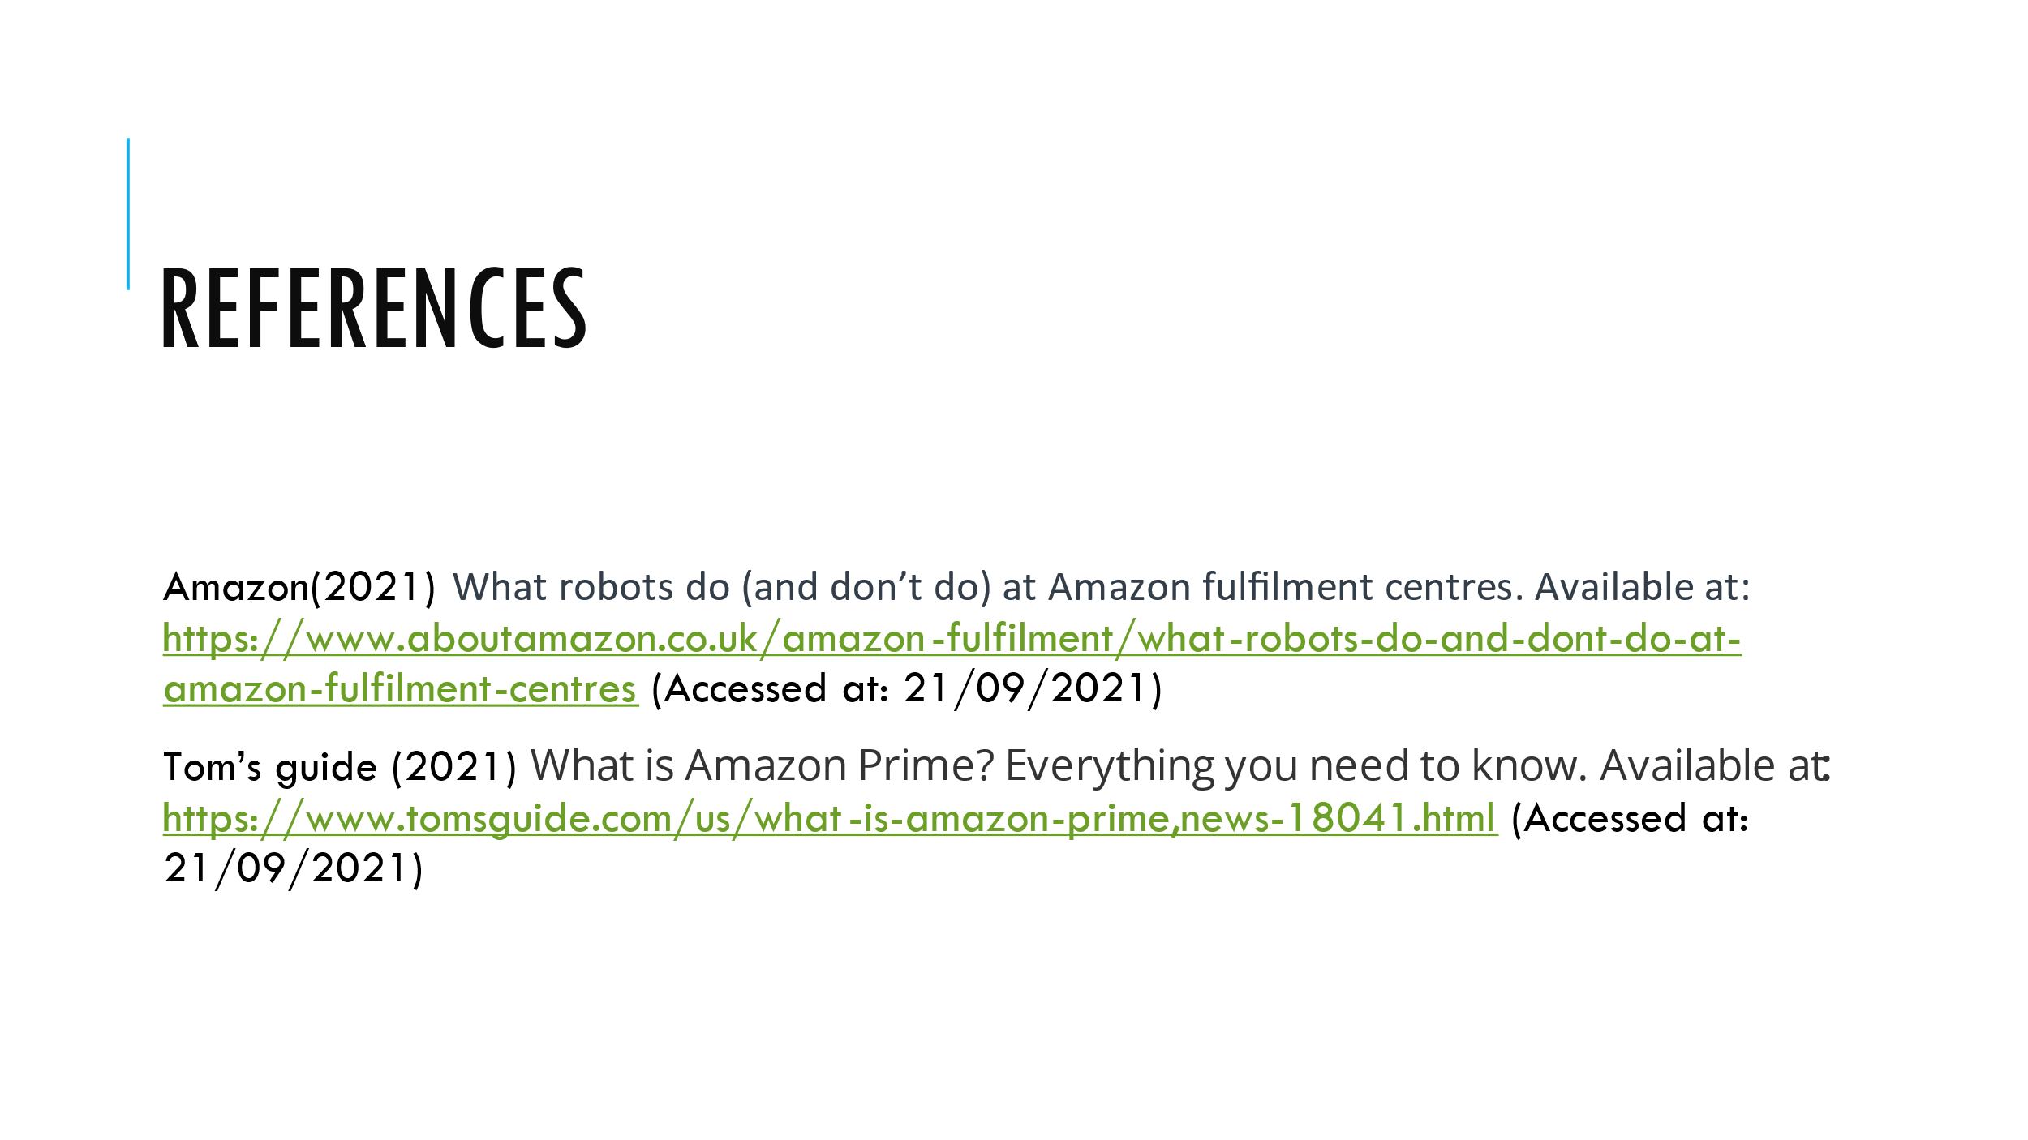

Silviu-references

Slide 23
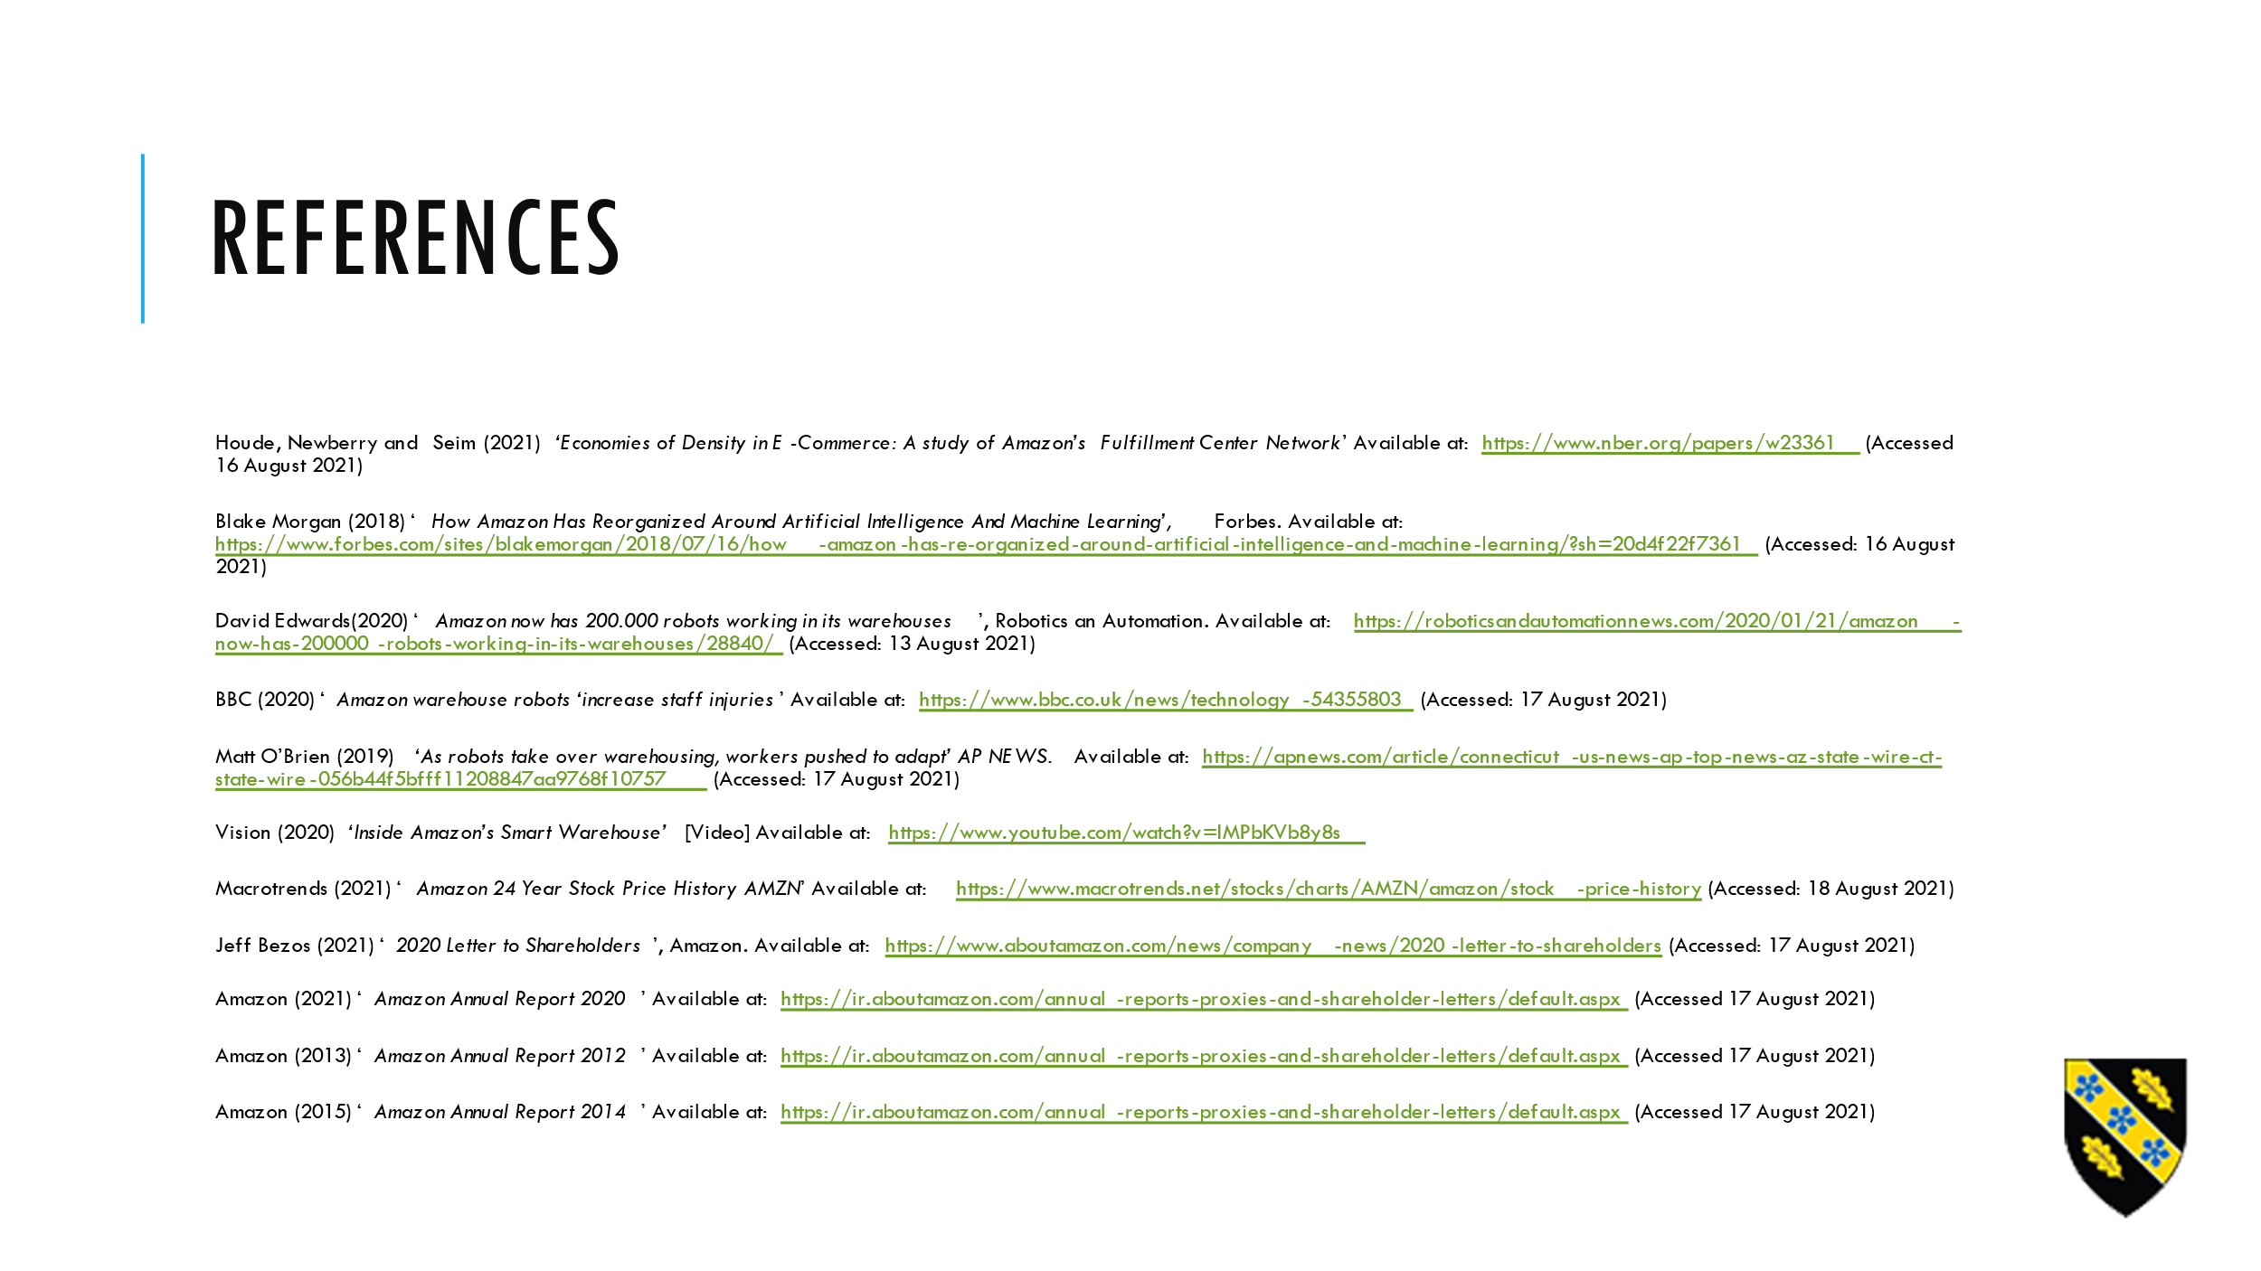
Teodor.-references

