5CO02 - Evidence-Based Practice
Emma Whitmarsh – 2405996

AC 1.1: Evidence-Based Practice (EBP)

The CIPD believes that EBP is an important step for the people profession to take, and their Profession Map describes ‘a vision of a profession that is principles-led, evidence-based, and outcomes-driven.’ (CIPD, 2015). Leadership decisions should be based on a combination of critical thinking and the best evidence available. They should seek to make a more informed, researched solution to a problem by using a variety of carefully selected evidence. (CIPD, 2023b).
To use quantitative data to examine people analytics to solve business problems, the data from HR and Payroll systems can be utilised. The application of qualitative data is also relevant from employee surveys, the experiences of colleagues, performance appraisals and exit interviews, as it can be converted into quantitative data. (CIPD, 2017).
Briner (2019a) identifies four sources of data evidence for people professionals: Scientific – using sources of literature. Organisational - from internal resources as HR and Payroll systems. Professional Expertise - the experience of colleagues, their expertise and opinions. Stakeholder - internal and external stakeholders.

With such a huge amount of information readily available to us nowadays, we need to gather evidence wisely, being selective in choosing a combination of trustworthy evidence from these sources to allow us to come to a solution with the likelihood of the most effective outcome. Bias needs to be considered, especially when looking at qualitative data. Rousseau (2021) suggested three areas of focus in developing an HR practice – systematic reading to prime decision-making – reading books and articles relevant to the question. Understand our organisation better - what makes it effective and successful? Investment in good information systems. HR leaders are important sources of organisational information, but unless we ask the right questions, we won’t be able to gather the organisational data needed; the ability to ask critical questions about what works, how, and why. (CIPD, 2017).

So how can we make effective EBP decisions? If we look to apply the 6 Steps when examining our evidence. Asking – looking at the problem and turning it into a question to answer. Acquiring – systematically searching for evidence from the four sources. Appraising – reviewing evidence and critically judging it for trustworthiness and accuracy. Aggregating – deciding which evidence to use and pulling it together. Applying – using data remaining for the decision-making process. Assessing – evaluating outcomes of decisions taken. This ensures a systematic approach and ensures that the right decisions are made based on all available evidence – it won’t always be possible to follow all the steps, but the more thorough we can be when examining evidence, the better the outcome will be. (CIPD, 2023c, Briner, 2019b).

AC 1.2: Analysis Tools and Method
Embracing data and analytics helps organisations to close their skills gaps, identify future leadership, and develop talent to future-proof the organisation with the employees and skills needed to thrive both now and, in the future. (People Management, 2024)

As a framework tool PESTLE is used to explore the external factors that may influence an organisation: Political, Economic, Social, Technological, Legal, Environmental. It can be applied to a range of scenarios and guide people professionals in strategic decision-making. (CIPD, 2017).

To consider the application of PESTLE in the Police Force - ‘Effective promotion preparation always includes, considers, or addresses strategic aspects, especially if you seek promotion to the more senior roles and ranks of Inspector and Chief Inspector’ (People Management, 2024). Political – updates in Government policies, College of Policing, HMICFRS Partnership collaboration. Economic – resource uplifts, budgets, spending reviews. Social – Population demographics, Race and Diversity, effects of social media on society, increased crime figures, leading to higher workloads and affecting wellbeing. Technology – digital solutions, AI, increase in targeted online fraud, data sharing, connectivity. Legal – National Decision Model (NDM), Offender Rehabilitation, Equality Duty and new legislation. Environmental - urban versus rural crime, sustainability, PEEL (Police Effectiveness, Efficiency and Legitimacy). (People Management, 2024)

The outcome of this research should provide the main factors to examine in further depth, but needs to be put together comprehensively, in real terms, and relate directly to the Force. With PESTLE, so much information is gathered, there is a risk of ‘paralysis by analysis’, and the over-summarisation and simplification of information gathered. The research needs to be repeated regularly to keep up with the changes in external factors. (CIPD, 2023).

A Survey is a particularly useful method of research to utilise in people practice, measuring employee engagement. It is a flexible mechanism to enable employees to feedback regarding issues that may affect work/life balance, allowing them to feel heard.

Judd, O’Rouke and Grant (2018) suggest that ‘Surveys are a vehicle for changing behaviour’, that when we ask employees for their input and ideas, we’re not just learning from their responses, we’re also influencing their ongoing thoughts on the topic.

Managers should carefully consider what they wish to achieve with a survey - which can be distributed in various ways - by text, email, company intranet, social media, as is required for the research. Pulse surveys (text or email) are quick, effective ways to capture feedback from employees and often only include a single question and can help to gather real-time feedback about a specific initiative or event. The Pulse survey isn’t a replacement for the traditional employee survey but rather more of a complementary survey that can work with other surveys to support continuous feedback and improvements for a workforce. (Access People HR, 2020).

Morrell-Samuels (2020) warns of poorly designed workplace surveys, with the difference simply being care and informed design, the truth being that too many managers and people practitioners are falling behind advances in survey design by using model design principles formulated 40-50 years ago.

AC 1.3 Critical Thinking (CT)
CT is a complex process – ‘the underlying concepts are useful to anyone who wishes to develop clearer thinking; produce effective arguments; be more observant of what they see and hear and to ’Understand concepts used in CT’. (Cottrell, 2023).
CT in people practice is an essential and crucial principle we need to apply daily to be rational in our thinking – applying the principles of clarity, accuracy, precision, relevance, depth, breadth, logic and fairness into the recruitment process. To examine the effective decisions and implement preventative solutions that deal with root causes.
The cognitive ability to think critically and apply critical reasoning is a key skill for a people practitioner. It involves being able to order thoughts logically; to listen, compare, consider, examine, and evaluate information in an unbiased way against other sources of information - for example, a collective of people’s opinions, together with the knowledge they already hold. (CIPD, 2019).
Aveyard, Sharp & Woolliams (2011) identify six ‘strategic’ questions to get people thinking critically: What is the problem and what are the key messages? Where did you find the information? Why has this been written or said? When was this? Who wrote or said this? How has the author or speaker come to this conclusion?
People unconsciously employ CT in everyday life at work, home, social media – it’s interpreting whether what we are seeing or hearing is truth or fake news, making decisions based on what we read and know. ‘We are living in a ‘VUCA’ world – Volatile, Uncertain, Complex and Ambiguous’ VUCA is an acronym to describe or to reflect based on the leadership theories of the world we live in. (Bennis,1986).
We need the ability to examine evidence objectively and logically and judge its relevance to our question or discard it - be able to recognise evidence or facts as useful, good or irrelevant, and identify a more significant evidence source. To question if we’re looking at this evidence with bias; do we favour this evidence because it suits our beliefs, or because it’s a useful, viable source for our research? ((soundcloud.com, n.d.).
CT drives effective Policing, as they face an extensive variety of issues on a day-to-day basis and need to make sense of a complex environment; accept that ambiguity is part of our contemporary working lives and be able to identify interrelationships between different factors. ‘Analysing critically is one of the six competencies in the competency and values framework (CVF). The CVF has 3 levels of analysing critically which are incorporated into the interview process and used as a measure to score interview performance for candidates (www.college.police.uk, 2024).

AC 1.4: Decision-making Processes
Good decision-making skills can enable management to address challenges and consider all options available as well as looking at alternatives and applying judgement to select an appropriate course of action. In people practice we need to be aware of the implications that bad decision-making could have on employees and productivity and ensure that we apply strategic thinking in our research for good successful outcomes. (CMI, 2020).

The Best Fit (BF) approach focuses on aligning decisions with the specific context and needs of the organisation. Instead of applying a generic solution, BF looks at the culture, structure and environment of the organisation. (anita.file@managers.org.uk, 2020).
In Recruitment, BF ensures that the successful candidate has the required skills and matches organisational values and culture. A benefit of this approach is its adaptability towards different organisations; however, a downfall is that it requires an in-depth understanding of the organisation to be effective. Instead of looking elsewhere for BF, people practitioners focus on how to best align their organisation internally and externally with the environment they operate in. ‘The core idea of this approach is that anything can work as long as it all fits naturally together’ (Jeroen Kraaijenbrink, 2019).
Police Forces uses the NDM (College of Policing, 2024a), where the Code of Ethics (College of Policing, n.d.) sits at the very centre and is the touchstone for all decision-making, as well as the Competencies, Values and Framework process (CVF). ‘The CVF provides clear expectations for everyone working in policing. It describes the behaviours required by you, as a police officer or member of staff, to be effective in your role and uphold the Code of Ethics. It plays a significant role in the recruitment, assessment, and development of officers and staff at every level’. (College of Policing, 2024).

De Bono's Six Thinking Hats (De Bono, 2014) encourages looking at problems in different ways, assigning 6 ‘hats’ that each represent a different way of thinking. The Blue hat – organisation, planning, allocates actions. Red - emotions and instincts, Yellow – the positives, Black - potential risks, White - facts and data available, and Green – creativity, possibilities, new concepts.

“Thinking is the ultimate human resource…The main difficulty of thinking is confusion. We try to do too much at once. Emotions, information, logic, hope and creativity all crowd in on us. It is like juggling with too many balls.’ (De Bono, 1999).

This approach encourages comprehensive thinking and is useful to explore a wide number of viewpoints but could result in an extended process with too much information and opinion. However, if used properly in people practice it can ensure that all angles are examined to arrive at a final decision. Indeed, Watson (2014) suggests that this approach helps the individual to think outside of the box, and that the quality of a decision is enhanced by the creative method used to solve it.

Both approaches are useful in defining the problem and considering alternative solutions, as they encourage deeper analysis and guide people practitioners through the complexities of the decision-making process, helping to avoid hastily made decisions.

AC 1.5: Ethical Perspectives
Ethical theories and values provide frameworks that help individuals and organisations decide what is right or wrong, shaping decisions in a structured way. These perspectives are crucial in people practice, where how we make decisions can significantly affect employees and the organisation. If decisions are based on good ethical principles, we can improve the lives of others around us and our employees at work. (CIPD, 2023).
CIPD (2015) describes eight ethical lenses that offer different perspectives on work dilemmas. Each lens draws on a major tradition of thought in philosophical ethics.
Well-being – suggests that work should be beneficial, creating a healthy work-life balance - based on Utilitarianism, the principle being that the greatest good will benefit the greatest number of people, focusing on the majority rather than the individual, on the outcomes or consequences of actions, aiming to maximise overall happiness or well-being. (CIPD, 2015).
(Buckley, Fedor, and Marvin, 1994) examine how moral philosophies of ethical behaviour can be applied to the recruitment process and suggest that decisions made should result in the greatest advantage for those who are stakeholders in a decision. The application of Utilitarianism would suggest that the needs of all parties in the process should be considered to maximise the positive outcomes for society.
Applied to people practice, Utilitarianism is flexible and useful for decisions involving large groups of employees - it may influence a decision to implement a new policy to benefit the majority of employees, even if negatively impacting the minority; so, the weakness being to overlook the rights and wellbeing of those in the minority.
The Fairness and Rights and Duties lenses focus on rules and obligations. Rights and Duties – people should be concerned with the rights and duties set in culture and law - doing some things and being free of others, with everyone having a duty to not violate others’ rights; whereas the Fairness lens summarises that everyone in an organisation should be able to agree to it, whatever their place in it. (CIPD, 2015).
Modern deontological theories focus on rules and obligations. Deontological (duty-based) ethics is concerned directly with the actions taken and not with the outcomes of those actions. (BBC, 2014).
In the context of people practice, the deontology approach ensures that employees are treated fairly and equally even if it doesn’t lead to the best outcome for the organisation, focusing on the individual, their morality, and their ethical duties to society, rather than the organisational culture. (Waite et al., 2021).
Kaptein and Wempe (2002) write that the main disadvantage of this approach is that it easily leads to a rigid application of rules. ‘However, it remains inadequate, especially in situations where major economic interests and specific principles are at stake. In situations like these, deontological ethics offers no adequate, watertight solution’.
Both perspectives offer valuable insights, but their applicability depends on the situation and the ethical priorities at stake. Ethical values provide a moral compass by which to live our lives and make decisions and highlight why organisations should focus on creating a shared ethical culture where employees feel empowered to do the right thing rather than just follow a set of rules given to them.

AC 3.1: Financial and Nonfinancial Performance
The application of financial and nonfinancial metrics is vital, for organisations to give leaders valuable insights into how to improve processes. Without metrics, people practitioners would be in the dark about how their workforce is performing and how they can improve when something isn’t working well. This in turn directly relates to organisational success which can also be measured through nonfinancial metrics.
There is much scientific data about the value of financial versus nonfinancial measures due to the considerable interest amongst practitioners and researchers. While financial metrics provide insight into profitability and efficiency, nonfinancial metrics offer a wider perspective on long-term sustainability and stakeholder satisfaction (VQ Solutions Ltd, 2024).
Kaplan and Norton (2001) write that the principal rationale presented to justify the use of nonfinancial measures for performance evaluation has been that these are leading indicators of financial performance, with most studies which have examined the relationship between financial and nonfinancial measures, showing mixed results (Ittner and Larcker 1998). (Kaplan and Norton, 2001) continue that the mixed results suggest these relationships may be contextual, which makes it important to understand the factors that moderate these relationships before application to internal processes and development. Emphasis on nonfinancial measures may make more sense in locations with high levels of competition than those businesses in rural areas, where competition is limited, with fewer choices existing for customers to shop and employees to work. (Urban Institute, n.d.). However, both metrics are essential to make informed strategic decisions.
Net profit (NP) as a financial measurement shows how much an organisation retains after all expenses have been considered and deducted and allows an immediate insight into profitability. It’s essential because it illustrates profitability and helps to assess the efficiency of operations. In HR, NP is a metric that can impact everything from training and development to talent acquisition and compensation. NP matters, as HR professionals can use NP margin to link departmental strategies to broader business objectives, to obtain buy-in from leadership, and save time. (Wellhub, 2024).
If we consider nonfinancial metrics, customer satisfaction (CS) is a powerful tool used to examine how well an organisation is meeting customer needs. This is generally measured through surveys or feedback mechanisms. To apply CS in terms of people practice, we initially need to define who our ‘customers’ are, since the context of the feedback is related to who gives it – finding out what managers and employees think of HR services and functions.
One such case study noted by IES (2017), examined a partnership of 64 NHS organisations in the Northwest who collected ‘stakeholder feedback’. Between 2008-2010, 8,000 people answered this survey. The content of the questions was linked to a model of World Class HR (WCHR) as part of a HR functional performance improvement project and consisted of 7 sets of items; the first 6 relating to WCHR, the 7th covered creating value, innovating and demonstrating impact The method was an online survey sent via an email with a link to the survey - administered at the beginning of the project as a baseline position and again 2 years later to assess progress.
In conclusion, financial and nonfinancial performance metrics complement one another and offer a wider view of organisation success.

AC 3.2: Adding value with People Practices

Creating value in an organisation can include both the development of structural capital (SC) – products, services, and human capital (HC) - employees (Waite et al., 2021b)
People practice tools include recruitment, talent management, employee engagement and training. Effective people practices boost productivity, satisfaction, and organisational culture. When employees are supported, they are more likely to be productive and committed, which will drive the organisations success. (Waite et al., 2021b)
An IFRS (2015) HC study states that peoples’ skills, talent, personal attributes and creativity affect organisational performance and shape its future, making HC essential for creating value.
In 2013 the IIRC published the Integrated Reporting (IR) framework, providing HR with ‘the opportunity to lead on what was highly regarded as the next evolution of corporate reporting’. (Newcombe, 2013). IR is designed to give investors and banks a holistic view of how an organisation creates and sustains value in the short, medium and long term. The IR framework defines HC as the ability to understand, develop, and implement an organisation's strategy, loyalties, and motivations for improving processes, goods, and services, as well as its approach to risk management and ethical values.
Baron and Armstrong (2007) explain that HC management is a process an organisation can take to obtain, analyse and report on data; data which can provide valuable insight into how value can be added through people practice, strategic investment and operational decision making at the higher levels of management, filtering down to front-line management decisions. For an organisation to remain competitive and knowledgeable today, value must be created through its people.
Stobierski (2022) describes Cost Benefit Analysis (CBA) as the process of comparing the projected or estimated costs and benefits (or opportunities) associated with a project decision, to determine whether it makes sense from a business perspective. It involves adding all costs of a project or decision and subtracting that amount from the total projected benefits of it. If the benefits outweigh the costs, we could argue that the decision is a good one to make, but on the other hand, if the costs outweigh the benefits, we may want to rethink the decision.
Bronsteen J, Buccafusco C & Masur JS (2012) propose using Well-being Analysis (WBA) as an alternative to CBA. Whilst CBA is a tool used by organisations to inform decision making, WBA can provide the same policy guidance as CBA without its reliance upon figures. However, Kahn and Juster (2002) who describe WBA as ‘Well–being, or quality of life, is a continuing goal for individuals and a major criterion for the evaluation of governments and societies. suggest that as a research concept it has been marked by persistent problems of definition and measurement, with uncertainties about its changing pattern over our lives.
Both the above methods help to measure both financial and nonfinancial impacts, ensuring people’s strategies align with organisational goals.

AC 2.1: Interpret Analytical Data

The below graph illustrates the performance reviews judgements in percentage form, in order of department, with each metric displayed as Q1 and Q2 for a side-by-side comparison for each department. This gives an overall view of the performance judgements for all departments together.

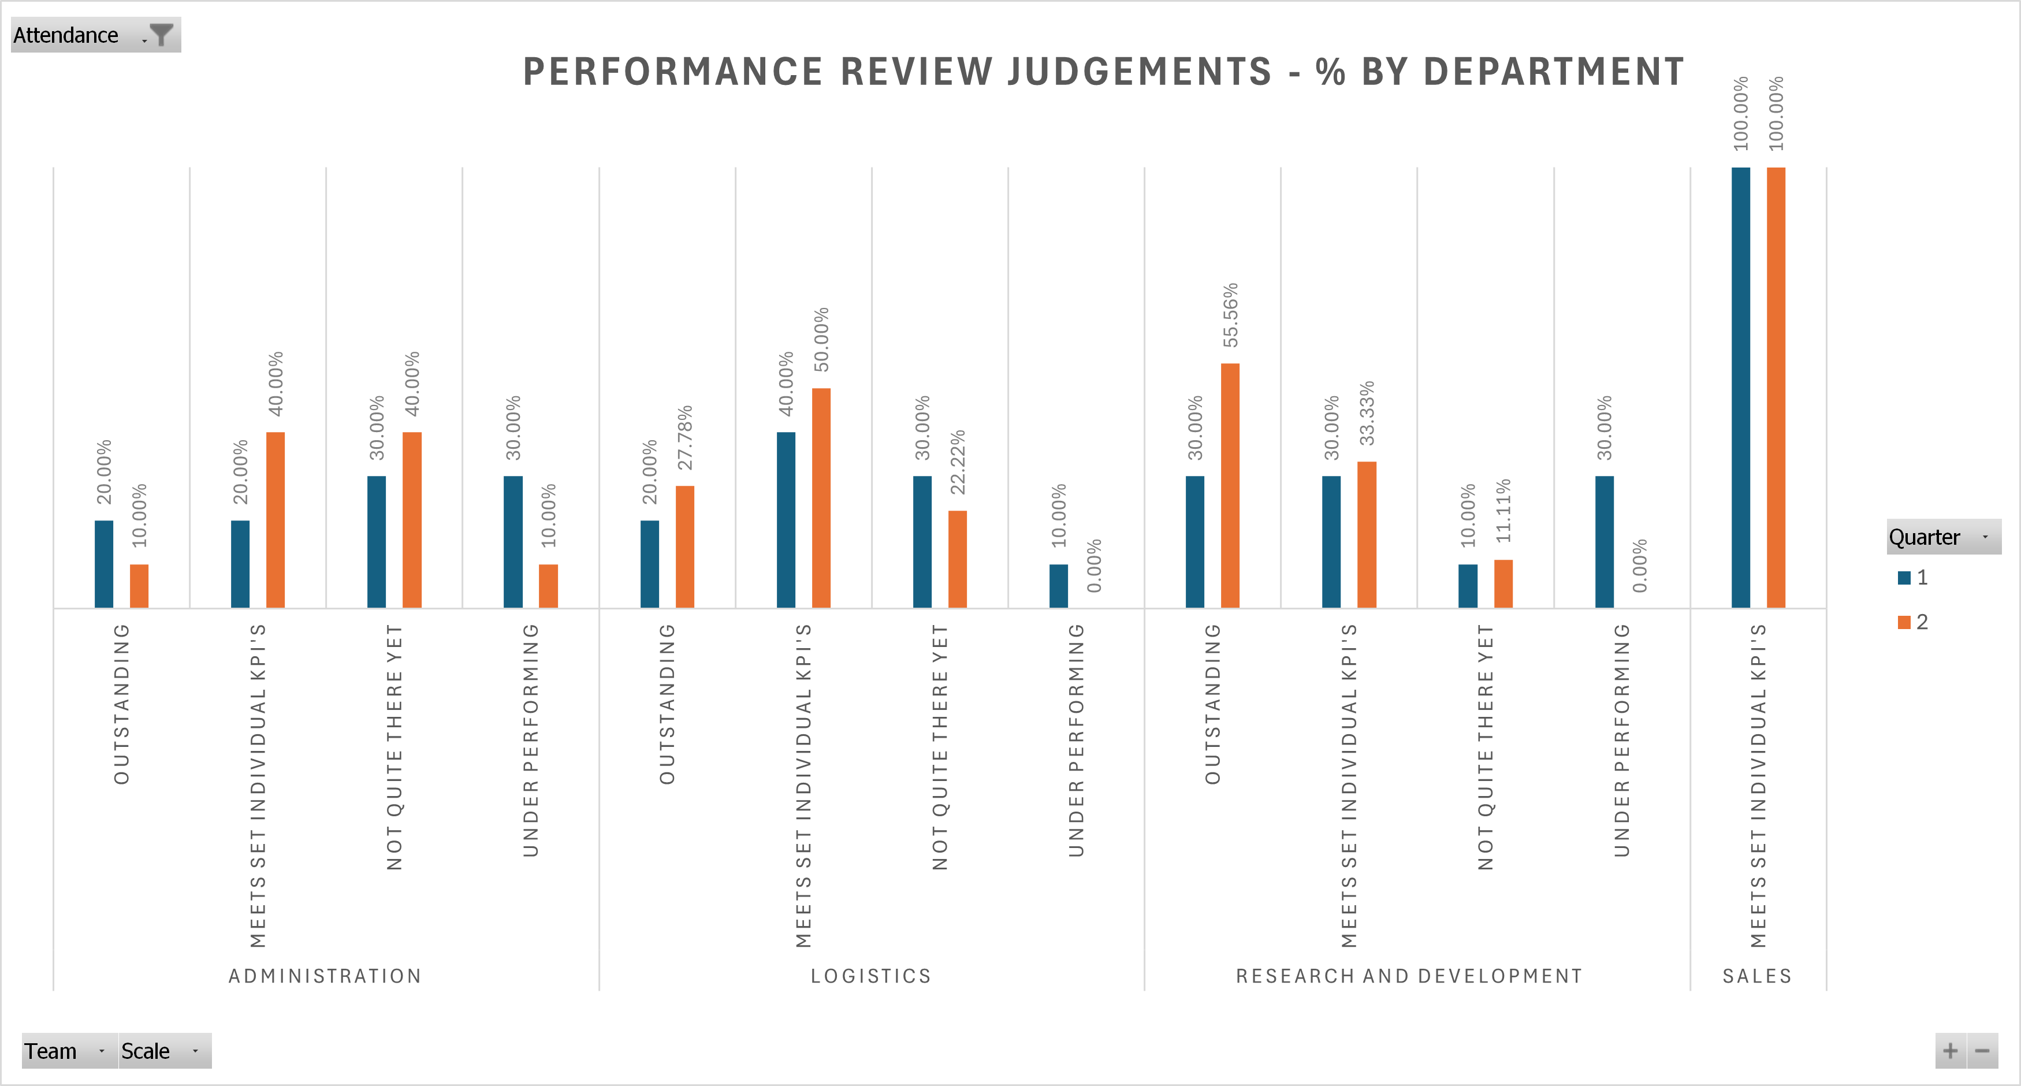

The below graph illustrates the results in another way, by looking at the judgement results with a departmental side by side comparison. This is useful as by looking at the columns in each judgement per quarter we can see which department has not been scored in that judgement metric.

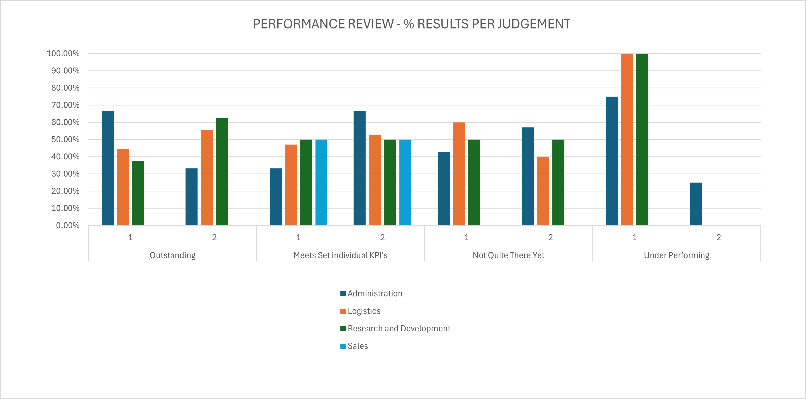

Employees achieving ‘Outstanding’ judgements are entitled to a four percent bonus payment each quarter. This is illustrated with the below graph:

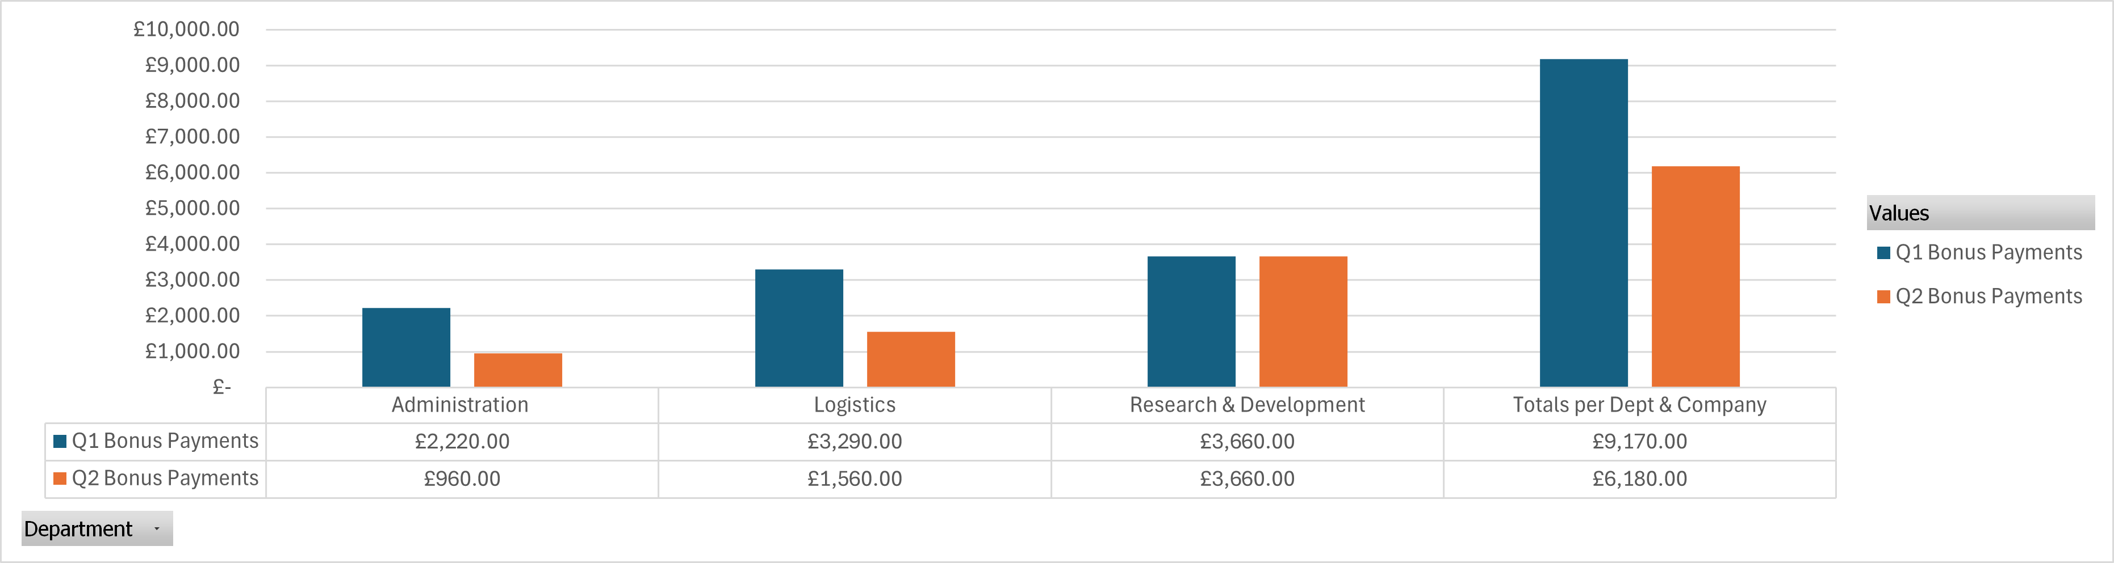

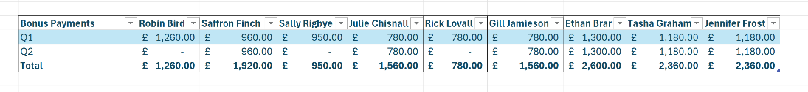

The below table shows the bonus payments totals split by Departments per Quarter with a total of the 2, and the overall bonus payment cost to the company for Q1, Q2 and the total.

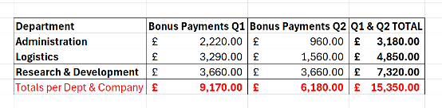

AC 2.2: Present Key Findings

Managers – Questionnaire on the Appraisal process:

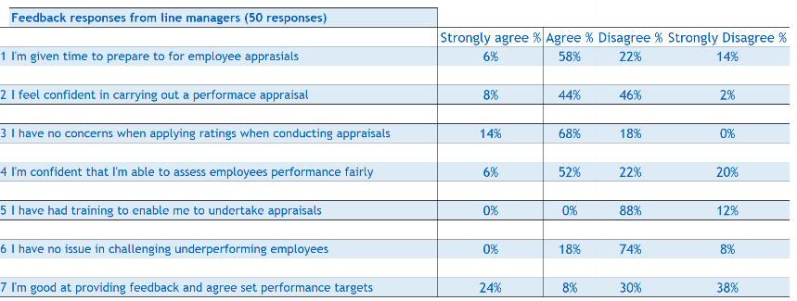

50 managers completed the questionnaire and overall, managers indicated they were satisfied with permitted time set aside to prepare for employee appraisals, with 64% in agreement. However, 36% indicated they were not given enough time to prepare, therefore this could be an area to investigate.

Although responses were in equal % measures in whether managers felt confident in conducting appraisals, the majority responded that they had no concerns about conducting an appraisal.

In assessing an employee’s performance – again the results were in the majority for confidence to do this, but there is enough of a disagreement in the findings that this could be flagged as an area of potential concern.

The training provided for managers to be able to prepare for and carry out an employee appraisal requires attention – 0% responded that they had trained, with 100% of managers in disagreement that training had been provided. The majority, although a close % are not confident to provide feedback and agree set performance targets for employees.
This finding links into the indication that managers are not confident to challenge an employee’s under-performance. If adequate training was provided it could include advisories on how to approach negative comments/feedback. There is the risk that due to lack of training that managers will make assumptions about the appraisal process, thus not ensuring a fair and consistent process for employees, companywide.

Employees – Questionnaire on the Appraisal process:

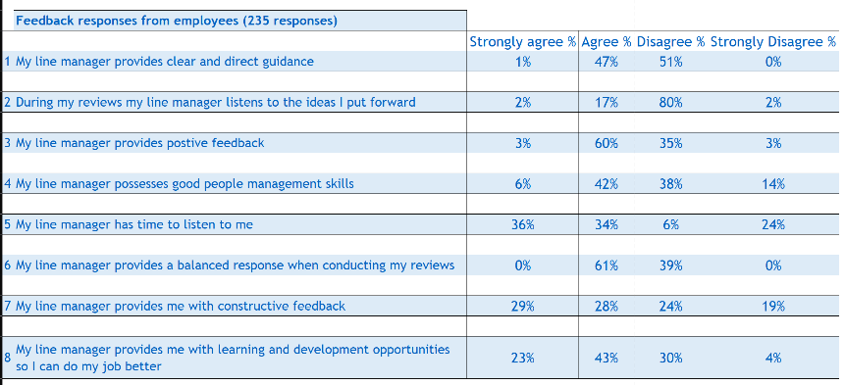

235 employees completed the questionnaire, with the majority indicating that they agreed with the statements put forward; however, there are areas where an equal number of employees disagree, and a clear trend that employees do not have faith that they are listened to by their manager. This could be due to communication in the review and/or previous experience that their ideas/suggestions are not taken forwards.

Although a majority of employees felt their managers gave positive feedback to their performance, 38% disagreed. There was a mixed response in regard to line managers having good people management skills, a concerning area to look further into and another training point for line managers linking into the lack of training for managers on the appraisal process, however, it should be noted that the employee isn’t sure what this means.
Employees will assume that their managers know the appraisal process and will be trained to be able to confidently undertake it and give balanced responses.

When we look to the statement regarding learning and development opportunities – do employees know what this means for their roles? The majority of employees agree (66%), but we should question why 34% disagree and ask if the company is potentially failing these employees.

AC 2.3: Recommendations, Risks and Financial Implications

Note: we are not given an indication whether the 50 and 235 responses are a good representative sample of the workforce.
The employees’ questionnaire was worded in the ‘positive’ – ‘My line manager has…provides positive…provides clear and exact guidance’, this is a potential influence over results of a questionnaire survey if employees are unclear about the questions.
Could this questionnaire include more free-text fields for ‘disagree’ and ‘strongly disagree’ to elaborate on the reasons? Some statements are not structed well and over-simplified, which may lead to assumptions and confusion in responses. For example – ‘My line manager provides a balanced response when conducting my reviews’. If an employee doesn’t know what the process should entail, because their manager isn’t trained on the process, this will influence their choice of response.
The risk of a poorly designed questionnaire is potential influence over the response of the person undertaking the survey. One recommendation is to consider a further look into the negatives – do we know which departments these employee responses came from? However, the risk of a follow-up questionnaire is survey fatigue whereby the same uptake rate will not be reached. Further research is required on how best to investigate further.
It could be assumed that the majority of negative responses from the employee survey relate directly to training issues flagged up from the manager’s survey – that is, training line managers on the appraisal process.

The financial implications of training. In looking at training - external training providers are often costly, and the cost to implement would be greater than appointing an experienced internal employee. Often if the appraisal process has been created in-house, there will be a questionable benefit in utilising an external trainer who would have to learn the process to be able to train others.

The cost of creating an internal training programme would include – creating a training programme, preparing the training materials for the training, time for training, minus the training materials and loss of time for managers for the training. Once trained, confident managers could be empowered to train others with a ‘train the trainer’ approach.
The benefits of implementing formal training for line managers would inspire confidence in appraisals, thus ensuring a consistent and universal process is applied throughout the company appraisals. In turn, employees would feel more confident and empowered to increase their performance.

Bibiography | AC
Access People HR (2020). What’s the point of a Pulse survey? [online] Peoplehr.com. Available at: https://www.peoplehr.com/en-gb/resources/blog/what-s-the-point-of-a-pulse-survey. Accessed: 21 November 2024. | 1.2
anita.file@managers.org.uk (2020). Decision Making. [online] CMI. Available at: https://www.managers.org.uk/knowledge-and-insights/resource/decision-making [Accessed 1 Dec. 2024]. ‌Accessed: 20 November 2024. | 1.4
Aveyard, H., Sharp, P. and Woolliams, M. (2011). A Beginner’s Guide to Critical Thinking and Writing in Health and Social Care. Maidenhead, Berkshire; New York: Open University Press. | 1.3
Baron, A. and Armstrong, M. (2007). Human Capital Management: Achieving Added Value Through People. London; Philadelphia: Kogan Page.‌ | 3.2
BBC. (n.d.). Duty-based Ethics: Duty-based or Deontological Ethics. [online] Available at: https://www.bbc.co.uk/ethics/introduction/duty_1.shtml. [Accessed 20 Nov. 2024]. | 1.5
Bennis, W. (1986). Leaders. The Strategies for Taking Charge. New York, Harper & Row. | 1.3
Briner, R. (2019a). The Basics of Evidence-Based Practice. https://cebma.org/assets/Uploads/Briner-The-Basics-of-Evidence-Based-Practice-v2.pdf. ‌Accessed: 20 November 2024. | 1.1
Briner, R. (2019b). The Basics of Evidence-Based Practice. https://cebma.org/assets/Uploads/Briner-The-Basics-of-Evidence-Based-Practice-v2.pdf.‌Accessed: 20 November 2024.‌ | 1.1
Bronsteen, J., Buccafusco, C.J. and Masur, J.S. (2012). Well-Being Analysis vs. Cost-Benefit Analysis. SSRN Electronic Journal. doi:https://doi.org/10.2139/ssrn.1989202. Accessed: 20 November 2024. | 3.2
Buckley, M.Ronald., Fedor, D.B. and Marvin, D.S. (1994). Ethical considerations in the recruiting process: A preliminary investigation and identification of research opportunities. Human Resource Management Review, 4(1), pp.35–50. doi:https://doi.org/10.1016/1053-4822(94)90003-5. Accessed: 20 November 2024. | 1.5
CIPD (2015) Ethical decision-making: Eight perspectives on workplace dilemmas. Available at: https://www.cipd.org/globalassets/media/knowledge/knowledge-hub/reports/ethical-decision-making-2015-eight-perspectives-on-workplace-dilemmas_tcm18-9564.pdf. Accessed: 20 November 2024. | 1.5
CIPD. (2015). CIPD. Explore the Profession Map. [online] Available at: https://www.cipd.org/uk/the-people-profession/the-profession-map/explore-the-profession-map. ‌ Accessed: 30 October 2024. | 1.1
CIPD (2017). PESTLE analysis. [online] YouTube. Available at: https://youtu.be/GFVKKTwkANY. Accessed: 15 November 2024. | 1.2
CIPD (2017a). Evidence-based practice: an introduction. [online] YouTube. Available at: https://youtu.be/ikJ687g2tPo?t=265&si=XlX6KIoKV1CUcCO. Accessed: 20 November 2024. | 1.1
CIPD. (2023b). CIPD. Evidence-based HR: Make better decisions and step up your influence. [online] Available at: https://www.cipd.org/en/knowledge/guides/evidence-based-profession/#what-evidence-should-we-use. Accessed: 10 November 2024. | 1.1
CIPD (2023c) Evidence-based practice. How do we make evidence-based decisions? The six steps. Available at: https://www.Evidence-based practicecipd.org/uk/knowledge/guides/evidence-based-profession/#how-do-we-make-evidence-based-decisions. Accessed: 10 November 2024. | 1.1
CIPD. (2023). CIPD | PESTLE Analysis. [online] Available at: https://www.cipd.org/uk/knowledge/factsheets/pestle-analysis-factsheet. Accessed: 15 November 2024. | 1.2
CIPD (2023). Ethical Practice and the Role of People Professionals. [online] CIPD. Available at: https://www.cipd.org/uk/knowledge/factsheets/ethics-role-hr-factsheet/. Accessed 15 November 2024.‌ | 1.5
www.college.police.uk. (2024). We analyse critically – CVF competency | College of Policing. [online] Available at: https://www.college.police.uk/career-learning/competency-and-values-framework/analyse-critically. Accessed 20 November 2024. | 1.3
College of Policing (2014). National decision model. [online] College of Policing. Available at: https://www.college.police.uk/app/national-decision-model. Accessed: 20 November 2024. | 1.4
College of Policing. (n.d.). Code of Ethics. [online] Available at: https://www.college.police.uk/tags/code-ethics. Accessed: 20 November 2024. | 1.4
College of Policing (2024). Competency and values framework (CVF) | College of Policing. [online] www.college.police.uk. Available at: https://www.college.police.uk/career-learning/competency-and-values-framework. Accessed: 20 November 2024. | 1.4
Cottrell, S. (2023) Critical thinking skills: effective analysis, argument and reflection. Fourth edition. London: Bloomsbury. | 1.3
De Bono, E. (1999). Six Thinking Hats. Boston: Black Bay Books | 1.4
De Bono, E (2014). Lateral Thinking: An Introduction, 1st Ed, London, Vermilion | 1.4
IFRS (2015). Creating Value: Human Capital Reporting. Available at:  https://integratedreporting.ifrs.org/wp-content/uploads/2015/12/CreatingValueHumanCapitalReporting_IIRC06_16.pdf. Accessed 22 November 2024. | 3.2
Ittner, C.D. and Larcker, D.F. (1998). Are Nonfinancial Measures Leading Indicators of Financial Performance? An Analysis of Customer Satisfaction. Journal of Accounting Research, [online] 36, p.1. doi:https://doi.org/10.2307/2491304. Accessed: 20 November 2024. | 3.1
Institute for Employment Studies (IES). (2019). Report Summary: The drivers of employee engagement | Institute for Employment Studies (IES). [online] Available at: https://www.employment-studies.co.uk/report-summaries/report-summary-drivers-employee-engagement.Accessed: 21 November 2024. | 3.1
Jeroen Kraaijenbrink (2019). Why Fit Beats Best Practice. Forbes. [online] 2 Apr. Available at: https://www.forbes.com/sites/jeroenkraaijenbrink/2019/04/02/why-fit-beats-best-practice.  ‌Accessed: 15 November 2024. | 1.4
Judd, S., O’Rourke, E. and Grant, A. (2018). Employee Surveys Are Still One of the Best Ways to Measure Engagement. [online] Harvard Business Review. Available at: https://hbr.org/2018/03/employee-surveys-are-still-one-of-the-best-ways-to-measure-engagement. Accessed: 15 November 2024. | 1.2
Kahn, R.L. and Juster, F.T. (2002). Well-Being: Concepts and Measures. Journal of Social Issues, 58(4), pp.627–644. doi:https://doi.org/10.1111/1540-4560.00281. Accessed 20 November 2024. | 3.2
Kaplan, R.S. and Norton, D.P. (2001). Transforming the Balanced Scorecard from Performance Measurement to Strategic Management: Part I. Accounting Horizons, 15(1), pp.87–104. Accessed: 20 November 2024. | 3.1
Kaptein, M. and Wempe, J. (2002). The Balanced Company: A Theory of Corporate Integrity. [online] academic.oup.com. Oxford University Press. Available at: https://academic.oup.com/book/1719. Accessed: 15 November 2024.‌ | 1.5
Morrell-Samuels, P (2020). Human resource management: Getting the Truth into Workplace Surveys. Available at: https://hbr.org/2002/02/getting-the-truth-into-workplace-surveys. Harvard Business Management. Accessed 20 November 2024. | 1.2
Newcombe, T. (2013). IIRC launches integrated reporting framework - HR Magazine. [online] HR Magazine. Available at: https://www.hrmagazine.co.uk/content/news/iirc-launches-integrated-reporting-framework [Accessed 1 Dec. 2024]. ‌Accessed: 22 November 2024. | 3.2
People Management. (2024). Upskilling your workforce: How data and analytics can solve your challenges. [online] Available at: https://pminsight.cipd.co.uk/upskilling-your-workforce-how-data-and-analytics-can-solve-your-challenges. Accessed: 24 November 2024. | 1.2
People Management. (2024). Upskilling your workforce: How data and analytics can solve your challenges. [online] Available at: https://pminsight.cipd.co.uk/upskilling-your-workforce-how-data-and-analytics-can-solve-your-challenges. Accessed:10 November 2024. | 1.2
Stobierski, T. (2019). How to Do a Cost-Benefit Analysis. [online] Harvard Business School Online. Available at: https://online.hbs.edu/blog/post/cost-benefit-analysis.Accessed: 22 November 2024. | 3.2
Urban Institute. (n.d.). Performance Measurement and Management. [online] Available at: https://www.urban.org/research/data-methods/data-analysis/quantitative-data-analysis/performance-measurement-and-management. Accessed: 20 November 2024. | 3.1
VQ Solutions Ltd (2024). CIPD Level 5 5CO02 3.1 Financial and Non-Financial Performance. [online] YouTube. Available at: https://www.youtube.com/watch?v=TmFZcScuFDk.  Accessed: 20 November 2024. | 3.1
Waite, K., Beevers, K., Small, N., Tomlinson, K. and Hussain, S. (2021a). People Practice: A Complete Guide. Ethical Principles and Professional Values. London, United Kingdom; New York, Ny: Kogan Page | 1.5
Waite, K., Beevers, K., Small, N., Tomlinson, K. and Hussain, S. (2021b). People Practice: A Complete Guide. Ethical Principles and Professional Values. London, United Kingdom; New York, Ny: Kogan Page. | 3.2
Watson, G (2014). Effective decision-making and problem solving. In G Watson and C Reissner (eds), Developing Skills for Business Leadership, 2nd ed, London: CIPD, chapter 16. | 1.4
Wellhub. (2024). How Net Profit Margin Directly Impacts HR Strategies | Wellhub. [online] Available at: https://wellhub.com/en-us/blog/organizational-development/net-profit-margin.  Accessed: 20 November 2024 | 3.1

