Research, build, and deploy, a virtualized network

Task1

Hypervisor
Hypervisors serve as the cornerstone of virtualization by providing an abstraction layer that lets multiple operating systems operate on the same physical hardware [1]. By intercepting instructions and adapting them for guest environments, hypervisors enable consolidation, isolation, and efficient use of resources [2]. There are two primary architectures: Type I (bare-metal) hypervisors like VMware ESXi (formerly ESX) and Xen, which run directly on physical servers, and Type II (hosted) hypervisors such as VMware Workstation or QEMU, which function as standard applications on a host OS [3].
A significant benefit of bare-metal hypervisors is tighter control over hardware and reduced overhead. Xen’s hypervisor, for example, delegates privileged device access through a specialized control domain, mitigating performance hits for I/O operations [4]. Likewise, Microsoft Hyper-V uses a “root partition” to manage physical devices, while guest partitions (child partitions) submit requests via synthetic drivers and the hypervisor layer [5].
In contrast, hosted hypervisors offer simpler installation and are often favored for development and testing scenarios. QEMU, for instance, dynamically translates instructions to emulate hardware devices, facilitating high portability across different platforms [3]. However, because they rely on a host OS, these hypervisors typically introduce more performance overhead compared to bare-metal options [2].
Among commercial solutions, VMware is known for enterprise-grade features like vMotion (live migration) and robust high-availability tools, while KVM (Kernel-based Virtual Machine) integrates directly into the Linux kernel and makes use of its existing memory management and device drivers [6].
In practice, organizations choose hypervisors based on cost, complexity, performance needs, and concerns about vendor lock-in [2]. Whichever solution is selected, effective virtualization strategies rely on sound security measures, hardware compatibility, and orchestrated resource management. As virtualization evolves, hypervisors will continue to advance, supporting more dynamic and scalable infrastructures and paving the way for new paradigms like container ecosystems and hybrid cloud deployments.

IP Addressing
During a recent group discussion, we explored how data traverses the Internet and the pivotal role IP addresses play in this process. Whenever a computer transmits a packet, the packet is tagged with an IP header containing both the source and destination addresses. With this the intermediary devices like routers are able to forward it according to routing tables [7]. Switches focus on Layer 2 or Data Link layer of the OSI model by directing frames via MAC addresses, whereas routers function at Layer 3, the Network layer, forwarding packets based on IP addresses. These distinct operations ensure smooth data transfer among different subnets and networks across the Internet.
Today’s networks mainly use two addressing schemes: IPv4 and IPv6. IPv4 uses a 32-bit address structure, typically expressed in dotted-decimal format (e.g., 192.168.1.1), while IPv6 relies on a 128-bit format, usually written in hexadecimal groups [8]. Because the number of connected devices keeps rising, IPv4 addresses are becoming limited, prompting a shift toward IPv6. Indeed, Google has documented steady growth in global IPv6 traffic, showing how dual-stack environments—running both IPv4 and IPv6 together—are gaining traction [9].
Subnetting is central to optimizing network efficiency and security. It divides large address ranges into smaller segments, lowering broadcast domains and improving address allocation (Stallings, 2016). For instance, a /24 IPv4 subnet, such as 192.168.10.0/24, offers 254 usable addresses, fitting for mid-sized LANs (Local Area Networks). In practice, organizations design subnets to separate departments, servers, or security zones, improving manageability and performance while conserving IP addresses [7]. A typical example is a university network with multiple VLANs (Virtual LANs) for students, faculty, and guest Wi-Fi. Each VLAN is allocated its own IPv4 or IPv6 subnet, and a router or Layer 3 switch routes traffic among them.
Overall, IP addressing is the foundation of end-to-end connectivity, ensuring each device can be uniquely identified and that data travels efficiently through complex networks. By carefully planning IP addresses—with considerations like subnetting, route summarization, and strategies for IPv6 adoption—network administrators can build infrastructures that are scalable, secure, and interoperable [10].

Routing
Routing is responsible for guiding data packets along an optimal path across interconnected networks. In a static routing setup, administrators manually set next-hop addresses or exit interfaces on each router for specific destination networks [11]. While this approach is easy to configure and anticipate, it is neither scalable nor flexible, as any changes to the network layout require manual updates. In contrast, dynamic routing protocols adjust and learn routes automatically, reacting to link outages or congestion in real time [12].
Within dynamic routing, distance-vector protocols such as RIP (Routing Information Protocol) use hop count as a metric and broadcast routing updates periodically. This simplicity works for small networks but there are hop-count limitations (e.g., 15 for RIP), which reduces scalability.
Link-state protocols like OSPF (Open Shortest Path First) develop a complete view of the network and compute the shortest paths based on cost, enabling quicker convergence but they consume more memory [12]. EIGRP (Enhanced Interior Gateway Routing Protocol) is a hybrid option. It integrates aspects of both distance-vector and link-state protocols. It achieves fast convergence and conserves bandwidth but was initially proprietary to Cisco.
In practical deployments, organizations usually employ multiple protocols to satisfy the requirements. An ISP, for instance, might run BGP (Border Gateway Protocol) externally while utilizing OSPF internally to facilitate faster convergence.
Selecting the most suitable protocol depends on network size, hardware resources, and security requirements. Static routing or RIP can be enough for smaller or less dynamic setups. In larger networks dynamic protocols are better because they are able to recalculate routes when conditions change.
Ultimately, network architects must consider protocol complexity, convergence rates, and resource demands to guarantee dependable, high-performance data transport—particularly vital for latency-sensitive services like VoIP and video streaming.

Network services
VPNs (Virtual Private Networks) create protected channels across untrusted networks, enabling encrypted data exchange between remote locations or users [13]. There are measures considered industry-standard to achieve this which include employing secure encryption algorithms like AES (Advanced Encryption Standard), routinely rotating keys, and implementing strict authentication. Split tunneling policies can balance security with performance by directing only necessary traffic through the VPN [14].
DHCP (Dynamic Host Configuration Protocol) streamlines network management by automatically providing IP addresses, subnet masks, and default gateways to devices, significantly reducing manual errors and improving scalability. Best practices involve assigning static leases (reservations) for crucial hosts setting shorter lease durations in networks with frequent device turnover [14].
Active Directory Domain Services (AD DS) offers a central directory service for identity and access control in Microsoft environments. Key capabilities include Kerberos-based user authentication, Group Policy administration, and the structuring of organizational units (OUs) for easier oversight [15]. Securing domain controllers, adhering to least-privilege principles, and routinely monitoring replication health are crucial safeguards.
Certificate Authorities (CAs) handle issuing and overseeing digital certificates that verify the legitimacy of devices, services, and users. Certificates establish trust for tasks like TLS/SSL encryption and resource access control [13]. Proper certificate lifecycle management entails protecting private keys, renewing certificates promptly, and revoking them if they are compromised [14]. Organizations often maintain their own internal CA for internal certificates, paired with commercial CA services for public-facing needs.
In modern networks, VPNs, DHCP, AD DS, and CAs each serve unique yet complementary functions: they protect connections, automate device configurations, centralised identity management, and foster trusted communications.

Task 2

Technical Documentation Report

Choosing the Hypervisor
Based on the research and careful consideration of the requirements for this network, I selected AWS EC2, which uses the Xen hypervisor, as a cloud-based virtualization platform [16]. The primary reasons for this decision stem from the need for scalability, cost-effectiveness, cross-platform compatibility, and ease of deployment.
As it was previously discussed, hypervisors can be broadly categorized into Type 1 (bare-metal) and Type 2 (hosted) hypervisors. Type 1 hypervisors, such as Xen (used by AWS EC2), offer better performance and resource management since they run directly on the hardware without an underlying operating system. Type 2 hypervisors, like VirtualBox or VMware Workstation, run as applications on a host OS, making them more suitable for testing rather than enterprise deployments.
Since the network topology involves both Windows and Linux servers, AWS EC2 was chosen to provide a cloud-hosted virtualized environment where instances could be spun up dynamically without the need for dedicated on-premises infrastructure. Additionally, my choice was partly influenced by the hardware limitations of my personal Apple M2 computer, which does not natively support Windows-based hypervisors like VMware or Hyper-V. Running a local virtualized environment for this project would have been challenging, making a cloud-based solution the most practical alternative.
AWS supports Windows Server 2022 Datacenter, making it an ideal choice for this project. Additionally, AWS offers a free tier that allows cost-free experimentation, which is critical given budget constraints.
The cloud hypervisor solution ensures portability, security, and reliability. Cloud-hosted VMs can be easily backed up and replicated, mitigating the risks of hardware failures. Moreover, network scalability is ensured since AWS allows rapid deployment of additional machines if needed. The availability of pre-configured Windows and Linux images on AWS Marketplace further streamlined the process of deploying the required systems.

Downloading and Setup
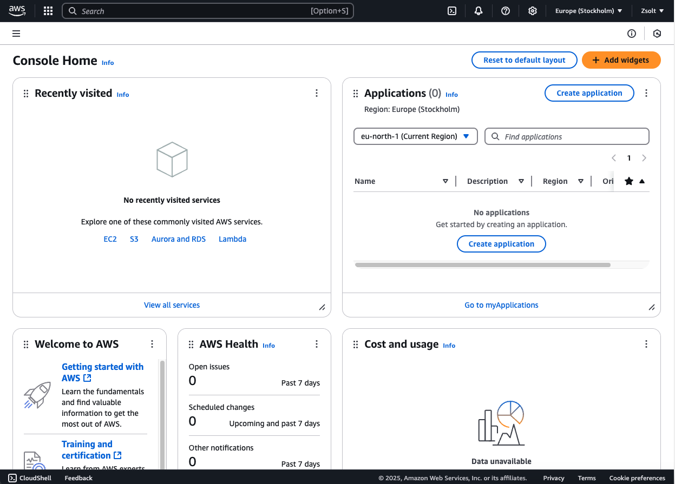
To begin, I created an AWS Free Tier account (Figure 1.) and launched instances based on the provided topology.
Figure 1. Screenshot showing the dashboard of the AWS account
The following OS images were downloaded and deployed (Figure 2):
- Windows Server 2022 Datacenter
- Windows Server 2019 as a client machine
- Debian Linux as both the server and client machines

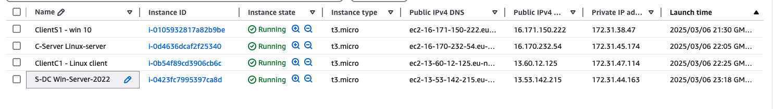
Figure 2. Screenshot of the launched instances showing the launch time and other important information
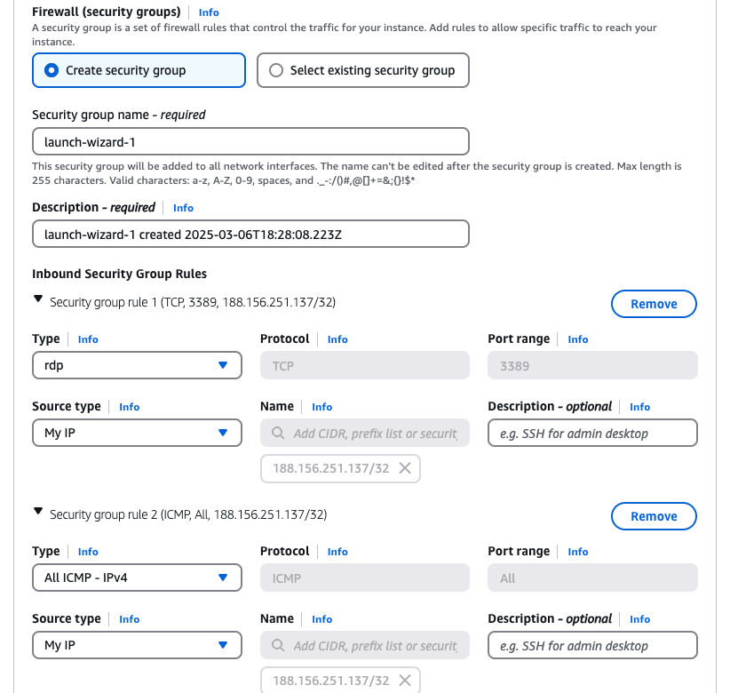
Each instance was configured with appropriate security settings. RDP (Remote Desktop Protocol) was enabled for Windows instances (Figure 3), while SSH was configured for Linux machines. Security Group rules were adjusted to allow necessary access while maintaining security best practices.

Figure 3. Screenshot showing the security configuration of a Windows instance

Deploying the Network
The network was deployed following the given topology. AWS provides a default Virtual Private Cloud (VPC), which simplifies network management. All instances were launched in the same VPC and subnet, ensuring that internal communication between machines was seamless without requiring custom routing.
Each instance was assigned a private IP dynamically by AWS, ensuring that it remains unique within the VPC. The assigned IPs were:
- Windows Server 2022: 172.31.44.163
- Windows Client (Server 2019): 172.31.38.47
- Linux Server: 172.31.45.147
- Linux Client: 172.31.47.114
AWS automatically assigns public IPs to instances with internet access, but for internal connectivity testing, private IPs were used.

Configuring IP Addressing
The network followed AWS’s default private IP range (172.31.0.0/16). AWS dynamically assigns private IPs from this range to instances, ensuring connectivity within the VPC without requiring manual IP configuration.
Although the topology could have been configured with a custom IP addressing scheme, I opted to remain within AWS's predefined CIDR block for simplicity and ease of management.
The windows instances were started using Apple’s Remote Desktop application and were checked for network configurations (Figure 4). The linux instances were connected to via ssh from the MacOS terminal (Figure 5).

Testing and Troubleshooting

Outcome 1: Successful Connectivity Within the Same Network
To verify internal network connectivity, ping tests were conducted between machines. To allow pinging the Windows machines these required some extra configuration, namely the firewall settings had to be adjusted (Figure 6).

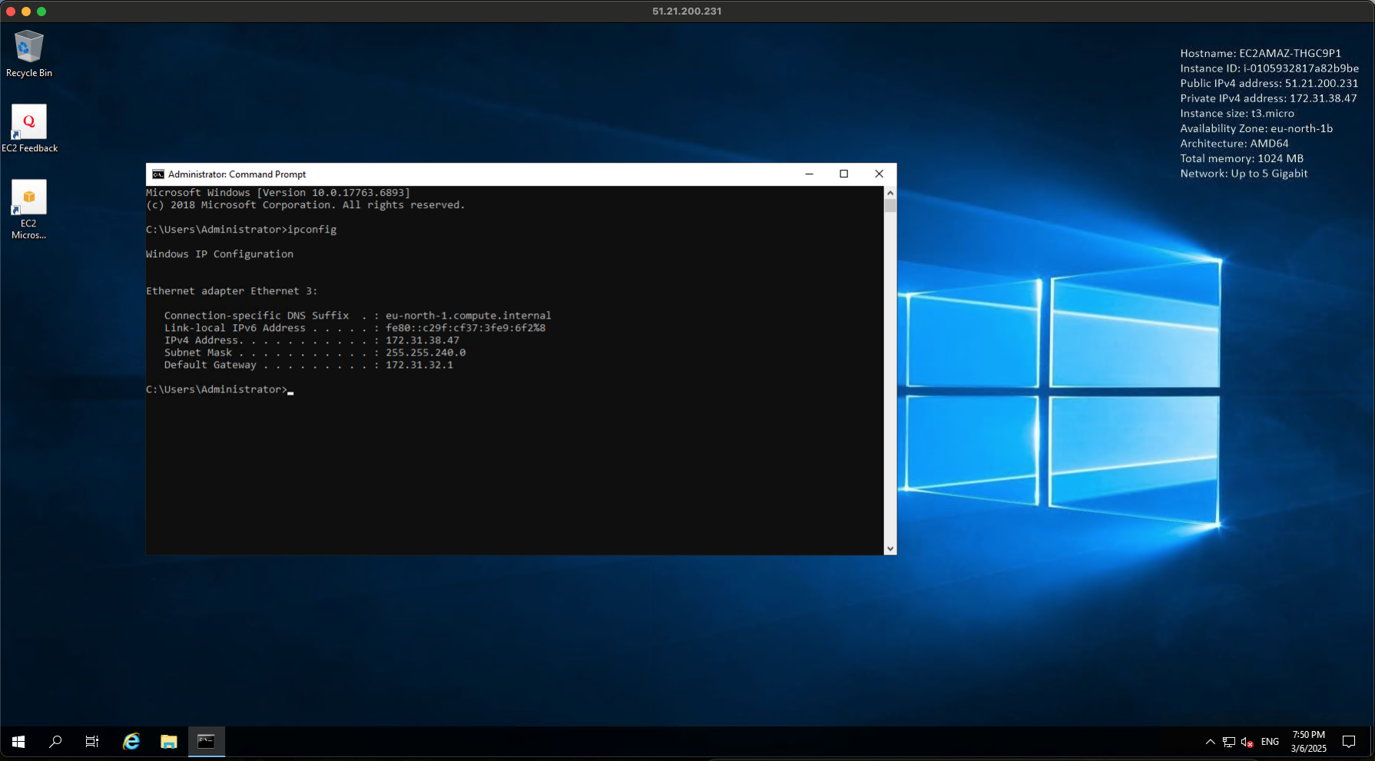
Figure 4. Screenshot showing the running Windows client from a MacOS computer
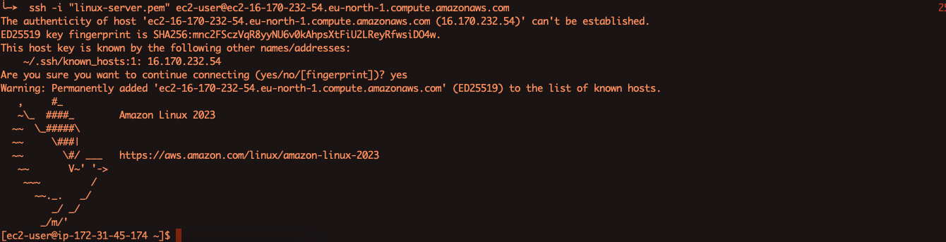
Figure 5. Screenshot showing the running Linux server from a MacOS computer terminal
Figure 6. Screenshot showing the modification of the inbound rules of the Windows firewall settings
Each computer was pinged. All ping tests were successful, confirming that machines within the same AWS VPC/subnet can communicate.
Screenshots of the tests were taken for documentation:
Figure 7 shows the ping test from Windows server to Windows client and the other way round. In addition, Figure 8 shows the ping test from the Windows client to the Linux client.

Figure 6. Screenshot showing the modification of the Windows firewall inbound rules
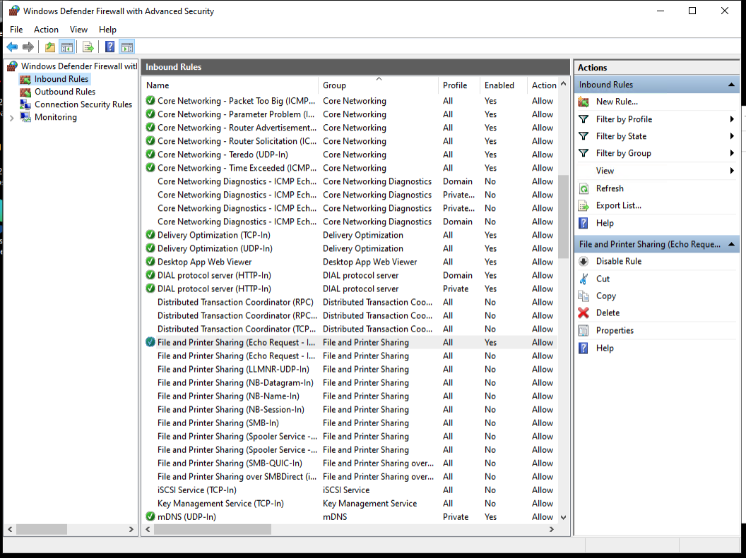
Figure 6. Screenshot showing the modification of Windows firewall inbound rules
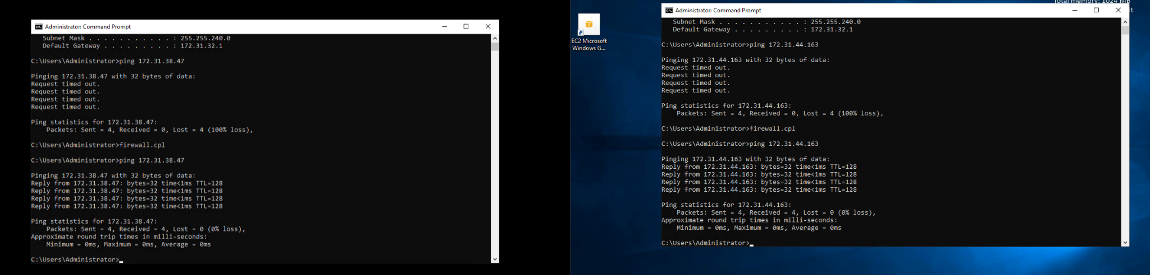
Figure 7. Screenshot showing the ping tests on the Windows machines

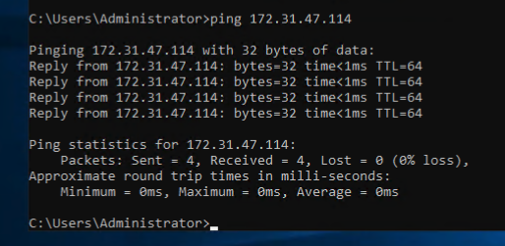
Figure 8. Screenshot showing the ping test on the Windows client to the Linux client

Outcome 2: Unsuccessful Connectivity Between Different Networks
To simulate a failed connectivity scenario, I attempted to ping an AWS private IP from my Mac, which is located on an external network (the Internet). The test failed as expected, confirming that AWS does not allow external access to private IPs. This result is correct since AWS private IPs are only accessible within the VPC.

Conclusion
The deployment was successfully completed following the given topology while incorporating best practices for IP addressing, network security, and troubleshooting.
The selection of AWS EC2 with Xen hypervisor proved advantageous due to its cloud scalability, cost-effectiveness, and cross-platform support. The network was deployed efficiently within AWS, allowing internal communication between instances while restricting external access. Additionally, the decision to use a cloud-hosted hypervisor was influenced by the limitation of using a personal Apple M2 Mac, which lacks support for native Windows virtualization solutions.
Connectivity tests verified both successful and unsuccessful network scenarios, ensuring that all network rules and security configurations were functioning as intended. Screenshots were captured at each stage with timestamps, providing evidence of proper time management and adherence to the coursework guidelines.

Task 3

Technical Reflection
The network deployment process presented several challenges, including firewall restrictions, security group misconfigurations, and connectivity issues. Initially, the Windows Server RDP connection failed due to incorrect inbound rules, requiring adjustments to allow RDP traffic. Additionally, ICMP (ping) requests were blocked by default, necessitating modifications in the AWS security group settings. Diagnosing these issues involved systematically checking firewall settings, security groups, and IP configurations to ensure proper internal communication while maintaining security best practices.

Personal Reflection
This task provided valuable experience in deploying cloud-based networks, troubleshooting connectivity, and configuring security settings. I gained hands-on knowledge of AWS networking, hypervisors, and internal routing. Overcoming challenges reinforced my problem-solving skills, particularly in diagnosing firewall and security group rules. The project enhanced my understanding of subnetting, cloud infrastructure, and testing methodologies. Successfully configuring the network within AWS while considering personal hardware limitations (Apple M2 Mac) demonstrated adaptability in a constrained environment. Overall, this experience has significantly improved my confidence in managing virtualized networks in a professional setting.

References
1. ExpertGlossary. Hypervisor Definition [Internet]. 2009 [cited 2025 Mar 06]. Available from: http://www.expertglossary.com
2. Desai A, Oza R, Sharma P, Patel B. Hypervisor: A Survey on Concepts and Taxonomy. IJITEE. 2013;2(3):222–225.
3. Belard F. Qemu, a Fast and Portable Dynamic Translator. USENIX Annual Technical Conference. 2005.
4. Xen. What is Xen Hypervisor? White Paper. 2009.
5. MSDN. Hyper-V Architecture. Microsoft Developer Network. 2012.
6. RedHat. KVM – Kernel-Based Virtual Machine. White Paper. 2009.
7. Cisco. Cisco IP Addressing Policy. San Jose: Cisco Systems; 2021.
8. IETF. RFC 8200: Internet Protocol, Version 6 (IPv6) Specification. 2017.
9. Google. IPv6 Adoption Statistics [Internet]. 2020 [cited 2025 Mar 06]. Available from: https://www.google.com/intl/en/ipv6/statistics.html
10. Stallings W. Foundations of Modern Networking: SDN, NFV, QoE, IoT, and Cloud. 2nd ed. Addison-Wesley; 2016.
11. Cisco. Cisco IOS IP Routing Protocols Configuration Guide [Internet]. 2022 [cited 2025 Mar 5]. Available from: https://www.cisco.com/c/en/us/td/docs/routers/ios/config/17-x/ip-routing/b-ip-routing/m_iri-iprouting.html
12. Sirika S, Mahajine S. Performance Evaluation of Dynamic Routing Protocols for Real Time Application. International Journal of Engineering Trends and Technology. 2016;32(7):328–337.
13. NIST. SP 800-77: Guide to IPsec VPNs. 2020.
14. Stallings W. Data and Computer Communications. 11th ed. Pearson; 2022.
15. Microsoft. Active Directory Domain Services Documentation. Microsoft Docs. 2021 [cited 2025 Mar 6]. Available from: https://learn.microsoft.com/en-us/windows-server/identity/ad-ds/get-started/virtual-dc/active-directory-domain-services-overview
16. AWS. What is a Hypervisor? [Internet]. [cited 2025 Mar 6]. Available from: https://aws.amazon.com/what-is/hypervisor/#:~:text=Cloud%20providers%20usually%20use%20bare,capacities%20with%20Xen%2Dbased%20hypervisors.

