Academic and Employability Skills
Student: Jason Read
ID: 1814541

Contents
Introduction 3
Description 4
Employability skills: 4
Employability Skills Required In Asda 4
Personal competencies: 7
Personal SWOT Analysis: 7
Personal Development Plan: 8
Time Management Plan: 9
Conclusion: 11
References: 12

Introduction
Employability Skills is defined as the skills that are transferable and needed by individual to make these skills ‘employable’. Employability skills are a group of important abilities that is involved with the development of knowledge based and expertise level mindset. Employability skills depends on a person’s knowledge, attitudes and skills, how this person uses those skills, and how this person presents these skills to employers. These skills are very important for success in the today’s modern workplace. These skills are now considered as an essential qualification for any job position and for this reason employability skills have become necessary for an employee’s employment success at any level within any business environment.
In this report, I have tried to show the employability skills that are needed by Asda. I have been in Asda for 6 months. From my experience, I have found that Asda needs different employability skills to accomplish its tasks.

Description

Employability skills:
According to Yorke (2014) employability skills are the core skills and the traits that are needed in every job. These are some general skills that make a person employable. Managers who hire people always look for those employees who have these skills. Employability skills are sometimes called the foundational skills or the job-readiness skills (Maund, 2017). These are skills that allows a person to work hand to hand with others. A person applies these skills to solve problems and to fit within the work environment. Besides the good subject knowledge and technical understanding, employers often demand a set of skills that they want from an applicant. They want these skills to well equip in the employees to carry out their role in the business and to the best of the employee’s ability.

Employability Skills Required in Asda
There are many employable skills that are valuable to the employers of Asda. Besides the specific job skills, employers of Asda also look for some general job skills. These skills are sometimes called ‘employability skills’. These skills will make an employee stand out (Maund, 2017). Even if a person does not think that he has no job skills, he also has these skills of he is dependable, open to learning new things and easy to get along with. According to Maund (2017) These skills may not be mentioned in the job description, but they are very common skills that are needed for most jobs (Morgan, 2016). It’s good to think about these skills when a person is taking job preparation.
Employability skills are defined in different ways. Generally, Asda needs these short of employability skills from the employees:
Communication: Asda look for job candidates who have strong communication skills. This is referred to as a person’s ability to convey information clearly to others. Asda is retail supershop. It wants employees who have strong verbal, nonverbal and written communication skills. They also need a person who is a good listener. Asda also needs employees who has good non-verbal communication. This includes the body language of an employee.
Foundational Skills: Asda need employees with some foundational skills. Asda needs employees who is organized, arrives to work on time, dependable, completes assigned tasks even if he does not like this, understands dress code or the guidelines and maintain personal hygiene.
Positive attitude: Asda needs employees who have positive attitude. An employee should have positive attitude towards his workplace. Positive attitude towards workplace means doing a person’s best. This person should be excited and ready to do tasks even if there is little chance of winning. He should not be fearful.
Teamwork: In Asda, there are different teams. Teamwork means a person should be able to get along with the employees with whom a person works. It involves the employees working together to achieve organizational goal. In Asda there is team for information collection, resource collection, work distribution and so on. If an employee works on a team he needs to be able to understand and work with them.
Ethics and Legal Responsibilities: Asda wants employees to act professionally with maturity. Ethics refers to an employee’s personal ethos and principals. Asda wants employees who are honest and trustworthy, understand company rules and follow this, and act professionally and with responsibly. They should take responsibility for their own decisions and actions.
Career development: An employee should be focused on career development (Maund, 2017). He should learn new skills and take on different projects. He should understand the business and the common practices. He should understand the different roles of coworkers. Asda needs these people.
Leadership: Asda needs leader to accomplish tasks. The leader willingly takes risks. He works as a mentor of the subordinates. A leader motivates and direct the employees toward achieving goals. The leader finds out the simplest process to solve a problem. He builds partnership and teams with the co-workers. A leader save time and money of the company through his leadership skills.
Problem solving and critical thinking: Asda has many problems. These problems need to be solved. Problem solving means finding the solutions when an employee is faced with difficulties. It involves the ability to use a logical process to solve the problem, have critical thinking. Critical thinking refers to a person’s ability to understand, analyze interpret and draw conclusions.
Planning and organizing: Asda has a plan. It has some short-term plan and some long term plan. ASDAs short term plan includes selling more and more to the employees and making profits. Long term goals include developing the shop condition to attract more people and increasing shareholders’ wealth.
Learning: There are many new thing happening around. As an employee, Asda needs him to be up to date what is happening. Learning is about understanding new things and coping up with them quickly and a person’s ability to adapt to the changing situation and taking the risk to understand the new tasks.
Information technology(IT) knowledge: Asda wants employees with good IT skills. Information technology is a hard skill which is now required from many job applicants. It involves the ability to use technology-based product. It also involves using social media. In most job applications employees with IT knowledge is preferred.
Patience: Asda needs patient employees. An employee needs to have patience in hard tasks. There may be many hurdles in the work environment. But he should not lose hope.
Adaptability: There may be many changing situations in the organization. The employee should adapt with the changing business situation. Asda wants employees who can adapt the changing situation quickly.

Personal competencies:
Every person has some sort of personal competencies. Competencies are the skills, knowledge and behaviors that lead to a successful performance. I also have some competencies. Those are:
Extraverted: I am an extrovert. I am sociable and assertive. I can easily talk with people and mix with them without hesitation. For this skill everyone loves me.
Listening: I always try to listen carefully. My employers always praise me for my listening skills.
Speaking: I am a good speaker. I can motivate others by speaking. I had 5 star in my previous workplace where many customers gave me feedback for my good speaking skills.
Presentation: I am very good at presenting something. I can present something to people in a very good way. I can impress people with my presentation.
Creative & Innovative Thinking: I am a creative thinker. I always try to use my own initiatives where I need to. I have had many compliments from my employer for my innovative problem-solving skills.
Positive: I am positive. I try to find out positivity even in my failure. Because I believe that even a minus has half plus.
Teamwork: I love to work with team. I try to help my team members and help them out whenever possible. Recently I did a group presentation for my managing enterprise in 21st century module. All my team member praised me for my commitment and helping attitude.
Leadership: I am good leader. I can lead my team from the front. I have demonstrated my leadership skills in my group presentation. I am always aware of the ultimate Goal.

Personal Development Plan:
After I finished the personal SWOT analysis, according to my own situation I make an action plan. For this I have made a personal development plan.
Anon (2019) said that personal development plan enables a person to take charge of their own learning. Everyone is not good at everything (Anon, 2019). Also I am not good at everything. I lack some employability skills. I need to develop those lacking. Some of my areas which needed to be solved are:
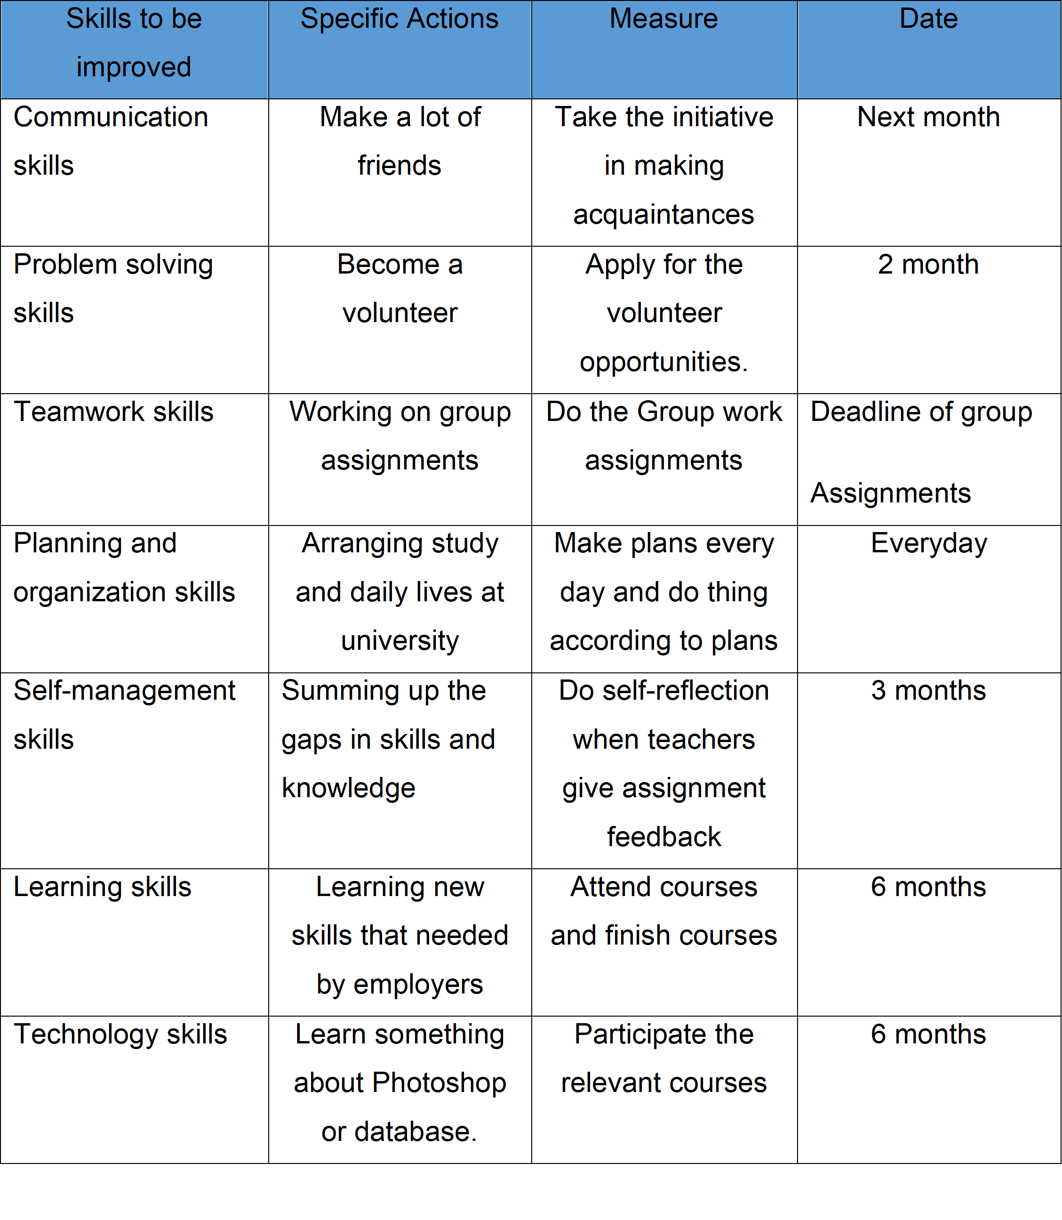

Time Management Plan:
For solving this problems, I have made a time management plan. Through this I am hopeful to solve my problems. I have developed a personal development plan as a part of this time management. This is given below:
 | Short-Term Time Frame | Mid-Term Time Frame | Long-Term Time Frame
Section 1 - My Goals | Get first promotion | Be the sales manager | Be the manager
Section 2 - Skills and Knowledge to be  Learned | Information technology knowledge. | Dreamweaver | Develop procedures and manuals.
Section 3 - Next Steps | Complete an informational course. | Dreamweaver class | Set upon project outline
Section 4 - Resources | Free time | Funding | Funding
Section 5 - Time Schedule | 3 months | 1 year | 3 years

Conclusion:
There is no doubt that employees who have a good employability skill. Employees who have a good employability skills have the door open for finding a good job. Employers need to see if the employee can bring benefits to the company and let the company in upper position in the competitive market. Employability is a set of skills and attributes that will enable a person to be successful in their working life. Employability skills are a must for a person in getting a job. Employability skills development are highly effective. Employers favor candidates with a wide range of employability skills to complement their job-specific skills and study. So a person who is looking for a job should first focus on developing employability skills, know the lacking and solve them. He should earn what these skills are, how to identify those he has to offer, and how to build upon them.

References:
- Maund, A. Schriek, M. and Tinkler, P. (2017). Certificate in Higher Education: Skills for the Workplace Student Yearbook. Sage Publications
- Morgan, P. (2016). The Business Student’s Guide to Study and Employability. Sage Publications
- McMillan, K. and Weyers, J. (2006) The smarter student: Skills and strategies for success at university, London: Prentice Hall.
- Cottrell, S. (2008) The Study Skills Handbook 3rd edition. Hampshire: Palgrave MacMillan.
- Georgina Andrews Marilyn Russell, (2012),"Employability skills development: strategy, evaluation and impact", Higher Education, Skills and Work-Based Learning, Vol. 2 Iss 1 pp. 33 – 44
- Asda.com - Online Food Shopping, George, & more. (2019). Retrieved from https://www.asda.com/about
- Yorke, M. (2004), Employability in higher education: what it is – what it is not, The Higher Education Academy/ESECT
- Denise Jackson (2014) “Testing a model of undergraduate competence in employability skills and its implications for stakeholders”, Journal of Education and Work, 27:2, 220-242
- Anon, (2019). [online] Available at: http://www.hr.ucdavis.edu/sdps/forms/IDP%20Final%2010.14.11.pdf [Accessed 13 Apr. 2019].
- Corporate.asda.com. (2019). Company Facts - ASDA Corporate. [online] Available at: https://corporate.asda.com/our-story/company-facts [Accessed 13 Apr. 2019].
- Barrie, S. 2004. A researched-based approach to generic skills graduate attributes policy. Higher Education Research and Development 23, no. 3: 261–75.
- Essays, UK. (November 2018). SWOT Analysis for Employability Skills. Retrieved from https://www.ukessays.com/essays/business/personal-swot-analysis-on-employability-skills-business-essay.php?vref=1

