
2024
Designing a Kiteboard: Structural Design Assessment

HARLEY OULTON

Abstract

This report discusses and analysis of the design, modelling and optimisation process for a kiteboard using Finite Element Analysis (FEA) techniques.
The report begins by discussing the beginning and advancement of FEA techniques. Starting with foundational studies in structural mechanics (Bendsoe & Sigmund, 2003; Rozvany, 1992) through to contemporary methods in topology optimisation, sensitivity analysis, and reliability-based design (Youn et al., 2003). Advancements in machine learning are discussed, highlighting their integration into FEA for real-time optimisation Liu et al., 2020; Bessa et al., 2017).
A kiteboard is modelled within Design Studios. Forces are applied to the board to mimic the ride position displayed by competent riders. An explanation is given to why the grid/mesh arrangement is not altered. The initial force, taken from the first assignment, is shown to be too large, causing the steel board to deflect above an acceptable range. The forces are altered and discussed.
The material is changed to CFRP and the analysis is run on the new material. The new deformation is shown to be 7mm larger than the steel board. An optimisation is run reduce the mass of the board, while lowering the deflection to match the steel board. The design variables are the laminate layers of the CFRP. These objectives are achieved.
Prototype testing is proposed to validate simulation results, using realistic conditions to simulate rider forces and water resistance. The findings underscore FEA’s value in producing lightweight, high-performance components, with prototype validation supporting the simulation’s applicability in real-world scenarios.

Contents

Abstract 1
Contents 2
List of Figures 3
Introduction 4
FEA Optimisation 4
Kiteboard Model 5
Kiteboard Optimisation 9
Prototyping 10
Conclusion 10
References 11
Appendix 12

List of Figures

Figure 1: FEA Mesh refinement around geometry 5
Figure 2: Steel board deformation with initial static load 6
Figure 3: Rider position 7
Figure 4: Force through the foot straps 7
Figure 5: Changes to bottom grid selection, matching Figure 2 7
Figure 6: Water force displayed in relation to board and cordinates 8
Figure 7: Updated deformation of steel board 8
Figure 8: Deformation of CFRP board (unoptimised) 8
Figure 9: Optimisation results for laminate layer thickness 9
Figure 10: Optimised CFRP final deformation 9
Figure 11: Mass objective 12
Figure 12: Deformation constraint 13
Figure 13: Design Variables 13

Table 2: Results 4

Introduction

This report will cover several tasks relating to the design, manufacture and modelling of a kiteboard. It will first cover how FEA techniques developed and how they may develop in the future. Their benefits and advantages during the design process will be covered, and how they improve the design process.

Following that, the report will discuss the model of the kiteboard. How the boundary conditions and forces acting on it were selected, and the reason behind the selection. The board material and laminate layers are discussed and the effect they have on the deflection.
An optimisation is run on the board to lower the mass of the board while minimising the deflection below a set constraint.

Finally, how a prototype can be used to understand the deflection that the board undergoes, and use the data gathered from that to refine the simulation parameters.

FEA Optimisation

FEA, or Finite Element Analysis, are optimisation techniques used to improve the design of components, structures or systems. They do this by refining or optimising different factors of the object, such as a components’ shape or it’s material distribution, to achieve set performance objectives. These objectives range from maximising component strength, reducing deflection or minimising the overall weight of the component. This report will later discuss reducing the deflection of a component using a specific material while reducing the overall weight.
Early stages and the foundation of FEA began as basic principles of structural mechanics and FEM modelling were developed in the 1960s and 1970. Researcher aimed to solve simple structural problems numerically. Size and shape optimisation techniques were the first developed. These involved basic parameters, like the thickness, length of width of a component is adjusted to achieve the performance (Bendsoe & Sigmund, 2003). The techniques used mostly gradient based, Newton’s or steepest descent. Both these methods were computationally intensive at the time.
Increases in computational power allows for more complex FEA optimisation to be completed. In the 1980s and 1990s, topology optimisation research and development was led by the likes of Martin Bendose and Ole Sigmund. Although, the principles of topology optimisation had been development earlier. For very low fractions key principles were established at the turn of the century by an Australian inventor Michell (1904). These principles were in the context of trusses. Seventy years later the concepts expanded to include beam systems by Rozvany (e.g. 1972a, b). Rozvany continued to develop and build on the use applications, such as foundational principles of optimal layout theory with Prager (e.g. 1977a), which they further broadened in the 1980s and 1990s (Rozvany 1992; Rozvany and Birker 1994). Their techniques transformed structural optimisation by optimising material distribution within a specified design space. This enabled lightweight and high strength components to be developed (Rozvany, 2001). In 2000s, topology optimisation for higher volume fractions was known as Generalised Shape Optimisation (GSO) (Rozvany and Zhou 1991) or Variable Topology Shape Optimisation (Haber et al. 1996). These techniques can simulate and optimise the topology of composite materials. The aerospace industry found many applications for topology optimisation as weight and material efficiency are crucial.
Techniques developed in the 2000s are Sensitivity Analysis and Reliability-Based Design (RBDO) and Multi-Objective Optimisation. Sensitivity analysis helped designers understand how small variations in the design parameters affected the performance and RBDO worked to address inherent uncertainties in the material properties, loads and boundary conditions (Youn et al., 2003). These two methods are crucial in industries where safety and reliability are vital, such as aerospace. Zhu et al, demonstrated how probabilistic models integrated into the FEA process led to more resilient designs that perform reliably when exposed to unforeseen stresses and environmental factors (2018).
Multi-Objective Optimisation allowed the designer to optimise for two different design goals, such as minimising weight while increasing strength. When combined with Pareto front analysis and genetic algorithms the ability to balance multiple design objectives, while understanding the design trade offs to a designer (Bed, 2001).
With the increasing computational power and capability of machine learning tools, these have been integrated into FEA optimisation. The integration of ML created the potential for real-time optimisation of design spaces. Neural network ML models are now used to approximate large and complex FEA simulations. This significantly speeds up the optimisation and allows for real-time predictions (Liu et al., 2020). Recent developments in ML have been applied to FEA to create a ‘smart’ design system. This system can learn from user inputs and environmental data to suggest optimisations in real-time (Bessa et al., 2017). Application uses of ML like this, streamlines the design process, which is beneficial when time and customisation is critical to the project.

Kiteboard Model

A CAD model of the kiteboard made of steel was loaded into Design Studio. The meshing was not altered from the original meshing loaded with the CAD model. The decision to not adjust the meshing was made as the shape of the kiteboard is uniform down the whole length. The kiteboard does not have any unique geometry, such as holes, only two small fins at either end of the part.
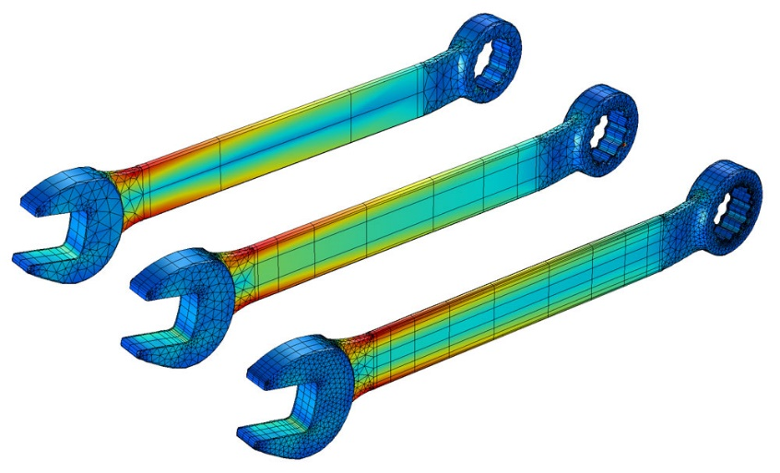
Figure 1: FEA Mesh refinement around geometry
If the kiteboard had more curved geometry, cut outs or holes in it, such as the examples above in Figure.1, refinement would be required. These areas would benefit from having a more refined mesh around them to more accurately simulate the deformation in these areas. Increasing the mesh density also increases the processes times of the software.
The forces calculated in the first assignment, shown below in the following table, were input into Design Studios using the analysis static load section. All the grids on the lower surface of the board were selected and the total force calculated in the first assignment was divided between these grids.
Table 2: Results
Forces | Values
Dynamic Pressure | $$78.13*{10}^{3}Pa$$
Drag Force | $$31.25*{10}^{3}N$$
Lift Force | $$19.53*{10}^{3}N$$

A genesis analysis was run on the steel component to calculate the deflection of the board, and act as a baseline for further testing with different materials.
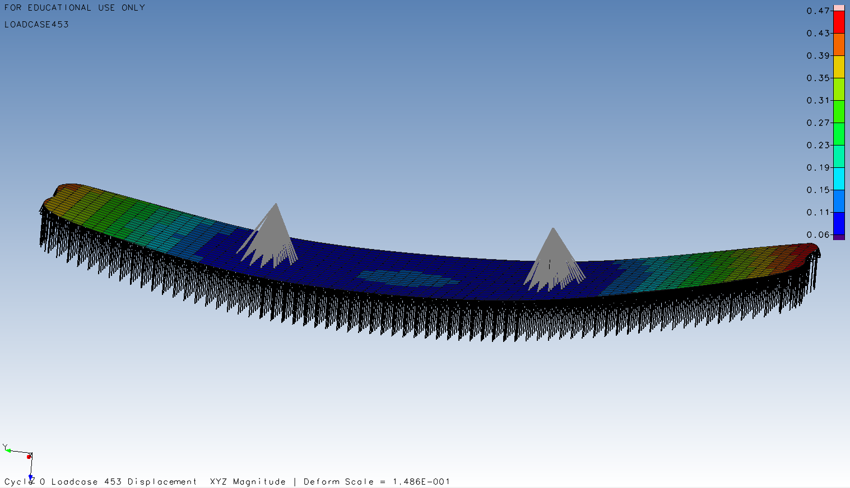
Figure 2: Steel board deformation with initial static load
The total deflection of the steel board achieved a maximum of 0.47m at the rear end. This deflection is vastly higher than is expected to be seen with this material.
Following this result, the forces calculated were deemed to be incorrect and too high, and new forces would need to be considered. The original force was applied vertically (-z-axis) to the underneath of the board. This direction of the force was a simplistic initial assumption of how the force would be applied to the board. This assumption would require the board to be fully horizontal and parallel with the water, and only considers an update force from underneath. The kiteboard would be travelling in the water, meaning some of the force would be applied at an angle to the bottom of the board, and from consulting images of kiteboarders riding, the nose of the board remains out of the water to stop the board stalling and the rider crashing. These factors were taken into consideration and the area of selected grid spaces was changed.
The weight of the rider was not considered in the original force calculations, and this was deemed an error. Upon first adding the rider weight to the simulation, the force was applied directly down through the RBE element grids. The force was applied similarly to the upward force. The gravitational force of a 75kg person was calculated and the weight divided between all the grid points for the RBE element of the model. The model was run with the new applied forces and the deflection results were deemed to be too high once again. The model forces required more refinement to achieve a likely deformation.

Figure 3: Rider position
Again, more images of rider positions were researched. When applying the rider’s force, the full weight of the rider was applied directly to the board, but this would not happen as the rider would experience lift from the kite. This would lower their applied force and change the direction that the force is applied in. The overall force of the rider was deemed to be halved by the lift from the kite. These changes were made to the model, as seen in Figure.4.
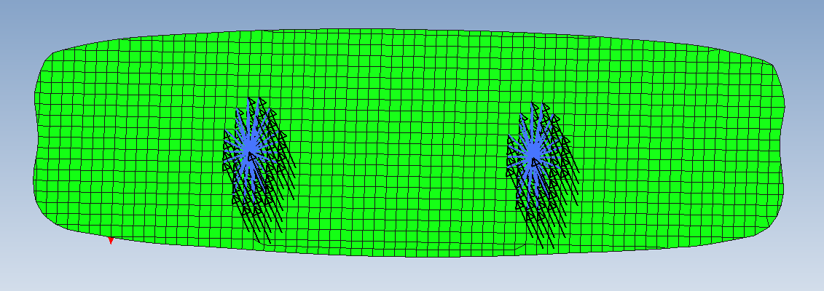
Figure 4: Force through the foot straps
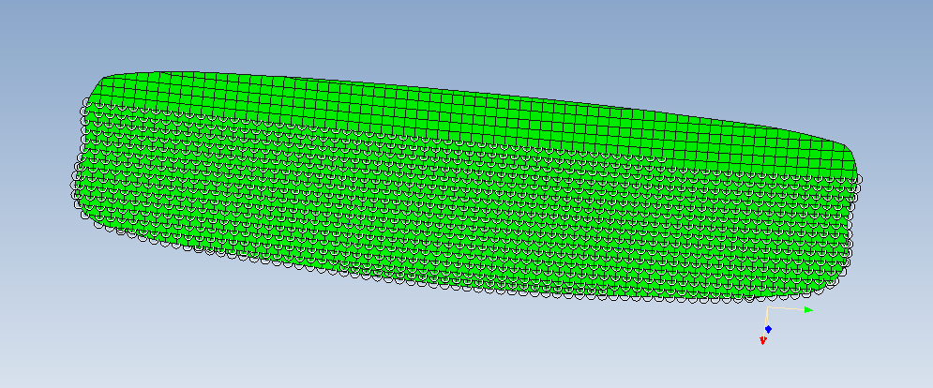
Figure 5: Changes to bottom grid selection, matching Figure 2
Following the change to the rider forces, a new grid selection for the underneath of the board was created. Consulting images of riders travelling at higher speeds, an area of the board running down the full length, remains out of the water. The total force applied to the underneath of the board was lowered to achieve a more realistic deflection.
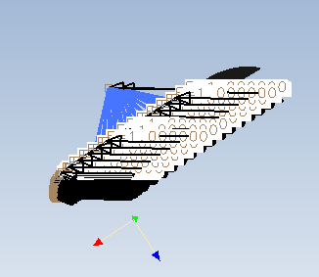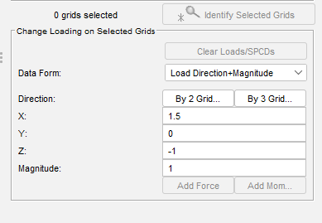
Figure 6: Water force displayed in relation to board and cordinates
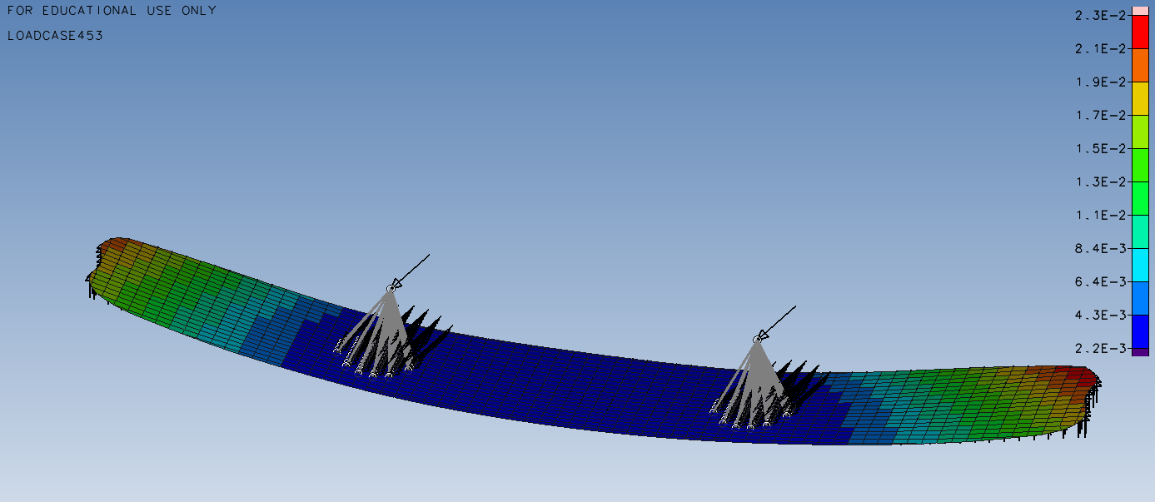
Figure 7: Updated deformation of steel board
The material properties for the CFRP were input and the laminate layers created. The material properties of the kiteboard were changed from steel to the CFRP and the Genesis analysis run to simulate the deflection. The new deflection results are seen below in Figure.8. The deflection was simulated to be higher than the steel board.
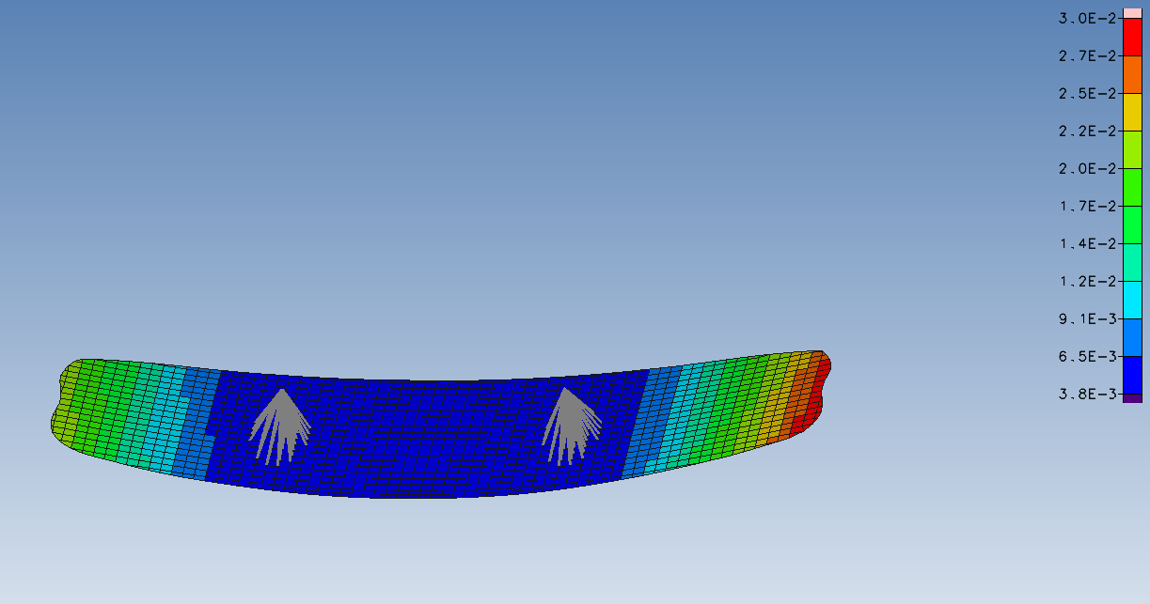
Figure 8: Deformation of CFRP board (unoptimised)

Kiteboard Optimisation

Before the optimisation for the Uni-carbon board was run, the software required design parameters objectives to be set. The objective of the simulation was to minimise the mass of the component whilst not passing a set deflection constrain. The deflection constraint was set at 0.025m. The laminate layers were given a range at which they could be increased or decreased by the software to lower the final deflection. See appendix for the constraints.
The optimisation was run for the component, and the results returned after 15 cycles. The optimisation met the deflection parameters. The max deflection was decreased to lower than the set constraint to 0.025m. The laminate layers were changed to the following amounts.
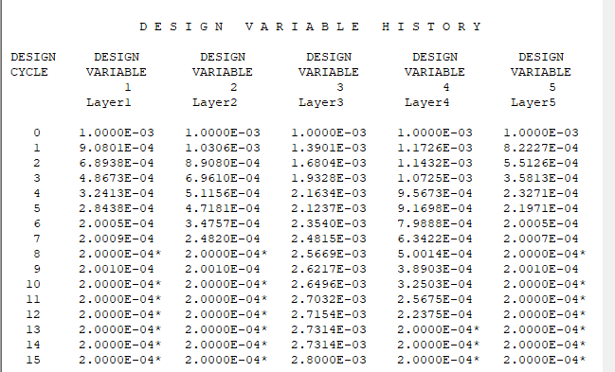
Figure 9: Optimisation results for laminate layer thickness
The optimisation met the requirements to lower the mass of the final component. While reducing the deflection. The deflection was reduced under the max constraint to 23mm max deflection at the rear tips. This final optimised deflection matched the deflection results gathered from the steel board. The simulation was successful.
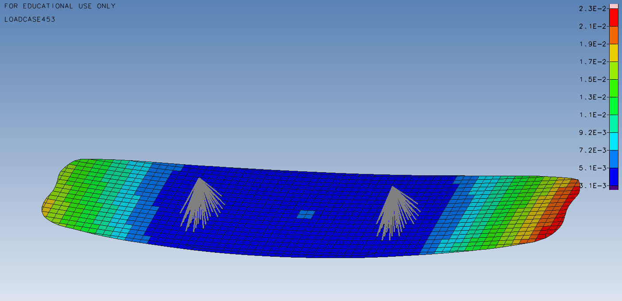
Figure 10: Optimised CFRP final deformation
The outcome for the optimisation is heavily affected by the forces applied to the model, and the constraints. The forces applied to the model are complex, being applied through every plane. This causes deflection across the board and down the length, requiring the laminate layers positioned at each angle to be strengthened. If the forces applied to the model were simplified, only applied through one place direction, the optimisation would only need to strengthen the laminate layer which is most affected. For a force applied in the z-axis, the 0° layer is most affected and the -45° and 45° layers are secondary. The -90° and 90° layer would be able to decrease as they offer the least benefit to strength.

Prototyping

Creating a prototype of the kiteboard design with the optimised laminate layers a good means of correlating the results gathered from the simulation. Prototype results would demonstrate whether the results gathered from the simulation were accurate and help to refine the parameters set in the simulations.
The steps to complete the physical test would be as follows, create a prototype, set up testing conditions, measure the deformation, compare the results and iterate from the findings.
To gain the most accurate data from the prototype it should be a 1:1 full size model, using the same material in the same lamination layout and thicknesses. If the manufacture of the prototype is constructed differently from the simulation model, the results will not be accurate, and the further iterations of the simulation created from the gathered data will produce anomalous results.
Using a water tank the board should be positioned in the same in the same orientation outlined in Figure.3. Two supports positioned in the RBE foot straps will mimic the riders force and allow the board to stay in the outlined position when the water flow is started.
Measurement devices, such as strain gauges and displacement sensors, should either be attached to the surface of the board. Laser displacement sensors are an option to measure the displacement, but the test would need to account for the refraction caused by the water and the currents around the board. Physical measurement devices attached to the surface will be more beneficial during this test. High-speed cameras and digital image correlation (DIC) will allow the deformation to be visualised across the whole of the board, not just a point where strain gauges are placed.
All the sensors must be calibrated before the test to gain the most accurate data.

The test should be run multiple times to account for any variability and clarify the repeatability of the test setup. All data points gathered should be recorded and used to compare against the simulation results.

Upon completion of the tests, the deformation results from both the physical and the simulation should be compared. If any discrepancies are found in the data, this will allow either the simulation or physical test to be refined and more tests to be completed. It may be discovered that the physical board does not deform as much as the simulation outlines, possibly due to incorrect forces being applied. By decreasing the forces in the simulation, the laminate layer thicknesses and arrangements may decrease, decreasing the other all mass of the board.

When an agreed tolerance range between the simulation and physical data is achieved, the results are accepted. The model is validated and the prototype moved to full production. The results parameters gained from this initial testing, will be vital for simulations of future boards, speeding up the design process.

Conclusion

In conclusion, FEA optimisation has been a transformative development in the design process of many components for several industries. High-performance, lightweight and durable components can be created using a range of techniques. A building on the early foundational work in structural and finite element modelling (Bendsoe & Sigmund, 2003; Rozvany, 1992), FEA techniques have developed to allow for more complex optimisations to be run, topology and multi-objective optimisation (Youn et al., 2003).
The model and optimisation of the board was successful, achieving a mass lower than the original layout, while undergoing a deflection lower than the steel board. The final thickness of the board was calculated to be 3.6mm, with a max deflection of 23mm
Finally, prototype testing is a critical validation test to ensure that the data gathered from the simulation matches the real-world performance of the component.

References
Baccouch, M. (2021) Finite Element Methods and Their Applications. 1st ed. Edited by M. Baccouch. London: IntechOpen.
Bendsoe, M. P., & Sigmund, O. (2003). Topology Optimization: Theory, Methods, and Applications. Springer.
Bessa, M. A., Bostanabad, R., Liu, Z., Hu, A., Apley, D. W., Brinson, C., & Chen, W. (2017). A Framework for Data-Driven Analysis of Materials Under Uncertainty: Countering the Curse of Dimensionality. Computer Methods in Applied Mechanics and Engineering, 320, 633-667.
Deb, K. (2001). Multi-Objective Optimization Using Evolutionary Algorithms. John Wiley & Sons.
Haber, R.B.; Bendsøe, M.P.; Jog, C.S. 1996: A new approach to variable-topology shape design using a constraint on the perimeter. Struct. Optim. 11, 1–12
Liu, C., Qi, J., Xu, W., & Wu, Y. (2020). Machine Learning Methods for Structural Optimization: A Review and Applications. Archives of Computational Methods in Engineering, 27(2), 361–378.
Moratal, D. (2010) Finite Element Analysis. 1st ed. Edited by D. Moratal. Rijeka, Croatia: IntechOpen.
Prager, W.; Rozvany, G.I.N. 1977a: Optimization of structural geometry. In: Bednarek, A.R.; Cesari, L. (eds.) Dynamical systems, pp. 265–293. New York: Academic Press
Rozvany, G.I.N. 1972a: Grillages of maximum strength and maximum stiffness. Int. J. Mech. Sci. 14, 651–666
Rozvany, G.I.N. 1972b: Optimal load transmission by flexure. Comp. Meth. Appl. Mech. Eng. 1, 253–263
Rozvany, G.I.N. 1992: Optimal layout theory: analytical solutions for elastic structures with several deflection constraints and load conditions. Struct. Optim. 4, 247–249
Rozvany, G. I. N. (2001). A Critical Review of Established Methods of Structural Topology Optimization. Structural and Multidisciplinary Optimization, 21(2), 151–158.
Rozvany, G.I.N.; Birker, T. 1994: On singular topologies in exact layout optimization. Struct. Optim. 8, 228–235
Rozvany, G.I.N.; Zhou, M. 1991: Applications of COC method in layout optimization. In: Eschenauer, H.; Mattheck, C.; Olhoff, N. (eds.) Proc. Conf. “Eng. Opt. in Design Processes” (held in Karlsruhe 1990), pp. 59–70. Berlin, Heidelberg, New York: Springer-Verlag
Liu W, Li S, Park H 2022: Eighty Years of the Finite Element Method: Birth, Evolution, and Future
Youn, B. D., Choi, K. K., & Park, Y. H. (2003). Hybrid Analysis Method for Reliability-Based Design Optimization. Journal of Mechanical Design, 125(2), 221–232.
Zhu, J., Zhang, W., & Sun, G. (2018). Reliability-Based Optimization for Automotive Body Design Under Uncertainty. Structural and Multidisciplinary Optimization, 57(1), 145–160.

Appendix

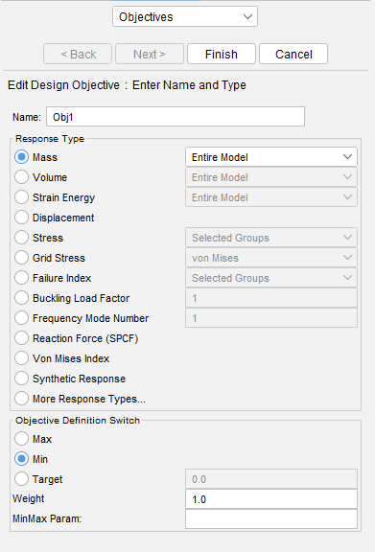
Figure 11: Mass objective
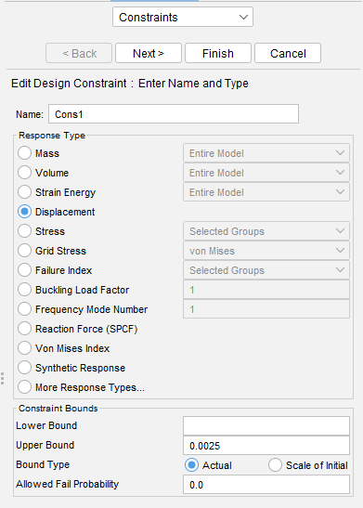
Figure 12: Deformation constraint
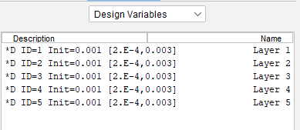
Figure 13: Design Variables

