1203416
ECSP6004 Curriculum Development and Enhancement
Research into the impact of inference grids on the way in which participants analyse sources in their extended writing.
Introduction
I decided to undertake my research with my Year 9 class. In my first placement school at school X, specifically the history classes, these are all mixed ability, and this allowed me to see difference abilities and how they would adapt to the intervention. I have chosen this class as I taught this class three times a week which allowed time for a three-lesson intervention, and that this was the class that I found struggled with their literacy work and therefore it became evident to me, that this Year 8 class would be an ideal opportunity. The first lesson consisted of a test which was on the topic of poverty in Britain and the institution of workhouses, the test looked at sources and the pupils had to write on ‘whether or not the Victorians looked after the poor’. The intervention involved the use of inference grids when the pupils were looking at sources, which were illustrating different views of life in the trenches, the whole lesson was given as time for the students to look and analyse each source they chose. This would allow the pupils to look at every aspect of the source and then conclude on whether the source was reliable and useful, in this case the lesson concerned the pupils examining the conditions in the trenches during World War One. I decided to undertake the research using this topic from World War One, as this is a topic that is of interest to the pupils and I have observed pupils being engaged in the topic previously. The pupils previously had several lessons on this topic and had investigated different areas of World War One, such as, exploring the local aspects of the impact of the war, by asking family members for stories on their experiences of the war, and also to the ways in which the war started in 1914. I chose to research into the impact of inference grids on the way in which participants analyse sources when doing their extended writing. During my time at the school and working with this particular class, it became clear to me that the lack of understanding on how to analyse sources, and how to analyse if a source is biased, reliable and whether or not it is useful when looking at a specific question. Also, most of the class lacked the ability to write extensive pieces of work that allowed room for analysis of sources, which is crucial moving into KS4. Therefore, while doing this research I would try and identify the key problems and solutions to the question and try and think and suggest solutions to these problems for future research.

Literature review
There are many skills needed in order to develop the historical ways of thinking: source analysis work, contextualization, being active readers and also verification. The process of analysing sources s when the pupil looks at a source and thinks about the author and how and why the source was created. Contextualization is the ability to read the source and understand its contextual background, such as its time and place in history. Being an active reader refers to the ability to consider more than just the source as a text. It’s the ability to see if the source has a deeper meaning and message. Finally, verification is the ability to look at various sources and ask questions about the important of the source. With these skills explained above, pupils will be able to understand and analyse evidence within primary and secondary sources. (Cowgill, D. and Waring, S. 2017).
Many social science and educationalist researchers have undergone research into the importance of engaging students in analysing primary sources. The important element when looking at primary sources is to ensure that they are age appropriate. As Joan Musbach explains, the age of the pupils in the classroom is vital component into choosing the correct sources in terms of their level. This implies that when the teacher decides on the sources used, there needs to be some sort of check list so that the teacher can chose the sources appropriately. (Musbach, J. 2001).
When looking at primary sources and the pupils understanding of primary sources, it is important that the teacher has the background knowledge so that the children feel that they can ask questions on the period of history and that the teacher can answer these questions. For those children that find it easier than others to understand primary sources, it is vital that they can participate in the learning of their classmates. This means that they can shed light on terms such as bias, reliability as so on. Defining the primary source is the first step for pupils as they can use their information on whether or not the source is a diary entry, an extract from a book etc; and whether or not it was conducted at the time of the historical event in question. In my case this would be life in trenches in World War One. (Hicks, D., Doolittle, P. and Lee, J. 2004. p. 215.)
This broad definition is strengthened by Cynthia Brown, who argues that a primary source is “any material created at the time of an event, or later from the memory, by someone in the event.” (Hicks, D., Doolittle, P. and Lee, J. 2004).
This definition would therefore help the students that were struggling to understand what a primary source was at the start of the lesson, also by giving them different sources, on for example a diary entry of Henry VIII or a solider writing to his parents during World War Two. (Hicks, D., Doolittle, P. and Lee, J. 2004).
The importance and the use of primary sources is illustrated in Cowgill and Waring’s article as they explain how providing pupils with the necessary skills to analyse primary sources provides the pupils an engaging insight into historical events from different perspectives, in a genuine style that allows the pupils to build meaning on events that have happened in the past. (Cowgill, D & Waring, S, 2017).
Through learning and developing about and starting to use the skill of analysing sources, the pupils will be provided with the opportunity to understand history concepts such as reliability and bias. In my short experience thus far as a student teacher, I have seen how difficult it is for pupils in KS3 to manage and understand reliability and bias. Vansledright (2004) in Cowgill, D & Waring, S, 2017).
In Keith Barton’s article on “Historical Sources in the Classroom: Purpose and Use”, he identifies four main purposes of why teachers should be teaching sources in the classroom. The first being that is helps teachers illustrate their points in the lesson. For example if the pupils read textbooks all day everyday on The Spanish Armada, this would become boring and the pupils would not engage in the class activities, but if the pupils could see an image of the Spanish Armada or a diary entry written by one of the men on the ship, this would clearly inspire pupils and therefore facilitate a more robust engagement in the subject. (Barton, K. 2018).
Barton’s second proposal is that the pupils will be able to answer historical questions through looking at and understanding historical sources. In my research project I decided to use inference grids as a form of guide in order to analyse sources. This aid places sources into a category which engages the pupils in a meaningful way encouraging them to think more deeply and as Blooms’ Taxonomy suggests, the pupils will be encouraged and enabled to answer questions which are of a more evaluative nature. Therefore, hopefully developing and encouraging the pupils to develop a passion for history and potentially becoming historians ( Barton, K. 2018) .
When deciding on this research topic, the literature identified many different limitations. The first is the misapplied and limited background knowledge that most pupils have on the historical even/topic. Due to their level of maturation pupils can find it difficult to place themselves in the context of the source given. Moreover, the misapplied and or limited background knowledge of the pupils can be inappropriately applied in a discussion or when developing an argument so that the pupils then use these misconceptions and use them when looking at historical sources. As Noakes argues, “Background knowledge plays an important role in the way readers construct meaning with texts and perceive the world around them.” (Noakes, J, 2011, p.388). This clearly links with Barton’s first principle of inspiring the pupils with real life events at the time of the historical event, as without this background knowledge and understanding of a topic the pupils will find it difficult to successfully engage in the subject.
While looking at the limitations of source analysis, Tony McAleavy illustrates the importance of delivering and the pupils receiving more than background knowledge on how to analyse a source effectively, it is that some pupils in the classroom, in particular the ones who are less able, find it very difficult to understand sources and to really understand where they have come from. An example of this would be the pupil’s inability to distinguish the difference between a secondary and primary source. This therefore is a problem that needs to be resolved before understanding the historical background of the event. (McAleavy,T. 2009)
Teachers that are teaching history know that they should be developing pupil’s knowledge and understanding of historical sources, but the purpose for using these sources are sometimes less clear. In their school life, students will have to face dealing with historical sources in textbooks, as part of an essay and they are required to analyse sources as part of their examinations at GCSE. But as Barton explains this quick skim of sources during a history lesson is not enough to provide the children with purpose behind why sources are in the curriculum, especially when they are difficult to understand and read the pupil. In order to try and ensure that there is a beneficial educational need and the value of historical sources is understood by pupils, teachers need to think about the importance of why historical sources, primary or secondary, are important and how they can successfully be used by children learning in the classroom. (Barton, K, 2018).
During my research I focused on the impact of inference grids. The skill to make inferences is one that is vital in order for the pupils to accurately understand what they are reading in the source material. Inference can be as simple as reading a text and understanding if the person is a male by looking for the word ‘he’, or be as multifaceted as understanding messages that are being portrayed through unique vocabulary. The skill of inference is important for pupils as it allows them to ‘read between the lines’ and understand what the source is trying to say, not just what the writing or other medium of source delivers. There might be a hidden meaning that explains at another level as to why the text or other material was made and therefore skill of inference would allow the pupils to grasp this and develop greater historical insights.
There are three techniques that Evans illustrates to show the importance of and develop the skill of understanding inference. The first which is that participants need to be active readers. The meaning behind this is that the reader of the source is actively engaged in the meaning behind the source and the effort is there in order to find that meaning. Inferring into a source is a demanding activity and therefore engaging in the text is absolutely necessary. (Evans, 2019). Cain and Oakhill argue that the reason why those who find reading difficult, find it hard to make inference is that they do not look at the text they are reading in an active and engaged way. (Cain, K., & Oakhill, J. V. 1999).
The effectivity of implementing primary sources into the classroom is important to the teacher. The teacher herself/himself needs to be knowledgeable in the approaches and can therefore assist the understanding of the pupils when reading the underlying meaning of the source, and not seeing it for face value. (Hicks, D., Doolittle, P. and Lee, J. 2004).
The students only realise their understanding of the text in not sufficient when someone e.g. a teacher tells them. Only when they are told that they lack an understanding of the text, do they look back and search for the information that will allow them to infer adequately. However, those who are active readers engage in the text and are more able to understand the information and infer while reading. (Evans, 2019)
The second factor that is important when inferring into a source is background knowledge. As mentioned above the importance of background is vital to understand the context of a source. As Long et al (1996) implied in Evans’ article that ‘studies demonstrate that access to world knowledge can be obligatory in the sense that a text cannot be completely understood without it’. (Evans, 2019, p.1)
The use of background knowledge such as facts and information about the real world, is important when inferring into a source. It might be easily argued or implied that the readers that seem to struggle with the source make fewer attempts to infer as they lack background or general knowledge. Studies have shown, that this assumption is incorrect and that the readers who are unable to infer correctly can continue to do so, even after they are given information about the background of the source. As Cain and Oakhill illustrated, the ability to apply inference skills is not about the accessibility of the background knowledge it is about how they can use this knowledge, applied in a way in which they can infer. (Cain, K., & Oakhill, J. V. 1999).
When inferring about a source is it vital that the learners look at their own knowledge in order to make precise inferences. There is a common misconception that when looking at a source you should only look at the text for the information but the background knowledge of the time of the source is very important. (Evans, 2019)
The final important part of inferring is that the reader and writer of the source needs to be ‘on the same page’. As Narvaez states when she conducted research, she found that the beliefs and political and ideological background can influence when inferring the source. This is when problems can arise when the reader interprets the source in a biased way because of their background, frame of reference, experience, knowledge etc. (Narvaez, 2002).
To conclude on my literature review, it is evident to me that the importance of teaching source analysis in the classroom through the form of inference grids is one that needs to be explored in KS3 and brought to the forefront of history teaching at KS4. It is also clear that the importance of being an active reader and having background knowledge on a particular source deepens the ability to truly find the message in a source.
School Policy and Practice
School A did not provide a school policy; however, the importance of source analysis was clear on the classroom floor. As every history classroom was provided with many posters on the ways in which to analyse sources. As this was a Welsh school the abbreviation is in Welsh, but it was called DAC2 – D standing for the date, A standing for the author, C standing for content and the final C standing for context. This abbreviation was used was an aid in every extended writing piece the pupils undertook in the History classroom. The schemes of work in School A illustrated the importance of source analysis in the history classroom, as from year 7 right up to year 10, the assessment tasks were all based around analysing sources, preparing the pupils for the GCSE’s. This links to my literature as Cowgill and Waring emphasised the importance of analysing sources and the impact this has on the pupils deepening learning. (Cowgill, D & Waring, S, 2017). However, when looking at the developmental improvement plan of School A does look at the need for improving the quality of teaching and learning in the school. This can be linked to the way in which they teach analysing sources at KS3 and prepare the pupils for KS4 and examinations. (See Appendix 1). The abbreviation that School A have used and adapted into the classroom is one that is widely used throughout different schools. Although school A does not have a clear policy in place regarding their implement of source analysis in the classroom, their emphasis on exam technique in KS4 is linked with it. This emphasis is placed into KS3 curriculum and enables the pupils to engage in higher order thinking earlier on in their school years and therefore is only enhanced in KS4 instead of it being implemented. School A’s Estyn report in 2015 (see Appendix 2) illiterates the recommendations of the improvement in the quality of teaching across the school and share best practices. This recommendation can then be seen through the developmental improvement plan which explains how the improvement of their learning and teaching is at the forefront of their plan. Estyn also explains that their needs to an improvement in the attainment gap between boys and girls and I believe that this has become clear to me during my intervention and the results that have come from it. Therefore, when deciding on my research topic it was clear to me that the area of practice and how the school look at improving this was a key area to research. Although, the school did not provide me with a school plan on this particular topic, I can see through my time at the school on placement that the ways in which the teachers illustrated the importance of teaching source analysis at KS3 and therefore preparing the pupils for KS4 and their GCSE’s. During my research I have seen that the ways in which the teaching of DAC2 has been implemented and that I wanted to change the ways in which the pupils looked and analysed sources.
Methodology and Ethics
There are a large number of methods that can be used by educational investigators to understand an educational or pedagogic or psycho-social intervention and to measure their impacts upon pupil performance. At an important level, evidence based interventions to improve educational performance are the preferred format, otherwise the suggested improvements are not open to tests of their validity (they do what they say they do) and reliability (the results can be repeated) (Cohen et al 2011). In a classical scientific experimental format, the research is typically conducted in a laboratory, so that the environment can be controlled in more rigorous way than for example, in a classroom. Therefore, in laboratory environment the variables can be controlled more carefully. The variables are those things that are being changed or manipulated (independent variables) to see their effect on the variable (dependant) being measured (Bryman A. 2012).
The debate as to which methodology to use when investigating the classroom has been influenced for years by differing views on what ‘good science’ is and also what is appropriate in a natural educational setting. Over the years there has been a large number of competing and often conflicting arguments in academia concerning the most appropriate way to investigate classroom based research. As (Cohen et al 2011) argue ‘the nature and foundations of educational research have witnessed a proliferation of paradigms over time’ (p. 1). Ranging from the more classical scientific quantitative approaches to the qualitative or interpretive methods. More recently a more general approach has emerged that sees the pros and cons of both broad camps and as Gage 1989 in Cohen et al 2011 argues these ‘paradigm wars’ have largely come to an end and a mixed methods approach that pragmatically recognises ‘what works’ approach to educational investigations (Cohen et al 2011; p. 23). When considering my research project, I knew that my investigation would be conducted in the natural environment of a classroom, therefore I looked at methods that are appropriate for this setting.
Moving on to the ethical considerations of educational research it is a fundamental element to be considered before conducting a piece of research and it needs to be in the forefront of the researchers thinking. As Cohen et al (2011) argue, the importance of ethical considerations can be seen by the increasing number of papers seeking to highlight and address these considerations (p. 75). They cite the work of Frankfort et al (1992) who developed a ‘costs/benefits ratio’ where the researcher needs to weigh up the potential benefits of the research against the potential personal costs to the participants. The researcher is required to apply their personal, organisational, or wider values when considering the costs/benefits analysis, for ethical questions are embedded in all social research whether it is because of the setting, institution, the participants, the wider socio-political setting etc; and whether the findings are used to interpret from the particular to the general or from the abstract to the concrete (Cohen 2011; p. 75).
The key ethical questions for my research were concerned with: informed consent; access and acceptance and confidentiality. Informed consent means that those who are participating (pupils) and significant others (parents/care givers and the school and College) are fully informed of the intentions of the research. As Howe and Moses 1999, in Cohen et al 2011) argue informed consent is the corner stone of ethical considerations, for it places at the forefront the rights of individuals to have self determined involvement. The ‘informed’ element of consent when working with children maintains that both the pupils and the significant adults involved have appropriate explanations as to the nature and purpose of the research and that all concerned can object and be respected, and also can choose to not participate, or withdraw participation at any time. This is evidenced in my ethics proposal to the University. Access and acceptance is concerned with approaching and gaining approval from the relevant authorities and organisations to carry out the research, this was conducted and approved by my University and the partnership school the research was to be conducted.
Confidentiality maintains that the identity of participants is no way disclosed, usually by using letters or numbers as identifiers and also includes not discussing individuals with inappropriate people etc.
My research involved a method that required a pre-test and post test scenario. There are a number of threats to the validity in these designs. These are, threats to internal and external validity. Internal validity is about to whether a finding from research that argues for a causal relationship between two or more variables is credible. External validity means how far the results can be extended beyond the actual study to other, individuals, groups settings etc. (Bryman A. 2012). Particularly in an educational classroom-based environment these two types of validity are difficult to control, manage and account for. My study falls more closely into the category of naturalistic experiment, as opposed to the laboratory controlled experiment or the quasi-experiment (where variables are identified, controlled and manipulated) (Cohen et al 2011, p. 315).
The ‘pre- and post-test’ method can be problem for a number of reasons to do with bias. Often in this design pupils are chosen on some criteria, pre-tested, then provided with an educational intervention and then post-tested. Any observed improvements in the results measured may be explained by the intervention in a way that says the change is caused by the intervention. (Marsden and Torgerson , But other factors such as history, maturation, the influence of the test itself that have not been considered etc. (Campbell & Stanley, 1963; Cook & Campbell, 1979; Shadish et al., 2002 in Marsden and Torgerson 2012)
An important factor is the time between the test and the post test, if too soon any changes might not be noticed and if too late other variables may be having an impact (Morrison 2009 in Cohen 2011 p. 327). This method conducted within the teaching classroom environment is limited in the sense of reliability, however it may have a level of validity if utilised with the same group of pupils and used as a teaching aid for the same teacher, assuming the results are positive.
An important thing to think about is the reflection of the researcher/teacher about their ‘frame of reference’ which has fundamental influences upon the selection of research topic, the method chosen, the conduct of the research and the inferences drawn. This type of thinking is important when considering the standpoint that social research is a subjective experience and not an objective exercise. The experience, understanding and interpretation of people in a setting is a valid way to explain what has/is happening in any social setting (Beck, 1979 in Cohen et al, 2011).
Evaluation
I planned three lessons that I had designated to carry out my research. These three lessons were conducted in the space of two weeks. I believe this links to my reading on how close the pre-test and intervention needs to be in order to create the biggest impact on the participants. This was important to me as the lack of lessons of History in school A were evident and therefore being able to have three lessons was a clear opportunity for me to present my research to the class. The lessons were based on two different topics, the lesson during the pre-test was on workhouses in Victorian times and the lessons including the intervention and the post-test lesson were based on the living conditions in the trenches in World War One.
The first lesson out of the three was planned in order to solve any problems that might happen when conducting the intervention. In this lesson, I spend this lesson introducing the topic to the children. This lesson was based on the Victorians and the main task in this lesson was looking at sources within this topic. The pupils were put into groups which I selected as the teacher. The groups were allocated in terms of their ability. With one more able and talented and one additional learning needs student in each group. As the classes in school A were mixed ability this was easier for me than it would have been if the classes were set into their abilities. The lesson consisted of looking into different sources and the pupils picked two sources and wrote an extended piece of writing on the question, “How did the Victorians treat the poor?”. During this lesson the pupils spend the majority of the time writing the extended piece of work, the pupils with additional learning needs had sentence starters and guidelines to follow in order to make sure that could successfully complete the task.
The next two lessons were designed to present the inference grids which was my intervention and the third lesson was designed for the pupils to finally write an extended piece of writing on a different topic which was “how bad were the living conditions in the trenches during World War One.”
The second lesson was one where I found the pupils adapted to the inference grids badly at the start. We spent time as a class looking through the different layers of inference that were on the pieces of work. This allowed for the pupils to understand some background knowledge and as my reading has previously noted the background knowledge and the skill of being active readers. This allowed for the pupils to come across any difficult words or content in the inference grids. As appendix three illustrates the ways in which the pupils answered the inference grid, they looked in detail at every layer of the inference grid. I spent the whole of this lesson allowing the students to pick four out of the eight sources I had handpicked. The sources varied from dairy extract by a soldier to images of ‘trench foot’. The availability and the choice allowed for every student to pick the source that they understood the best. As the reading on this suggests the pupils need to know some basic background knowledge on a source to able them to fully inference properly. (Narvaez, 2002).
My final lesson in the sequence was based around the pre-test design. The pupils now had the opportunity to answer another question on the sources provided, but it was different to the first lesson as the pupils could use the inference grids in order to answer the question thoroughly. This meant that the students will be able to analyse the sources deeply through using the help of the inference grids and not just the abbreviation they have previously been using DAC2. The final lesson was adapted in order for the pupils to understand the help the inference grids had on their extended writing.
When examining my results for this research, it was evident that the pupils hit their targets in their extended piece of writing on how Victorians treated the poor. As you can see from Figure 1, pupils 8 and 22 were not present in that particular lesson and therefore their results will not be taken into consideration when looking at the before and after intervention. This emphasised to me the importance of ensuring that the right data was being used in my research. I therefore decided to disregard the 6 pupils in the research, but I will still be mentioning the impact of this on my research and future development.
Figure 2 illustrates the impact of the intervention (inference grids) on the pupils’ grades and their extended writing. The data collection shows that six pupils in the class failed to complete the extended piece of writing the allocated time in the lesson. The two figures below illustrate the results of the two extended pieces of work done by the participants. Before the intervention the average score of the pupils was 12 out of 20, discarding the pupils who failed to complete or failed to attend the lesson. After the intervention it is clear that there was an improvement following the intervention of the inference grids. With the average of the class raising to 13.1 out of 20. This makes the average improvement of the class at 5.5%. Looking at the data, I can confirm that out of the 20 that completed the work before and after the intervention, 50% of the pupils made an improvement and 20% of the pupils saw no impact of the inference grids on their extended writing and analysing sources. Looking at the results it was evident to me that there were no apparent gender differences in the results of boys and girls in the class. Potentially the results from this investigation indicated that further research by teachers in the classroom might have an impact o the gender attainment gap problem that is apparent in School A as seen as a recommendation by Estyn in 2015. (Appendix 2). With the class being a mixed ability, looking at the results it was important to look at the additional learning needs and the more able and talented pupils in the classroom. For example, pupil three is a pupil with additional learning needs and the pupil has made improvement through the additional help of the inference grids and has seen a benefit of the intervention. Furthermore, pupil 26 who is a more able and talented student saw a considerable increase in grades before and after the intervention, with their marks improving by 25%. A similar increase occurred with the results of pupil 16 with a 20% improvement in marks after the intervention. This is a significant finding since the age of the participants (year 9) is one year prior to them beginning their GCSE in History, therefore these differences in marks could prove to be the difference between two grade boundaries. Another finding conveys that the students who received marks at the lower end of the scale before the intervention were generally the pupils who then also failed to finish after the intervention. This could suggest that these pupils did not benefit from the intervention to the same degree that some of the other pupils did. There are several reasons why this could have been the case, one of which is that these students were generally less able than other students from the outset and will require further help in the future. Figure one below;
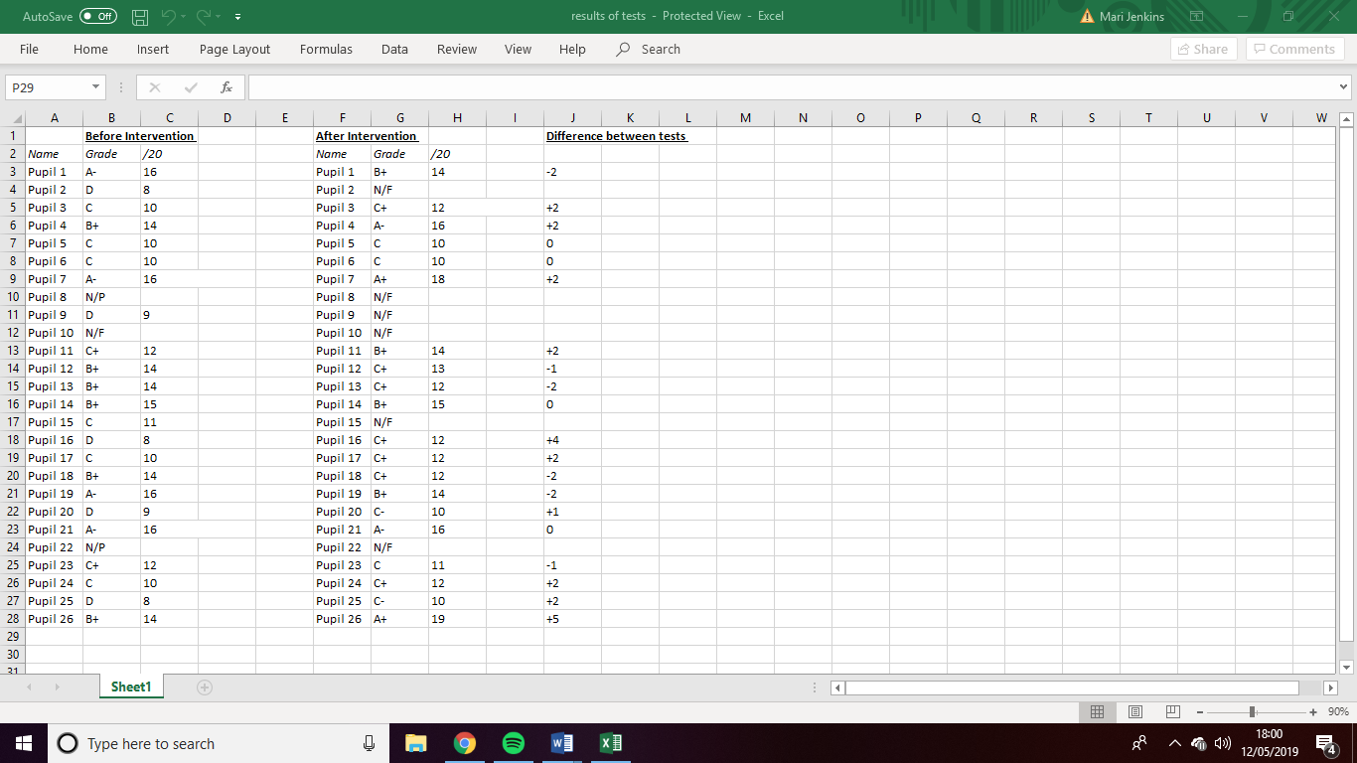
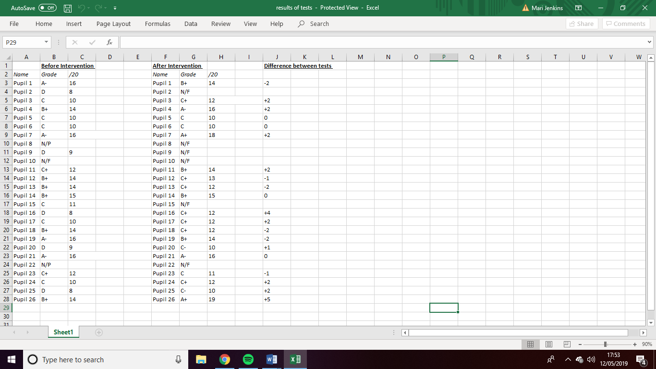

Conclusion
To conclude, conducting this research has illustrated the importance of inference grids as a tool when analysing sources. This is evident through the results of the data. With an average improvement of 5.5%, the impact of this has helped my teaching as this teaching framework will become visible in my future teaching development. The experience of designing a research project was one which interested me as a practitioner, the responsibility of conducting appropriate research interventions within a classroom and all the ethical considerations has focus my thoughts with respect to the important factor involvement with carrying out such activities in a classroom. I have also learned to be more self-reflexive in my approach to considering the topic, method, approach and interpretation of results as I know realise from my reading and small research project that the researcher/ teacher’s ‘frame of reference’ is a fundamental element of research and interpretation process. During this research it was important for me to make sure that all pupils had the opportunity to withdraw at any time and that the pupils felt at ease when being a part of the research. The full attention of the pupils was evident as seen by the 70% of the pupils either having the same results or improving from the intervention I provided. There have been many challenges along the way when conducting this research, such as time with the pupils and the facilities in School A.
My research method of pre and post test design has been one that has shown its strengths when conducting as part of a small group or in my case, one class, however I future research the validity of this method would weaken due to the inability to generalise my data for all year 9 pupils. Looking forward towards future research, I would be interested in the impact on other teaching tools on the pupils’ ability to analyse sources when writing an extended piece of work. Next time, I believe that by narrowing the scope of the research, e.g. looking at the impact of a teaching tool on source analysis in girls only, or more able and talented pupils in the class. This change in the research project could allow for changes in my research method, in that there is a controlled group involvement in my research. This would potentially strengthen my research as the impact of the intervention would be clear seen next to the controlled group who have not been given the intervention. Through my research I have seen the importance of being an active reader and having background knowledge on an historical event before analysing sources. As Cain and Oakhill explained, it’s the way in which the pupils can use the background knowledge whilst analysing sources, to be able to read between the lines of the source, which is a complex factor for pupils in year 9. (Cain & Oakhill, 1999). Reflecting on the way in which I concluded my research, it is evident that the I should have conducted this research with different classes and possibly different age groups in order to be able to generalise this research. Through conducting my research, I have realised how important self-reflection is on my teaching development and how this research has deepened my mindset on how I conduct research and the ways in which I analyse my data. The importance of confidentiality has become evident to me during this research, as the willingness of the pupils to participate in the research was determined by the knowing that their personal information will be completely confidential. In future research, I would allow more time for analysing my data, and using the data in different ways. With the lack of data on six of the pupils in the class this made the sample at 20, instead of 26. Therefore to conclude this research has allowed me to see the impact of inference grids on the understanding of source analysis, but it can not be generalised for the whole of year 9.
Limitations and future development
During the research I discovered several potential limitations to my findings. There were some that could be changed slightly for future research and some that I would take out or change completely with regards to future classroom enquiry. The first problem is regards to the particular class and school where the research was conducted. The limitations that I personally struggled with was the lack of time with the pupils and lack of time in lessons. This problem was one that I felt impacted the results of my research as the time of day or even the temperature of the day played a pivotal role on the research. The lack of time with the pupils is one that could not be helped as with History not being a core subject, this limited my lessons to three lessons a fortnight, whereas the impact of the research if it was a mathematics lesson, this could potentially be scaled up to the number of contact hours every pupil has a week with particular subjects. Another limitation that I found with my research was the inconsistency of topic during the research, this can be linked to my previous limitation on time as the lack of time did not allow me to spend three lessons looking at the trenches and their living conditions. In my future development and future research I would allow time for the pupils to have the pre-test, intervention and post-test all on the same topic, this would allow for a more valid research as some pupils would find the topic of trenches more engaging that the topic of workhouses and the Victorian times.
The other problem with regards to the time was the lack of consistency within the classroom. As seen through my results in Figure 1, there were six pupils who were unable to finish the extended piece of writing which illustrates the lack of time that was available to the pupils during this research. Another limitation during this research was the number of trails. This indicates to the size of the sample taken during the research. With only 20 pupils taking part in this small-scale investigation it is impossible to generalise. This research would not be able to be transferrable to over teachers in the profession. This is because there are many variables that make this research unique. The fact that myself as the teacher play a pivotal role in teaching the intervention lesson and that I personally chose the class under investigation does not make this research viable for success for every teacher to succeed using my approach. In my future teaching and learning, I would make sure that the inference grids were clear and coherent for the pupils to understand the sources correctly. During my research and intervention, it became clear that the choice of eight inferenced grid sources made room for confusion amongst the lower ability students. The lack of consistency amongst the students when filling in the inference grids implied to me that the choice only made it more difficult for the pupils to analyse the sources effectively.
I would like further development my classroom-based research methods as a way to develop my teaching practice, skills and knowledge so as to assist my pupils in their learning. I am particularly interested in understanding the Feminist research approaches, for they challenge any research in education that does not challenge whether oppressed and otherwise invisible groups e.g. women are either ignored or not appropriately considered. (Cohen et al, 2011, p. 40). As Thapar-Björkert and Henry (2004) imply in Cohen’s book that the predictable, one sided view sees the researcher as the commanding and powerful role, and the participants as the vulnerable less-powerful. The researcher can therefore manipulate the research and could be constructed by cultural bias e.g. western white males. (Cohen et al. 2011, p.42). In my research, there is a power imbalance between the teacher and pupils in the classroom, and this makes the
My research for this project was a pre-experimental design: the one group pre-test-post-test. This can be represented by the following,
Experimental 01 X 02

Cohen et al, 2011, p.322
In my future development from my limited experience of research and in particular with this report, I would have a control group e.g. a group that did not have an intervention. This would deliver more robust results as I would be able to have more confidence that the intervention had the effect noted in my results compared to the control group who did not have the intervention but were matched across a range of criteria. The criteria being the same age pupils, both classes being mixed ability with more able and talented pupils and pupils with additional learning needs, etc. This can be represented by the following;
Experimental 01 X 02
----------------------------------------------
Control 03 04

Cohen et al, (2011). p.323

Furthermore, from my reading I have realised that it is more appropriate to use the words “design based research” as opposed to an experiment because as Brown(1992) in Cohen et al suggests, “design studies attempt to ‘engineer innovative educational environments and simultaneously conduct experimental studies of those innovations’” (p. 330.) Using the example of engineering he argues that a designer develops a product and then tests it in real conditions and observes during the testing if there are any problems with the design, if anything needs to be improvement, whether the faults and problems are etc, therefore the engineer would then redesign the product to solve the problems found. (Cohen et al, 2011).
It seems to me that educational research in the classroom often focuses on it being iterative i.e. each trial or intervention builds on the previous one and improving every time and unlike the engineering model explained above where a particular product is perfected , in education research as Brown argues affects theory of learning, teaching, and other kinds of relevant knowledge as the research takes place in real world classroom context, can add to knowledge of intervention design. (Brown, 1992, in Cohen et al, 2011). Therefore, what I like about this approach to educational classroom research is that it understands the “complex, real, multi-variate world of learning, teaching and education.”. (Gorard et al, 2004.p.578,582 in Cohen et al, 2011, p.331). All the above show how real social educational research in the classroom is complex and not to be undertaken lightly which requires much thought and careful design to ensure that any results are valid, reliable and carefully explores any power imbalances in the design implementation, analysis and interpretation of results.

Appendices
Appendix 1
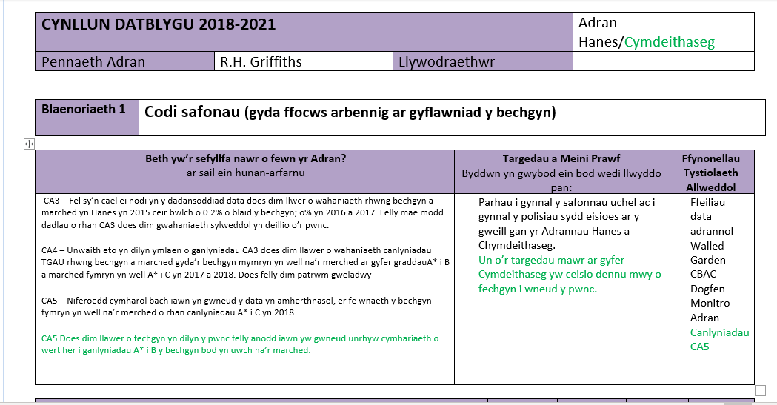
Appendix 2
https://www.estyn.gov.wales/sites/default/files/documents/Ysgol%20Gyfun%20Gymraeg%20Bro%20Myrddin%20eng.pdf
Appendix 3
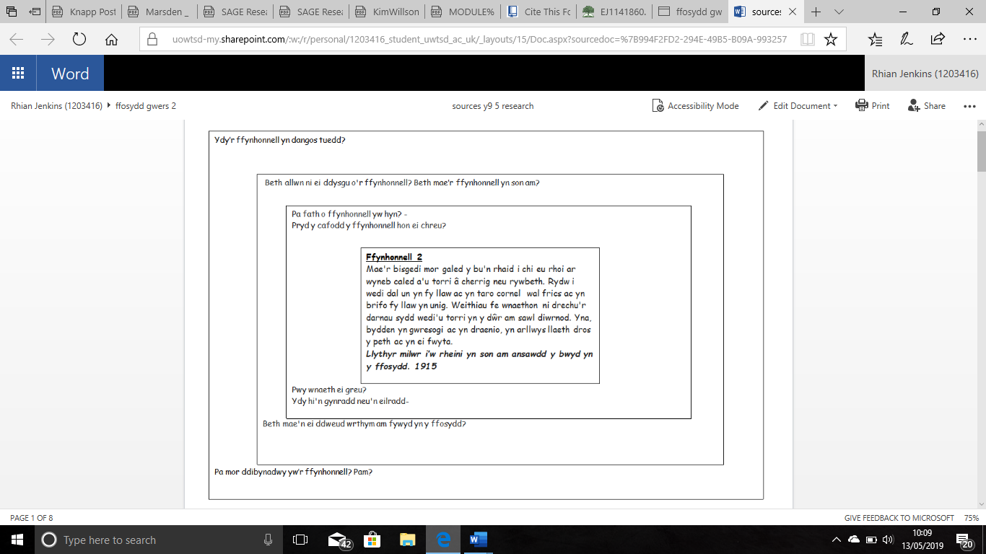
References
Allen, M. (2018). The Sage encyclopedia of communication research methods. London: Sage Publications Ltd.
Barton, K. (2018). Historical Sources in the Classroom: Purpose and Use. [online] Hsseonline.edu.sg. Available at: https://www.hsseonline.edu.sg/sites/default/files/uploaded/journal_articles/1.%20Keith_Sources.pdf [Accessed 13 May 2019].
Bryman, A. (2012). Social Research Methods 4e. Oxford, UK: Oxford University Press.
Cain, K., & Oakhill, J. V. (1999). Inference making ability and its relation to comprehension failure in young children. Reading & Writing: An Interdisciplinary Journal, 11, 489-503.
Cohen, L., Manion, L. and Morrison, K. (2011). Research methods in education. Hoboken: Taylor and Francis
Cowgill, D. and Waring, S. (2017). Historical Thinking: An Evaluation of Student and Teacher Ability to Analyze Sources. Journal of Social Studies Education Research, 8(1), pp.115-145.
Evans, T. (2019). Effective Teaching of Inference Strategies: Part One | Exceed Academies Trust. [online] Exceedacademiestrust.co.uk. Available at: https://exceedacademiestrust.co.uk/effective-teaching-of-inference-strategies-part-one/. [Accessed 12 May 2019].
Hicks, D., Doolittle, P. and Lee, J. (2004). Social Studies Teachers' Use of Classroom-Based and Web-Based Historical Primary Sources. Theory & Research in Social Education, 32(2), pp.213-247.
Marsden, E. and Torgerson, C. (2012). Single group, pre- and post-test research designs: Some methodological concerns. Oxford Review of Education, 38(5), pp.583-616.
McAleavy, T. (2009). Using the Attainment Target in Key Stage 3: Interpretations of History. [online] The Historical Association. Available at: https://www.history.org.uk/secondary/categories/8/resource/2416 [Accessed 12 May 2019].
Musbach, J. (2001). Using Primary Sources in the Secondary Classroom. OAH Magazine of History, 16(1), pp.30-32.
Narvaez, D. (2002). Individual Differences that Influence Reading Comprehension. In M. Pressley & C. C. Block (Eds.), Reading Comprehension Instruction (pp. 158-175). New York: Guilford
Noakes, J. (2011). Recognizing and Addressing the Barriers to Adolescents' "Reading Like Historians." The History Teacher, 44(3), pp.379-404.
Veccia, S. (2004). Uncovering our history. Chicago: American Library Association.

