Cover Page

Name: Denise Fitzsimmons

Student Number: 2007361

Word Count: 4,200

Link to Blog on Sway:

Introduction Page

ABOUT ME
The blog below draws on my experiences of working within an HR environment in HDUHB over the last 24 months. My experiences are described and evaluated to show where I have acquired skills and used them to support my CPD and learning and development. I am currently an Associate Member of the CIPD.
I will be using Gibbs’ reflective model for my blog, as seen in the below image.
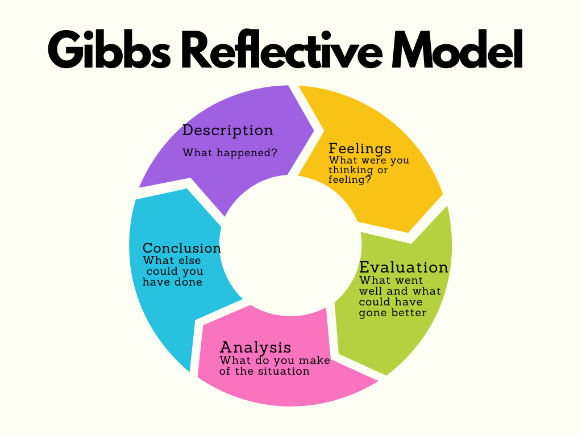Figure 1: Gibbs Reflective Model (The University of Edinburgh, 2020)

I have also used the CIPD Profession Map to assess my skills and experience against the work I’m currently doing.

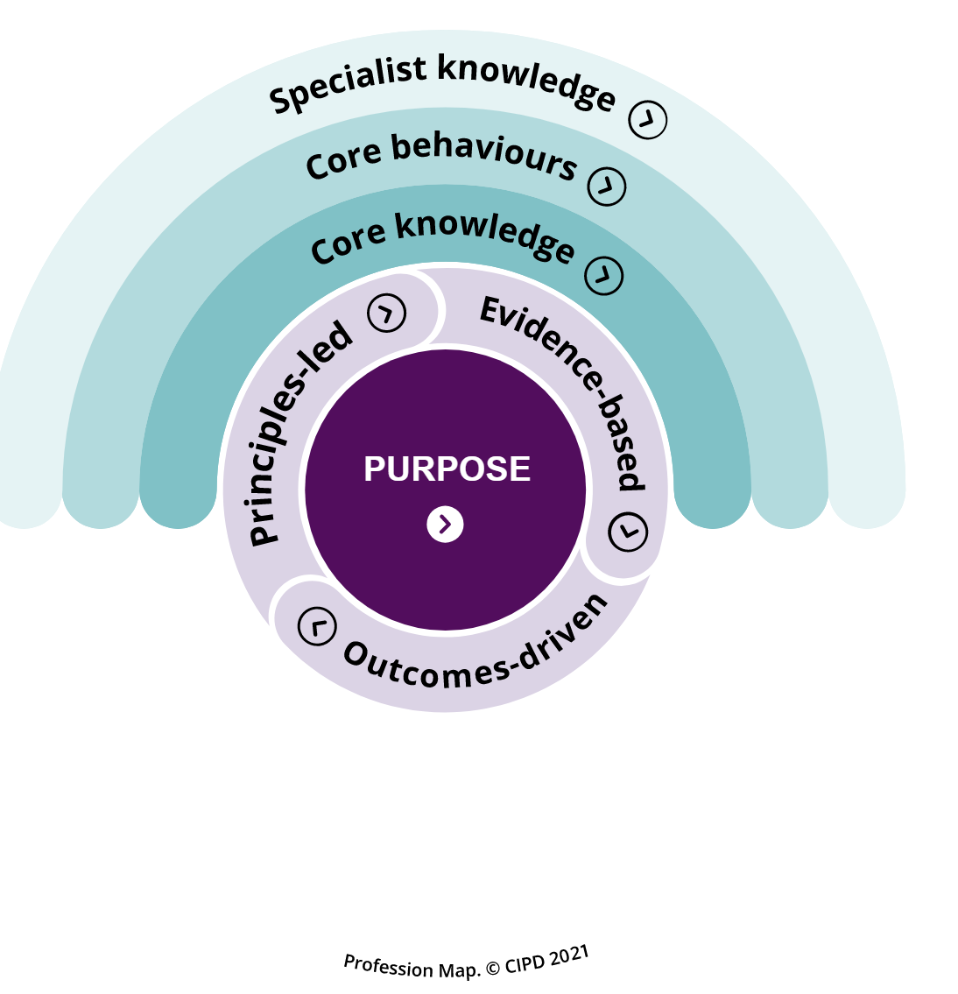

Changing Tact – A job role change from operational HR to Organisational Development

Describe: In December 2021, I acquired a new job in Organisational Development within HDUHB. This change has taught me more about human process interventions such as training, coaching, group work facilitation, and strategic support such as culture change and transformation (CIPD, 2020a) . This was a learning experience, as I was previously working in an HR Advisor role.
I underwent additional training to help me manage myself more effectively at work (LOC 1). This has included 360-degree feedback, using the NHS Leadership model (NHS, 2022) and completing a Myers Briggs 16 personalities questionnaire (16 Personalities , 2022), (Myers Briggs Foundation, 2022)
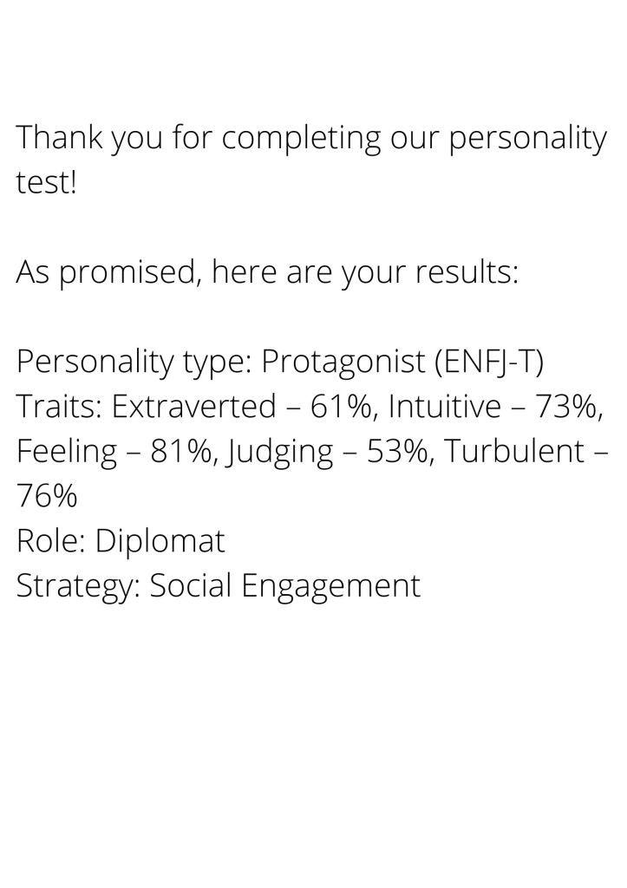
Figure 1: The Results of my 16 Personalities Test (16 Personalities , 2022)
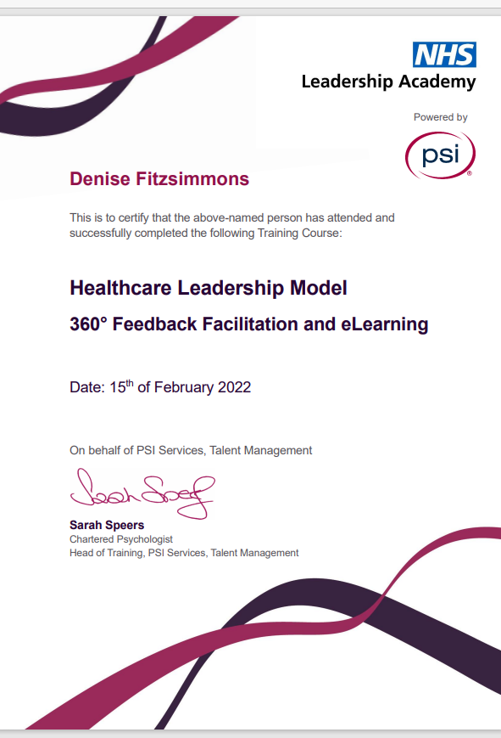

Figure 2: HLM 360 Feedback Facilitation Document (NHS, 2022)
Feelings: I felt excited and nervous about starting a new role. It certainly was a challenge to take on board the developmental feedback! Before starting, I thought I was aware of how I worked, but I didn’t readily ask for feedback, so I was interested in seeing how others perceived my work. I also had a small amount of experience coaching and developing others before undertaking this work!
Evaluation:
I used my feedback to improve my self-awareness and become a better facilitator. For example, some of my feedback was "speaking less and allowing others more space to talk in group sessions.” This was a challenge for me, as I’m a big talker! But it helped develop my active listening skills (West, 2021)
I utilised the Johari Window (Saxena, 2015) to support my reflection. I found this helpful. However, I found there were limitations to this model, as although I feel comfortable receiving feedback using this, not all individuals will be open to this.
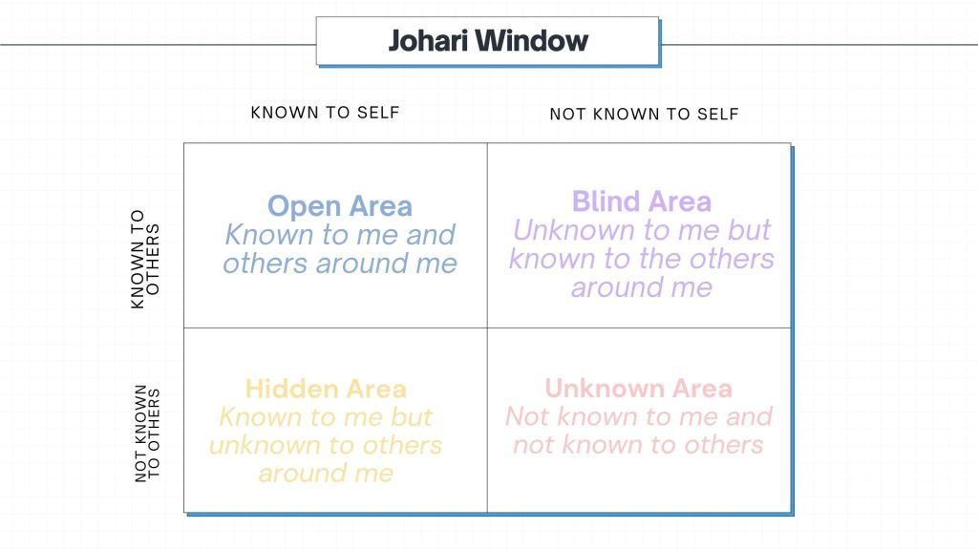Figure 3: Johari Window (Saxena, 2015)
I also feel this helped develop my emotional intelligence, making me more aware of when I am struggling (Goleman, D. , 2005) and supporting others. It also helped challenge my professional identity; I would argue that Schein’s (1978) theory that attributes and beliefs remain stable and endure is not always the case. I feel that mine has been changed through my self-awareness during this process!
Using my feedback and enhancing my listening skills led me to use the OSCAR model to guide & influence others more effectively and support organisational change (LOC 4).
This supported me in adopting a coaching style that I used in responding to queries and advising others. I am helping drive culture change in the organisation by promoting and encouraging constructive feedback and communication in teams. This, in turn, has helped remove some of the ‘culture blocks’ that can be barriers to organisational change (Forsyth, P. , 2012) and increase performance (CIPD, 2020). It was also crucial for me to consider that although feedback and coaching are beneficial other factors such as appropriate skills and operational pressures can impact performance and change.

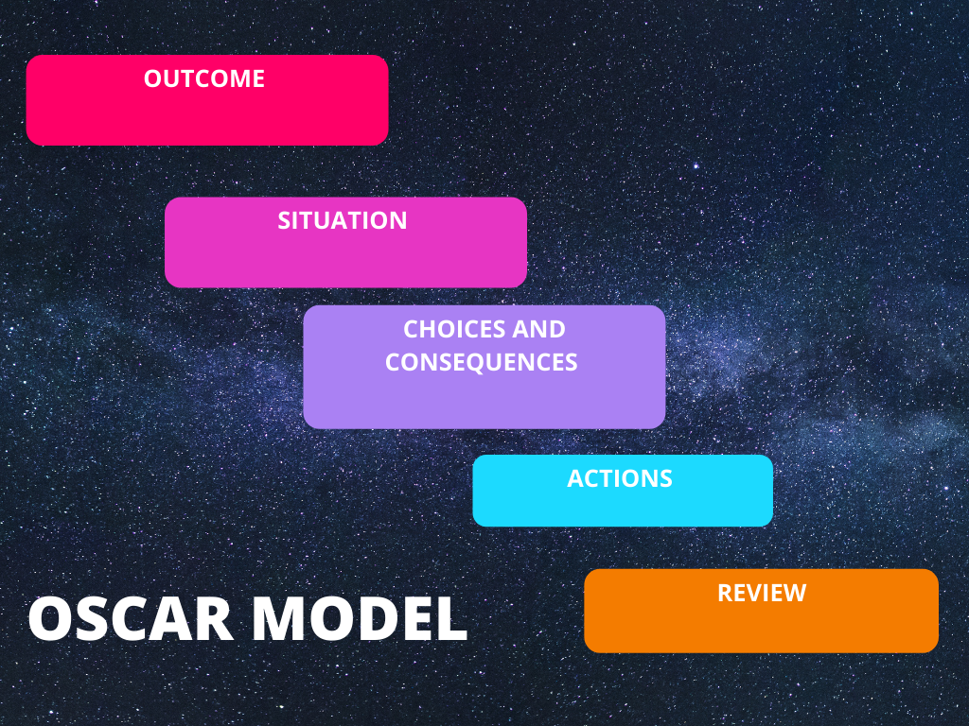Figure 4: OSCAR Model for Coaching (Bangor University, 2020)
Analysis:
Using self-reflection has helped my professional practice and my approach to my work in my new role.
Since completing the learning, I believe I’m closer to developing to the Chartered CIPD level relating to change by being able to engage a range of stakeholders to enable a difference and build capability (CIPD, 2022) . I have learned that effective listening and self-awareness are vital when managing myself in a work context.
Conclusion: The experience has improved my awareness of how I work professionally. Having detailed feedback has influenced how I give constructive feedback to others and support positive performance in HDUHB. Regarding the CIPD profession Map Core behaviour, I think that to have a deeper understanding of myself and my impact on others to develop to the Chartered level (CIPD, 2022), I will need to do further team reflections to demonstrate this.
Action plan: To improve this situation further, I would potentially use additional methods for feedback on the work I’ve done previously.
In the future, I would consider using Belbin’s team roles (Belbin, 2022)to help assess the work I currently do within my team. I would also like to complete my level 5 ILM Coaching training (ILM, 2022) as I feel that this would help further my ability to coach and develop others and coach myself.

Learning to work in ‘spaghetti’ – Becoming a workplace mediator
Description
In the summer of 2021, I became a workplace mediator and completed an ILM Mediation qualification (ILM, 2019). Although the training I received was beneficial, it is not the same as being in a conflict situation in a workplace and there were both positive and negative experiences when I came to do the mediation sessions both face to face and on MS Teams.

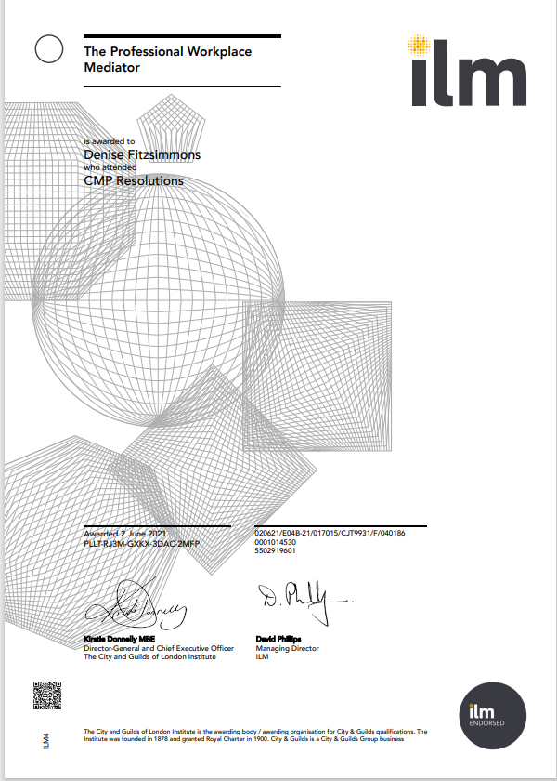
Figure 1: My mediation certificate! (ILM, 2019)

Feelings
After initially feeling quite excited about becoming a mediator, I found the idea of trying to mediate in conflict situations quite daunting. After the first two sessions, I felt more comfortable dealing with conflict; however, one of the mediation sessions I facilitated was unsuccessful, and I found it disappointing. Before undertaking the qualification, I felt that I was good at building relationships with other colleagues, but I could have done more to challenge conflict. After becoming a mediator, I felt more confident addressing conflict with colleagues (LOC 2). It also helped me feel more confident in supporting the early resolution, which according to the CIPD (2020), is essential in successfully managing conflict in organisations.
Evaluation
The positive outcomes of becoming a mediator have included better awareness of how I deal with conflict; for example, my understanding of the Thomas Kilmann model (Thomas, K. W., and R. H. Kilmann, 1977)supported me in challenging my views of conflict.
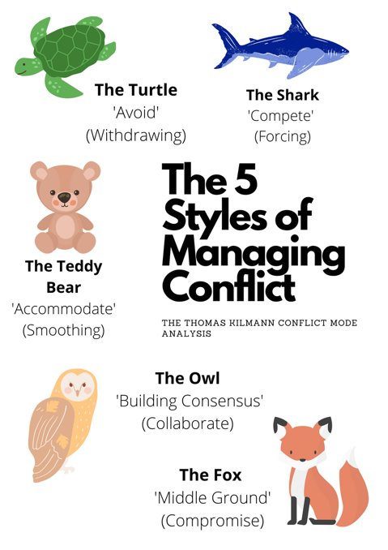
Figure 2: Thomas Kilmann 5 styles of conflict for the online training ‘handout pack’ I developed (HDUHB , 2022)
Now instead of shying away from conflict during a mediation session or group work with my team members, I would be more likely to challenge and not shy away from constructive conflict. I have also used the Karpman drama triangle (Nelson, J. B., 2015, p.38–42) to understand when I am being drawn into conflict at work. It has helped me become better when maintaining relationships; I would get caught in the ‘rescuer’ role before this.
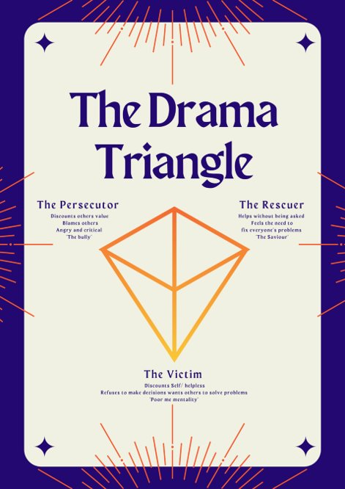
Figure 3: Karpman Drama triangle, the model used in internal training handouts (HDUHB , 2022) I developed for online sessions
I also used the skills I learned in the mediation to create conflict management training. I needed to use IT skills such as Microsoft Teams to make the required training (LOC 6). Before becoming a mediator, I had some experience delivering training online, but I had never created online training from scratch on Teams; I felt that I had to hone my IT skills to support using programmes for delivery. If I could have done anything differently, I would have experimented with more innovative technology such as different programmes and included some analytics, such as the cost of conflict, e.g. grievances, to strengthen my training and use analytics to create value (CIPD, 2021)
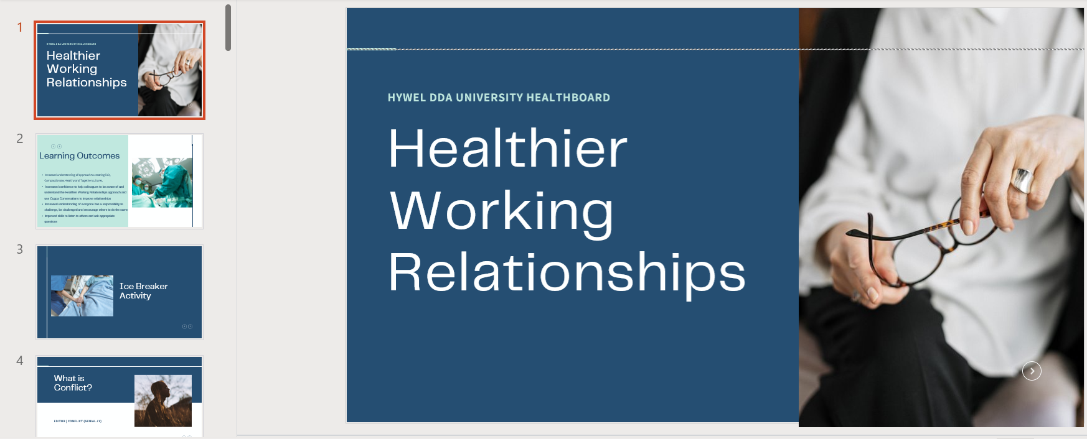
Figure 4: Conflict Management Intervention that I created using my newly learned IT skills on Canva (HDUHB , 2022)

Analysis
I feel that involvement in conflict situations has been educational from the perspective that I now understand the difference between functional and dysfunctional conflict and how to drive change and support positive relationships in work. I feel better at approaching topics with my colleagues now that I’ve had this experience. I have altered my approach to mediation because of the session that wasn’t successful. As a result, I have become better at assessing if a situation is suitable for mediation and it is not.
Conclusion
I learned a great deal from this situation, especially when managing interpersonal relationships at work more effectively. Reflecting on my conflict styles means I have become better at handling my emotions during conflict. Being involved in conflict situations has also improved my empathy and understanding.
To ensure a more favourable outcome in the next mediation that I do, I will not be so hard on myself when the mediation isn't successful and understand that not all relationships can be rebuilt this way. I now also feel that I have a bank of reliable sources and theories that I can draw on to use for further training and the IT skills needed to support additional training.
Action Plan
If I were to change anything, I would likely reflect more and debrief after the unsuccessful mediation. I would also have asked for support from our peer group of learners or a network of professionals to help share ideas. I will set up an internal peer mediation group to develop my skills further and develop to the Chartered CIPD membership level in my Core Behaviours (CIPD, 2022). This will help to build collaborative relationships across the whole of the organisation.
I will also need to research other methods to ensure that I develop to the Chartered level of the CIPD map Core Knowledge (CIPD, 2022), where I will be exploring more innovative ways of using technology to support the use of online or hybrid training in the organisation.

The Art of Investigations – Being an Investigating Officer
Description
In June 2021, I became a Bank Investigating Officer. This required me to investigate an alleged disciplinary issue (LOC 7). This was the first investigation I had undertaken in the organisation, and I had to learn the policies and processes.
When writing the report, I had to assess the information I was given and make justifiable decisions for inclusion in my investigation report. If I failed to do this, then the disciplining officer would not be able to make clear decisions about the outcome. I had to be clear about the content of my report while understanding my role as an investigating officer and following the CIPD (2021) and ACAS (2019) guidance.
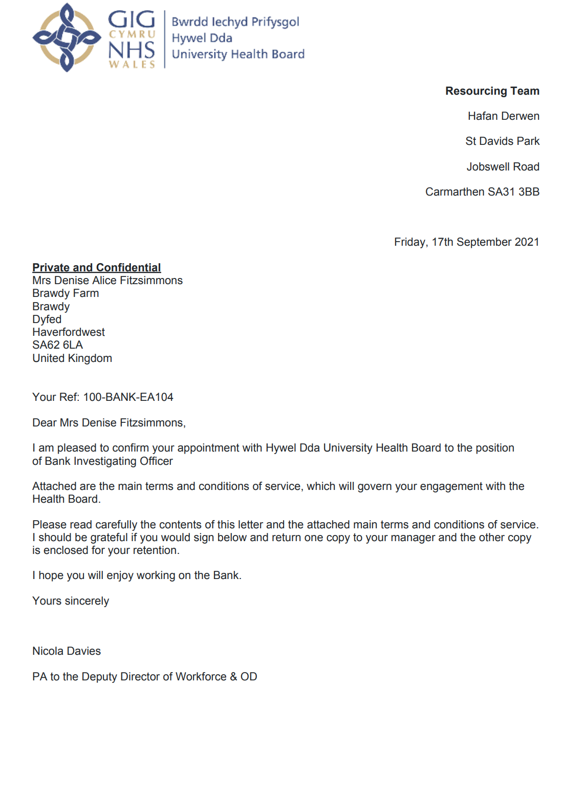
Figure 1: Internal offer letter for becoming a bank investigating officer.

Feelings
Conducting a disciplinary investigation was new to me working in the Health board. The process was very stringent, and I wasn't used to doing an investigation in a public sector organisation. The training that I received was helpful, and it did help me feel more confident. However, I learned a lot from shadowing some of the processes with a colleague. I was also required to develop my knowledge and ensure that my outcomes were evidence-based.
Evaluation
I followed the suggested approach to conducting a disciplinary interview and ensuring that all the facts were collated before the meeting. Throughout the investigation, the employee was aware of why we were meeting and that they could be accompanied by another member of staff or a trade union representative. I reflected on the information I was given during the investigation by using interview questions and evaluating the options and evidence.
I feel that the investigation went well and that I could keep to timescales and work in an ethically sound, professional way (LOC 3). I kept the report objective and did not offer a solution or an outcome for the investigation. I don’t think it would have gone as smoothly if my colleague hadn’t been helping to coordinate the investigations! I felt like I had to do a lot of background reading despite having the training initially. I had to work through quite a few policies, and I found that quite stressful as I didn't want to miss anything and make the process unfair.
Analysis
From conducting this investigation, I feel that I was able to enhance my essential people management skillsets. In terms of elements that didn't go so well, I found the additional reading, for example, the terms of reference, the re-registration policy and accessing the re-registration guidelines, quite time-consuming. This is probably due to inexperience, and the next time I interview an investigation, it probably will feel a lot smoother. I thought that I used an active listening style in the interviews and remained objective, which helped me work professionally and ethically.
According to Armstrong’s Handbook of Human Resource Management Practice (Armstrong, M. and Taylor, S., 2020), to be ethically sound, I should do what is possible to establish the facts and uncover what isn’t explicitly being said. In the investigation, I identified that getting the facts is a crucial part of problem-solving and understanding the motivations for the situations. I believe for my investigation, utilising this format helped support work and help with the ethical outcomes that I needed.
Conclusion
I learned the importance of being prepared and sure of the information I collected at the interview stage from this situation. Although the structure of a disciplinary hearing is very formal, I was very conscious of the human element of the process, which is why having a fair and ethical investigation is so important. Having more practice in complex investigations would help me feel more confident. In this situation, I could have spent some more time with some of the more experienced Workforce Advisors to go through what to expect and prepare for the disciplinary hearing.

Action Plan
According to the CIPD profession map (CIPD, 2022) , to work at a chartered member level, I should acknowledge how to apply and interpret employment law in complex work situations and mitigate risk as part of my specialist knowledge. To do this, I could take more time to review our current policies and attend employment law updates to ensure a complete understanding of these points. I could also conduct research and review sources of evidence (e.g. internal and external professional expertise, research and stakeholder concerns and values) to test assumptions and ideas to help me progress to the next stage of the CIPD profession map (CIPD, 2022)

Assessing the Impact of the Menopause on sickness absence in HDUHB

Describe
In Summer 2021, I was required to investigate a business issue as part of my Post Graduate Diploma. I chose to investigate the impact of Menopause on sickness absence in HDUHB. For the research, I decided to collect predominantly quantitative data relating to health conditions experienced by staff during menopause.
This learning helped me develop my critical thinking and enhance my postgraduate skills (LOC 8). It helped me understand how financial factors can help influence service decisions and how research can help highlight the financial aspects that impact organisations (LOC 5). According to sources, the critical drivers for organisational success lie in a close relationship with HR functions and finance (Bhatt, 2018) , (Hppy, n.d.)
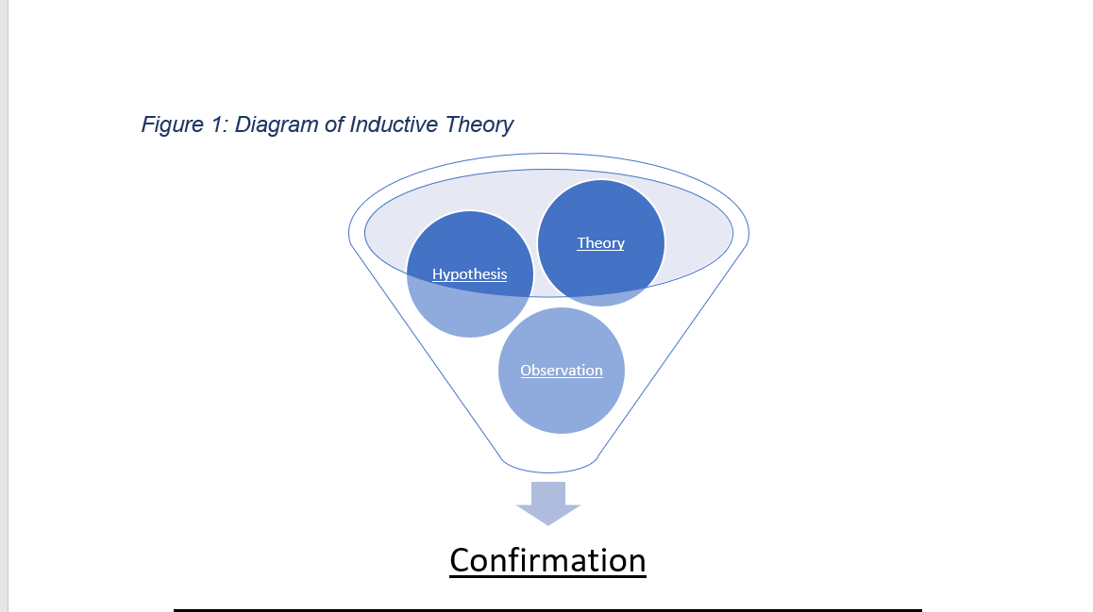
Figure 1: Diagram of Inductive Theory, used in my Investigating a Business Issue report (Business Research Methodology, n.d.)
Feelings
Initially, I felt out of my depth in starting the research as I hadn’t completed anything like this previously, so it was quite a learning curve. I also felt that not having access to budget information or a prior understanding of many of the financial factors impacting the organisation would be challenging for me.
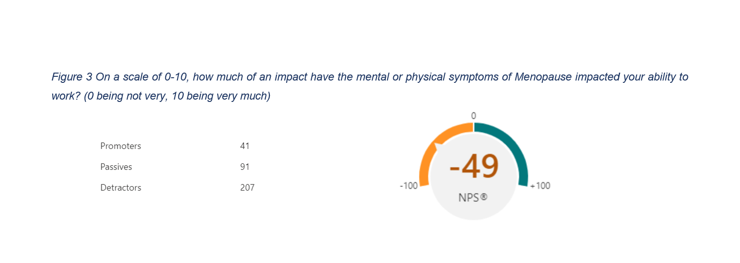
Figure 2: An example of utilising Net Promoter Scoring to gather and interpret information from my research (ANSTEAD, M., 2008)

Evaluation
In terms of what went well, I found it was beneficial to have previous experience in postgraduate learning and critical analysis of texts, especially during my literature review. I did have to test my knowledge and learn more about specific aspects, such as statistical analysis and coding for qualitative data. I found this quite tricky as it's something I hadn't done previously. Although I had experience with evidence-based research in my previous assignment, statistical analysis was very new. I did feel that I was very successful in attaining enough responses to make my research valid; however, I did lose marks for not exploring my methodology further.
Regarding enhancing my financial awareness, the research paper allowed me to explore the financial impact that conditions relating to menopause can have on the organisation in terms of sickness absence. It also highlighted the effect of presenteeism, which can be linked with decreased productivity. The report allowed me to investigate the cost impact of sickness on the organisation and how reducing sickness by even a small amount could save significant money.
 | Cumulative Absence FTE % | Absence Estimated Cost
2018- 2019 | 5.08% | 13,801,645.21
2020 - 2021 | 5.29% | 13,830,628.70
Figure 3: Internal data regarding HDUHB sickness rates and the estimated cost of sickness (HDUHB, 2021)

Analysis
Utilising the research onion model (Saunders, M., Lewis, P. and Thornhill, A, 2007) supported me in effectively establishing my methodology; using this model, I decided how to collect the data and approach my research. On reflection, this model was beneficial. However, I should have researched more models for my methodology to make it more robust, as it was one of the weaker areas. I also feel that I helped to develop my critical thinking skills by utilising systematic and independently formulated ideas (Haber, 2020)
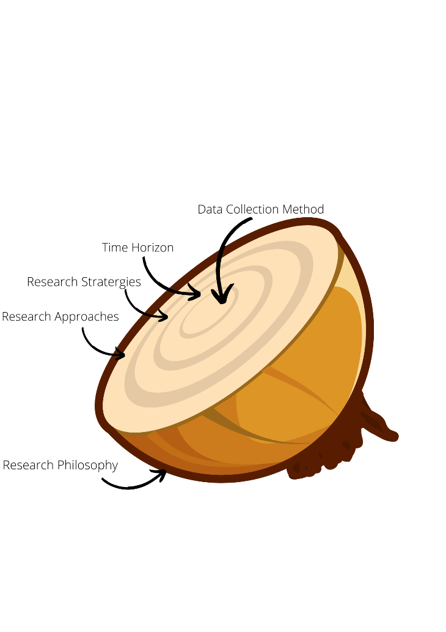
Figure 4: The Research Onion I used in my research (Saunders, M., Lewis, P. and Thornhill, A, 2007)
In addition to this, I used the Toulmin model to navigate my hypothesis for my research. When critically analysing literature for my review, ensuring that I had data and information to back my hypothesis was essential for critically analysing my work, for example, when I reviewed my project to check the limitations of my research. Regarding the work that we had to do for the project, I had to focus on being able to reference and critically analyse and ensure that the information I was using was robust under academically sound. I also felt that it was difficult to quantify some financial factors, such as presenteeism. If I were to conduct the research again, I would potentially use calculations, such as those that suggest that presenteeism was found to be 11.5 times higher than the direct costs of taking sick leave (Hemp P. , 2004).
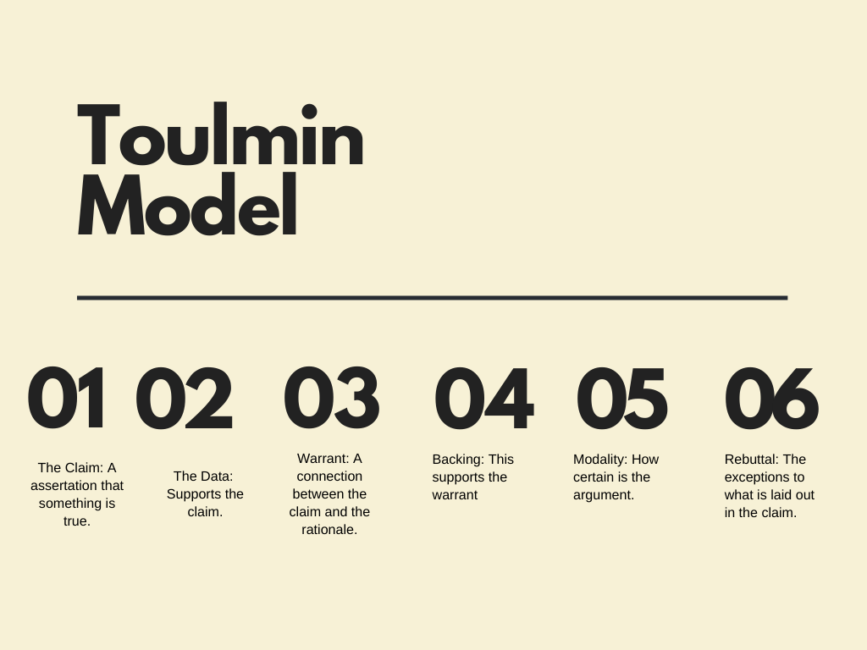
Figure 5: The Toulmin Model that I used to critically analyse my work (Toulmin, S., 1958)
Conclusion
Overall, I feel that my research approach went well; however, on reflection and using the CIPD profession map for reference, for me to be working at a chartered member level, I would be using my postgraduate skills to look for opportunities to test and develop new innovative ideas (CIPD, 2022). I felt that I used tried and tested evidence-based research methods in my report. In future projects, I would likely explore other approaches to collecting data, such as experimental learning, to enhance this skill.
I also feel that how I interpret financial information and financial resources could be improved. Regarding the CIPD profession map, I should develop and present robust business cases using evidence to demonstrate a return on investment (CIPD, 2022). I feel that I did give a good business case as to why supporting menopause in the workplace is essential financially for the organisation. However, I do think that I need to have more exposure to budgets and financial forecasting to understand better how this would work in a practical setting.
Action Plan
If I were to repeat the research, I would spend more time reviewing my methodology to enhance my postgraduate skills and utilising the most innovative and appropriate analysis methods. I will also need to spend more time with our finance team to understand how research can help the organisation save money. By having an enhanced understanding of financial information, I would be better positioned to support the organisation with cost-saving measures.

Personal Development Plan
From April 2022 To April 2023

Planned Outcome: I would like to be working at a level where I am achieving the set outcomes at the Chartered CIPD level on the CIPD Map.
What do I want/ need to learn | what will I do to achieve this | what resource is or support will I need | what will my success criteria be | target dates for review and completion
I need an enhanced understanding of financial information, basic costing concepts, and techniques.  This will help me develop and present robust business cases using evidence to demonstrate a return on investment (LOC 5). This will help me build my ‘business acumen’ as suggested in the CIPD profession map (CIPD, 2022) | I will spend time with the HDUHB finance team to review the supply chain models in the organisation and see where value is created and lost. | I will need support from my manager in allowing time off to spend time with the finance team. | I will be able to create business cases for procurement of services and show value in the changes I suggest regarding projects. For example, I will be able to offer the cost analysis for presenteeism in the organisation and demonstrate ROI on interventions that I recommend. | August 2022
To develop my postgraduate skills (LOC 8), I will need to pursue opportunities to test  and develop new innovative approaches. It would be beneficial to speak to other HR and OD professionals in the wider NHS Wales community to gain insight and ideas on new ways of working. This will support skills such as exploring alternatives creatively and reflectively. | Create an All Wales NHS community of OD and HR professionals to share knowledge, benchmark and develop new thinking. | I will need time to complete this and buy-in from senior leadership. To do this, I will need to produce a report outlining the value of doing this for the service. | I will have set up an HR and OD Action Learning set to discuss different approaches to issues in the teams. | September 2022
To improve my knowledge of IT skills to deliver innovative training virtually to staff (LOC 6) | Learning to run learning events through ‘Teams Webinars’ rather than just the Teams meeting app and review other potential platforms for agile and hybrid working | I will need access to reports relating to technology and access to workshops on how to use Teams Webinars | I will have new methods of delivering training in the organisation. | June 2022
I should acquire and source multiple sources of evidence (e.g. internal and external professional expertise, research and stakeholder concerns and values) to test assumptions and ideas ( Loc 3) | Sign up at the HDUHB library to get more information about how to conduct specific research and link in with the organisation’s research and development team to see if I can be involved in research projects | I will need access to the library and time with our research teams | I will have a bank of tried and tested evidenced based solutions to support with organisational development and change in the organisation | January 2023
(LOC 2)  Build collaborative relationships across organisation boundaries, cultures and other disciplines | To better understand how conflict affects relationships in the organisation and what can be done to reduce the costs in the organisation. | I will need support from the organisation to create and build collaborative networks for early resolution. | Set up an early resolution network of qualified mediators to support a reduction in conflict and grievances in the organisation | December 2022
Manage myself effectively (LOC 1); now I have more self-awareness; I need to see how I fit into my team dynamics and set team objectives. | Learn how I fit into our teams using Belbin Team scores to ensure that I work effectively with my team. | The time and cost element of completing the Belbin team assessment, I will also need to get buy-in from my team to complete the evaluation, and we will need to consider an ongoing action plan. | I will be able to look at how I fit into our team, work more collaboratively, and set team objectives in my work. | August 2022
To review organisational Employee Relations policies and attend employment law updates to ensure that I am aware of complex employment law updates (LOC 7) | Spend time reviewing policies with members of the Senior HR teams and attend an employment law update in the next three months | Time to complete the review and time to attend the employment law updates. | I will have adequately reviewed the organisational policies and recommended any necessary changes, and I will also have attended an employment law update. | November 2022
To demonstrate an essential people management skillset, I should work to be able to coach, advise and build people management capability in the organisation (LOC 4) | Complete a Level 5 ILM coaching qualification to support coaching within HDUHB | I will need my manager to agree to fund the qualification and the time to complete the coaching qualification. | I will be qualified to undertake coaching in the organisation. | September 2023

4183

References
- 16 Personalities, 2022. 16 Personalities Quesionnaire. [Online]
Available at: https://www.16personalities.com/profile?utm_source=email&utm_medium=welcome-protagonist&utm_campaign=profile
[Accessed 20 March 2022].
- ACAS, 2019. As guide to conducting workplace investigations. [Online]
Available at: https://www.acas.org.uk/acas-guide-to-conducting-workplace-investigations
[Accessed April 12 2022].
- ANSTEAD, M., 2008. Research: How & Why To Properly Use Net Promotor Scores. Credit Union Journal , 12(7), p. 8.
- Armstrong, M. and Taylor, S., 2020. Ethical Dilemas. In: Armstrong’s Handbook of Human Resource Management Practice . London: Kogan Page Limited, p. 297.
- Bangor University, 2020. OSCAR Model. [Online]
Available at: https://www.bangor.ac.uk/health-sciences/research/documents/OSCAR_Model.pdf
[Accessed 3 March 2022].
- Belbin, 2022. Belbin Team Roles. [Online]
Available at: https://www.bing.com/search?q=belbin+team+roles&cvid=f3ccf74fa6c942dfa70923353a40d0d1&aqs=edge.0.0l9.5001j0j1&pglt=43&FORM=ANNTA1&PC=HCTS
[Accessed 3 March 2022].
- Bhatt, N., 2018. Relationship Between HR and Finance. [Online]
Available at: https://www.linkedin.com/pulse/relationship-between-hr-finance-nidhi-bhatt/
[Accessed 1 April 2022].
- Business Research Methodology, n.d. Inductive Approach (Inductive Reasoning). [Online]
Available at: https://research-methodology.net/research-methodology/research-approach/inductive-approach-2/
[Accessed 2 April 2022].
- CIPD, 2020a. Organisational Development Factsheet. [Online]
Available at: https://www.cipd.co.uk/knowledge/strategy/organisational-development/factsheet
[Accessed 3 March 2022].
- CIPD, 2020. Managing conflict in the Modern Workplace. [Online]
Available at: https://www.cipd.co.uk/Images/managing-conflict-in-the-workplace-2_tcm18-70655.pdf
[Accessed 1 April 2022].
- CIPD, 2020. Performance Management: an Introduction. [Online]
Available at: https://www.cipd.co.uk/knowledge/fundamentals/people/performance/factsheet
[Accessed 2 April 2022].
- CIPD, 2021. Discipline and grievance at work. [Online]
Available at: https://www.cipd.co.uk/knowledge/fundamentals/emp-law/discipline/factsheet
[Accessed 1 March 2022].
- CIPD, 2021. People Analytics. [Online]
Available at: https://www.cipd.co.uk/knowledge/strategy/analytics/factsheet
[Accessed 3 April 2022].
- CIPD, 2022. The Profession Map, Core Behavours. [Online]
Available at: https://peopleprofession.cipd.org/Images/full-standards-june-2021_tcm29-95364.pdf
[Accessed 1 May 2022].
- CIPD, 2022. The Profession Map, Core Knoweldge. [Online]
Available at: https://peopleprofession.cipd.org/Images/full-standards-june-2021_tcm29-95364.pdf
[Accessed 2 April 2022].
- Forsyth, P. , 2012. Managing Change. London: Kogan Page.
- Goleman, D. , 2005. Emotional Intelligence: Why It Can Matter More Than IQ. s.l.:Random House Publishing .
- Haber, J., 2020. Critical thinking. Cambridge,: Massachusetts : The MIT Press..
- HDUHB , 2022. Internal Training Document. s.l.:s.n.
- HDUHB, 2021. Internal Buisness Intelligence Data. s.l.:s.n.
- Hemp P. , 2004. Presenteeism: at work-but out of it. Harvard Bussiness Review, 82(10), pp. 49-58.
- Hppy, n.d. Why Finance and HR Should Have a Close Working Relationship. [Online]
Available at: https://gethppy.com/talent-management/finance-and-hr-close-working-relationship#:~:text=Why%20Finance%20and%20HR%20Should%20Have%20a%20Close,ineffective%20traditions%20and%20outdated%20perspectives.%20More%20items...%20
[Accessed 2 April 2022].
- ILM, 2019. Mediation. [Online]
Available at: https://www.institutelm.com/resourceLibrary/mediation.html
[Accessed 3 April 2022].
- ILM, 2022. ILM Coaching Level 5. [Online]
Available at: https://www.i-l-m.com/Learning-and-Development/management/coaching-and-mentoring/8580-level-5-coaching-and-mentoring
[Accessed 3 March 2022].
- Myers Briggs Foundation, 2022. MBTI Basics. [Online]
Available at: https://www.myersbriggs.org/my-mbti-personality-type/mbti-basics/home.htm?bhcp=1
[Accessed 3 March 2022].
- Nelson, J. B., 2015. The Karpman Drama Triangle and Diabetes’,. AADE in Practice , 3(1), p. 38–42.
- NHS, 2022. Healthcare Leadership Model 360 Feedback. [Online]
Available at: https://www.leadershipacademy.nhs.uk/resources/healthcare-leadership-model/supporting-tools-resources/healthcare-leadership-model-360-degree-feedback-tool/
[Accessed 4 March 2022].
- Saunders, M., Lewis, P. and Thornhill, A, 2007. Research methods for Business Students. 5 ed. Essex: Pearson Education Limited.
- Saxena, D. P., 2015. Johari Window: An Effective Model for Improving Interpersonal Communication and Managerial effectiveness. Journal of Management, 5(2), pp. 134-146.
- Schein EH, 1978. Career Dynamics. Matching Individual and Organizational Needs. Reading: MA: Addison-Wesley.
- Thomas, K. W., and R. H. Kilmann, 1977. Developing a forced-choice measure of conflict-handling behavior: The “mode” instrument. Educational and Psychological Measurement, 37(2), pp. 309-325.
- Toulmin, S., 1958. The Uses of Argument. Cambridge: Cambridge University Press.
- West, M., 2021. Compassionate Leadership. 1 ed. s.l.:Swirling Leaf Press.

