

Digital Skills for Personal and Professional Growth

BMSW4008
Student ID: 2331553
Date: 04/11/2024
04/
Table of Contents

Task 1 3
Task 2 6
Task 3 11
Task 4 18

Task 1
Introduction
In a competitive marketplace the primary task is to develop a system of values that will attract consumers’ attention and make them emotionally involved. The goals reached through storytelling for Fur & Friends Café include the presentation of its aims and principles, identification with clients interested in a friendly environment for their pets. It is a place where people read or hear stories that we are using, they are likely to patronise the café and therefore, the café obtains a strong and unique brand image.
Main Body
In advertisement storytelling is much more than just promotion and advertising within the context of a brand story. It is a very wise model that extends an open invitation to customers to become part of the story that the brands communicate (Kang et al., 2020). At Fur & Friends Café, storytelling is the act of telling or retelling the Fur & Friends Café story, the company’s mission to promote animal welfare, and the stories that unfold inside the café. This sort of narrative socialises the brand, turning the café into an actual place where owners can bond with each other, cherish time spent with their pets, and share ownership in a common cause. Thus Fur & Friends Café uses storytelling to create a long-term association with its customers as it helps the consumers not only in using services but also embrace the company’s values.
A compelling similar-store reality is embodied by Pawsitive Café in London. Pawsitive Café has been able to construct a separate brand personality by using stories that are touching every lover of pets. The topic of the café is happiness, connectedness, and kindness to animals. Thus, expert opinions and success stories of clients, events on animal protection become effective ways for inspiring a personal interest in Pawsitive Café. In this way the organism of storytelling reinforces the brand-customer bond where the café is not only a place to consume bread, but an operational advocate for wellness and a community for consumers. By these events, Pawsitive Café has been capable of creating a target customer base that feels that brand is a part of their way of life (Pawsitivecafe, 2024).
For Fur & Friends Café, storytelling helps open such a path in constructing the same level of loyalty and interest. Fur & Friends Café can achieve the development of a distinctive brand image and thus stand out in the competition by telling the story that focuses on its status as a home for the fans of pets. It may initially seem that clients visit this brand to dine with their pets and keep them, but they return to support the values and goals of the brand themselves. Adoption stories, new partnerships between the Café and rescues, or ‘friendship stories’ between the café-goer and their pets could be key parts of Fur & Friends Café’s position on narrative. They offer customers more than a place in which to consume food and drinks by providing them with a reason to relate to the café and become involved with it.
Storytelling is also used for the bricks-and-mortar approach of strengthening customer loyalty. Every brand communicates through stories that are of relevance to the customers, their emotions and virtues, customers feel that they belong. Having customers does not simply mean the acquisition of the product and or service, but the acquisition of an identity (Forbes, 2018). In the case of Fur & Friends Café, this type of link can lead to greater customer loyalty for, if people are emotionally connected with the brand, it will help customers become loyal patrons. They identify themselves with the macroculture of The Café as a community, thus, their patronage is not totally based on the exchange.
Moreover, storytelling is beneficial for the company since it allows it to become unique among many competitors. Of course there are many cafes in the UK that allow pets, but storytelling helps the café to stand out from the crowd with its own values and objectives. That way Fur & Friends Café can develop a unique brand image that would fit the company and its target clientèle well as a place where people with similar feelings towards animals are welcomed. Storytelling thereby also becomes a form of interaction as well as the brand’s strategic positioning on the market. This is much bigger than just a café; it becomes a place that the customer wants to support because they like the brand message or the values of the company.
In the world of growing technologies, the kind of storytelling makes Fur & Friends Café present beyond the physical café. The beauty of social profiles is that the café can post stories and conduct webinars, which will allow addressing potential customers who have not visited the place yet (Dadwal, 2020). Thus, expressing customers’ stories; publishing pet-friendly recipes; and informing clients about the next adoption event, the café can create an online community that can be compared to the live one. It also plays a part in boosting the prominence of the brand to new clientele and builds up expectation for the many intending to go for the same.
Conclusion
In conclusion it can be understood that storytelling is an effective way for Fur & Friends Café to create a strong brand image. Consumers are able to identify with the café through stories involving community or customer interaction and pet welfare, helping to ensure that pet lovers will be loyal to the café rather than being lured by other cafés in the area. Narration makes it possible for Fur & Friends Café to transform into a warm spot where the audience can meet knowing that the values and emotions promoted correspond to the company’s meanings and foster sense-making that builds lasting experiences for the dedicated audience.
References
Dadwal, S. S. (Ed.). (2020). Handbook of Research on Innovations in Technology and Marketing for the Connected Consumer. IGI Global.http://doi:10.4018/978-1-7998-0131-3
Forbes, (2018) How brick-and-mortar retailers can use storytelling to go beyond the store, Forbes. Available at: https://www.forbes.com/sites/steveolenski/2018/07/13/how-brick-and-mortar-retailers-can-use-storytelling-to-go-beyond-the-store/ (Accessed: 04 November 2024).
Kang, J.A., Hong, S. and Hubbard, G.T., (2020). The role of storytelling in advertising: Consumer emotion, narrative engagement level, and word‐of‐mouth intention. Journal of Consumer Behaviour, 19(1), pp.47-56.https://onlinelibrary.wiley.com/doi/abs/10.1002/cb.1793
Pawsitivecafe, (2024) London’s Finest Dog Café: Notting Hill Pawsitive Café. Available at: https://pawsitivecafe.com/ (Accessed: 04 November 2024).

Task 2


Introduction
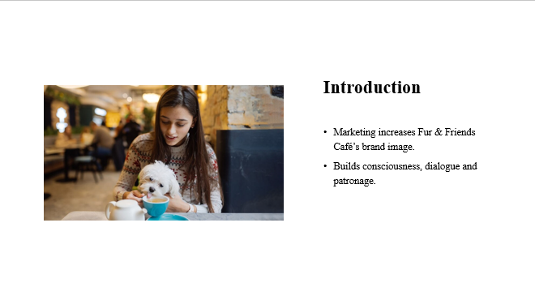
Marketing is crucial in the creation and development of Fur & Friends Café as a social networking site created exclusively for pet owners and their pets. Marketing targets are useful to create awareness of the brand, communicate with the target market and encourage buyers’ loyalty.
Importance of marketing for a brand named ‘Fur & Friends Café’
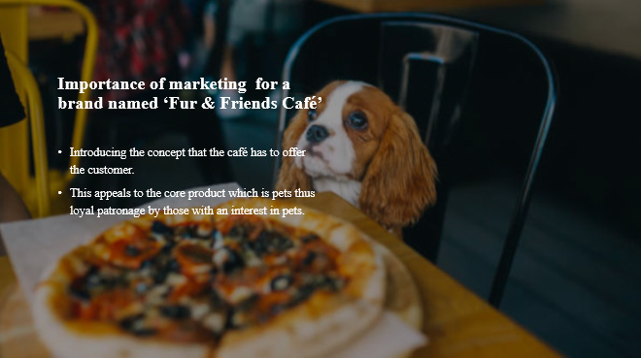To Fur & Friends Café, marketing is vital in presenting its selling proposition, evoking patron’s passion for pets and building a regular base.
Storytelling marketing for ‘Fur & Friends Café’
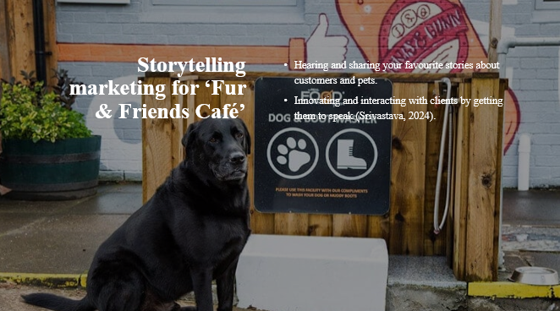The use of storytelling is a pleasant way of promoting Fur & Friends Café, telling about some specific cases from the customers’ and their pets’ lives, and making the clients interested and ready to share their stories (Srivastava, 2024).
Influencer marketing for ‘Fur & Friends Café’
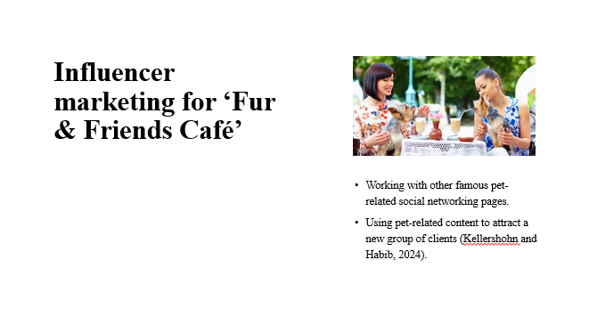According to Kellershohn and Habib (2024), partnering with pet pages and engaging with pet personalities increase the audience and potentially attract new clients to the café thanks to an emphasis on the café’s pet-friendly environment and special menu.
Social media campaigns for ‘Fur & Friends Café’
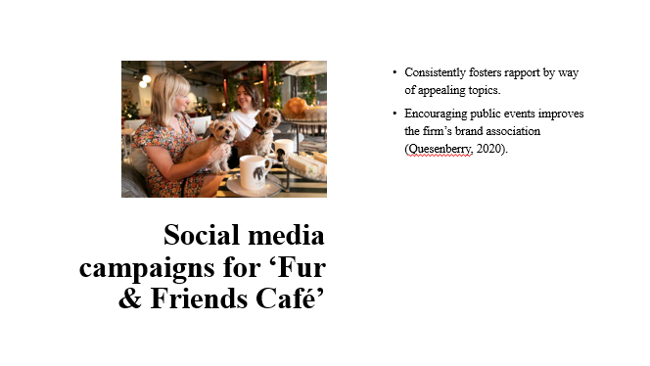
Organising public relations also helps in developing a relationship between the café and the audience by sharing great content and events and therefore helps in branding the café (Quesenberry, 2020).
Conclusion
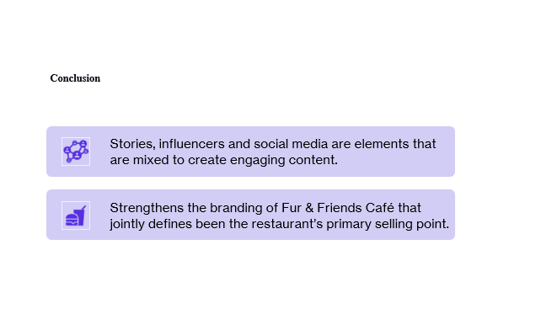A combination of narrative topics, key opinion leaders, and a social media approach will prove useful in enhancing the brand of Fur & Friends Café.

References
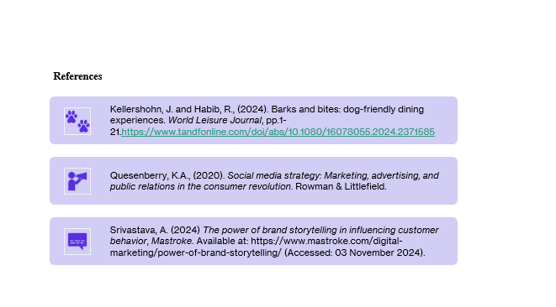

Task 3
Questionnaire for the market research analysis
10 questions were prepared for market research where several individuals responded. The questions are provided below:
1. What age group do you belong to?
- A) 18-25
- B) 26-35
- C) 36-50
- D) 51+
2. How often do you visit pet-friendly cafés?
- A) Weekly
- B) Monthly
- C) Occasionally
- D) Never
3. What is the primary reason you would visit a pet-friendly café?
- A) Quality time with my pet
- B) Socialising with other pet owners
- C) Unique pet-friendly menu options
- D) Events and activities for pets
4. What type of environment do you prefer in a pet-friendly café?
- A) Cozy and quiet
- B) Lively and social
- C) Outdoor-focused with pet play areas
- D) Modern and trendy
5. How important is a pet-friendly menu when choosing a café?
- A) Extremely important
- B) Somewhat important
- C) Not very important
- D) Not important at all
6. How likely are you to attend events for pets (e.g., adoption days, training classes) at a café?
- A) Very likely
- B) Somewhat likely
- C) Unlikely
- D) Very unlikely
7. What would make you a repeat visitor to a pet-friendly café?
- A) Friendly and inclusive atmosphere
- B) Quality food and drinks
- C) Opportunities for pet interaction
- D) Regular events and promotions
8. Which factor would most influence your decision to visit Fur & Friends Café?
- A) Location and accessibility
- B) Pet-friendly policies
- C) Quality of food and drinks
- D) Unique pet-related activities and services
9. What social media platform would you most likely use to follow Fur & Friends Café?
- A) Instagram
- B) Facebook
- C) TikTok
- D) Twitter
10. How important is the café’s support of animal welfare causes to you?
- A) Very important
- B) Somewhat important
- C) Not very important
- D) Not important at all
Analysing the responses from the survey
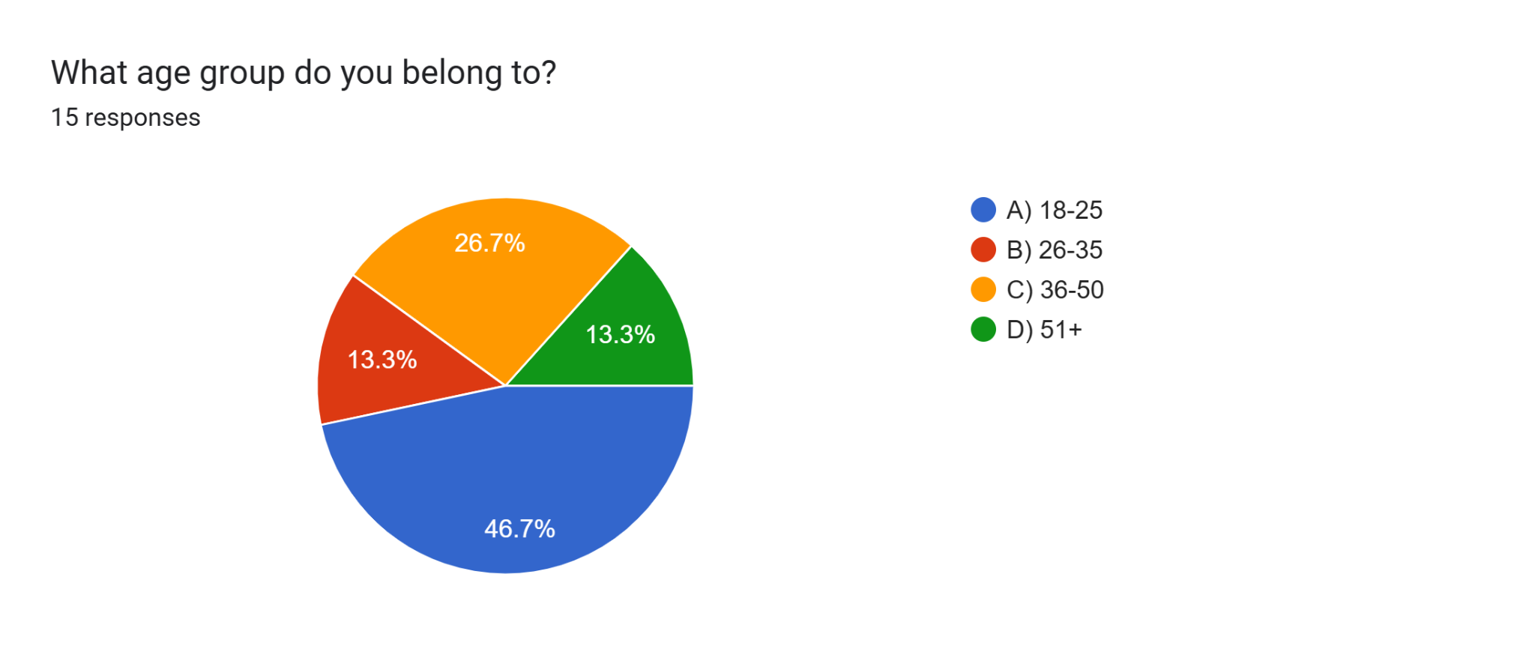
Age Group Distribution: Some 46.7% of the respondents are in the age group of 18-25 years while 26.7% are in the age group of 26-35 years old. The proportions of older groups (36-50 and 51+) are, thus, smaller.
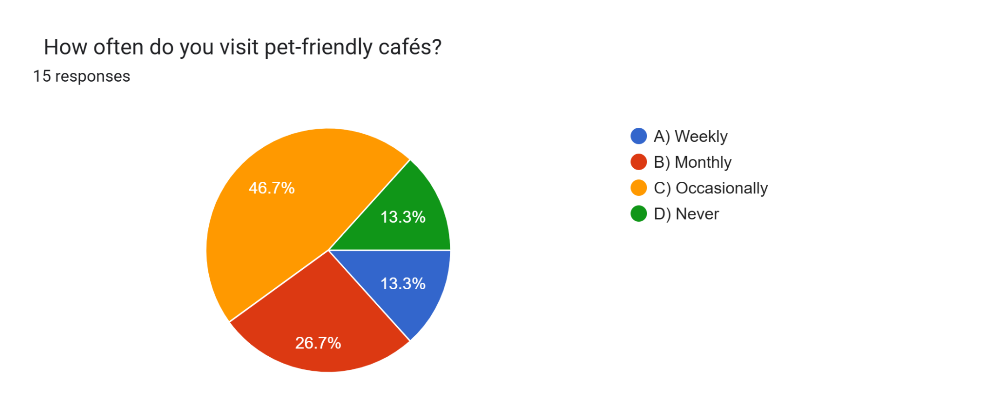
Frequency of Visits: Occasional visitors of pet-friendly cafés are slightly higher than monthly visitors: 46.7% of respondents; 26.7%, correspondingly. 9% visit more than once daily while 13.3% visit once a week, 13.3% never visit.
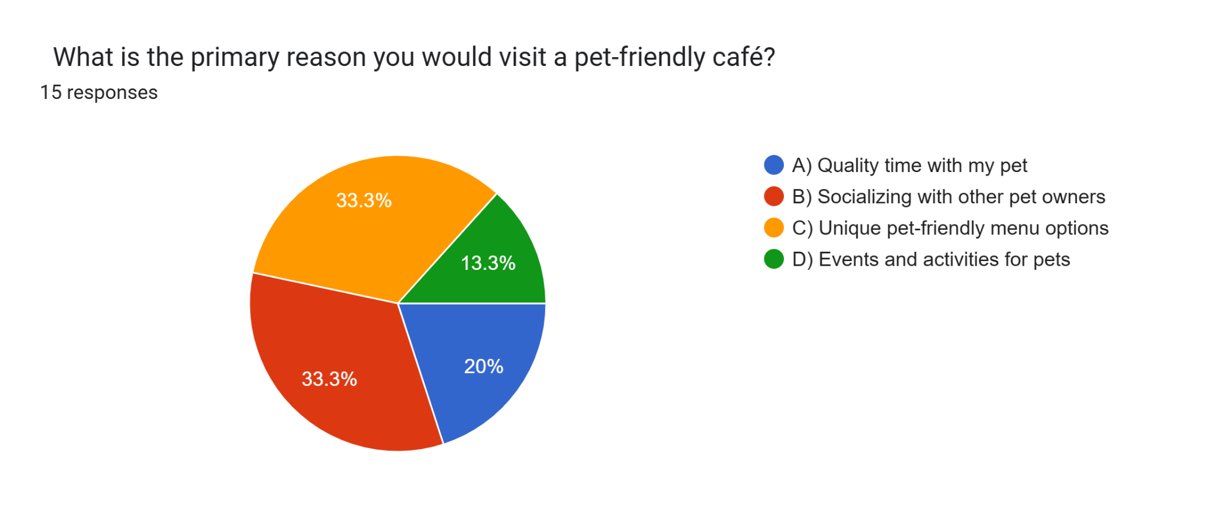
Primary Reason for Visiting: They receive equal importance for socialising with other pet owners and sensitive unique pet friendly menu options with a rating of 33.3%, 20% for having quality time pet’s menu,and 13.3 for events menu of the restaurant.

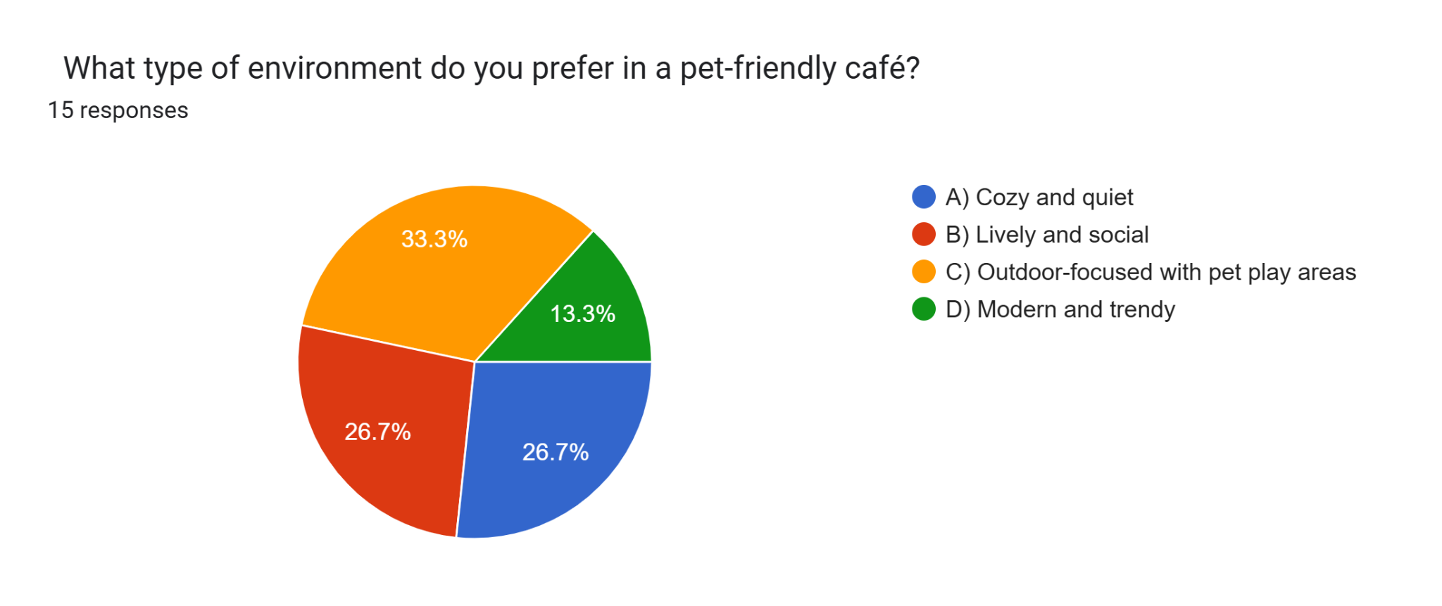
Preferred Environment: Indoor and outdoor activities dedicated to pets including play zones are the most preferred by the participants, by 33.3%, meanwhile a vibrant and sociable environment also meets with positive attitude among 26.7% of participants, whereas comfortable and understated interiors are least popular.
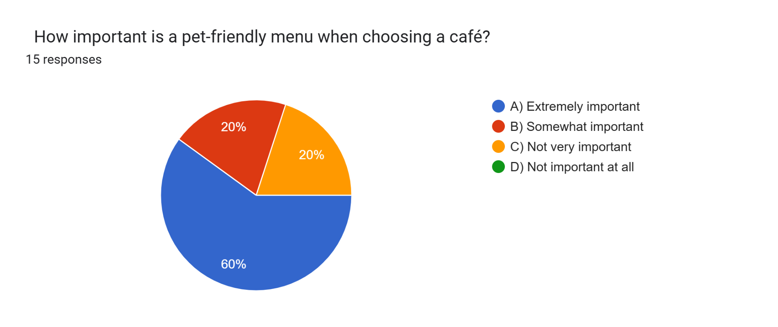
Importance of Pet-Friendly Menu: Most of the respondents (60%) find an option of taking pets along with the cafe's menu extremely important, while 20% found it somewhat or not very important, pointing out the menu importance to café choice.
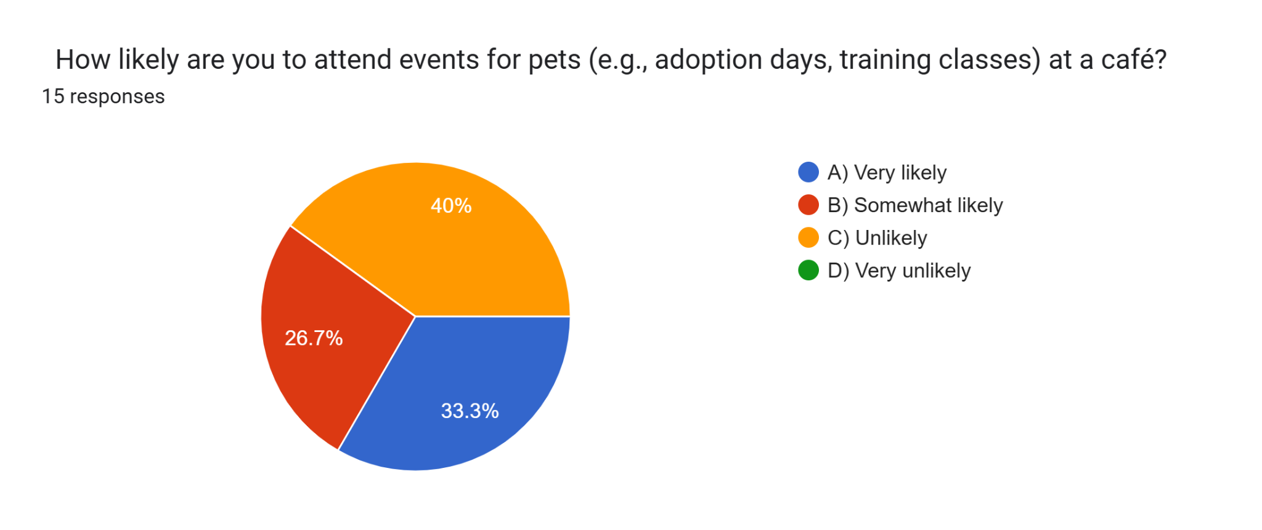
Event Attendance for Pets: 33.Three percent of the respondents are very likely to attend pet events at a café while 40 percent are somewhat likely to do so. This sheldon positive intent, more than 70% of the participants showing some degree of readiness to participate.
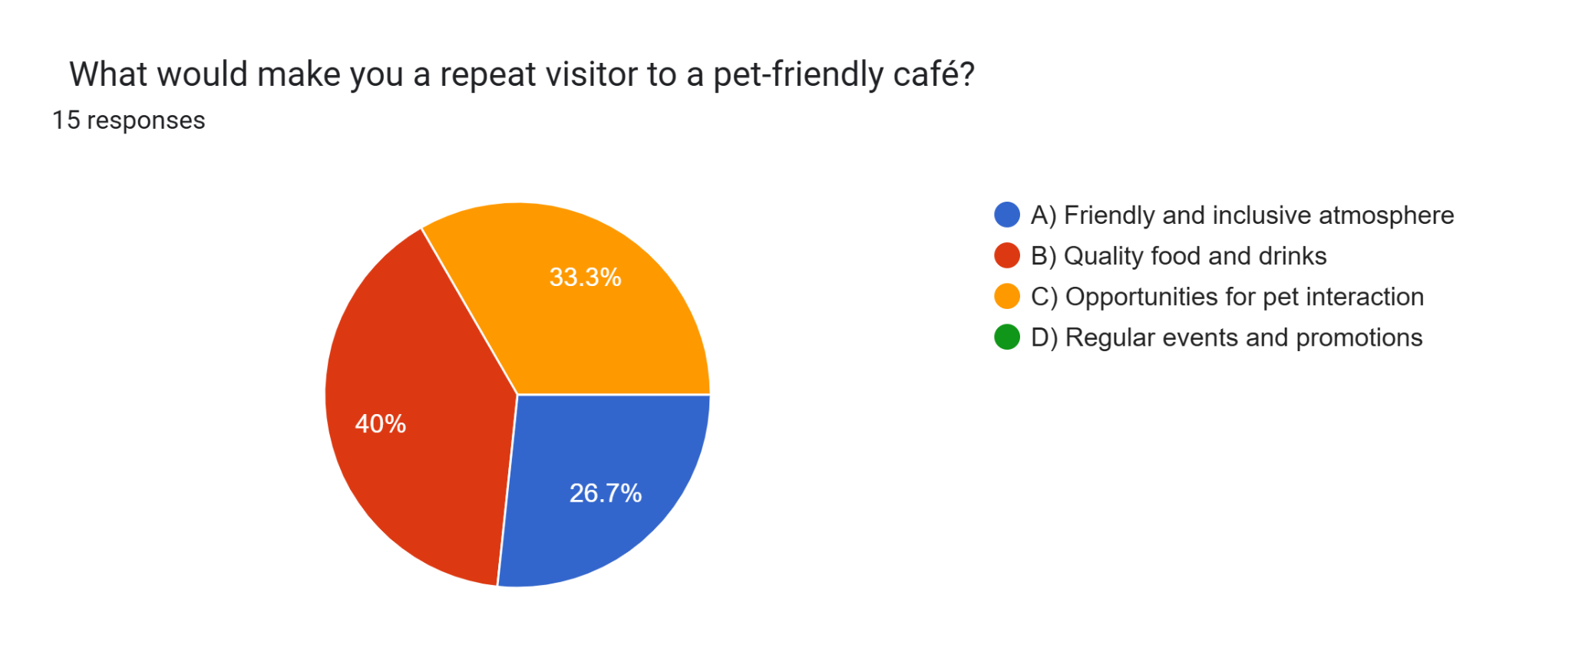
Repeat Visitor Motivations: The highest reason that customers are likely to come back is by repeated delivery of quality food and drinks (40%) and inviting environment (33.3%). This goes to prove that proper ambiance and quality food is vital in customers’ loyalty at a certain café.

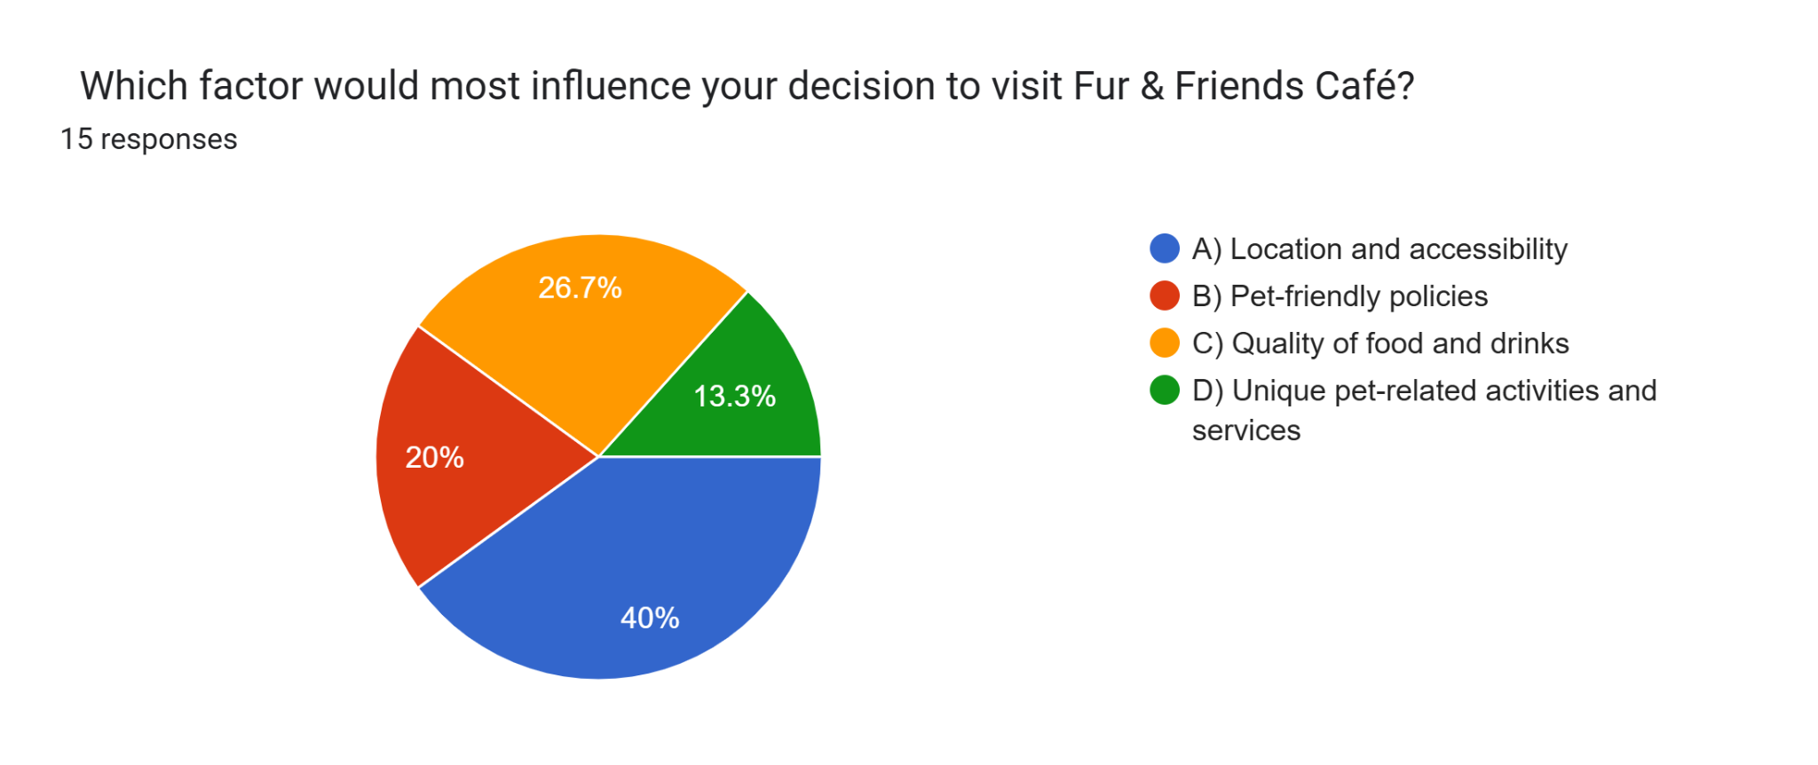
Factors Influencing Visits to Fur & Friends Café: The most critical hindering factors comprising location and accessibility are rated highest (40%) while the level of exclusive pet activities is the second most significant at (26.7%). This simply implies that convenience as well as uniqueness of destination is the key to prompting the visits.

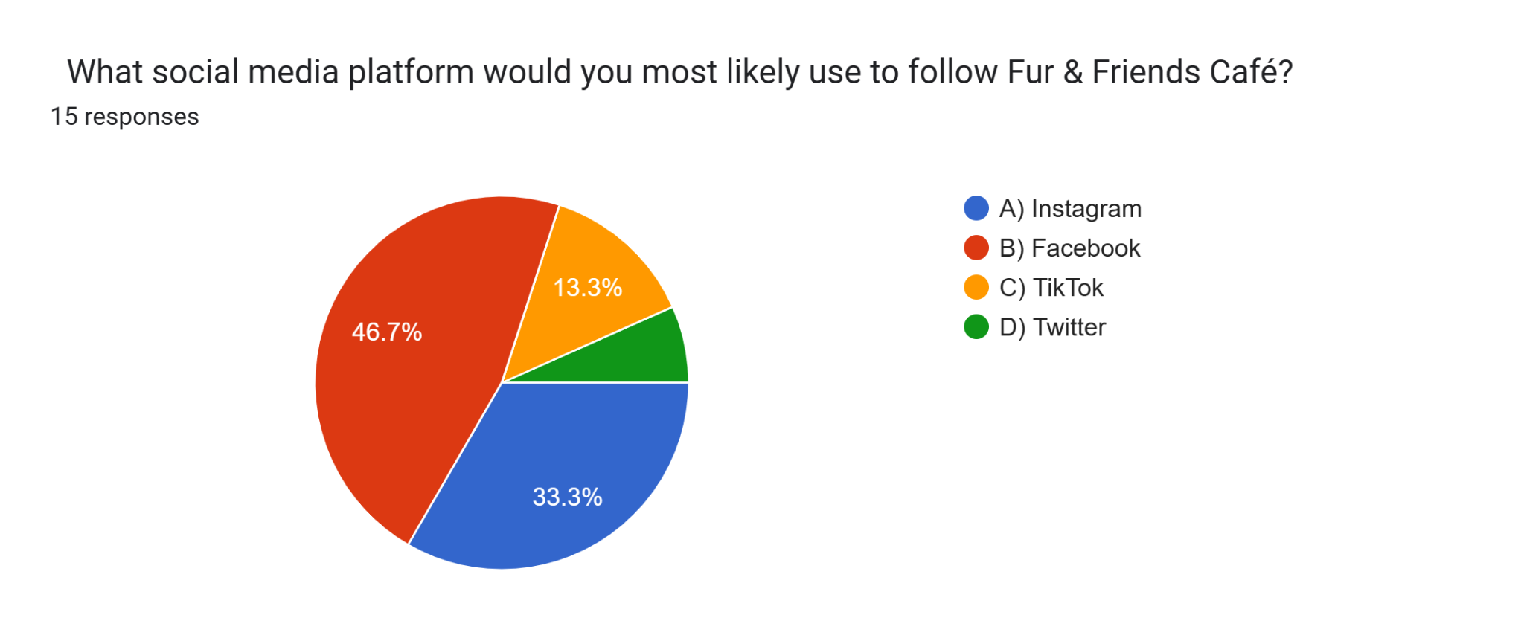
Preferred Social Media Platform: Facebook is adopted more frequently (chosen by 46.7%) than following the cafè on Instagram which has 33.3%. This simply means that marketers and businesses should direct their social media marketing strategies to these social sites.

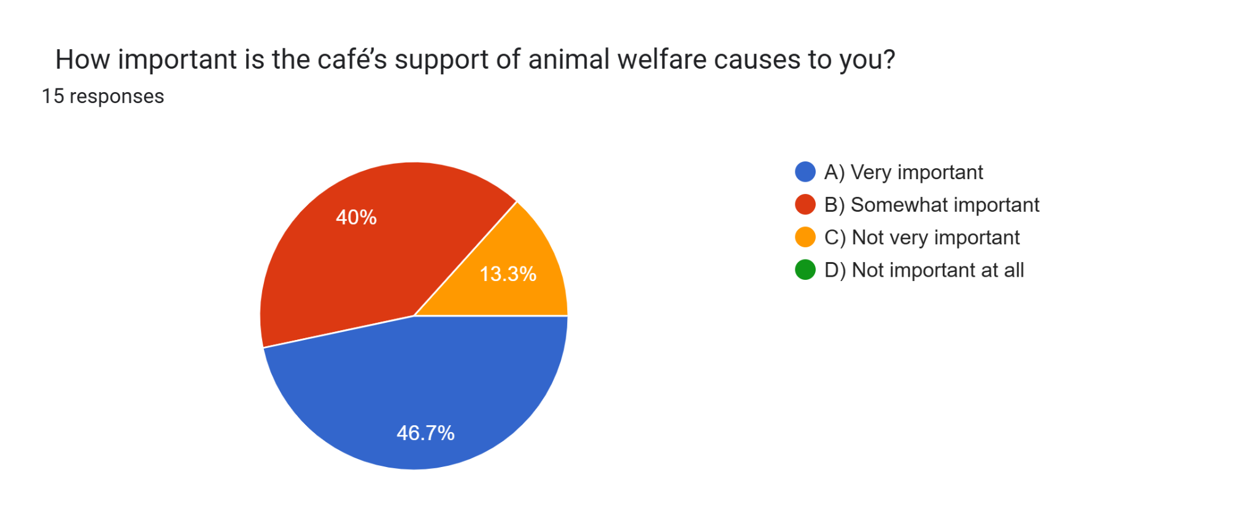

Importance of Animal Welfare Support: Respondents identify animal welfare support as absolutely essential with 46.7% stating that it is very important and 40% stating that it is somewhat important. This confirms the importance of ethical activities needed to make an invitation for consumption in the café.

Task 4
The analysis of the results obtained through the questionnaire was significant in determining the Fur & Friends Café website and the set of marketing materials. Thus the analysis of the responses made provided me with knowledge regarding the consequent preferences of the targeted audience to design a relevant online platform and promotional content.
Segmentation
Out of the respondents 46.7% were aged between 18-25 and 26.7% were aged between 26-35 years, young people who would prefer modern fashionable places that allow them to take their pets. It informed the website design decisions in a more modern and cheerful design that captured a younger audience. Moreover, since 46.7% of the respondents go to pet cafes from time to time, promotional messages such as ‘Events and Festive Season Promotion’. ‘Special Order, End of Season Sale’ were strategically placed on the website’s banner and the poster. The survey also revealed that 33.3% visit mainly to get to know other pet owners not just to shop, which is why we focused on community participation and perfect catalyzer to attend pet events as hosts, a pleasant atmosphere throughout all our promotions.
Website Design and Content
Custom icons on the homepage include a separate menu bar listing Pets Welcome, inviting atmosphere, and community activities of interest to the target audience. Since 60% showed positive appreciation for a pet-friendly menu, we reserved a special tab called “Pet Menu” in the flyer, and also incorporated the flyer on top of it. Furthermore, inviting interior and vast space exterior were selected because most people would prefer either exterior (33.3%) or a number of people communicating (26.7%), thus, our website involves the vibe preferred by the audience.
SEO - Search Engine Optimisation
From the questionnaire data obtained, the vision and presentation of SEO and marketing strategies suitable for Fur & Friends Café were developed. By incorporating such phrases such as the pet friendly café, the pet friendly menu, the social space for pets and the outdoor pet play areas on the content of the website, it improved its search engine optimisation for pet-related search queries. These keywords are entirely focused on self-actualization of our audience who wished to socialise with pets, targeting unique menu options and pet-friendly zones.
The layout of the content on the website adhered strictly to the SEO guidelines; the heads and the formats followed a logical sequence of what any pet owner would search for. The Home, About, and Contact sections are designed to attract visitors, for which the typical questions based on the data are answered on the FAQ page. It increases relevancy and there is a chance of increased organic search rankings as well.
Social media and also influencer marketing also emerged as significant. About our audience, insights revealed that people care about community and social purposes, and we highlighted Instagram and Facebook to reveal our menu, customers’ stories, and activities. The use of stories and content created by users encourages customers to submit their cases and cultivate relationship worldview.
The poster design developed in Canva, was the following: warm colours and pictures related to pets, inviting atmosphere and menu. These considerations are based on what seems to be youth’s desire for a social gathering that targets those young people who own pets, in an environment that is open and friendly.
Marketing Material Poster


