

LEVEL 6

MODULE CODE: ECAD6004

Enterprising and Creative Teaching and Learning

Assessment Type: Assignment
Assessment component: 1
Component weighting: 50%

Assignment Title:
Critically evaluate your creativity and enterprise dispositions in terms of the Entrecomp frame work and how you might develop these to the next level and demonstrate progression.

Word Count: 2500 WORDS

1500643

SUBMISSION DETAILS: 15/12/17

ASSESSMENT AND MARKING CRITERIA FOR ECAD5001/C ASSIGNMENT
Level 5 | Assessment Criteria Descriptors for BA Primary Education with QTS  This format emphasizes the holistic nature of judgements to be made by markers. Criteria weighting is adjusted for each module.
 | 0-39 (F) | 40-49 (P) | 50-59 (P) | 60-69 (P) | 70-79 (P) | 80-100 (P)
 | Poor / Weak F | Satisfactory 3rd | Good 2:2 | Very good 2:1 | Excellent 1st
Assessment Criteria | Poor, superficial, unsystematic, incomplete and/or inaccurate | Satisfactory understanding of main issues demonstrated | Good understanding demonstrated with some analysis | Very good understanding of basic principles and relevant evidence, with a coherent and logical argument | Thoughtful answer informed by wider reading, showing clarity of thought and personal insight | Outstanding answer, well written, highly structured and informed, showing striking personal insight and originality
Module Learning Outcomes matched to: | 0-11 | 12-14 | 15-17 | 18-20 | 21-23 | 24-30
Subject Knowledge and Understanding  (Conceptual)  (Reading) | Basic misunderstanding, misconceptions, misinterpretations and/or superficial knowledge in places | Outline knowledge of few key issues with evidence of understanding and application | Defined knowledge of some key issues and wider implications | Wider knowledge of most key issues, concepts and arguments | Clear understanding of the key issues under discussion with logical discussion | Excellent knowledge of key issues, concepts and arguments clearly discussed
Subject Knowledge and Understanding  (Conceptual)  (Reading) | Some inappropriate literature/material with limited reading range and lack of accuracy | Satisfactory range of reading drawn from the recommended list and other sources | Good range of reading drawn from the recommended list and other sources | Very good range of relevant literature from a variety of sources beyond recommended list | Evidence of well-considered thinking from a wide reading base using a variety of sources | Clear evidence of independent thinking informed by an excellent range of reading from a variety of sources
 | 0-11 | 12-14 | 15-17 | 18-20 | 21-23 | 24-30
Intellectual skills  (argument)  (presentation of findings/analysis)  (critical /reflective evaluation) | Argument is weak, little attempt to present differing viewpoints.  Generally too descriptive | The argument is beginning to be balanced with a growing awareness of other viewpoints | A balanced argument is presented while attempting to justify other viewpoints | A balanced argument is presented showing an understanding of different viewpoints and the reasoning behind them | A thoughtful argument is presented with appropriate consideration of viewpoints | A well- structured critical argument is presented with insightful consideration of viewpoints
 | Findings presented within incomplete descriptive framework and few or inaccurate conclusions are drawn | Findings are beginning to be presented in a developing framework with some analysis and reasonable conclusions | Findings are presented in a framework with some analysis and interpretation of data to form reasonable conclusions | Findings are presented in a framework with some analysis, interpretation and evaluation of data to form reasonable conclusions | Findings presented with some analysis and justified conclusions | Findings presented in a critical and analytical framework. Thoughtful conclusions, firmly based upon the evidence presented
 | Lack of evidence of evaluation and/or critical reflection | Evaluation and/or reflection are present but lacks depth | Good engagement with evaluation and reflection | Very good evidence of beginning to evaluate and critically reflect | Evidence of thoughtful critical engagement with evaluation and reflection | Effective and more in-depth critical engagement with evaluation and reflection
 | 0-11 | 12-14 | 15-17 | 18-20 | 21-23 | 24-30
Pedagogic and Professional applications  (linking theory to practice)  (professional reflection)  (ethical conduct where appropriate) | Superficial or lack of understanding of pedagogic and professional context(s) | Relates principles and concepts to underlying theoretical frameworks and approaches with respect to the pedagogic and professional context(s) | Identifies principles/ concepts underlying theoretical frameworks and begins to identify their strengths and weaknesses with respect to the pedagogic and professional context(s) | Evidence of the use of relevant research or developments to inform actions with respect to the pedagogic and professional context(s) | Clear evidence of integration of theory and practice with respect to the pedagogic and professional context(s) | Effective integration of theory and practice with respect to the pedagogic and professional context(s)
 | Little or no evidence of reflection | Reflection is evident | Evidence of good reflection | Beginning to critically reflect | Critical reflection is evident | Effective and in-depth logical and critical reflection is evident
 | Little or no awareness of ethical issues | Awareness of ethical issues | Awareness of ethical issues and able to discuss these in relation to personal beliefs and values | Ethical issues have been discussed showing an awareness of personal responsibility and professional codes of conduct | Ethical issues have been clearly discussed in the context of personal responsibility and professional codes of conduct | Ethical issues have been effectively addressed especially in the context of personal responsibility and professional codes of conduct
 | 0-3 | 4 | 5 | 6 | 7 | 8-10
Key/Transferable Skills  (Referencing techniques) | Weak presentation of written work | Satisfactory presentation of written work | Good presentation of written work | Very good presentation of written work | Effective presentation of written work | Outstanding presentation of written work
Key/Transferable Skills  (Referencing techniques) | A number of basic errors in spelling, punctuation or grammar | Some errors in spelling, punctuation or grammar | Few errors in spelling, punctuation or grammar | Very few errors in written language | Minor errors in written language | No errors in written language
Key/Transferable Skills  (Referencing techniques) | Weak structure with unclear writing style in parts | Satisfactory structure with a mostly coherent writing style | Good structure with a coherent writing style | Very good structure which supports the reader | Effective structure which supports the reader | Highly coherent and mature writing style which fully engages the reader
Key/Transferable Skills  (Referencing techniques) | Little or no use of protocols and conventions of Harvard referencing | Satisfactory use of Harvard referencing protocols and conventions | Good use of Harvard referencing protocols and conventions | Harvard system mainly used accurately, with some secondary sources | Harvard system used accurately including secondary sources | Harvard system used accurately, consistently and effectively with all sources

Student Self Evaluation Form
This section repeats in brief the common assessment criteria detailed on previous pages. The extent to which these are demonstrated by you determines your mark. Using these criteria, tick the box that best indicates the level of achievement you feel you have achieved with regard to each of them.

Common Assessment Criteria Applied | Level of Achievement
Common Assessment Criteria Applied | REFER |  | 3rd | 2:2 | 2:1 | 1st | 1st
 | OUTRIGHT FAIL | UNSATISFACTORY | SATISFACTORY | GOOD | VERY GOOD | EXCELLENT | EXCEPTIONAL
1. Subject Knowledge and Understanding (which includes using research-informed literature and knowledge and understanding of the subject) | 0-29% | 30-39% | 40-49% | 50-59% | 60-69% | 70-79% | 80-100%
2. Intellectual Skills (Analysis) | 0-29% | 30-39% | 40-49% | 50-59% | 60-69% | 70-79% | 80-100%
3. Pedagogic and Professional Applications  (Practical Application and Deployment) | 0-29% | 30-39% | 40-49% | 50-59% | 60-69% | 70-79% | 80-100%
4. Key Transferable Skills | 0-29% | 30-39% | 40-49% | 50-59% | 60-69% | 70-79% | 80-100%
PLEASE COMMENT ON AREAS IN WHICH YOU FEEL THAT YOU HAVE PERFORMED WELL | PLEASE COMMENT ON AREAS you feel that you need TO DEVELOP
I feel as though I have developed my subject knowledge understanding of what creativity and enterprise means as a teacher | I feel as though I could have synthesized evidence further to support my points.
Student’s Name | Caitlin Jones | Date | 15/12/2017
Student’s Signature | CJones
The generation of an innovative culture is perceived as a critical area of focus for organisations in the twenty-first century (Thorne, 2007). However, many question how education is meeting these demands. To better understand the role of a teacher, the authors own creativity and enterprise dispositions as a teacher are critically evaluated in terms of the Entrecomp framework. Also discussed is how these dispositions, inherent qualities of mind and character, could be developed to the next level to demonstrate progression.

The Entrecomp framework, comprised of fifteen competencies designed to support the development of creativity and enterprise skills, aims to establish a bridge between the worlds of work and education (Bacigalupo et al., 2016). It provides structure for the reflection of personal strengths and weaknesses. Depending on the context, more emphasis may be put on some of the competencies (Bacigalupo et al., 2016), and for the purpose of this essay three competencies will be considered. Particular competencies are less relevant as a teacher and tailored more towards business ventures, therefore the author has chosen to discuss competencies that, in their opinion, relate to developing creativity and enterprise.

Creativity and enterprise are central features of modern life (Donaldson, 2015) and are valuable skills a teacher can possess to prepare children for the future (Gov.co.uk, 2014). Initially, enterprise skills appear to relate to business more than education. However, enterprise refers to the enhanced capacity to generate ideas and the skills required to realise those ideas. These could include digital literacy, critical thinking and team work (Earp, 2016) and are arguably required for an innovative teacher. Enterprising does not necessarily represent becoming an entrepreneur, as these skills can be invested in other positive uses (Loughnan, 2013). Carter and Jones-Evans (2012) refer to enterprise as the discovery of ideas as oppose to the realisation side, whilst QAA (2012) define it as the application of creative innovations. The Welsh Government recognise the potential of enterprise education (Pennycook, 2014) and have implemented initiatives to develop enterprise skills within education. Furthermore, Donaldson (2015) recognises the importance of enterprising and creative teachers who connect and apply their knowledge, take risks and grasp opportunities. Two criteria for creativity are suggested: novelty and appropriateness (Starko, 2010) and Amabile (2012) maintains creativity is the production of these two elements. However, disagreement occurs over creativity’s definition (Amabile, 1996) as there is a lack of universal agreement (Karkockiene, 2005) Creativity is often viewed as the preserve of a gifted few (NACCCE, 1999). However, in reflection of this perhaps dated report, Pappano (2014) comments that creativity is now recognised as a prized and teachable skill. Robinson (2011) and Craft (2001) support this, recognising creativity is possible in activities that engage human intelligence and popular definitions involve an inclusive approach. The ability to solve problems requires creativity to apply knowledge to new situations and ultimately use these skills to identify new problems (Hewitt and Tarrant, 2015).

The following section critically evaluates personal levels of three competencies from the Entrecomp framework: creativity, motivation and perseverance and spotting opportunities. This reflection is critical as a teacher (Grigg, 2015) and the author has previously been reflective throughout Professional Teaching Experience (PTE) (see appendix A).

The Entrecomp frame work identifies five threads to creativity (see appendix K). All aspects of creativity as a teacher are considered, as creativity does not only involve the arts (Beetlestone, 1998). Teaching creatively and teaching for creativity are distinctly different (Jeffrey and Craft, 2004), with the former involving imaginative approaches to make learning more interesting (N.A.C.C.C.E., 1999). The author displayed ability to motivate learners during PTE (see appendix B). Furthermore, Johnson (2015) argues teachers require creativity to engage learners and this should be released to provide rich learning for children (Donaldson, 2015). Teachers show creativity by developing pedagogy that fires children’s interests (N.A.C.C.C.E., 1999). They are more able to prepare learners for life outside the classroom by utilising creative approaches (Hicks, 2015). Education is expected to aid children to build lives that have meaning in a future we can scarcely predict (NACCCE, 1999), so arguably teachers must be creative in their approaches to best equip learners for this uncertainty. However, there is conflict as to whether to teach creativity to trainee teachers as something that enhances the human soul or to give more practical advice (Banaji, Burn and Buckingham, 2006). Successful Futures (Donaldson, 2015) gives prominence to developing the ability in children to make connections, therefore a balance should be sought between enabling teachers to use their professionalism and creativity to respond to the needs of their own children. Therefore, teachers should utilise pedagogy that makes use of creative and critical thinking. Carlile and Jordan (2012) believe there is often a relationship between the creativity displayed at classroom level and the overall creative environment of the school. This suggests a possible challenge if there is not a creative, enabling environment within the school, as the teacher’s own creativity may be inhibited.

The author has attempted experimentation with pedagogies, aiming for interactive activities (see appendix C and D). Creativity involves being interactive (Beetlestone, 1998) and this proved engaging for the class and teacher. Experimenting with different techniques places the author at level three of the developing ideas thread. However, testing these new ideas is not easy and this was discussed as a target with the PTE tutor (see appendix E). Although some creative ideas were produced during PTE, it was evident that the author then plateaued rather than producing further creative outcomes (see appendix F). Idea generation is the result of divergent thinking, which uses imagination to produce many ideas by exploring different solutions (Cox, 2017). This has proved difficult under pressure during PTE, such as time restraints to produce creative outcomes. The generative thought processes that give rise to ideas are very different to those analytical thought processes required to refine them (Howard-Jones, 2002).

Although the author identifies with a level three in the being curious and open strand (see appendix K), difficulties arise in promoting this further and actually searching for new solutions that meet the author’s needs. An aspect which possibly acts as a barrier to creativity is functional fixedness, an inability to realise that something with a particular use may also be used for another function (Boyd, 2013). An example of this was during the interview for the Primary Education degree, where candidates were provided with an object not typically found in the classroom and asked to produce an alternative creative use for them. This was unfamiliar to the author and was subsequently difficult to generate ideas. This idea of functional fixedness links to premature articulation, where a problem is solved by default rather than exploring other options. Furthermore, at the age of twenty-one, the author’s dorsolateral prefrontal cortex is beginning to develop, therefore filtering ideas and preventing them from surfacing, proving a challenge to creativity. Following this discussion, the author feels as though the level of creativity displayed as a teacher is mediocre although has begun to develop, supported by a PTE mentor with the key word ‘becoming’ (see appendix G).

Motivation and perseverance, belonging to the resources area of the framework (see appendix L), is defined by Bacigalupo et al. (2016) as a determination to turn ideas into action, satisfying a need to achieve. Research shows a greater satisfaction in teaching than other professions (Morgan, 2005), suggesting motivation may be a characteristic of successful teachers. Fisher (2004) believes motivation is feeling that an endeavour is worthwhile, highlighting the need to stay focused and resilient to be creative and enterprising. Although the author identifies this area as the strongest of the three competencies discussed, this does not come easily and requires perseverance. An example of this is switching to an unfamiliar age group on PTE (see appendix H). High levels of motivation and perseverance seemingly enabled the author to overcome this and adapt. Perseverance is the ability to stick at something and one habit of mind is devoted to this (Costa and Kallick, 2008). Motivation is identified as one of four keys to creativity (Fisher, 2004) and is also a component in the componential theory of creativity; intrinsic task motivation (Amabile, 2012). The capacity to motivate yourself is identified as one of five domains of emotional intelligence (Goleman, 1995), highlighting its importance. Teacher motivation is dependent on many variables (Han and Yin, 2016) and more creative is portrayed when motivated (Amabile, 2012). Motivation relates to self-efficacy; the belief in your own capacity to do things well (Grigg, 2015) which could arguably increase motivation. Overcoming simple adverse circumstances is highlighted as a strength, linking with level three of the resilience thread, however it is difficult to judge when it is not worth continuing with an idea. Motivation is important to provide the drive in which to follow ideas through.

Environmental factors which include extrinsic motivators, has been shown to undermine intrinsic motivation and block creativity (Amabile, 2012). Pink (2009) supports this, stating extrinsic motivators, such as money, dull creative thinking and restrict possibilities. Glucksburg’s (1962) research into behavioural science, based on the candle problem (Duncker, 1945), began interest into the effect of extrinsic motivators. Arguably, this research is often ignored within schools, with teachers providing incentives such as stickers for completion of tasks. An example of this occurring to the author is during PTE, when there has been rewards such as a higher mark for the lessons delivered. Better work was produced when driven by intrinsic motivators, those in which something is done because it is important or interesting. The urge to direct your own life, the desire to get better at something and the yearning to do what we do in service of something larger than ourselves has proved to increase creativity and productivity (Pink, 2009).

The third competency discussed is spotting opportunities, part of the ideas area of the framework (see appendix J), described as using imagination and abilities to identify opportunities for creativity (Bacigalupo et al., 2016). Imagination is challenging to describe, although (Robinson, 2011) believes it is the power to see past the present moment and our immediate environment also stating it is the source of human achievement (Robinson, 2015). The author finds imagination a difficult concept to measure, although can recall times where it has been utilised. Examples of this include creating ideas for lesson activities using imagination to produce engaging tasks for children. Analysing the context is one thread of this competency and the author identifies with a level four (see appendix J). An example of this is during a recent assignment, where the author proposed innovative strategies to raise the attainment of children. However, throughout PTE the author did not always seize the opportunity to be creative with activities and often followed a similar pattern to previous teaching. Spotting opportunities for creativity proves difficult in certain circumstances, for example during PTE when there is a large workload and time constraints. Overall, the author scores low within the level descriptors for this competency.

Teachers should take responsibility for their professional development (Furlong, 2015 and Craft, 2000), therefore the following section proposes methods to develop the author’s ability in the three competencies to demonstrate progression. The three competencies will be discussed holistically, as the author believes their development is linked. This reflection allows teachers to develop their skills and understanding (Blandford, 2000). The author wishes to develop the ability to devise creative ideas and show progression from previous teaching. As a teacher, developing creativity is important and Robinson (2011) believes we must promote this in order for the education system to better suit the 21st century. However, teachers must be afforded the time to explore their own creative abilities (Kinsella and Fautley, 2017). The author possesses intrinsic motivation to develop levels of creativity and wishes to introduce more innovative methods of teaching. Supposedly, there is a concrete set of methods and environmental factors that can increase imagination (Seelig, 2012). One model is the innovation engine (Seelig, 2012), which includes three factors; attitude, knowledge and imagination, each running parallel to a different factor which can inhibit or enhance its level. For example, the author identifies imagination as an area for improvement, and the model suggests that an enabling habitat can enhance imagination. This is supported by NACCCE (1999) who report creative achievement is possible, providing the conditions are right.

Engaging in heutogogy may allow for enhanced levels of creativity, where learning is self-regulated. This may include taking more risks, something Thorne (2007) advocates in order to reach creative outcomes. This has previously been identified by the author (see appendix E) and in discussion with a previous PTE tutor (see appendix I). Robinson (2015) supports this, stating teachers should utilise a variety of creative approaches. The author understands the importance of continuous learning and creativity is viewed as central to this (Kinsella and Fautley, 2017). Moreover, conversing with fellow teachers may spark creative thoughts (Johnson, 2015), therefore the author proposes to spot more opportunities to discuss ideas to develop enterprise skills. This links to Seelig’s (2012) innovation engine, where culture affects the individual’s attitude. However, following the birth of an idea, it may be important to allow incubation time; time for an idea to further develop before analysing with convergent thinking. This could be perceived as crucial for learning, as fluctuating between the beta brain frequency of convergent thinking to the alpha state of divergent thinking is required. In order to aid divergent thinking, the author proposes to allocate time to walk, as research indicates walking allows individuals to produce more novel and appropriate creative ideas than people not walking (Oppezzo and Schwartz, 2014). Furthermore, different stimulus may spark imagination so visiting places where ideas may be and playing there could be a way of improving idea generation. For example, planning inter-disciplinary approaches to learning may encourage connection making and innovative ideas based on an experience (Barnes, 2009). Savage (2010) supports this, stating cross-curricular planning allows teachers the opportunity to be imaginative.

The mnemonic SCAMPER (Eberle, 1990) will be utilised in order to recall thinking strategies to aid creativity and overcome functional fixedness. This will allow the mind to follow a particular direction in order to modify an idea and ignite creativity. Unlike other creative strategies, SCAMPER facilitators can move between different techniques without being restricted by a specific flow (Elmansy, 2017). However, Simonton (1999) believes that for an idea to be considered creative, it must be original and the SCAMPER model merely adapts an idea that already exists.

A new approach built around intrinsic motivation would be useful to the author, based on autonomy, mastery and purpose, described as the three elements to a more successful system for creativity (Pink, 2009). Therefore, having autonomy over time and tasks may be useful in becoming more creatively productive. This approach is utilised by Google, where employees are provided with 20% of paid time to work on anything of interest to them, with Google’s most innovative and successful products often emerging from this (Pink, 2009). In order to sustain a high level of motivation and remain focused, the author will set long-term goals in addition to short term to gain that feeling of satisfaction that is important. This correlates to the goal-setting stage of Winnie and Hadwin’s (2008) model of motivation and moving into this stage is often the most difficult. Resilience courses are available in order to develop levels of resilience and understanding of how it impacts life as a teacher. It will be evident that the author has an increased level of motivation and perseverance when challenges that arise are dealt with in a positive and strategic manner.

Everything provides an opportunity to leverage what you know to stretch your imagination (Seelig, 2012), the author however needs to improve the ability to spot these opportunities. Every opportunity should be seized in which to be creative and enterprising, relating to the previous discussion of taking up challenges in order to find creative value. With enhanced creativity, the author will perceive obstacles as opportunities (Seelig, 2012). It will be evident when ability matures in the three competencies discussed, as a mix of creative techniques will be utilised to continuously generate valuable ideas (Bacigalupo et al., 2016). This relates to the Pro-C level of the four C model of creativity, where one has the ability to be creative in a profession (Kaufman and Beghetto, 2009).

To conclude, this piece of reflecting writing has allowed a deeper understanding of the author’s creative and enterprise dispositions and discover how they could be further developed. Most teachers are unaware of their mental habits and how this can impact on their teaching (Dewey, 1910), although this reflection has provided the opportunity to understand the connections between theory and practice.

Word Count: 2,773

References

Amabile, T. (1996) Creativity in Context, Boulder: Westview Press.

Amabile, T. (2012). Componential Theory of Creativity. Harvard Business School.
Bacigalupo, M., Kampylis, P., Punie, Y., Van den Brande, G. (2016). EntreComp: The Entrepreneurship Competence Framework. Luxembourg: Publication Office of the European Union.
Banaji, S., Burn, A. & Buckingham, D. (2006) The Rhetorics of Creativity: A Review of the literature. A report for Creative Partnerships, London: Arts Council England.

Barnes, J. (2009). Cross-curricular learning 3-14. London: Sage publications.

Beetlestone, F. (1998). Creative Children, Imaginative Teaching. Buckingham: Open University Press.

Blandford, S. (2000). Managing Professional Development in Schools. London: Routledge.

Boyd, D. (2013). Fixedness: A Barrier to Creative Output. [Blog] Inside the Box. Available at: https://www.psychologytoday.com/blog/inside-the-box/201306/fixedness-barrier-creative-output [Accessed 7 Dec. 2017].

Carlile, O. and Jordan, A. (2012). Approaches to creativity. Berkshire: Open University Press.

Carter, S. and Jones-Evans, D. (2012). Enterprise and Small Business. 3rd ed. Essex: Pearson.

Costa, A., Kallick, B. (2008) Learning and Leading with Habits of Mind, Virginia: ASCD.

Cox, T. (2017). Creative Habits of Mind.

Craft, A. (2000) Continuing Professional Development: A Practical Guide for Teachers and Schools, London: Routledge.

Craft, A. (2001). An Analysis of Research and Literature on Creativity in Education. Qualifications and Curriculum Authority (QCA): 1-37

Dewey, J. (1910). How We Think. Lexington. MA: D.C. Heath.

Donaldson, G. (2017). Successful Futures. Crown.

Earp, J. (2016). Equipping students with ‘enterprise skills’. [online] Australian Council for Educational Research - ACER. Available at: https://www.teachermagazine.com.au/articles/equipping-students-with-enterprise-skills [Accessed 11 Dec. 2017].

Eberle, R. (1990). Scamper. Buffalo, N.Y.: D.O.K. Publishers.

Elmansy, R. (2017). A Guide to the SCAMPER Technique for Creative Thinking. [online] Designorate. Available at: http://www.designorate.com/a-guide-to-the-scamper-technique-for-creative-thinking/ [Accessed 10 Dec. 2017].

Fisher, J. (2004). What is creativity? In R. Fisher and M. Williams. Unlocking Creativity. London: David Fulton.

Furlong, J. (2015). Teaching Tomorrow's Teachers. Oxford: University of Oxford.

Glucksberg, S. (1962). The influence of strength of drive on functional fixedness and perceptual recognition. Journal of Experimental Psychology 63, 36–41.

Gov.uk. (2014). Enterprise for All: the Relevance of Enterprise in Education. [online] Available at: https://www.gov.uk/government/uploads/system/uploads/attachment_data/file/338749/EnterpriseforAll-lowres-200614.pdf [Accessed 8 Dec. 2017].

Grigg, R. (2015). Becoming an outstanding primary school teacher. New York: Longman.

Han, J. and Yin, H. (2016). Teacher motivation: Definition, research development and implications for teachers. Cogent Education, 3(1).

Hewitt, D. and Tarrant, S. (2015). Innovative Teaching and Learning in Primary Schools. London: SAGE.

Hicks, K. (2015). Why Creativity in the Classroom Matters More Than Ever | Edudemic. [online] Edudemic.com. Available at: http://www.edudemic.com/creativity-in-the-classroom/ [Accessed 30 Oct. 2017].

Howard-Jones, P. (2002). A Dual-state Model of Creative Cognition for Supporting Strategies that Foster Creativity in the Classroom. International Journal of Technology and Design Education, 12(3), pp.215-226.

Jeffrey, B. & Craft, A. (2004). Teaching creatively and teaching for creativity, distinctions and relationships, Journal of Educational Studies, 30, 1(March), 77–87.

Johnson, B. (2015). "Creative Teacher" Is Not an Oxymoron. [online] Edutopia. Available at: https://www.edutopia.org/blog/creative-teacher-not-oxymoron-ben-johnson [Accessed 30 Oct. 2017].

Karkockiene, D. (2005). Creativity: Can it be Trained? International Journal of Educology. 51.

Kaufman, J. C., & Beghetto, R. A. (2009). Beyond Big and Little: The Four C Model of Creativity. Review of General Psychology, 13(1), 1-12.

Kinsella, V., Fautley, M. (2017) Creativity – Getting it right in a week, St Albans: Critical Publishing.

Loughnan, K. (2013). How to introduce enterprise into your school's curriculum. [online] the Guardian. Available at: https://www.theguardian.com/teacher-network/teacher-blog/2013/nov/23/teaching-enterprise-school-curriculum [Accessed 11 Dec. 2017].

Morgan, J. (2005). JobLab: A Study into the Experience of Teaching. London: TDA.

N.A.C.C.C.E. (1999) All our futures: creativity, culture and education, London: DfEE.

National Advisory Committee on Creative and Cultural Education (1999). All Our Futures: Creativity, Culture and Education. [online] Available at: http://sirkenrobinson.com/pdf/allourfutures.pdf [Accessed 31 Oct. 2017].

Oppezzo, M. and Schwartz, D. (2014). Give your ideas some legs: The positive effect of walking on creative thinking. Journal of Experimental Psychology: Learning, Memory, and Cognition, 40(4), pp.1142-1152.

Pappano, L. (2014). Creativity Becomes an Academic Discipline. [online] Nytimes.com. Available at: https://www.nytimes.com/2014/02/09/education/edlife/creativity-becomes-an-academic-discipline.html?_r=0 [Accessed 30 Oct. 2017].

Pennycook, L. (2014). The Welsh dragon: the success of enterprise education in Wales. Dunfermline: Carnegie United Kingdom Trust.

Pink, D. (2009). Drive. New York: Riverhead Books.

Pink, D. (2009). The Puzzle of Motivation. [image] Available at: https://www.ted.com/talks/dan_pink_on_motivation [Accessed 11 Dec. 2017].

QAA. (2012). Enterprise and entrepreneurship education: Guidance for UK higher education providers. QAA.

Robinson, K. (2011). Out of our minds: learning to be creative. London: John Wiley.

Robinson, K. (2015). Creative Schools. London: Penguin Books.

Savage, J. (2010). Cross-curricular teaching and learning 5: Definitions - Jonathan Savage. [online] Jonathan Savage. Available at: http://www.jsavage.org.uk/research/cross-curricular-teaching-and-learning-5-definitions/ [Accessed 8 Nov. 2017].

Seelig, T. (2012). InGenius: A Crash Course on Creativity. London: Hay House.

Simonton, D.K. (1999). Origins of Genius: Darwinian Perspective in Creativity. New York: Oxford University Press.

Starko, A. (2010). Creativity in the Classroom: Schools of curious delight. New York: Routledge.

Thorne, K. (2007) Essential Creativity in the Classroom, Abingdon: Routledge.

Winne, P. and Hadwin, A. (2008). The weave of motivation and self-regulated learning. In D. Schunk and B Zimmerman. Motivation and self-regulated learning: theory, research and applications (pp. 297-314). Hillsdale, NJ: Lawrence Erlbaum Associates.

Appendices of Evidence

Appendix A: Summative Assessment, Year 1.
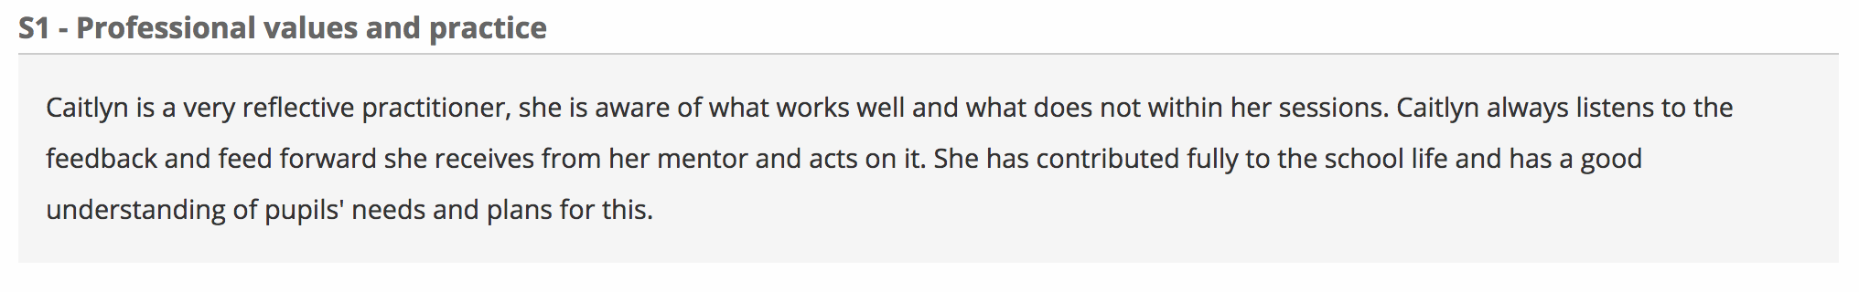

Appendix B: Formative Assessment (12.12.16).
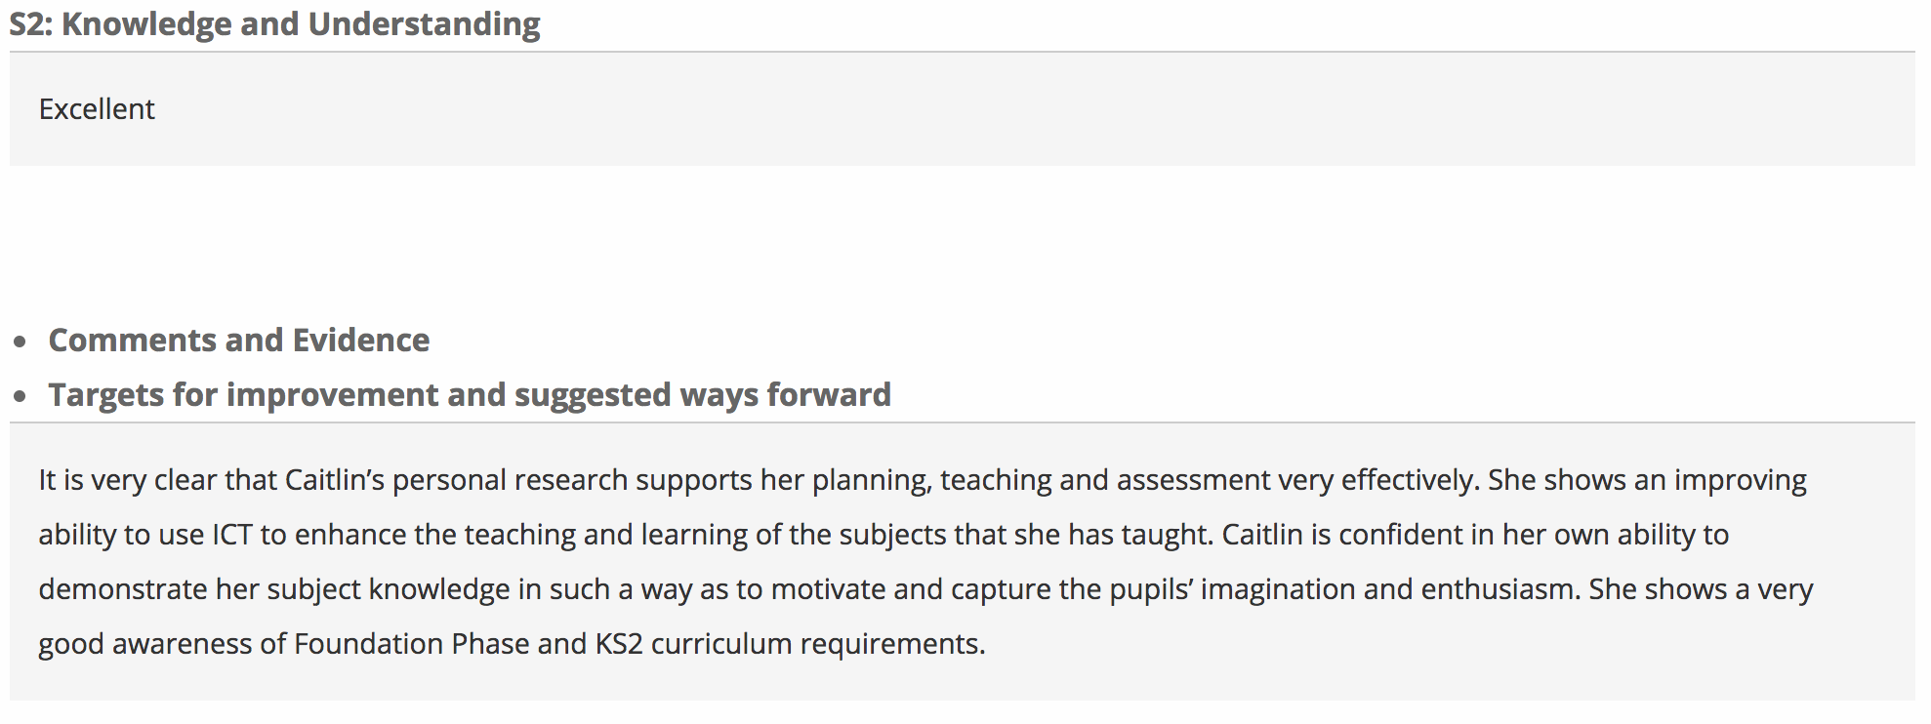

Appendix C: ARC (08. 03.17)
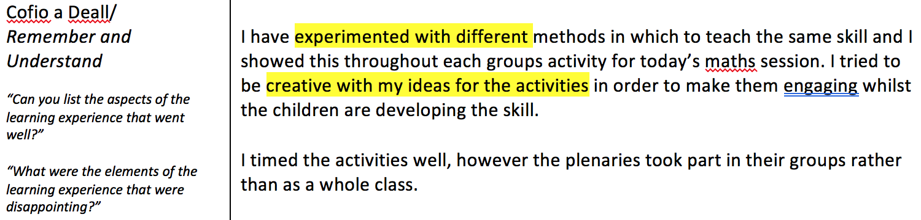

Appendix D: Summative Assessment, Year 1.
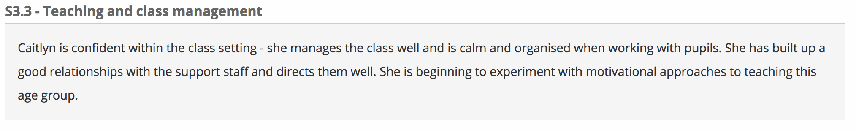

Appendix E: End of Week Review (17.03.17).
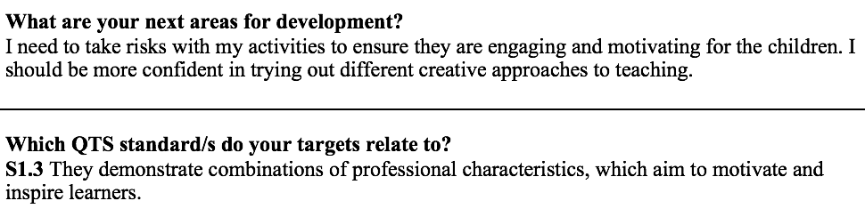

Appendix F: ARC (14.03.17)
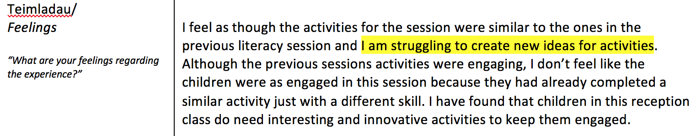

Appendix G: Formative Assessment (12.12.16).
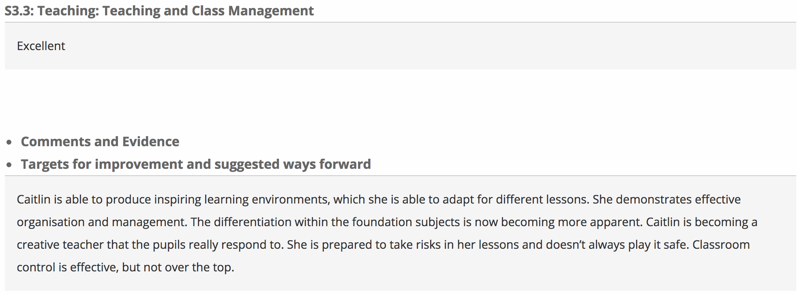

Appendix H: Formative Assessment (27.03.17).

Appendix I: Formative Assessment (28.03.17).

Appendix J: Levels of Proficiency in ‘Spotting Opportunities’ according to the Entrecomp Framework
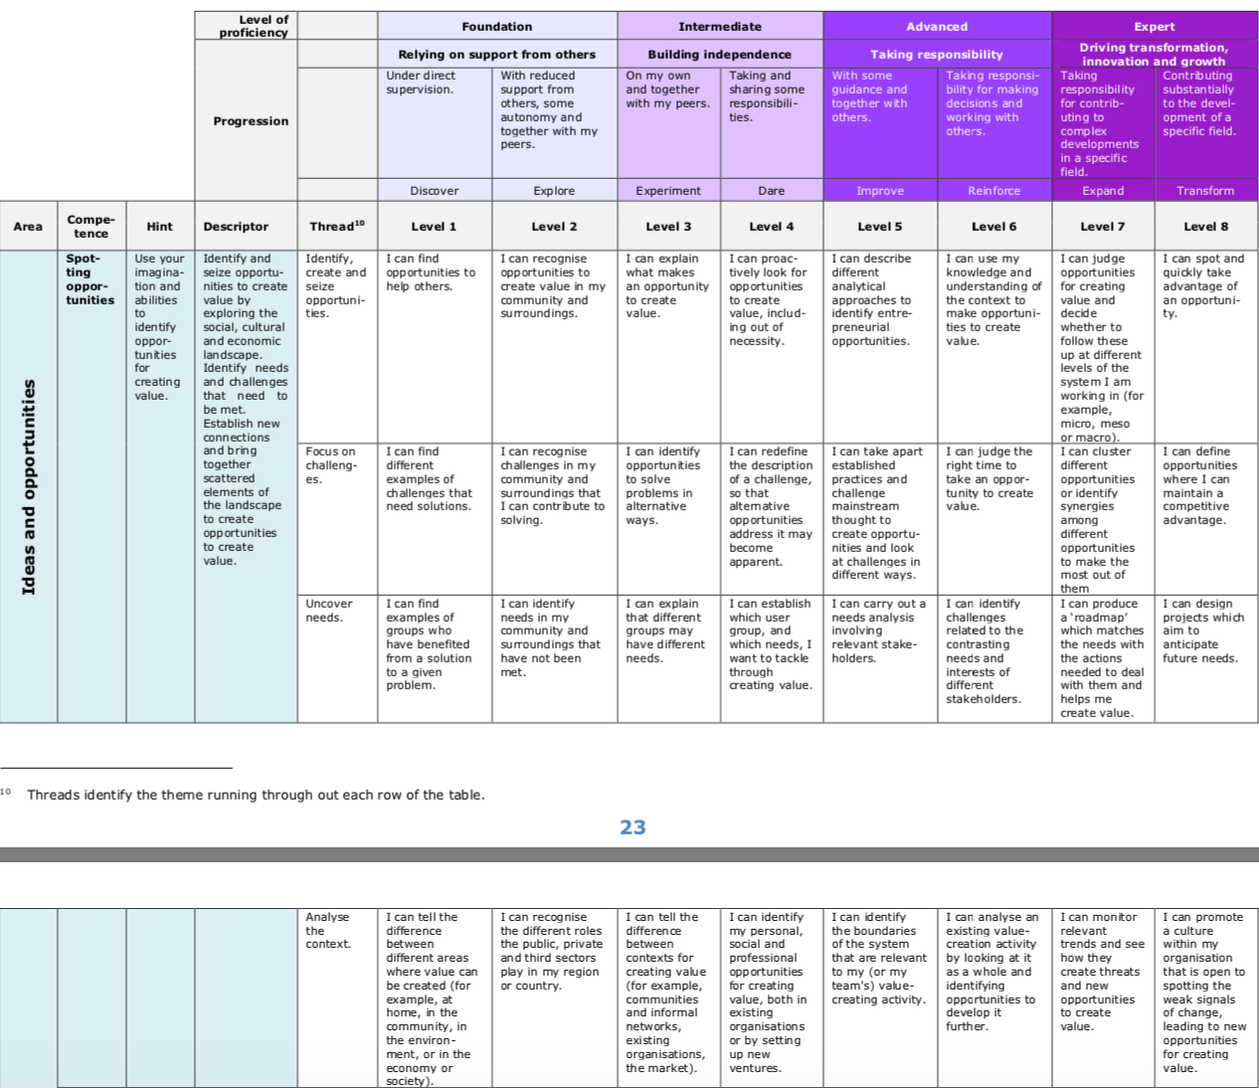

Appendix K: Levels of Proficiency in ‘Creativity’ according to the Entrecomp Framework
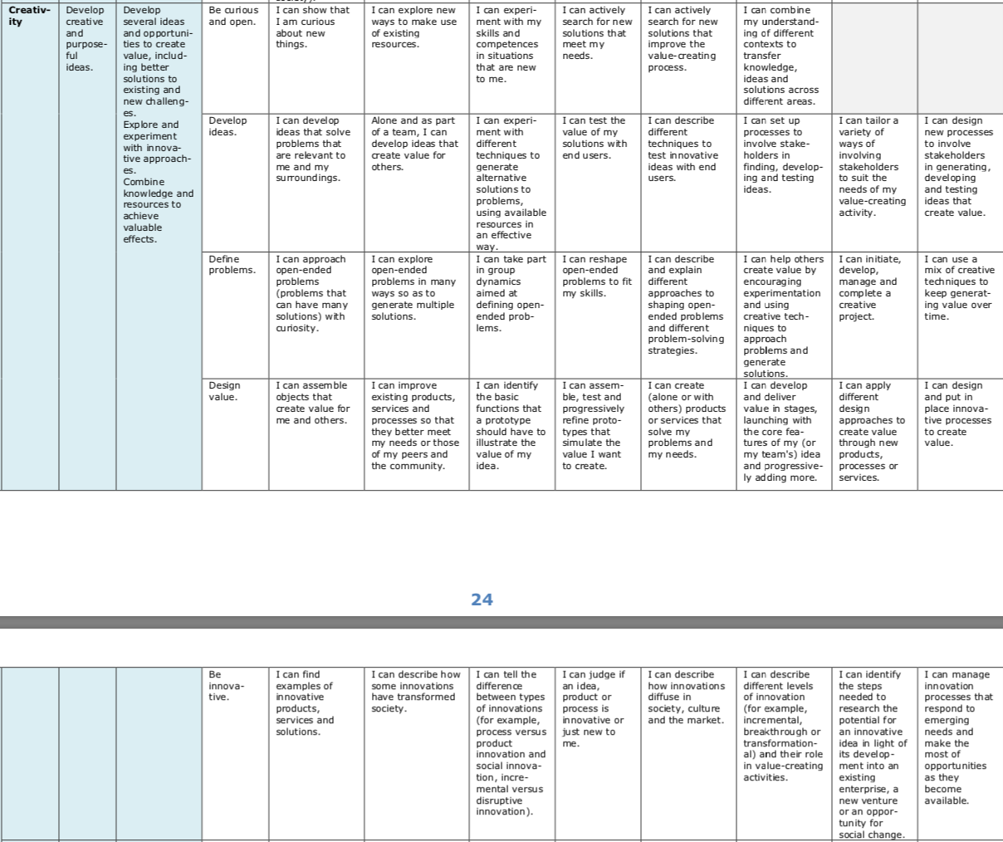
Appendix L: Levels of Proficiency in ‘Motivation and Perseverance’ according to the Entrecomp Framework

