

LEVEL 5 ASSESSMENT SPECIFICATION
Programme: | BSc Health and Social Care
Module: | Protecting and Supporting Families in Health and Care
Student Name: | Munaza Sakindar
Student ID: | 2419348
Module code: | BMHP5021 | Contribution to Overall Module Assessment (%): | 50%
Lecturer: | Precious Igbinigie | Internal Verifier: | Chloe Harries
Assignment Title: | Component 2: Written Report | Word count (or equivalent): | 2,000 words (+/- 10%)
Submission deadline: | Monday 20th July 2026  14:00 (2PM) - (Week 11) | Return date of provisional marks & written feedback: | Monday 17th August 2026

Table of Contents
1. Introduction 3
2. The Early Help System 3
3. Multi-Agency Working 4
4. Evaluation of Local Authority Websites 6
4.1 Evaluation of Leeds City Council Website 6
4.2 Evaluation of Norfolk County Council Website 6
5. Evaluation of Nottinghamshire County Council, Comparative Analysis, Conclusion and Recommendations 7
5.1 Evaluation of Nottinghamshire County Council Website 7
5.2 Comparative analysis 8
6. Conclusion 9
7. Recommendations 10
8. Reference 11

Introduction
The United Kingdom’s health and social care sector has a key obligation to protect and care for children, young people and families. Many families are faced with issues such as domestic violence, poverty, parental mental health issues, substance abuse, housing problems and concerns about behaviour. Failure to address the problems in their early stages might affect children’s physical well-being, educational achievements, personal growth, and life prospects in the future (Department for Education (DfE), 2023). To prevent problems from escalating, the UK Government endorses the Early Help approach which involves families before any statutory intervention occurs.
The Early Help approach is a preventative approach that focuses on early identification of risks and coordinated support of families through effective partnerships. The objective of Early Help is to improve family resilience, improve parenting skills, as well as working together in a multi-agency approach to bring about positive outcomes for families (DfE, 2023). Most families and professionals will use local authority websites as their first point of reference for information, therefore the provision of accurate, well presented and easy to understand online information is critical to families accessing the support they require.
This report evaluates how three local authorities in England (Leeds City Council, Norfolk County Council and Nottinghamshire County Council) provide information about Early Help through their websites; it looks at how each local authority has set up their early help system; it discusses the role of multi-agency working and it gives an overview of the strengths and weaknesses of the online resources available from each authority.

The Early Help System
Early Help is the provision of help when a difficulty first arises, prior to that difficulty rising above the threshold to require statutory intervention from social care.The aim of Early Help is to identify a family’s needs early, so prevention lies at the heart of the support provided to families, which ultimately prevents escalation of need and provides families with the right support at the right time (DfE, 2023) as highlighted by the Early Help System Guide, which states that ‘Early Help is a collaborative approach that achieves early identification of need and an effective coordinated response.’ In addition, Early Help does not just focus upon safeguarding once harm has happened; it addresses the wider issues that affect children’s wellbeing, including educational attainment, health, housing, family relationships and emotional wellbeing (DfE, 2024).
One of the main principles of Early Help is its family-centred, strengths-based approach, where all families are encouraged to identify their own strengths and obstacles and then work with other professionals to formulate a plan that meets their family’s needs (Featherstone et al. 2018). The way in which Early Help provides support is by way of a continuum of service provision, starting with universal services (e.g. schools, health visitors and GPs). Once families’ additional needs have been identified, the Early Help team will coordinate the delivery of support by way of targeted Early Help services using a thorough assessment and multi-agency planning process.
Research has shown that early intervention and early help will lead to improved educational attainment, improved mental health, improved family relationships, improved social mobility in the long term, and a reduction in the pressure on expensive statutory services (Allen, 2011; Plinth, 2026). Consequently, communicating the availability of Early Help services so that parents have immediate access to support via Local Authority websites is essential.
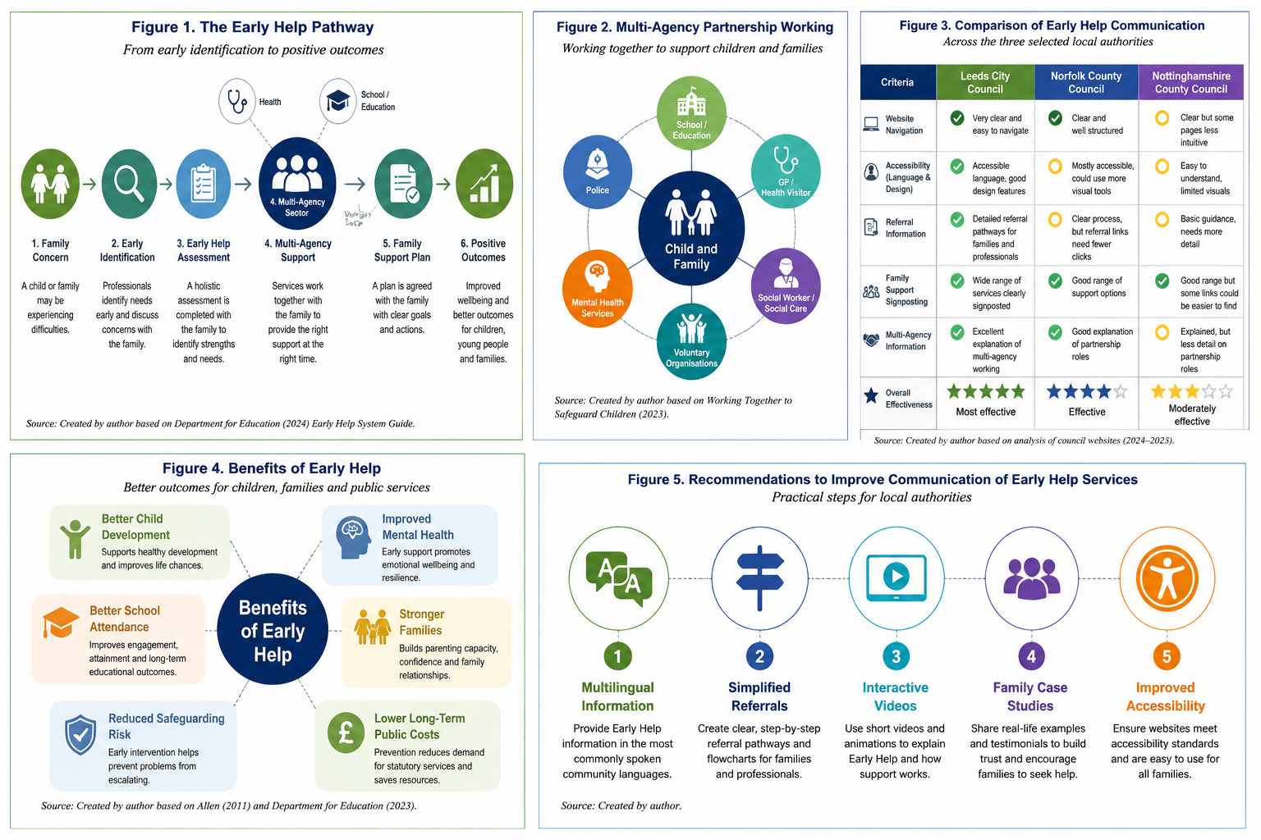
Figure 1: Early Help System

Multi-Agency Working
Multi-agency working is fundamental to the effective delivery of Early Help, as families often require input from a range of service providers. The levels of success of Early Help are determined by how well professionals in the health, education, social services, housing, police and voluntary sectors are able to work in partnership with one another. The collaboration of these individuals also allows them to exchange information, evaluate risk factors, and provide a more coordinated and integrated support system for families in need (DfE, 2023).
Professionals from various disciplines combine their expertise to help each other generate mutually beneficial results.As an example, schools can identify issues about attendance; medical professionals can offer physical or mental healthcare to children; and social service providers can assist families with more extensive needs (Siraj-Blatchford & Clarke). Therefore, sharing information between the various agencies is critical because one of the primary problems identified in case reviews regarding vulnerable children has been that there were significant failures of communication.
The Early Help Assessment framework promotes collaborative working between agencies, allowing them to collaboratively assess the needs of children, jointly establish outcomes, and monitor/address their progress. While barriers to collaboration may exist due to different priorities between agencies and organisational resources being limited, collaborative working has to be based on good communication and establishing effective partnerships. Local authority sites should provide clear instructions on how to refer to them, what services are provided, and what the roles of the various agencies are to assist in increasing participation and facilitating access to services.
Figure 2:Multi-Agency Working

Evaluation of Local Authority Websites

4.1 Evaluation of Leeds City Council Website
The Leeds City Council website has an excellent provision of information on Early Help services. The use of well-defined headings and easy navigation makes it possible for the user to find what he or she is looking for, which is very essential during times of pressure or crisis for families (DfE, 2024). The site describes Early Help using simple language, discussing various issues ranging from parental problems, mental health, domestic violence, money worries, and poor attendance at schools among others (DfE, 2023).
The first key strength of this site is its focus on inter-agency cooperation. The website notes that the support can be accessed via schools, health services, children’s centers, social care, and voluntary organizations, illustrating the teamwork emphasized in Working Together to Safeguard Children (DfE, 2023). Moreover, it offers referral options, resources for downloading, contact information, and links to related resources such as support for SEND, mental health services, parent programmes, and domestic violence services. This approach is consistent with the holistic approach to Early Help (Featherstone, White & Morris, 2018).
However, the huge amount of information could be an obstacle for some users, especially those who lack digital literacy skillsThere seem to be some tools that are more useful for professionals than parents, and there should be more usage of visual media on the website, such as videos and infographics.
In summary, Leeds is successful in promoting prevention, partnership work, and family-based care, as well as offering complete information and various referrals.

4.2 Evaluation of Norfolk County Council Website
This is evident in the Norfolk County Council website where it provides the Early Help service in a structured and services oriented manner. This makes information easily accessible to both parents and professionals and hence the user will be able to access useful resources in a quick manner (Local Government Association, 2024). In addition, the website shows the process that goes into the Early Help Assessment and stresses on partnership working in areas such as education, health, social services, police, and voluntary organizations as suggested in the national safeguarding guidelines (DfE, 2023).
Its strength lies in the explanation of processes involved in assessment and interventions to assist parents in understanding how help is offered. Moreover, the website refers to a variety of support services such as emotional wellbeing, services for SEND, parent education courses, substance misuse, and financial advice.
Nevertheless, there are still some disadvantages when comparing the website to that of Leeds. First of all, there are fewer examples of the actual application of Early Help practices to real life situations. Second of all, referral information might be found only after several clicks that creates additional obstacles to the families in need of emergency help. Also, the overuse of written content makes the website less accessible for the people with low literacy level.
All in all, the Norfolk website is an effective one which promotes partnership working and Early Help very much, but there are some areas that need to be improved such as accessibility and visual communications.

Evaluation of Nottinghamshire County Council, Comparative Analysis, Conclusion and Recommendations

5.1 Evaluation of Nottinghamshire County Council Website
As described by the Nottinghamshire County Council website, the Early Help initiative provides a service for the prevention which helps children, young people and families through early intervention and collaboration between professionals. In accordance with the Early Help System Guide, the website highlights the importance of early identification of needs, partnership work and help (DfE, 2024).
One of its strengths is that it has a family-based approach. The information is provided in simple English and it tells families how the Early Help could help them in their situation such as parenting difficulties, emotional problems, poverty, absence from school and poor relationships.This easy-to-understand style can make families seek help earlier, thus contributing to the preventive nature of Early Help (DfE, 2023).
Moreover, the website emphasizes multi-agency working and states the roles of schools, health services, social care, youth services, and voluntary organizations. This is in line with the statutory guidance that states that effective cooperation of different agencies is crucial for safeguarding (DfE, 2023). Besides, there are numerous services offered on the website that can be used to receive support: SEND services, mental health services, parenting services, services for domestic abuse victims, and financial help.
The website is user-friendly and includes clear labels and contact details; however, unlike Leeds and Norfolk, Nottinghamshire does not provide much information about the procedures of referral and the Early Help assessment. Thus, families who do not know how the system works need to receive more information. It would be useful for the website to include more multimedia resources such as videos, infographics, and frequently asked questions, as well as multilingual resources.
Moreover, provision of specialized multilingual materials would increase inclusivity for diverse groups.
In general, the Nottinghamshire County Council website is very clear and family-centered, which efficiently conveys the message of Early Help, even though referral guidelines and website accessibility might be enhanced to increase efficiency.

5.2 Comparative analysis
From the comparative evaluation of the three counties’ websites - Leeds, Norfolk, and Nottinghamshire County Councils – it can be seen that all of them efficiently communicate the key elements of Early Help: prevention, partnership, and family-focused approach (DfE, 2023).There are variations in accessibility, navigation, information presentation, and referral guidance.
The Leeds City Council presents the most comprehensive information on Early Help services. The website includes all the necessary details and information regarding referrals, clear information on multi-agency, and numerous links to other services. Although there is a lot of information, it gives the most comprehensive picture of the matter both for professionals and parents.
The Norfolk County Council uses a systematic and organized way of presenting the information by clearly separating the information for families and professionals. There are detailed explanations of how the Early Help assessment works and strong evidence of partnership working. However, the use of textual information only may hinder the accessibility of the website.
The most family-friendly communication style is used by Nottinghamshire County Council since it uses accessible language and highlights the practical assistance. However, even though it is very easy to navigate, it does not provide as much detail about the referral and assessment process as the other two websites.
From a multi-agency approach, all three websites successfully highlight the collaborative roles of the education sector, health, social services, police, and third-sector organizations, which comply with statutory requirements. However, all could enhance accessibility by using more multilingual sources, visuals, and digital interactions.
On the whole, the Leeds City Council is the one that offers the best combination of detailed information, easy navigation, referrals, and supporting services. Therefore, it should be regarded as the most efficient local authority among the three concerning communication of Early Help services online.
Figure 3:Comparative Analysis

Conclusion
The Early Help service is a critical part of the UK’s safeguarding structure because it offers help to children, young people, and their families before the issues become severe. This report analyses the way Leeds City Council, Norfolk County Council, and Nottinghamshire County Council deliver the message about Early Help on their websites. All three councils do an excellent job in conveying the importance of early intervention, cooperation, and family-based interventions. However, the Leeds City Council has managed to provide the best delivery of the Early Help message due to its comprehensiveness and accessibility. Overall, Leeds is the most successful authority in terms of the communication strategy for Early Help and early engagement.

Recommendations
Taking into account the findings from this report, the following recommendations are made:
- Introduce multilingual content in order to provide Early Help information in commonly used languages in communities.
- Introduce multimedia resources in the form of videos, infographics, and guides to make content more accessible.
- Make the process of referring simpler by providing families with flowchart schemes.
- Introduce the cases and stories about families' experience in using Early Help services.
- Provide explanations about multi-agency working including roles of health services, schools, social care and voluntary organizations
Implementation of these recommendations would contribute to increased digital accessibility, early engagement with services and better results for children, young people and families.
Figure 4: Recommendations

Reference
Plinth (2026) What is early intervention? Prevention Services, Evidence and Cost Savings. Available at: https://www.plinth.org.uk/complete-guide/what-is-early-intervention [Accessed: 28 June 2026].
Allen, G. (2011) Early Intervention: The Next Steps. London: HM Government. Available at: https://assets.publishing.service.gov.uk/media/5a7b837d40f0b645ba3c4d09/early-intervention-next-steps2.pdf [Accessed: 28 June 2026].
Department for Education (2023) Working Together to Safeguard Children. London: Department for Education. Available at: https://www.gov.uk/government/publications/working-together-to-safeguard-children--2 [Accessed: 28 June 2026].
Department for Education (2024) Early Help System Guide. London: Department for Education. Available at: https://assets.publishing.service.gov.uk/media/628de13be90e071f5f7e1bd2/Early_Help_System_Guide.pdf [Accessed: 28 June 2026].
Featherstone, B., White, S. and Morris, K. (2018) Re-imagining Child Protection: Towards Humane Social Work with Families. Bristol: Policy Press.
Leeds City Council (2026) Early Help and Family Support. Available at: https://www.leeds.gov.uk/ [Accessed: 28 June 2026].
Local Government Association (2024) Children and Young People. Available at: https://www.local.gov.uk/ [Accessed: 28 June 2026].
Munro, E. (2011) The Munro Review of Child Protection: Final Report – A Child-Centred System. London: Department for Education. Available at: https://assets.publishing.service.gov.uk/media/5a7b455ee5274a34770ea939/Munro-Review.pdf [Accessed: 28 June 2026].
Norfolk County Council (2026) Early Help. Available at: https://www.norfolk.gov.uk/ [Accessed: 28 June 2026].
Nottinghamshire County Council (2026) Early Help. Available at: https://www.nottinghamshire.gov.uk/ [Accessed: 28 June 2026].
Siraj-Blatchford, I. and Clarke, K. (2010) Supporting Identity, Diversity and Language in the Early Years. Maidenhead: Open University Press.

