DS 1 Template

My Screenshots/Photos
- Please add 4–6 screenshots or photos of your digital life.
- You can use your phone or laptop.
- For each screenshot, write one or two sentences explaining what it shows.

Screenshot/Photo 1
[Insert Photo/Screenshot below]
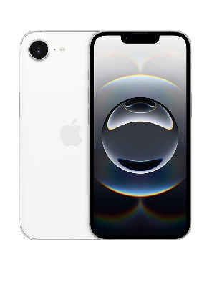
Mobile phone
We use our mobile phones, everyday to help organise our life, help keep in connect with friends and family. Help you get to different places while using maps. We don’t need to improve our phones as it is done for us when they do an update. Some people use their phones for there work, and keep it all in one place. Multi-function device can do multi digital skills. The calendar to keeps you self-organised.

Screenshot/Photo 2

Computer
Is a very good digital life, as it has more storage and have all the digital things in one place. You can take it places with you and keep all work in one place. They are getting more advanced as the years go one, you can use its to keep all the files and downloads as it will have loaded more storage than any other devices. You can brose most things, you can edit and re design any artwork.

Screenshot/Photo 3
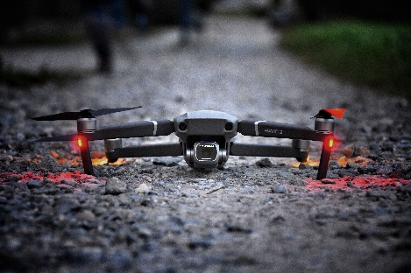
Drone
Is good for capturing good videos and photos. Mapping out designs for new planning work. Very sturdy a equipment to have, its has loads of up to date software, gps tracker. Collects and downloads information to get new routes. People love it as a hobbies Aswell, to capture beautiful work.

Screenshot/Photo 4
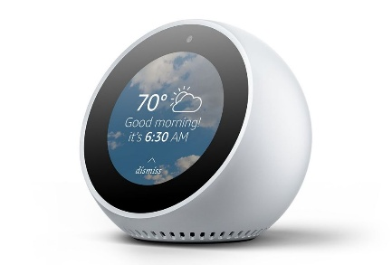
Alexa
A home Alexa is good for listening to music, podcasted, audio books, a timer for your cooking. To help turn on your heating and lights around your house. You can ring the Alexa and speak to whomever is at home or need to get in contact with whoever you want, you can ask it to make shopping list, you can but products from your Alexa from amazon just must ask it and it will do most things for you, you can ask it questions and it will tell you the answer, you can ask it to tell silly jokes and it will do it.

Screenshot/Photo 5
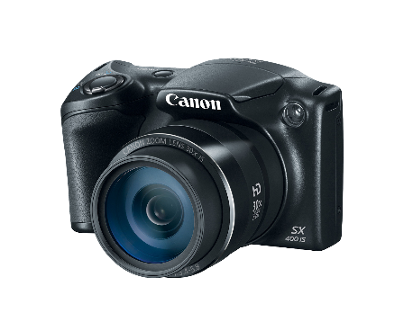
Camera
A camera nowadays can be used for loads of digital skills, for at home or work. Content creator for one. You can capture beautiful memorise and moment. You can take it everywhere you go. You can transfer photos and videos from your camera to you mobile phone while on the go, you have smart camera glasses, where you can take on the go photos and videos, you can edit and share while on the go.

Screenshot/Photo 6
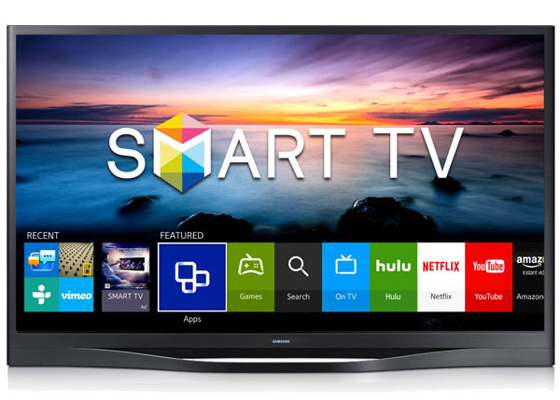
Smart television
Has loads of digital skills, you can talk to most of them and ask it to find a show or film you want to watch or find. You can download most apps on the tv and use them, you can screen share, you can record and pause live television. You can use your tv like phone nowadays. They connect to wifi, used apps and streaming services.

My Short Reflection
- Write 5–8 simple sentences about your digital life.
- You can use the sentence starters below if helpful.
I use digital tools in everyday life, to keep in contact with friends and family, and for my work to arrange my appointments for hospitals.
I feel confident using digital products as we have grown up with them, we have loads of digital products in the house.
I don’t know what I need to improve on yet, as I am okay with everything for now.
I often use all these digital products such as an Alexa and smart tv.
I feel like is this course is going to help me refresh my mind about all the digital skills I do have and can do.
Digital skills are important to me as we use them in everyday life nowadays, most things are digital like even paying money, not many places take cash now, they all want it digitally.
I hope this module helps me better navigate around a laptop a bit better.

Sentence starters
- I use digital tools to …
- I feel confident when I …
- I want to improve …
- I often use these tools: …
- I sometimes feel nervous about …
- I hope this module will help me …
- Digital skills are important for me because …
You can write more if you want.

Submission Checklist
Before you submit, please check:
​​​ ☒ I added 4–6 screenshots
☒ I wrote short sentences for each screenshot
☒ I wrote my short reflection
☒ My work is my own
☒ My file opens correctly
​​☒ My file opens correctly

