James Gau

ACCB4012
Database Design (The Book Store)
Information Engineering

Contents
Introduction/Abstract 2
Initial Design 2
Entity Relationship Diagram 2
Data Dictionary 3
Creation of Tables 3
Creation of Relationships 4
Populating Tables with Relevant Data 4
Creation of Forms 5
Creation of Menus 7
Creation of Reports 8
Production of Queries 9
Implementation of Successful Querying and Use of SQL 9
SQL Relationships (Primary and Foreign Keys) 9
SQL Record Addition 10
Producing a Report from a Query 10
Use of Additional MS-Access Functionality 11
Calculation in a Report 11
Master and Embedded Forms 11
Menu Display 12

Introduction/Abstract
This report will detail the process that went into designing a database system for a company known as ‘City Bookstore.’ The database was built with a specific requirements list in mind, and these requirements will be detailed throughout the report, along with the ways that the database contains these features. The database was built using Microsoft Access.
This report will start with the initial database design, showing any diagrams that were made, before detailing the base layout of the database, as well as any forms, reports, menus and queries that were created to accompany it. Then, the report will explain the implementation of successful querying and use of SQL. This section will show evidence that SQL can be and was subsequently used to create relationships and add records. This section will also show evidence of reports being produced from a query and main menus working with form navigation. Finally, the next section will show the use of additional Microsoft Access functionality, such as calculation being produced in a report, master and embedded forms being produced, reports and forms from a macro query being produced and menus being displayed immediately after a database opens.

Initial Design

Entity Relationship Diagram
To begin with, a diagram was made to show how the relationships between each table would work:
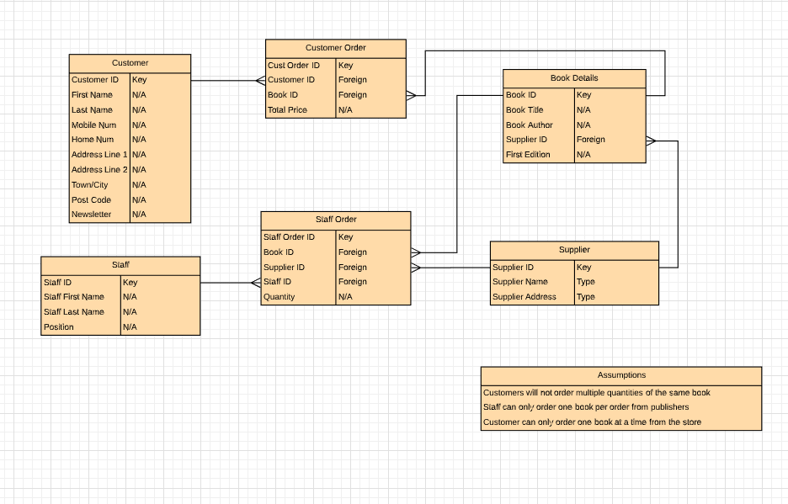
The diagram above shows how each table in the database will connect to each other, and what sort of relationship they will share. These connections will be seen later on when actually designing the database, and this diagram is important because it gives a basic understanding of how the table will connect.

Data Dictionary
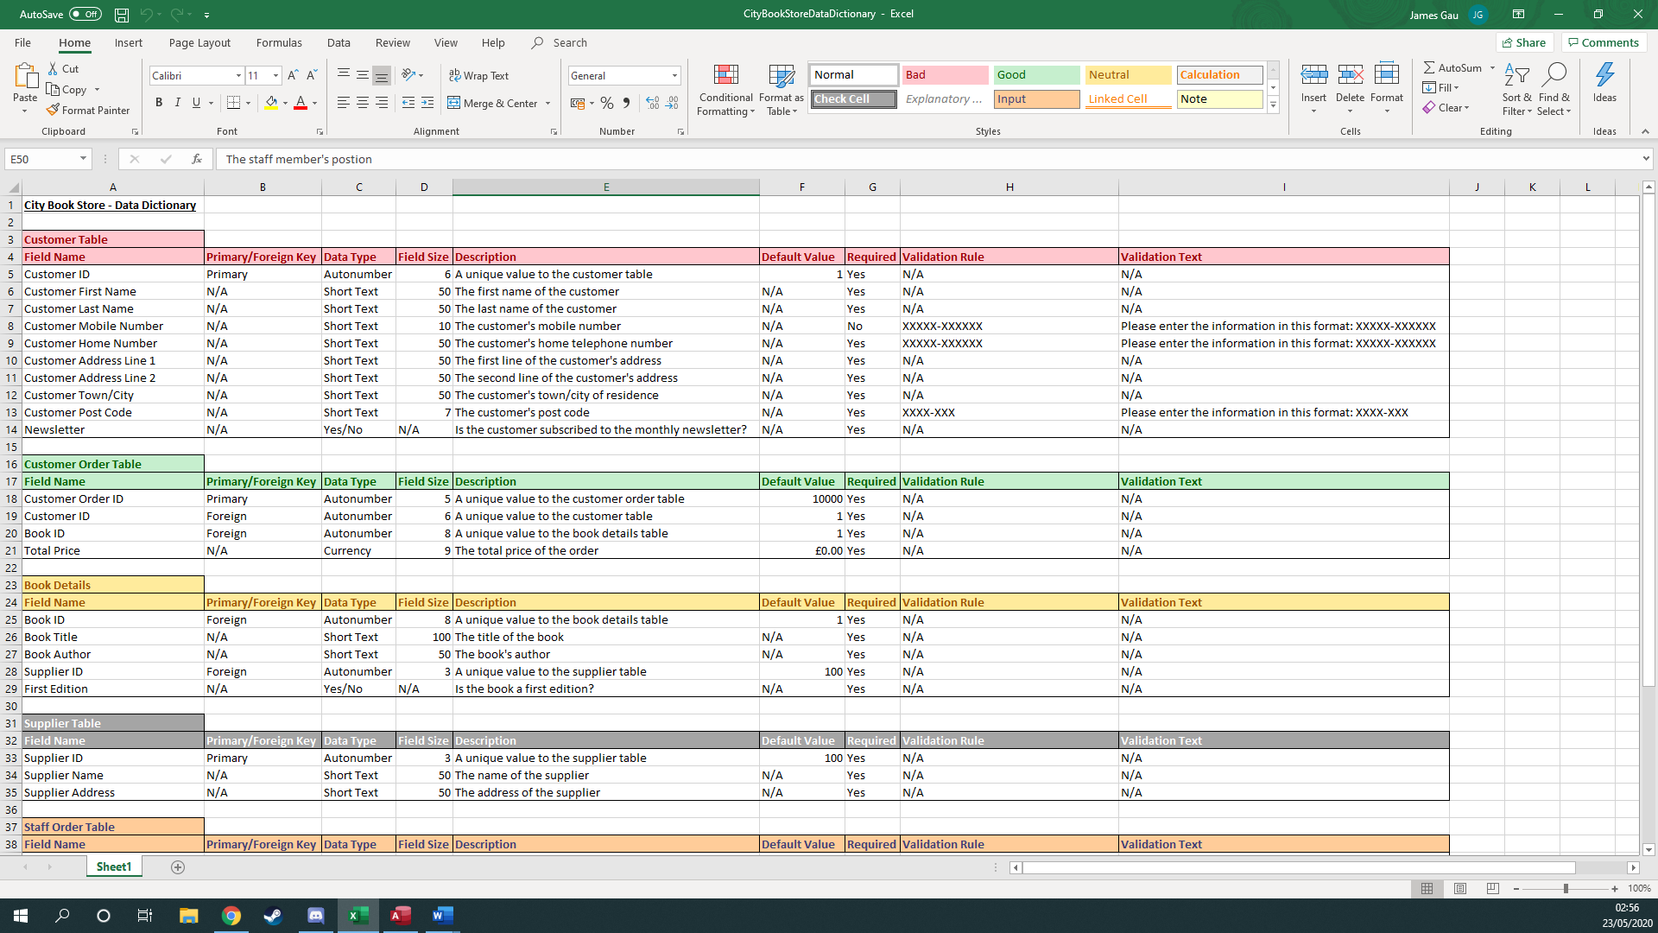
After the ERD was created, the information from the tables was then imported into a spreadsheet using Microsoft Excel, in the form of a data dictionary:
This was useful, as the data could then be made into tables, using this data dictionary as a template as to what sort of fields should be put into each specific table, and how they would act with each other. This spreadsheet would be brought up many times when making this database, it is very useful for that.

Creation of Tables
After that was done, it was time to finally start implementing the designs into a database, to begin with, six tables were made to allow for the data to be input. These tables would be the base for all future forms, queries, menus and reports, so it is important that the data be accurate. The tables were also labelled accordingly, so as to avoid confusion.
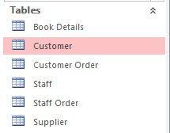

Creation of Relationships
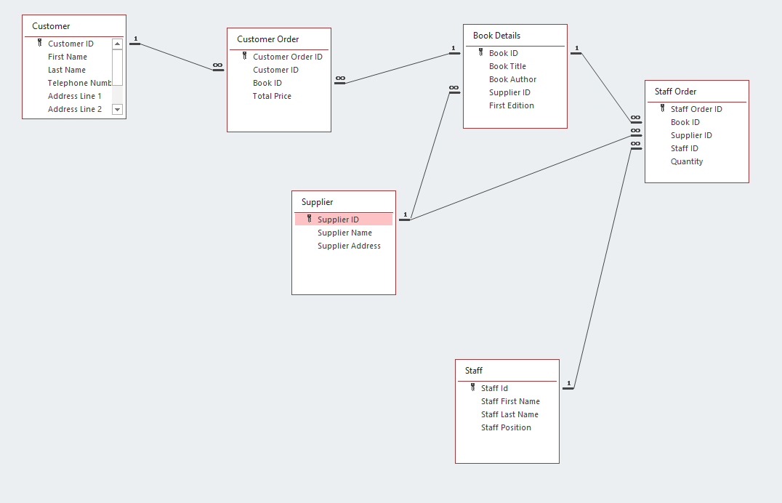
Then, the relationships between the tables were added, to ensure that they interacted and worked with one another synonymously. The design of the relationships is MS-Access was very similar to the design in the diagram made earlier, which is good because it shows that the database is going as planned.

Populating Tables with Relevant Data
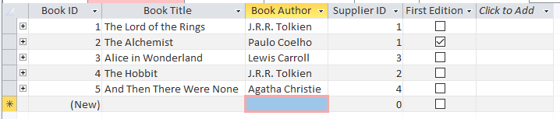
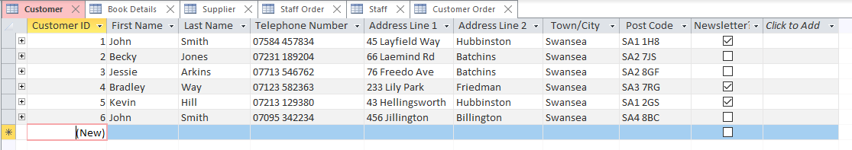
In order to show evidence that these tables can add data to the database, work correctly with the other tables and show data with clear, concise quality, some appropriate data had to be added with a nicely sized population of example data. The data that was added had to make sense in context, but also make sure that it was different enough, so that the forms and reports could be shown to their full extent. All of the tables were subsequently populated.
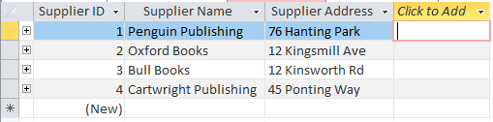
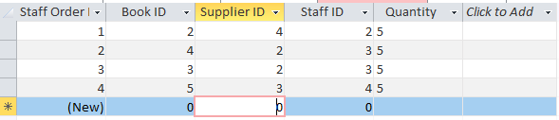
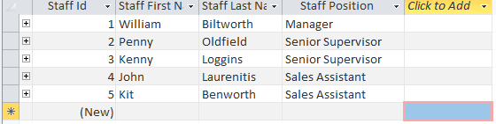

Creation of Forms
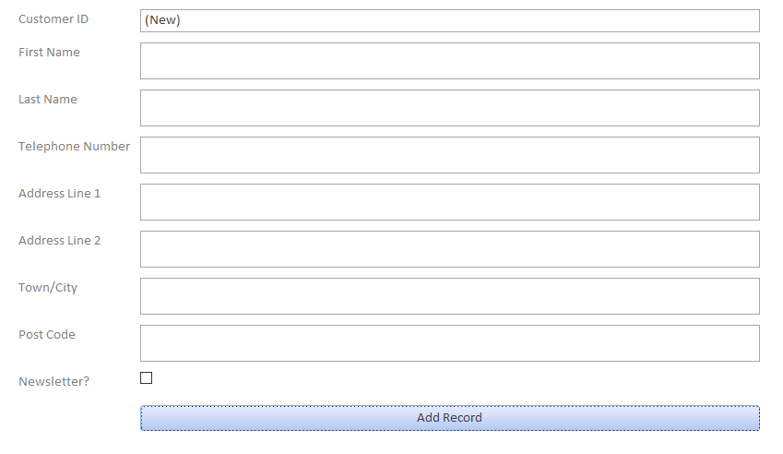
Entering records into the tables themselves can be confusing for staff members, so it is important to make the addition of records an easy process. This is where forms come in. They lay the fields out in a clear, concise way, allowing users to input data through the use of typing and buttons, all labelled clearly. A form was created for each table, and the designs for each form were kept simple, so as to not confuse matters.
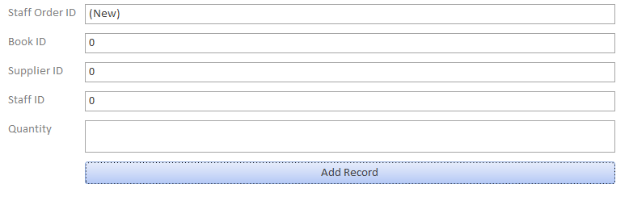
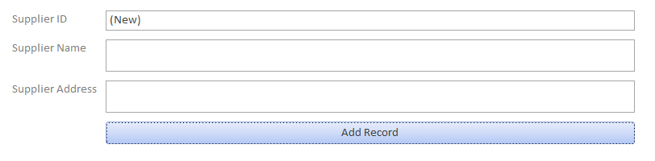
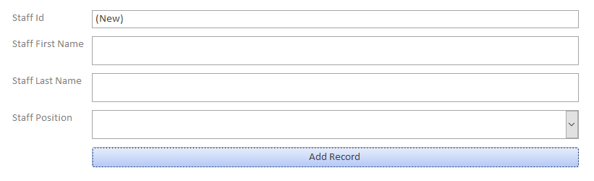
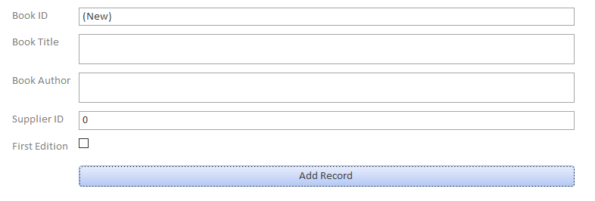
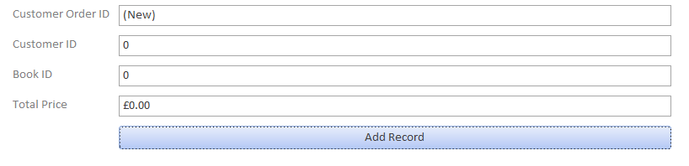
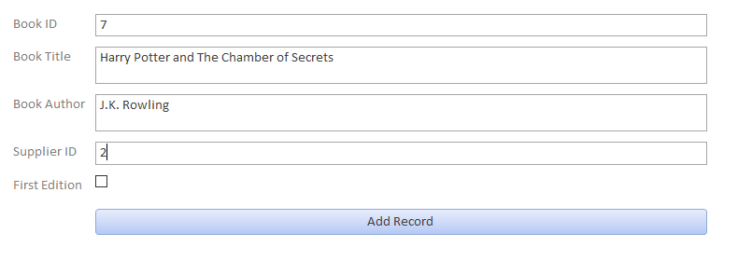
The forms were then tested to see if the ‘add record’ button worked. A new book was typed into the book detail form, then the button was pressed to add that to the list of records. As you can see below, the form makes it substantially easier to input data.

Creation of Menus
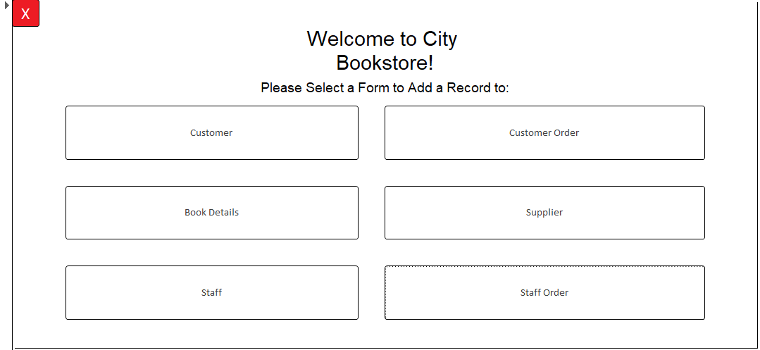
Of course, to get to the forms, the user had to manually click on the side of the program. A less technologically knowledgeable person may struggle with this system and they may lose track of what form they are looking at. So, some sort of form navigation system was in order. The creation of a main menu form would remedy this problem. The main menu would contain links to all of the forms, all in one place. Subsequently, a navigation button that takes you back to the main menu would have to be added to each form, so it was. Also, the main menu had a button that closed the entire program, to allow for users to quickly enter and exit from it at any given time.

Creation of Reports
After the menu system was created, the next step was to create reports. As an example, a few reports were created to show that they system was capable of doing so. This was the reason that a lot of varying data was input into the system earlier. 3 reports were created, to show that the system is able to produce reports on a wide variety of topics, as the client asked for.
Here is a report created from the customer table that details the different addresses that correspond to each customer ID:
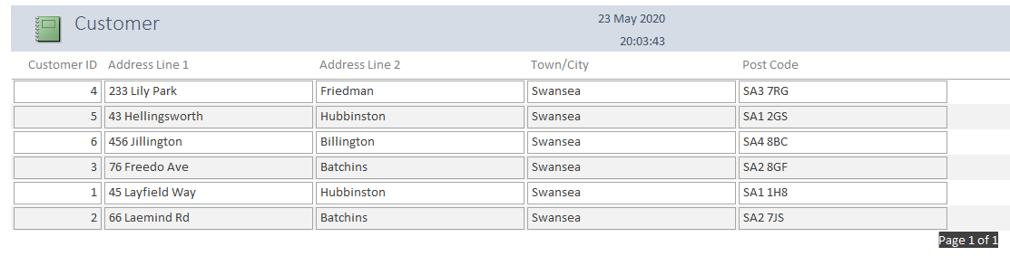
Here is a report that just lists the books that shop currently owns and their respective authors, along with whether or not they are first edition:
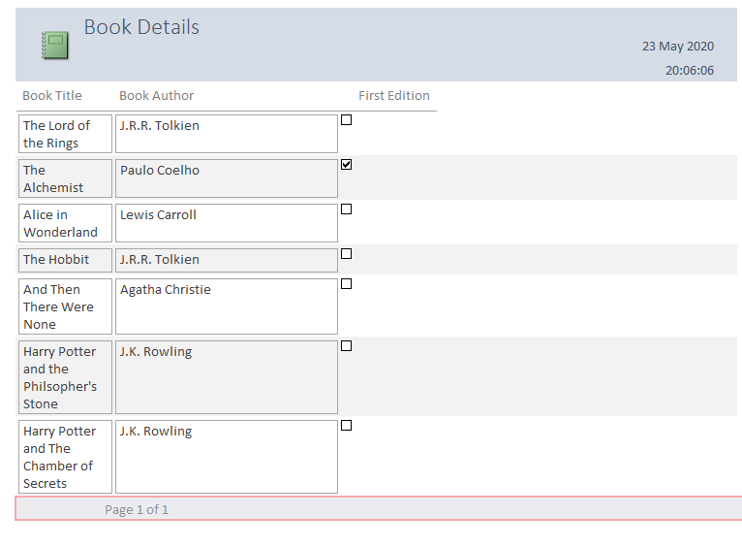

Finally, here is a report of all the staff members and their relevant position:
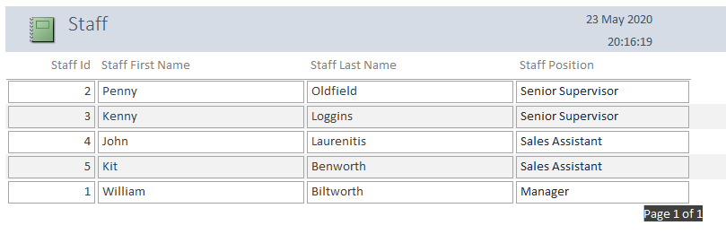

Production of Queries
The last stage in the initial design process is to show evidence that queries can be produced from this database, allowing users to search specific records and bring back a set of results that corresponded to what they queried. This database is fully capable of doing that, as is about to be demonstrated in these 2 examples shown below:
Here is a query run on the customer table, with the criteria of showing only customers who have ‘Batchins’ as their second address line:
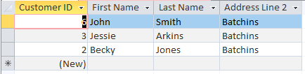
As well as that, here is a query that was run through the book details table, looking for books that were written by J.R.R. Tolkien:
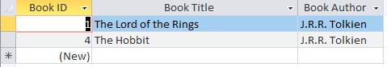

Implementation of Successful Querying and Use of SQL

SQL Relationships (Primary and Foreign Keys)
SQL is a language that is used to program and design relational database systems. It is present in most databases, being the most widely used database programming language out there. It is useful for when it comes to handling structured data, like relationships and variables. SQL can be used to do all sorts of functions of a database. As Microsoft Access is a product that prides itself on being easy to use, SQL coding is not present for a lot of the features, therefore programming in SQL using this software can be difficult. Nevertheless, it can be input into a query to allow for table creation.
To begin with, a duplicate for the Customer Order table was created and a primary key was added using this line of code:
CREATE TABLE CustomerOrder (
ID int NOT NULL PRIMARY KEY
);
After that, a foreign key for the customer ID field had to be added, using this line of code. The entire code had to be revised in order to avoid constraint clause SYNTAX errors:
CREATE TABLE CustomerOrder (
CustomerOrderID int NOT NULL,
CustomerID int,
PRIMARY KEY (CustomerOrderID), CONSTRAINT FK_CustomerOrder FOREIGN KEY (CustomerID)
REFERENCES Customer(Customer ID)
);
This subsequently created a table called CustomerOrder with the fields ‘CustomerOrderID’ as the primary key and ‘CustomerID’ as a foreign field.
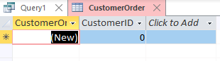

SQL Record Addition
SQL can also be used to add records to a table. A new table called ‘cust2’ was created and a new record needed to be added. So, an ‘INSERT INTO’ syntax had to be added to the SQL. This was done so using this line of code:
CREATE TABLE Cust2 (
CustID int NOT NULL PRIMARY KEY,
LastName varchar(255) NOT NULL,
FirstName varchar(255),

INSERT INTO Cust2 (CustID,LastName,FirstName),
VALUES ('1','Smith','John')
);
This created a record in the Cust2 table for a man named John Smith with the ID of 1.
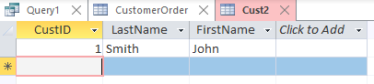

Producing a Report from a Query
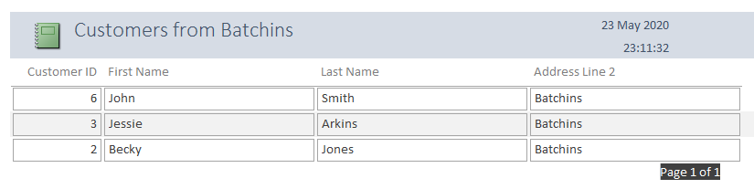
The database should have the ability to produce both a report and a query. To show that it can do both properly, evidence should be given that these functions can be used in tandem with one another. So, a query that was made earlier was used, namely the query that listed the customers from Batchins. All that then had to be done was a report design. The final report looked like this:

Use of Additional MS-Access Functionality
Microsoft Access is a good piece of software for when it comes to database design, as it has many extra features that you can add to your database to help with accessibility, ease of use and all around just extra functions for the user to be able to play around with. Here are a few features in the database that take advantage of this program:

Calculation in a Report
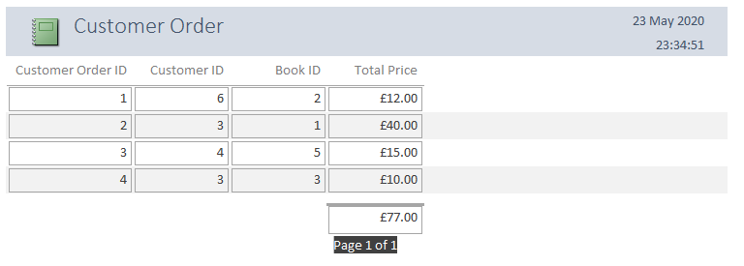
MS Access can create calculations for any report that uses numbers. So, in the table where the customer orders are stored, a report was created, and then a calculation was done to show the sum of all of the prices, which came to £77. The final report looked like this:

Master and Embedded Forms
While it wasn’t used in the database, Access also allows the use of embedded forms within master forms. To show this feature off, the form for the customer order table was placed in the customer form. The sub form displays as a small box underneath the main form content, giving off this appearance:
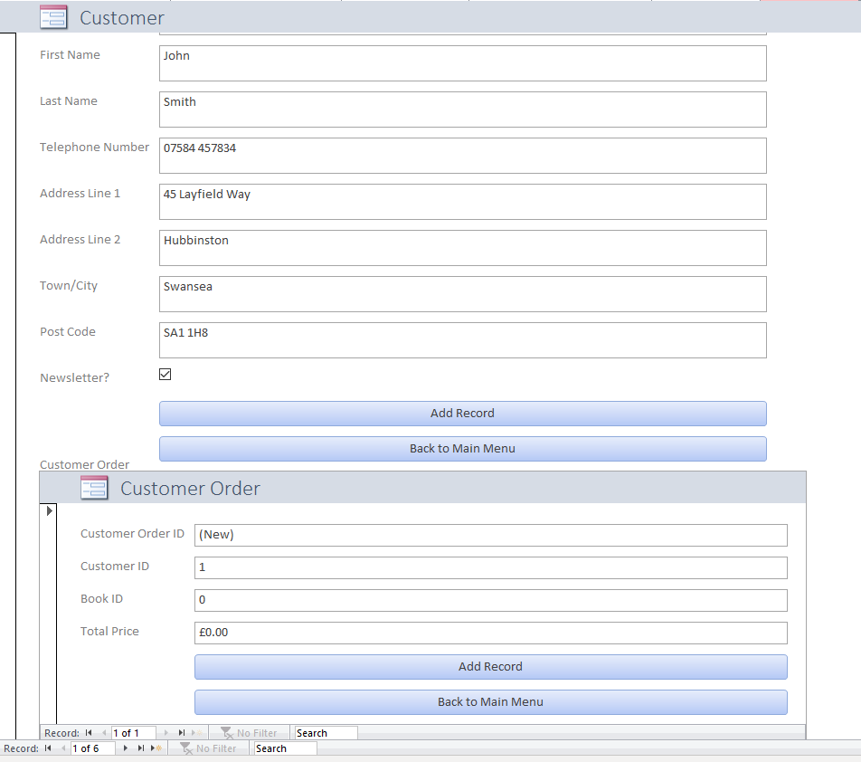

Menu Display
To make a database more usable and accessible, an important feature is the main menu, as was implemented in my initial design. The main menu is a very handy feature, because it has a simple design that helps users navigate the pages of the database without having to click the tabs at the side. There is one problem, however. The main menu is a form in the database. When Access first opens on a computer, nothing gets displayed until you manually click a form, table, report or query to open. Having the user manually click on the main menu, just to then click to another form is quite pointless and defeats the point of the main menu in the first place. So, Access has a feature that allows the designer to set a main form for the database, and then display it when Access is booted. All you have to do is go to the options menu and click current database, and then select your main form display as your main menu. Now, when Access is booted up, it immediately takes you to the main menu form, saving clicks and confusion. This is a very handy feature to have.

