Management & Organisational Behaviour
BMIH5004
Kobirul Islam
2130690
Charlotte Joyner

Table of Contents
Introduction 1
Organisation's background 1
Organisation structure, culture, and goals 2
The group's structure 2
Organisational culture and corporate goals 4
Recent change initiatives, their impact and how well these were managed 5
Recent major change initiatives implemented by the group 6
The way they implemented the change Initiative 6
Impact of these initiatives on stakeholders 8
The way the organisation managed the change initiatives 9
The organisation’s strategic direction and current business performance 10
Group's current strategic direction and focus areas 10
Compare performance with competitors and industry trends 12
Conclusion 13
References 14

Introduction
Organisational management is effectively planning, organising, delegating, directing, leading, and controlling the employees and other resources to attain the business aims and objectives (Czichos, 2020). Conversely, the study of the behaviour of human resources within an organisation to understand their personality to select appropriate leadership and management for leading and managing them is called organisational behaviour (Donne, 2017). The purpose of this report is to demonstrate an understanding of the organisational management of the selected hotel group “Hayat Hotel Group” based in the Hospitality industry. It will detail the organisational behaviour of Hyatt inside the hospitality industry critically evaluating their culture, structure, goals, and their recent change initiatives using relevant theory and audit. In addition, it demonstrates the impact of the initiatives and the strategic direction of the organisation along with the current performance for demonstrating a greater understanding of effective hotel management.

Organisational background
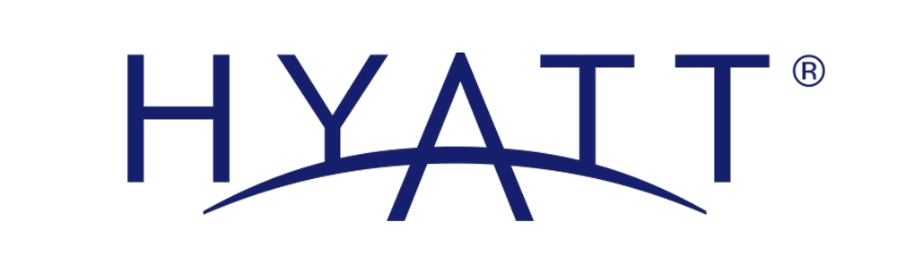
Figure 01: Corporate Logo of Hyatt.
Source: (Hyatt, 2024).
Hyatt Hotels Corporation is one of the most reputed Hotels & Resorts based in America. The hotel was founded on September 27, 1967, and its headquarters is situated in Chicago, U.S. (Hyatt, 2024). The company started to expand its operation internationally in 1969 managing its resources and operations in the parent company and domestic market successfully (Hope, 2021). The hotel runs its operation in around 1,350 branches worldwide in 6 continents and around 69 countries it has around 3700 rooms and its product is hotels and resorts (George, 2017). The overall revenue of the business is around £ 7.99 billion and it gives employment to almost 20,000 employees (Hyatt, 2024).

Organisation’s structure, culture, and goals

The group's structure
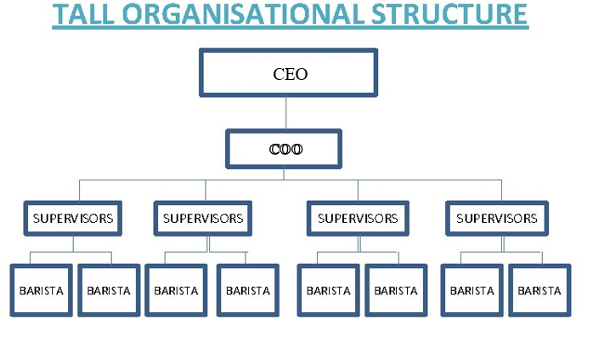
Figure 02: Tall organisational structure.
Source: (Layra, 2020).
The hotel group Hyatt utilize tall structures from 4 major organisational structures for controlling their large employee base and ensuring greater monitoring and supervision with many leaders and layers of management (Armstrong, 2012). A business structure that contains a vast amount of management layers and follows a long chain of command for supervising employees and controlling their behaviour in a desired way is called a tall organisational structure. The greater authority, managerial layer, control, and monitoring of the leader of Hyatt improves 5-10% performance each year because they get continuous feedback and corrective action from the leader and manager (Adair, 2009). Furthermore, as the responsibilities are distributed transparently under each of the managerial layers, employees can report clearly and it reduces confusion and misunderstanding by 19% and thus enhances the business efficiency. Finally, the opportunity for promotion immensely motivates employees to remain committed and dedicated to Hyatt.
Nevertheless, Arnold (2005) argued that, due to the long chain of command, the decision-making is much slower in Hyatt which reduces their efficiency in responding to certain situations by 25%. Boddy (2014) here added that Hyatt cannot remain up-to-date with the challenging need for the long hierarchy and it makes them fail to become the market pioneer. Moreover, as per Donne (2017), due to high authority and hierarchy, the empowerment of employees declined by 15-30% compared to flat-structured businesses which makes employees feel inferior and enhances their job dissatisfaction and turnover.

Organisational culture and corporate goals
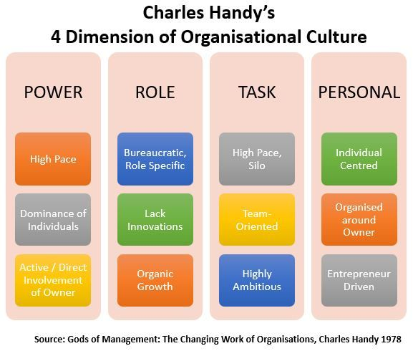
Figure 03: Handy’s culture model.
Source: (Fruit, 2022).
As per the culture model of Handy, there are four types of organisational culture which are power, role, task, and person. The organisation Hyatt Group apply the role culture in their organisation and they provide job roles concerning employee available skills and knowledge under each business function for the greater supervision of leader and manager (Buchanan and Huczynski, 2007). It helps them while showing the maximum cordiality and talent because an employee finds their job role relevant to their available skill. It enhances the output and performance of the employees by 45% (George, 2017). Here individuals get hierarchy and greater supervision for which they remain 55% more focused on attaining their job role (Fruit, 2022). It gives them freedom and control and employees understand what is expected from them as this culture follows a hierarchy with formal rules and procedures.
However, as per Hope (2021), as the role culture follows a hierarchy and narrowly defined rules, it reduces the opportunity for employees to develop and expand their skills and knowledge by 20%. It also reduces the possibility of innovation and creativity because employees are binned by specific rules. Here Zara (2021), argued that the bureaucratic nature makes structured procedures reduces the adaptability skill of businesses.
Corporate goals
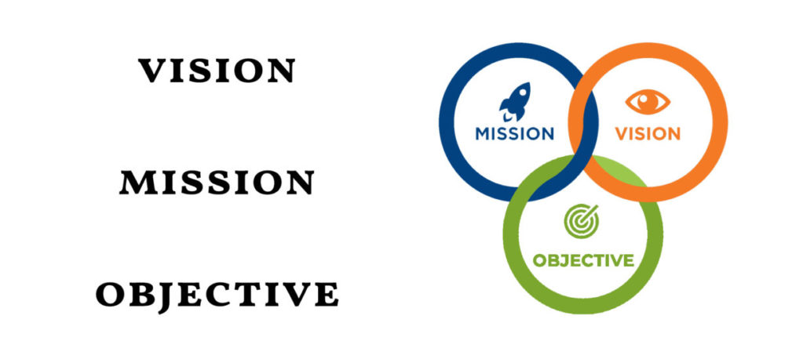
Figure 04: Corporate Goals of Hyatt.
Source: (Zara, 2021).
The vision of it is to be the most preferred hotel business in the UK. The mission of it is to provide authentic hospitality and give something different. Its objective is to capture around 20% market share and be the most valued and largest hotel brand within the next 5 years (Hyatt, 2024). So, it wants to focus on role culture and tall torture for greater supervision and effective task accomplishment to remain a market pioneer.

Recent change initiatives, their impact and how well these were managed

Recent major change initiatives implemented by the group
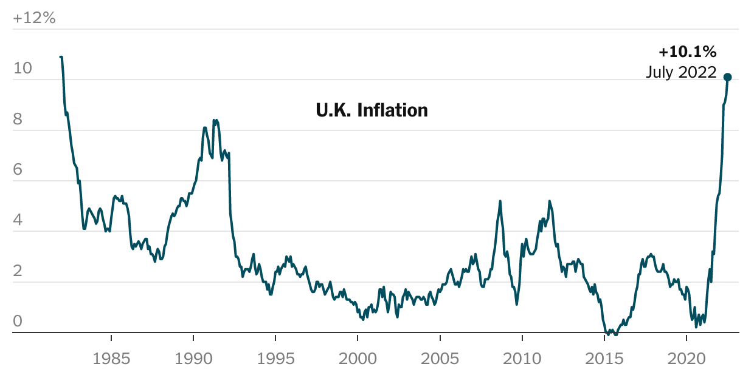
Figure 05: Inflation in the UK.
Source: (William, 2022).
The organisation Hyatt Group saw a major supply chain disruption due to the impact of COVID-19 in the years 2021-2022 and Russia Ukraine War (William, 2019). Due to the supply chain disruption, the inflation rate of the UK reached 10.2% in 2023 due to currency fluctuation, unstable market conditions and the rising price of all commodities (Layra, 2020). However, the high inflation enhanced the Company cost of Hyatt Group by 25-30% and declined their profit by 22.1% even after the post-pandemic time (Lewis, 2021). In such a situation, the company want to enhance their sales although enhanced consumer purchasing power immensely declined by 15% (Rochester, 2023). So, they decided to reduce their operating cost and maximise the competitive advantage of the business taking the change initiative of “change in the use of technology”. Using technology, they decided to maximise their efficiency for enhancing efficiency and reduce operating costs to maximise their business revenue by 14% within the next 2 years (Zara, 2021).

The way they implemented the change initiative
Implementation is given below using the Lewis change model:
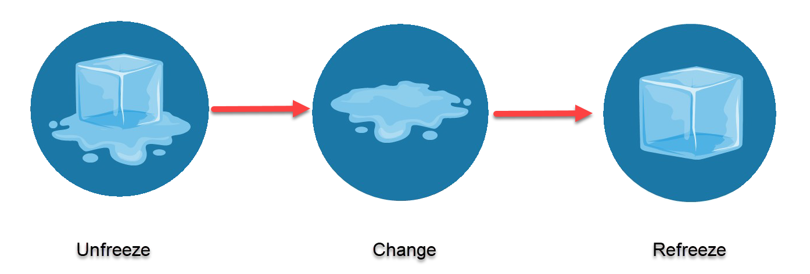
Figure 06: Lewis change model.
Source: (Fruit, 2022).
Unfreeze: In this stage, the leaders of Hyatt Group recognise the need for change and encourage the replacement of the old behaviour of their employees giving mandatory support and resources. For example, they determined that, due to high inflation of 10.1%, the price of all commodities and operations is enhanced greatly and the supply chain disruption rude the operational efficiency (Lewis, 2021). At that time, they decided to change their use of technology and go digital by digitalising their workplace, shifting their operation online, communicating with Stokehole online, starting e-commerce, recruiting employees online and doing digital marketing by buying IT equipment and making new company policies.
Change: In this stage, the hotel group Hyatt decided to implement the planned change by reducing employees' resistance to change, giving them support, mandatory education as well as training. For example, Hyatt started to teach how to use technology devices, build digital skills by hiring trainers and instructors and developing available skills and knowledge of the employees.
Refreeze: This is the final stage where the change is sustained and stabilised within the organisation by making it normal in the organisation and celebrating its success (Mullins, 2020). For example, Hyatt Group here continue digital practising and ensures continuous monitoring and supervision for reducing error and ensuring continuous development of the employees by giving digital. Finally, they also celebrate success by arranging lunches, celebration parties and many more to motivate employees to keep up their good work.

Impact of these initiatives on stakeholders
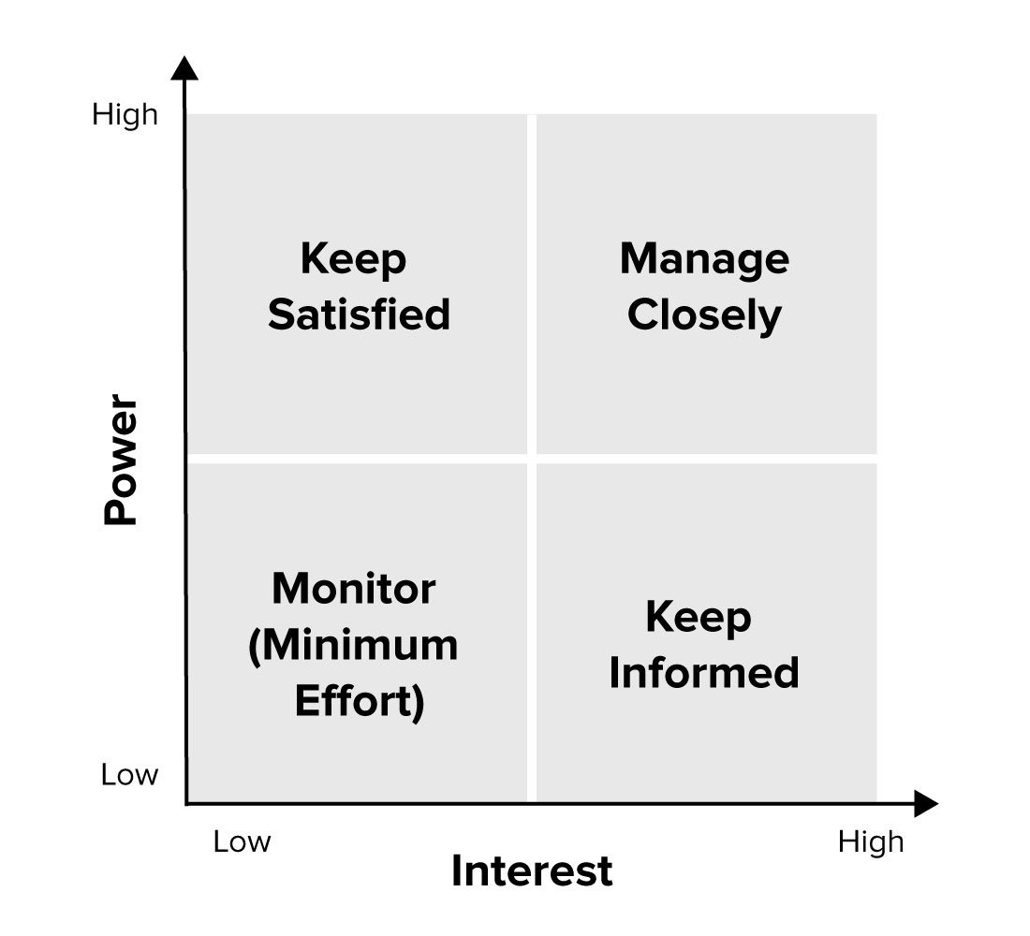
Figure 07: Stakeholder mapping.
Source: (Rochester, 2023).
The stakeholders of Hyatt Group
High Power, Low interest  Customers, Investors | High Power, High Interest  Employees, management,
Low Interest, Low Power  The public, Helpdesk | High Interest, Low Power  Trainer, supplier

The change initiatives impacted the stakeholders of Hyatt Group. For example, the high power and high-interest stakeholders of the group are customers and investors and they are highly motivated to remain committed to the brand getting the opportunity to remain connected with digital devices and stay up to date about their offering and performance (Mullins and Dosser, 2013). The high power and high-interest group employee and upper management also negatively impacted initially because it enhanced their complication like changing old behaviour, developing digital skills and fear of losing their job but it also saved their effort saving time and work-life balance which they understood later. It enhances performance and company efficiency which also positively impacts the public low power and interest stakeholders and the trainers who are high power and interest get the opportunity to work continuously for employee skill development.

The way the organisation managed the change initiatives
With the change initiative, the resistance to change by the employees occurred in Hyatt Group at a great scale. To manage the change effectively the organisation, follows the Kubler-Rose change management model in the following way:
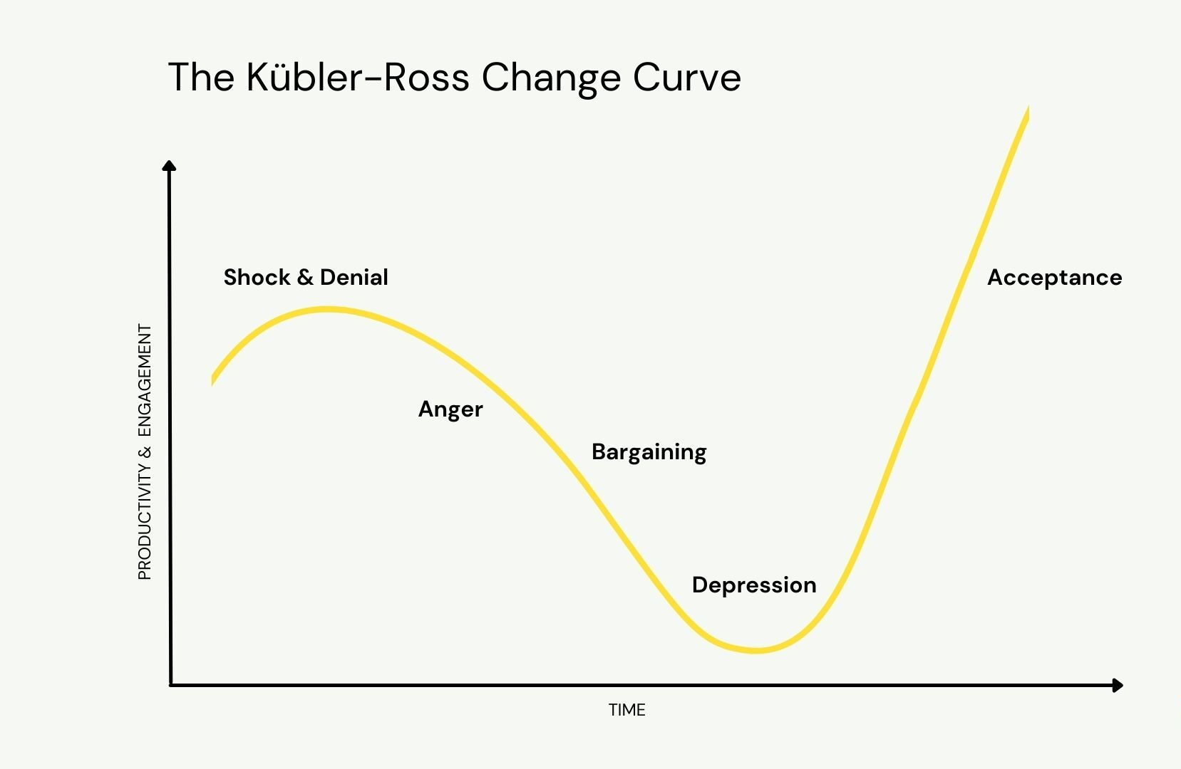
Figure 08: Kubler-Ross change curve.
Source: (Mullins, 2016).
Shock and Denial: The first stage of the model is Shock and Denial where the employees of Hyatt reacted to the change initiative because it enhanced their complications like changing old behaviour, developing digital skills and fear of losing their jobs but it also saved their effort saving time and work-life balance which they understood later.
Anger and Bargaining: In this stage, the employees disagreed to accept the change and showed their anger. They bargained with the upper management to keep the organisation traditional without going digital (Rochester, 2023).
Depression: In this stage, the employees go into depression due to the denial of accepting the proposal by an upper magnet to avoid change. But for managing and sustaining the change, the peer magnet. Leaders and managers detail the advantages of the change and give training and education.
Acceptance: Finally, the employees accepted the change by understanding the advantage and getting mandatory support and resources from the organisation.

The organisation’s strategic direction and current business performance

Group's current strategic direction and focus areas
The plan that needs to be implemented for an organisation to attain its vision and fulfil its goal is called strategic direction. The strategic direction of Hyatt Group given below determines market position and environment:
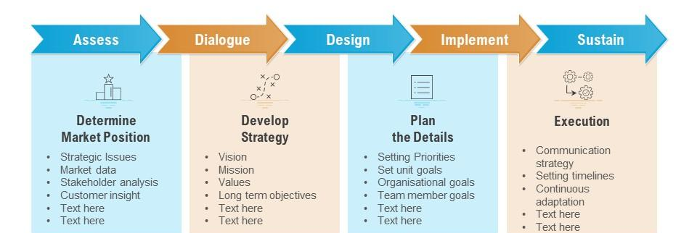
Figure 09: Strategic direction model.
Source: (Layra, 2020).
Determining market position: Here the market condition asses identifying market data, taking customer insight and stakeholder analysis. For example, the Hyatt Hotel corporation captured 11.70% market share which is £13.52 billion (Hyatt, 2024). Hyatt Hotel is the 8th largest in the USA and has around 1200 worldwide.
Developing strategy: The vision of it is to be the most preferred hotel business in the UK. The mission of it is to provide authentic hospitality and give something different. Its objective is to capture around 20% market share and be the most valued and largest hotel brand within the next 5 years (William, 2019). So, it wants to focus on differentiation to remain a market pioneer.
Plan the details: The business wants to go 100% digital setting digital proprieties by 2030 (Zara, 2021). It wants to do e-commerce, digital marketing, and customer service as over customer demand and reduce operating costs making its team more effective.
Execution: The strategies of the business they want to implement and sustain are accepting feedback, personalising communication, asking questions, using democratic leadership, and setting a timeline of 3 years (Lewis, 2021).

Compare performance with competitors and industry trends
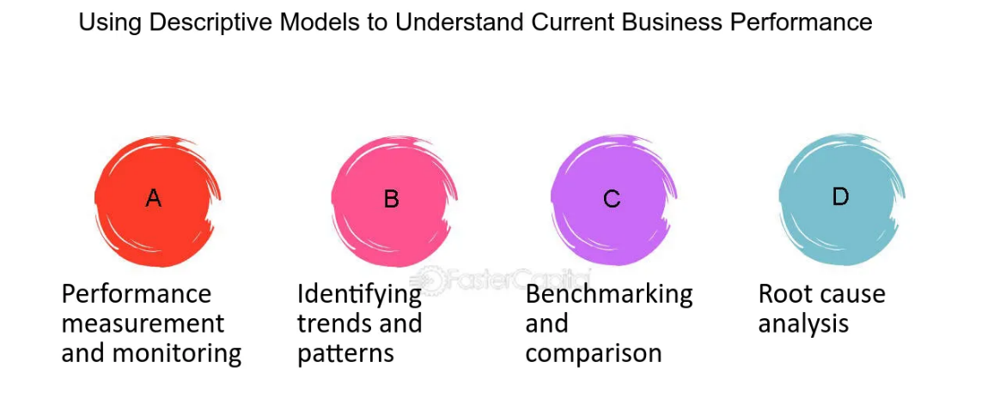
Figure 10: Descriptive model.
Source: (Zara, 2021).
Performance measuring and monitoring: By analysing the revenue and captured market the performance of the company can be measured. For example, the net revenue of the company is £3.12 billion and it captured £13.52 billion market where Mariott Internecion captured £69.63 billion, Hilton worldwide captured £590.1 billion, Vail Resort captured £10.12 billion and Intercontinental £15.2 billion (Hope, 2021). That means the company performing at a satisfactory level. However, its customers are 9% less satisfied than its customers for their lack of digital presence which they need to improve (George, 2017).
Identifying trends and patterns: In this state current trends and patterns can be determined according to market trends customer behaviour and demand. For example, the trend of eCommerce, digital marketing, social media marketing and online business is on top and demanding which should focused on by the business.
Benchmarking and comparison: The company can determine their turnover rate, employee satisfaction and productivity. For example, as per the research conducted on 10 major competitors by Donne (2017), it has been identified that their employees are 10% less productive for lack of digital skills and 5% less satisfied for which turnover is a 7% high average (Layra, 2020).
Root cause analysis: Here the company can determine the root cause by conducting statistical analysis and facilitating corrective action. For example, comparing data with competitors, determined that the business needs to thrive toward globalisation and digitalisation by going digital by adopting workplace and doing product differentiation to remain competitive.

Conclusion
The organisation Hyatt group ideally adopted the role culture, and tall business structure, for the attainment of business goals along with taking change initiatives like change in the use of technology in different circumstances like the impact of the pandemic and Russia-Ukraine war. The business implemented change management models for sustaining the change initiatives. However, using strategic direction the business can set the strategy of workplace digitalising and product differentiation to become a credible, sustainable, and highly popular leading hotel group in the world.

References
Adair, J. (2009). The Inspirational Leader (2nd Ed), London: Kogan Page
Armstrong, M. (2012). Armstrong’s Handbook of Management and Leadership (3rd Ed), London: Kogan Page.
Arnold, J. (2005). Work Psychology (4th edition) Harlow: Prentice Hall.
Bloisi, W. et al. (2007). Management and Organisational Behaviour, (2nd edition) Maidenhead: McGraw-Hill.
Boddy, D. (2014). Management: An Introduction (6th Ed), Harlow, Pearson
Buchanan, D. And Huczynski, A. (2007). Organisational Behaviour: An Introductory Text (6th edition), Harlow: Prentice Hall.
Czichos, R., (2020). Change Management. Freiburg im Breisgau: Haufe-Lexware.
Donne, J. (2017). The Multi-level Analysis on the Causal Relationship among Organisational Structure, Organisational Culture, and Organisational Effectiveness. Korean Review of Organisational Studies, 13(1), pp.33-62.
Fruit, j. (2022). What is stakeholder Analysis? [online] Visual-paradigm.com. Available at: <https://www.visual-paradigm.com/guide/strategic-analysis/what-is-stakeholder-analysis/> [Accessed 24 January 2024].
George, P. (2017). Organisational Structure and Organisational Learning. SSRN Electronic Journal.
Hope, (2021). Understanding the Process of Change. [online]. Psychology Today. Available at: https://www.psychologytoday.com/us/blog/understanding addiction/202110/understanding-the-process-change.
Hyatt (2024). Hotels & Resorts | Book your Hotel directly with Hyatt Corporations. [online] Hyatt. Available at: https://www.Hyatt.com/en-gb/default.mi.
Layra, (2020). Resistance to Change. Washington, D.C.: U.S. Environmental Protection Agency.
Lewis, L. (2021). Stakeholder Model of Change. The Oxford Handbook of Organisational Change and Innovation, 250–274.
Mullins, L. and Dosser, P. (2013). Hospitality Management and Organisational Behaviour (5th Ed) Harlow, Pearson.
Mullins, L. (2016). Management and Organisational Behaviour (11th edition) Harlow: Pearson
Mullins, L. (2020). Organisational Behaviour in the Workplace (12th edition) Harlow: Pearson.
Rochester, (2023). Rebooting the Digital Workplace. Deloitte Insights.
William, A. (2019). Incentives, Capital Budgeting, and Organisational Structure. Journal of Economics & Management Strategy, 22(4), pp.810-831.
Zara, V. (2021). Organisational Structure Modeling of Innovative Company. 11(4), pp.1469-1477.

