Task 1:
Evaluation of blended learning and classroom learning on student attainment (report)

Name: Haleema Qureshi
UWTSD
STUDENT NUMBER: 21112158
Lecturer name: Tekumbi

Table of Contents:
Reflective report: 2
Definition: 2
Pros of blended learning: 2
Introvert definition: 2
Cons of blended learning: 3
Traditional classroom learning pros: 4
Traditional teaching cons: 5
Evaluation of teachings (present): 5
Evaluation of teachings (past): 6
Recommendations/conclusions: 6

Reflective report:

Modern technology improves every day with various types of inventions. Technology has a major influence from a variety type of industries and educational purposes. It has influenced the way we communicate, think, feel and discover things around the globe. With the ongoing current global pandemic both blended learning and traditional learning techniques have been affected massively. This report will debate the pros and cons of blended/traditional learning in the higher education sector, with recommendations and a conclusion given at the end. The world is in a endless cycle of releasing new inventions and types of ways to do things more efficiently. From writing up work from using typewriters to laptops, we have evolved a long way.
Blended learning is an efficient way of ‘schooling students’ as it allows traditional learning practices and contemporary learning to coalesce.

Definition:
“Blended learning is a combination of onsite and online experiences. The purpose of blending is to make teaching and learning experiences more flexible, efficient, and effective by designing for the best of each mode” (Graham and Stein, 2020)

Pros of blended learning:
As technology innovates, hybrid learning students can benefit from online lectures and lessons, as it gives them the opportunity to master their technical skills. Nevertheless, having a set a technical skill is important. In similarity, most classroom resources are pre-recorded and if any student misses some work out, most material is uploaded digitally.
“Computer-centred networks and technologies are reshaping social relations and constituting new social domains. These transformations assume multiple forms and involve diverse actors. In this volume we focus on a particular set of instances: communication and information structures largely constituted in electronic space.” (Latham and Sassen, 2021)

Introvert definition:
“One-third to half of your students are likely introverts. Some are easy to identify, while others might surprise you. Some introverts love being in groups and interacting with others. But there’s a limit to how much time they can spend doing so before they desperately need some quiet time to themselves.” (Kiedaisch, 2021)
To elaborate, blended learning is a new learning curve, as it also promotes flexibility. This is beneficial for those who are parents, and people of many ages to fix a schedule that suits them. Along with technology being a breakthrough online teaching is the next big thing! people can connect more via the internet and gain loads of social skills and students can build a supportive network between themselves. Confidence can also be gained in the process of learning digitally as you will get a chance to refine skills even better.

Cons of blended learning:
Money for equipment can’t be easy to fund because all the necessary items are most likely be available in a physical classroom. The main thing students require in a hybrid learning environment included using video-audio to make group or conference calls and a webcam or a PC with a built-in webcam to communicate with teachers. Another essential point that can be viewed as a threat, is that blended learning through increased screen-time can cause long-term vision problems for people, as they are focused on a digital device majority of the time. This can cause extreme dependency regarding screen time along with other health problems like eye strain, vision problems, fatigue etc.
That also being said, people from households with a low income would struggle to afford some resources, like printers, computers and the most important thing being lack of internet, or slow Wi-Fi connection in order to get submissions sent out in due time.
Winstead expressed the opinion that “The other issue is IT literacy, which may be a significant barrier for teachers rather than students. The availability of solid tech support and trainers is an absolute must. It’s also important to nurture a blended learning community to evangelize the value of training technology.” (Winstead, 2021)
Some universities might not be able to provide their students with the technological infrastructure to expand their knowledge, and this could potentially stop some students from gaining their desired grade because they would have to take separate lessons for ICT skills in order to understand their lecture content in time- this could be for example: creating databases in Excel, but the student has no previous or current knowledge on this software. This can cause poor performance which can tigger negative emotions which lead the student feelings demotivated, lack of punctuality, and undisciplined.

E-learning won’t necessarily encourage social interaction between peers, as Chandran expressed in her blog, “Distance learning fails in building social relationships, feels Shalaka, and not seeing peers for a prolonged period could also have an adverse effect on the child’s mental health. You can’t really build friendships and nurture relationships through screens. We are human: we need to be able to see other faces and interact in person. I am sure in a classroom; teachers are also inspired to do their best when they see their students in person.” (Chandran, 2021)

With hybrid learning, if pupils are left unsupervised, they might struggle to meet assignment deadlines, and waste time. This is called procrastination, which defines to “put off or defer (an action) until a later time; delay” (Procrastinate definition and meaning | Collins English Dictionary, 2021)
On the other hand, hybrid learning can overwhelm some students, as it is completely different compared to a traditional classroom setting. Some pupils may require one-to-one discussions and may learn better in person rather through a four-by-four screen. Those who suffer with behavioural problems may struggle to always maintain focus, such as ADHD, dyslexia, Tourette’s syndrome etc. Some may enjoy working alone and cannot cope working in teams or groupwork.
However, it is stated “Almost four in 10 university students are addicted to their smartphones, and their habit plays havoc with their sleep, research has found. A study of 1,043 students aged 18-30 at King’s College London found that 406 (38.9%) displayed symptoms of smartphone addiction, as defined by a clinical tool devised to diagnose the problem.” (Campbell, 2021)

Traditional classroom learning pros:
Traditional classroom learning is where there is a physical presence of a teacher/lecturer, and they are educating you the content in person. This is the most common teaching practice in the world. The old-fashioned way of teaching would be chalk and board where the students would listen in silence whilst the teacher taught them. This could also be classed as ‘conventional teaching.’ (The typical chalk-and-talk learning style)
The benefits of traditional classroom learning can vary from the teacher giving immediate feedback, to achieving a good networking system between peers. However, pupils in the higher education system can become more confident whilst interacting within classroom environment.
Moreover, students can gain more motivation as traditional classroom settings can increase student-engagement with the lecturer. Organisational skills can develop over the period, which include time management and communication skills- these are crucial interpersonal skills so one can think strategically and set goals according to their ability.

Traditional teaching cons:
“However, it is often argued that the traditional approach may not provide students with valuable skills and indeed some even go as far as saying the traditional method leads to a student not retaining knowledge after exams - they have little or no recall of the body of knowledge learnt beyond the end of a semester” (Tularam, 2021)
This suggests that some pupils can struggle to retain information during ‘fast-paced’ traditional classroom settings. Just like introverts, extroverts exist too. Extroverts are the type of people who enjoy the company of others and just like being around people. These types of people can get distracted within a traditional classroom environment and may struggle to stay motivated and goal driven. Additionally, the atmosphere will just seem very uninteresting to most because a traditional classroom environment requires a schedule and a fixed time/routine for everyone to follow. (Fixed schedule)

Evaluation of teachings (present):
Based of the information that has been collected, blended learning is an innovative way to teach new generations all sorts of content and material.
“Almost every university in Britain and around the world has adopted online teaching using various technological tools to keep their pupils updated and ahead on the crowd. Most of the higher educational institutions also considered delivering their regular programmes online.” (Munna, 2021)
Resources are easily accessed through a few taps and clicks, and students can learn a lot from using the appropriate types of media via the internet for example, YouTube, Moodle, university websites. Discoveries in the digital world are endless, samples and work from many people across the world online can offer a type of support for students to look back and structure their tasks accordingly.

Evaluation of teachings (past):
“Teaching styles have changed significantly over the years. The traditional way that education was delivered was through recitation and memorisation techniques, whereas the modern way of doing things involves interactive methods.” (Teaching Methods: Traditional Vs Modern, 2021)
From chalk boards to touch screens, technology within the education sector have improved dramatically. Teaching in the past has changed, students would copy the notes by hand on paper whereas, now everything can just be typed up and memorised. Some traditional education expects you to continue with your academic year even if you didn’t understand the topics etc. Another thing would be the total travel cost going to a traditional teaching style school, restrictive attendance times and students who experience low confidence with asking their teacher in person for support. All these factors contribute to a bigger picture.

Recommendations/conclusions:
“While computers are an exciting technology, and one that has numerous benefits and applications, the trend is moving away from techniques that have worked for centuries now. Writing and the way we write is rapidly changing, and there seems to be no going back. The essay as we first learned it is now referred to as the "traditional" essay, because it has become just that. With all the new methods of communication, the printed word is beginning to take a back seat to faster and wider methods and because speed has become such an important factor, the essay is suffering. Computers are a resource, just as there are many different writing resources, and should be used as such. They are an undisputedly important tool to the writer, but you cannot complete a project with just one tool.” (Jane, 2021)
E-learning/hybrid learning is very effective as it can be suitable for those who are abroad and cannot attend class physically, very unwell, or suffering from health issues that prevent them from attending. This can vary from physical health, emotional or self-esteem issues.
On the other hand, traditional classroom teaching is a hands-on type of job which requires the presence of both student and teacher. Some may find thus daunting because they may not want to attend for specific reasons. One or two students may find – traditional learning quite intimidating and feel left out- because the teacher is teaching at one pace for everyone rather than teaching at a specific speed.
To conclude, blended learning and traditional learning are two different types of learning techniques which have both played a huge role in our modern society. Without the backbone of ‘traditional learning’ there would be no blended learning as the term was influenced by past teaching methods. The best recommendation to give to educational programmes would be to invest in a range of different types of technology and technical skills classes for pupils, as the world is developing more digitally. With the latest type of software and media resources it can be hard to keep up, but the best thing educational programs/universities can do is invest in the generation ‘today’ that will impact our lives ‘tomorrow’. With the updated understanding of gadgets and resources on the internet, pupils can also be one step ahead when conducting research for their work; that too once they have mastered technical ICT skills. Whilst technology is the biggest innovation, it can be just as useful, and can be just as dangerous, so pupils should be taught e-safety, to avoid the misuse of technology.

Reference list:
Campbell, D., 2021. Nearly four in 10 university students addicted to smartphones, study finds. [online] the Guardian. Available at: <https://www.theguardian.com/society/2021/mar/02/nearly-four-in-10-university-students-addicted-to-smartphones-study-finds> [Accessed 14 December 2021].
Chandran, S., 2021. Emergence of Online Learning during COVID-19: The Pros and Cons - Global EdTech. [online] Global EdTech. Available at: <https://global-edtech.com/emergence-of-online-learning-during-covid-19-the-pros-and-cons/> [Accessed 14 December 2021].
Graham, C. and Stein, J., 2020. Blended Teaching and Learning | Jared Stein, Charles R. Graham | Taylo. [online] Taylor & Francis. Available at: <https://www.taylorfrancis.com/chapters/mono/10.4324/9781351043991-1/blended-teaching-learning-jared-stein-charles-graham?context=ubx&refId=4c3465d3-662f-4feb-9e18-7588d52d285a> [Accessed 13 December 2021].
Kiedaisch, J., 2021. 10 Ways to Support Introverts in the Classroom. [online] WeAreTeachers. Available at: <https://www.weareteachers.com/support-introverts-in-the-classroom/> [Accessed 14 December 2021].
Latham, R. and Sassen, S., 2021. [online] Available at: <https://www.jstor.org/stable/j.ctt7s4z8.5> [Accessed 14 December 2021].
Lee J. Mental health effects of school closures during COVID-19. The Lancet Child & Adolescent Health. 2020;4(6):421. doi: 10.1016/S2352-4642(20)30109-7. [PMC free article] [PubMed] [CrossRef] [Google Scholar]
Munna, A., 2021. Online Learning: A View from Higher Education - Research Repository. [online] Repository.uwtsd.ac.uk. Available at: <https://repository.uwtsd.ac.uk/id/eprint/1854/> [Accessed 14 December 2021].
Stephen Perse Foundation. 2021. Teaching Methods: Traditional Vs Modern. [online] Available at: <https://sixthform.stephenperse.com/blog/?pid=458&nid=45&storyid=4728> [Accessed 14 December 2021].
Tularam, G., 2021. Traditional vs Non-traditional Teaching and Learning Strategies - the case of E-learning!. [online] Cimt.org.uk. Available at: <https://www.cimt.org.uk/ijmtl/index.php/IJMTL/article/view/21> [Accessed 14 December 2021].
Winstead, S., 2021. 6 Disadvantages of Blended Learning You Have to Cope With. [online] My eLearning World. Available at: <https://myelearningworld.com/6-disadvantages-of-blended-learning/> [Accessed 14 December 2021].

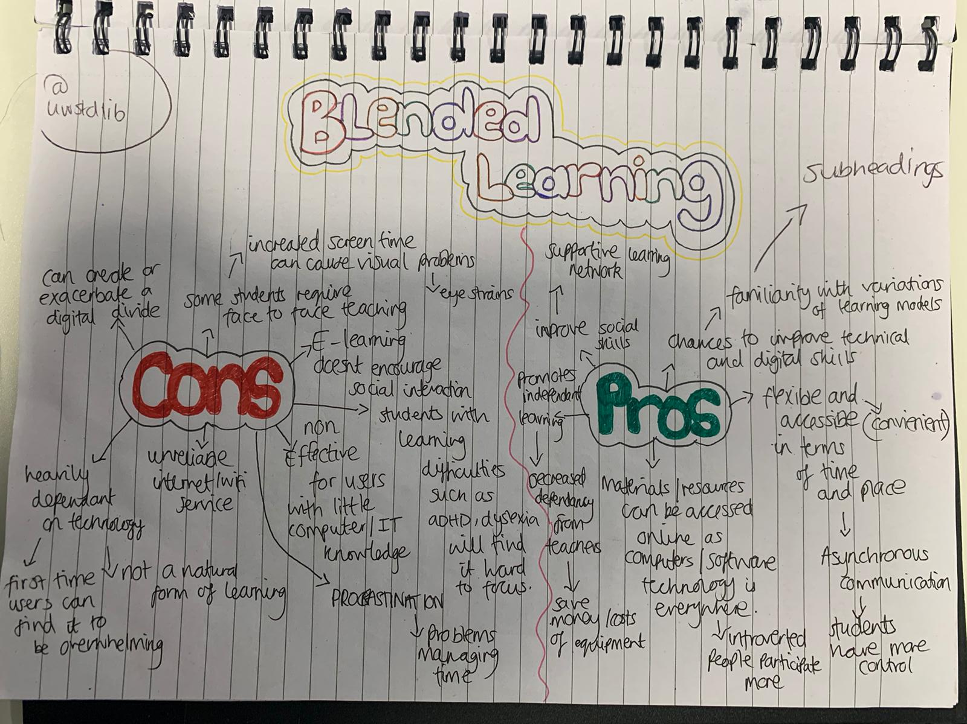
Appendix

Appendix 1

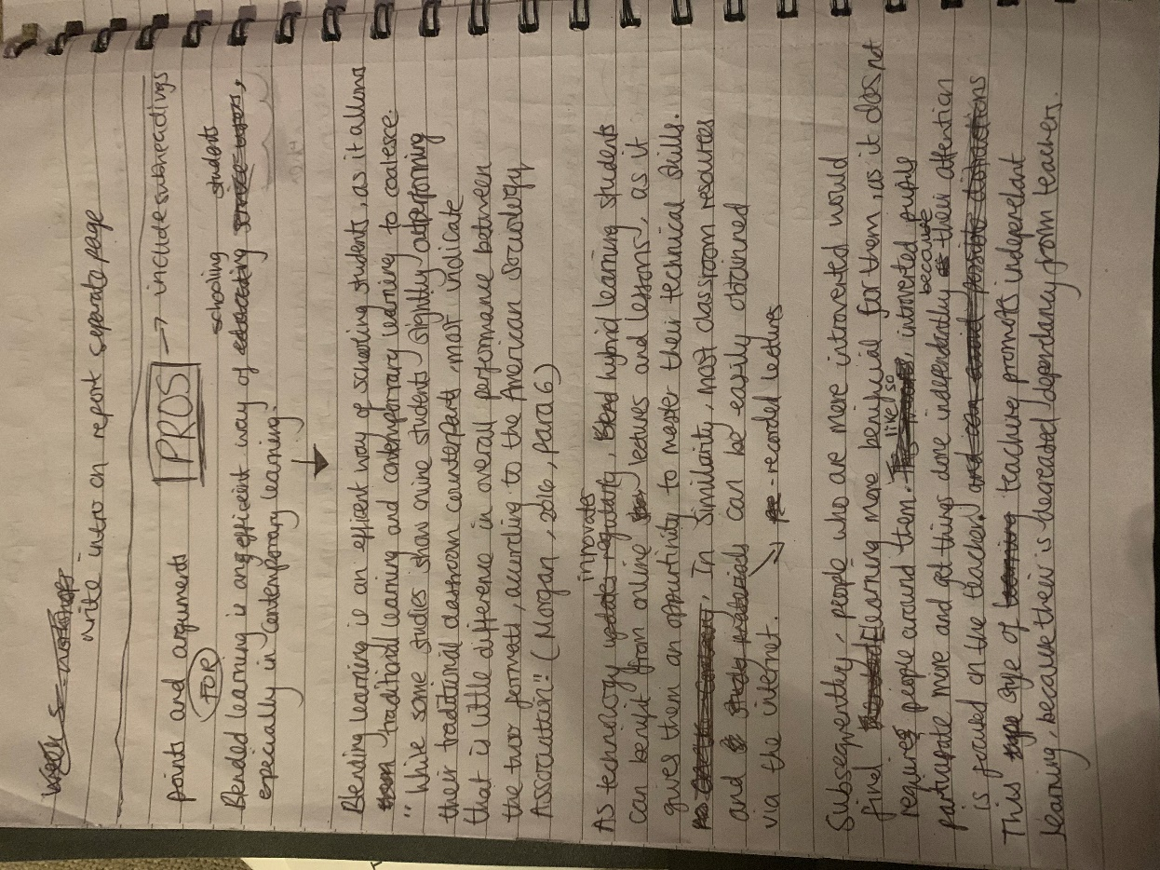
My planning for my report on blended learning

:

Appendix 2
Drafting my work out by hand

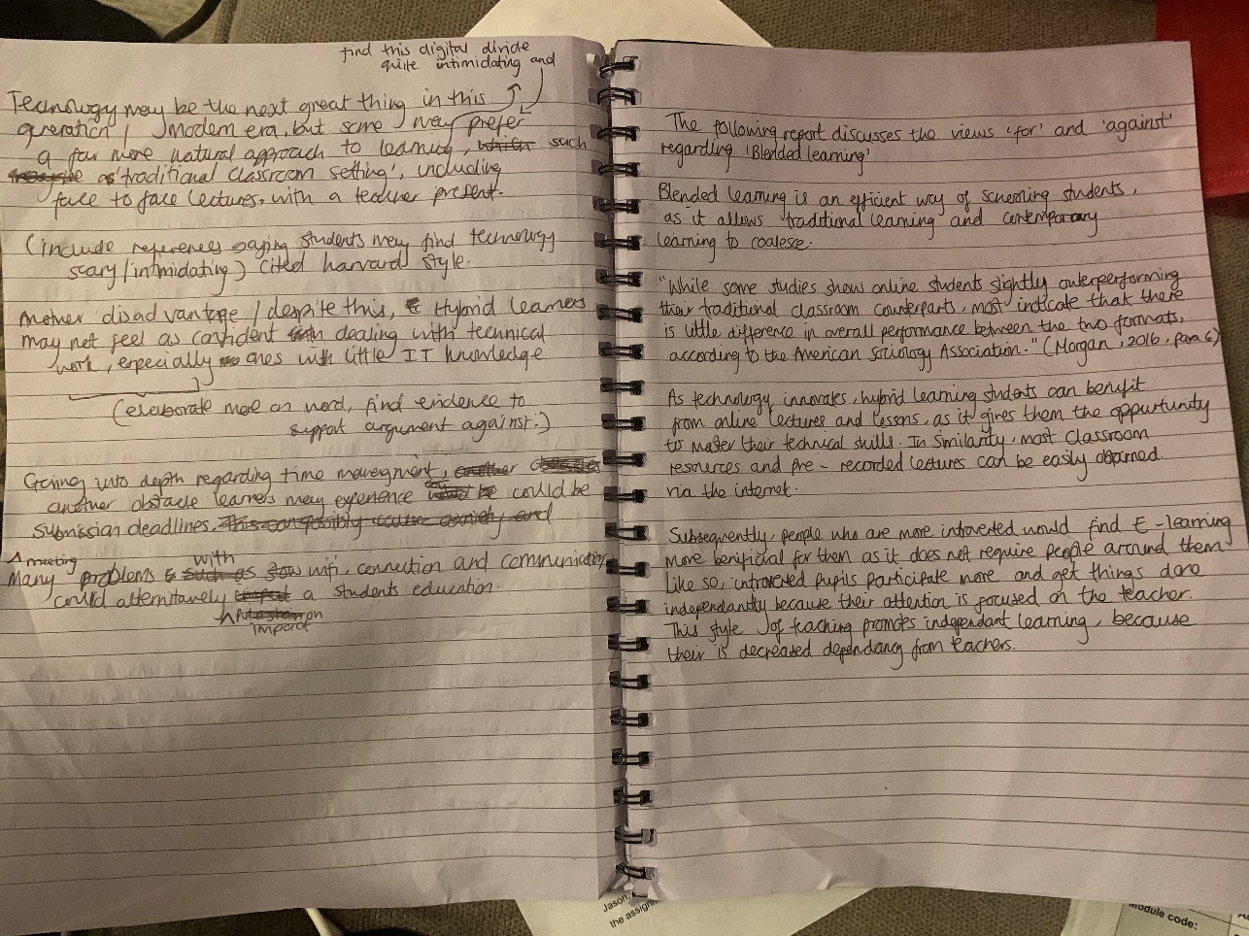

Appendix 3 : more drafting

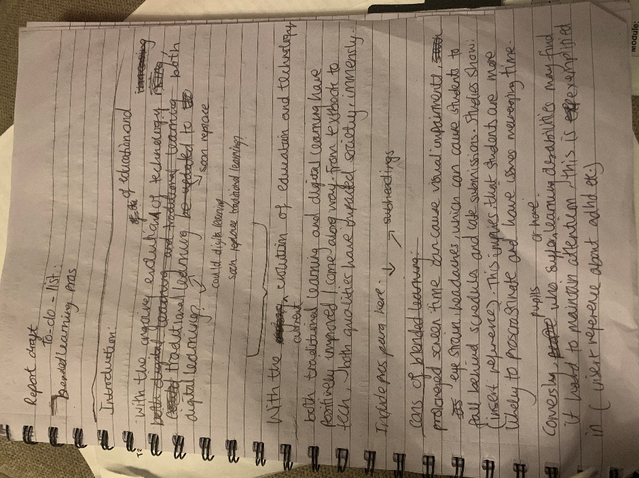

Appendix 4 : rough draft

