Student name: | Yagnik b bhakhar | Student ID number: | 2431085
Programme: | Master of Business Administration
Module: | International Marketing: Principles and Practices
Module code: | LCMB7026 | Contribution to Overall Module Assessment (%): | 100%
Lecturer: | Mustakkima Afrin | Internal Verifier: | Vasilios Tavlaridis Hoang Nguyen
Assignment Title: | Assessment component 1: Individual report | Word count (or equivalent): | 5480
Submission deadline: | 24th April 2026 by 2PM | Return date of provisional marks & written feedback: | 19th May 2026
LEVEL 7 ASSESSMENT SPECIFICATION

Assignment Title: Assessment component 1:

Individual report

Report on the International Marketing Mix of Zara in India and the UK

Table of Contents
1. Section 1 4
a. A comparative analysis of the market in India and the United Kingdom 4
b. A comparative analysis of STP and International Marketing Mix (7Ps) strategies in India and the United Kingdom 7
c. An analysis of the brand’s directional development strategy in India 14
d. Evaluation of possible ethical issues related to this brand’s marketing mix in both countries 16
e. Recommendations on how this company should go forward with their international marketing strategies 18
2. Section: 2 22
3: Conclusion 26
Reference List 27
Appendices 33
Appendix 1: Hofstede’s cultural dimensions of Indian market 33
Appendix 2: Marketing Mix strategy of Zara 33
Appendix 3: Market positioning of Zara 34
Appendix 4: Social media followers of Zara 34

Executive Summary
The report is a critical analysis of the global marketing platforms of Zara in India and the United Kingdom and the adaptation of the company to suit the different markets. Through the PESTEL analysis, the paper determines the main macro-environmental differences in the form of price sensitive, culturally diverse market in India and mature, sustainability-oriented environment in the UK. The STP and 7Ps models indicate that Zara follows a niche, premium positioning in Indian market, and broader, value-based strategy in the UK market. The analysis also reveals that India is strategically shifting towards optimisation and not expansion with the help of omnichannel integration and selective growth. Both markets however have ethical issues like sustainability, labour practices and transparency in the supply chain. The report suggests the move to a circular fashion system, AI-enhanced localisation, blockchain-based transparency, ethical branding and low-carbon logistics. These measures are meant to increase its competitiveness and design its operations throughout the world as per the changing consumer demands and sustainability requirements.

1. Section 1

a. A comparative analysis of the market in India and the United Kingdom
Comparative macroenvironmental analysis using PESTEL framework
The globalised marketing of Zara across India and the United Kingdom signifies the association of contrasting macro-environmental impact which has been reflected below using PESTEL framework. In the context of macro-environmental assessment, frameworks like PESTEL are highly effective due to its major emphasis on the evaluation of different external factors like political, socio-cultural, economic, technological, legal, and environmental factors in line with their significant impact in the organisational settings as per Buye, (2021 p. 4).
PESTLE Factors | India | United Kingdom
Political Factors | India has a more complicated regulatory environment as compared to the UK (Vijayagopal et al., 2024 p. 8). An example is the recent tax reforms by India, which raised the GST of mid-range apparel taxation to 18% instead of 12%, which directly affects the pricing strategy and the demand of Zara among price-sensitive consumers in India (Kalra, 2025). | The UK on the other hand has a stable regulatory environment with fewer price distortions (Kalra, 2025). The 2025 India-UK Free Trade Agreement would however lead to a decrease in tariffs and an increase in bilateral fashion trade as per Jhawar (2022, p. 8) which could lead to a reduction in sourcing prices of Zara in the UK market.
Economic Factors | The fashion market in India is also fast growing, estimated to hit up to 60 to 80 billion USD by 2026 due to the increasing incomes of Indians and urbanisation (TKC, 2025). Nevertheless, the growth is not smooth, and the prices are highly sensitive and are challenged by home value brands (Zheng, 2025). An increase in revenues of Zara has decelerated in India, even though profitability is improving, which means that it is already saturated and the competition is intense (Aleem, 2026, p. 4). | The UK on the other hand is a more established and high-income market with stable demand but reduced growth and thus Zara needs to concentrate on efficiency and high-end positioning and not expansion (Vijayagopal et al., 2024 p. 2). Onifade et al. (2021 p. 3) states that such economic differences affect the decisions of standardisation vs. adaptation in global marketing.
Social Factors | The young population of India and the increasing number of middle classes are trend-following, inexpensive-style fashion consumers, yet the cultural diversity demands the localisation of fashion styles and sizing (Kumar, Kulkarni and Rathi, 2022, p. 3). Zara reacts with few stores in metro urban areas and selective product adjustment. | In the UK, consumer tastes are focused on sustainability and ethical sourcing, and Zara has to adapt to the trends of ESG standards (Onifade et al. 2021, p. 9). As observed in the study of Dona, Campus, and Lanka (2025 p. 5), brand perception in developed countries is becoming more influenced by social values.
Technological Factors | As per India Today, (2024), the fast digitalization of India is thriving above 800 million smartphone customers which has motivated the omnichannel strategy of Zara, such as product tracking in apps and in-store technology adoption | A high level of logistics and e-commerce infrastructure in the UK is facilitating a quicker supply chain and faster delivery, as well as greater inventory turnover, to support the global standardisation model of the supply chain used by Zara (Dona, Campus, and Lanka, 2025, p. 3).
Environmental Factors | As it is increasing the awareness of sustainability, India is cost-oriented, and it does not allow premium pricing of sustainable goods (Dharan, 2025, p. 6). | In the UK, the pressure on sustainability is greater because of regulatory extremism and consumer activism, which require Zara to market environmentally friendly collections (Kurt and Yolaçan, 2024, p. 2).
Legal Factors | The legal environment of India mandates the company to adhere to guidelines related to GST compliance, labour laws, and the Consumer Protection rules influencing the e-commerce policies and pricing transparency (Sharma and Bhadoria, 2024, p. 6). Moreover, the Digital Personal Data Protection Act is also involved in safeguarding the data and digital functioning at the company (Ranjan, 2024, p. 1) | Within the market of the United Kingdom, more transparent and strict regulations are deployed, such as competition norms and the Consumer Rights Act 2015. These lead to standardise the return policies alongside ensuring greater consumer protection (Nannini, Balayn and Smith, 2023, p. 6).
Table 1: Comparative PESTEL analysis between India and the United Kingdom
Critical in-depth comparison of social factors
In the context of consumer behaviour and culture in the market of India, the collectivist culture, price sensitive behaviour, and occasion-based buying behaviour significantly (Kumar, Kulkarni and Rathi, 2022, p. 4). It needs to address seasonal relevance in light of designing collections based on the diverse Indian cultural events like Diwali and other festivals (Ranjan, 2024, p. 6). The value consciousness of the Indian customer in line with high price sensitivity leads them to evaluate the switching cost and embed comparative buying behaviour (Kumar, Kulkarni and Rathi, 2022, p. 7). The cultural dimensions of Hofstede as mentioned by Dhingra, Srivastava, and Srivastava (2024, p. 8) emphasised on the Indian collectivist societies, indicating high social influence on the fashion choices and buying behaviour [Refer to Appendix 1].
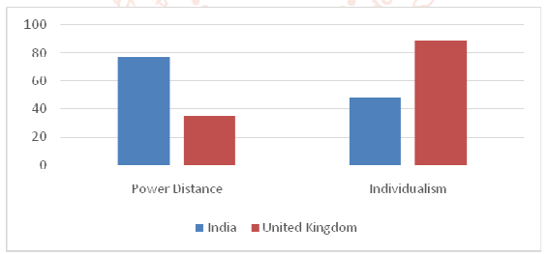
Figure 1: Comparative projection of Individualistic culture between India and the UK
(Source: Khan, 2021)
In contrast, self-expression and individualistic consumption behaviour has been detected in the United Kingdom according to Khan (2021, p. 7). It implies the priority of the population toward high convenience, personal collection, and brand values compared to social validation and influence. Customers across this market highly tend toward ethical and sustainable fashion choices (Khan, 2021, p. 6). It imperatively influences Zara to ensure ethical sourcing, transparent reporting, and eco-conscious designing. As revealed by Jia et al. (2023, p. 5), identity signalling is in line with the ethical and sustainable consumption within developed industry.

b. A comparative analysis of STP and International Marketing Mix (7Ps) strategies in India and the United Kingdom
Comparative analysis of STP
A comparative STP analysis shows the strategic efficiency of Zara to differentiate marketing approaches in India and the United Kingdom to suit the diverse dynamics in both the countries (Khan, 2021, p. 9). Philip Kotler’s STP theory would support in reflecting how modern strategic marketing has been embraced by the enterprise and tailoring value proposition within the competitive market (Sagar et al. 2021, p. 2).
STP Bases | India | United Kingdom
Segmentation | In India, Zara implements the strategy of multi-layered segmentation with a combination of demographic comprising the age group of 18 to 40, geographic segmentation of metro cities such as Mumbai and Delhi, and psychographic segmentation integrating middle and upper-middle classes with high fashion consciousness and aspirational mindset (Wijeweera, 2024, p. 2). It is also important with behavioural segmentation since consumers are occasion driven and value conscious. | On the contrary, the UK segmentation is more lifestyle and behavioural as it targets fashion-conscious people with different income levels, and sustainability-conscious people and heavy online buyers are the key priorities (Wiltshire and Cousins, 2026, p. 3). The relatively homogeneous urban structure of the UK can also be covered over a wider geographic area than the fact that India has a concentrated retail footprint.
Targeting | Zara in India pursues the selective or niche targeting approach and targets wealthy urban consumers that are interested in the global fashion trends yet price conscious (Khan, 2021, p. 3). The exclusivity is supported by a small store presence and high prices (Kumar and Madan, 2021, p. 5). | On the other hand, Zara in the UK uses mass-affluent targeting strategy, which targets a broader group of middle- to high-income buyers (Xia, 2023, p. 4). Zara is able to reach various customer groups effectively due to its large number of stores and good integration of e-commerce. This is in line with the knowledge of Philip Kotler, who conveys that market maturity determines the scope of targeting strategies (Acharyulu, 2022, p. 6)
Positioning | Zara is an aspirational high-end fast-fashion brand, which in India represents global lifestyle and prestige (Gasamáns Gesto, 2023, p. 7). The brand is capitalizing on scarcity as evidenced by few stores and curated collections to create the sense of exclusivity (More, 2024, p. 8). | In the UK, Zara has positioned itself as a trend-oriented, affordable fast-fashion leader, balancing fashion, speed and growing sustainability attributes (Kurt and Yolaçan, 2024, p. 5). Brand value in this case is not status-driven but rather an immediacy-based and ethically agreeable value. Urdea, Constantin, and Purcaru (2021, p. 8) states that ethical and experiential aspects are becoming more and more a part of the positioning of the developed markets.
Table 2: Comparative analysis of STP in between Indian and the UK market of Zara
Hence, the STP strategy as applied by Zara demonstrates the niche positioning in India compared to scalable positioning in the UK, indicating the variations in the earning distribution, consumer maturity, and cultural expectations.
Comparative analysis of International Marketing Mix (7Ps) strategies
The 7Ps marketing mix framework helps to focus on 7 fundamental elements of marketing strategies including Product, Price, Place, Promotion, People, Process, and Physical Evidence as highlighted by Sadri and Aprianingsih (2025, p. 7). The comparative assessment of 7Ps marketing mix would indicate the various strategic approaches of Zara for marketing its product in the market of India and the UK corresponding to the contemporary cultural and economic environment.
Product Strategy
Zara is based on the globally standardized fast-fashion model but selectively adapts. In India the product mix is also limited and includes western based apparel with modest changes including longer hemlines and festival-based designs like Diwali (More, 2024, p. 5). This is a sign of cultural diversity and consumption based on occasions.
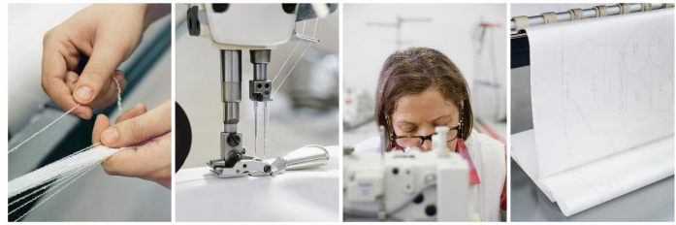
Figure 2: Sewing workshop by Zara
(Source: Gaudó, 2025)
The UK market, in its turn, is provided with the entire range of products that is updated regularly and with the help of increased inventory turnover (Aleem, 2026, p. 4). The consumers in the UK require trendiness and diversity, which Zara should provide with its nimble supply chain. Ugwuoju (2025, p. 3) confirms the fact that the culturally diversified markets demand more product localisation.
Price Strategy
Purchasing power reflects the differences in pricing. In India, Zara uses a high pricing strategy, where it positions itself as an aspirational brand among the upper-middle-income earners (Gaudó, 2025, p. 8). Although revenue in the past few years has reported to approximately ₹2,562 crore as per The Economic Times (2023), increased price sensitivity and competition with domestic brands has impacted the growth of the company.
Zara in the UK uses the value-based pricing strategy, which means that the products are comparatively cheap among the middle-income earners. When there are frequent sales and markdowns, this enhances access (Gaudó, 2025 p. 5; Ugwuoju, 2025 p. 4). As argued by Dong and Li, (2025; p. 7), competitiveness in the markets is defined by perceived value and not the absolute price.
Place (Distribution) Strategy
Zara in India employs the selective distribution model where the company has about 2022 stores located in high end malls in cities like Mumbai and Delhi. Such a small footprint doubles exclusivity and controls logistical issues (Das, 2022; p. 9). E-commerce is growing but with limitations due to differences in infrastructure.
Zara is pursuing an intensive omnichannel strategy in the UK as it has extensive physical outlets and well-optimized online interfaces (Gaudó, 2025; p. 5). High-tech logistics will make delivery speedy and a smooth click-and-collect experience, which will be more convenient and satisfying to customers.
Promotion Strategy
The promotion of Zara in India is sparse and brand-focused and involves store design, excellent retailing position and word-of-mouth instead of intensive advertising (Gaudó, 2025; p. 6). There is an increase in digital interaction, which is becoming less personalised.
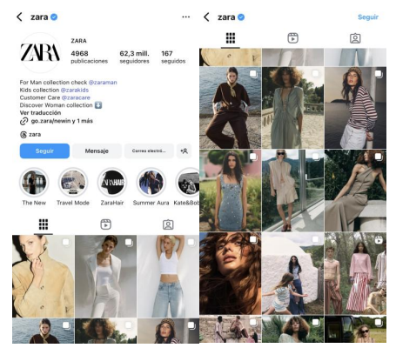
Figure 3: Zara's Instagram as social media channel of promotion
(Source: Gaudó, 2025)
The UK approach, in its turn, is digitally aggressive, using apps, social media, and marketing based on data. One of the major promotional themes is sustainability, which is a consumer expectation (Jhawar, 2022; p. 7). As Gaudó (2025; p. 8) emphasizes, the ethical branding matter is vital in developed countries, which affects the UK communication strategy of Zara.
People Strategy
A high-touch customer service facility is organised by the company Zara in India since in-store shopping assistance is highly expected by the customers (Nguyen, 2023; p. 9). Here, the buying decisions are influenced by the in-house staff.
On the other side, self-service oriented store design is constructed by Zara in the market of the United Kingdom since customers in this industry prioritise autonomy and efficiency (Gaudó, 2025 p. 7). It signifies culture-based variation between collectivist and individualist markets.
Process Strategy
Zara fosters a vertically integrated supply chain management process in line with the operational management based on advanced design-to-retail cycle as per Sanni (2024, p. 7). Moreover, it is to be noted that Indian outlets of Zara are required to address the logistical issues followed by the longer replenishment cycles (Nguyen, 2023 p. 8).
In the UK market, Zara ensures the process with the support of real-time inventory tracking, faster stock optimisation, and smooth returns systems. Integration of process efficiency aligns higher intricacy across the developed market due to the convenience-based priorities among the customers.
Physical Evidence
Consistent and visual merchandising store design in line with premium ambience and minimalist layouts are followed by the brand. In the Indian market, it reinforces brand visibility and appeal by placing its outlets across premium luxury malls (More, 2024, p. 6).
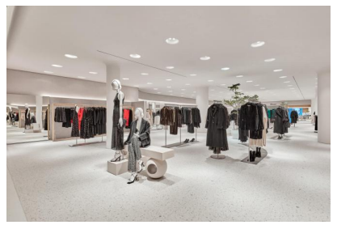
Figure 4: Zara's in-store physical outlet
(Source: Gaudó, 2025)
In the UK market, the store design is based on the focus of sustainability cues including recycling practices and use of eco-friendly materials (Gaudó, 2025 p. 8).

c. An analysis of the brand’s directional development strategy in India
A directional development analysis of Zara in India reveals that there is a distinct change of the rapidly growing model to technology-based profitability plus selective growth paradigm due to changing market conditions (Wiltshire and Cousins, 2026 p. 9).
Expansion to Optimisation in Strategic Direction
The initial approach of Zara in India, after entering through the JV with Tata Group was on the positioning of the premium brand in the metro cities. Nevertheless, there has been a shift in strategic direction as seen in recent performance data. Zara India posted stable revenue growth amounting to 2782 crore in FY2025 with a 23% increase in profit, suggesting that Zara India has started to focus on efficiency and margin improvement rather than rapid growth (TOI, 2025).
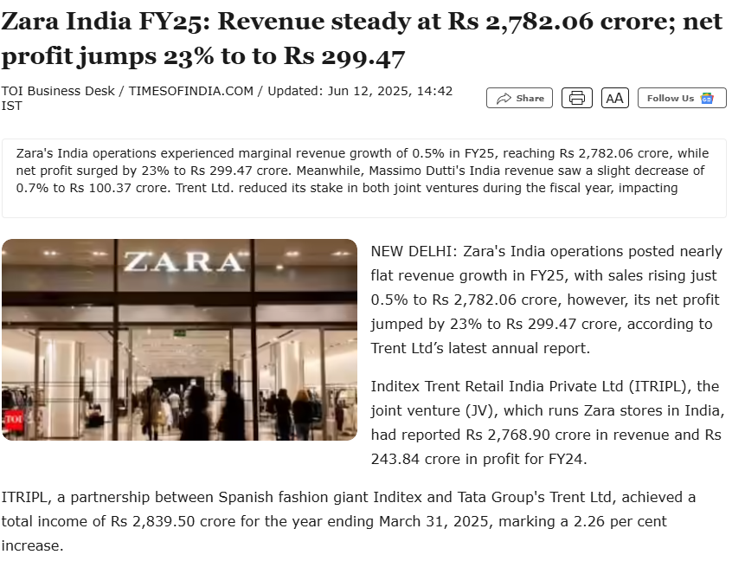
Figure 5: Zara India’s strategic expansion to optimisation
(Source: TOI, 2025)
This is in line with international strategic tendencies of the parent company Inditex, where optimisation and profitability of the stores is of primary focus rather than an increase in store count (TOI, 2025). The modern international business theory claims that firms in emerging markets usually shift their market entry into consolidation once the growth begins to slow down as per Huang (2023 p. 6) which has been observed in the case of Zara in India.
Omnichannel and Tech-based Growth
Online transformation and integration of the omnichannel is one of the main pillars of Zara in India directional strategy. By 2025, Zara will have 22 stores and an online platform that is entirely integrated with further investments in in-store technology and online interfaces (ET, 2025).
Instead of aggressively expanding into the Tier-2 cities, Zara is spending its funding on store restructuring, digital in-store inventory, and online-offline fluidity (ET, 2025). This is indicative of a phygital approach to retail, in which the tech improves the customer experience and the efficiency of operations. Intelligent integration of omnichannel is highlighted in scholarly studies as the problem in the emerging markets that have high mobile penetration but unbalanced physical infrastructure, therefore, integrating Zara would be strategically aligned with the digital consumption trends of the Indian market (Huang, 2023 p. 5).
Premium Positioning and Selective Expansion
Zara maintains a restrained physical growth, targeting areas that have high performances (Aleem, 2026 p. 3). New locations in Pune and Bengaluru, as well as renovations on flagship locations in Delhi, suggest a quality-not-quantity strategy.
This is an indication of a market penetration strategy and an approach of market consolidation and not diversification (LY, 2024 p. 7). Zara is not trying to enter new geographies aggressively; it is reinforcing its presence in the already established urban clusters (Dharan, 2025 p. 4). Also, Inditex has enhanced its grip on its India business through re-engineering joint ventures and ownership stakes, which have been indicators of long-term strategic investment (ET, 2025). Moreover, it can be stated that this relates to the applications of the Ansoff matrix in which Zara focuses on market penetration and operational control in a high-potential market that has already matured.
Strategic Response to Market and Competitive Challenges
The increasing competition and price elasticity in India also influence Zara's strategic direction. Brand entry and expansion such as H&M, Nike, and UNIQLO, and powerful local competitors have slowed the sales growth despite increasing profits (TOI, 2026). On account of resolving the concern, Zara is concentrating on the following strategic plans -
- Optimisation of Supply chain and cost efficiency (ET, 2025)
- Selective merchandise transactions to minimize inventory risk (ET, 2025).
- Fostering the aspirational brand positioning without any effect on pricing strategy (TOI, 2026).
It is an attempt at a defensive, but dynamic policy, which is between exclusivity and operational resilience.
Global Strategic Integration
The India strategy of Zara is similar to the global direction of Inditex that has an investment of two and a half billion euros in upgrading stores, logistics, and digital infrastructure in 2026 (TOI, 2026). The company is focusing on larger, more efficient stores and greater integration into the online world around the world, as opposed to adding more stores.
India can be described using this model as a long-term growth market and not a volume-oriented market. As described by Onifade et al. (2021 p. 6), multinational companies shift towards global strategies more often, achieving global efficiency and local responsiveness, which is reflected in the India business of Zara.

d. Evaluation of possible ethical issues related to this brand’s marketing mix in both countries
Overproduction and Sustainability Issue in Production
The fast-fashion concept that Zara has adopted, and its features of quick production and short product life have become a subject of significant environmental concern (Silverstein, 2022). It has been reported that the industry adds to approximately 10 percent of carbon emissions in the world and is also a leading producer of high-water consumption where Zara is a main stakeholder in this paradigm (Wolff, 2023). Even though Inditex has embarked on a path of being circular and using sustainable materials, according to independent assessments, Zara has a score of less than 50 percent in environmental sustainability indicators, which is minimal given its market size (Silverstein, 2022).
In the UK, these problems are more evident as they are subject to high consumer awareness and scrutiny by the regulators. In 2025, an investigation into waste discarded fast-fashion clothes, including those of Zara, revealed that they were dumped in covered wetlands in Ghana, a spotlight of the UK fast-fashion consumption waste on the planet (Kilbridge, 2025 p. 8). Awareness is increasing in India but because of the lower regulatory enforcement and price sensitivity, such environmental concerns are less focal to the purchasing decision making which is ethically questionable in terms of discrepancy in sustainability standards in the dissimilar markets (Srivastava and Gupta, 2023 p. 7).
Issue of Transparency and Labour Exploitation
The cost-effective supply chains that Zara uses to facilitate its competitive pricing strategy is also facilitated by the fact that such supply chains have traditionally been associated with labour exploitation (Bafna, 2023). Loans in the industry have revealed that garment workers have extremely low wages, at times even below the threshold of the living wage. Historical accusations of Zara include working conditions in sweatshops, underpayment, and excessive workload, and they are currently being investigated in some of its stores in Europe as late as 2023 (Quiroz, 2024).
As part of its supply chain, a study by Agrawal (2024) linked Zara reported deforestation, land grabbing and human rights abuses in Brazil, despite its scheme of certified sustainability. This brings up important ethical concerns of greenwashing and lack of traceability. The fast-fashion companies usually resort to so-called ethical distancing, when the complexity of the supply chain hides the liability (Jhawar, 2022 p. 5). This is true of both UK and India, but the UK consumers are more prone to question such practice.
Cultural Sensitivity and Campaign Misrepresentation Challenge
Criticisms of culturally insensitive marketing campaigns have occurred several times in Zara, and it suggests some ethical issues with global standardisation of promotion (Agrawal, 2024 p. 3). One of the prominent campaigns in 2023 was even accused of similarity to the imagery in conflict regions, and the advertisements were removed amid public outrage (Quiroz, 2024 p. 6). These matters are especially delicate in international markets such as India where cultural differences require subtle communication approaches. The relatively standardised promotional strategy that Zara has, however, is a risk of cultural misunderstanding and the absence of moral sensitivity (Dona, Campus, and Lanka, 2025 p. 7). Reputational risks are more immediate and serious in the UK because the backlash is amplified with the help of social media (Agrawal, 2024).
Challenge in Place and Distribution Ethics
The distribution model of Zara focuses on speed and in most cases, it utilises carbon intensive logistics like air freight. Inditex, in the year 2024, announced that transport emissions leading to 2.6 million tonnes of carbon had reported a 10% rise because of the rise in air transport according to Reuters (2025). This brings ethical issues of inconsistency between sustainability messages and actions of Zara. Although these types of emissions impact the global supply chains in general, it is especially pertinent to the UK, where the demands on sustainability are greater (Dona, Campus, and Lanka, 2025). In India, ethical conflict is not as pronounced but it matters even as much as a global responsibility.

e. Recommendations on how this company should go forward with their international marketing strategies
Faster changing Fast Fashion to Responsive Sustainable Fashion
It is time that Zara goes beyond measuring its sustainability in small steps and adopts a closed-loop production system with recycling, resale, and repair services built into its operations in India and the UK (Zheng, 2025 p. 6). As an example, circular consumption can be motivated by providing store credit schemes with in-store garment return kiosks. This in India can be initially piloted in the metro cities whereas in the UK it can be scaled nationally since there is greater awareness of sustainability. This is in line with the Circular Economy Model, which puts emphasis on resource efficiency and lifecycle extension as per Masnec, Hrustek, and Kutnjak (2025 p. 4). It is also a reaction towards an increasing regulatory and consumer pressure, especially in the developed markets. With the introduction of the idea of circularity in the product approach, Zara can minimize the need to over-produce and build more trust in the brand.
AI-Based Strategy Hyper-Localised Product and Pricing
Zara ought to take advantage of AI-based demand prediction and micro-segmentation and use these tools to adjust the assortment of products to local cultural and economic factors (Nannini, Balayn and Smith, 2023 p. 5). In India, it would be to increase the number of region-specific collections including climate specific fabrics and festival edits implement a tiered pricing system or diffusion lines to maintain price sensitivity without watering down brand equity (Wiltshire and Cousins, 2026 p. 5). In the UK, the sustainability-driven demand can be projected with the help of AI, and the percentage of eco-labelled products should grow (Gasamáns Gesto, 2023 p. p. 3). This tool is indicative of the data-driven marketing capability framework, which emphasizes that analytics can expand localisation and minimise inventory wastage.

Radical Supply Chain Transparency with the help of Blockchain
In order to mitigate ethical issues of labour and sourcing, Zara ought to introduce supply chain tracking with blockchain functionality where people could scan QR and track the origin of products, working conditions, and environmental impacts (Kurt and Yolaçan, 2024 p. 4). This approach addresses directly the problem of greenwashing and ethical obscurity. Such transparency can be a major point of differentiation in the UK where consumers expect accountability whereas in India it can slowly gain awareness and trust. Oriekhoe et al. (2024 p. 2) indicates that the blockchain increases credibility and trust in supply chains and stakeholders in the global retailing environment.
The Repositioning Promotion to Ethical Storytelling
In the UK, Zara needs to change a minimalistic approach to promotion toward a purpose-based communication (Gasamáns Gesto, 2023 p. 8). The worker welfare, sustainable sourcing, and circular initiatives and campaigns should be emphasized, and they should be supported with verifiable data. Promotions in India need to be aspirational branding and culturally sensitive, local influences and local storytelling instead of standardisation across the board. This is in line with the Integrated Marketing communications (IMC) model that focuses on consistency with local relevance according to Niu (2021 p. 7).
Re-design Distribution based on Low-Carbon logistics
Zara needs to invest in regionalised supply centres and green logistics, eliminating the use of airfreight. As an illustration, nearshoring of production to the UK market and more local sourcing in India could greatly reduce emissions (Gasamáns Gesto, 2023 p. 4). This is in line with the framework of Triple Bottom Line, which balances the economic, environmental, and social performance as per Chowdhury et al. (2021 p. 5). In the UK this would conform to higher ESG expectations whereas in India it would have the ability to enhance cost effectiveness and responsiveness.

Retail and Service Innovation (People and Process) Experiential
Technology-based personalisation such as introducing smart fitting rooms and styling suggestions with apps should be improved in the in-store experience of Zara retail outlets (ET, 2025). Staff training in India should be done on consultative selling as high-touch service expectations (Aleem, 2026 p. 6). In the UK, the focus should be on self-service efficiency with the help of digital tools. This is indicative of the Service-Dominant Logic where resultant value is achieved by creating a customer experience instead of merely delivering a product (Zheng, 2025 p. 4).
Implement Ethical KPIs and Accountability by the market
Lastly, Zara needs to incorporate market-specific ethical performance indicators, e.g., carbon footprint per product (UK) and applying fair wages (India), as part of its strategy (ET, 2025). The KPIs qualify to be publicly disclosed to promote accountability and stakeholder confidence.

2. Section: 2
A reflective account is a guided approach of critically assessing the process of learning, decisions and outputs in order to uplift performance in the near future. It enables one to learn more about the way of knowledge construction and application to practice. In this evaluation, the reflective process will be directed through the framework of the Gibbs Reflective Cycle of Graham Gibbs, composed of six steps, namely description, feelings, evaluation, analysis, conclusion and action plan (Jin, 2021 p. 2). This paradigm allows reflecting on the research, analysis, and preparation of international marketing reports on Zara in India and the United Kingdom in a systematic manner.
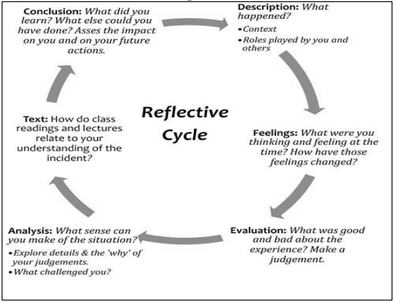
Figure 6: Gibbs Reflective Cycle
(Source: Oviawe, 2020)
Description
I initiated the process through identifying the scope of the report, which involved the analysis of the international marketing mix and macro-environment of Zara in the frameworks of PESTEL, STP and 7Ps. The collected data was based on a mix of academic publications, industry reports, and reputable news outlets. The research stage entailed the comparison of two different markets, which included India and the United Kingdom, to distinguish the major differences in terms of consumer behaviour, economic factor and regulatory roles. In line with accumulative industry insights, I procedurally used different theoretical frameworks to organize the analysis. As an example, macro factors were assessed using PESTEL, whereas the marketing strategies were measured with the help of STP and 7Ps. The last step was to evaluate findings into a coherent report whereby there was consistency with theory with real-world data and critical analysis (based on section 1).
Feelings
First, I was sure that I chose Zara because of its international character and its applicability to international marketing. Nonetheless, I faced difficulties in getting valid and current data as the study went on and especially in the Indian market whereby information was at times divided. This posed a degree of doubt as to the validity and comparability of data in different countries. Concurrently, I considered the process to be intellectually stimulating, particularly in the process of associating theoretical models with the business practices in the real world. The use of models like STP and PESTEL gave me more confidence to organize marketing and macroenvironmental assessment (Hong, 2025 p. 3). At the concluding point of the task, I was more confident in my analytical skills which contribute to spot areas in line with working on to improve the critical depth (Ruiz-Rojas, Salvador-Ullauri, and Acosta-Vargas, 2024 p. 4).
Evaluation
The extensive research capacity aligning academic theory and real-life evidence was one of my strengths. Application of recent evidence enhanced the topicality and the credibility of the analysis. Moreover, the analysis of two opposite marketplaces enabled making more informative conclusions regarding the strategies of adaptation and standardisation.
However, this also included constraints. There was a concern at times that the analysis would become very descriptive as opposed to a critical approach especially when data was presented without a critical examination of its connotations. Moreover, although I utilized more than one source, I could have used other peer-reviewed journals to enhance the academic rigour. Another challenge was time management since it was necessary to prioritise what depth should be done in the research and the number of words to be used (Steenkamp and Brink, 2024 p. 5).
Analysis
The process indicates fundamental academic ideas in reflective learning. In this regard, Taneja, Kiran, and Bose (2022 p. 6) emphasised on the experiential theory of learning indicating learning as a cycle of experience, reflective, conceptualisation and experimentation. The experience tied to researching the strategies of Zara and then reflecting on them with the help of Gibbs model matches the cycle.
Furthermore, the problem of having a balance between theory and real-time data indicates that critical thinking is an essential part of academic research (Rivas, Saiz, and Almeida, 2023 p. 7). According to Rivas, Saiz, and Ossa, (2022 p. 1), to become an effective reflector, one should go beyond description and ask questions, review evidence. In my scenario, the use of frameworks like PESTEL helped me to structure the information but the more critical analysis at a higher level like doubting the sustainability demands of Zara was necessary.
It also revealed the applicability of the evidence-based management concept guided by Wilcox, Fernandez Conde, and Kowbel, (2021 p. 2) in which the decision-making process and analysis are to be based on valid data. This further justified the essence of utilizing genuine sources and cross-verify information to achieve reliability.
Conclusion
To conclude, this report study on the International Marketing Mix of Zara helped me improve my skill of implementing marketing theories in practice. I gained more proficiency in comparative writing, data analysis, and systematic writing. Nevertheless, the reflection shows that the critical evaluation, source diversity, and time management should be enhanced. Gibbs Reflective Cycle contributed significantly in determining the strengths and weaknesses in my approach. It gave a clear structure by which I could not only judge what I did, but the manner in which I did it and why it happened so that I could draw a more meaningful conclusion regarding my learning process.
Action Plan
To enhance my performance in future assignments, I will embrace a number of strategies. To begin with, early planning and time allocation will be my priority, and there should be enough time to conduct research and critical analysis. Second, on account of enhancing theoretical foundation, I will increase the usage of peer-reviewed academic materials, especially published in high-quality journals.
Third, I will concentrate more on enhancing critical thinking through making assumptions when questioning, comparing, and assessing the implications of data instead of presenting them. Also, I will enhance digital proficiency and use more digital tools to manage the sources effectively.
Lastly, I will also carry on with the reflective models like Gibbs cycle to keep track of my learning outcomes and keep enhancing my scholarly and analysis skills.

3: Conclusion
Thus, the future international marketing approach at Zara needs to be developed into a model of a global, transparent and circular one in which global efficiency is matched by local responsiveness and ethical accountability. By introducing sustainability, digital intelligence, and cultural sensitivity to its marketing mix, Zara will be able to shift its approach towards adapting to changes to being proactive and responsible and show responsible leadership in the market, which will give it long-term competitiveness in India and the United Kingdom.

Reference List
Section 1
Acharyulu, A. R. (2022). Agility as a Driver of Marketing 5.0–Challenges for Marketing Professionals to Succeed in Market Space. IBA Journal of Management & Leadership, 13(2), 19.
Agrawal, V. (2024). The Environmental degradation of the Cerrado: Unraveling the impact of Fast Fashion’s Cotton Supply chain.
Aleem, A., (2026). Strategic Resilience in Fast Fashion: A Critical Analysis of Zara’s Competitive Positioning. Social Science Review Archives, 4(1), pp.1002-1015.
Aleem, A., (2026). Strategic Resilience in Fast Fashion: A Critical Analysis of Zara’s Competitive Positioning. Social Science Review Archives, 4(1), pp.1002-1015.
Bafna, A., (2023). From Design to Distribution, Supply Chain Strategies in the Fast Fashion Industry: Insights from H&M, Benetton, and Zara. Supply Chain Strategies in the Fast Fashion Industry: Insights from H&M, Benetton, and Zara (June 21, 2023).
Buye, R. (2021). Critical examination of the PESTEL Analysis Model. Project: Action Research for Development, 1-12.
Chowdhury, N., Faysal, G. M., Al, A., Shikder, R., and Moula, A. T. M. G. (2021). A study on sustainable fashion supply chain of zara. In 6th Int. Conf. Eng. Res. Innov. Educ., Sylhet, Bangladesh (p. 1).
Das, S.K., (2022). A REPORT ON INDIAN ORGANIZED RETAIL SECTOR AT CENTRAL FASHION MALL.
Dharan, A., (2025). Evaluating Pricing Strategies of Multinational Companies in India's Manufacturing Industry. Digital Repository of Theses.
Dhingra, D., Srivastava, S., and Srivastava, N. (2024). The impact of leadership styles, cultural dimensions and values on academic leaders. International Journal of Experimental Research and Review, 44, 76-90.
Dona, I. D. D. M., Campus, L. C., and Lanka, S. (2025). Sustainable Consumption: Unveiling the Rise of Ethical and Eco-Friendly Purchasing in Modern Markets. International Journal of Research and Innovation in Social Science, IX, 1735-1744.
Dong, P., and Li, X. (2025). Cultural identity and value perception as drivers of purchase intention: A structural equation model analysis of cultural products in Luoyang City. Sustainability, 17(3), 1317.
ET (2025). Zara India banks on tech-driven expansion amid sluggish sales growth. [online] ETRetail.com. Available at: https://retail.economictimes.indiatimes.com/news/apparel-fashion/apparel/zara-india-boosts-tech-innovations-for-growth-amid-stagnant-sales/123183007 [Accessed 16 Mar. 2026].
Gasamáns Gesto, L., (2023). A change beyond fast fashion: An analysis of Zara’s positioning and communication.
Gaudó, M. L. (2025). The ROLE of DIGITAL COMMUNICATION in GLOBAL FASHION BUSINESS: ZARA’S BRANDING STRATEGY.
Huang, H. (2023). Research on the importance of cross-cultural integration in international business management. In Modern Economics & Management Forum (Vol. 4, No. 6, p. 171).
India Today (2024). 80 crore out of poverty ‘simply by smartphones’: UN praises India’s digital boom. [online] India Today. Available at: https://www.indiatoday.in/india/story/unga-president-dennis-francis-indians-rural-poverty-smartphone-use-digital-revolution-2575491-2024-08-02 [Accessed 18 Mar. 2026].
Jhawar, H. (2022). An Analysis of Brexit Implications for India's Relations with the United Kingdom.
Jia, T., Iqbal, S., Ayub, A., Fatima, T., and Rasool, Z. (2023). Promoting responsible sustainable consumer behaviour through sustainability marketing: the boundary effects of corporate social responsibility and brand image. Sustainability, 15(7), 6092.
Kalra, A. (2025). India’s higher tax on clothing threatens setback for global fashion brands. Reuters. [online] 4 Sep. Available at: https://www.reuters.com/business/retail-consumer/indias-higher-tax-clothing-threatens-setback-global-fashion-brands-2025-09-04/ [Accessed 16 Mar. 2026].
Khan, M. R. (2021). Individual’s leadership style changes due to different culture in the UK. International Journal of Trend in Scientific Research and Development (IJTSRD), 5(3).
Kilbridge, R., (2025). From Trend to Trash: Unraveling the Waste Issue in Fast Fashion and its Impact on Ghana.
Kumar, G.S., Kulkarni, M. and Rathi, N., (2022). Evolving food choices among the urban Indian middle-class: a qualitative study. Frontiers in nutrition, 9, p.844413.
Kumar, H., and Madan, S. (2021). ESEE2: Zudio: Revolutionizing Affordable Fashion in India Through Strategic Cost Management and Offline Expansion. CASES SUBMITTED FOR PUBLICATION, 5.
Kurt, H.E. and Yolaçan, A.O., (2024). Examining the Relationship Between Sustainability Practices in the Textile Industry and Planetary Boundaries: A Qualitative Study of European Textile Companies, Their Environmental Impacts, and Compliance with Safe Limit.
LY, X. T. (2024). Fast Fashion. Available at: https://www.researchgate.net/profile/Xuan-Thu-Ly/publication/388221151_Fast_Fashion_CASE_STUDY/links/678fa7efec3ae3435a7336c4/Fast-Fashion-CASE-STUDY.pdf [Accessed 16 Mar. 2026]
Masnec, L., Hrustek, L., and Kutnjak, A. (2025, October). The Role of Sustainable Marketing in the Transformation of the Textile Industry Towards a Circular Economy. In 10th International Scientific Conference (CRODMA 2025): Book of Papers (pp. 149-159). Varaždin: Croatian Direct Marketing Association.
More, A., (2024). Analysing the Application of Behavioural Economics Principles in Zara's Marketing Strategy in India. Available at SSRN 5741625.
Nannini, L., Balayn, A. and Smith, A.L., (2023, June). Explainability in AI policies: A critical review of communications, reports, regulations, and standards in the EU, US, and UK. In Proceedings of the 2023 ACM conference on fairness, accountability, and transparency (pp. 1198-1212).
Nguyen, T., (2023). Zara’s organization apparatus: what is the key behind Zara's fast fashion success?.
Niu, H. (2021). Marketing Communication Strategy for International Fashion Retail Brands after COVID-19.
Onifade, A. Y., Ogeawuchi, J. C., Abayomi, A. A., Agboola, O. A., and George, O. O. (2021). Advances in multi-channel attribution modeling for enhancing marketing ROI in emerging economies. Iconic Research and Engineering Journals, 5(6), 360-376.
Oriekhoe, O. I., Oyeyemi, O. P., Bello, B. G., Omotoye, G. B., Daraojimba, A. I., and Adefemi, A. (2024). Blockchain in supply chain management: A review of efficiency, transparency, and innovation. International Journal of Science and Research Archive, 11(1), 173-181.
Quiroz, M., (2024). Fast Fashion: A Thorough Examination on Human Rights Violations in Bangladesh and Global Environmental Degradation
Ranjan, M. R. (2024). Digital Personal Data Protection Act 2023: Safeguarding Your Online Identity. Sustainable Development Goals & Business Sustainability, 108.
Reuters (2025). Zara owner Inditex’s transport emissions jump in 2024. [online] Reuters. Available at: https://www.reuters.com/business/retail-consumer/zara-owner-inditexs-transport-emissions-jump-2024-2025-03-14/ [Accessed 17 Mar. 2026].
Sadri, I., and Aprianingsih, A. (2025). Strategic Marketing Approaches Leveraging the 7P Marketing Mix Framework to Overcome Sales Challenges and Enhance Purchase Intention for IELTS Programs at Athena English Course. Journal of Research in Social Science and Humanities, 5(1), 120-125.
Sagar, S., Jadhav, R., Mehta, A., and Patil, S. (2021). BASICS OF MARKETINGMANAGEMENT.
Sanni, B. (2024). Customization and Flexibility in Entrepreneurial Supply Chains. https://www.researchgate.net/profile/Babatunde-Sanni-2/publication/386452912_Customization_and_Flexibility_in_Entrepreneurial_Supply_Chains/links/675199b2d11777322643844b/Customization-and-Flexibility-in-Entrepreneurial-Supply-Chains.pdf [Accessed 16 Mar. 2026]
Sharma, U. and Bhadoria, G., (2024). Legal Challenges and Regulations for E-Commerce Companies. Issue 3 Int'l JL Mgmt. & Human., 7, p.1314.
Silverstein, L. (2022). Is Zara Sustainable? [online] Medium. Available at: https://lexysilverstein.medium.com/is-zara-sustainable-338d3d00ac32 [Accessed 17 Mar. 2026].
Srivastava, V. and Gupta, A.K., (2023). Price sensitivity, government green interventions, and green product availability triggers intention toward buying green products. Business Strategy and the Environment, 32(1), pp.802-819.
The Economic Times, (2023). Zara logs 40.4% revenue growth in India at Rs 2,562 crore, profit up 77.6% to Rs 264 crore. https://m.economictimes.com/industry/cons-products/fashion-/-cosmetics-/-jewellery/zara-logs-40-4-revenue-growth-in-india-at-rs-2562-crore-profit-up-77-6-to-rs-264-crore/articleshow/100246358.cms [Accessed 16 Mar. 2026]
TKC (2025). Madhulika Tiwari decodes 25 Years of Indian Fashion Retail in 2025. [online] The Knowledge Company. Available at: https://tkc.in/the-transformation-of-fashion-retail-in-india-25-years-on/ [Accessed 17 Mar. 2026].
TOI (2025). Zara India FY25: Revenue steady at Rs 2,782.06 crore; net profit jumps 23% to to Rs 299.47. [online] The Times of India. Available at: https://timesofindia.indiatimes.com/business/india-business/zara-india-fy25-revenue-steady-at-rs-2782-06-crore-net-profit-jumps-23-to-to-rs-299-47/articleshow/121797484.cms [Accessed 17 Mar. 2026].
TOI (2026). India’s fashion appeal changes! Uniqlo, Nike gain ground; M&S, Adidas & others see muted growth. [online] The Times of India. Available at: https://timesofindia.indiatimes.com/business/india-business/indias-fashion-appeal-changes-uniqlo-nike-gain-ground-ms-adidas-others-see-muted-growth/articleshow/126541812.cms [Accessed 18 Mar. 2026].
Ugwuoju, E. C. (2025). Brand Localization versus Globalization: A Comparative Analysis of Adaptation Strategies in Diverse Markets.
Urdea, A. M., Constantin, C. P., and Purcaru, I. M. (2021). Implementing experiential marketing in the digital age for a more sustainable customer relationship. Sustainability, 13(4), 1865.
Vijayagopal, P., Jain, B. and Ayinippully Viswanathan, S., (2024). Regulations and fintech: A comparative study of the developed and developing countries. Journal of Risk and Financial Management, 17(8), p.324.
Wijeweera, S., (2024). Purchase intention increasing strategy: factors contribute to differentiate fast fashion clothes and sustainable fashion clothes.
Wiltshire, J. and Cousins, C., (2026). Fashion Marketing: Strategies, Trends and Innovation. Kogan Page Publishers.
Wolff, A. (2023). Zara and Sustainability: the High Cost of Low Prices. [online] The Fashion Globe. Available at: https://thefashionglobe.com/zara-can-never-be-sustainable/ [Accessed 15 Mar. 2026].
Xia, Y. (2023). The 4Ps of marketing and applications in various brands. Journal of Education, Humanities and Social Sciences, 16, 165-170. https://pdfs.semanticscholar.org/0063/9e03801397b6d20ee1c059da83663e8ce065.pdf
Zheng, X., (2025). Zara’s Fast Fashion Strategy: A Dual Analysis of Market Segmentation and Price Elasticity. Advances in Economics and Management Research, 14(1), pp.227-227.
Section 2
Hong, T. K. (2025). Guide to Developing an International Marketing Strategy Report. https://www.researchgate.net/profile/Kwan-Hong-Tan/publication/391636636_Guide_to_Developing_an_International_Marketing_Strategy_Report/links/68203dd1bd3f1930dd70682f/Guide-to-Developing-an-International-Marketing-Strategy-Report.pdf [Accessed 16 Mar. 2026]
Jin, L. K. (2021). Impact of Structured Reflective Writing on Adult Learners’ Knowledge, Skills and Attitude: A Case Study in a Manufacturing Organization. https://kwpublications.com/papers_submitted/17697/impact-of-structured-reflective-writing-on-adult-learners-knowledge-skills-and-attitude-a-case-study-in-a-manufacturing-organization.pdf [Accessed 16 Mar. 2026]
Oviawe, J. (2020). Application of Graham Gibbs model of reflection to improve teaching understanding among technical education students in Ambrose Alli University Ekpoma Edo State. Sumerianz Journal of Education, Linguistics and Literature, 3(2), 1201-2617.
Rivas, S. F., Saiz, C., and Almeida, L. S. (2023). The role of critical thinking in predicting and improving academic performance. Sustainability, 15(2), 1527.
Rivas, S. F., Saiz, C., and Ossa, C. (2022). Metacognitive strategies and development of critical thinking in higher education. Frontiers in psychology, 13, 913219.
Ruiz-Rojas, L. I., Salvador-Ullauri, L., and Acosta-Vargas, P. (2024). Collaborative working and critical thinking: Adoption of generative artificial intelligence tools in higher education. Sustainability, 16(13), 5367.
Steenkamp, G., and Brink, S. M. (2024). Students’ experiences of peer learning in an accounting research module: Discussion forums, peer review and group work. The International Journal of Management Education, 22(3), 101057.
Taneja, M., Kiran, R., and Bose, S. C. (2022). Critical analysis of Kolb experiential learning process: Gender perspective. International journal of health sciences, (I), 8713-8723.
Wilcox, G., Fernandez Conde, C., and Kowbel, A. (2021). Using evidence-based practice and data-based decision making in inclusive education. Education Sciences, 11(3), 129.

Appendices

Appendix 1: Hofstede’s cultural dimensions of Indian market
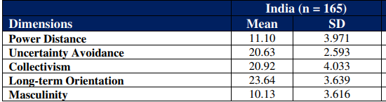

Appendix 2: Marketing Mix strategy of Zara
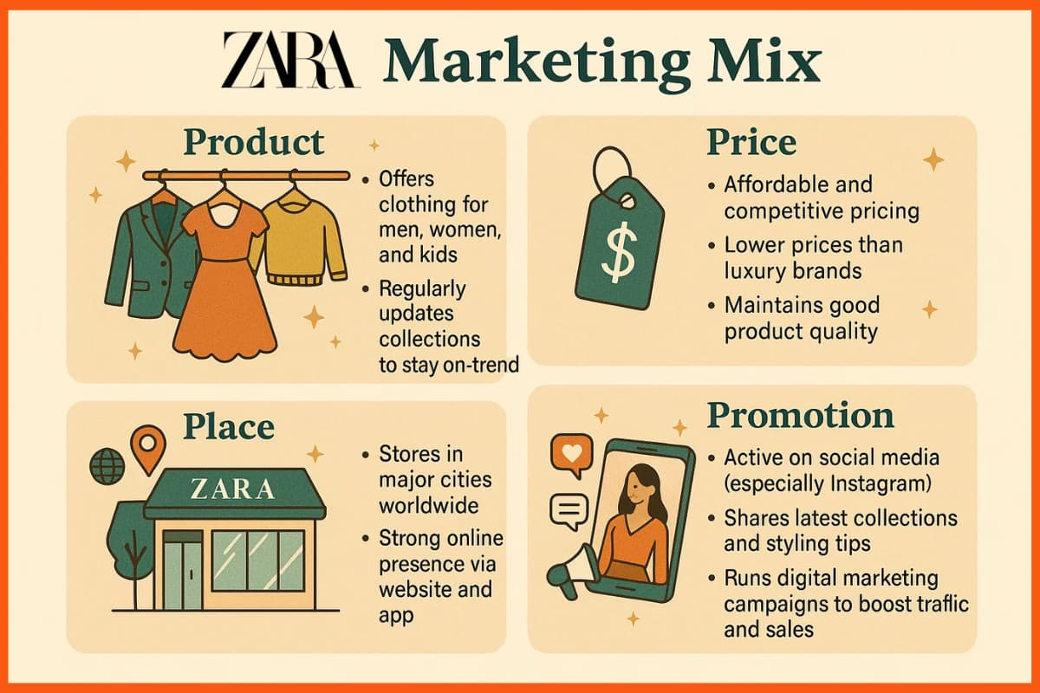

Appendix 3: Market positioning of Zara
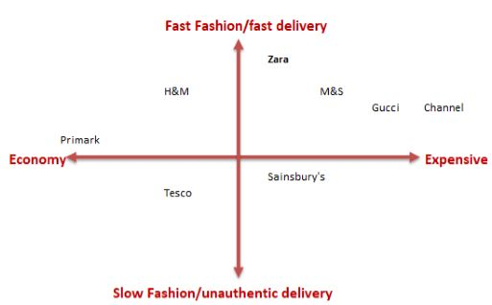

Appendix 4: Social media followers of Zara


