11/11/2025
Suneth Fernando
UNIVERSITY OF WALES ST TRINITY ST DAVID
IWD: Database Design and Development
Assignment 01

Table of content

Introduction to the case study
This case study I will be analysing and showcasing different types of way to store data I will also be showcasing what they look like across different platforms like Microsoft access and Visio which are the key source of operations for implementing them

Entity Relationship Diagram (ERD):
Take a screenshot of your ER- Diagram and Paste it here
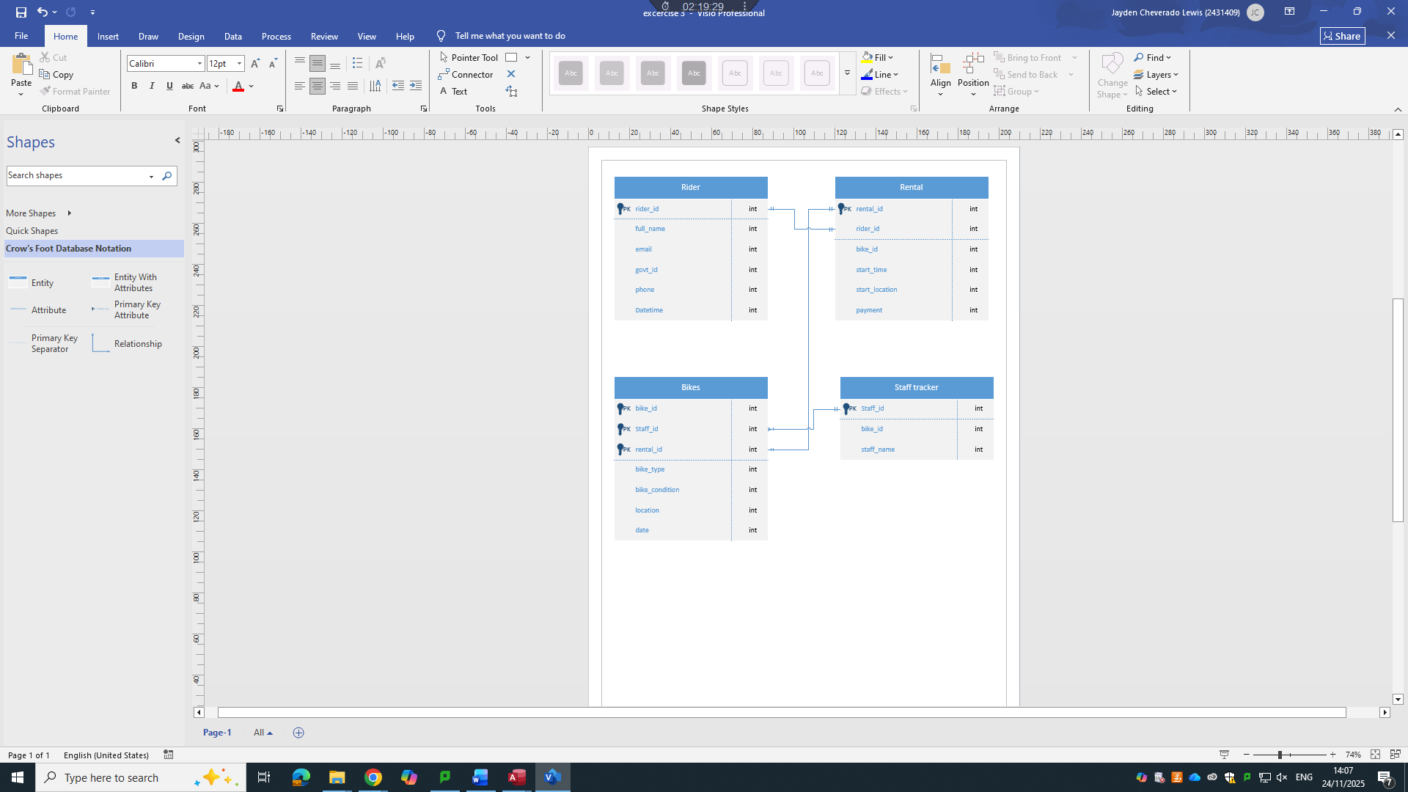

Type of Relationship between Entities (please explain each relationship with appropriate examples from the case study.)
One – to – One
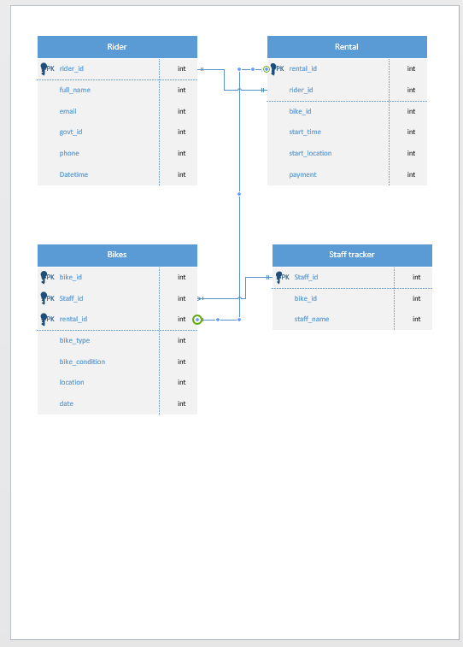
ERD (One to One)

In the realm of programming and operating systems, a One-to-One (1:1) relationship refers to a scenario where one instance of an entity is associated with exactly one instance of another entity. This type of relationship is the most restrictive and is used when two entities are tightly coupled but stored separately for design clarity, modularity, or security.
Conceptual Overview
A One-to-One relationship ensures that for every record in Entity A, there is a corresponding and unique record in Entity B. This relationship is often implemented using foreign keys in relational databases or pointers in data structures. It is particularly useful when an entity has optional or sensitive information that should be stored in a separate table or module.
Example in Operating Systems: Process ↔ Process Control Block (PCB)
One of the most illustrative examples of a One-to-One relationship in operating systems is between a Process and its Process Control Block (PCB). A process is a running instance of a program, and the PCB is a data structure maintained by the operating system to store information about that process.
• Process: Represents the active execution of a program.
•PCB: Contains metadata such as process ID, program counter, CPU registers, memory management information, and scheduling details.
In this relationship:
• Each process has one unique PCB.
• Each PCB is associated with only one process.
This design ensures that the operating system can manage processes efficiently, with each PCB acting as a control hub for its corresponding process.
Example in Programming: Object ↔ Configuration
In object-oriented programming, a One-to-One relationship might exist between an object and its configuration settings. For instance, consider an object in an application that has a corresponding object:
• Contains identity and profile information.
• Stores preferences like theme, notification settings, and language.
Here:
• Each user has one settings profile.
• Each settings profile belongs to one user.
This separation allows for cleaner code, better encapsulation, and easier maintenance.
Security and Modularity
One-to-One relationships are often used to isolate sensitive data. For example, in a system where user credentials are stored separately from user profiles, an entity might have a One-to-One relationship with an entity. This design enhances security by limiting access to authentication data and allows different modules to handle user data and login logic independently.
Implementation Techniques
In relational databases:
• A foreign key in one table references the primary key of another.
• Unique constraints ensure that the relationship remains strictly One-to-One.
In programming:
• Classes may contain references or pointers to other objects.
• Encapsulation and access control mechanisms enforce the relationship.
Benefits
• Data integrity: Ensures precise mapping between entities.
• Modularity: Allows separation of concerns.
• Security: Enables isolation of sensitive information.
• Scalability: Facilitates future extensions without disrupting core logic.

Let me know if you'd like this formatted into a document or expanded with diagrams and code examples!

One – to – Many
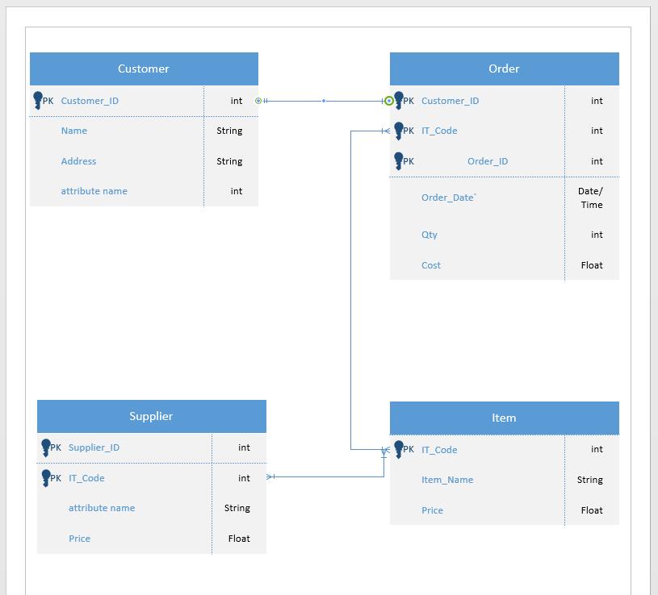
In programming and operating systems, a One-to-Many (1: N) relationship describes a scenario where a single instance of one entity is associated with multiple instances of another entity. This is one of the most common and practical relationship types used in data modelling, system architecture, and software design. It reflects hierarchical or parent-child structures where one controlling or parent entity governs multiple dependent or child entities.
Conceptual Overview
A One-to-Many relationship means that:
• Entity A (the "one") can be linked to multiple instances of Entity B (the "many").
• Each instance of Entity B is linked to only one instance of Entity A.
This relationship is essential for modelling real-world systems where a single controller or resource manages multiple subcomponents or records.
Example in Operating Systems: Process → Threads
A classic example in operating systems is the relationship between a process and its threads.
• Process: Represents a program in execution, with its own memory space and resources.
• Thread: A lightweight unit of execution within a process that shares the process’s memory and resources.
In this relationship:
• One process can spawn multiple threads to perform concurrent tasks.
• Each thread belongs to only one process.
This One-to-Many relationship allows operating systems to manage multitasking efficiently. Threads within the same process can communicate easily and share data, which is critical for performance in multi-core systems.
Example in Programming: Class → Objects
In object-oriented programming, a One-to-Many relationship can be seen between a class and its instances (objects).
• Class: A blueprint defining attributes and behaviours.
• Object: An instance of a class with actual values.
Here:
• One class can be used to create many objects.
• Each object is an instance of only one class.
This relationship is foundational to object-oriented design, enabling code reuse, abstraction, and modularity.
Example in File Systems: Folder → Files
Another example is the relationship between a folder (directory) and the files it contains.
• One folder can contain many files.
• Each file resides in only one folder (ignoring shortcuts or symbolic links).
This structure supports hierarchical file organization, allowing users and systems to manage data efficiently.
Implementation Techniques
In relational databases:
• The "many" tables includes a foreign key referencing the primary key of the "one" table.
• For example, a table might include a foreign key linking it to the table.
In programming:
• Arrays, lists, or collections are used to store multiple child objects within a parent object.
• For example, a class might contain a list of objects.
Benefits
• Scalability: Easily accommodates growth in child entities.
• Modularity: Separates concerns between parent and child components.
• Efficiency: Enables structured data access and resource management.
Many – to – Many
In the design of databases, software systems, and operating systems, understanding how entities relate to one another is critical for building scalable, efficient, and maintainable architectures. Among the various types of relationships, the Many-to-Many (M: N) relationship stands out for its flexibility and complexity. It allows multiple instances of one entity to be associated with multiple instances of another, enabling rich interactions and dynamic data modelling. This essay explores the characteristics, implementation, and practical applications of Many-to-Many relationships in programming and operating systems.
Conceptual Overview
A Many-to-Many relationship exists when:
• Multiple instances of Entity A can be associated with multiple instances of Entity B.
• Conversely, each instance of Entity B can be associated with multiple instances of Entity A.
This type of relationship is common in systems where entities interact in non-hierarchical, collaborative, or shared ways. Unlike One-to-One or One-to-Many relationships, many-to-Many relationships require an intermediary structure to manage the associations.
Structural Characteristics
Bidirectional Association
The defining feature of a Many-to-Many relationship is its bidirectional nature. Both entities can have multiple links to each other, and these links are often dynamic and context dependent.
Requires a Junction Table or Mapping Structure
In relational databases and programming models, many-to-Many relationships are typically implemented using a junction table (also known as a bridge or associative entity). This table contains foreign keys referencing both entities and may include additional attributes that describe the relationship.
Examples in Programming and Operating Systems
1. Users and Files (Access Control)
In a multi-user operating system, multiple users can access multiple files, and each file can be accessed by multiple users. This is a classic Many-to-Many relationship.
• Entities:
• : Represents a system account.
• : Represents a stored data object.
• Junction Table:
• (foreign key)
• (foreign key)
• (e.g., read, write, execute)
This structure allows the operating system to manage permissions efficiently, enabling collaborative access while maintaining security.
2. Modules ↔ Functions (Software Design)
In modular programming, multiple modules may use multiple functions, and each function may be used by multiple modules.
• Entities:
• : A logical grouping of code.
• A reusable block of code.
• Junction Structure
This relationship supports code reuse and modularity, allowing developers to build scalable and maintainable systems.
3. Processes and Resources (OS Resource Allocation)
Operating systems manage multiple processes that may require access to multiple resources (e.g., printers, memory blocks, I/O devices).
• Entities:
• A running instance of a program.
• A system component required for execution.
Junction Table:
- PROCESS ID
- RESOURCE ID
- ALLOCATION TIME
This model enables dynamic resource allocation and helps prevent conflicts and deadlocks.
Implementation Techniques
In Relational Databases
To implement a Many-to-Many relationship:
- Create two primary tables for the entities.
- Create a junction table with foreign keys referencing both primary tables.
- Optionally, include additional attributes to describe the relationship.

Entities interact within the database
Explain how ER modelling helps you when developing your database solution
ER modelling is used to store and track data especially in a business environment with customers
ER modelling helps to gather and organise functional data requirements from stakeholders
It helps ensure that all necessary data elements and their relationships are captured before implementation
ER diagrams enhance communication and collaboration the visual tools make it easy for developers, analysts and clients to understand and discuss the database structure
This reduces conflict and aligns everyone’s interest on the systems design
ER Tables also compliment physical design strategies as once the model is complete it can be translated into a relational schema which are the actual components of the table finalised into a final product. This transition will ensure the database is normalized efficient and scalable

Logical Design
Table Creation in MS – Access (take screenshots of each table (Datasheet view and design view) and paste it here and annotate each screenshot.
Customer Details table (Design view and datasheet view)
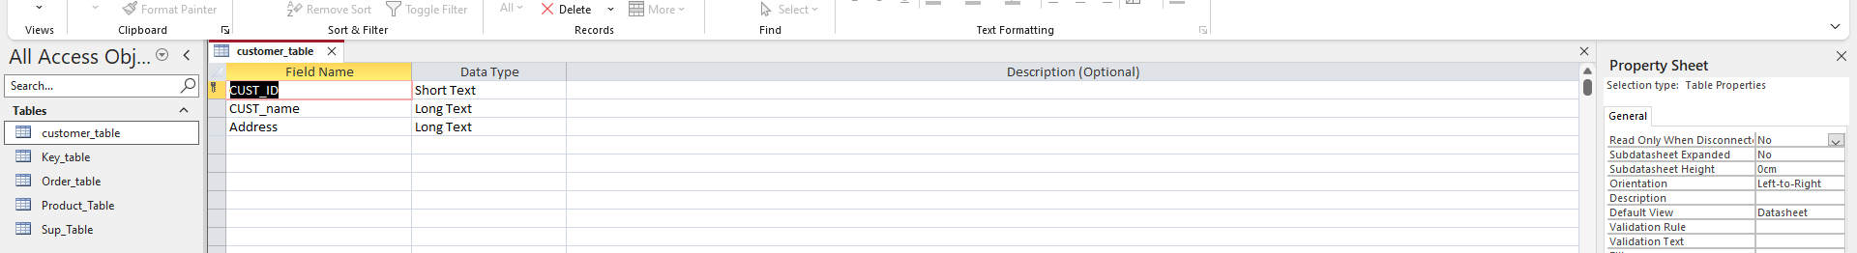
This is the design view of customer table
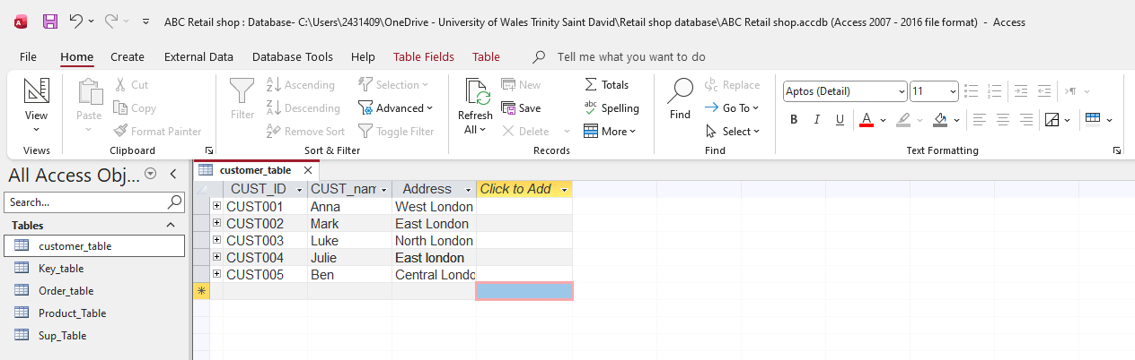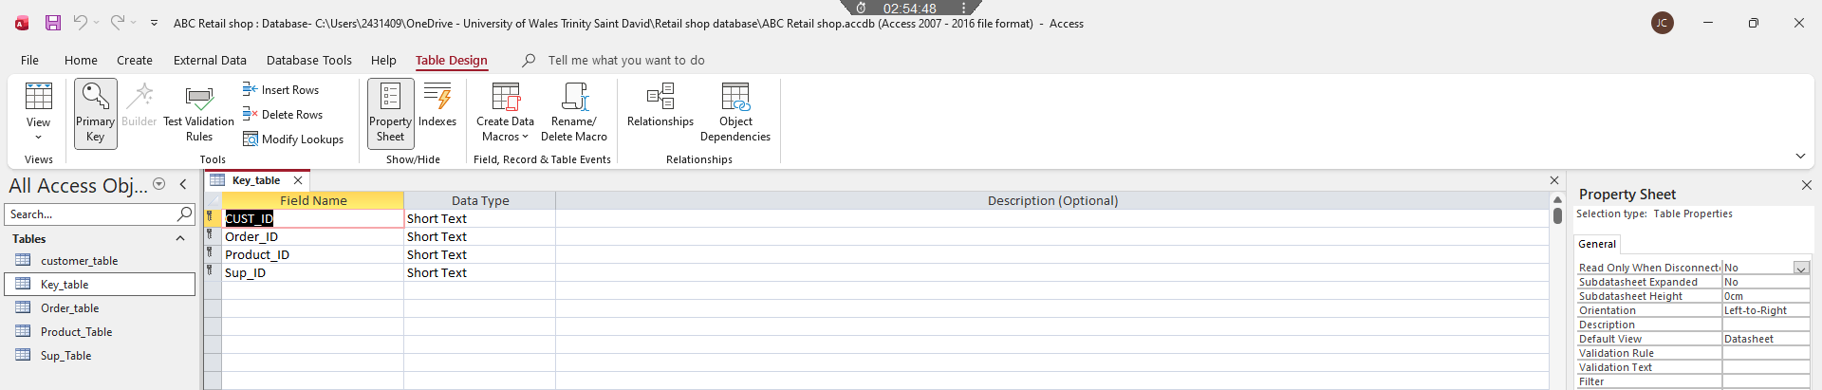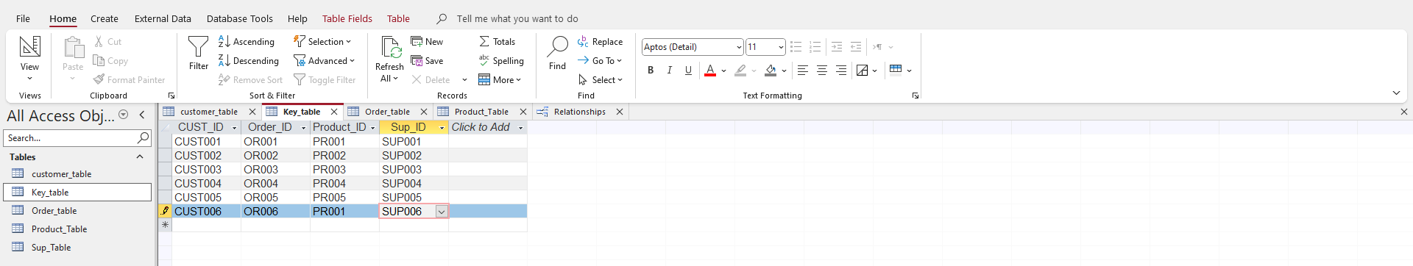
This is the design view of the key table
Datasheet view of key table
This is the data sheet view of customer the customer table

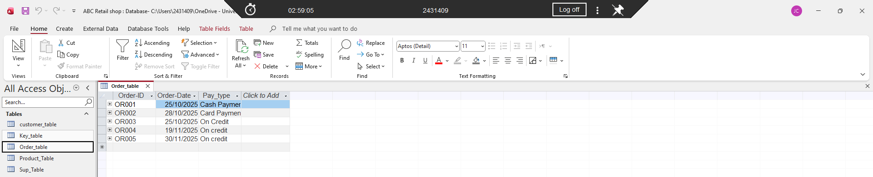

This is the data sheet view for the customer table

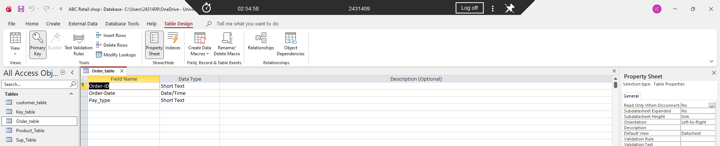

This is the design view for the customer table

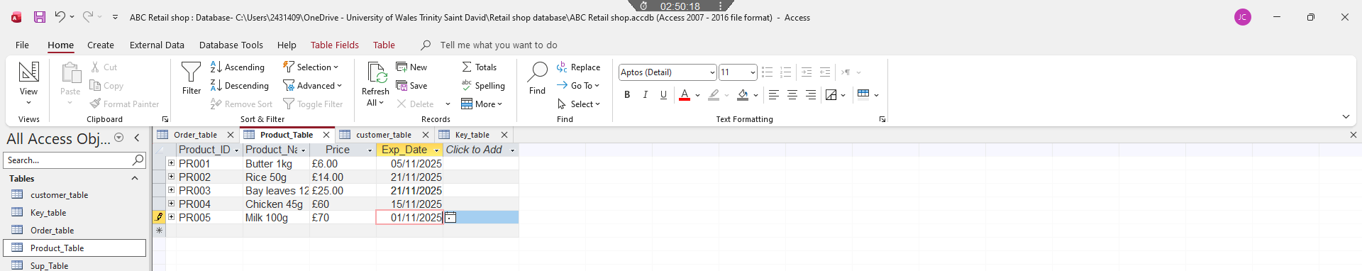

This is the data sheet format for the product table

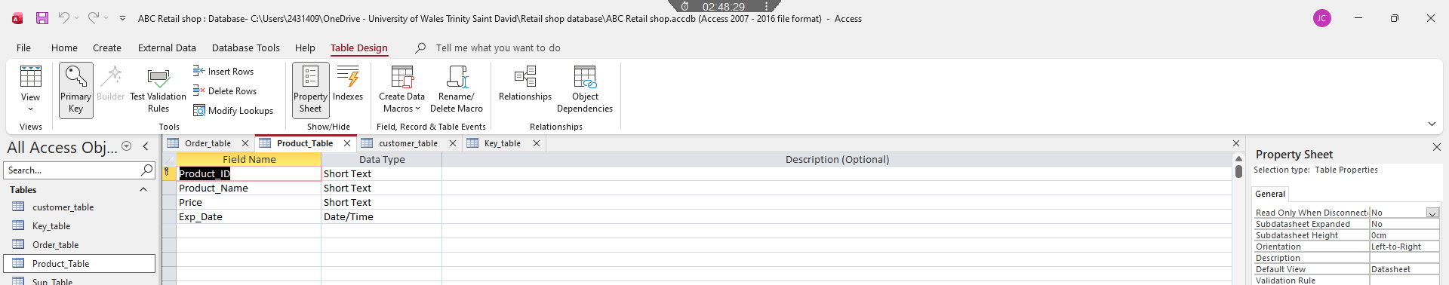

This is the design view for product table

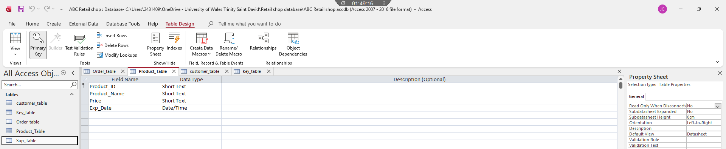

This is the deign view for supply table

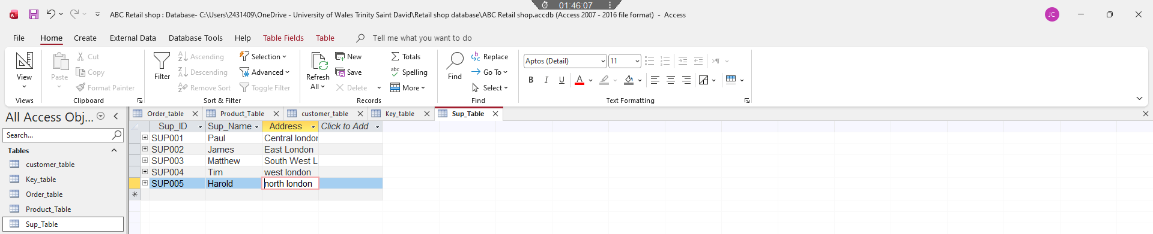

This is the data sheet viewpoint in Microsoft access for my supply table

Relationships between tables
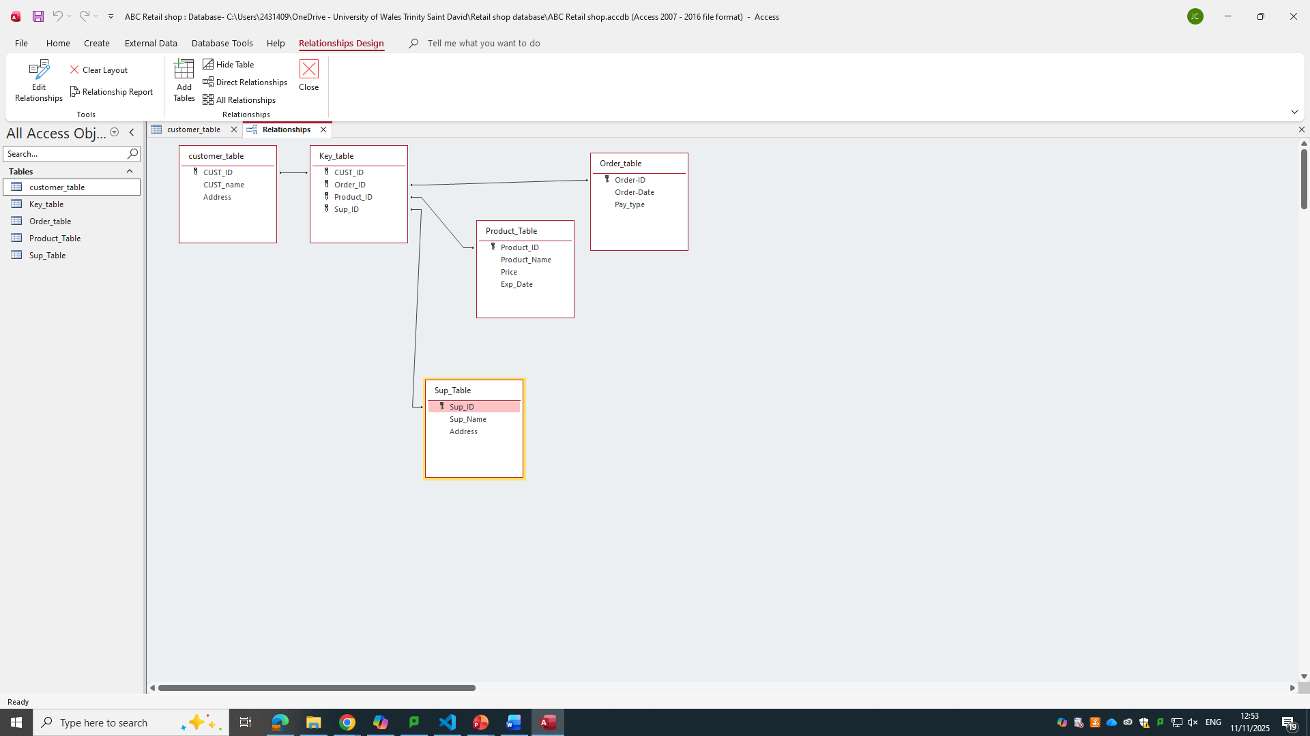
Explain what type of key attributes (each table) used to create relationships between tables.

1. Primary Key
• Definition: A unique identifier for each record in a table.
• Purpose: Ensures that each row is distinct and can be referenced reliably.
• Example: in a table.
2. Foreign Key
• Definition: An attribute in one table that refers to the primary key in another table.
• Purpose: Establishes a link between two tables.
• Example: in a table referencing in.
3. Composite Key
• Definition: A combination of two or more columns used together as a primary key.
• Purpose: Uniquely identifies a record when a single column isn’t sufficient.
• Example: and in a table.
4. Candidate Key
• Definition: A column (or set of columns) that could serve as a primary key.
• Purpose: Offers alternative unique identifiers.
• Example: or in a table.
5. Alternate Key
• Definition: A candidate key that wasn’t chosen as the primary key.
• Purpose: Can still be used for lookups or constraints.
• Example: If is the primary key, might be an alternate key.

Testing and Validation
Requirements of the case study
- Manage an inventory: in this case a table called, “product” has been designed and developed to maintain inventory of all the products.
- Customer Information: A table called "Customer” has been designed and developed……..
Test Cases | Expected Results | Actual Results | Any Discrepancies
Tried to enter duplicate information | Navigate information | Couldn’t save protocol effectively | no
Create an interactive data dashboard | Take me to customer form page via command button | A dashboard has been created to bridge together different pieces of information accurately documentation needed | No
Create working command buttons to navigate between different pieces of information | Showcase data | Showcased data effectively | no
Provide information pertaining to the order profile | Create an order table | Table was created and saved | no
Create a product table to relay data information | Order IDs were sampled | Could not be saved at first but was done after | no

Normalization Process
Take screenshots of 3rd Normal form from MS-Excel and Paste here and annotate each table.
3rd NF TABLES
 | Rider_Details table
Rider_ID | Rider_Name | Rider_Tele | Rider_Address | E-Mail
R100 | Smith | 7916500806 | Walthamstrow | Smith@sample.com
R102 | Harri | 7916500800 | Ilford | Harri@sample.com
R103 | Kisha | 7916500450 | Walthamstrow | Kisha@sample.com
R105 | Sami | 7916860800 | Kent | Sami@sample.com

 | Staff Table
Staff_ID | Staff_Name | Staff_Tele | Staff_Mail | Staff_Task
ST321654 | Leema | 791823546 | leema@sample.com | Mechanic
ST321654 | Leema | 791823546 | leema@sample.com | Mechanic
ST321655 | Vinoth | 126549875 | vinoth@sample.com | Admin
ST321656 | Ravi | 754623546 | ravi@sample.com | Manager
ST321657 | Victor | 789456215 | victor@sample.com | Admin

Rider_ID | Date | Bike_ID | rental time | Return time | usage duration | hourly rate | Bike_Cost
R100 | 04/11/2025 | BIK10 | 8.00 | 14.00 | 6.00 | £3.50 | usage duration
R100 | 04/11/2025 | BIK12 | 15.00 | 18.00 | 3.00 | £3.50 | £6.00
R102 | 03/11/2025 | BIK10 | 7.00 | 12.00 | 5.00 | £3.50 | £3.00
R103 | 02/11/2025 | BIK12 | 10.00 | 15.00 | 5.00 | £3.50 | £5.00
R105 | 01/11/2025 | BIK13 | 9.30 | 12.30 | 3.00 | £3.50 | £5.00

Staff_ID | Bike_ID | Location_ID | Bike_Track_No | Bike_Location
ST321654 | BIK10 | LO002 | 300-000-100 | University Park
ST321654 | BIK12 | LO003 | 300-000-101 | Uni campus
ST321655 | BIK10 | LO001 | 300-000-101 | Train Station
ST321656 | BIK12 | LO002 | 300-000-102 | University Park
ST321657 | BIK13 | LO002 | 300-000-103 | University Park

Bike_Details_Table
Bike_ID | Bike_Type | Bike_Condition
BIK10 | Mountain | Excelent
BIK12 | City curiser | Good
BIK10 | Mountain | Excelent
BIK12 | City curiser | Good
BIK13 | City curiser | Good

MS- Access

Forms Creation (take screenshots of all the forms and annotate them)
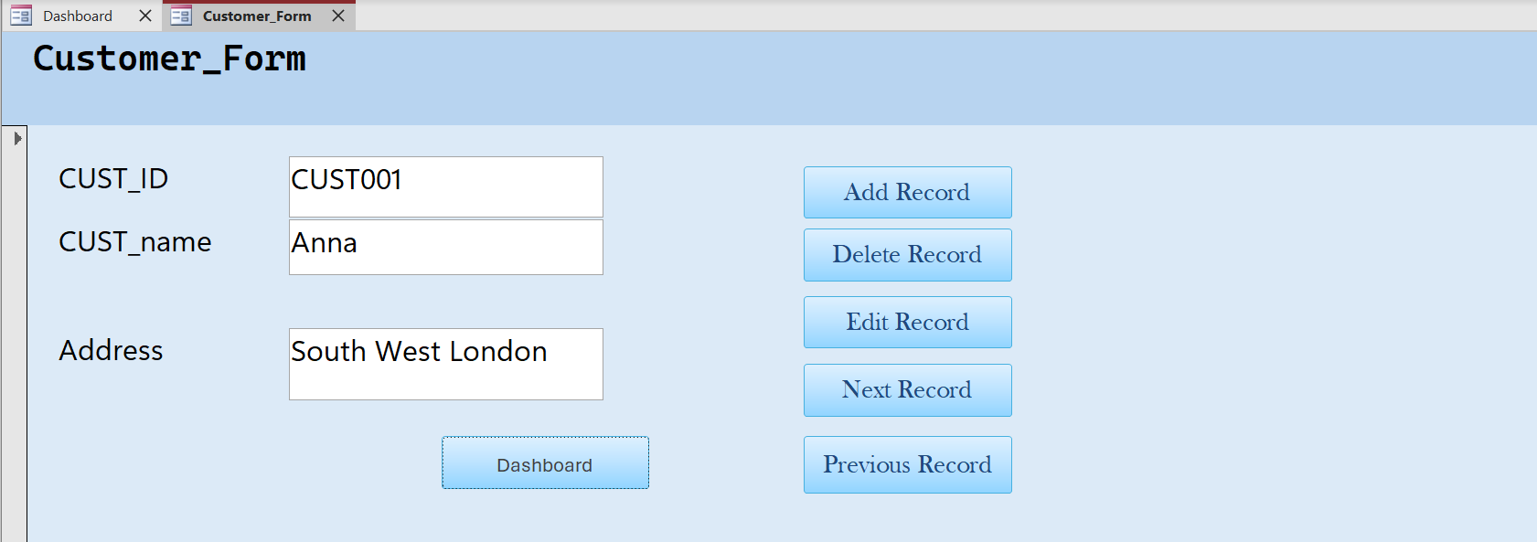
This is my customer form
This box outlined in red are the main functions of this page

This dashboard button once clicked leads to my database dashboard as seen below:

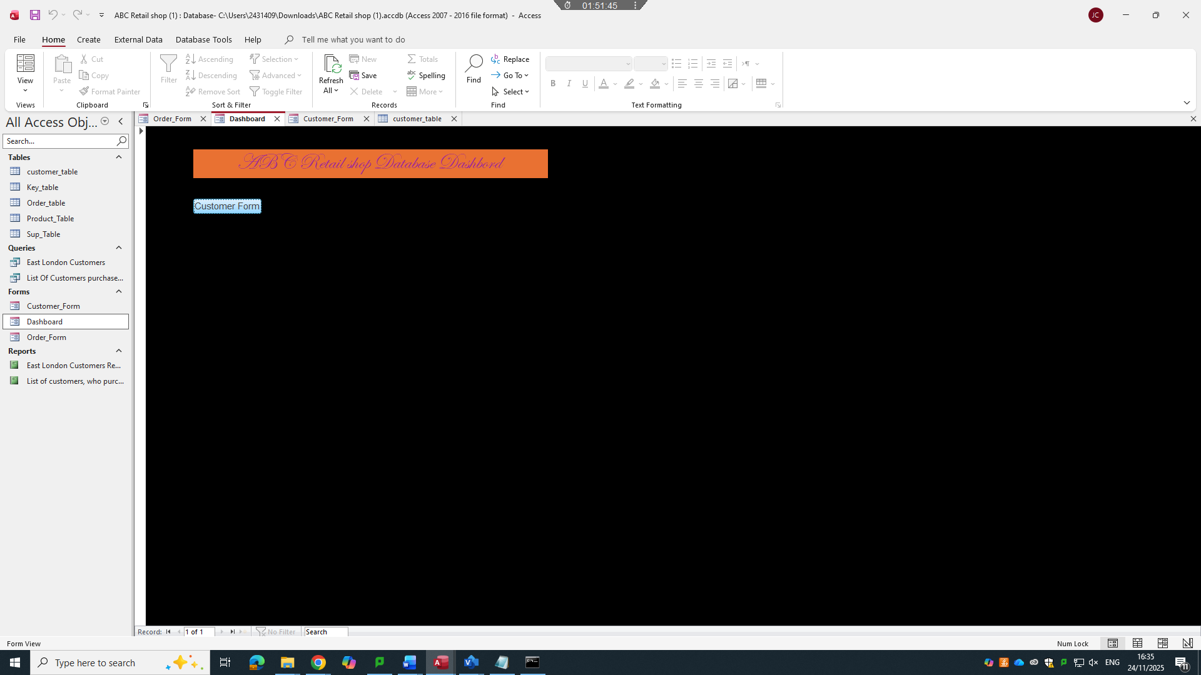

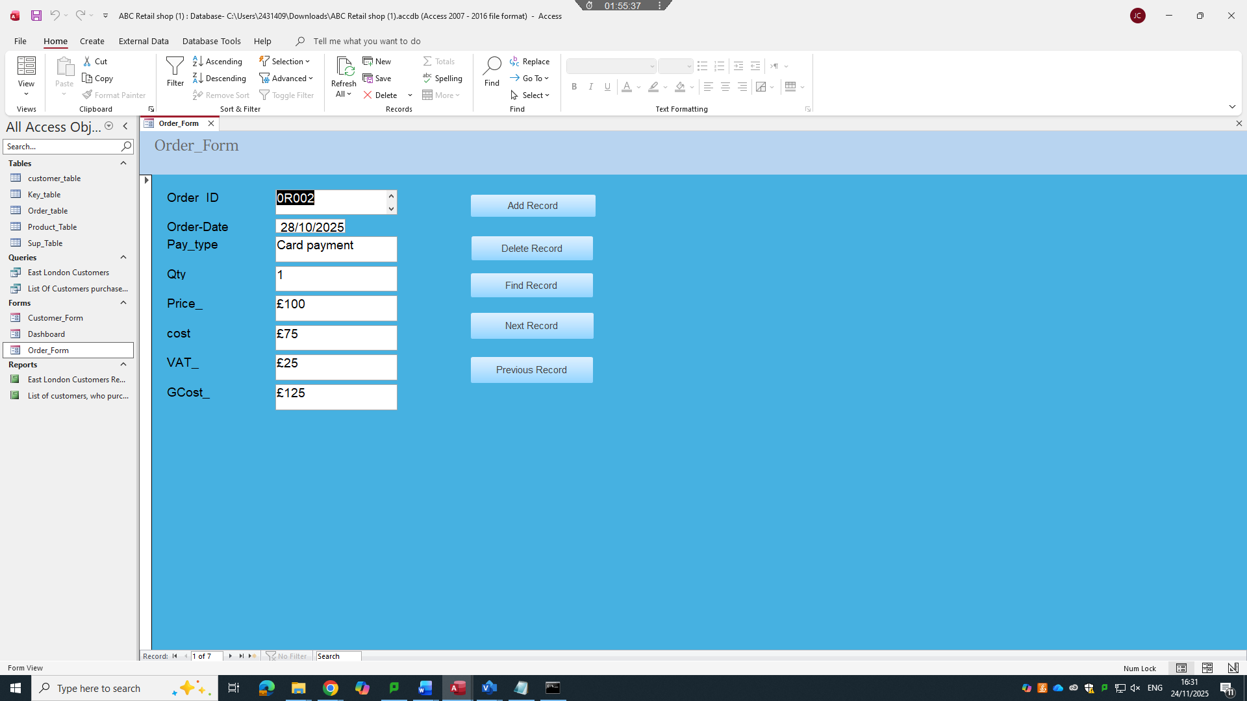
This form also has navigation tools as shown on the customer form
This is my order form it consists of all order information pertaining to the nature of the order

Queries Creation (take screenshots of the design view, datasheet view and SQL view of each query and annotate them)
Based on your critical thinking, create at least two – three queries
SQL view

SELECT
Customer_Details.Cust_ID,
Customer_Details.Name,
Customer_Details.Address
FROM

Customer_Details
WHERE
(((Customer_Details.Address) = "East London"));
1 Query for east London customers data (sheet view)
Here is the data for the east London query table it has 2 customers Mark and Julie
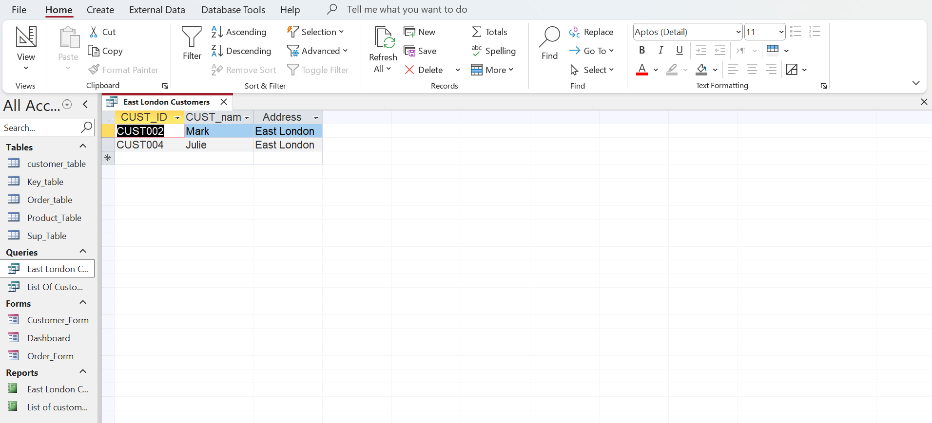
2 – Design view
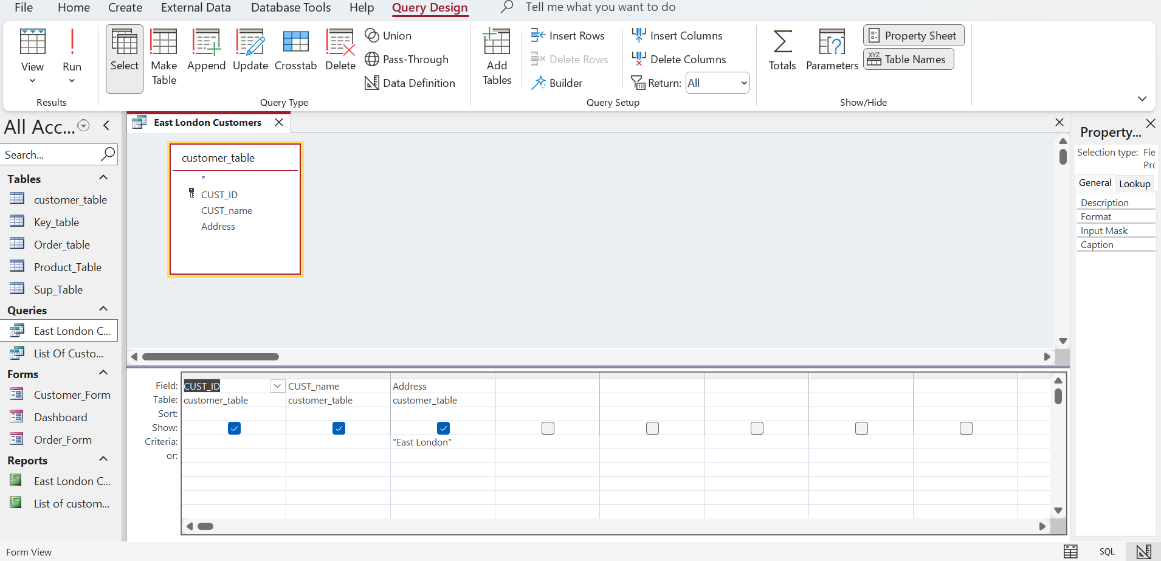
The box beneath is another representation of the information seen above
Here is the design view of east London customers in the is customer ID Customer name and lastly the address

3 SQL view of east London customer query
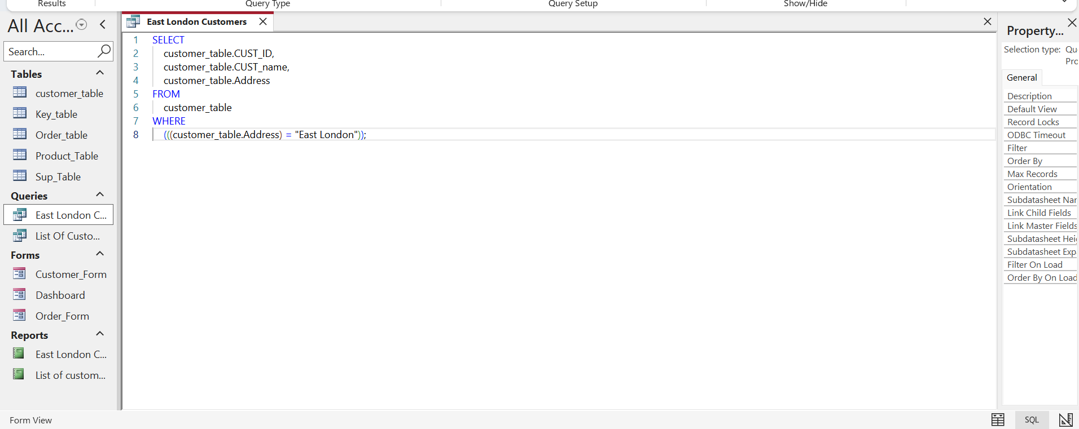
This is the SQL view of the east London customer query table this represents the coding language of the operation
Part 2
List of customers who purchased product1
Data sheet view:
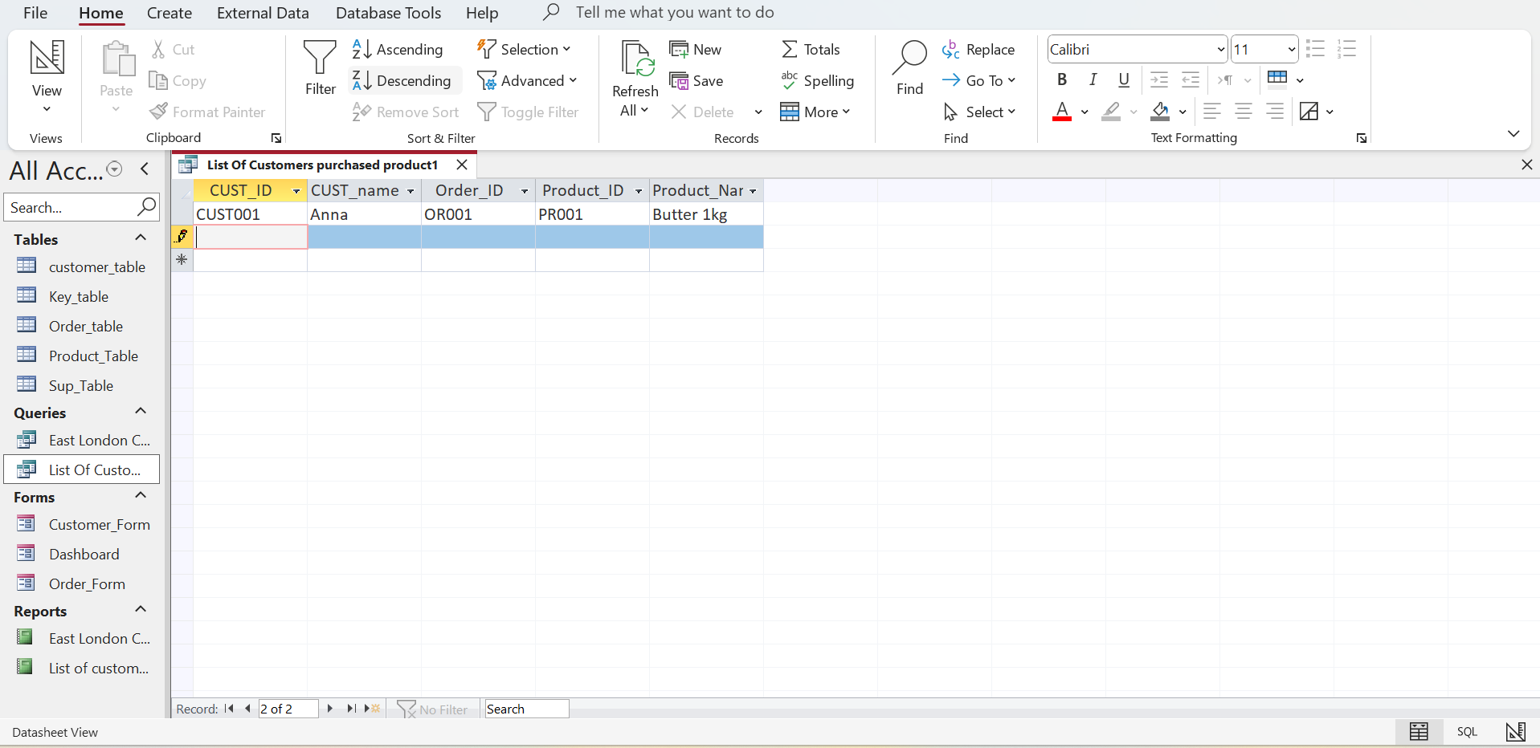
This is the data sheet view containing the list of customers who purchased product1

Design view:
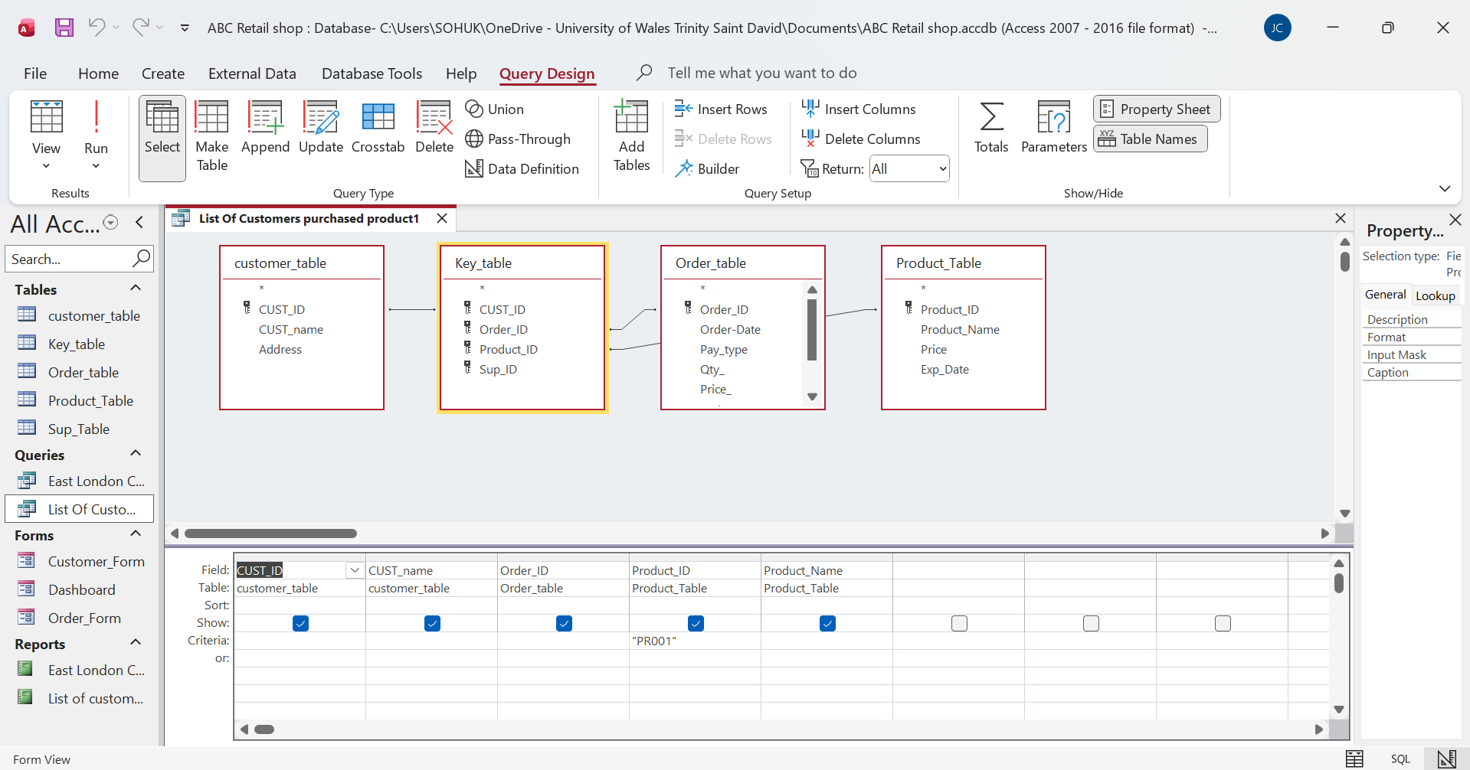
This is the design view template which shoes the relationship between customer table, Key table, Order table and product table

SQL View:
This is the SQL View of the query table containing the information of customers who purchased Product1
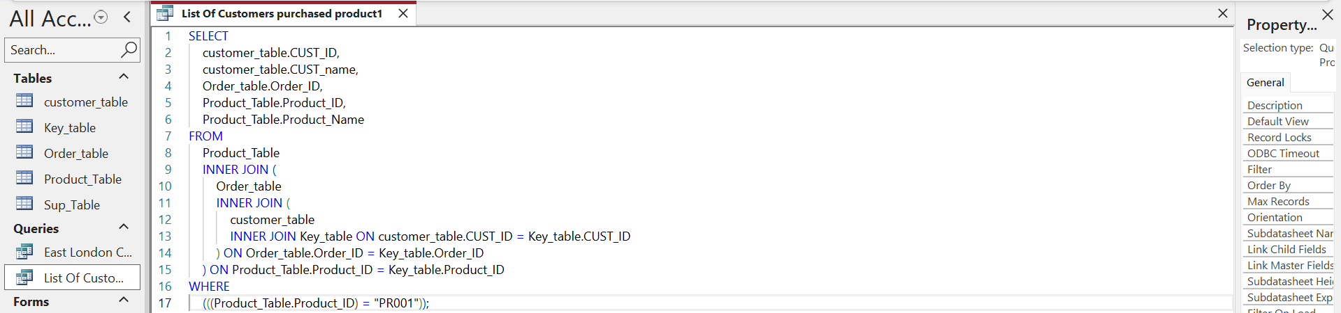

Report Creation (create reports from each query and annotate them)
- East London Query Report

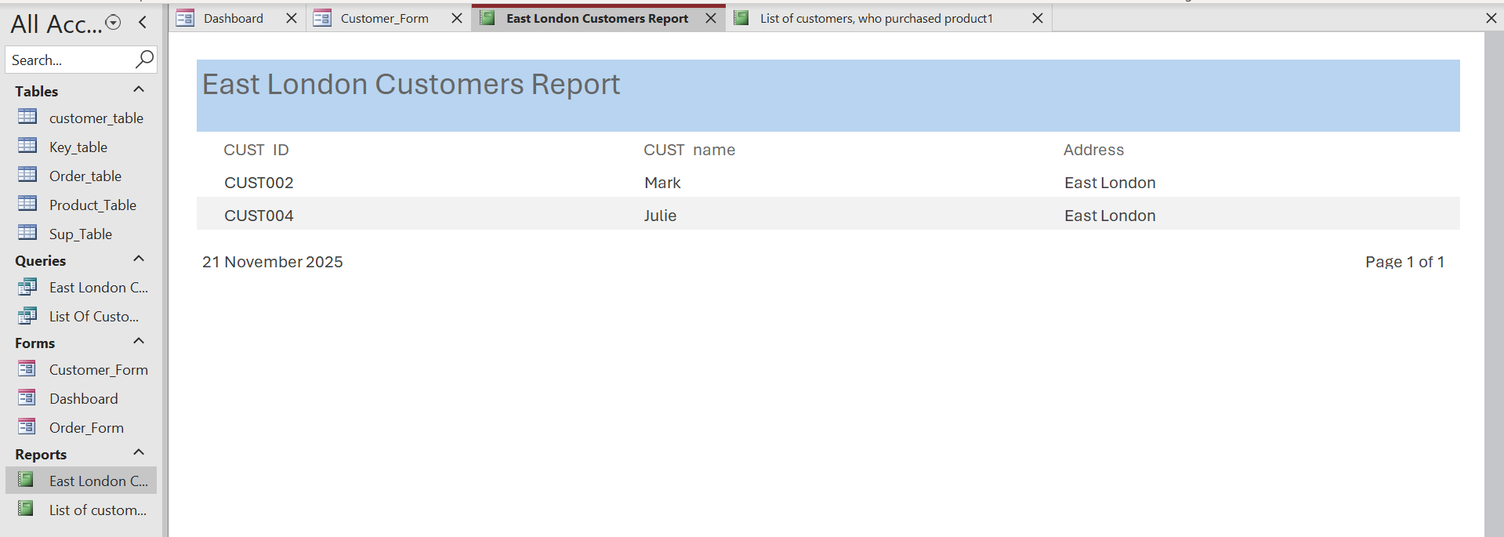

These are the names of the customers on the east London report sheet this is set in a table format to information effectively
These are the customer ID numbers as represented in the database beneath you can see the date the form was created

2)List of customers who purchased product1

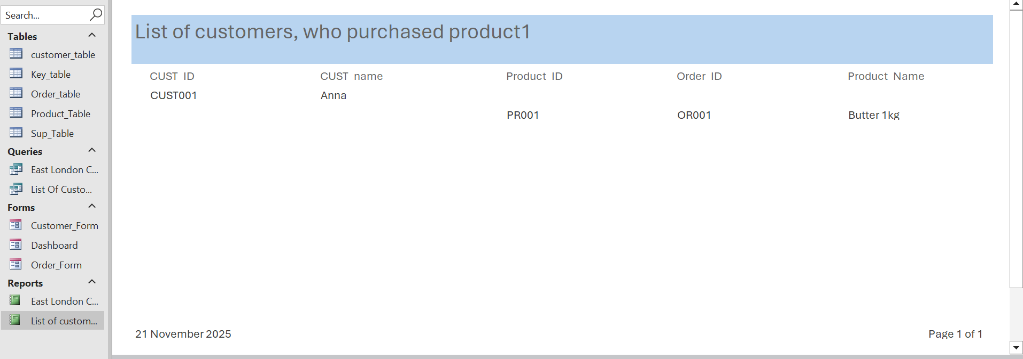
You can also see that this report was done on the 21st of November 2025 like the first report which consisted of customers residing in East London

This form represents the list of customers who purchased product 1 which is anna there are no more customers in my report who purchased product 1

Dashboard Creation (show how to navigate from dashboard to forms and forms to dashboard)
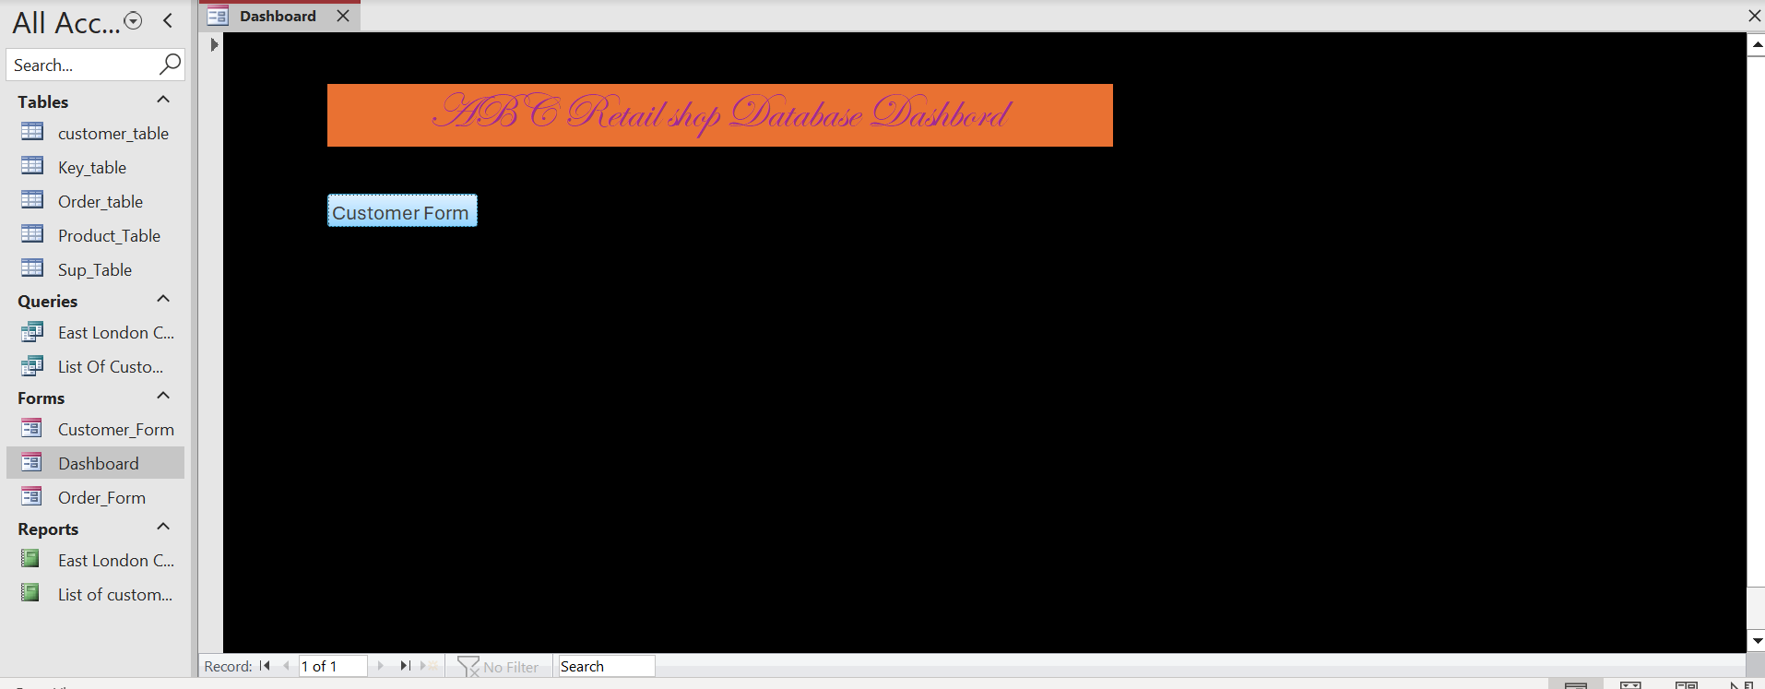
Click this button to get to customer forms you will be presented with the customer form as seen below



