Excretion
The Removal of waste products (often toxic) that have been produced by chemical reactions in the body, eg CO₂
Urea is formed in the liver from the breakdown of amino acids not required by the body.
The Urinary System
Humans have 2 kidneys inside the rib cage at the back of the body, halfway down the spine. The kidneys are well supplied with blood by the renal arteries and renal veins. The kidneys filter the blood to remove waste substances such as excess water, urea and mineral ions. These make up urine which flows out of the kidneys down the ureters into the bladder. The bladder stores the urine until the ring of muscle at its base is released, then the urine flows out of the bladder out of the urethra (and into the loo).
Label the diagram
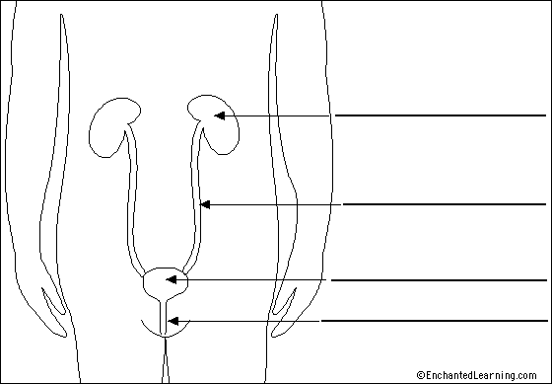
The kidneys are responsible for 3 important jobs;
- ULTRAFILTRATION – Filtration on a molecular scale between the glomerulus and Bowman’s capsule (cleaning of the blood).
- SELECTIVE REABSORBTION – some substances are filtered out of the blood and then selectively reabsorbed.
- OSMOREGULATION - The regulation of the concentration of water molecules in the blood.
Ultrafiltration
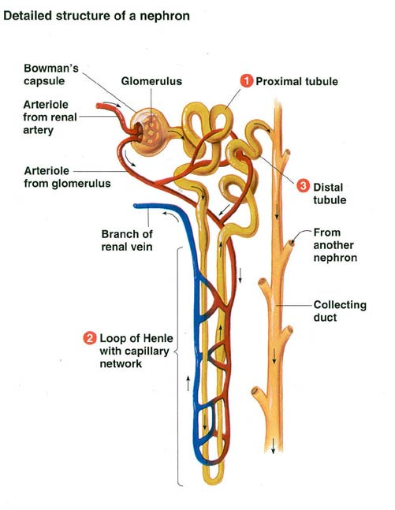
The Kidneys have around 1 million tiny tubules called nephrons, each associated with a blood capillary. Waste products leave the blood and enter the nephron to form urine.
- Dirty blood enters the kidney via the renal artery.
- The artery splits up into a ball of capillaries called the glomerulus.
- The Blood is under high pressure (coming from the pumping heart and also because the blood vessel leading away from the glomerulus has a smaller diameter)
- The high pressure forces all small molecules out of the holes in the capillary walls leaving only large molecules like proteins in the blood.
- The small molecules enter the Bowman’s capsule (now called glomerular filtrate) and travel into the proximal convoluted tubule where glucose is reabsorbed back into the blood by active transport.
- The filtrate travels down through the loop of Henlé where water is reabsorbed by osmosis.
- The filtrate then enters the distal convoluted tubule where minerals, amino acids and other useful substances are reabsorbed back into the blood.
- The remaining fluid containing urea, excess salts and excess water passes into the collecting duct.
- The distal convoluted tubules from several other nephrons join up to form the collecting duct.
- The collecting ducts from the other nephrons join to form the ureter, which leads to the bladder.
- The fluid (urine) is stored in the bladder ready for excretion.
- The urine travels down the urethra to the outside.
Selective Reabsorption
As the filtrate travels through the proximal convoluted tubule most sodium ions and all glucose molecules are reabsorbed back into the blood. These are essential molecules that are not lost in urine.
Water is also reabsorbed back into the blood from the loop of Henlé and distal convoluted tubule by osmosis. There is a higher concentration of water molecules in the filtrate than in the blood, so water osmoses into the blood. Other substances such as vitamins, mineral ions and amino acids are also reabsorbed from the distal convoluted tubule.
Label the diagrams
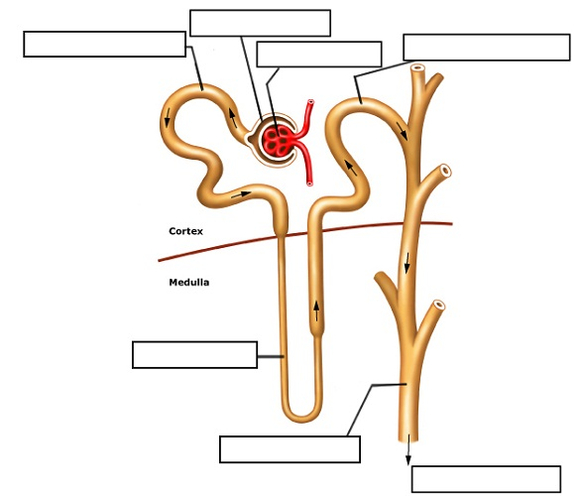

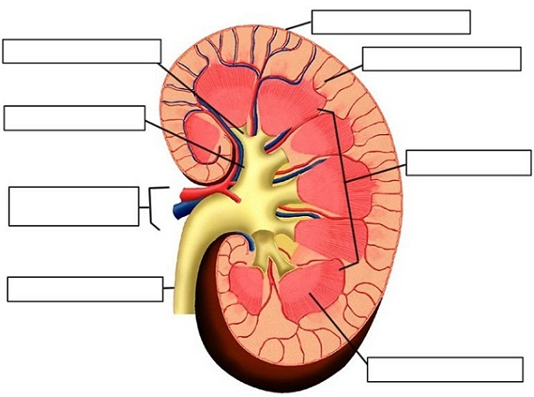

Osmoregulation
The control of the concentration of water in the blood.
Water is essential for cellular reactions and as a solvent for the many substances in blood.
If the concentration of water in the blood falls too low the body is dehydrated. Water will be drawn out of cells by osmosis which could be damaging to cell processes.
Too much water in the blood is over hydration; too much water can burst animal cells.
When blood water levels too low (Blood too concentrated)
- The hypothalamus in the brain detects low water levels in the blood.
- This causes the pituitary gland to release anti-diuretic hormone (ADH) into the blood.
- ADH travels around the body in the blood stream to its target organ; the kidneys.
- The cells of collecting tubules in the nephrons have ADH receptors which respond to ADH.
- ADH makes the cells in the collecting ducts become more permeable to water, so more water is reabsorbed from the duct into the blood.
- ADH receptors in the hypothalamus also stimulate a thirst centre in the brain so you feel thirsty and take a drink.
- Water levels in the blood return to normal.
- The urine becomes more concentrated.

When water levels are too high (Blood too concentrated)
- The hypothalamus detects high water levels in blood.
- ADH is no longer released, none reaches the collecting ducts
- The cells of the collecting duct become less permeable to water.
- Less water is reabsorbed into the blood.
- Water levels in the blood return to normal.
- The urine is more dilute.

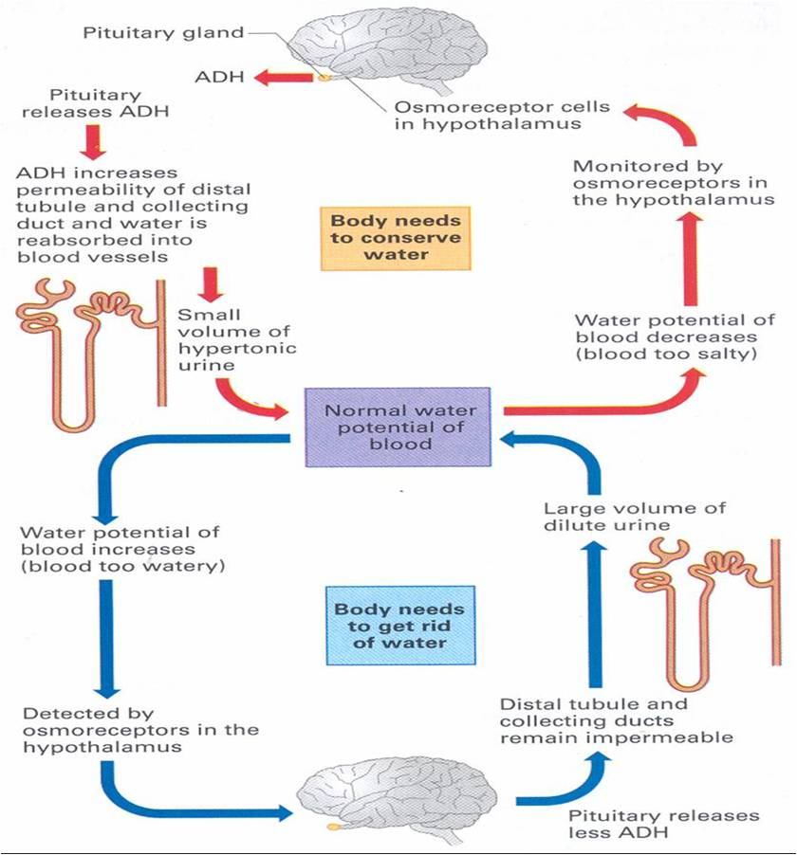
Urine contains water, urea and salts.

